Supplementary Material

Table S1. XGBoost parameter set used in the mortality model.

Hyperparameter | Definition | Value | Default
learning_rate | Learning rate | 0,0202 | 0,3
n_estimators | Number of estimators | 440 | 100
gamma | Minimum split loss | 0 | 0
max_depth | Maximum tree depth | 5 | 6
min_child_weight | Minimum sum of instance weights in a child | 2 | 1
subsample | Sub-sample ratio of training instances | 0,46 | 1
colsample_bytree | Sub-sample ratio of columns for each tree | 0,52 | 1
colsample_bynode | Sub-sample ratio of columns for each node | 1 | 1
colsample_bylevel | Sub-sample ratio of columns for each level | 1 | 1
reg_alpha | L1 regularization term | 0 | 0
reg_lambda | L2 regularization term | 1 | 1
scale_pos_weight | Weight balance between positive-negative class | 8 | 1

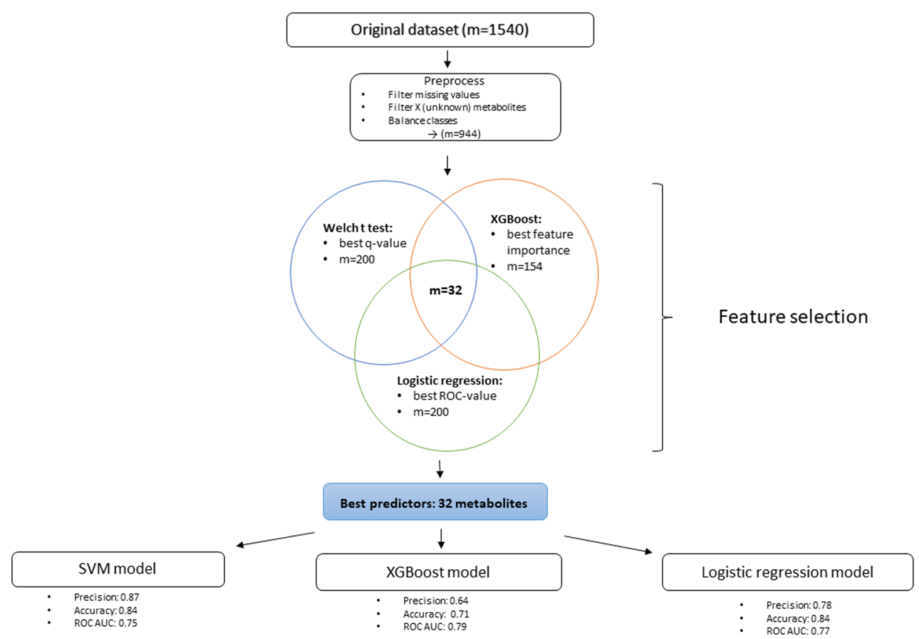

Fig. S1. Processing of the data from the original dataset to the identification of the most impactful metabolites predicting mortality

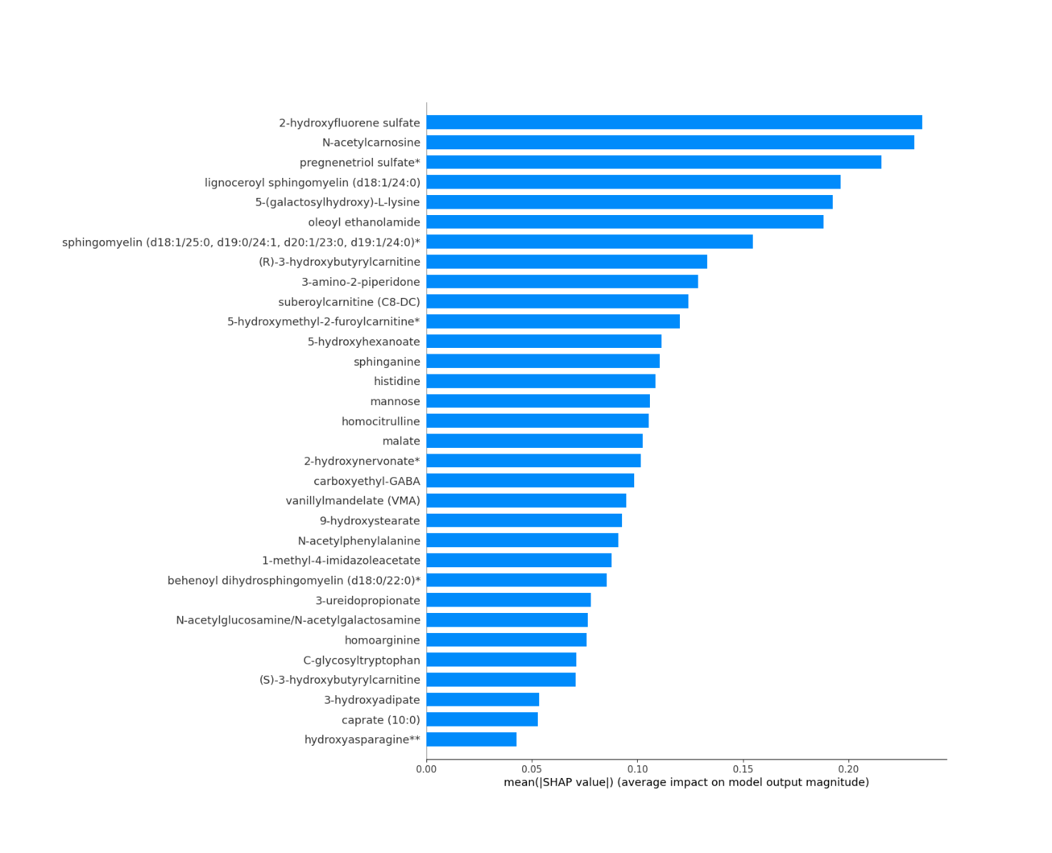
Fig. S2. The relative importance of the metabolites on mortality prediction shown by absolute SHAP values.
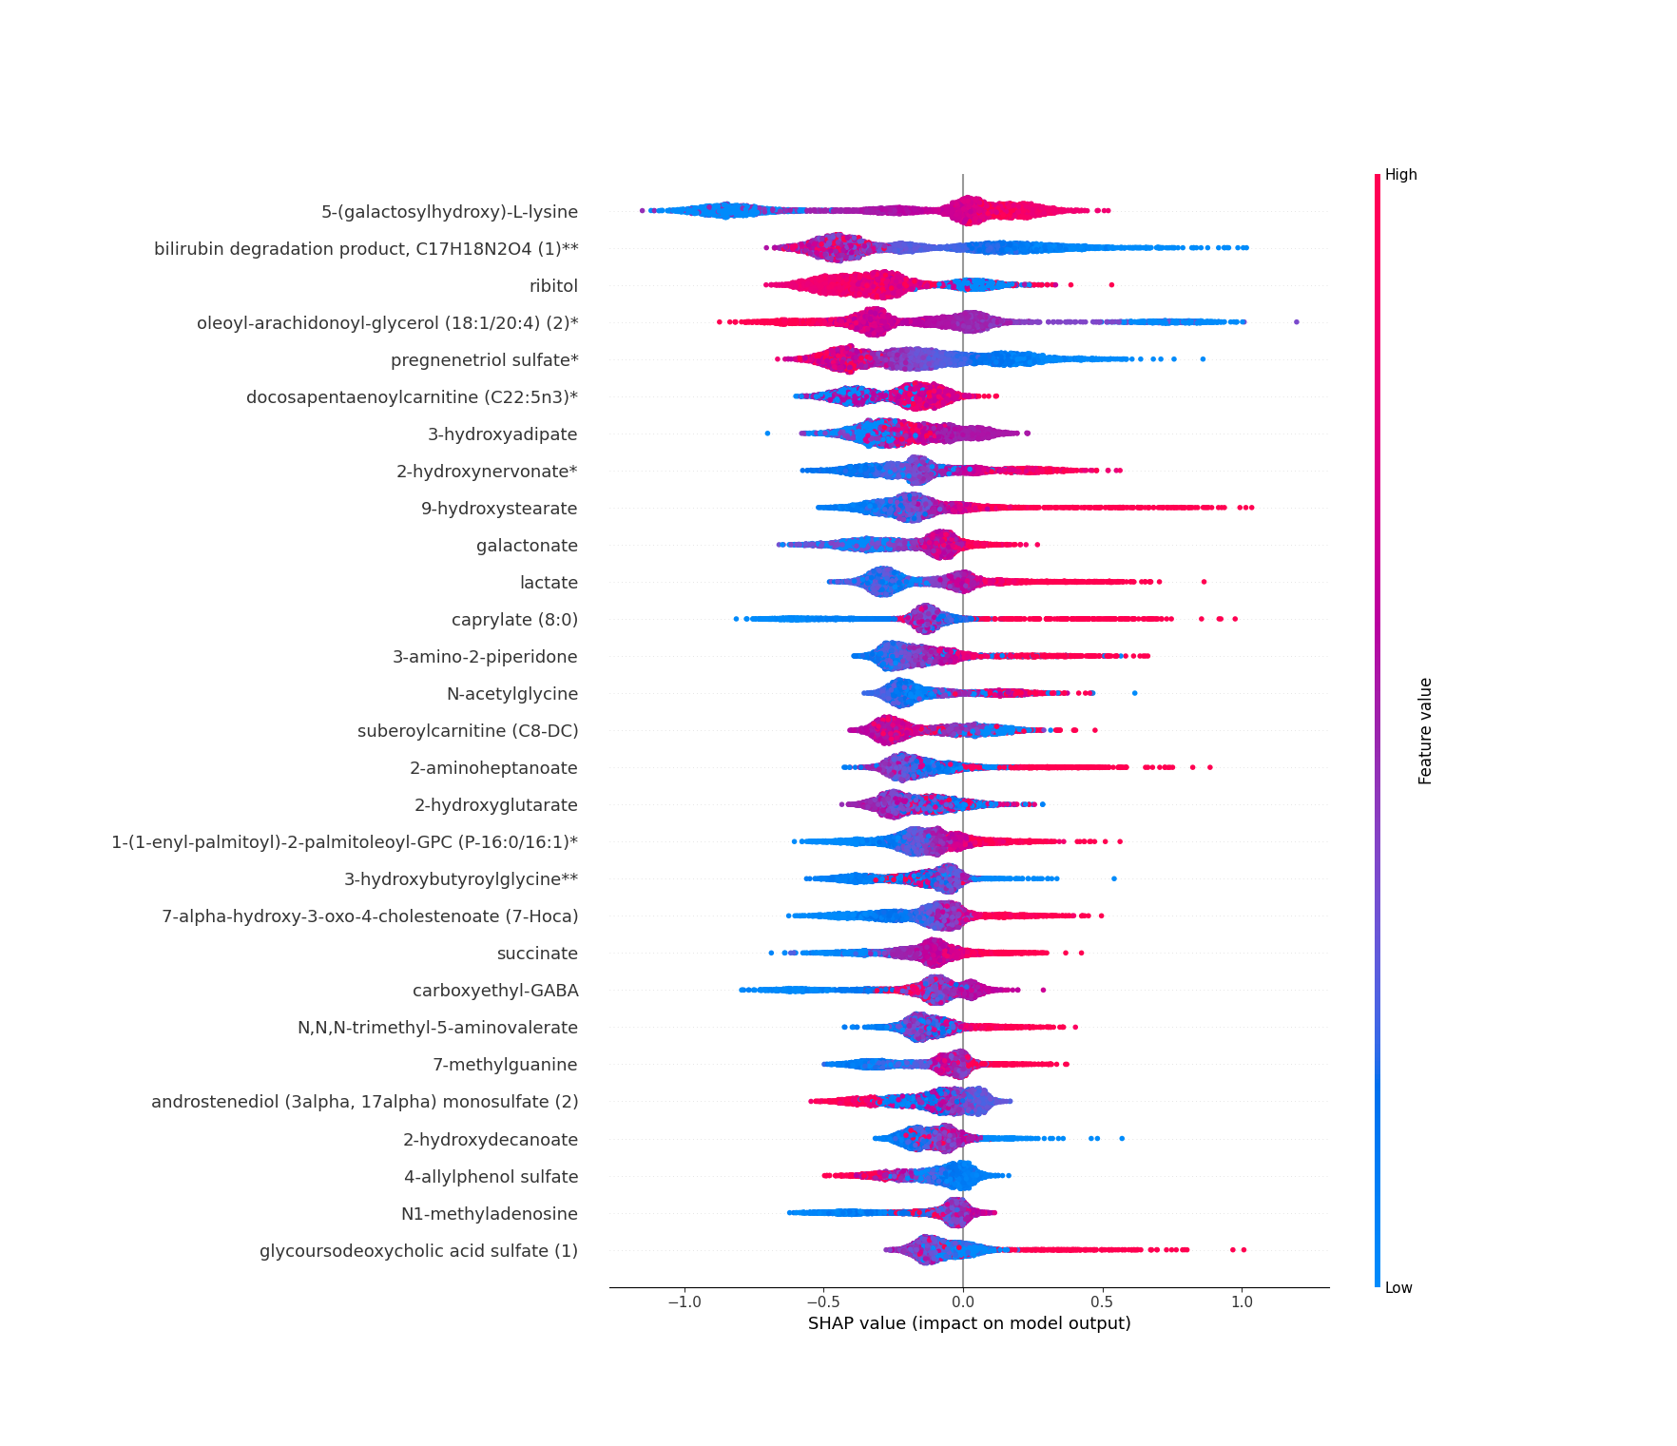

Fig. S3. SHAP summary plot of the most impactful predictors of short-term mortality. Positive SHAP value indicates an increased risk prediction of mortality and negative SHAP value indicates protective effect. Each dot corresponds a single observation and the highest value of the variable is shown in red and the lowest value in blue.

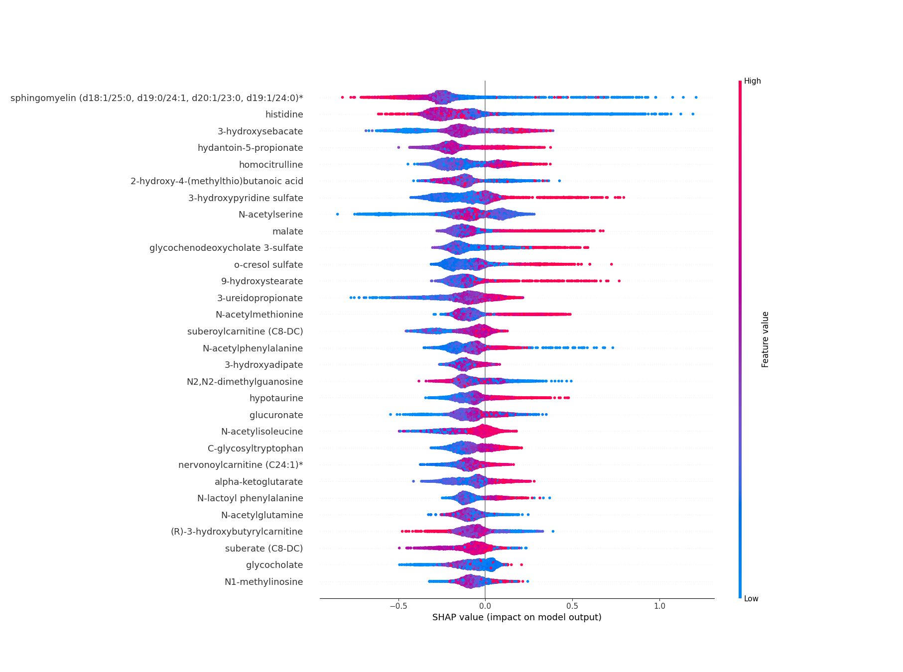

Fig. S4. SHAP summary plot of the most impactful predictors of intermediate-term mortality. Positive SHAP value indicates an increased risk prediction of mortality and negative SHAP value indicates protective effect. Each dot corresponds a single observation and the highest value of the variable is shown in red and the lowest value in blue.

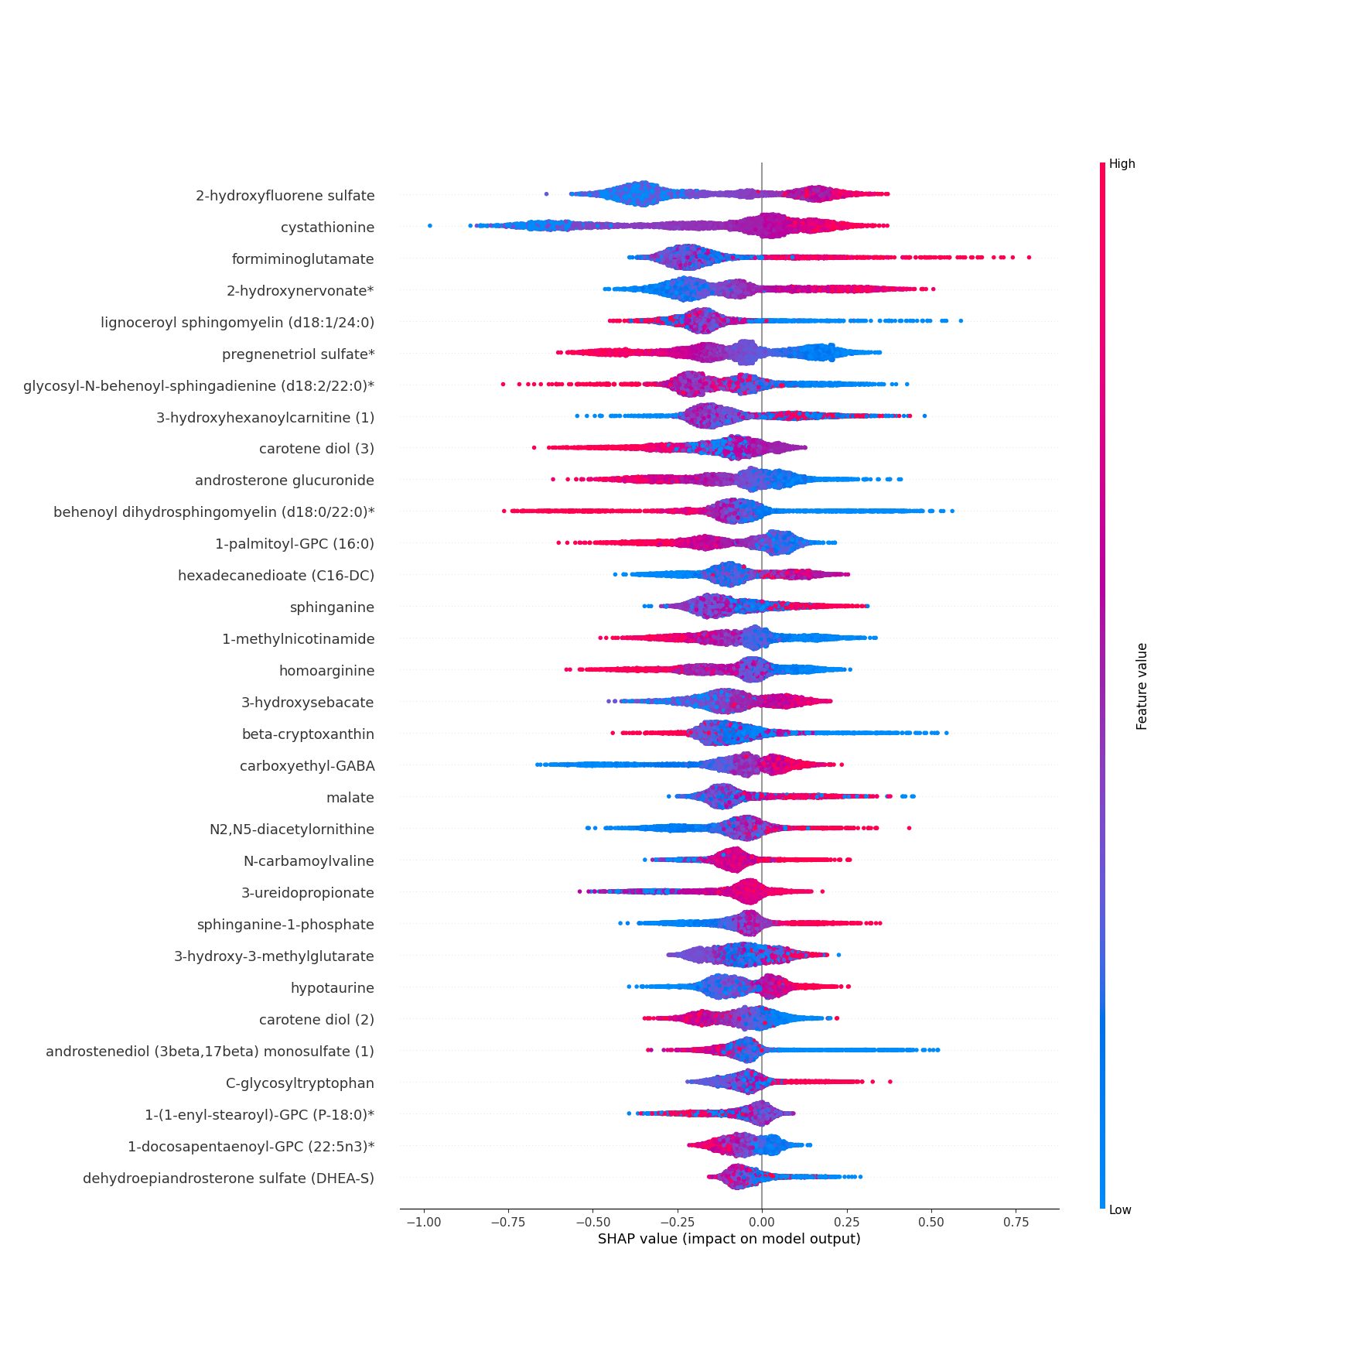
Fig. S5. SHAP summary plot of the most impactful predictors of long-term mortality. Positive SHAP value indicates an increased risk prediction of mortality and negative SHAP value indicates protective effect. Each dot corresponds a single observation and the highest value of the variable is shown in red and the lowest value in blue.

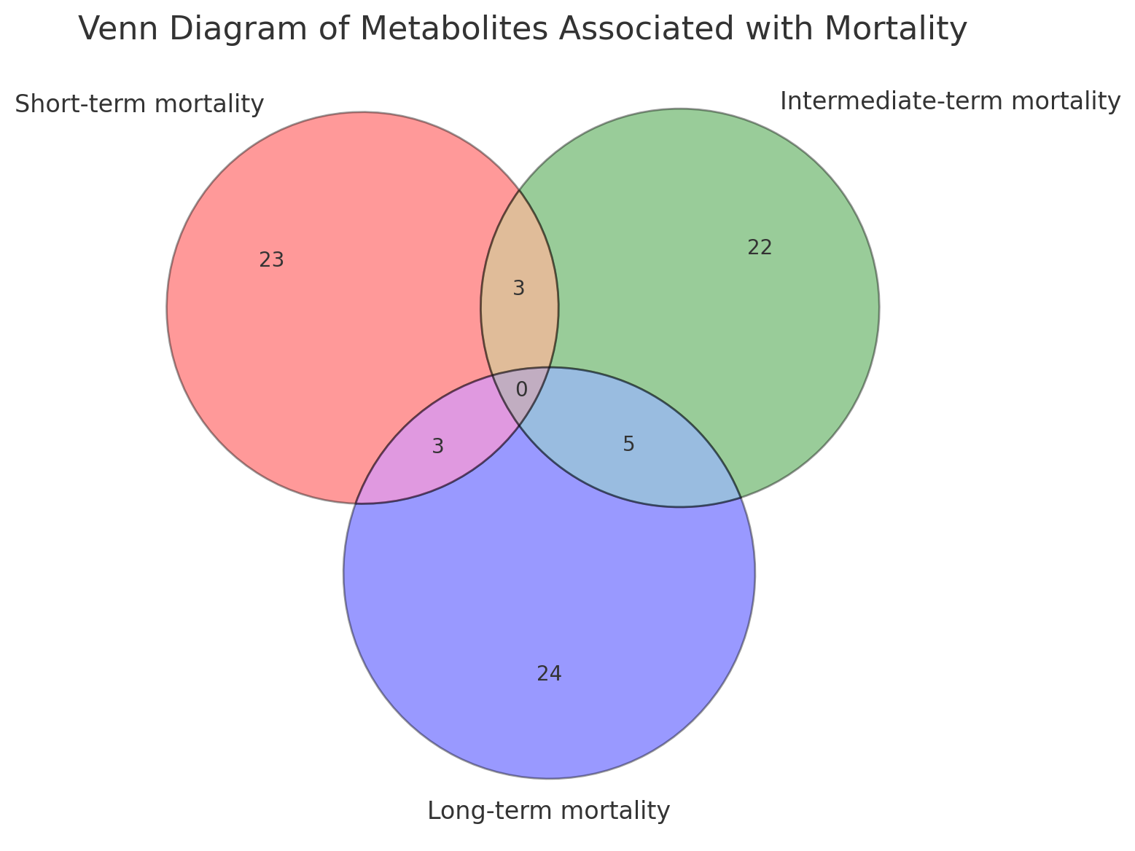

Fig. S6. Distinct and overlapping metabolites associated with short-, intermediate-, and long-term mortality.

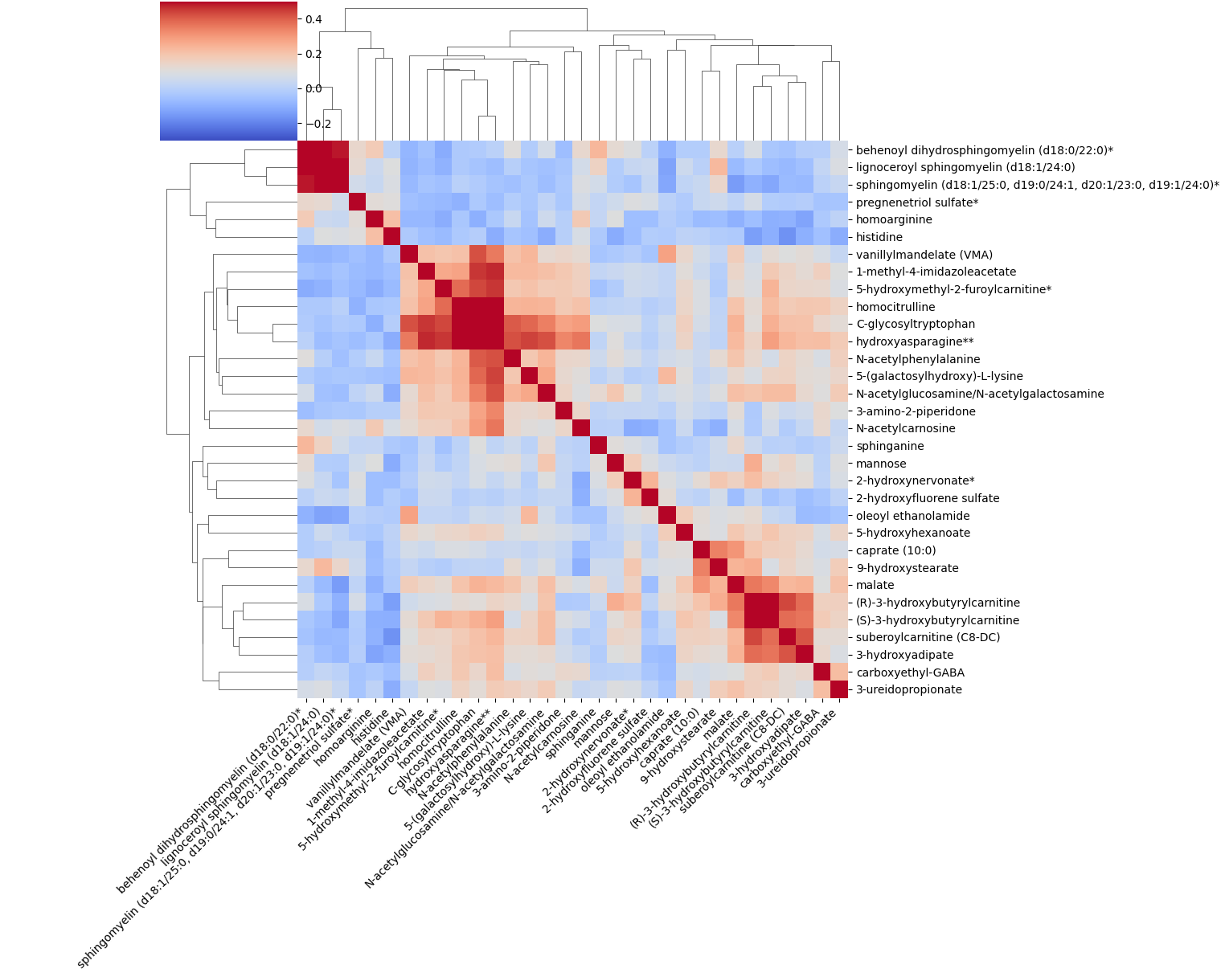

Fig. S7. Clustered heatmap of 32 metabolites

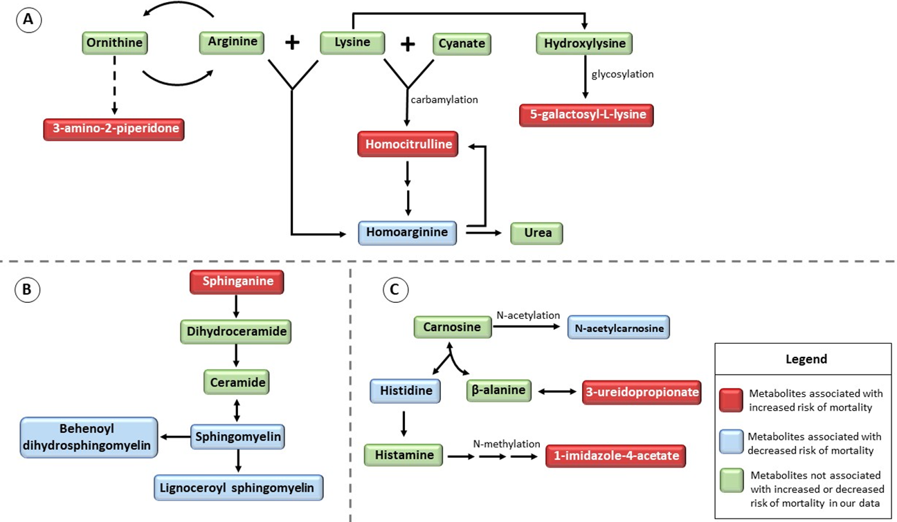

Fig. S8. Main metabolic pathways of the metabolites associated with increased or decreased risk of mortality.

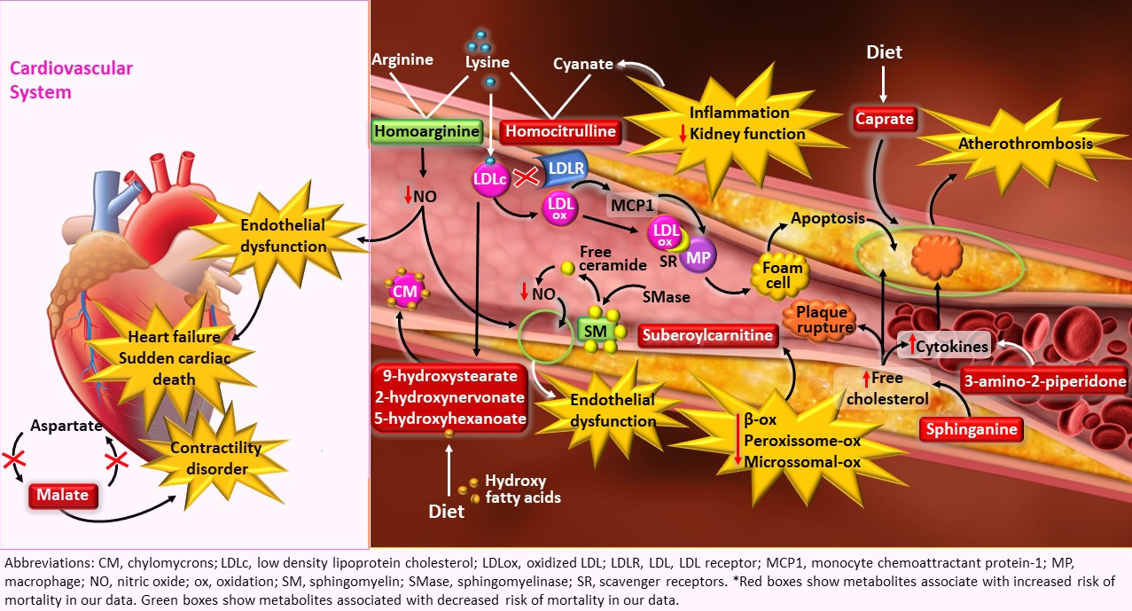

Fig. S9. Metabolites affecting the cardiovascular system. Distubance in the malate-aspartate cycle leads to increased malate levels and contractility disorder in the heart. Inflammation and decline in kidney function generates cyanate which carbamylates with lysine yield homocitrulline. Lysine might be directed to the homocitrulline pathway, decreasing the generation of homoarginine, and consequently of NO, resulting in endothelial dysfunction, which can result in heart failure. Lysine from LDLC can be carbamylated to generate homocitrulline, and oxidized LDLC, which is unable to bind LDLR, and in turn accumulates attracting macrophages, and generates foam cells, contributing to the atherosclerotic plaque formation. Caprate also contributes to atherosclerotic plaque. Hydroxy fatty acids coming from the diet are incorporated into chylomicrons. Degradation of sphingomyelin generates free ceramides, which decrease NO levels, causing endothelial dysfunction. Disruption of β-oxidation, peroxisome and microsomal oxidations leads to an increase in suberoylcarnitine levels. Sphinganine leads to an increase in free cholesterol and cytokines, which accumulate and contribute to plaque rupture. 3-amino-2-2piperidone leads to increase in cytokines, promoting atherothrombosis.
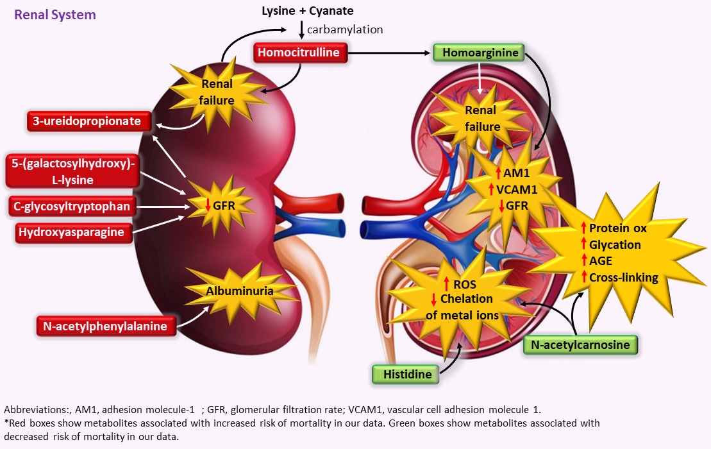

Fig. S10: Metabolites affecting the renal system. Decline in kidney function leads to an increase in cyanate, which is carbamylated with lysine to generate homocitrulline, which is associated with renal failure. Progression of renal failure and decrease in GFR generates 3-ureidopropionate. 5-(galactosylhydroxy)-L-lysine, C-glycosyltryptophan and hydroxyasparagine decrease GFR. N-acetylphenylalanine is linked to albuminuria. Since lysine is directed to the homocitrulline pathway, homoarginine levels are decreased, which increases AM1 and VCAM1, leading to endothelial dysfunction, a decrease in GFR, and renal failure. Low levels of N-acetylcarnosine and histidine increase ROS and decrease chelation of metal ions. N-acetylcarnosine increases protein oxidation, glycation, cross-linking and AGEs generation.
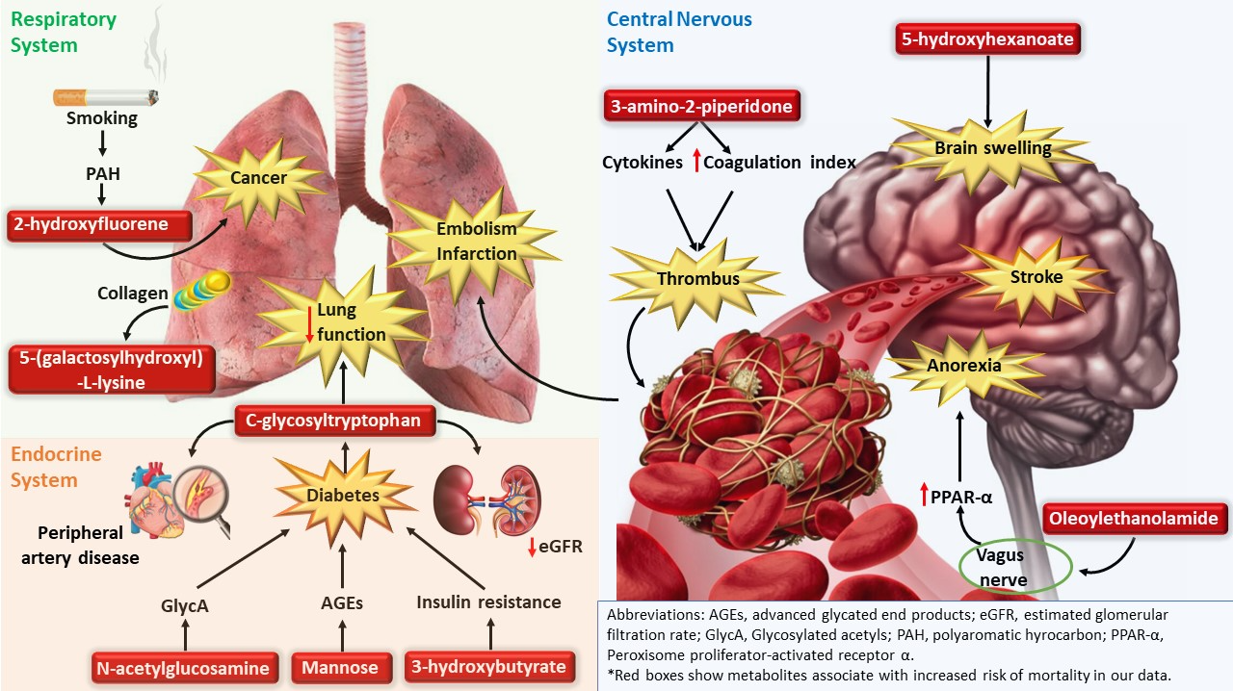

Fig. S11. Metabolites affecting respiratory system, endocrine system, and central nervous system. Smoking increases PAH and consequently 2-hydroxyfluorene resulting in an increase in the risk of lung cancer. Degradation of collagen in the lungs generates 5-(galactosylhydroxy)-L-lysine. N- acetylglycosamine, mannose and 3-hydroxybutyrate contribute to the development of diabetes by generation of GlycA, AGEs and insulin resistance. Diabetes leads to an increase in C-glycosyltryptophan, which contributes to the development of peripheral artery disease and a decrease in GFR. C glycosyl tryptophan also contributes to a decrease in lung function. 3-amino-2-piperidone increases cytokines generation and coagulation index, leading to thrombus formation, that can lead to lung embolism or infarction, and cerebral stroke. Oleylethanolamide acts on the vagus nerve, increasing PPAR-α, leading to anorexia. 5-hydroxyhexanoate is associated with brain swelling.

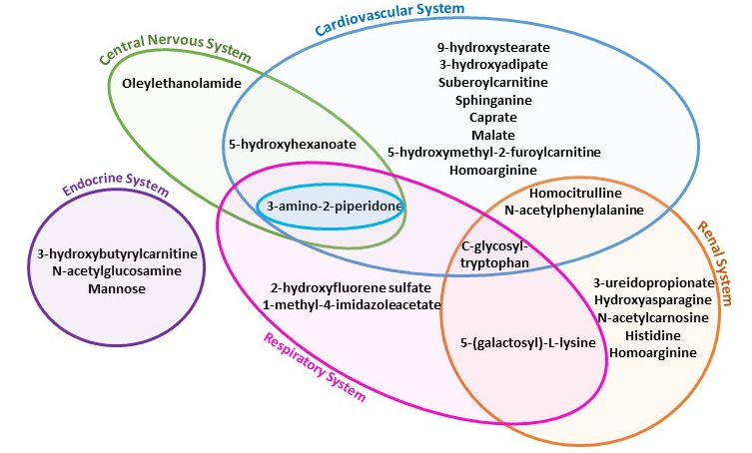
Fig. S12. Veen diagram showing the body systems affected by the metabolites associated with the risk of mortality.

