Supplementary Informations

Urolithin A protects hepatocytes from palmitic acid-induced ER stress by regulating calcium homeostasis in the MAM

Gayoung Ryu1, Minjeong Ko1, Sooyeon Lee1, Se In Park1, Jin-Woong Choi2, Ju Yeon Lee2,3, Jin Young Kim2,3 and Ho Jeong Kwon1,*

1Chemical Genomics Leader Research Laboratory, Department of Biotechnology, College of Life Science and Biotechnology, Yonsei University, Seoul 03722, Republic of Korea.

2Digital Omics Research Center, Korea Basic Science Institute, Ochang 28119, Republic of Korea.

3Critical Diseases Diagnostics Convergence Research Center, Korea Research Institute of Bioscience and Biotechnology, Daejeon 34141, Republic of Korea

* Correspondence: kwonhj@yonsei.ac.kr

**Supplementary Figure 1.**

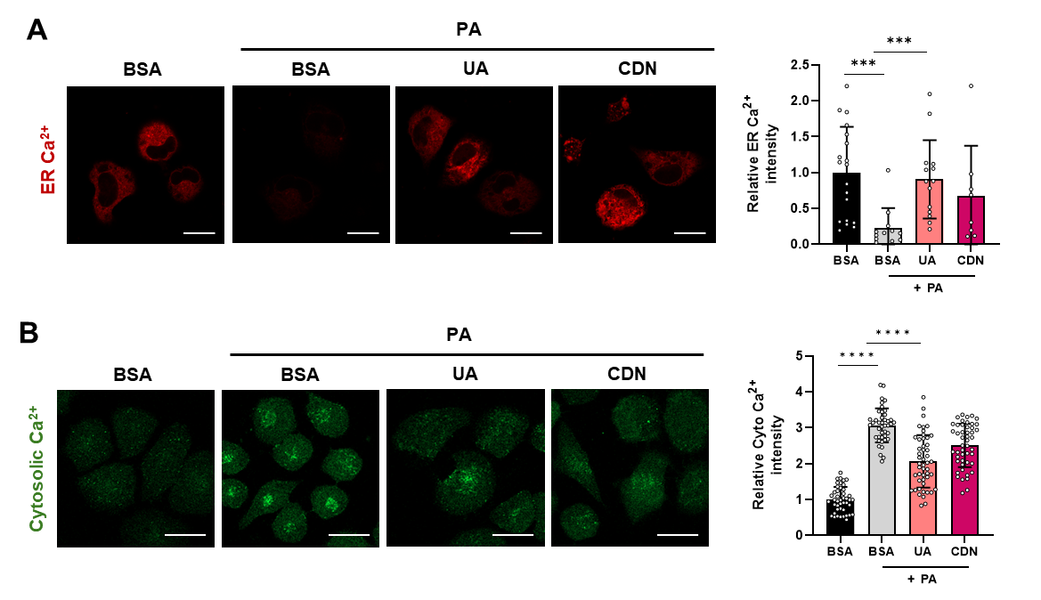

(**A**) ER calcium levels were measured in HepG2 cells treated with PA (500 μM) for 24 h, either alone or co-treated with UA (40 μM) and CDN1163 (10 μM) (scale bar: 10 μm). (**B**) Cytosolic calcium levels were assessed using the Fluo-4-AM after 24 hours of treatment with PA, either alone or co-treated with UA (40 μM), and CDN1163 (10 μM) (scale bar: 20 μm). (*p < 0.05, * *p < 0.01, * **p < 0.001, * ** *p < 0.0001)

**Supplementary Figure 2.**

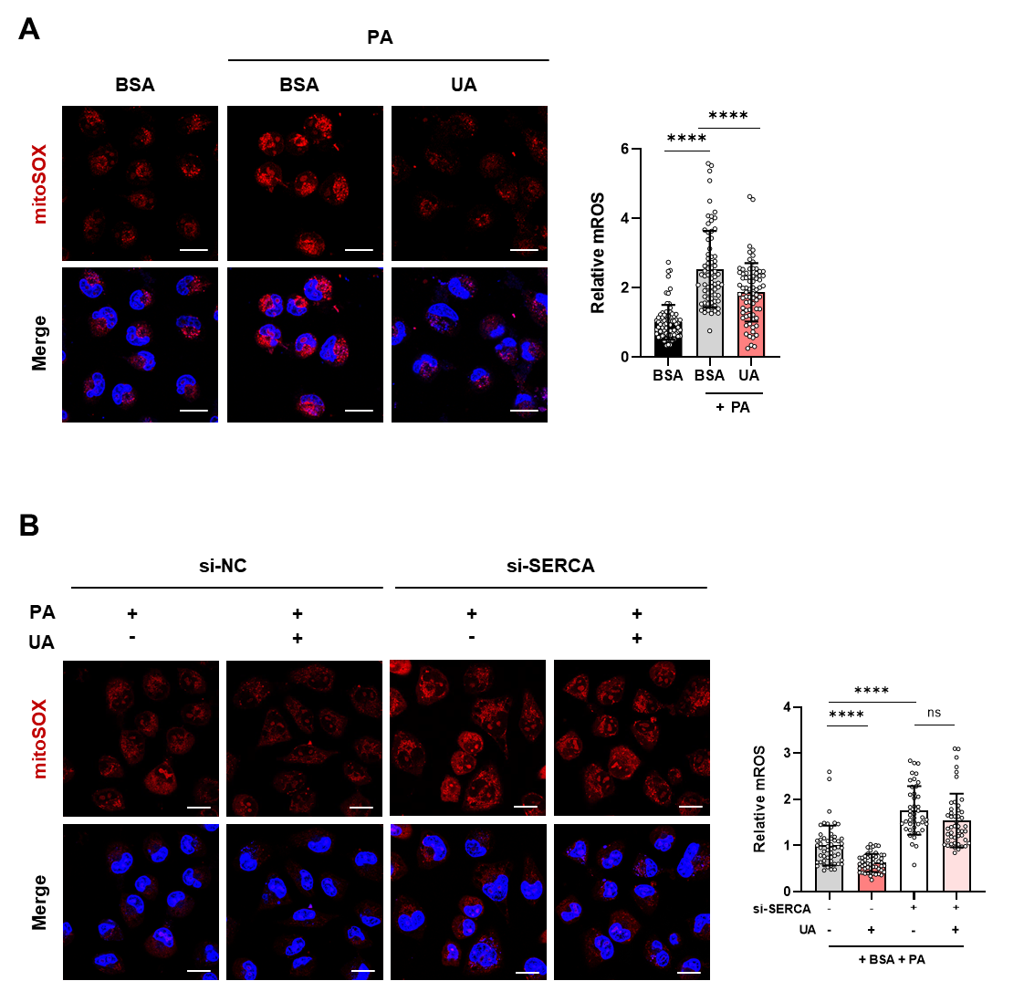

(**A**) HepG2 cells were treated with PA for 24 hours with or without UA, followed by mitoSOX staining (scale bar: 20 μm). (**B**) Mitochondrial ROS levels were assessed to evaluate the effect of UA following SERCA knockdown in HepG2 cells (scale bar: 20 μm). (*p < 0.05, * *p < 0.01, * **p < 0.001, * ** *p < 0.0001)

**Supplementary Figure 3.**

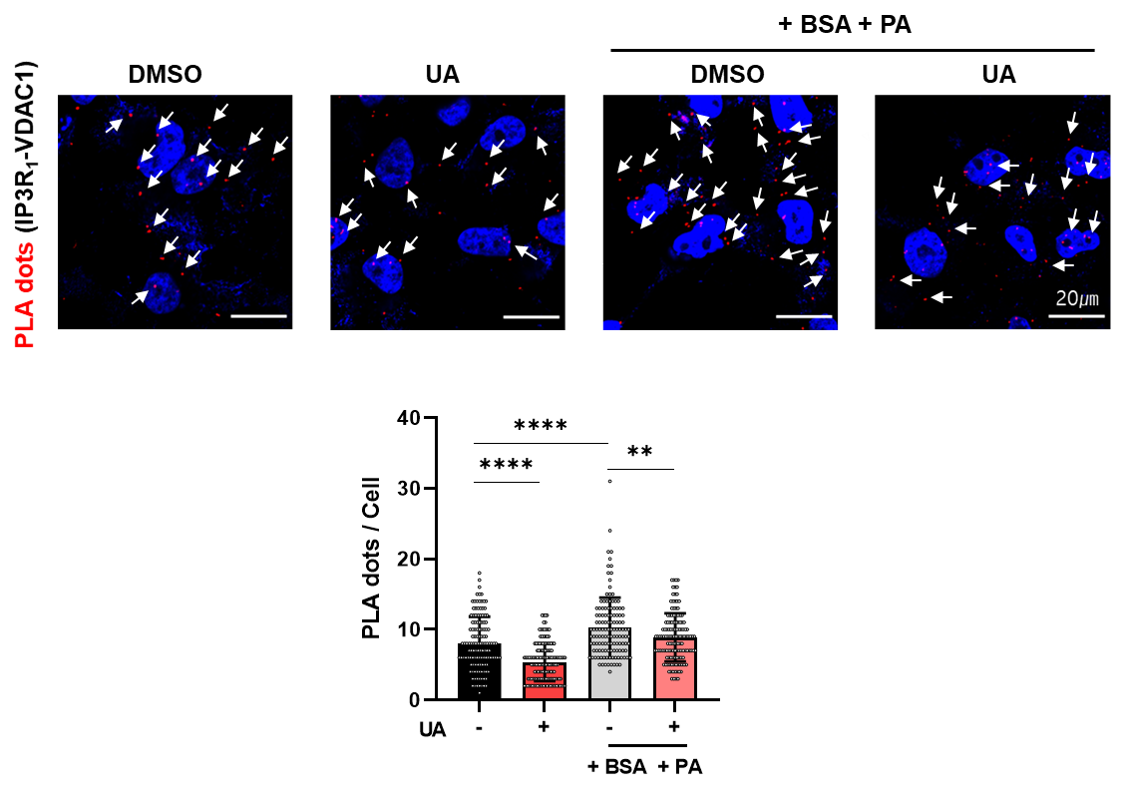

Proximity ligation assay (PLA) of IP3R and VDAC1 in HepG2 cells treated with PA (0.5 mM) and UA (40 μM) for 24 hours was performed. The red fluorescent dots indicate sites of close proximity between the ER and mitochondria. Quantification was conducted by counting the number of red fluorescent dots (scale bar: 20 μm). (*p < 0.05, * *p < 0.01, * **p < 0.001, * ** *p < 0.0001)

**Supplementary Figure 4.**

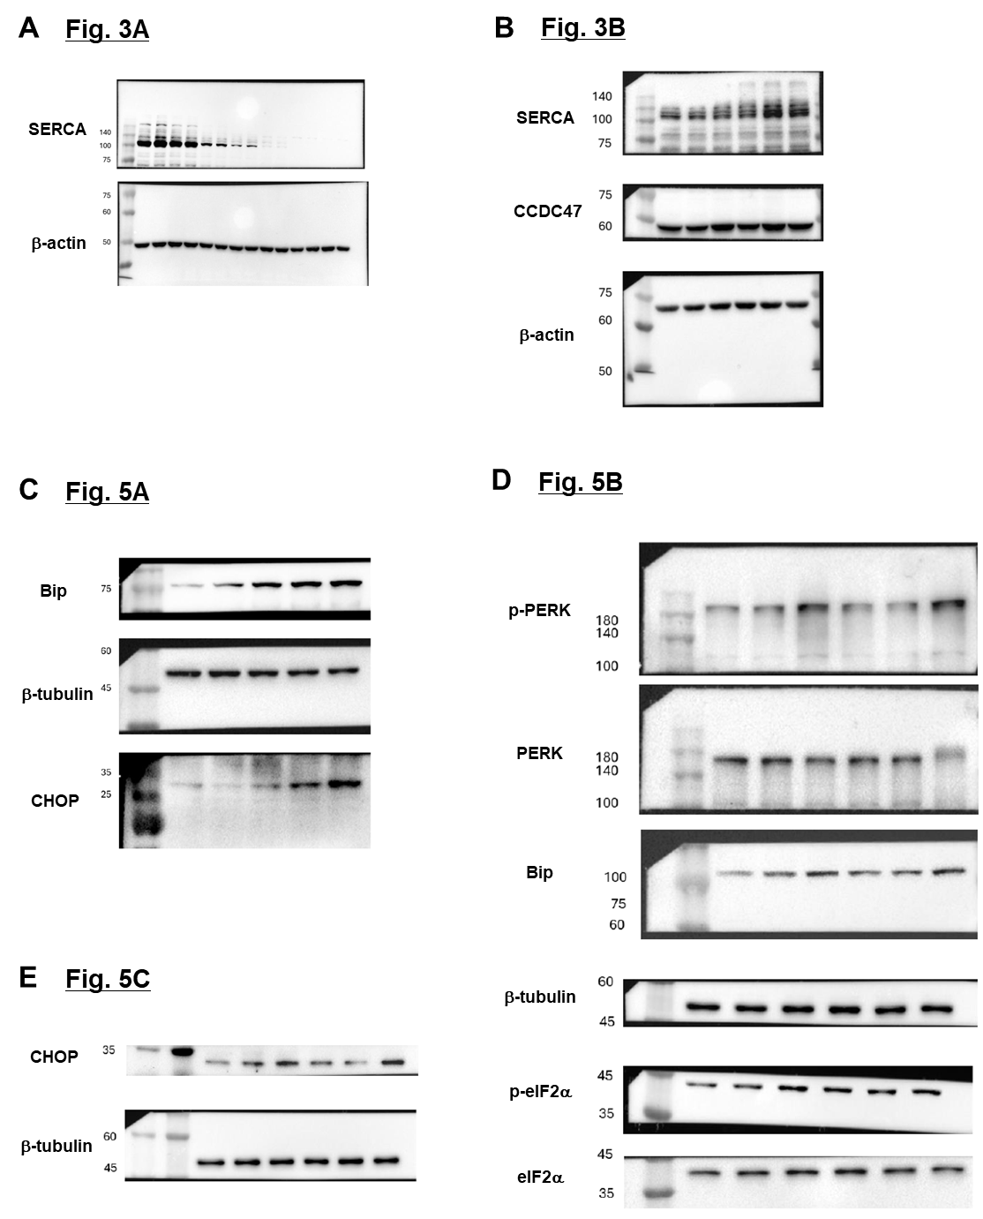

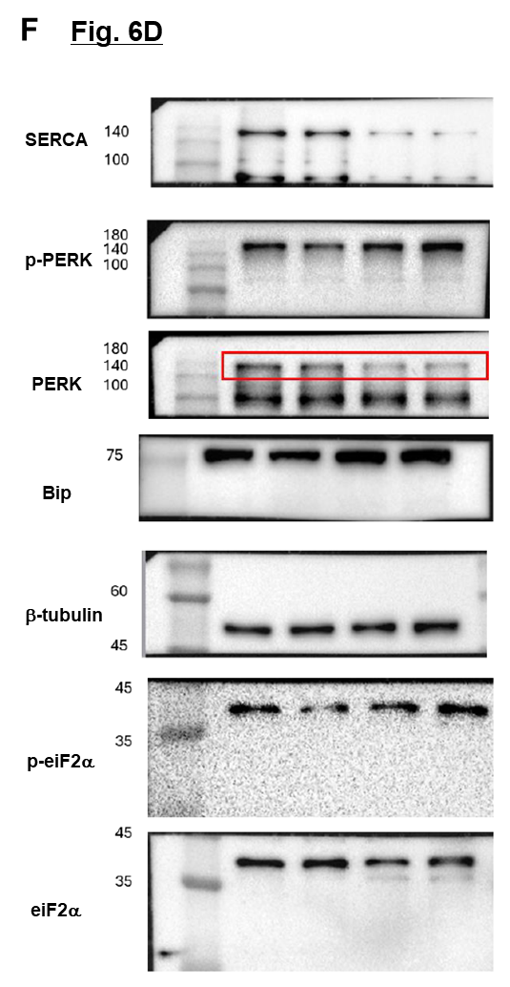

The raw images of the Western blot in Figures.