Supplementary

Sub-ppb H₂S Sensing with Screen Printed Porous ZnO/SnO₂ Heterostructures
Mehdi Akbari-Saatlu *, Masoumeh Heidari, Claes Mattsson, Renyun Zhang and Göran Thungström
Department of Engineering, Mathematics and Science Education, Mid Sweden University, Holmgatan 10, SE-85170 Sundsvall, Sweden.
* Correspondence: author: mehdi.akbarisaatlu@miun.se

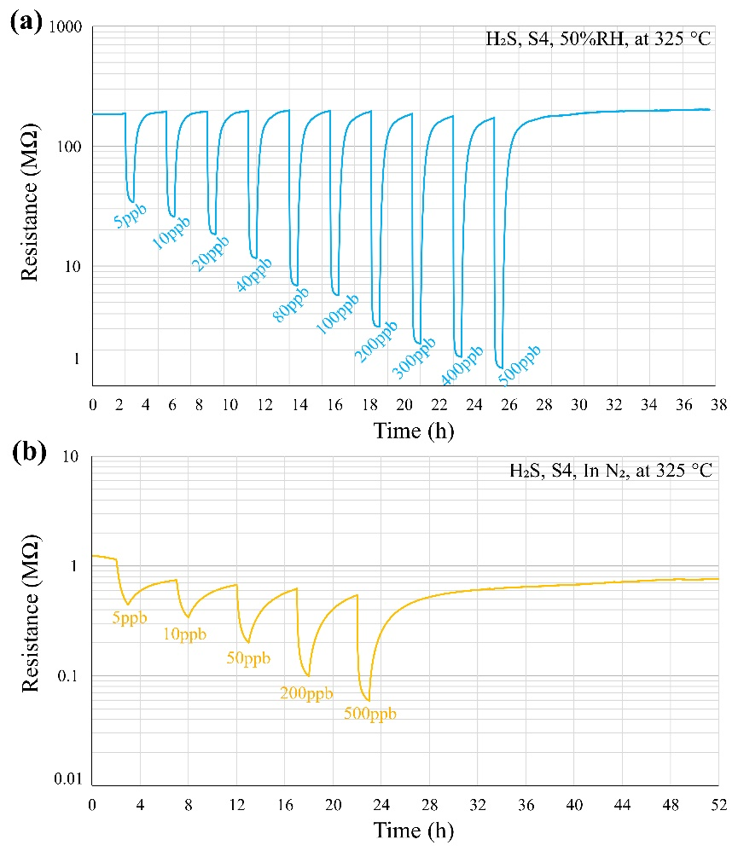
Figure S1. Dynamic response (R_{g}) of the sensor S4 to different concentrations of H₂S under 50%RH and in N₂ conditions.

