**Geospatial variation in vaccination coverage and zero-dose prevalence at the district, ward and health facility levels before and after a measles vaccination campaign in Nigeria**

C. Edson Utazi1,2, Iyanuloluwa Olowe1, Theo H. M. Chan3, Winfred Dotse-Gborgortsi1, John Wagai4, Jamila A. Umar5, Sulaiman Etamesor5, Brian Atuhaire6, Biyi Fafunmi7, Jessica Crawford6, Adeyemi Adeniran7, Andrew J. Tatem1

*1 WorldPop, School of Geography and Environmental Science, University of Southampton, Southampton, SO17 1BJ, UK   
2 Department of Statistics, Nnamdi Azikiwe University, Awka, PMB 5025, Nigeria*

*3School of Mathematical Sciences, University of Southampton, Southampton, SO17 1BJ, UK*

*4World Health Organization Consultant, Abuja, Nigeria*

*5National Primary Health Care Development Agency, Abuja, Nigeria*

*6Gavi, The Vaccine Alliance, Geneva, Switzerland*

*7National Bureau of Statistics, Abuja, Nigeria*

**Supplementary File**

**Supplementary Figure 1: A map showing the 13 states where the 2021 measles campaign was implemented.**

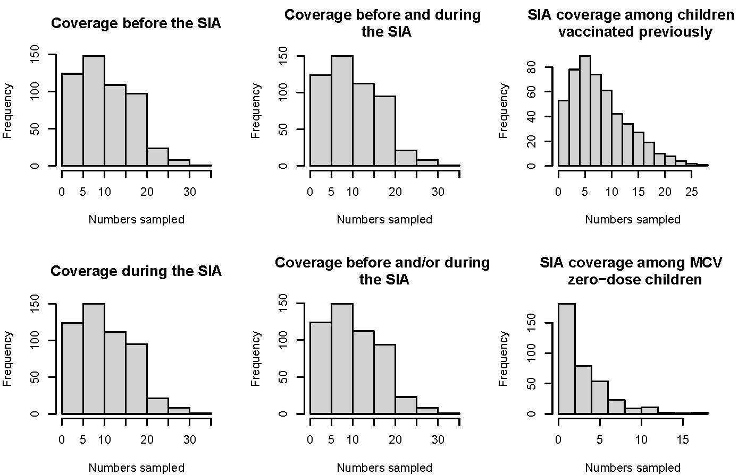

**Supplementary Figure 2: Distribution of cluster level sample sizes for all six indicators.**

**Supplementary Table 1: Covariates selected to model vaccination coverage in the study.**

|  |  |  |  |
| --- | --- | --- | --- |
| **Geospatial covariate** | **Definition** | **Spatial Resolution** | **Source** |
| Distance to UCDP Conflict Locations | Distance to conflict areas identified by the Uppsala Conflict Data Program (UCDP) | 1km | Pettersson, Therese, Shawn Davis, Amber Deniz, Garoun Engström, Nanar Hawach, Stina Högbladh, Margareta Sollenberg & Magnus Öberg (2021). Organized violence 1989-2020, with a special emphasis on Syria. Journal of Peace Research 58(4). Sundberg, Ralph and Erik Melander (2013) Introducing the UCDP Georeferenced Event Dataset. Journal of Peace Research 50(4). https://ucdp.uu.se/downloads/index.html#ged_global |
| Livestock Index | Count of livestock per square kilometre | 1km | Gilbert M., G. Nicolas, G. Cinardi, G.R.W. Wint, S. Vanwambeke, T.P. Robinson (2018) Global Distribution Data for Cattle, Buffaloes, Horses, Sheep, Goats, Pigs, Chickens and Ducks in 2010. Sci. Data. 5:180227 https://doi.org/10.1038/sdata.2018.227 |
| Night time Lights | Annual Visible Infrared Imaging Radiometer Suite (VIIRS) nighttime lights | 1km | C. D. Elvidge, K. E. Baugh, M. Zhizhin, and F.-C. Hsu, “Why VIIRS data are superior to DMSP for mapping nighttime lights,” Asia-Pacific Advanced Network 35, vol. 35, p. 62, 2013 |
| Distance to all OSM roads | Distance to all road types identified by OpenStreetMap | 1km | WorldPop (www.worldpop.org - School of Geography and Environmental Science, University of Southampton; Department of Geography and Geosciences, University of Louisville; Departement de Geographie, Universite de Namur) and Center for International Earth Science Information Network (CIESIN), Columbia University (2018). Global High Resolution Population Denominators Project - Funded by The Bill and Melinda Gates Foundation (OPP1134076). https://dx.doi.org/10.5258/SOTON/WP00644 |
| Average Maximum Temperature | Maximum Temperature averaged between 2017 and 2021 | 1km | Harris I, Osborn TJ, Jones P and Lister D (2020) Version 4 of the CRU TS Monthly High-Resolution Gridded Multivariate Climate Dataset. Sci Data 7,, 109 (2020). https://doi.org/10.1038/s41597-020-0453-3 |
| Distance to Cultivated areas | Distance to edges of cultivated areas from ESA-CCI-LC classes. | 1km | WorldPop (www.worldpop.org - School of Geography and Environmental Science, University of Southampton; Department of Geography and Geosciences, University of Louisville; Departement de Geographie, Universite de Namur) and Center for International Earth Science Information Network (CIESIN), Columbia University (2018). Global High Resolution Population Denominators Project - Funded by The Bill and Melinda Gates Foundation (OPP1134076). https://dx.doi.org/10.5258/SOTON/WP00644 |
| Elevation | Topography | 1km | WorldPop (www.worldpop.org - School of Geography and Environmental Science, University of Southampton; Department of Geography and Geosciences, University of Louisville; Departement de Geographie, Universite de Namur) and Center for International Earth Science Information Network (CIESIN), Columbia University (2018). Global High Resolution Population Denominators Project - Funded by The Bill and Melinda Gates Foundation (OPP1134076). https://dx.doi.org/10.5258/SOTON/WP00644 |
| Distance to GHSL settlements | Distance to settlements identified in the Global Human Settlement Layer dataset | 1km | WorldPop (www.worldpop.org - School of Geography and Environmental Science, University of Southampton; Department of Geography and Geosciences, University of Louisville; Departement de Geographie, Universite de Namur) and Center for International Earth Science Information Network (CIESIN), Columbia University (2018). Global High Resolution Population Denominators Project - Funded by The Bill and Melinda Gates Foundation (OPP1134076). https://dx.doi.org/10.5258/SOTON/WP00644 |
| Average Malaria Prevalence | Parasite rate in 2-10 year olds, averaged between 2015 and 2019 | 1km | Weiss DJ, Lucas TCD, Nguyen M, et al. Mapping the global prevalence, incidence, and mortality of Plasmodium falciparum, 2000–17: a spatial and temporal modelling study. Lancet 2019; published online June 19. DOI: 10.1016/S0140-6736(19)31097-9. Battle KE, Lucas TCD, Nguyen M, et al. Mapping the global endemicity and clinical burden of Plasmodium vivax, 2000–17: a spatial and temporal modelling study. Lancet 2019; published online June 19. DOI: 10.1016/S0140-6736(19)31096-7 |
| Walking Travel time to Health Facilities | Travel time (by walking distance) to health facilities | 1km | D.J. Weiss, A. Nelson, C.A. Vargas-Ruiz, K. Gligoric?, S. Bavadekar, E. Gabrilovich, A. Bertozzi-Villa, J. Rozier, H.S. Gibson, T. Shekel, C. Kamath, A. Lieber, K. Schulman, Y. Shao, V. Qarkaxhija, A.K. Nandi, S.H. Keddie, S. Rumisha, P. Amratia, R. Arambepola, E.G. Chestnutt, J.J. Millar, T.L. Symons, E. Cameron, K.E. Battle, S. Bhatt, and P.W. Gething. Global maps of travel time to healthcare facilities. (2020). Nature Medicine. doi:10.1038/s41591-020-1059-1 Available from: https://malariaatlas.org/research-project/accessibility-to-healthcare/ |

**Supplementary Figure 3: Covariates used to model vaccination coverage in the study.**

**Supplementary Figure 4: Locations of all (left panels) and selected (right panels) health facilities in Kano and Ebonyi states included in the study.**

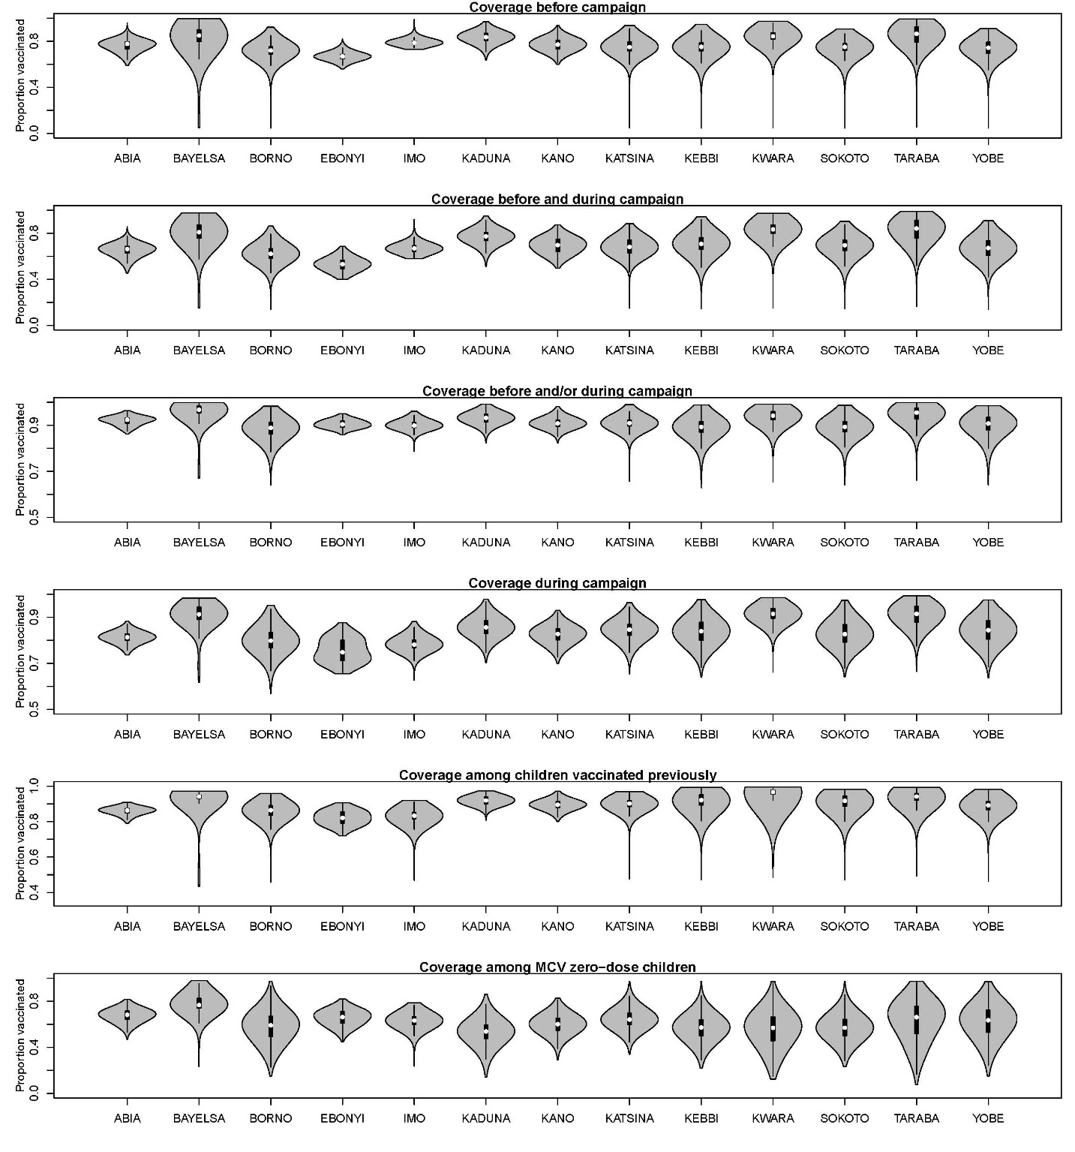

**Supplementary Figure 5: Violin plots showing the distribution of modelled estimates of PCCS indicators for each state.**

**Supplementary Table 2: Modelled estimates of 2021 measles post-campaign coverage survey indicators at the state level**

|  |  |  |  |  |  |  |  |
| --- | --- | --- | --- | --- | --- | --- | --- |
| **State** | **2021 estimate of children aged 1-4 years** | **Coverage before the campaign** | **Coverage before and during the campaign** | **Coverage during the campaign** | **Coverage among children vaccinated previously** | **Coverage among MCV zero-dose children** | **Coverage before and/or during the campaign** |
| Abia | 375835 | 0.7768 | 0.6597 | 0.8082 | 0.8481 | 0.6882 | 0.9230 |
| Bayelsa | 247057 | 0.7728 | 0.7327 | 0.8526 | 0.8833 | 0.7191 | 0.9100 |
| Borno | 987788 | 0.7107 | 0.5925 | 0.7537 | 0.8098 | 0.5752 | 0.8640 |
| Ebonyi | 380362 | 0.6525 | 0.5086 | 0.7389 | 0.8024 | 0.6492 | 0.8930 |
| Imo | 551770 | 0.7816 | 0.6656 | 0.7702 | 0.8236 | 0.5976 | 0.8820 |
| Kaduna | 1405201 | 0.8401 | 0.7619 | 0.8421 | 0.9049 | 0.5186 | 0.9330 |
| Kano | 2240534 | 0.7846 | 0.6941 | 0.8112 | 0.8750 | 0.5678 | 0.9040 |
| Katsina | 1429811 | 0.7276 | 0.6585 | 0.8392 | 0.8913 | 0.6469 | 0.8970 |
| Kebbi | 747121 | 0.7343 | 0.6800 | 0.8223 | 0.8993 | 0.5753 | 0.8850 |
| Kwara | 469823 | 0.8162 | 0.7831 | 0.8822 | 0.9296 | 0.6192 | 0.9220 |
| Sokoto | 901541 | 0.7510 | 0.6848 | 0.8050 | 0.8974 | 0.5405 | 0.8810 |
| Taraba | 484847 | 0.8156 | 0.7687 | 0.8725 | 0.9105 | 0.6324 | 0.9290 |
| Yobe | 554201 | 0.7380 | 0.6621 | 0.8268 | 0.8778 | 0.6274 | 0.8970 |

**Supplementary Figure 6: Modelled estimates of coverage among MCV zero-dose children at the local government area (LGA) level.**

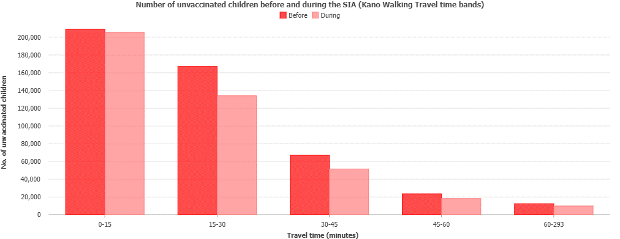

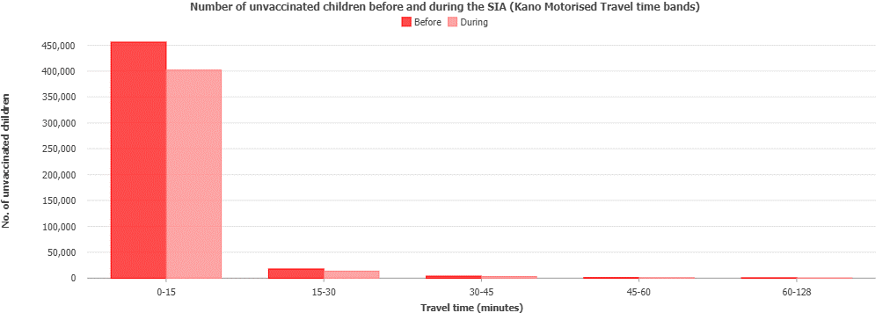

**Supplementary Figure 7: Distribution of unvaccinated children before and during the SIA within different walking and motorised travel time bands in Kano state.**

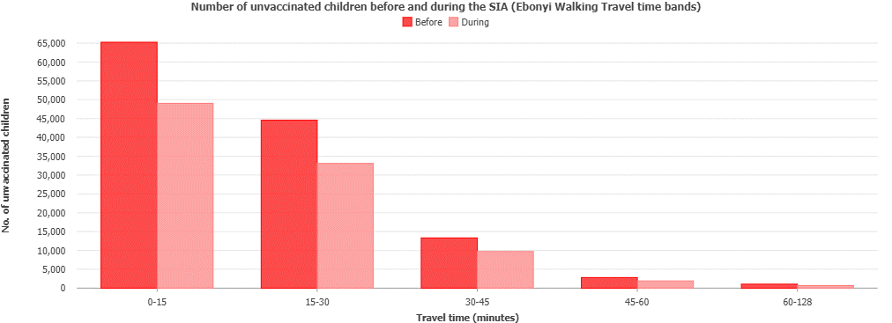

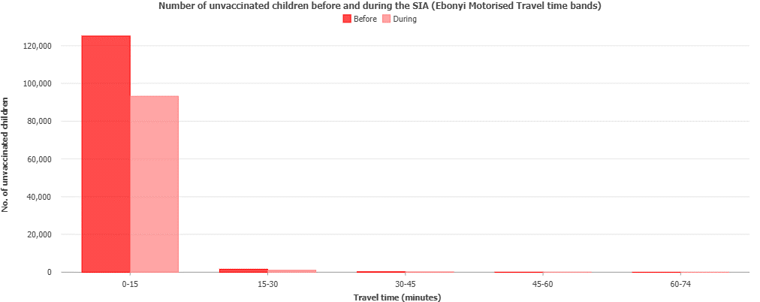

**Supplementary Figure 8: Distribution of unvaccinated children before and during the SIA within different walking and motorised travel time bands in Ebonyi state.**

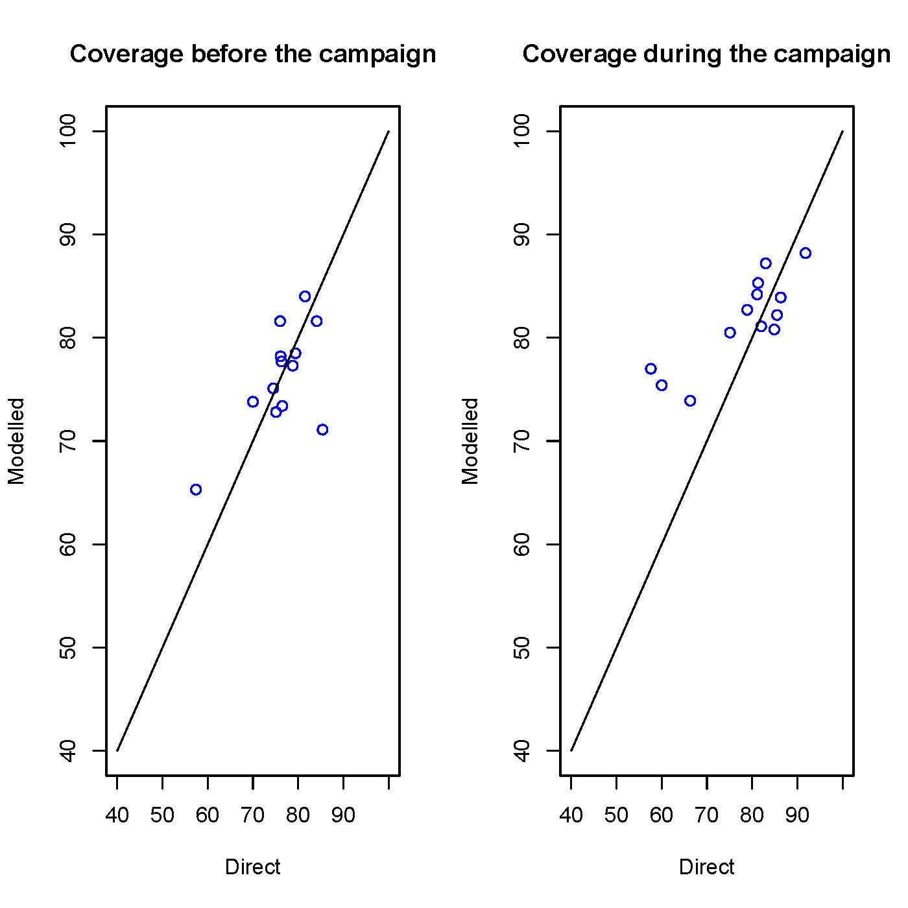

**Supplementary Figure 9: Comparisons between 2021 PCCS modelled estimates and direct survey estimates at the state level.**

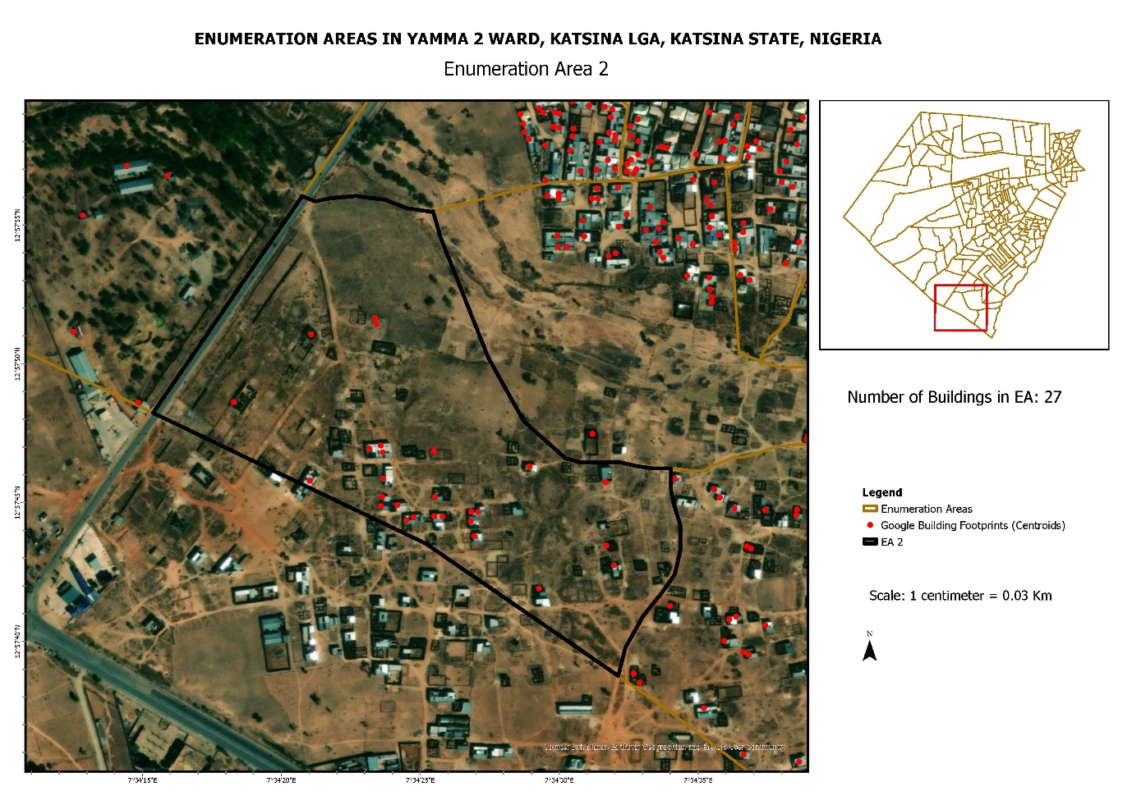

**Supplementary Figure 10: A map of an enumeration area within Yamma 2 ward in Katsina State overlaid with Google building footprint data to identify the buildings within the area. The enumeration area was created using the preEA tool referenced in the manuscript.**