**Propidium Iodide**

**Annexin V**

**0Gy**

**2Gy**

**2Gy + CUDC-101**

**Annexin V**

**Propidium Iodide**

**B.**

**0Gy**

**2Gy**

**2Gy + CUDC-101**

**Annexin V**

**Propidium Iodide**

**C.**

**0Gy**

**2Gy**

**2Gy + CUDC-101**

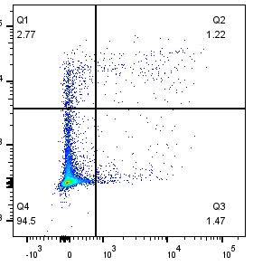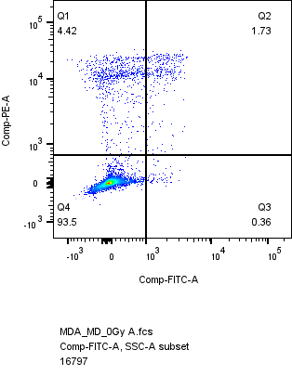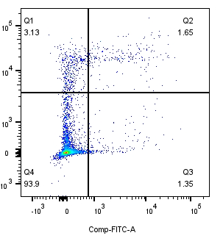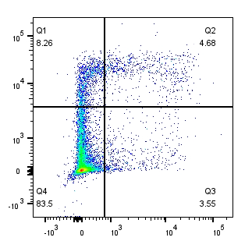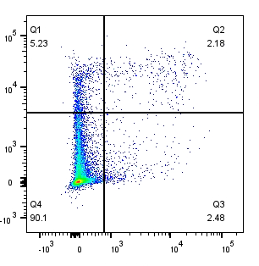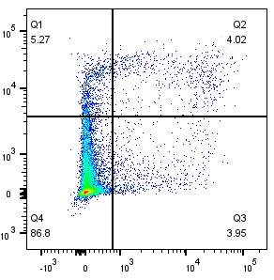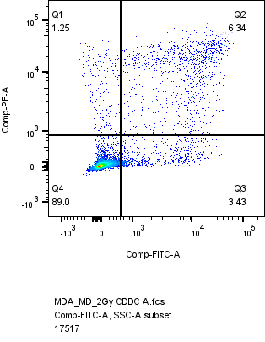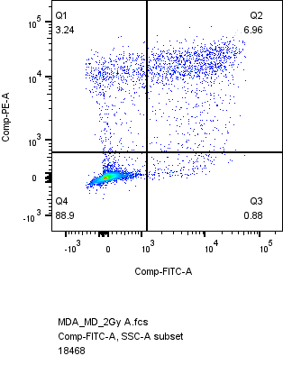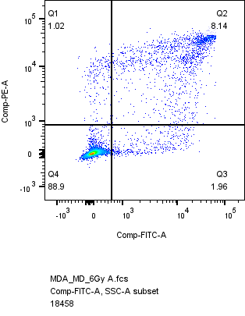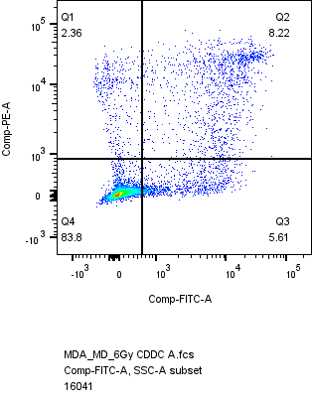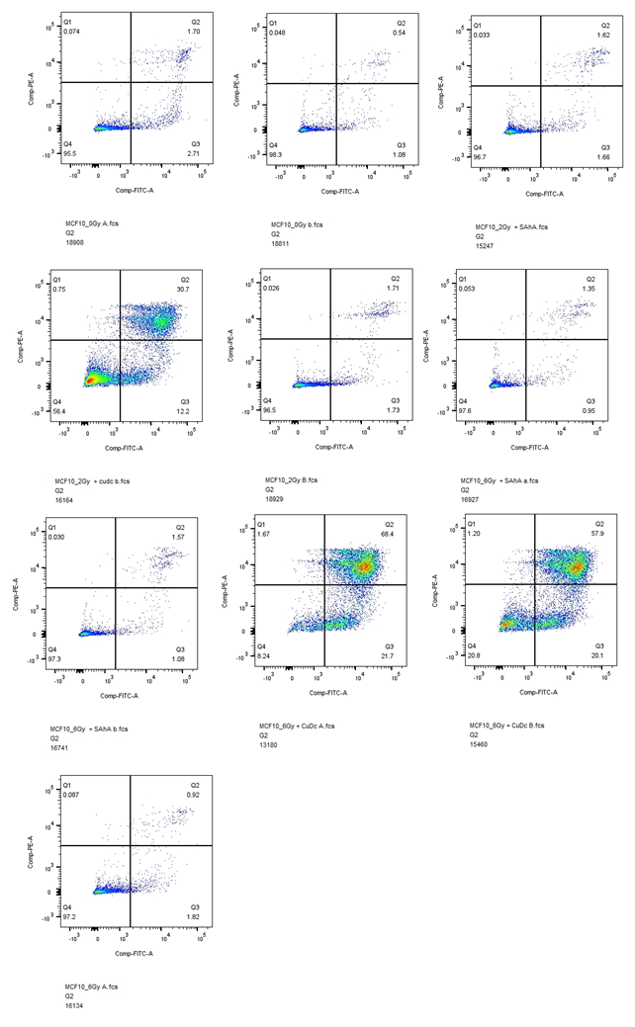

Figure S1: Apoptosis profiles of MCF-7 (A), MDA-MB-231 (B) and MCF-10A (C) cell lines post treatment with 2Gy protons, 2Gy protons and CUDC-101,6Gy protons and 6Gy protons and CUDC-101.

**6Gy**

**6Gy + CUDC-101**

**6Gy**

**6Gy + CUDC-101**

**6Gy**

**6Gy + CUDC-101**

**A.**

**2Gy**

**6Gy + CUDC-101**

**6Gy**

**2Gy + CUDC-101**

**MCF-7**

**MDA-MB-231**

**0Gy**

**24 Hours**

**48 Hours**

**48 Hours**

**24 Hours**

Figure S2: Cell cycle profiles of MCF-7 and MDA-MB-231 cell lines post treatment with 2Gy protons, 2Gy protons and CUDC-101,6Gy protons and 6Gy protons and CUDC-101.

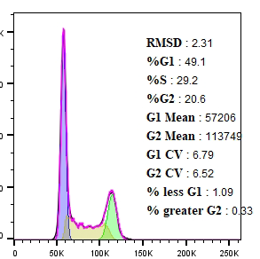

%G1 = 49

% S = 29

% G2/M = 22

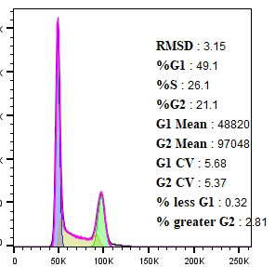

%G1 = 49.40

% S = 26.60

% G2/M = 24

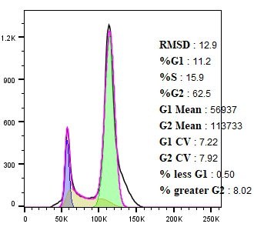

%G1 = 12.9

% S = 15.9

% G2/M = 62.5

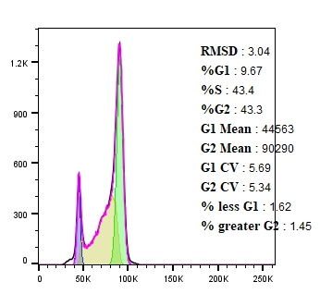

%G1 = 9.67

% S = 43.4

% G2/M = 43

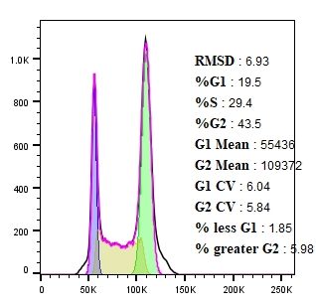

%G1 = 20

% S = 29.4

% G2/M = 43

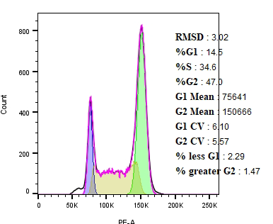

%G1 = 14.5

% S = 34.6

% G2/M = 47

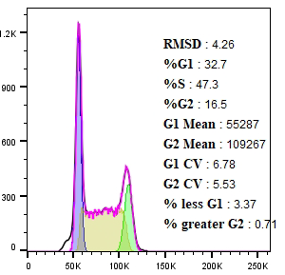

%G1 = 47.6

% S = 33

% G2/M = 16.5

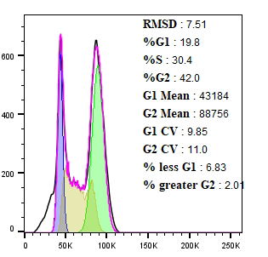

%G1 = 19.8

% S = 30.4

% G2/M = 42

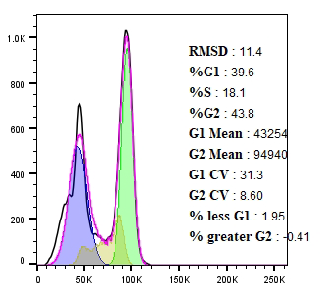

%G1 = 39.6

% S = 18.1

% G2/M = 43.8

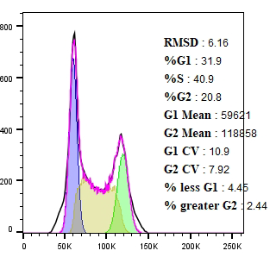

%G1 = 31.9

% S = 40.9

% G2/M = 20.8

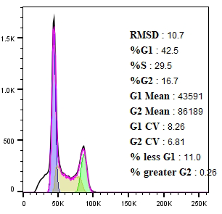

%G1 = 42.5

% S = 29.5

% G2/M = 16.7

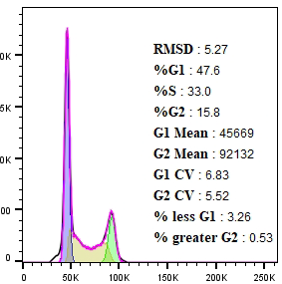

%G1 = 47.6

% S = 33

% G2/M = 15.8

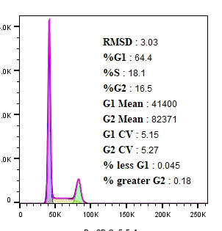

%G1 = 64.4

% S =18.1

% G2/M = 16.5

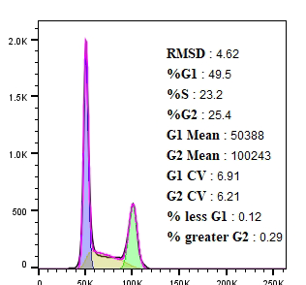

%G1 = 49.5

% S = 23.2

% G2/M = 25.4

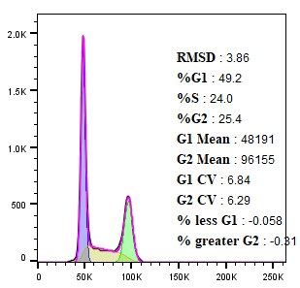

%G1 = 49.2

% S = 24

% G2/M = 25.4

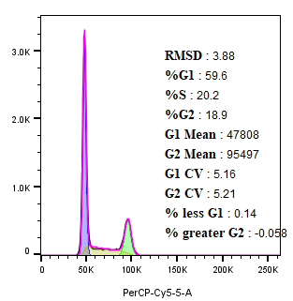

%G1 = 59.6

% S = 20.2

% G2/M = 18.9

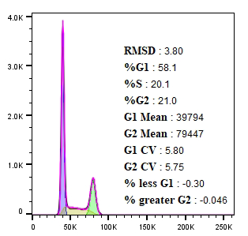

%G1 = 58.5

% S = 20.5

% G2/M = 21

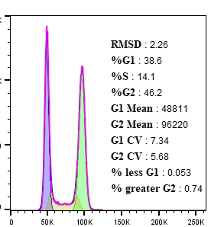

%G1 = 46.5

% S = 14.5

% G2/M = 39

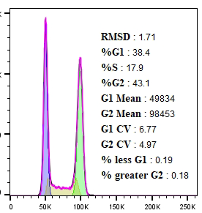

%G1 = 43

% S = 18

% G2/M = 39

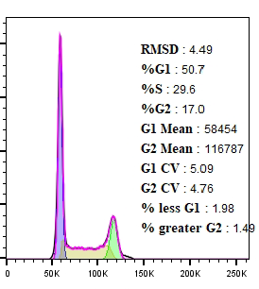

%G1 = 52

% S = 31

% G2/M = 17