The aggregation-induced emission enhancement properties of heteroaryl fused triazapentalens: Synthesis and fluorescence characteristics

Yingchun Wang 1,2, Junfeng Wu1,* and Wim Dehaen 2,*

1 Henan Key Laboratory of Water Pollution Control and Rehabilitation Technology, Henan University of Urban Construction, Pingdingshan 467036, PR China.

2 Sustainable Chemistry for Metals and Molecules, Department of Chemistry, KU Leuven, Celestijnenlaan 200F, 3001 Leuven, Belgium

**\*** Correspondence: jf8047@163.com (J.W.); wim.dehaen@kuleuven.be (W.D.)

Contents

Synthesis of HetATAP1 2

1D NMR spectra 3

Synthesis of HetATAP1

To an oven-dried reaction tube equipped with a magnetic stirring bar were added 2,6-dichloro-3-nitropyridine (192.98 mg, 1 mmol, 1 equiv) , indazole (130 mg, 1.1 mmol, 1.1 equiv), cesium carbonate (358.4 mg, 1.1 mmol, 1.1 equiv) and acetonitrile (6 mL). The mixture was left and stirred for 14 hours at 85 °C in an aluminum heating block. The crude reaction mixture was filtered and concentrated, after which it was dissolved in ethyl acetate (15 mL) and washed with water (2 × 20 mL) and brine (1 × 20 mL). The organic layer was subsequently dried over magnesium sulfate and concentrated under reduced pressure. Further purification by column chromatography, using a PE-DCM gradient as the eluent, afforded the 1-(6-chloro-3-nitropyridin-2-yl)-1*H*-indazole 1 as solid. The 1-(6-chloro-3-nitropyridin-2-yl)-1*H*-indazole **1** (0.5 mmol, 1 equiv) were added to an oven-dried reaction tube equipped with a magnetic stirring bar and dissolved in P(OEt)3 (2.5 mL). The microwave assisted reaction was kept at 140 °C for 105 minutes. After removing the solvent under reduced pressure, the mixture was diluted with EtOAc (1 × 20 mL), and washed with water (2 × 20 mL) and brine (1 × 20 mL). The organic layer was subsequently dried over magnesium sulfate and concentrated under reduced pressure. Further purification by column chromatography, using DCM as the eluent, afforded the pure **HetATAP1** (Scheme S1).



Scheme S1. The synthesis of HetATAP1.

1-(6-Chloro-3-nitropyridin-2-yl)-1*H*-indazole **1**：White solid. Yield 146 mg, 53 %. Mp: 160 – 170°C. 1H NMR (300 MHz, CDCl3) δ 8.83 (d, J = 8.6 Hz, 1H), 8.48 (d, J = 8.9 Hz, 1H), 8.30 (s, 1H), 8.13 (d, J = 8.9 Hz, 1H), 7.82 (d, J = 8.0 Hz, 1H), 7.65 (t, J = 8.1 Hz, 1H), 7.41 (t, J = 7.5 Hz, 1H). HRMS (ESI-Q-TOF): m/z [M + H]+ calcd for C12H7Cl1N4O2: 275.0330, found: 275.0332.

1D NMR spectra

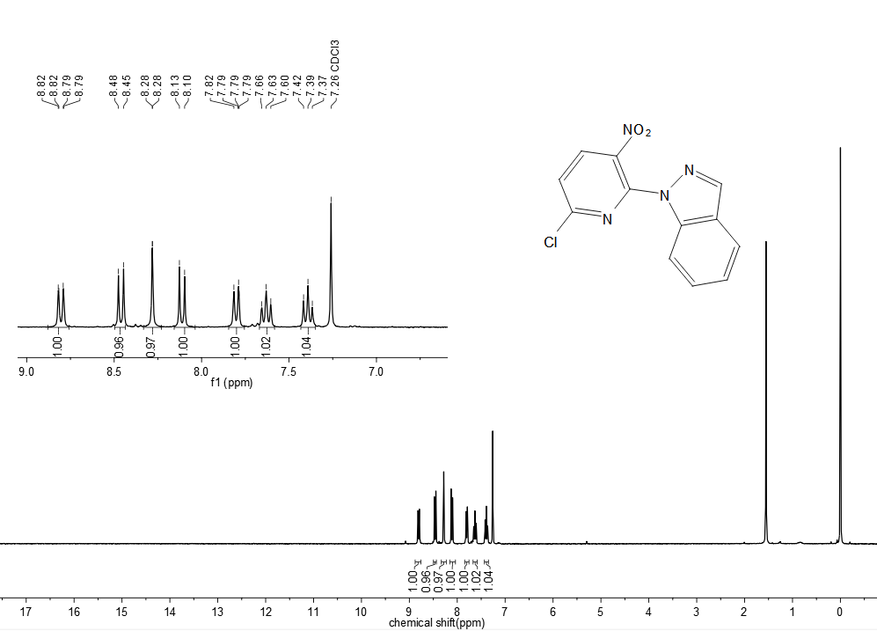

Figure S1. (2-nitropyridinyl)-1H-indazole **1,**1H, CDCl3

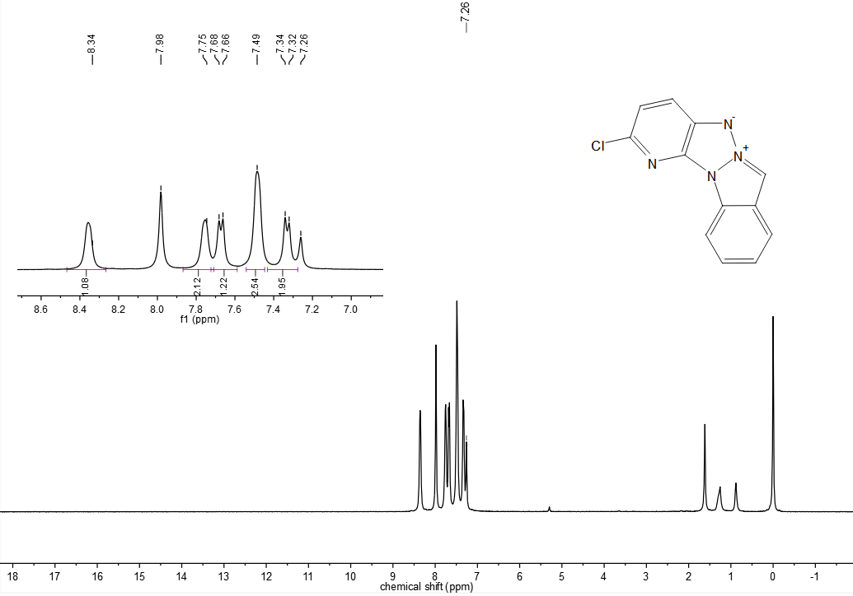

Figure S2.HetATAP**1,**1H, CDCl3

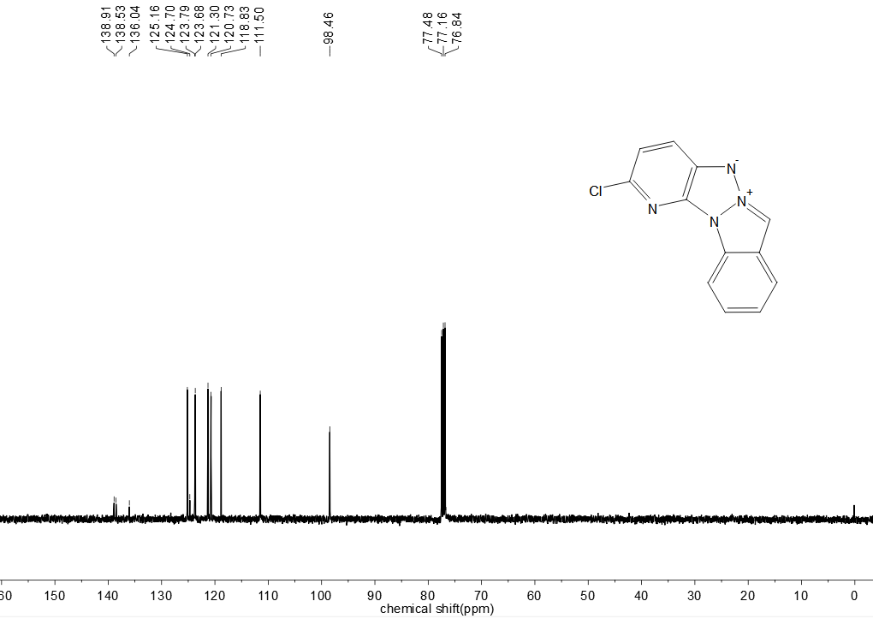

Figure S3.HetATAP**1,**13C, CDCl3

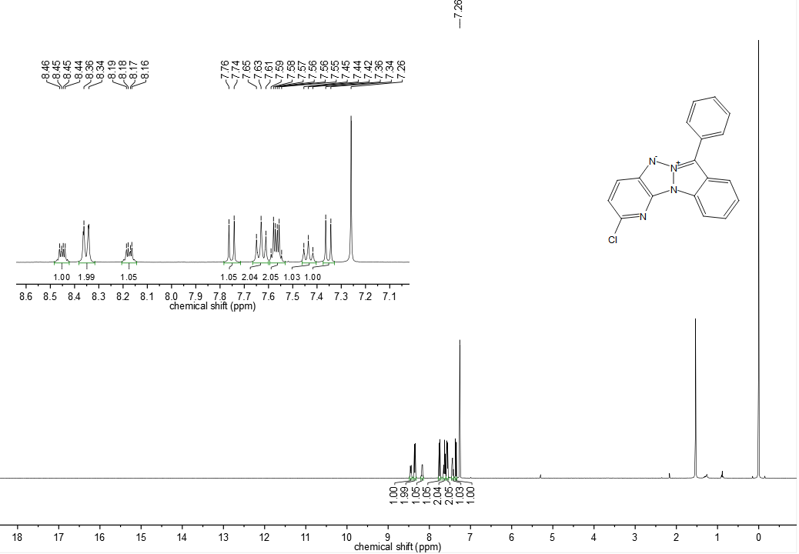

Figure S4.HetATAP**2,**1H, CDCl3

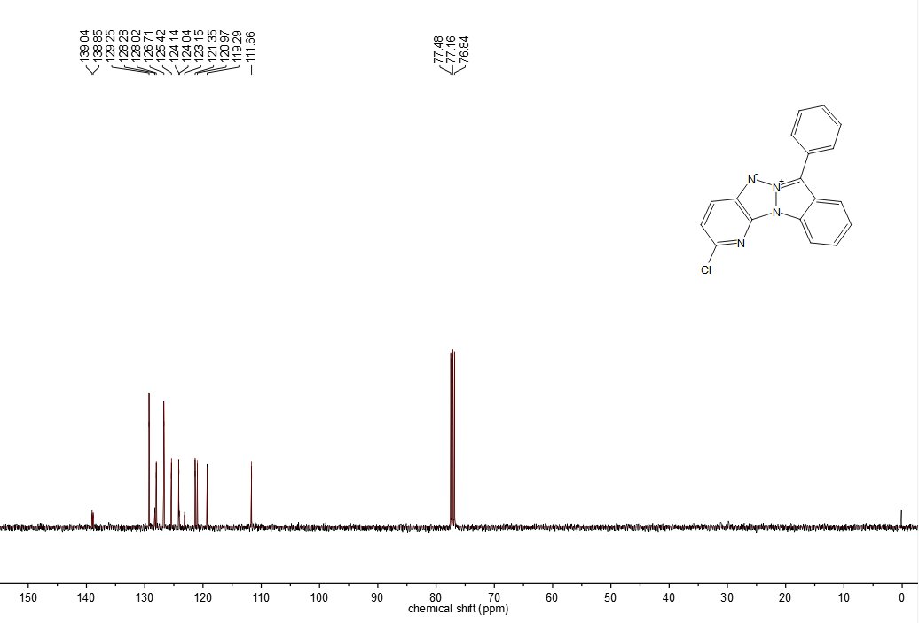

Figure S5.HetATAP**2,**13C, CDCl3

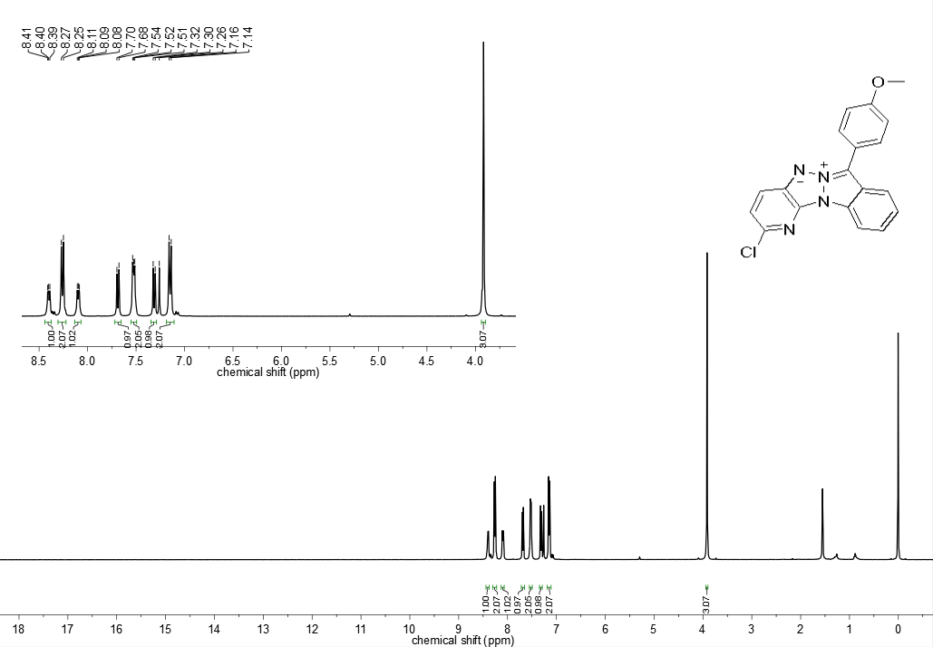

Figure S6. HetATAP**3,**1H, CDCl3

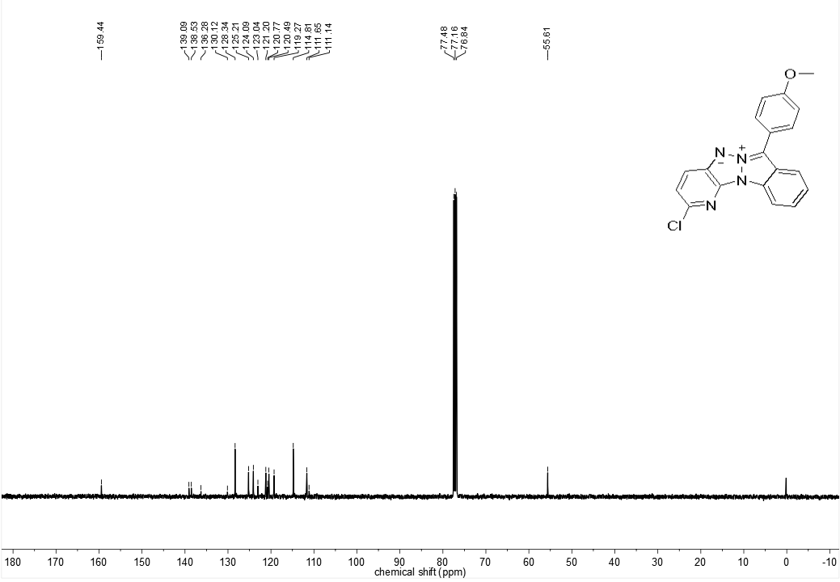

Figure S7. HetATAP**3,**13C, CDCl3

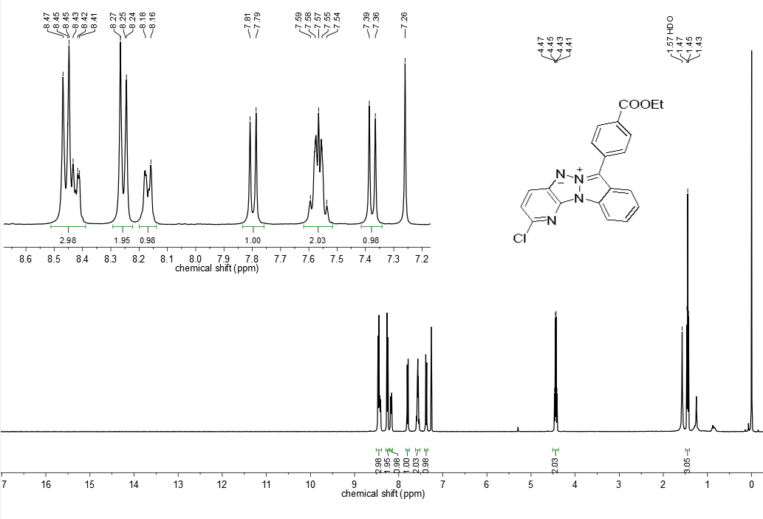

Figure S8. HetATAP**4,**1H, CDCl3

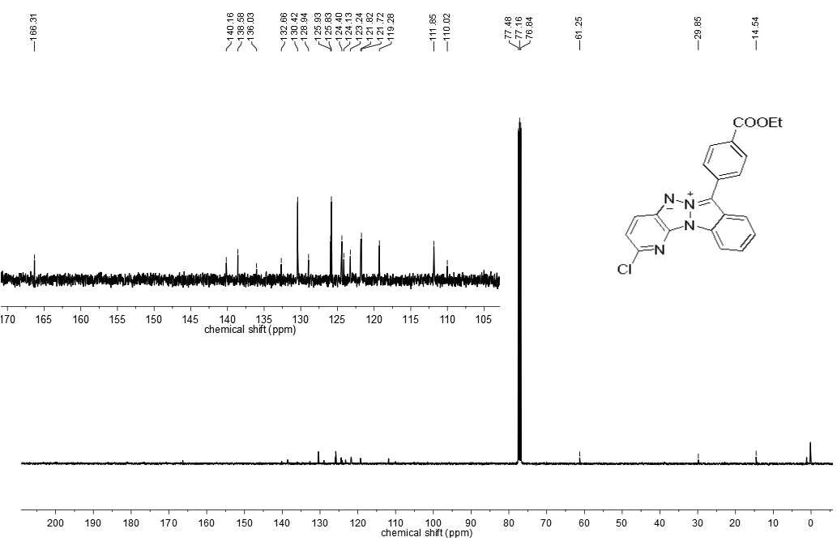

Figure S9. HetATAP**4,**13C, CDCl3

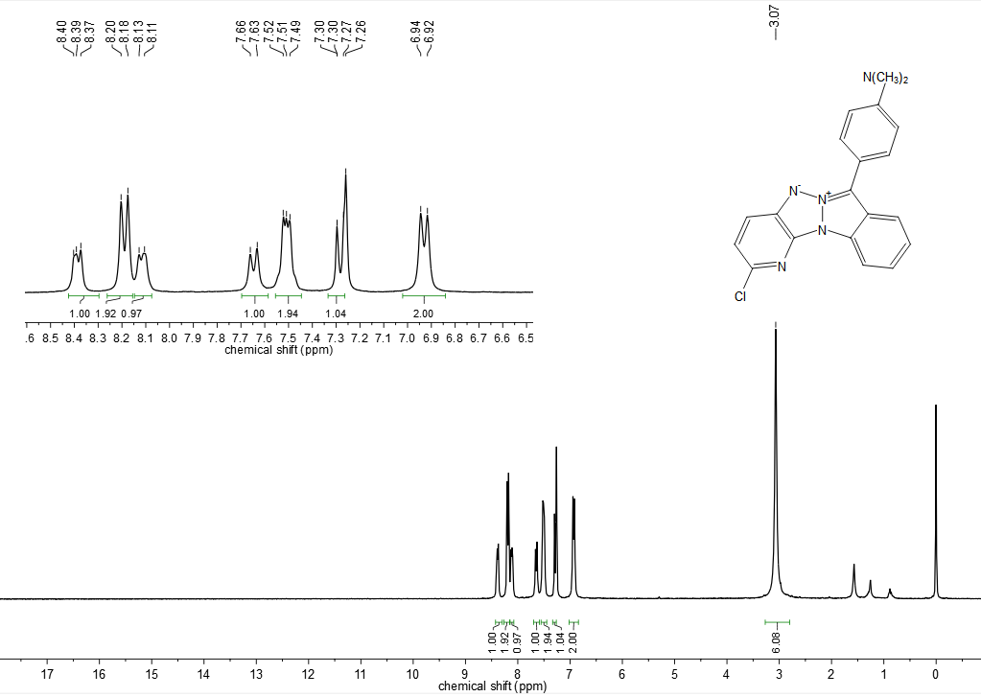

Figure S10. HetATAP**5,**1H, CDCl3

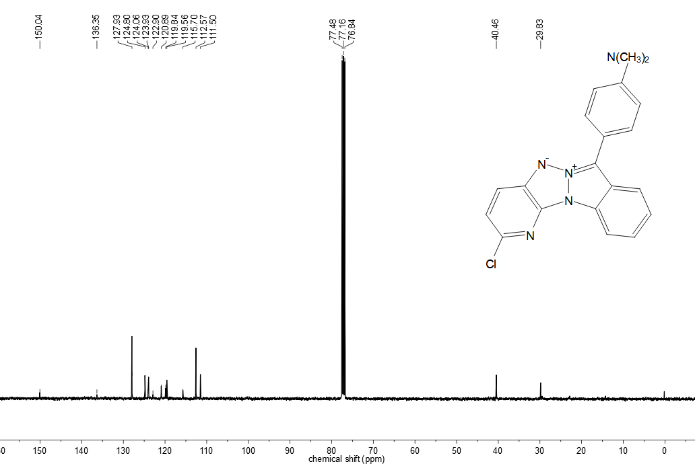

Figure S11. HetATAP**5,**13C, CDCl3

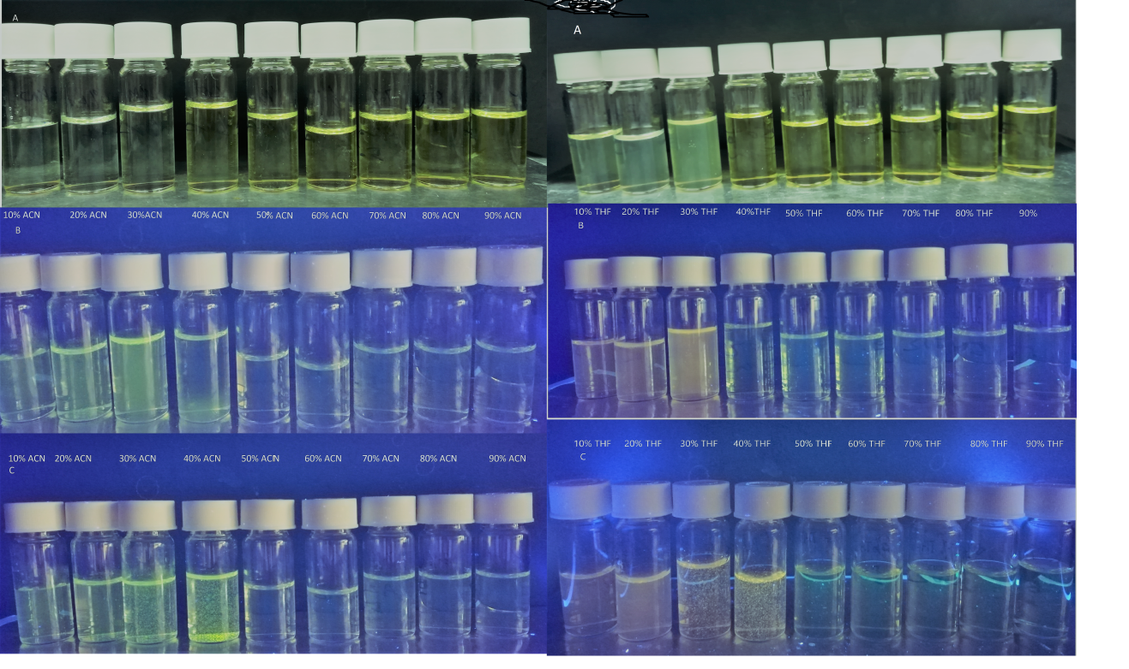

Figure S12. The fluorescence of compounds **HetATAP3(left)** and **HetATAP4(right)** at 0 (A), 10 (B), 30 (C) min in ACN/water and THF/water mixtures with an organic solvent content of 10% v/v under the UV lamp (365 nm) , respectively.