# Supplementary Material

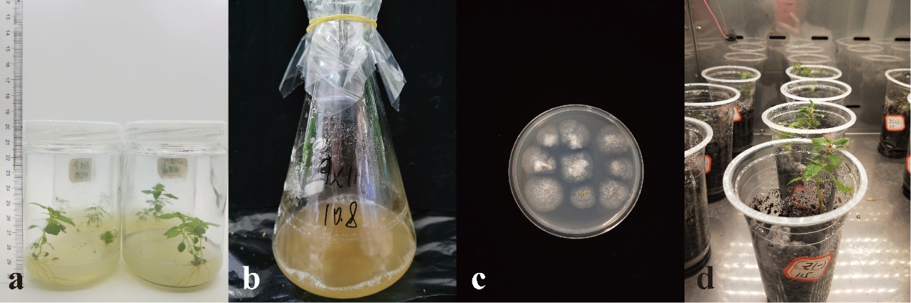

**Figure S1 Planting host *A. adenophora* and inoculation with *Colletotrichum*.**

a, aseptic seedlings cultured in a tissue culture bottle; b, preparation of the spore solution of the *Colletotrichum* strain; c, isolation rate of *Colletotrichum* strains was detected by MEA media; d, seedlings infected with *Colletotrichum* transplanted into soil in a plant growth chamber.



**Figure S2** **Isolation rates of *Colletotrichum* strains in *A. adenophora*.**

Different letters indicating significant differences. The error bars are the standard errors.

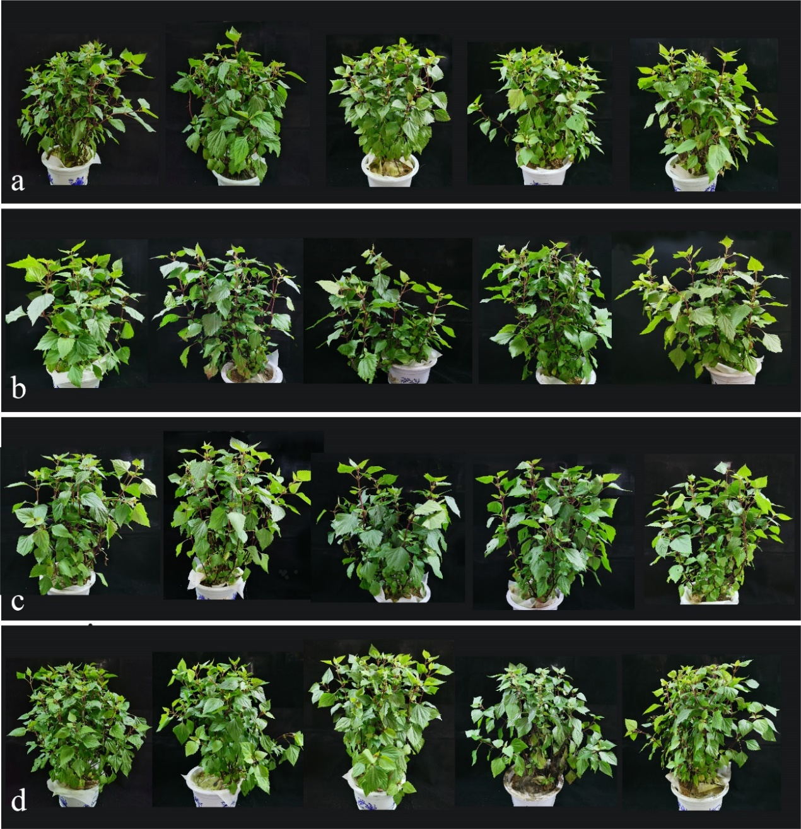

**Fig. S3 Growth effects of *A. adenophora* inoculated with endophytic *Colletotrichum* strains.**

Individuals of *A. adenophora* inoculated with nothing (a), AX39 (b), AX115 (c), or AX198 (d) growing in the greenhouse.

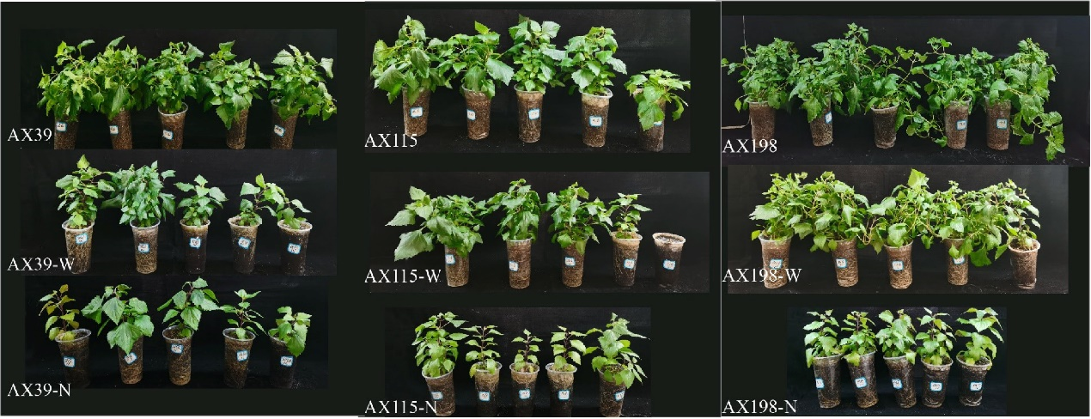

**Fig. S4 Growth effects of *A. adenophora* inoculated with endophyte** ***Colletotrichum* strains under** **nutrient stress**(-N) **and drought stress**(-W)**.**

Individuals of *A. adenophora* inoculated with AX39, AX115, or AX198 growing in a plant growth chamber.