Article
Cyclic and multi-year characterization of surface ozone at the WMO/GAW coastal station of Lamezia Terme (Calabria, Southern Italy): implications for the local environment, cultural heritage, and human health

Supplementary Materials
Supplementary Materials shown below integrate the main content from the research paper D’Amico et al. (2024d) with evaluations aimed specifically at each year of the entire LMT surface ozone observation period, from 2015 to 2023.
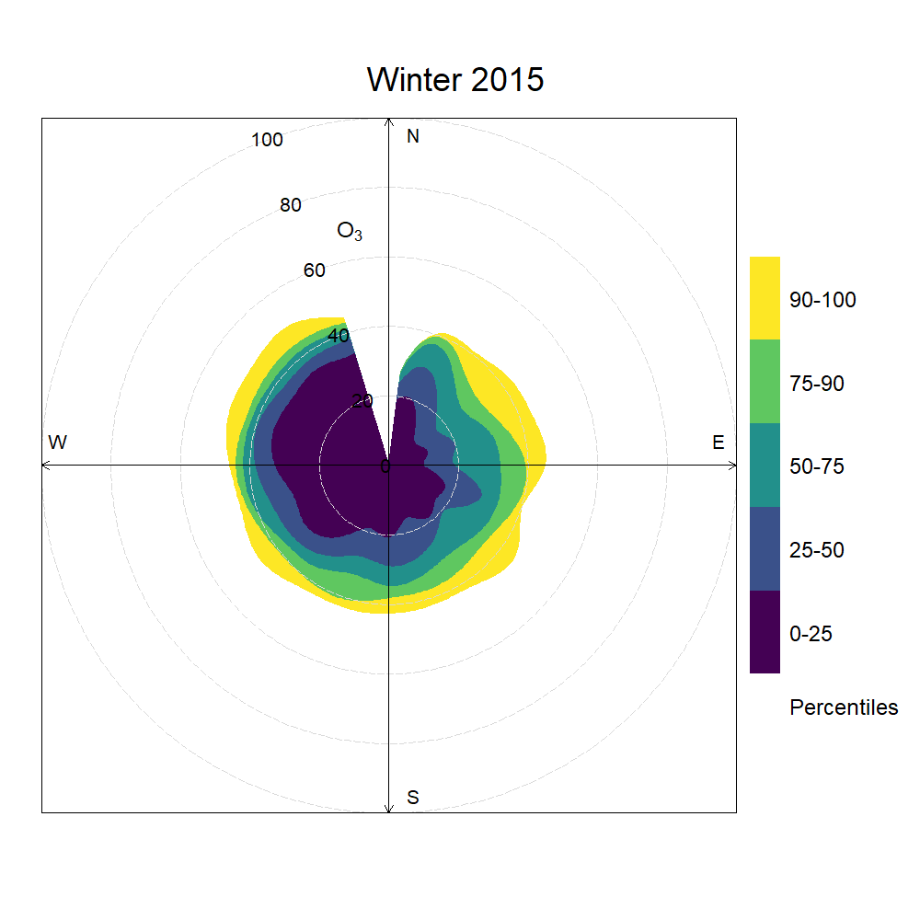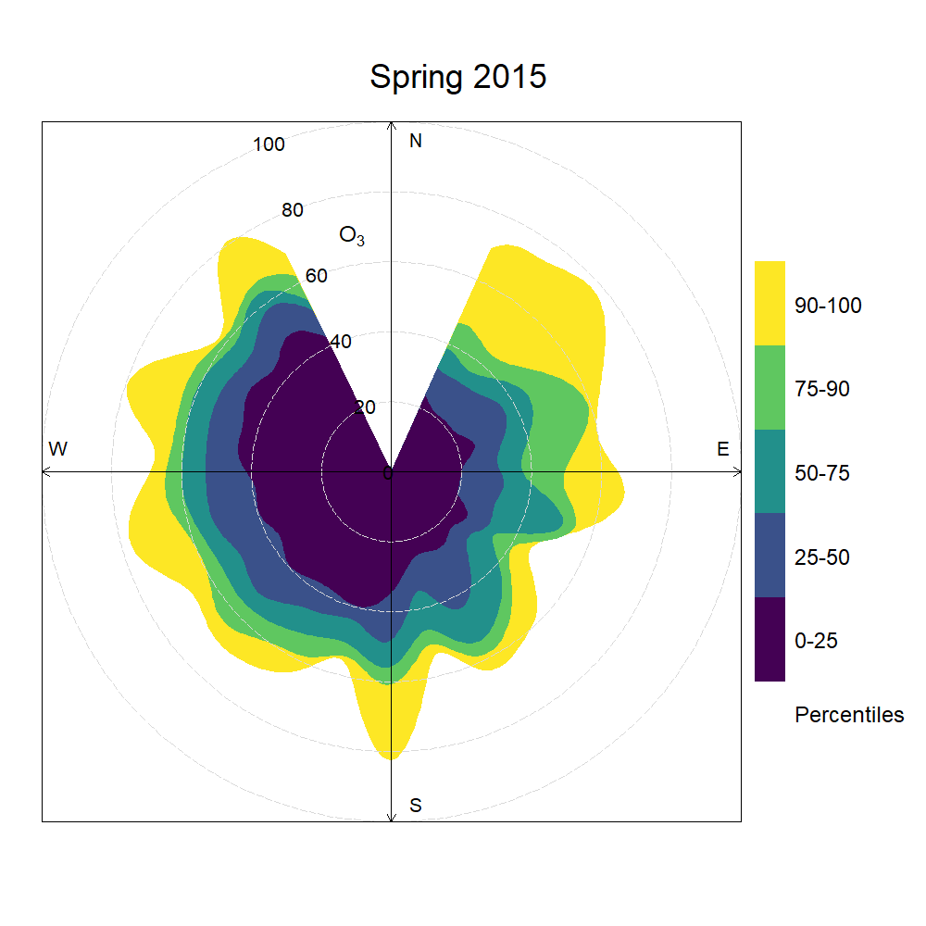
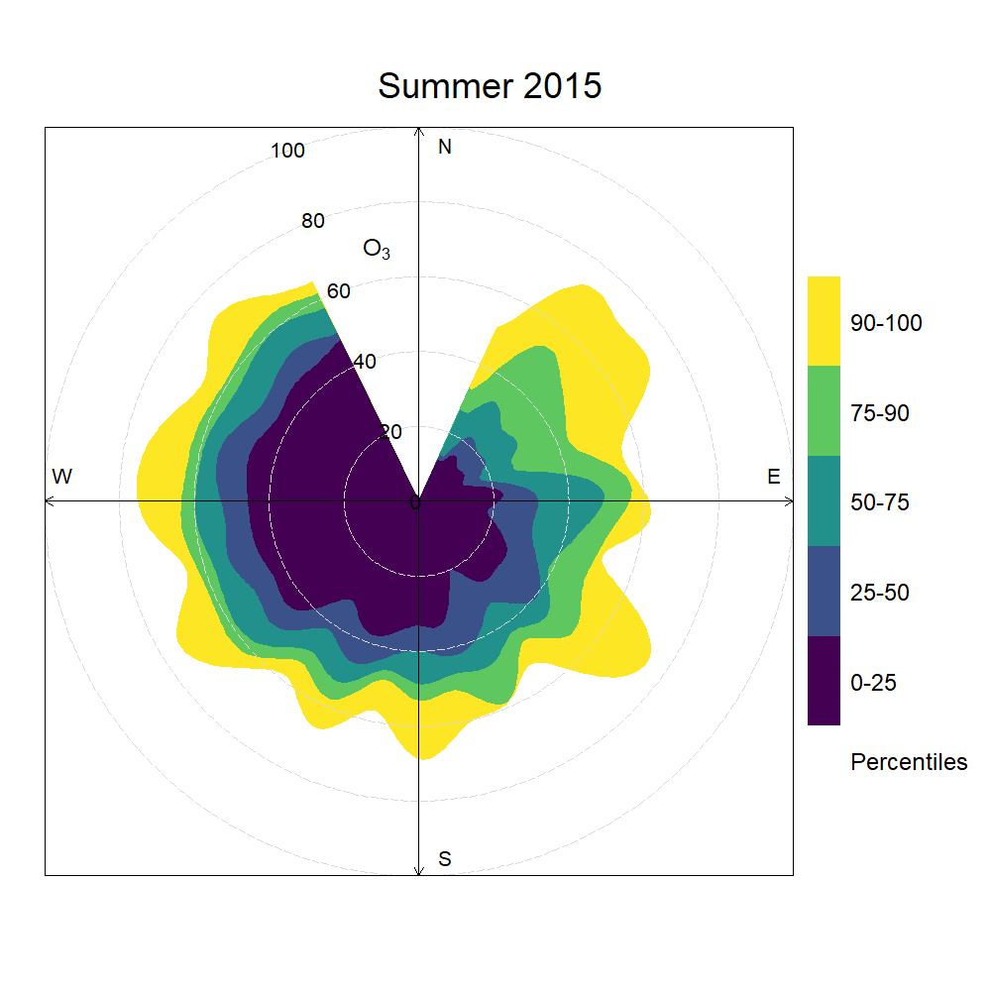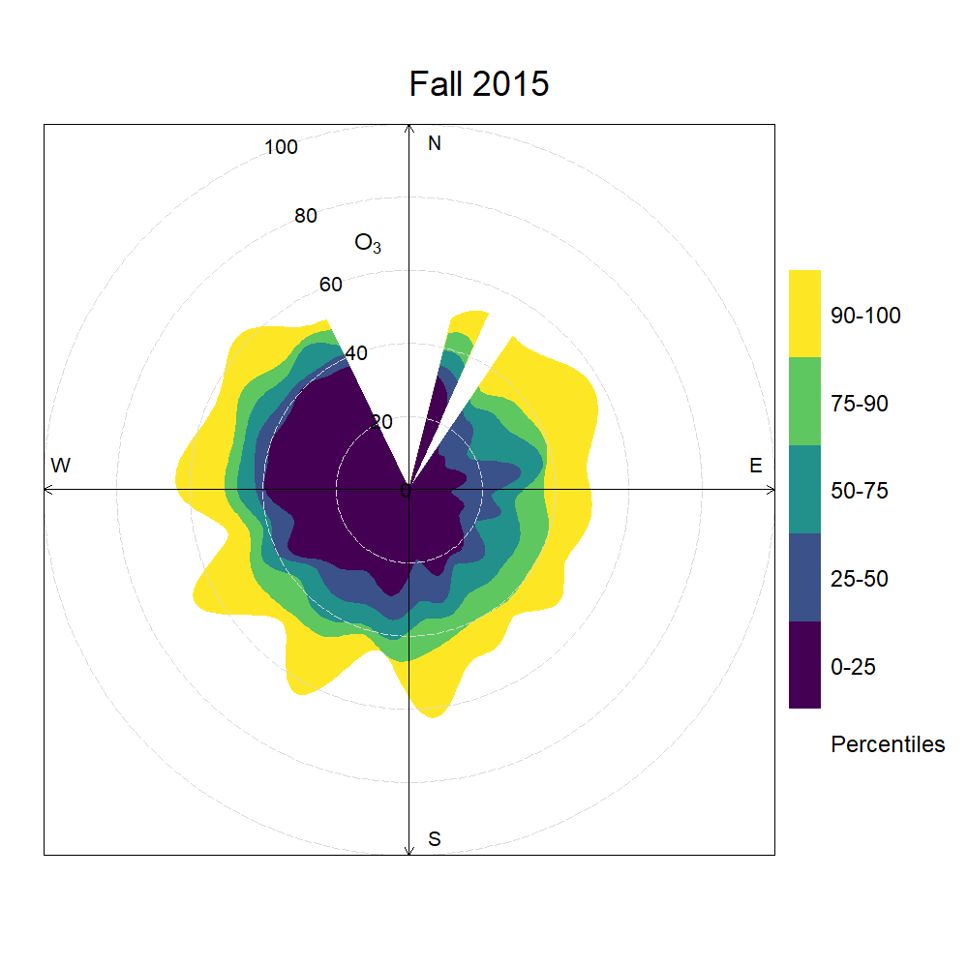
Supplementary Material S1-A. Smoothed seasonal percentile rose plots showing 2015 hourly variations in ozone concentration thresholds by wind direction. Shaded areas refer to percentiles, while the radius refers to observed mole fractions in ppb.
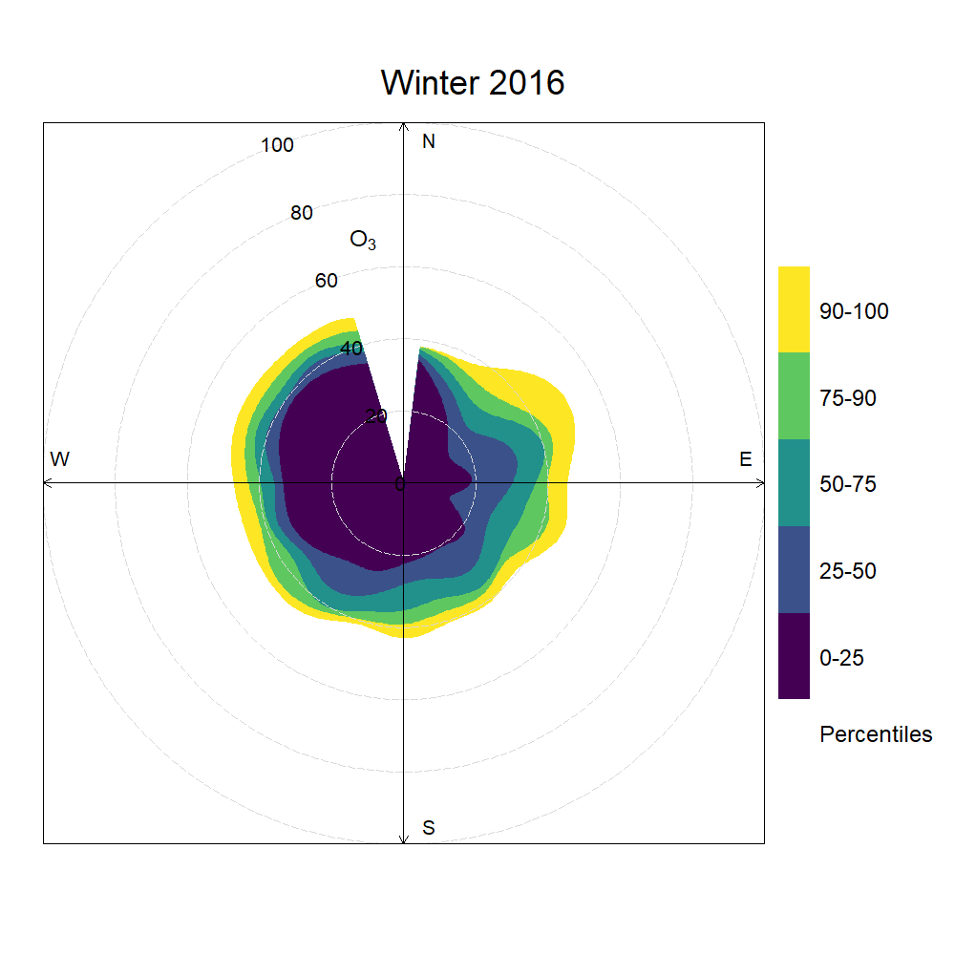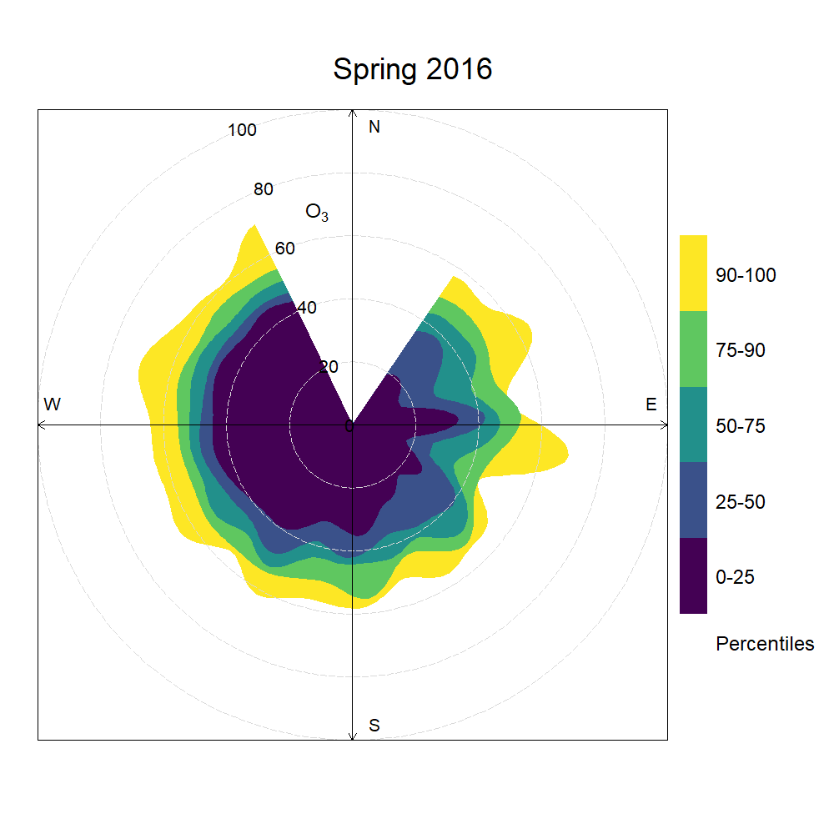
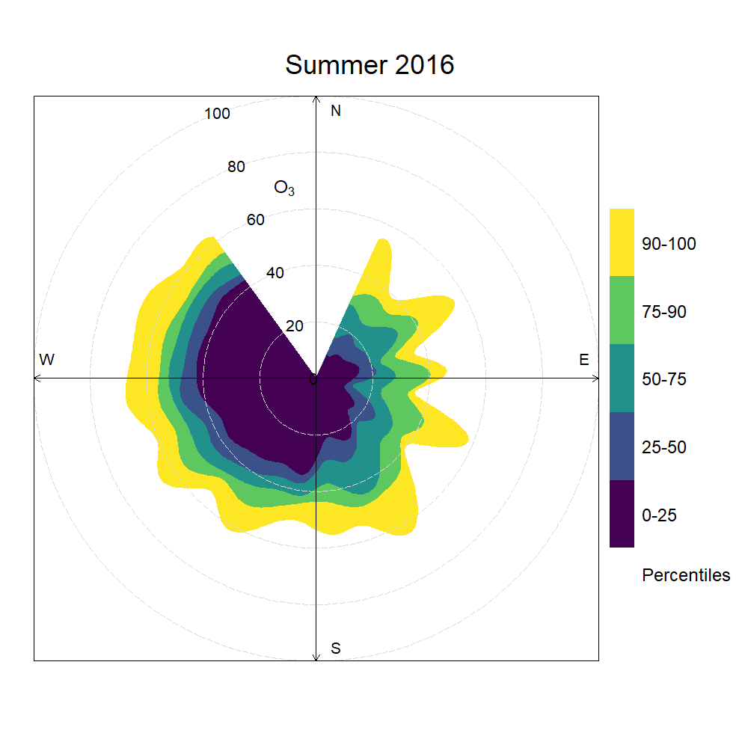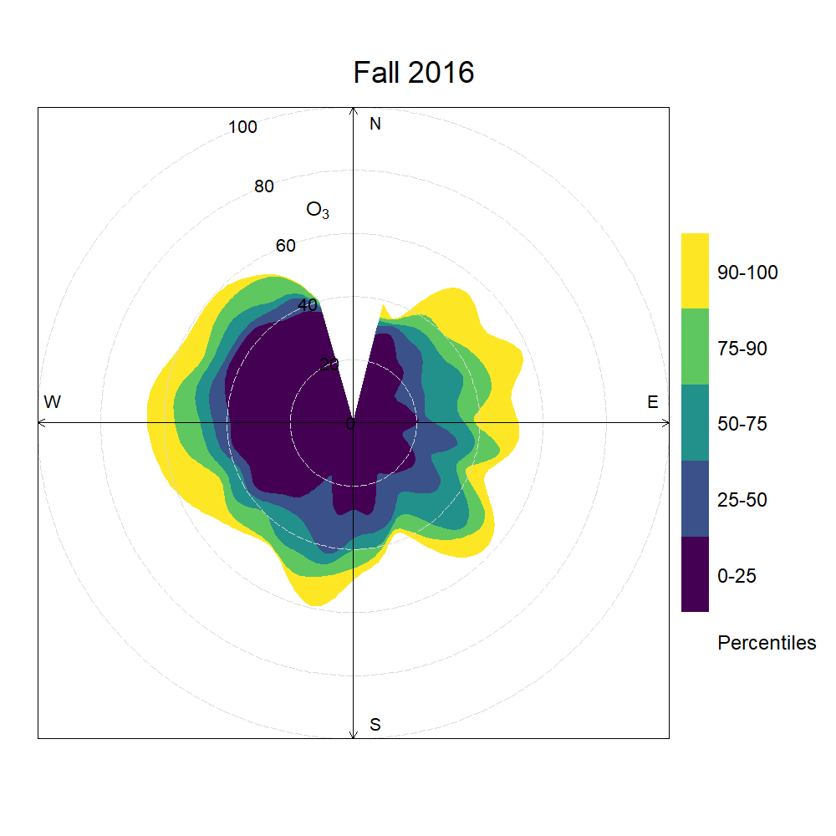
Supplementary Material S1-B. Smoothed seasonal percentile rose plots showing 2016 hourly variations in ozone concentration thresholds by wind direction. Shaded areas refer to percentiles, while the radius refers to observed mole fractions in ppb.
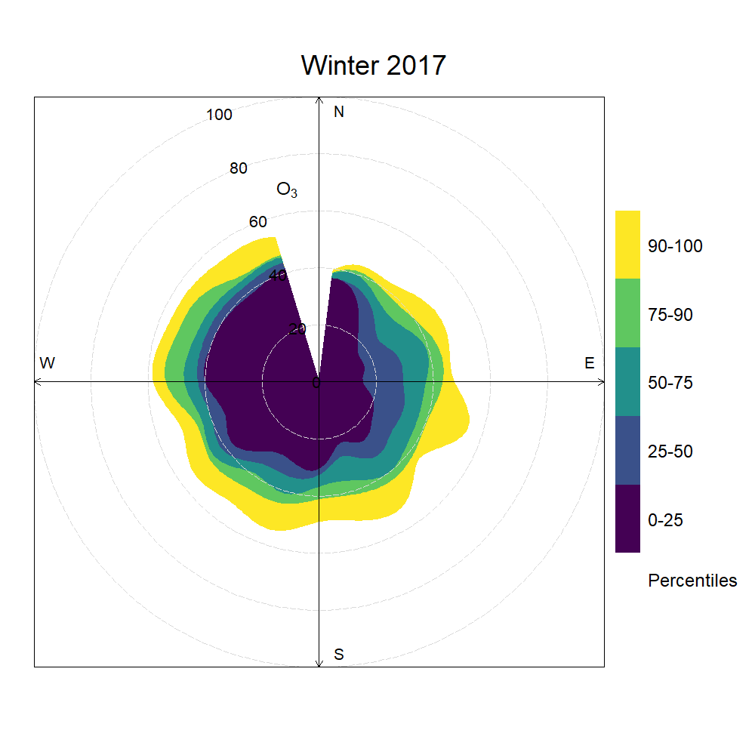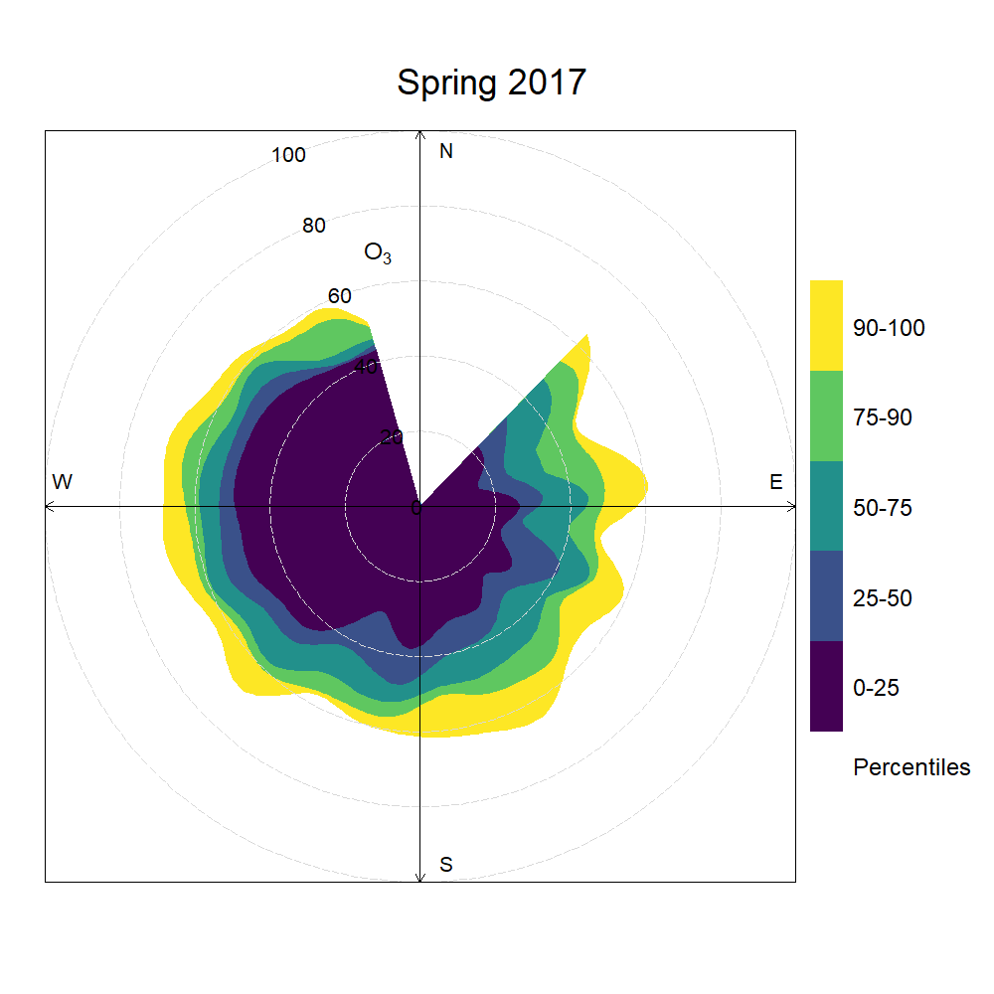
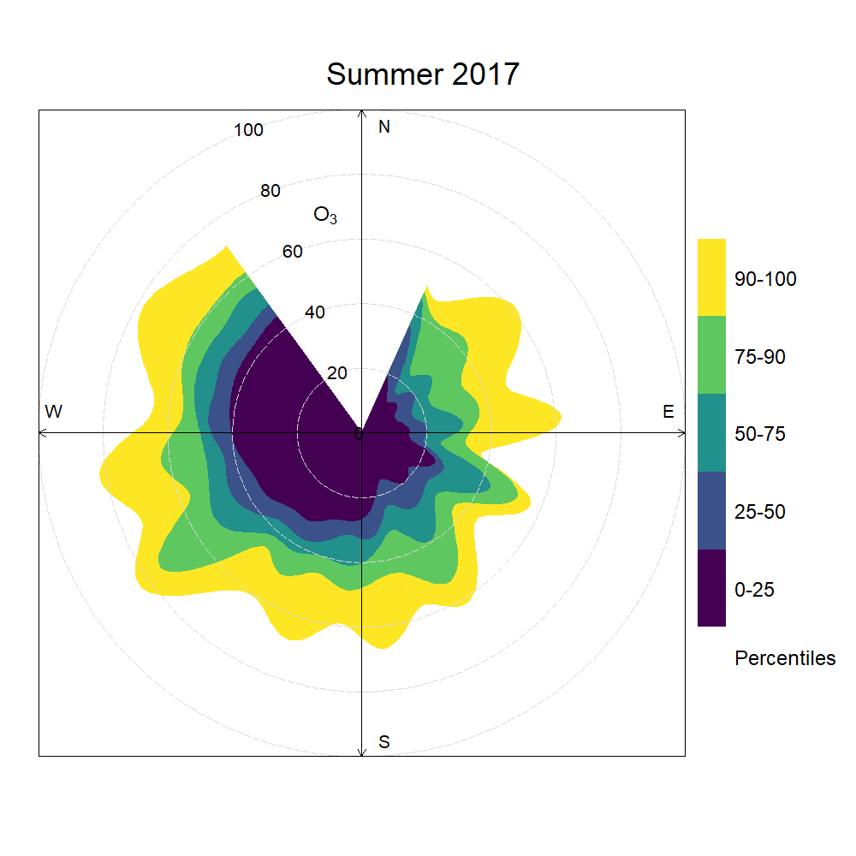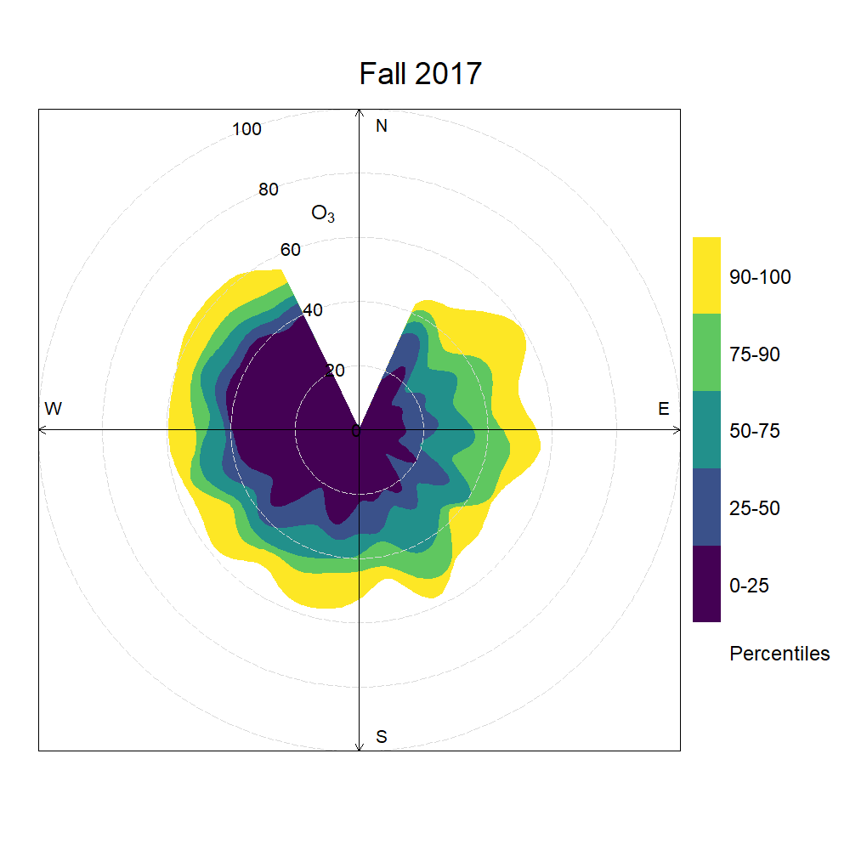
Supplementary Material S1-C. Smoothed seasonal percentile rose plots showing 2017 hourly variations in ozone concentration thresholds by wind direction. Shaded areas refer to percentiles, while the radius refers to observed mole fractions in ppb.
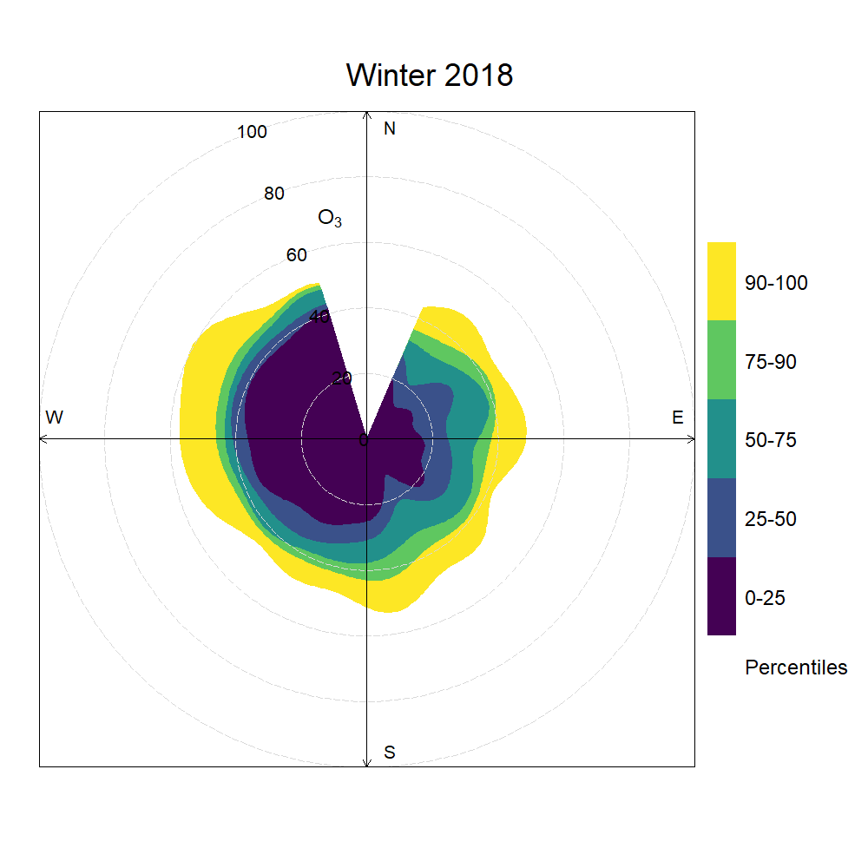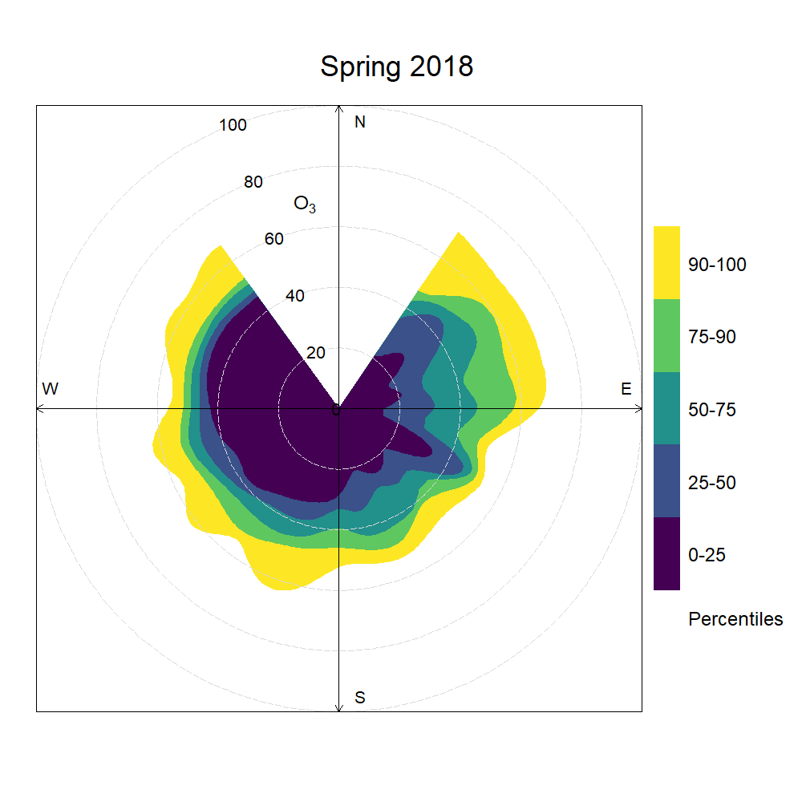
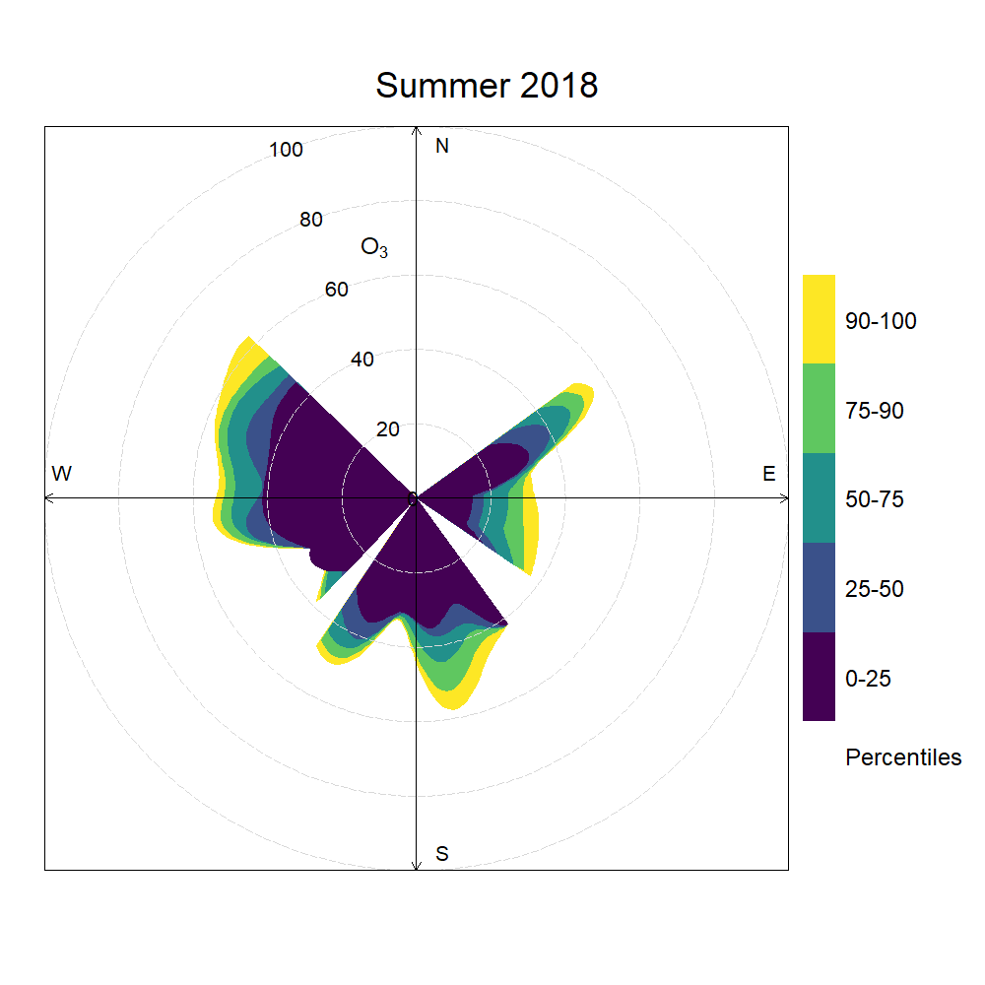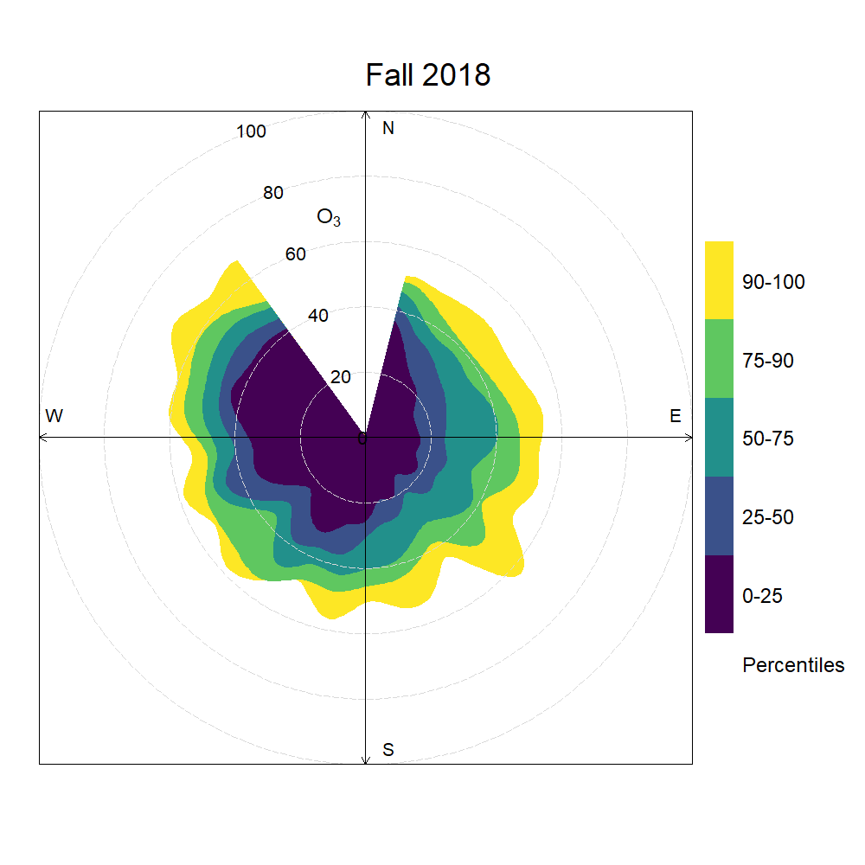
Supplementary Material S1-D. Smoothed seasonal percentile rose plots showing 2018 hourly variations in ozone concentration thresholds by wind direction. Shaded areas refer to percentiles, while the radius refers to observed mole fractions in ppb.
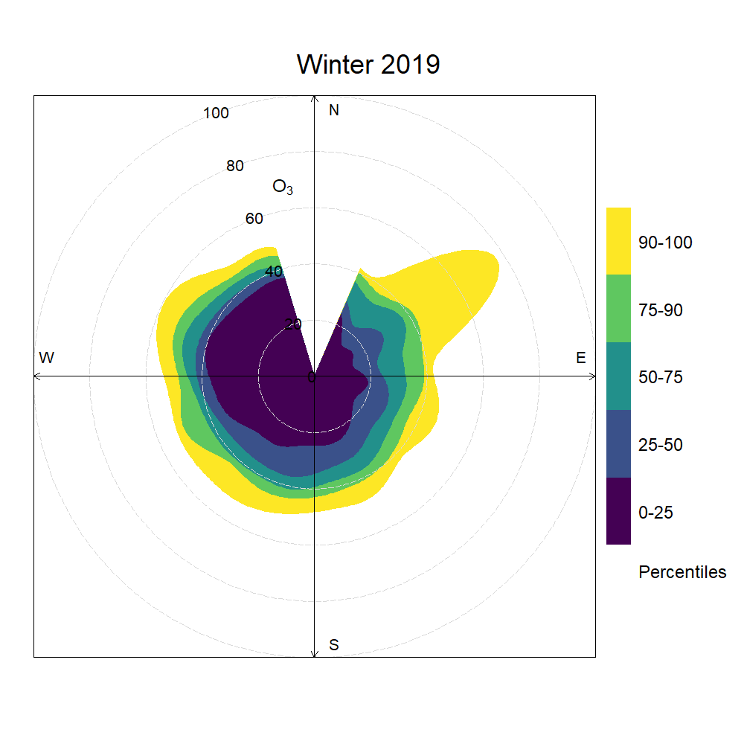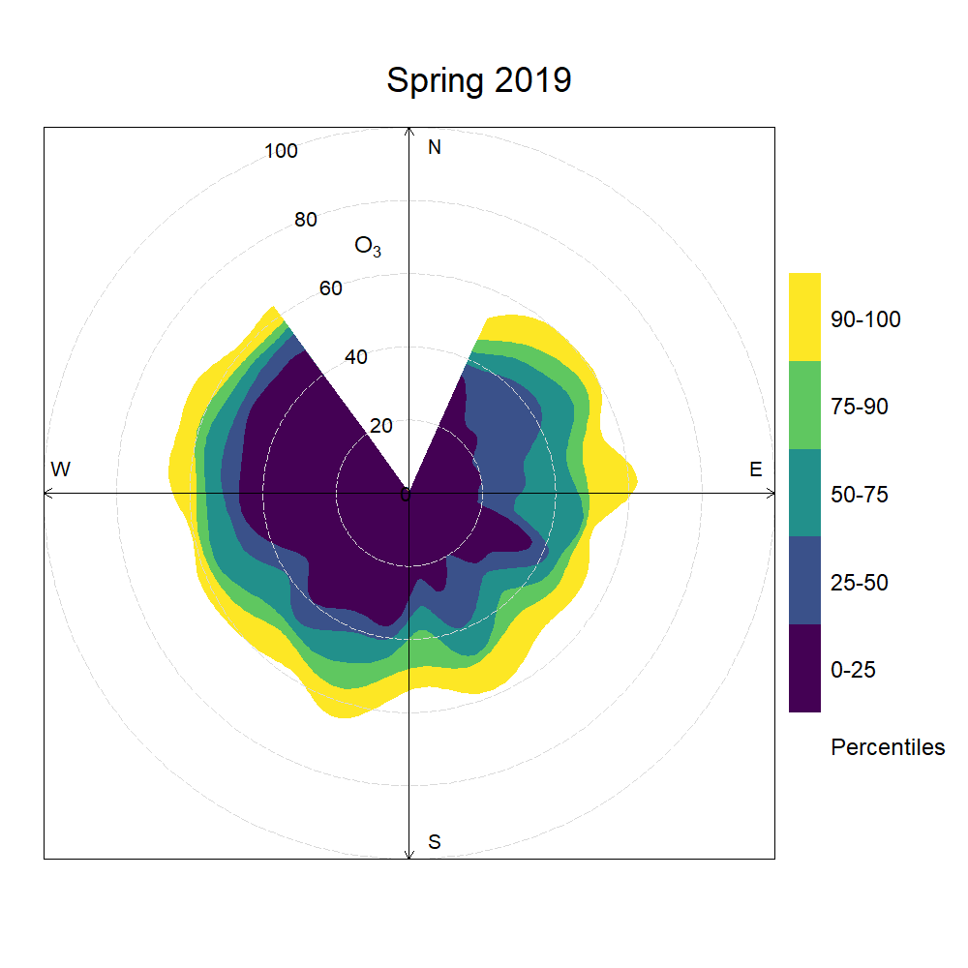
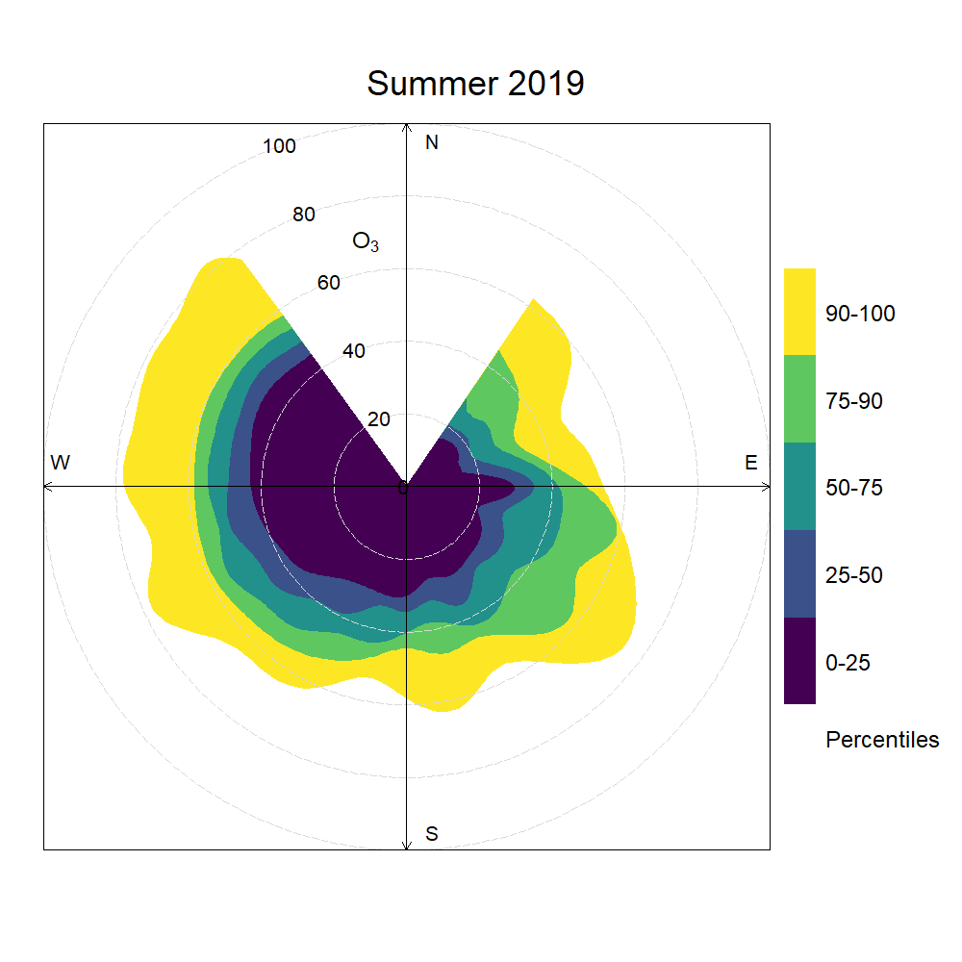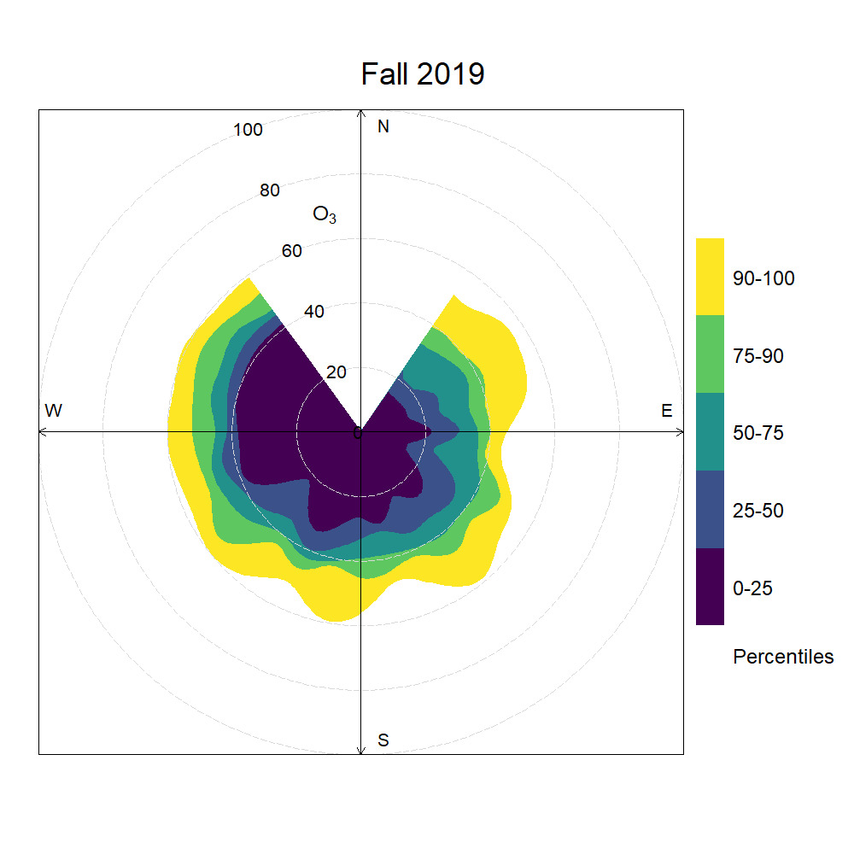
Supplementary Material S1-E. Smoothed seasonal percentile rose plots showing 2019 hourly variations in ozone concentration thresholds by wind direction. Shaded areas refer to percentiles, while the radius refers to observed mole fractions in ppb.
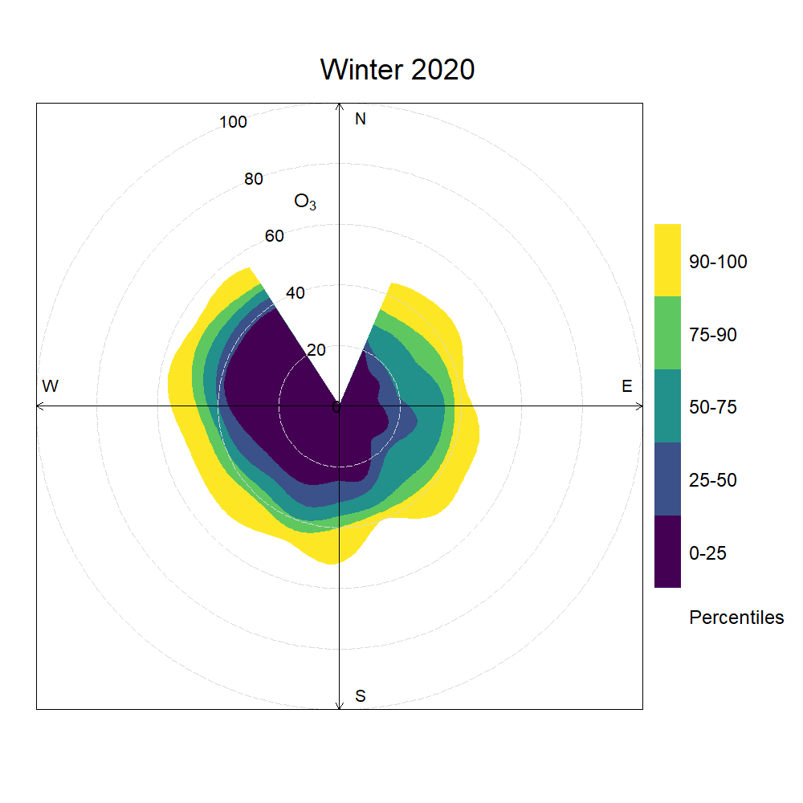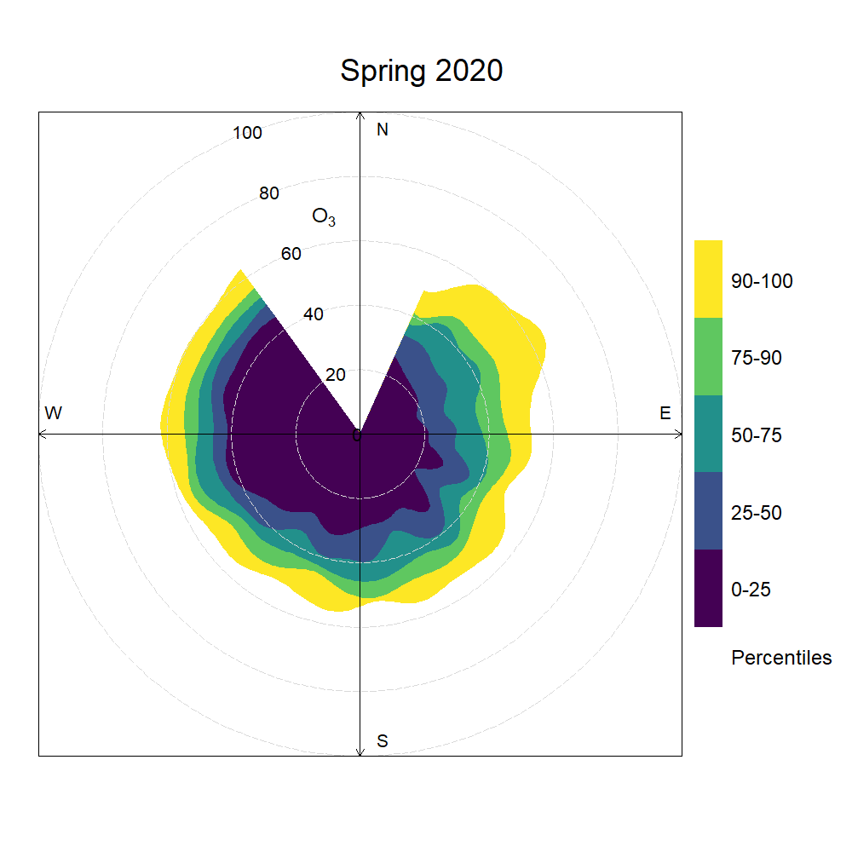
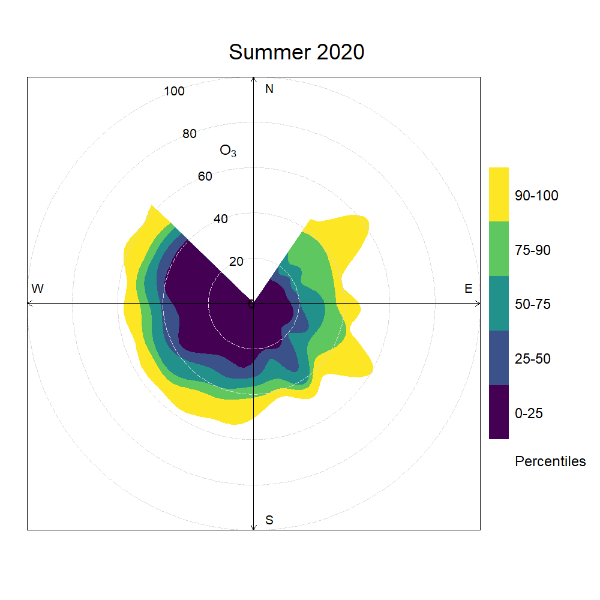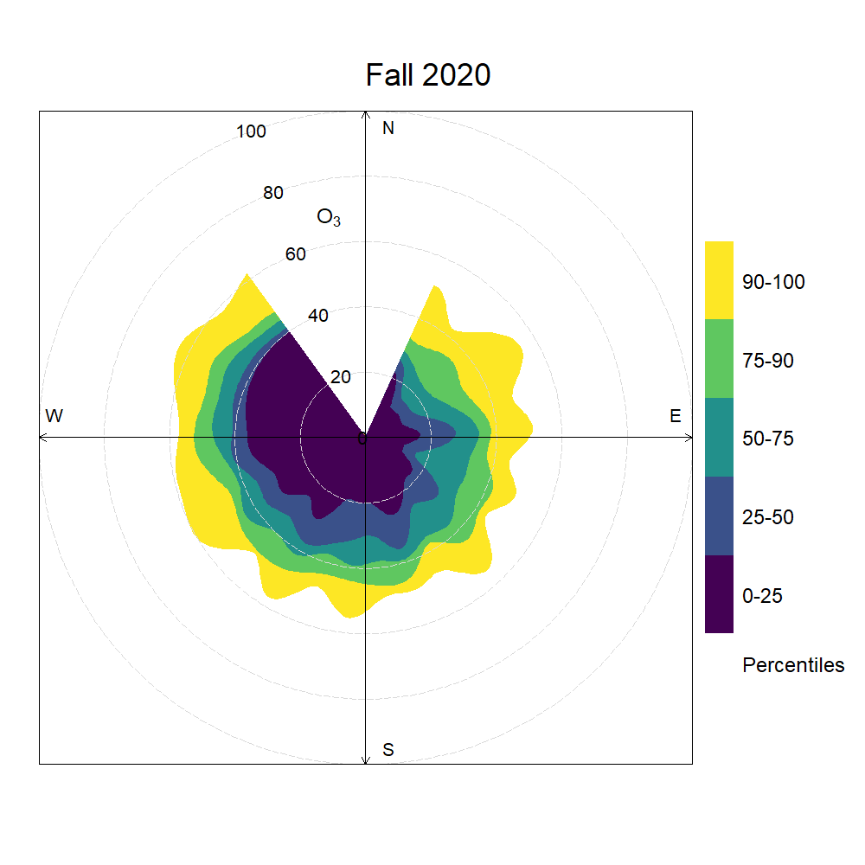
Supplementary Material S1-F. Smoothed seasonal percentile rose plots showing 2020 hourly variations in ozone concentration thresholds by wind direction. Shaded areas refer to percentiles, while the radius refers to observed mole fractions in ppb.
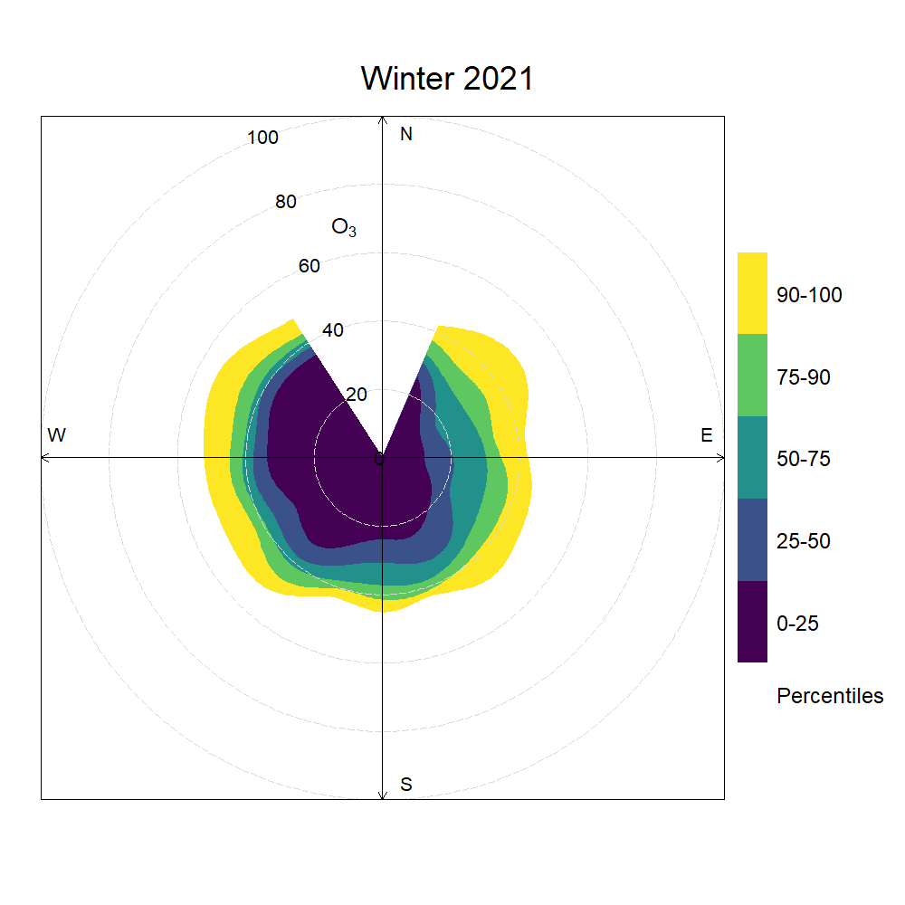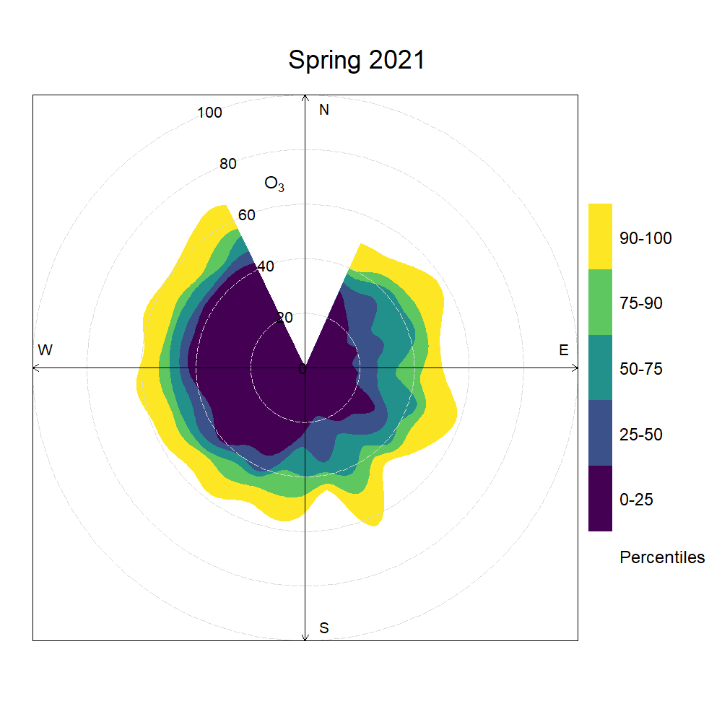
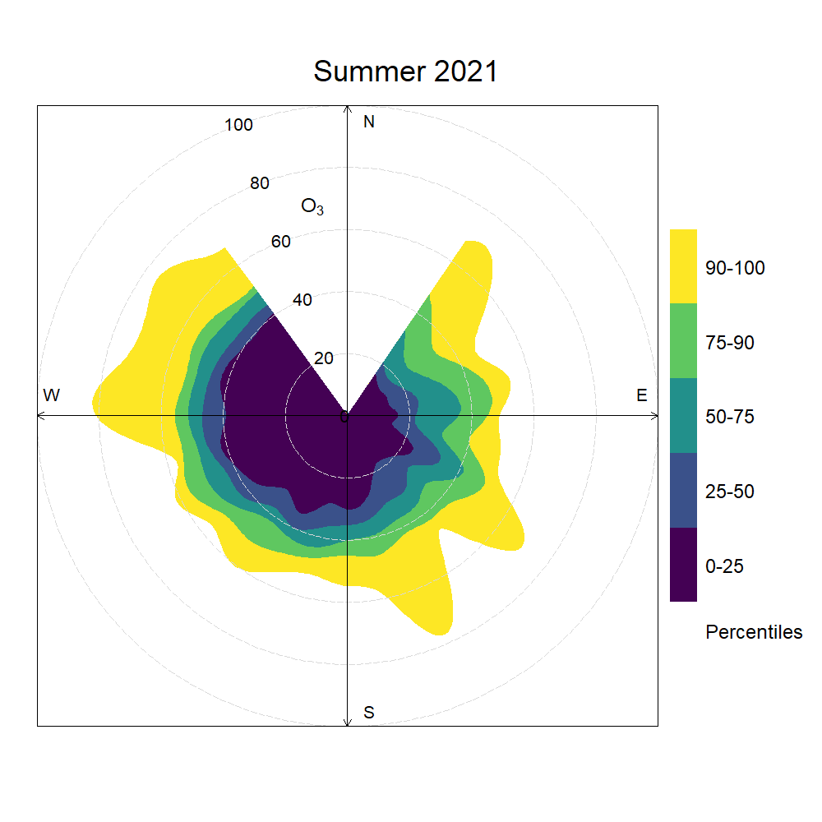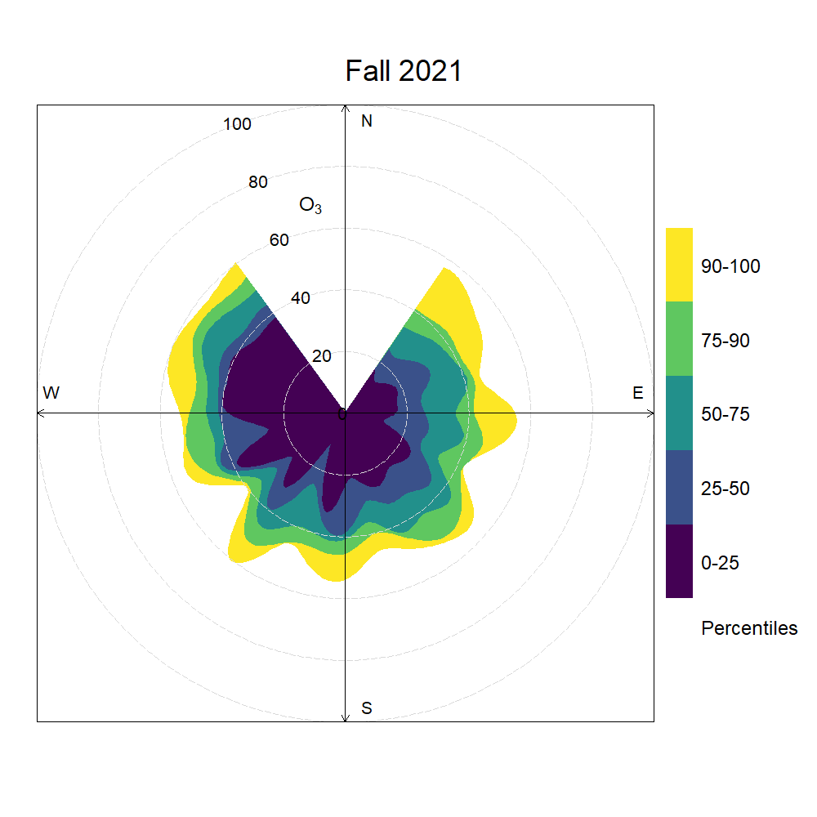
Supplementary Material S1-G. Smoothed seasonal percentile rose plots showing 2021 hourly variations in ozone concentration thresholds by wind direction. Shaded areas refer to percentiles, while the radius refers to observed mole fractions in ppb.
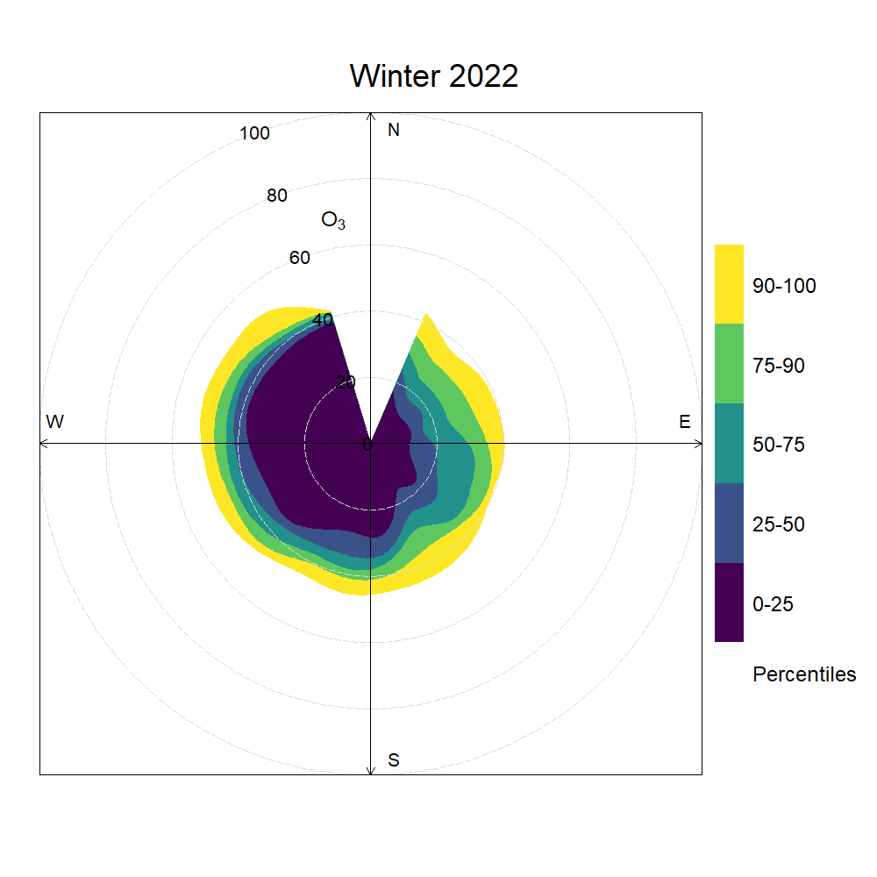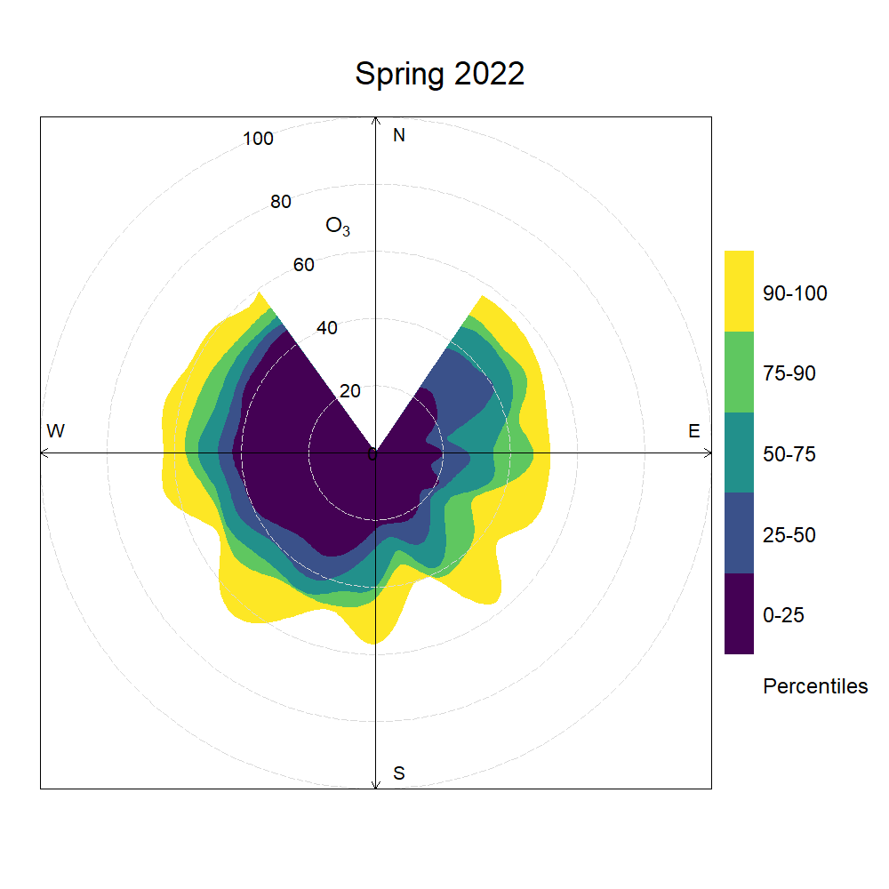
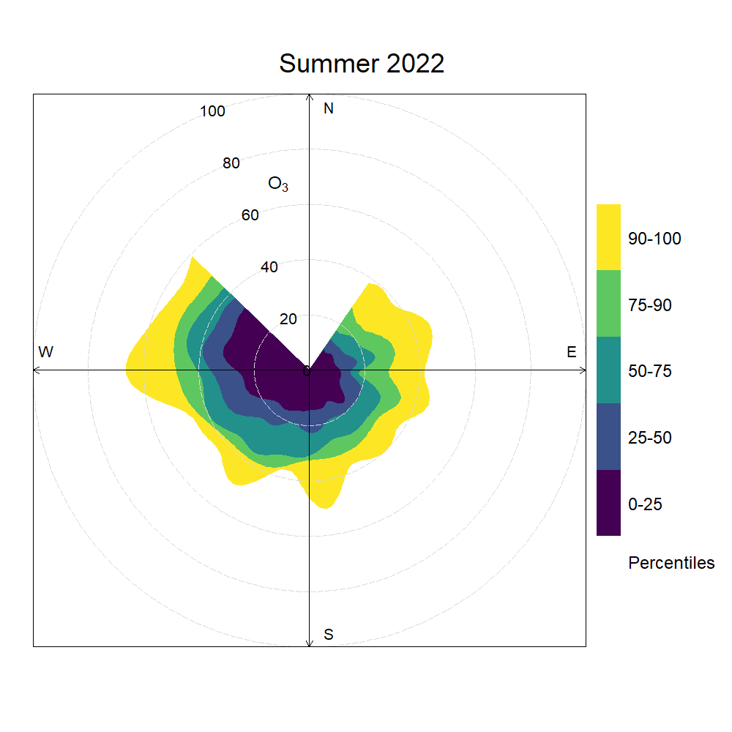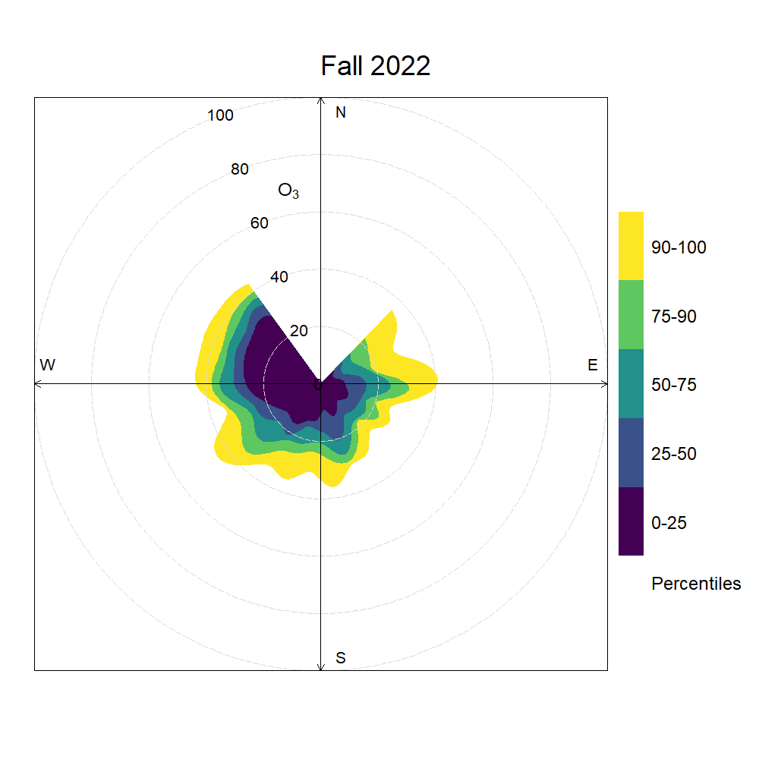
Supplementary Material S1-H. Smoothed seasonal percentile rose plots showing 2022 hourly variations in ozone concentration thresholds by wind direction. Shaded areas refer to percentiles, while the radius refers to observed mole fractions in ppb.
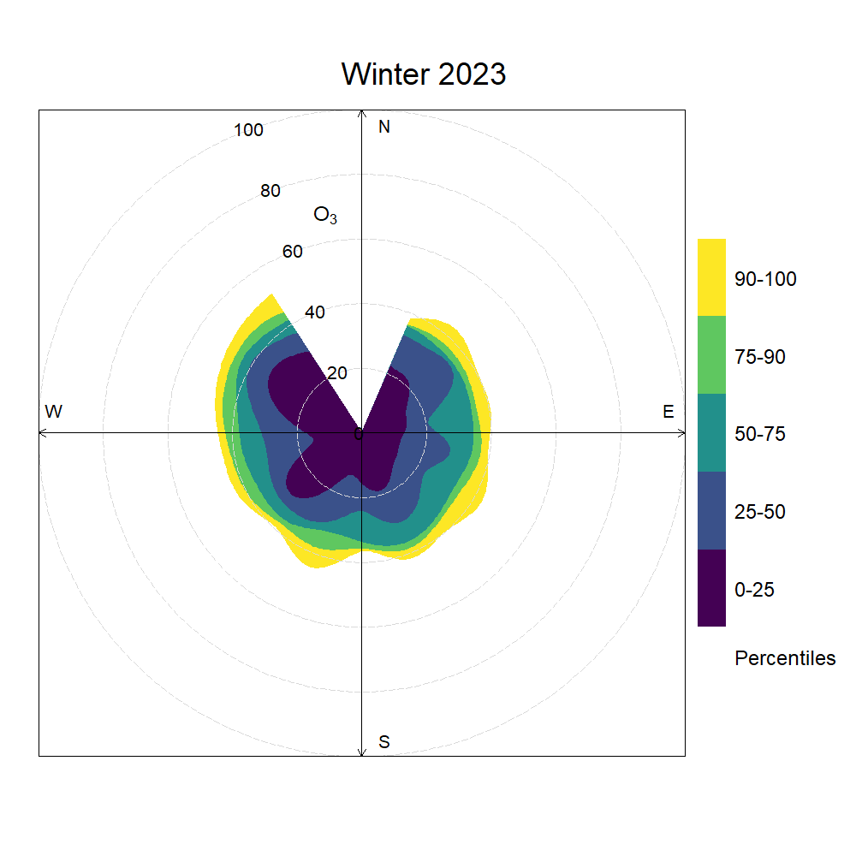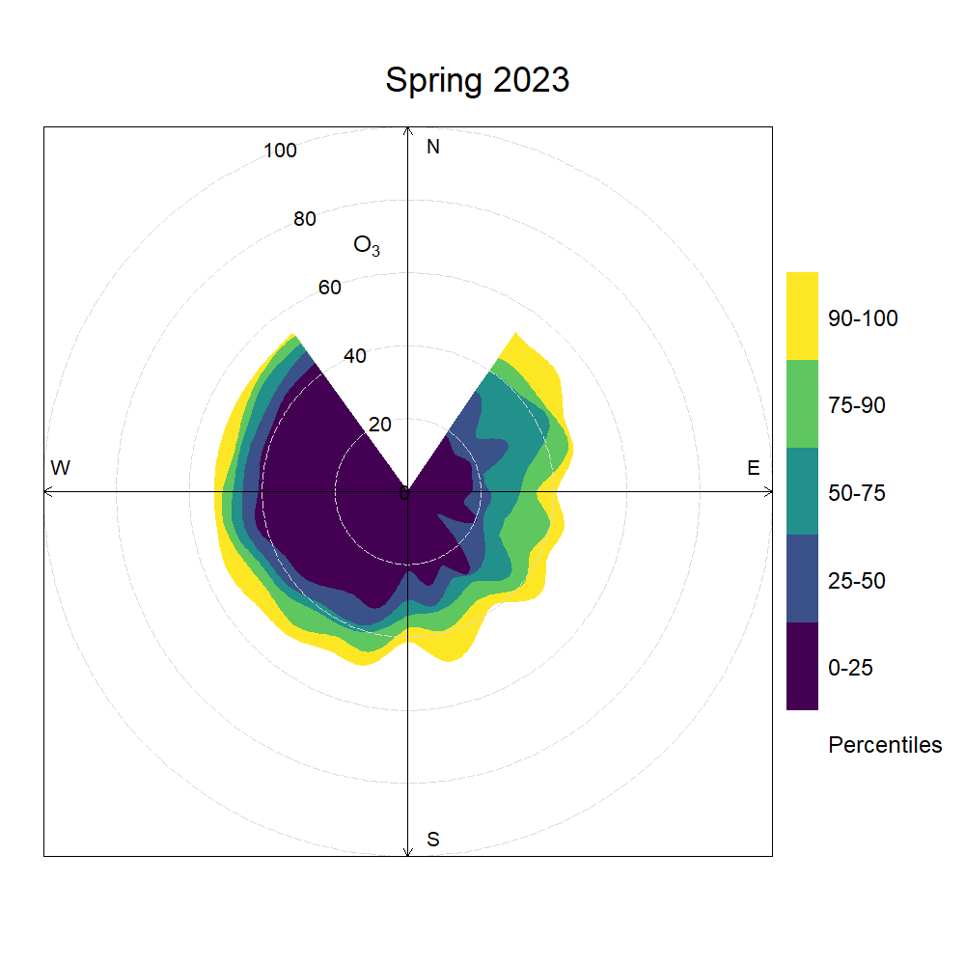
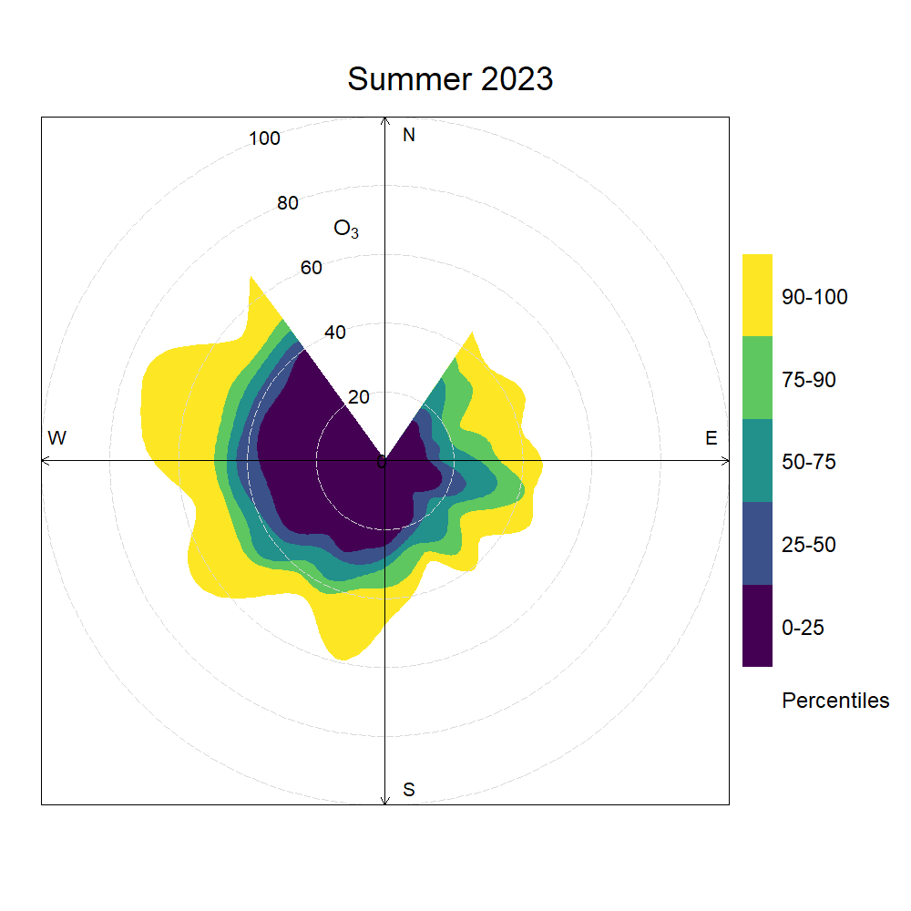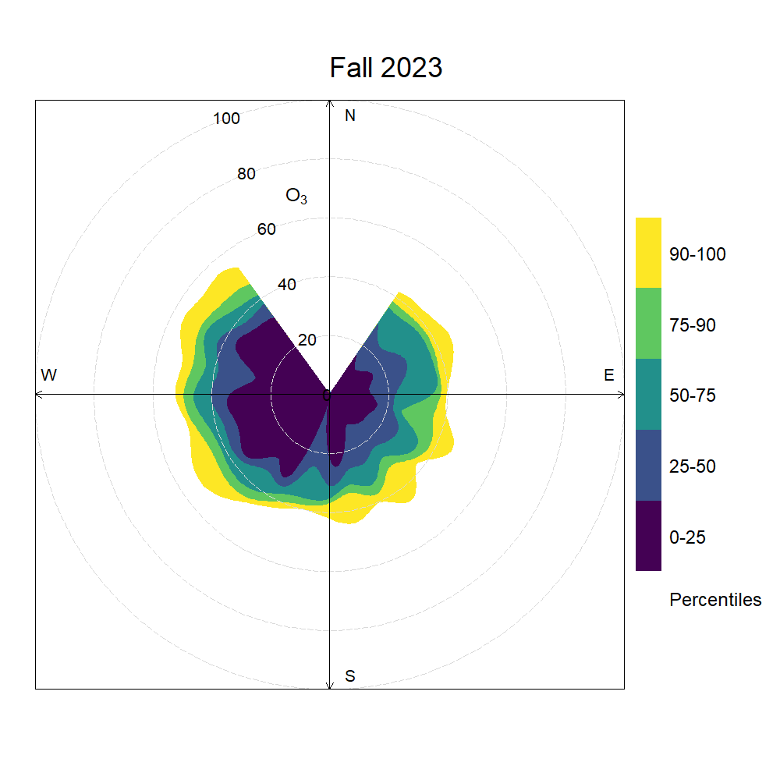
Supplementary Material S1-I. Smoothed seasonal percentile rose plots showing 2023 hourly variations in ozone concentration thresholds by wind direction. Shaded areas refer to percentiles, while the radius refers to observed mole fractions in ppb.

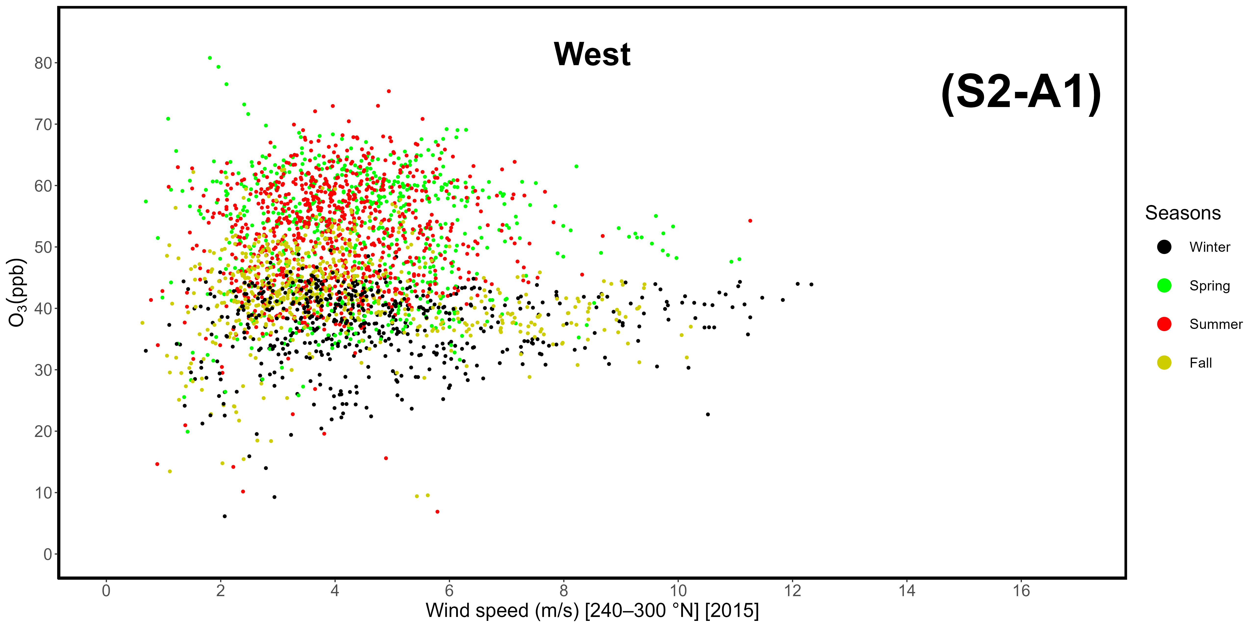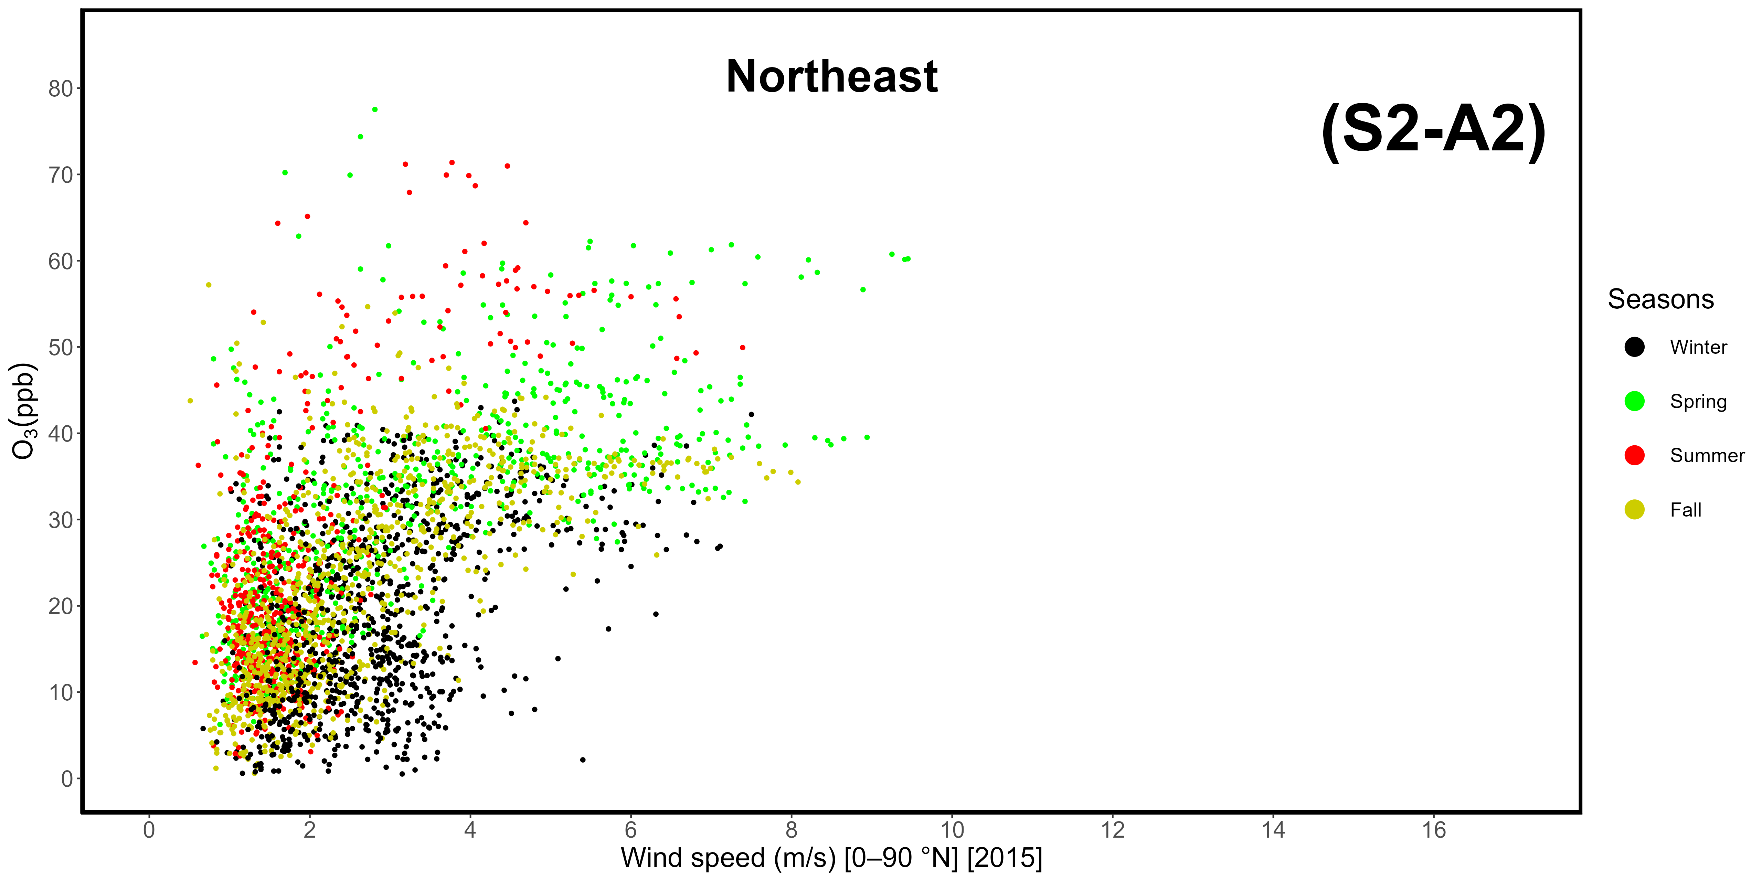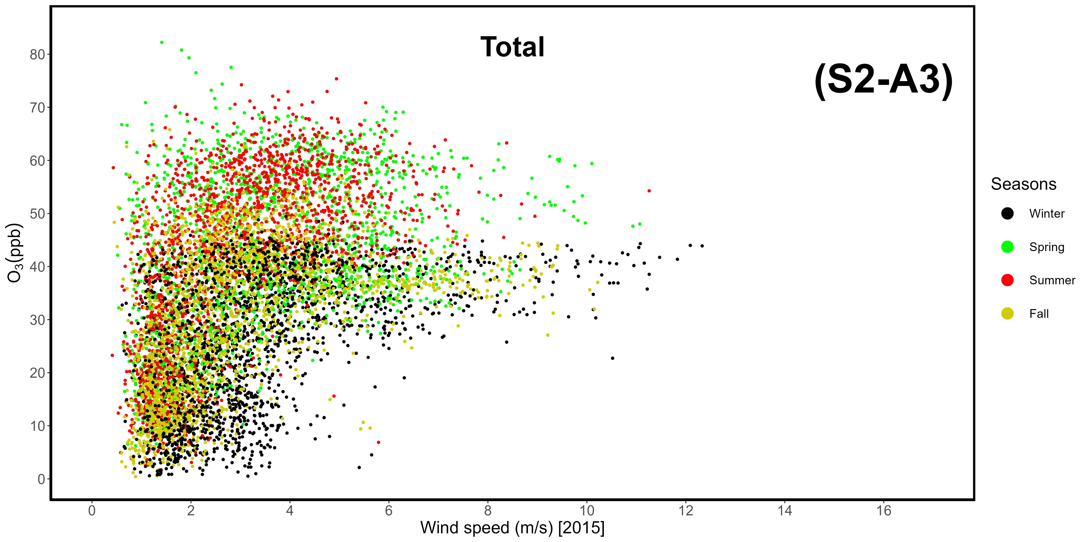
Supplementary Materials S2-A1, -A2, -A3. Correlation between wind speeds and ozone mole fractions in 2015, divided by sector. A1: western-seaside (240-300 °N); A2: northeastern-continental (0-90 °N); A3: total data.
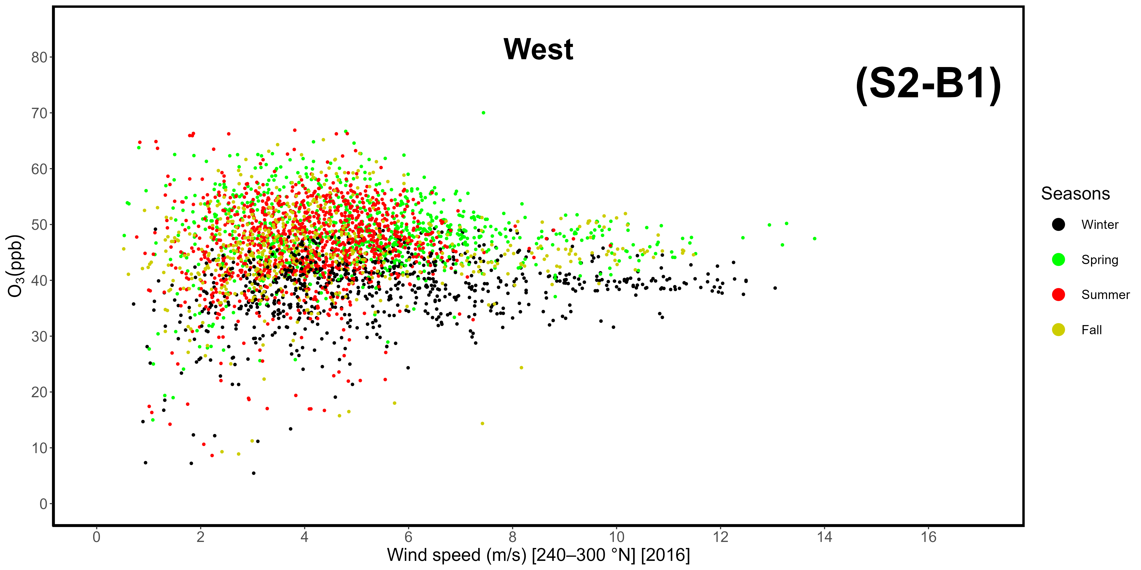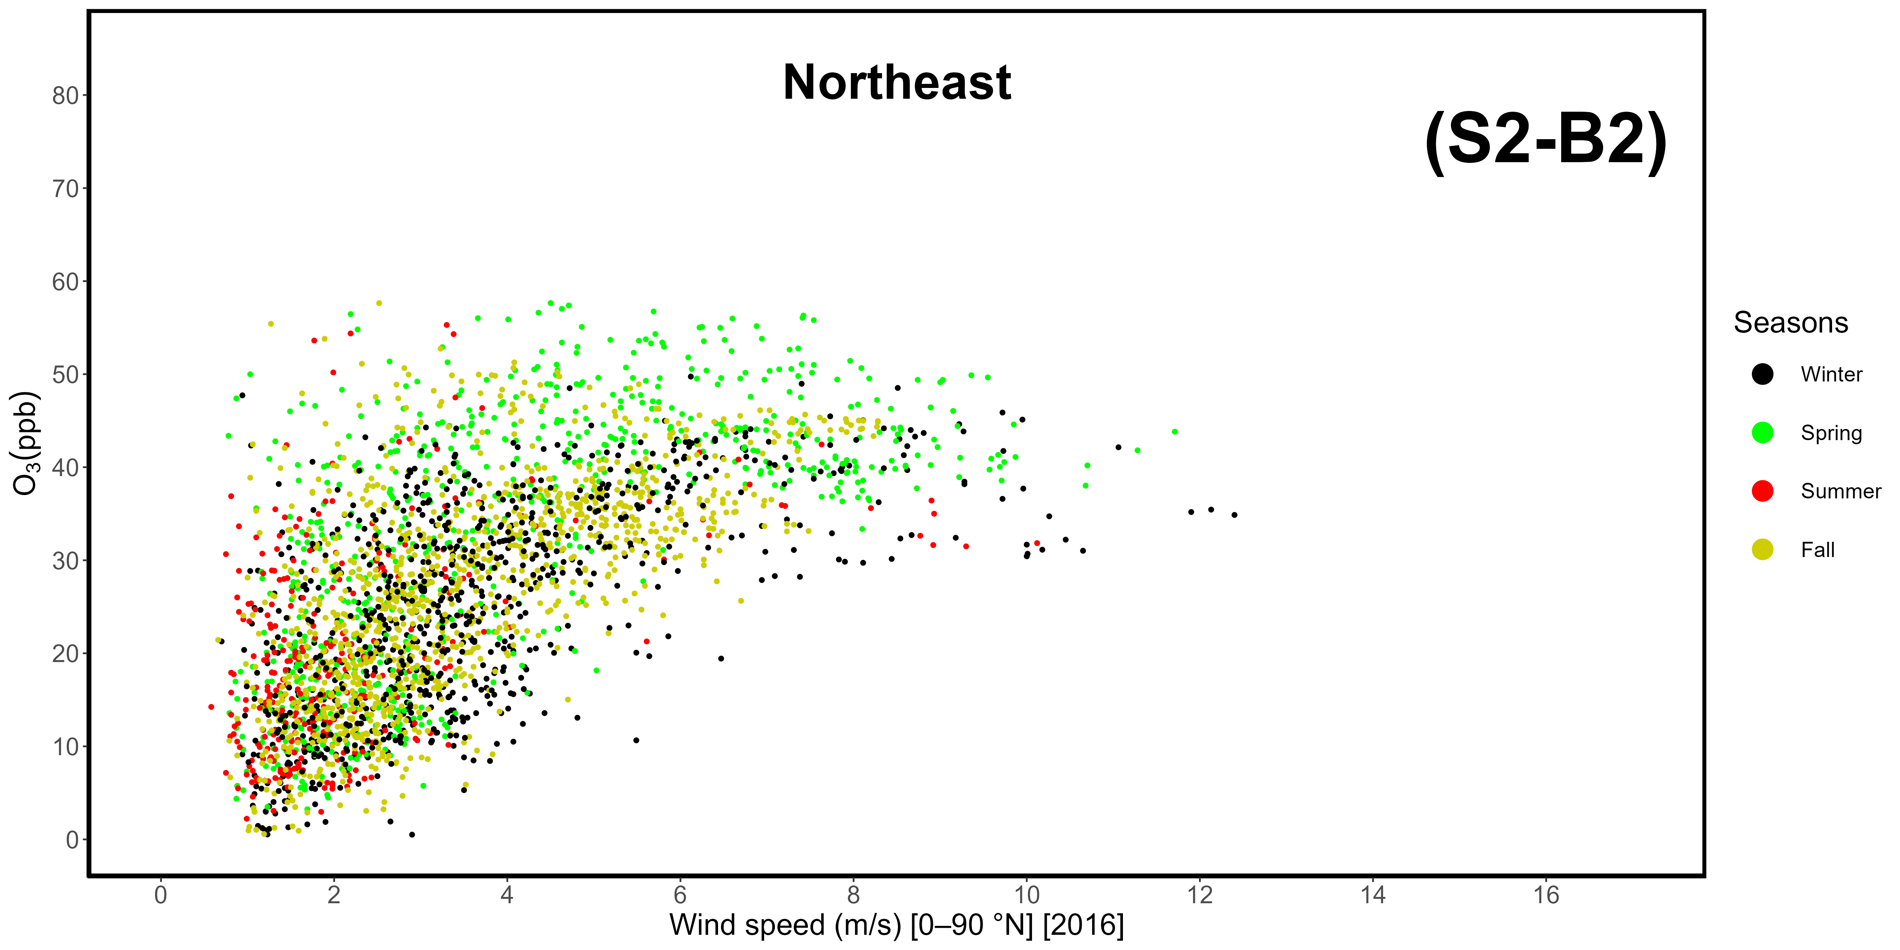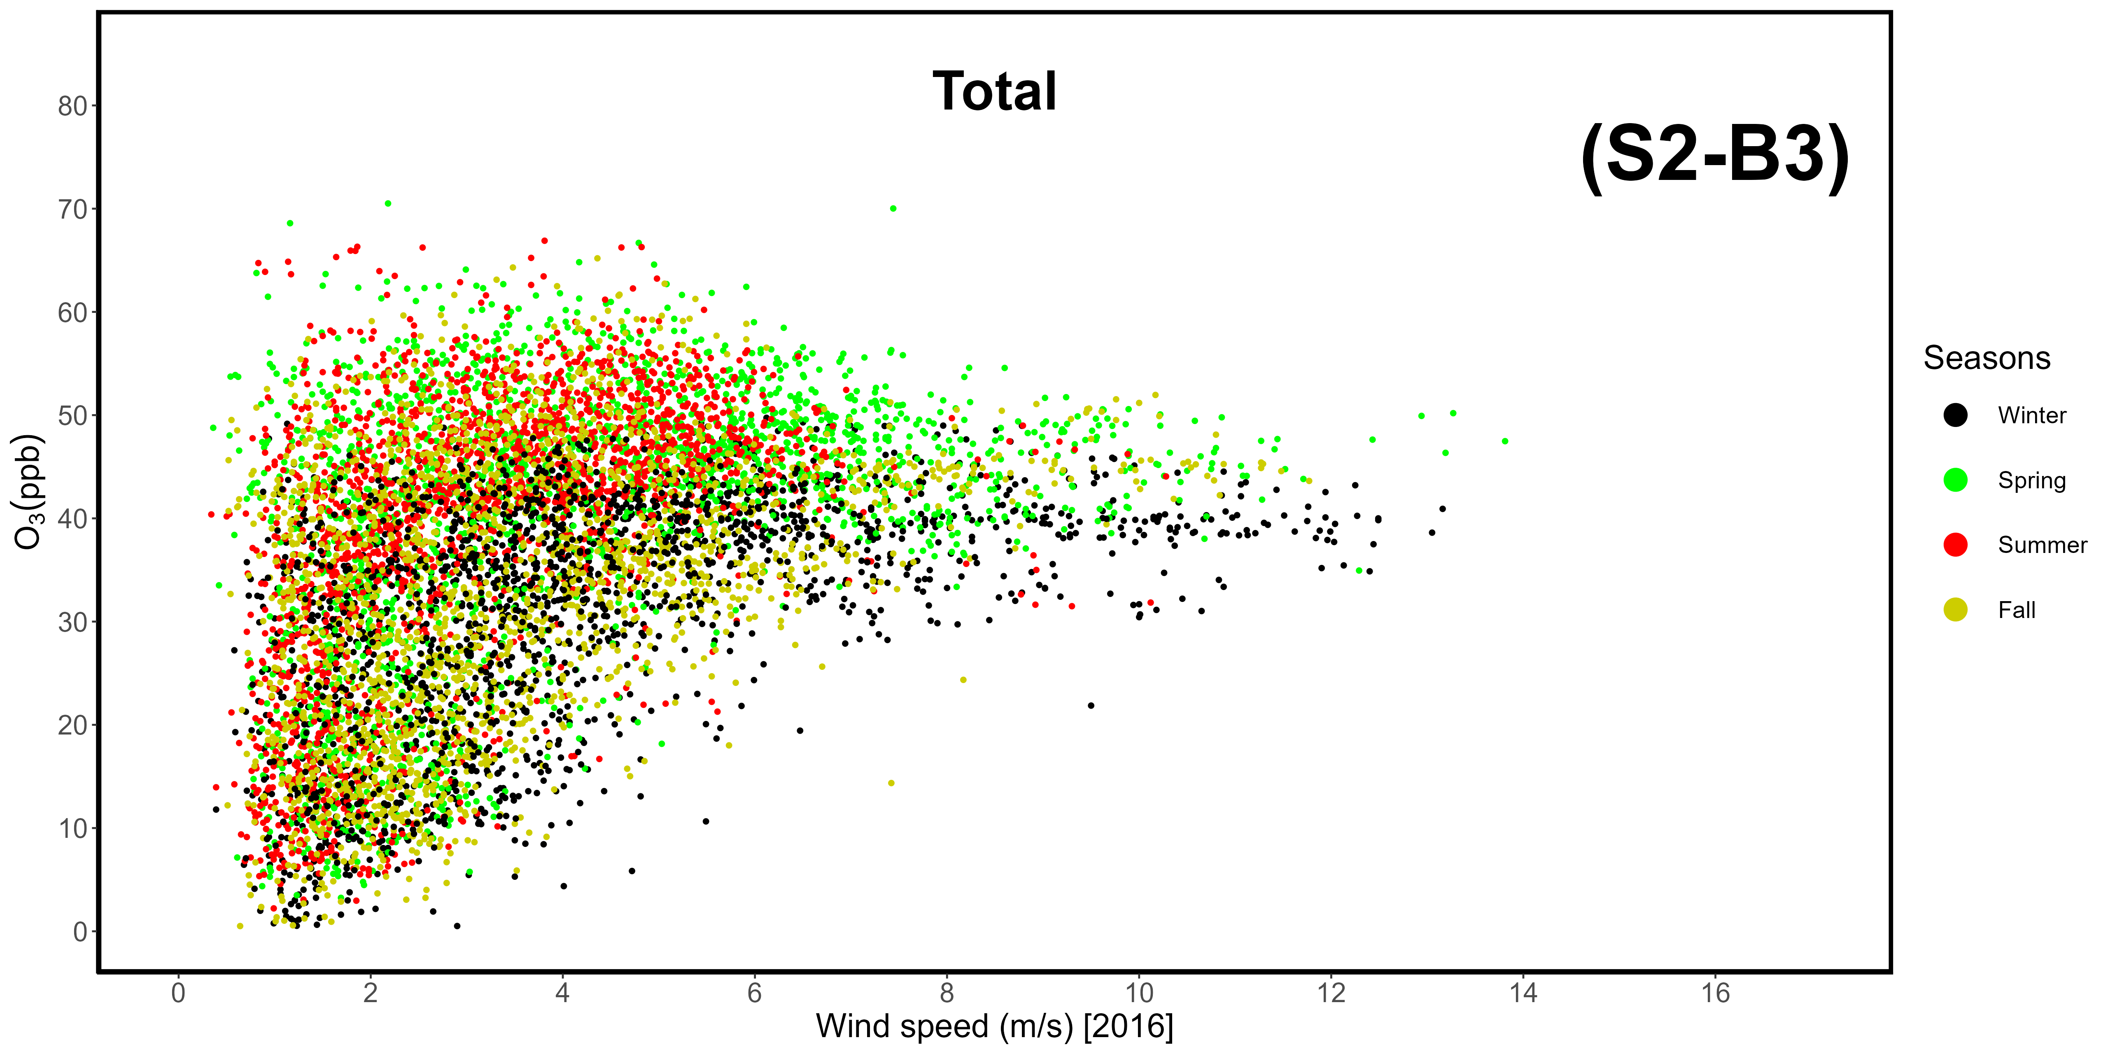
Supplementary Materials S2-B1, -B2, -B3. Correlation between wind speeds and ozone mole fractions in 2016, divided by sector. B1: western-seaside (240-300 °N); B2: northeastern-continental (0-90 °N); B3: total data.
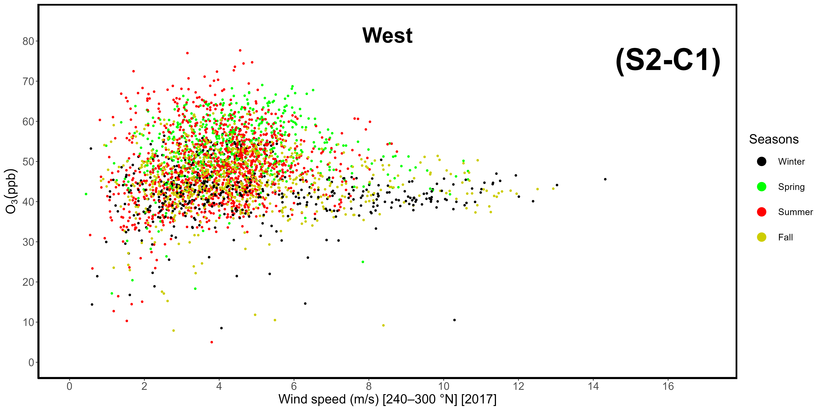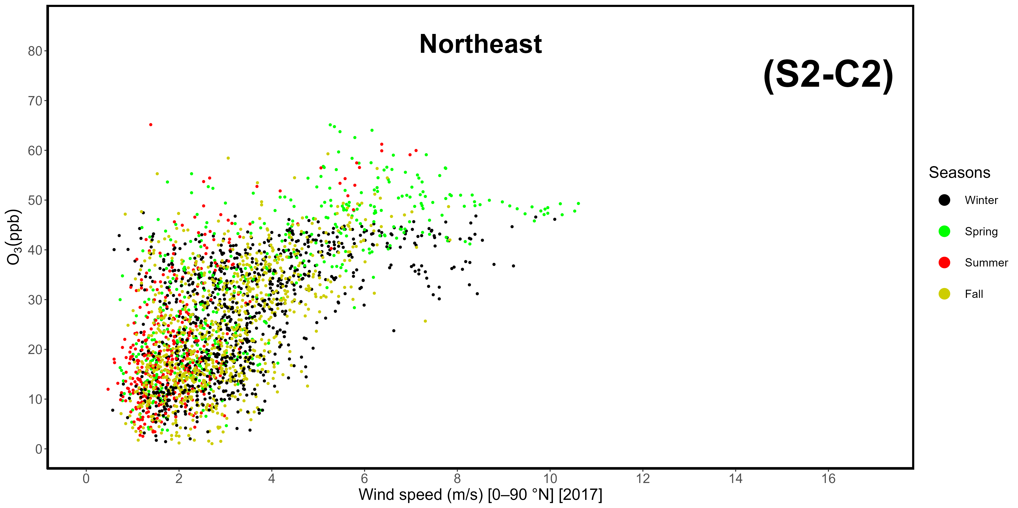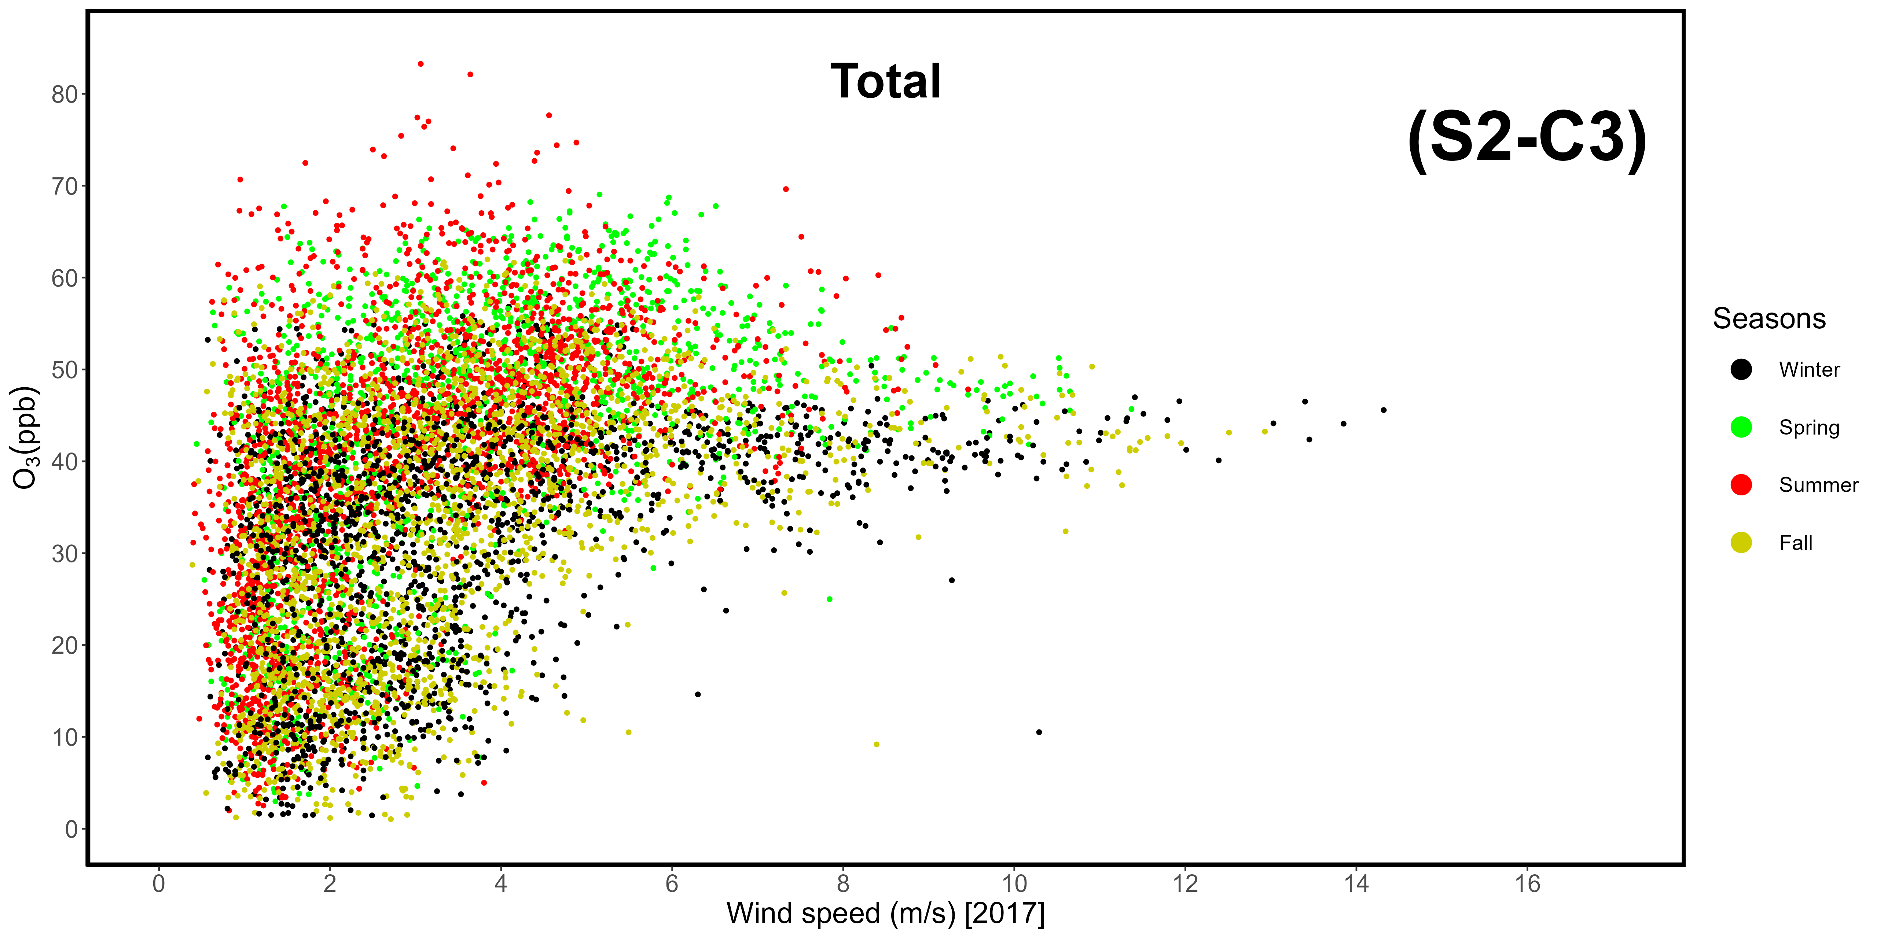
Supplementary Materials S2-C1, -C2, -C3. Correlation between wind speeds and ozone mole fractions in 2017, divided by sector. C1: western-seaside (240-300 °N); C2: northeastern-continental (0-90 °N); C3: total data.
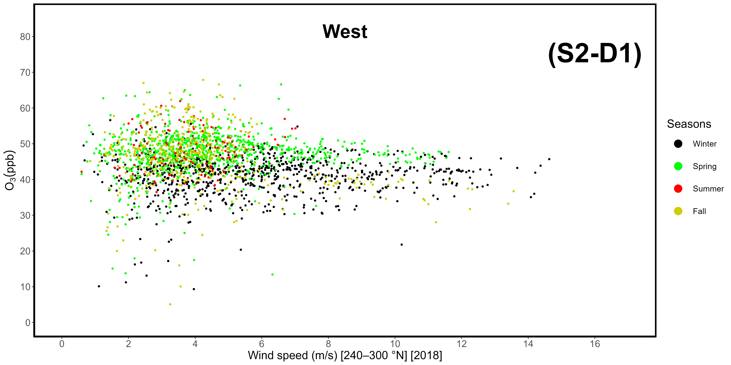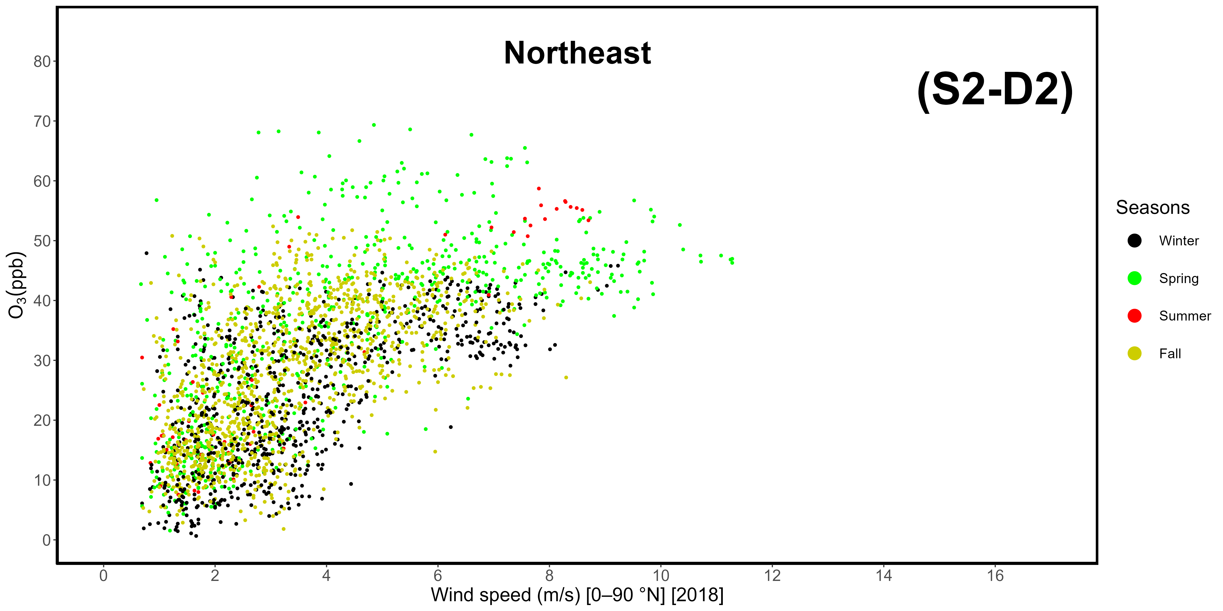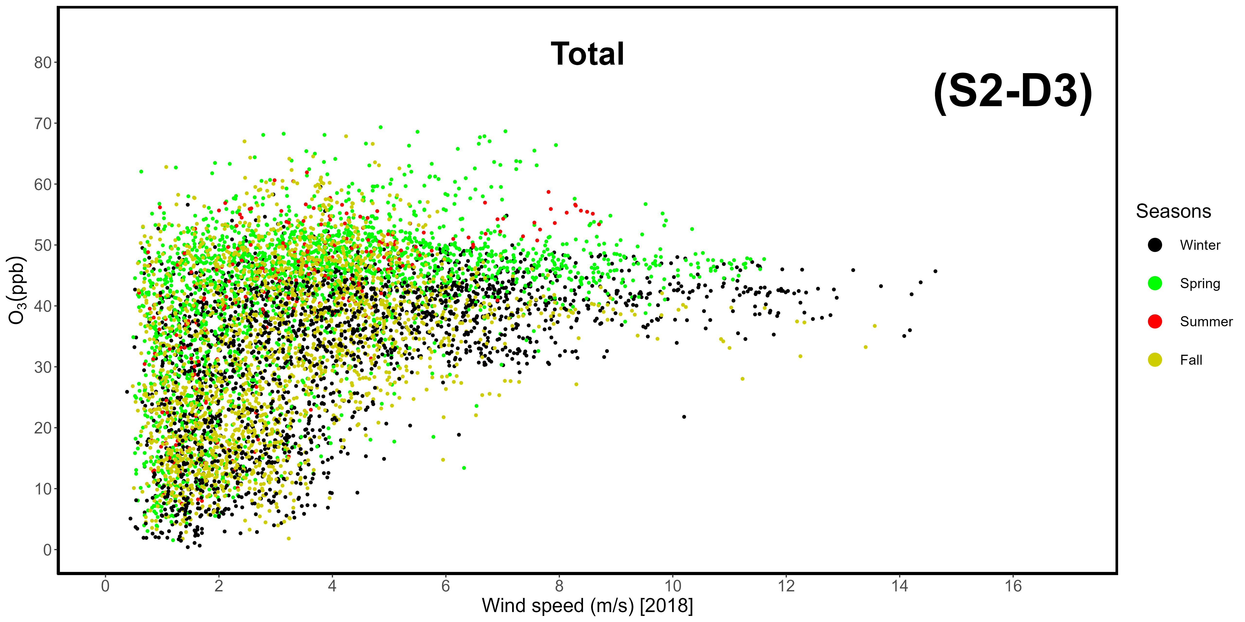
Supplementary Materials S2-D1, -D2, -D3. Correlation between wind speeds and ozone mole fractions in 2018, divided by sector. D1: western-seaside (240-300 °N); D2: northeastern-continental (0-90 °N); D3: total data.
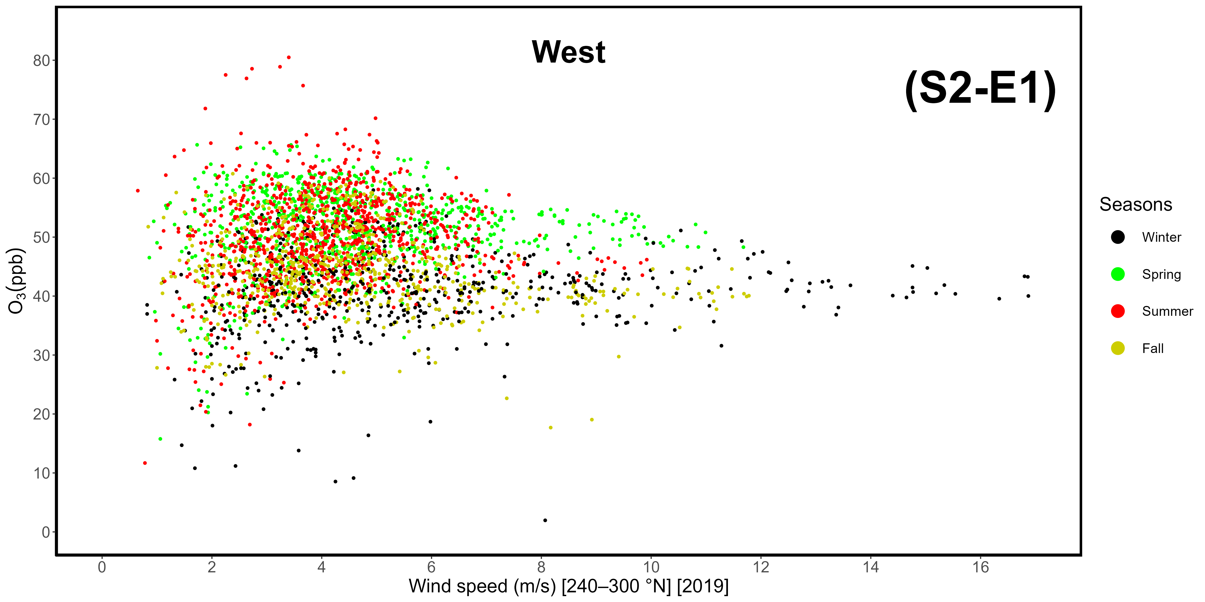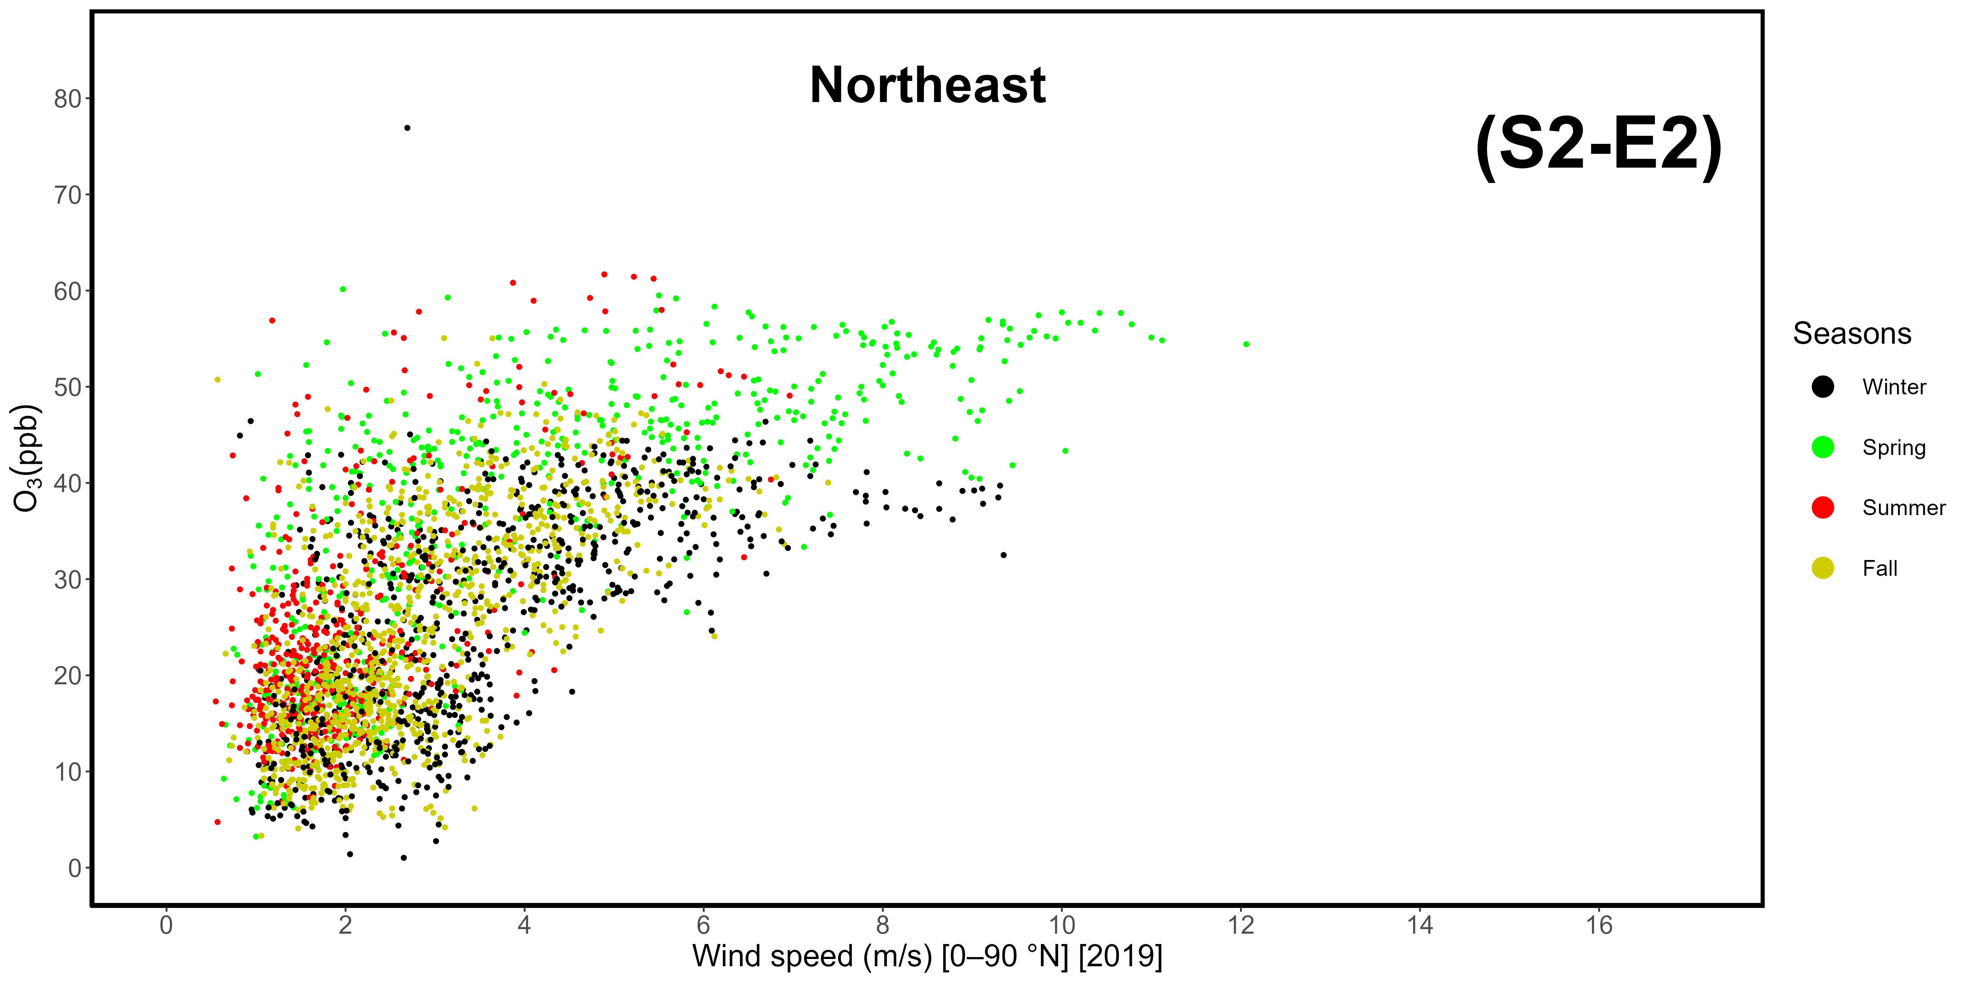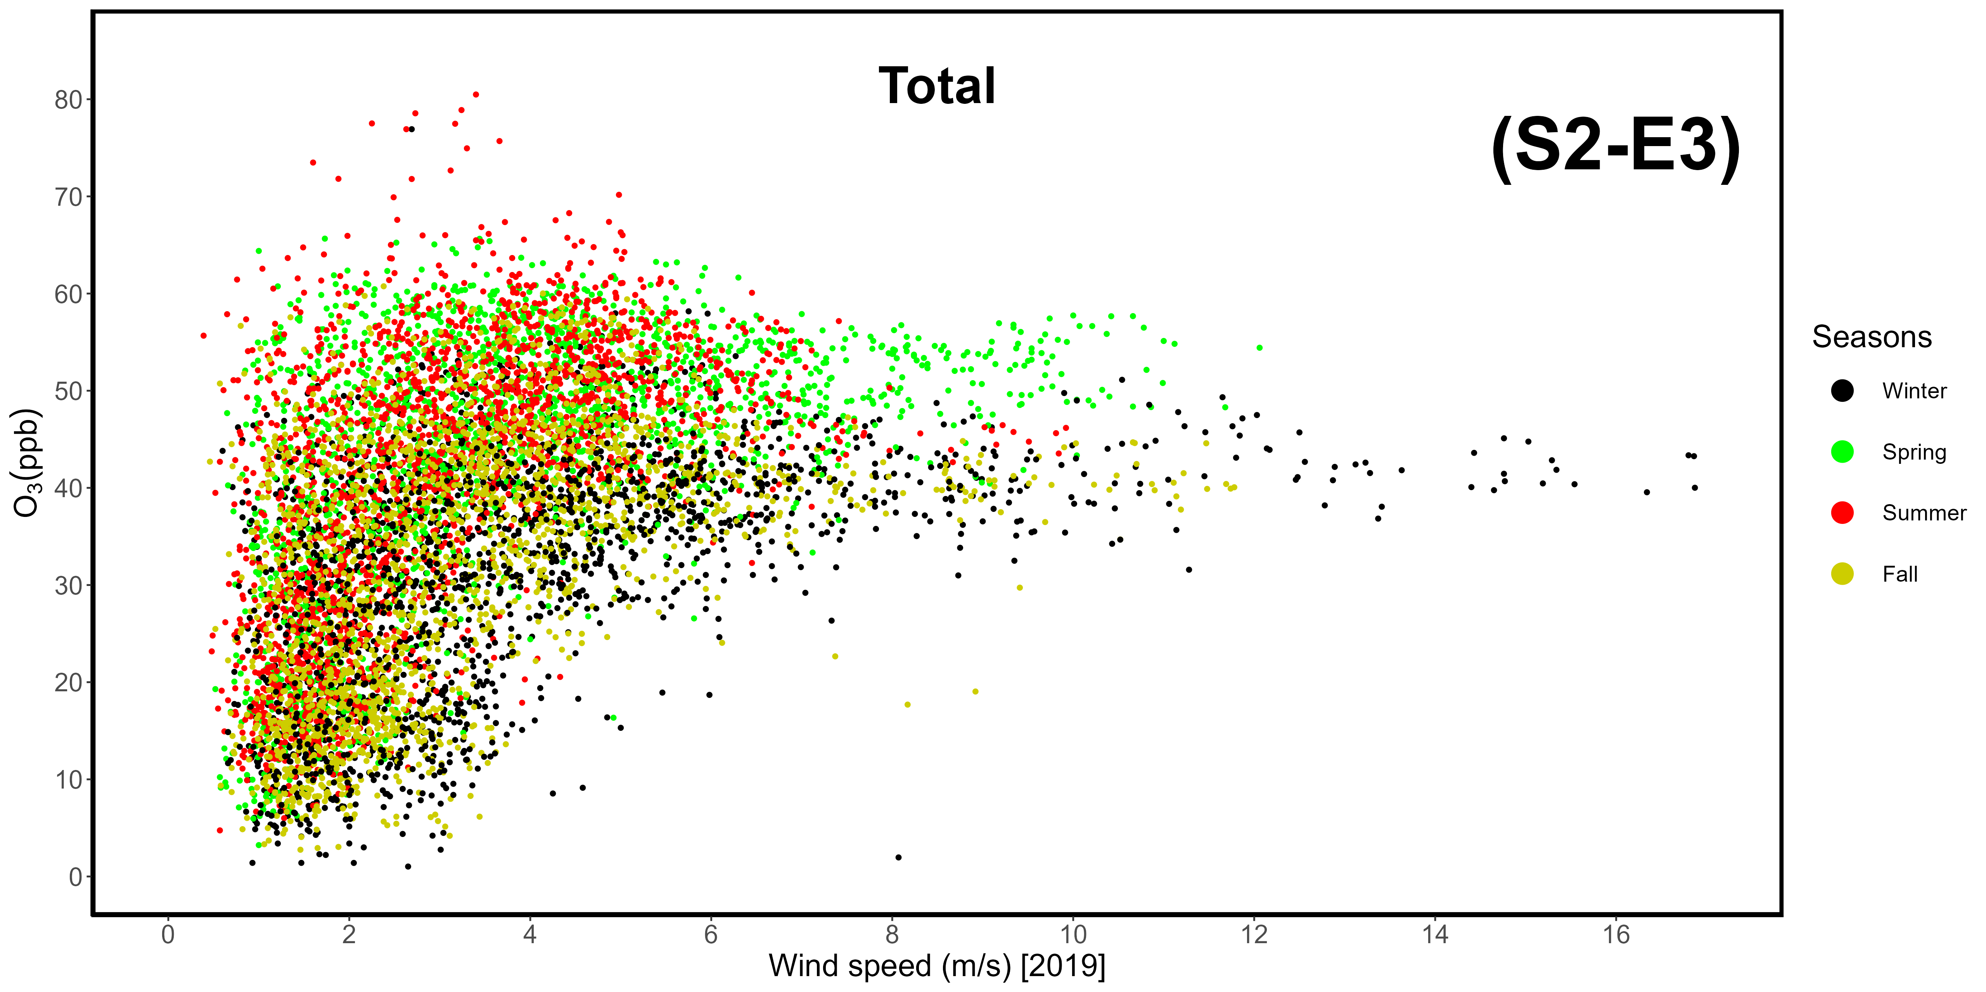
Supplementary Materials S2-E1, -E2, -E3. Correlation between wind speeds and ozone mole fractions in 2019, divided by sector. E1: western-seaside (240-300 °N); E2: northeastern-continental (0-90 °N); E3: total data.
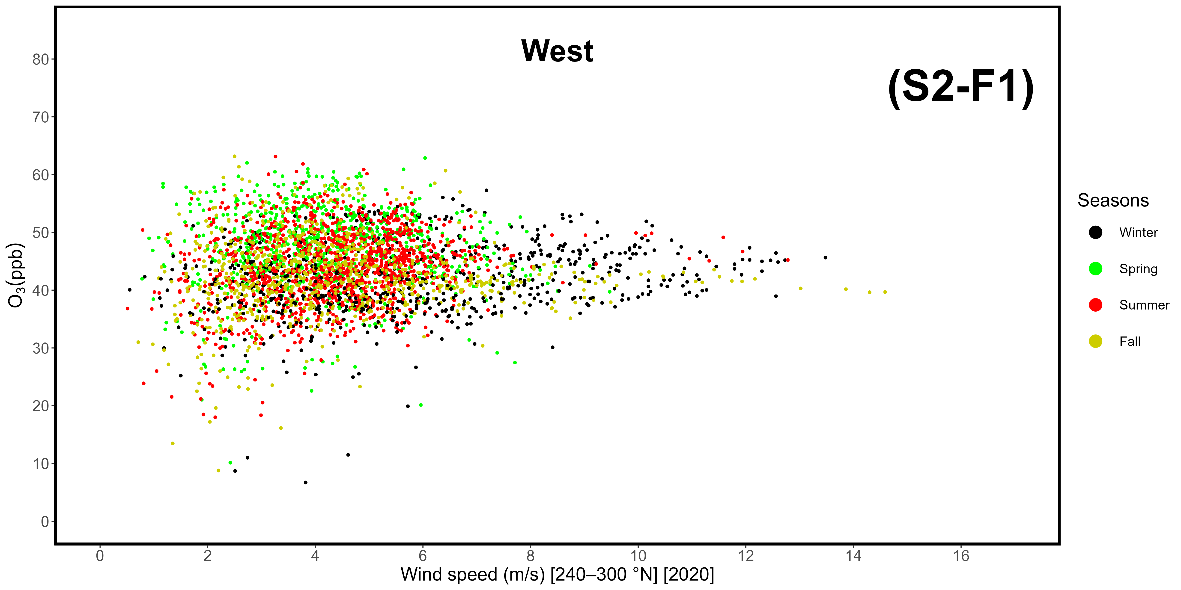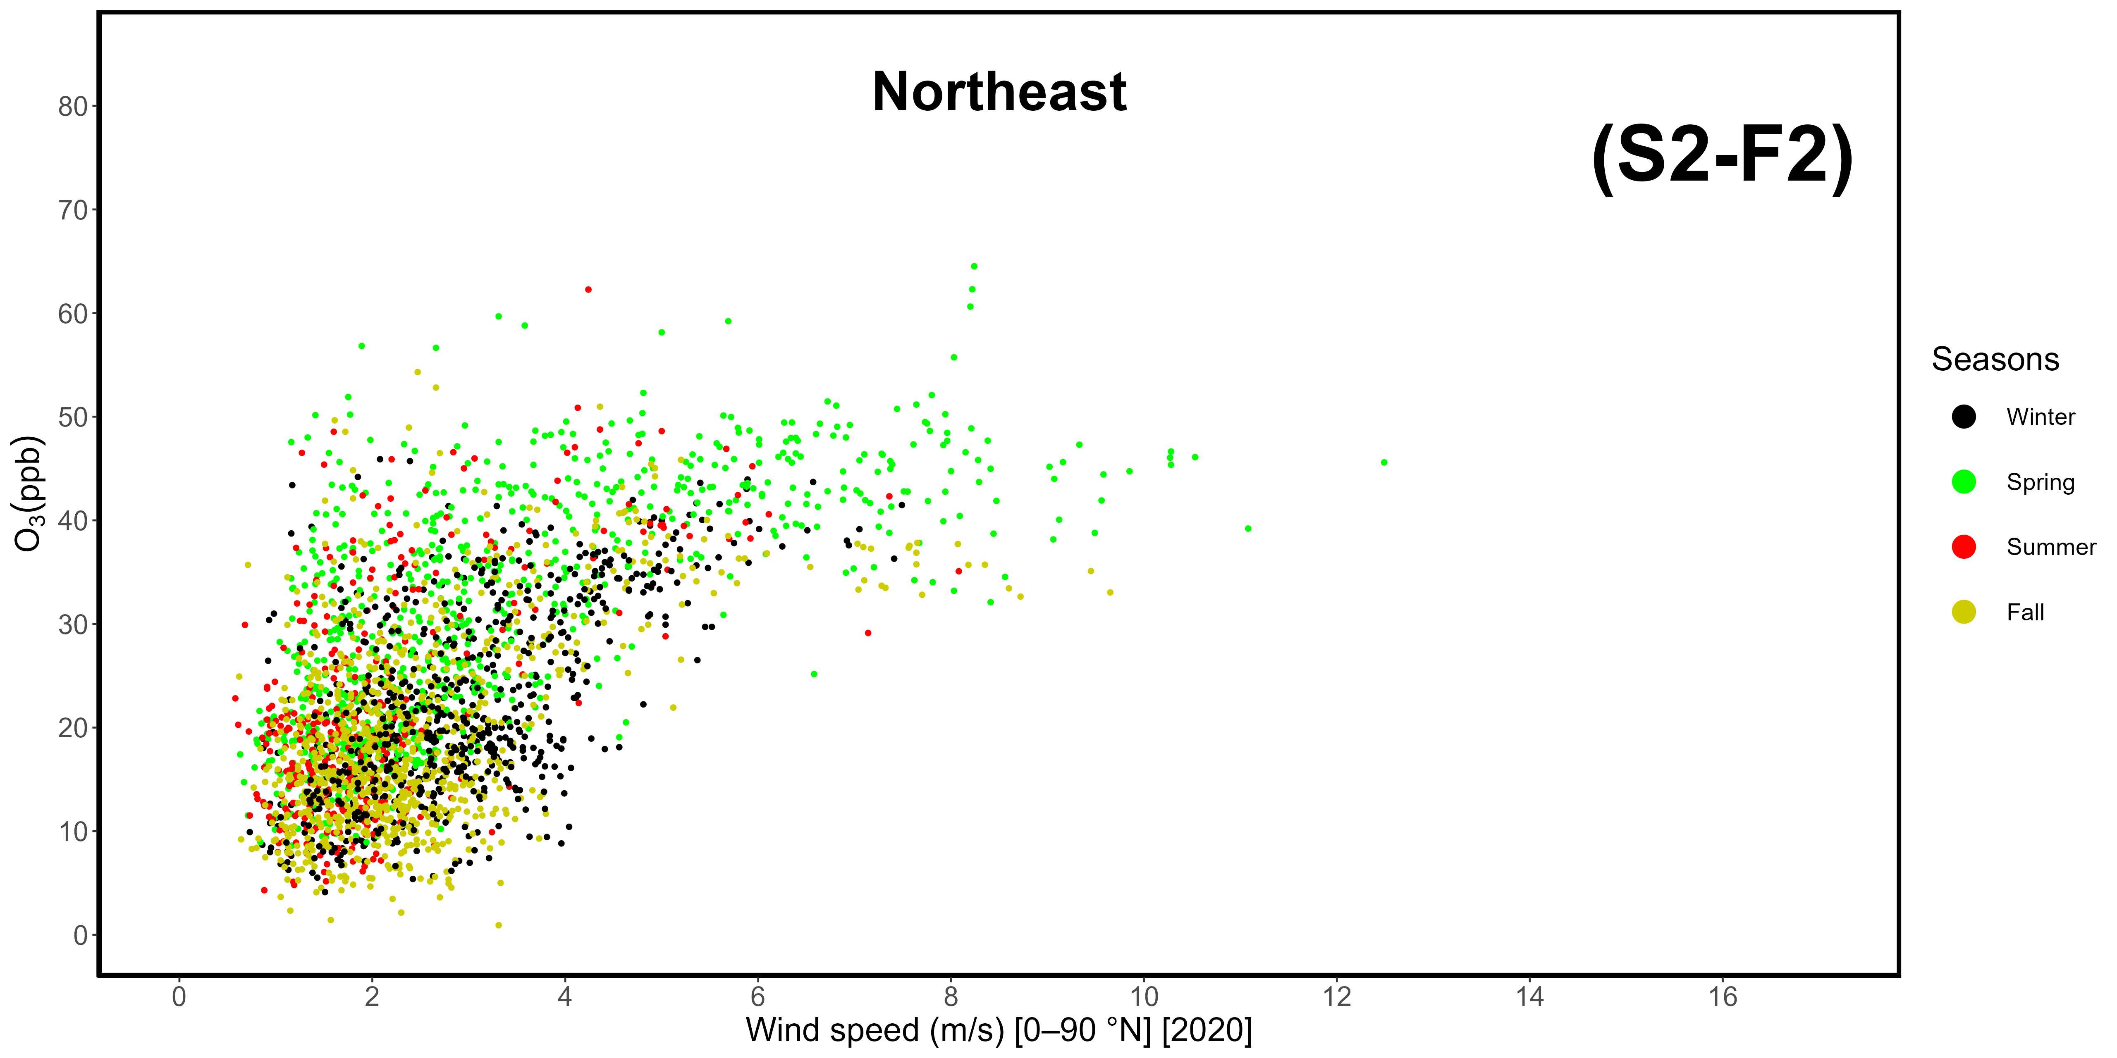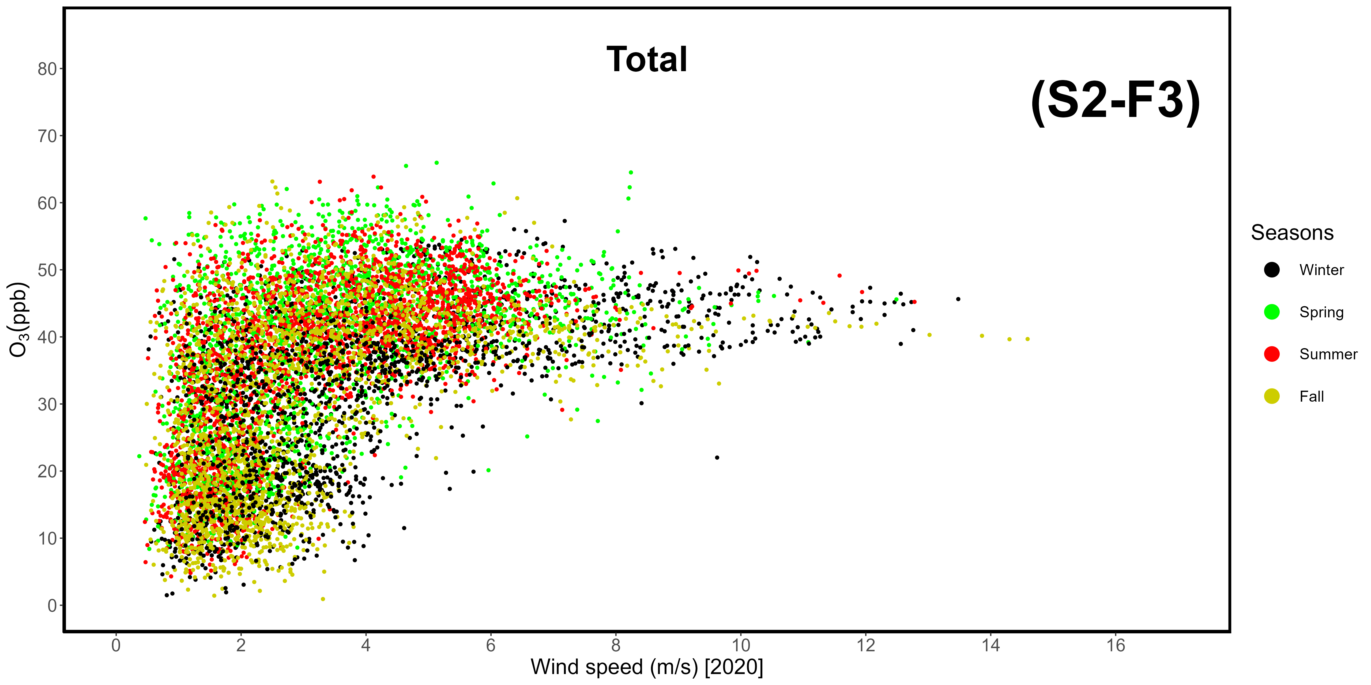
Supplementary Materials S2-F1, -F2, -F3. Correlation between wind speeds and ozone mole fractions in 2020, divided by sector. F1: western-seaside (240-300 °N); F2: northeastern-continental (0-90 °N); F3: total data.
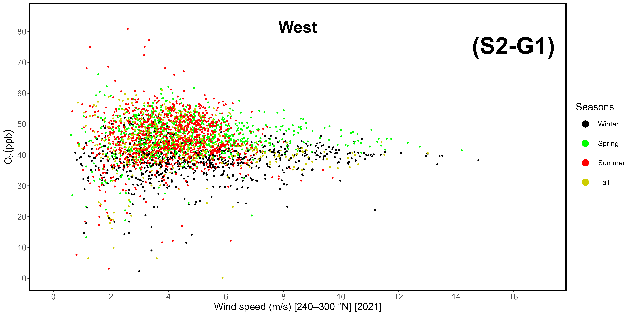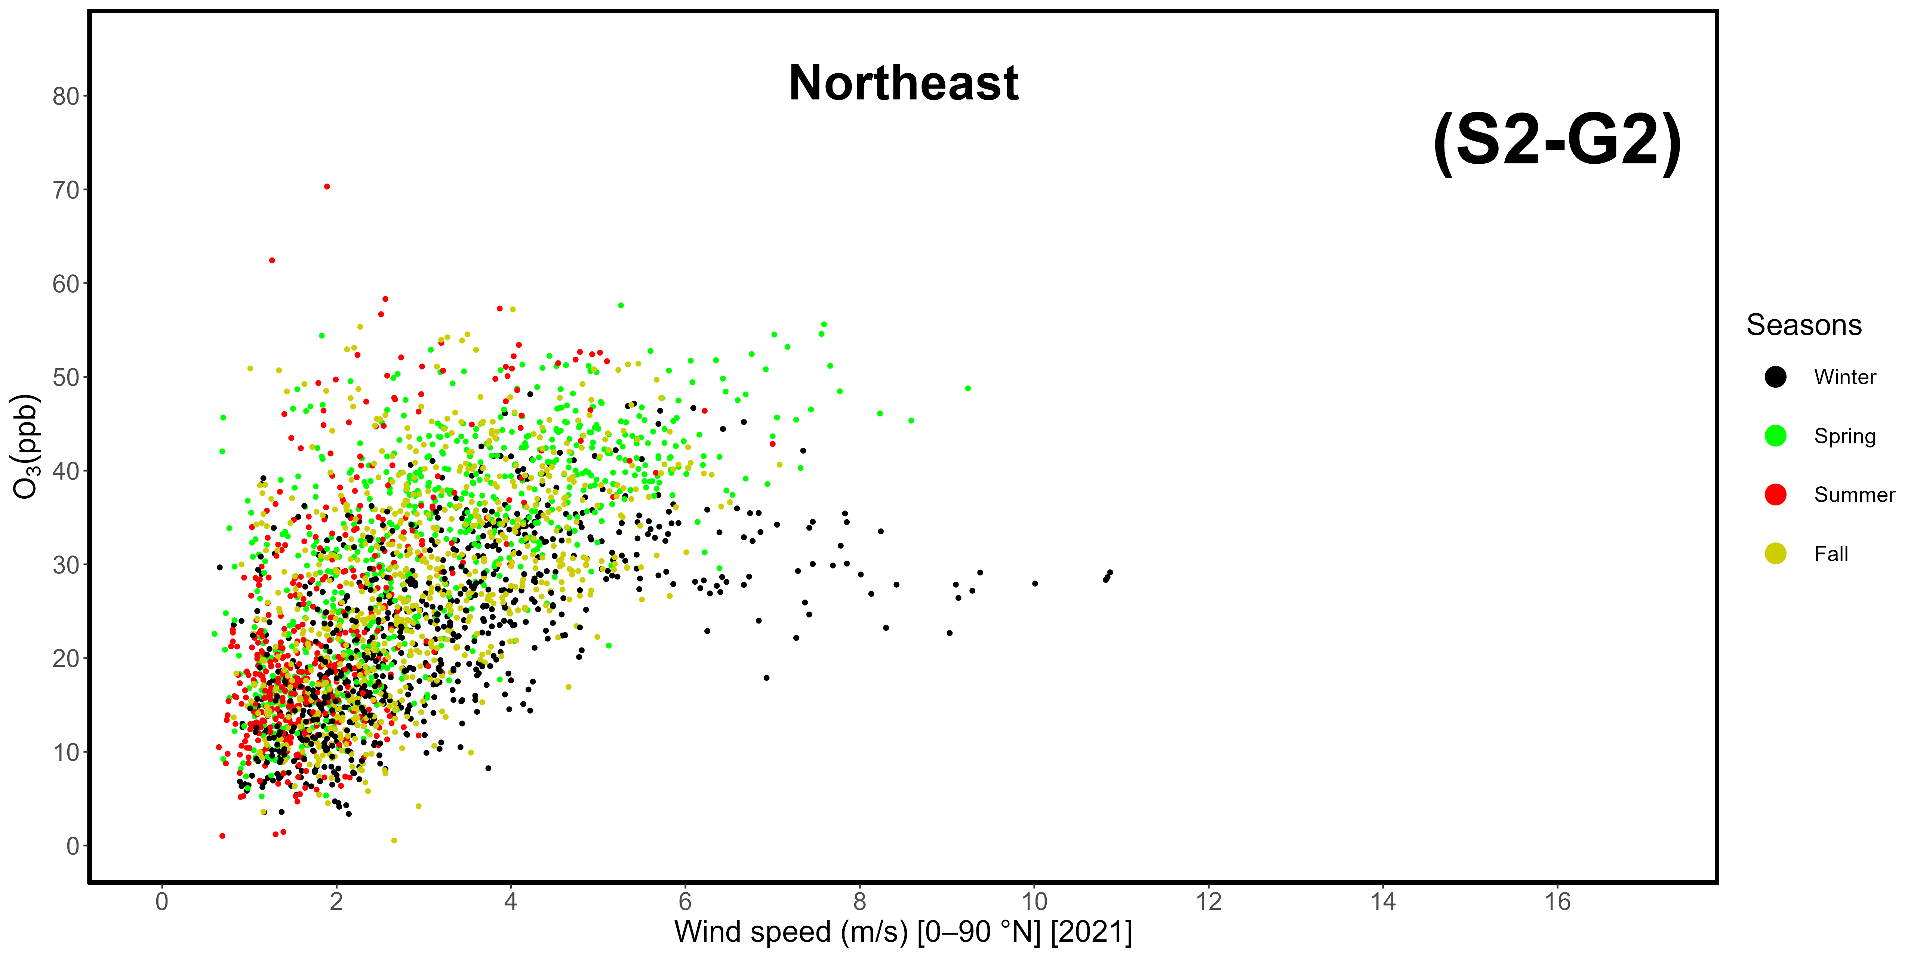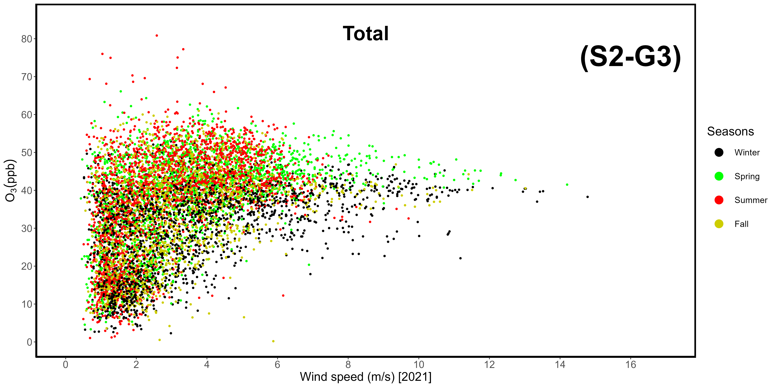
Supplementary Materials S2-G1, -G2, -G3. Correlation between wind speeds and ozone mole fractions in 2021, divided by sector. G1: western-seaside (240-300 °N); G2: northeastern-continental (0-90 °N); G3: total data.
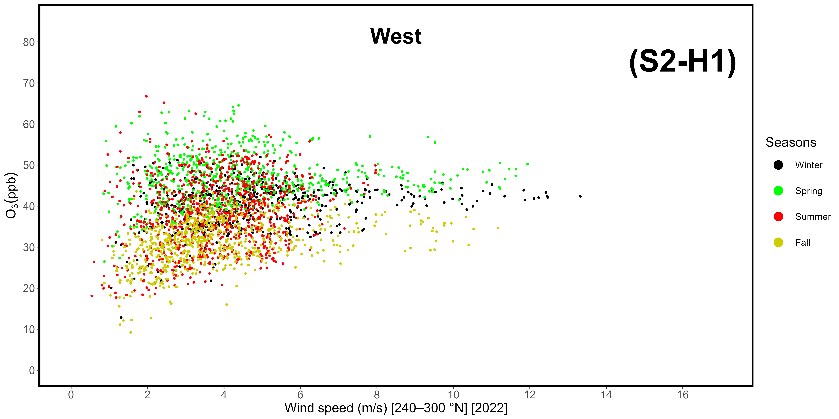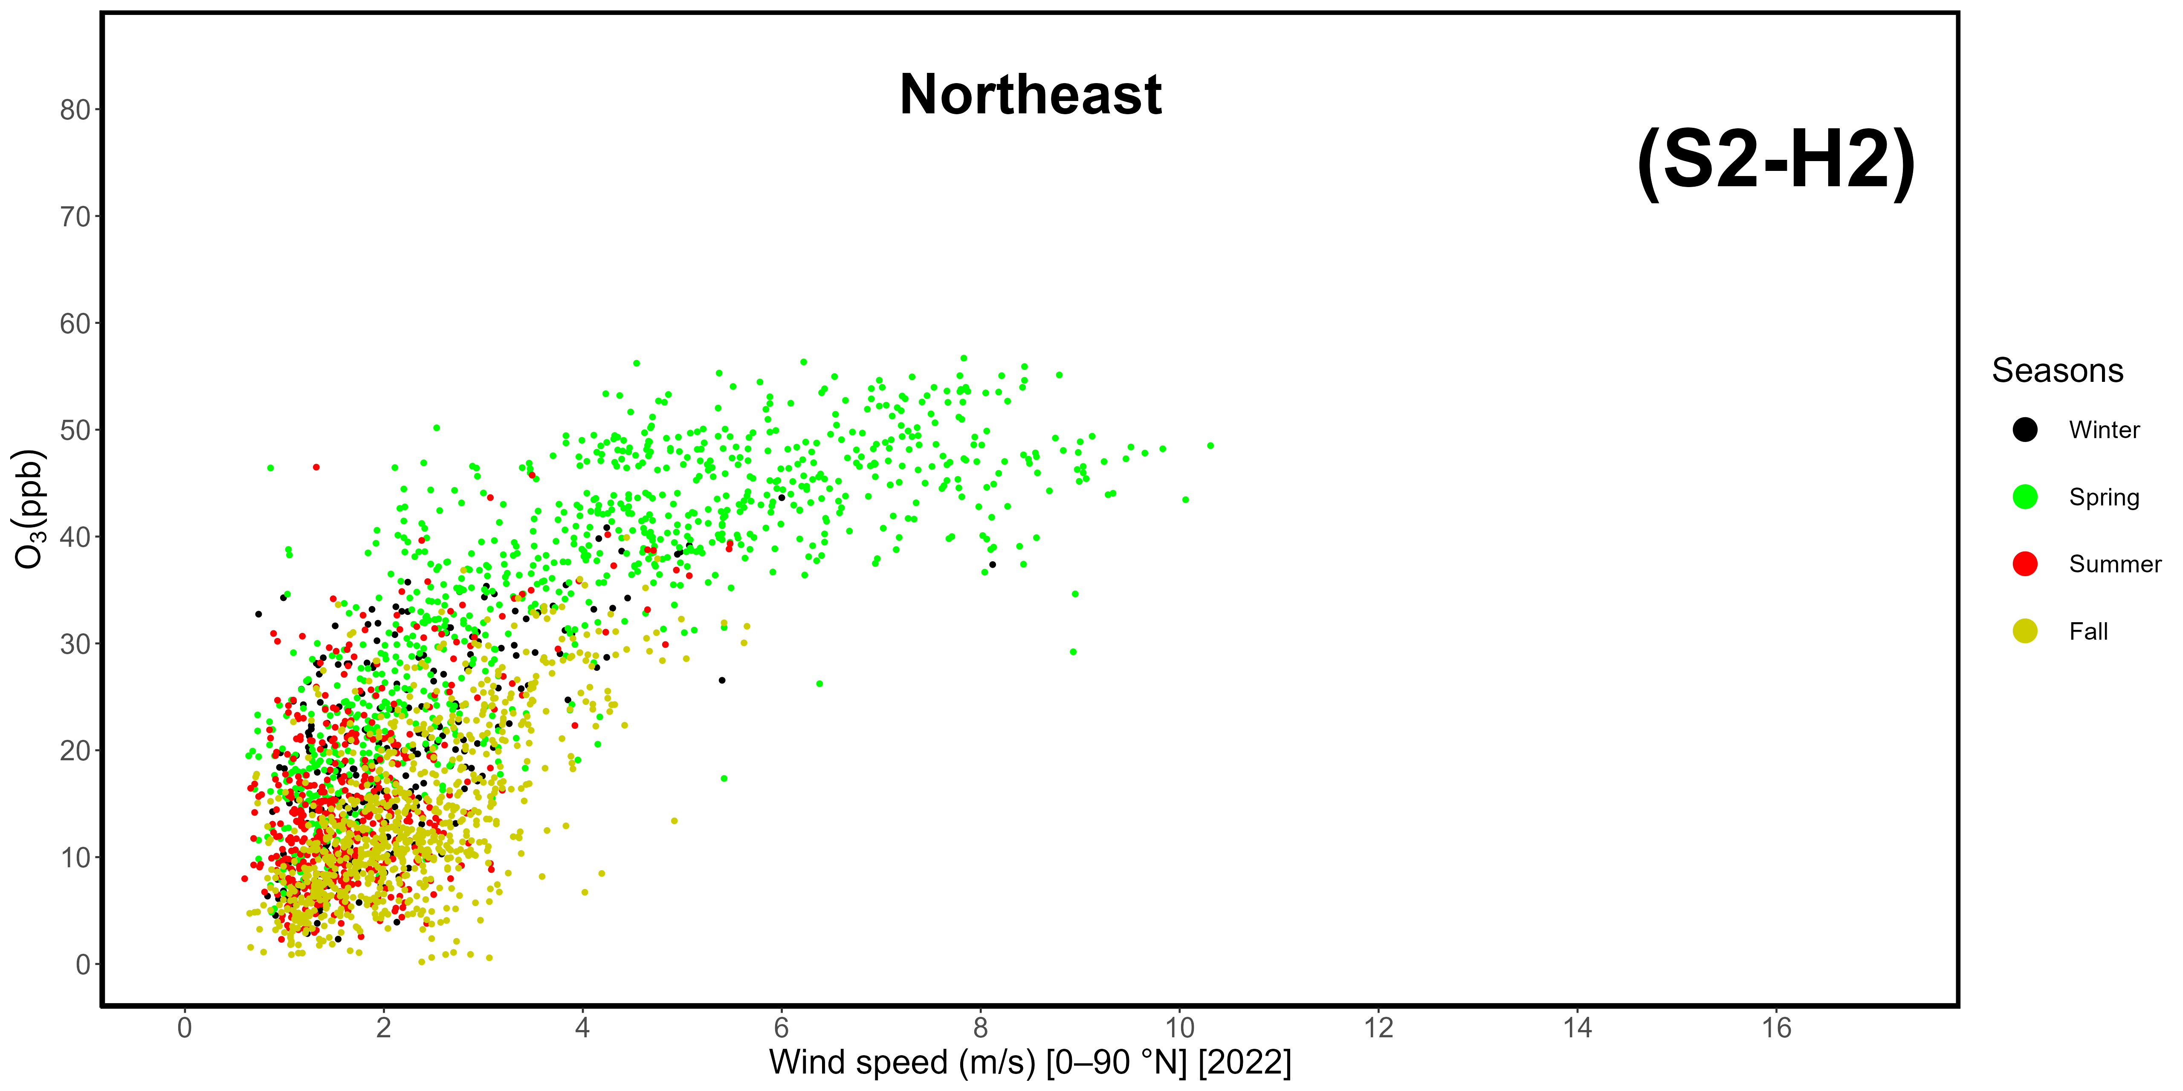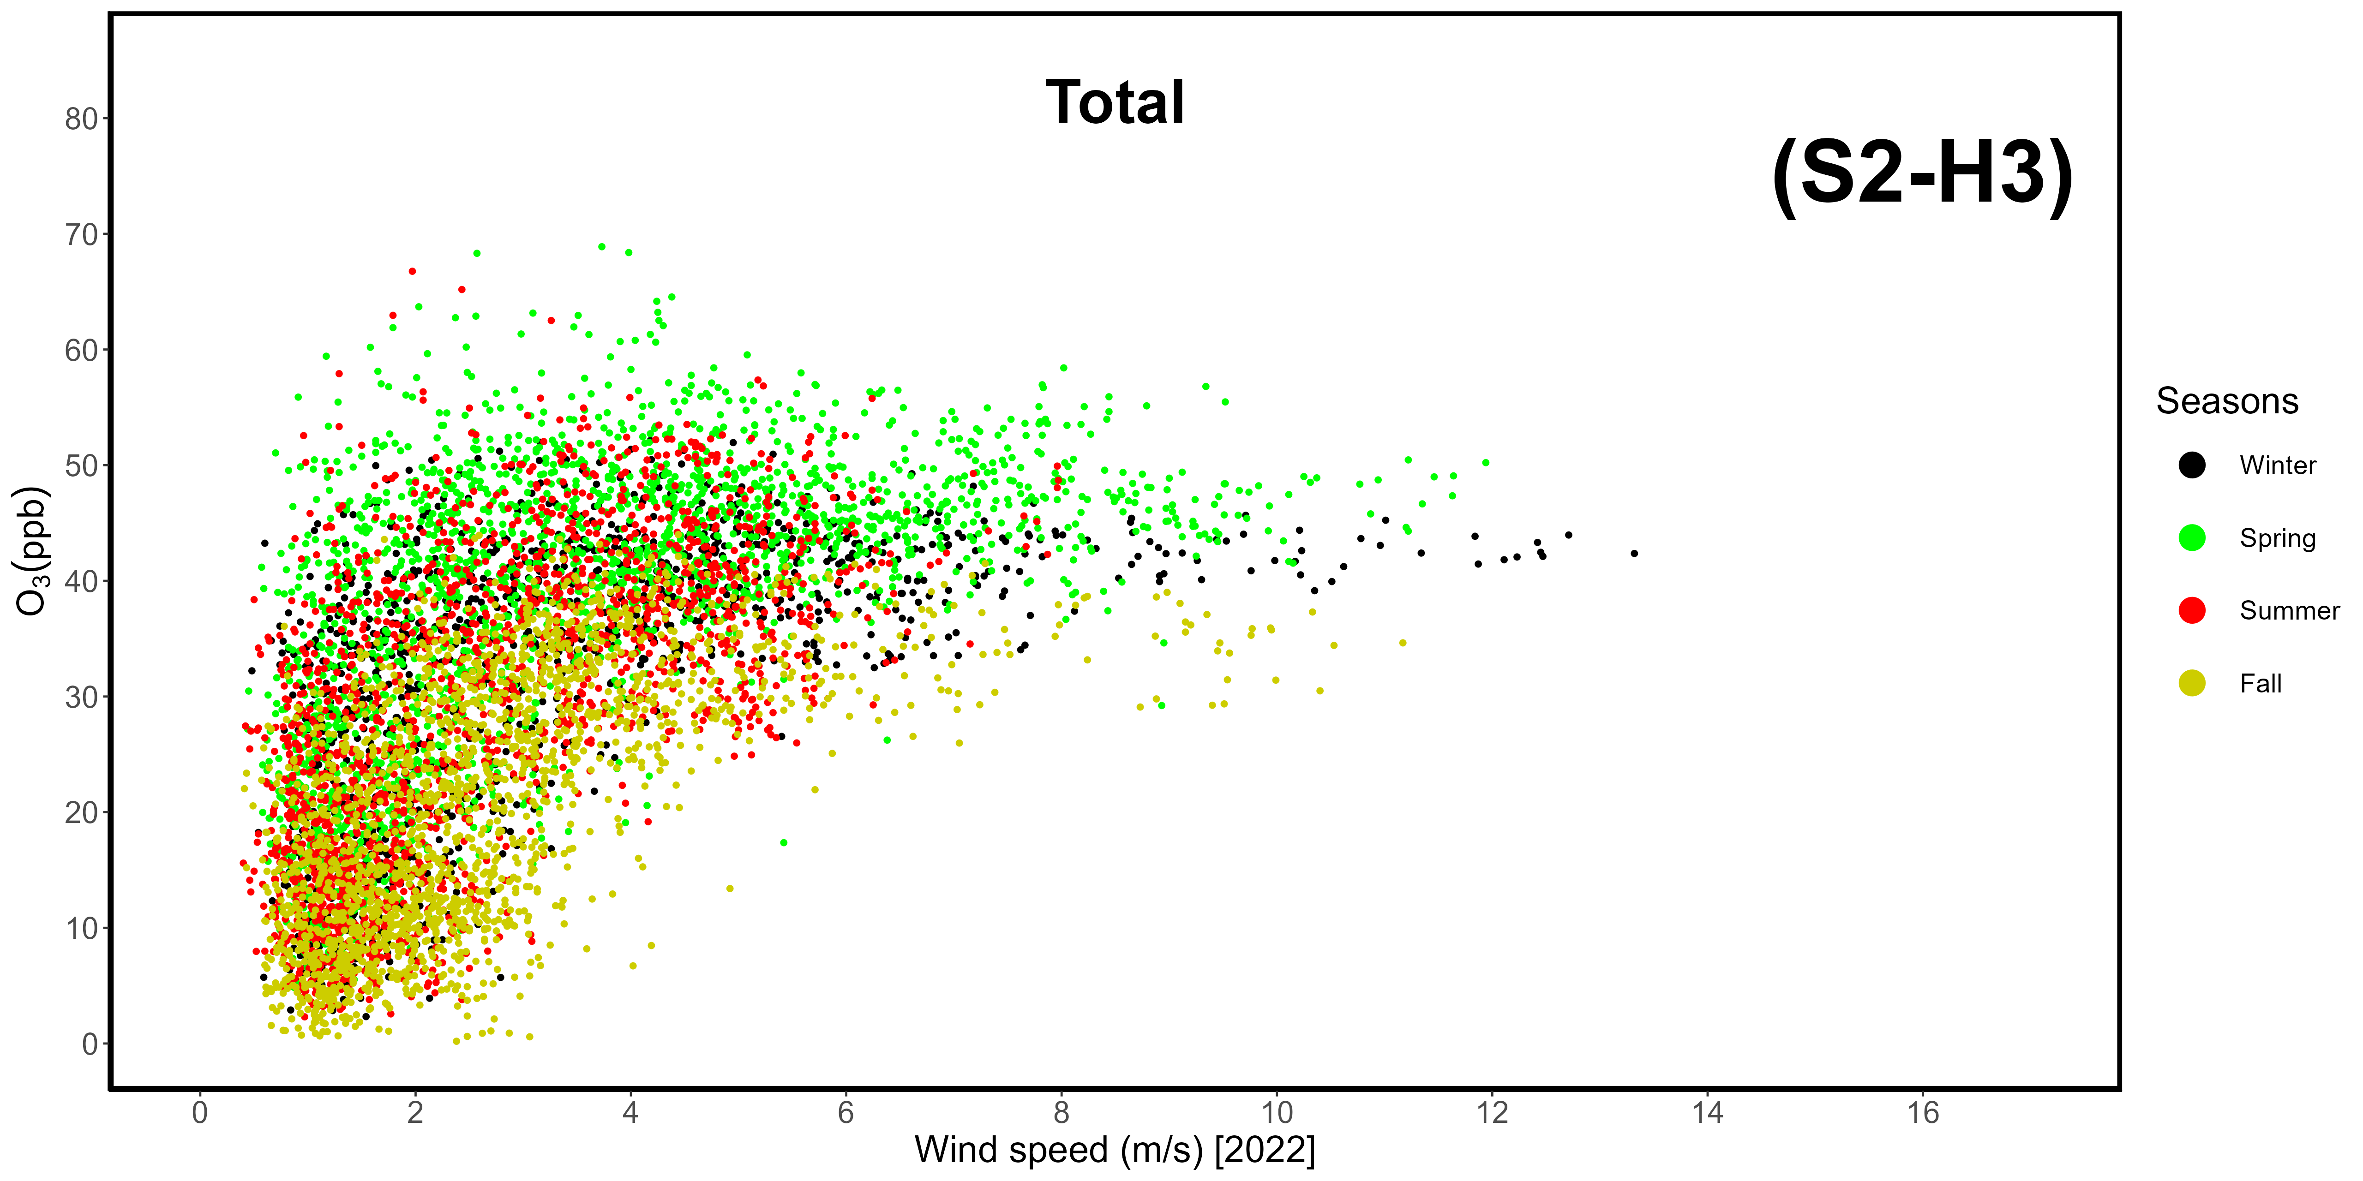
Supplementary Materials S2-H1, -H2, -H3. Correlation between wind speeds and ozone mole fractions in 2022, divided by sector. H1: western-seaside (240-300 °N); H2: northeastern-continental (0-90 °N); H3: total data.
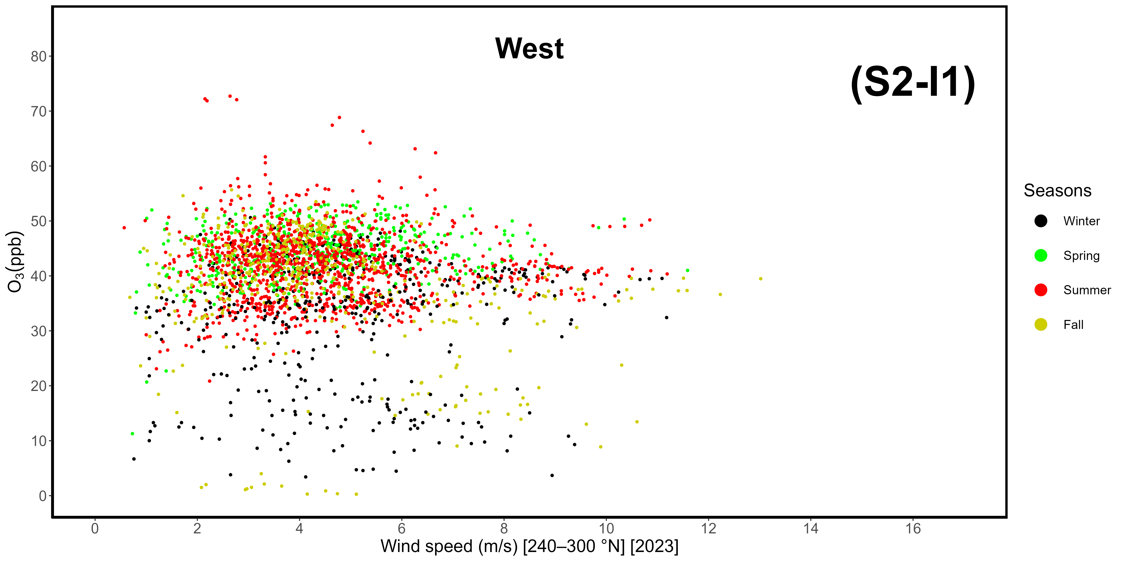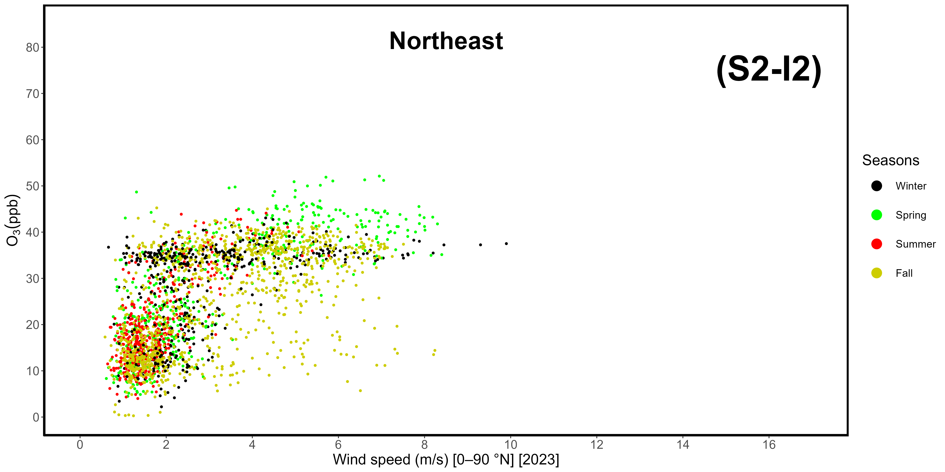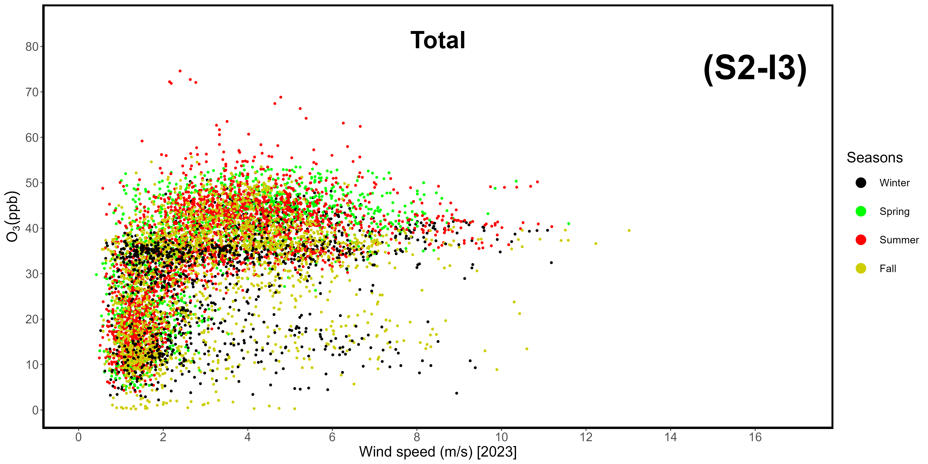
Supplementary Materials S2-I1, -I2, -A3. Correlation between wind speeds and ozone mole fractions in 2023, divided by sector. I1: western-seaside (240-300 °N); I2: northeastern-continental (0-90 °N); I3: total data.
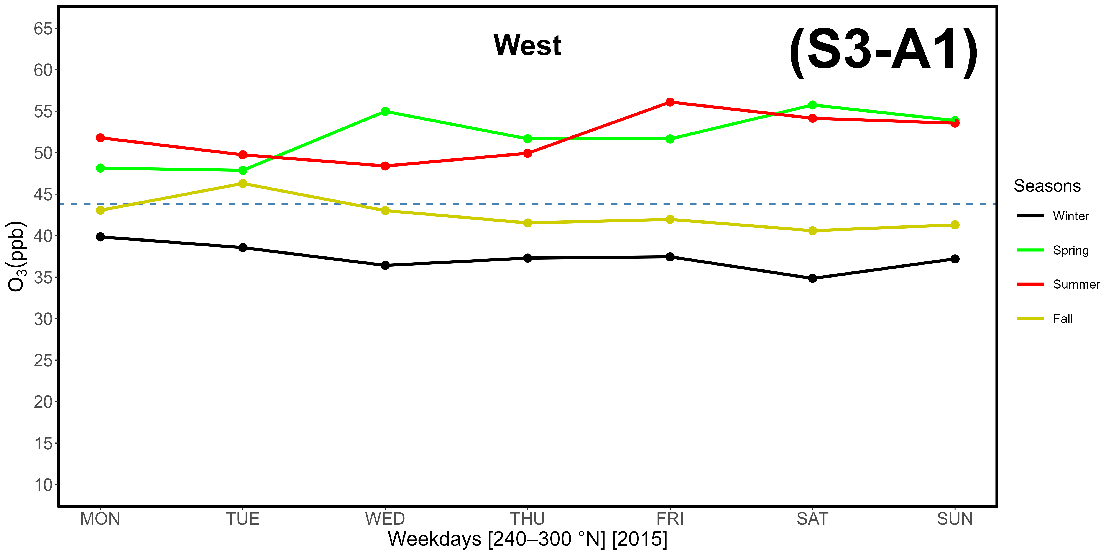
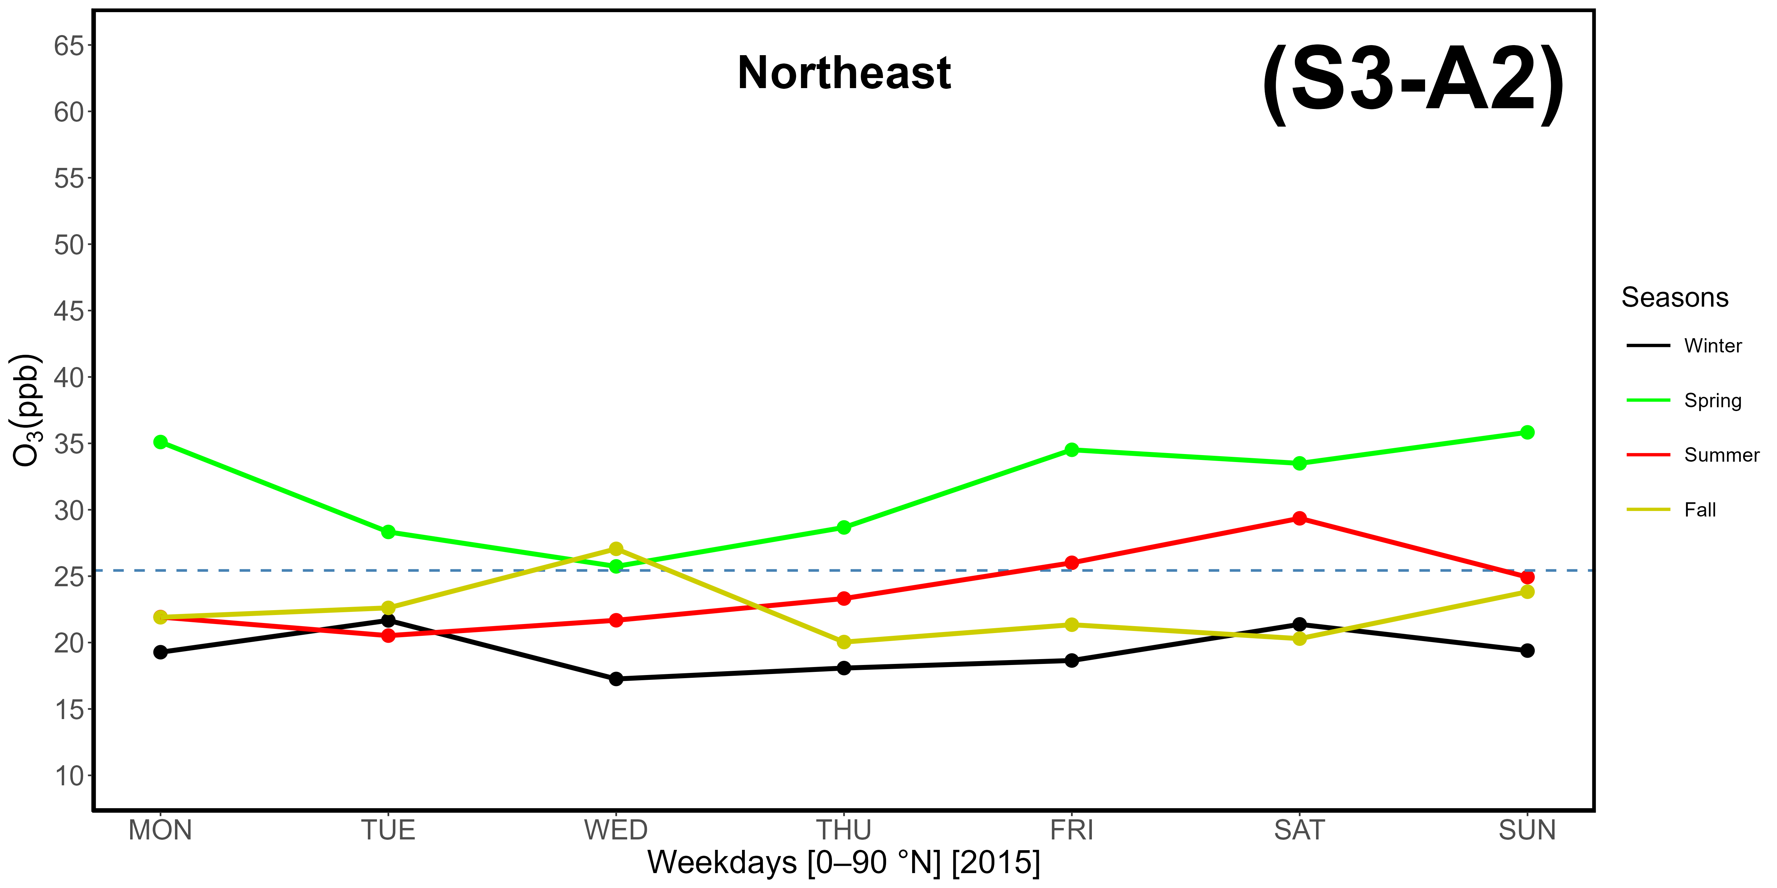
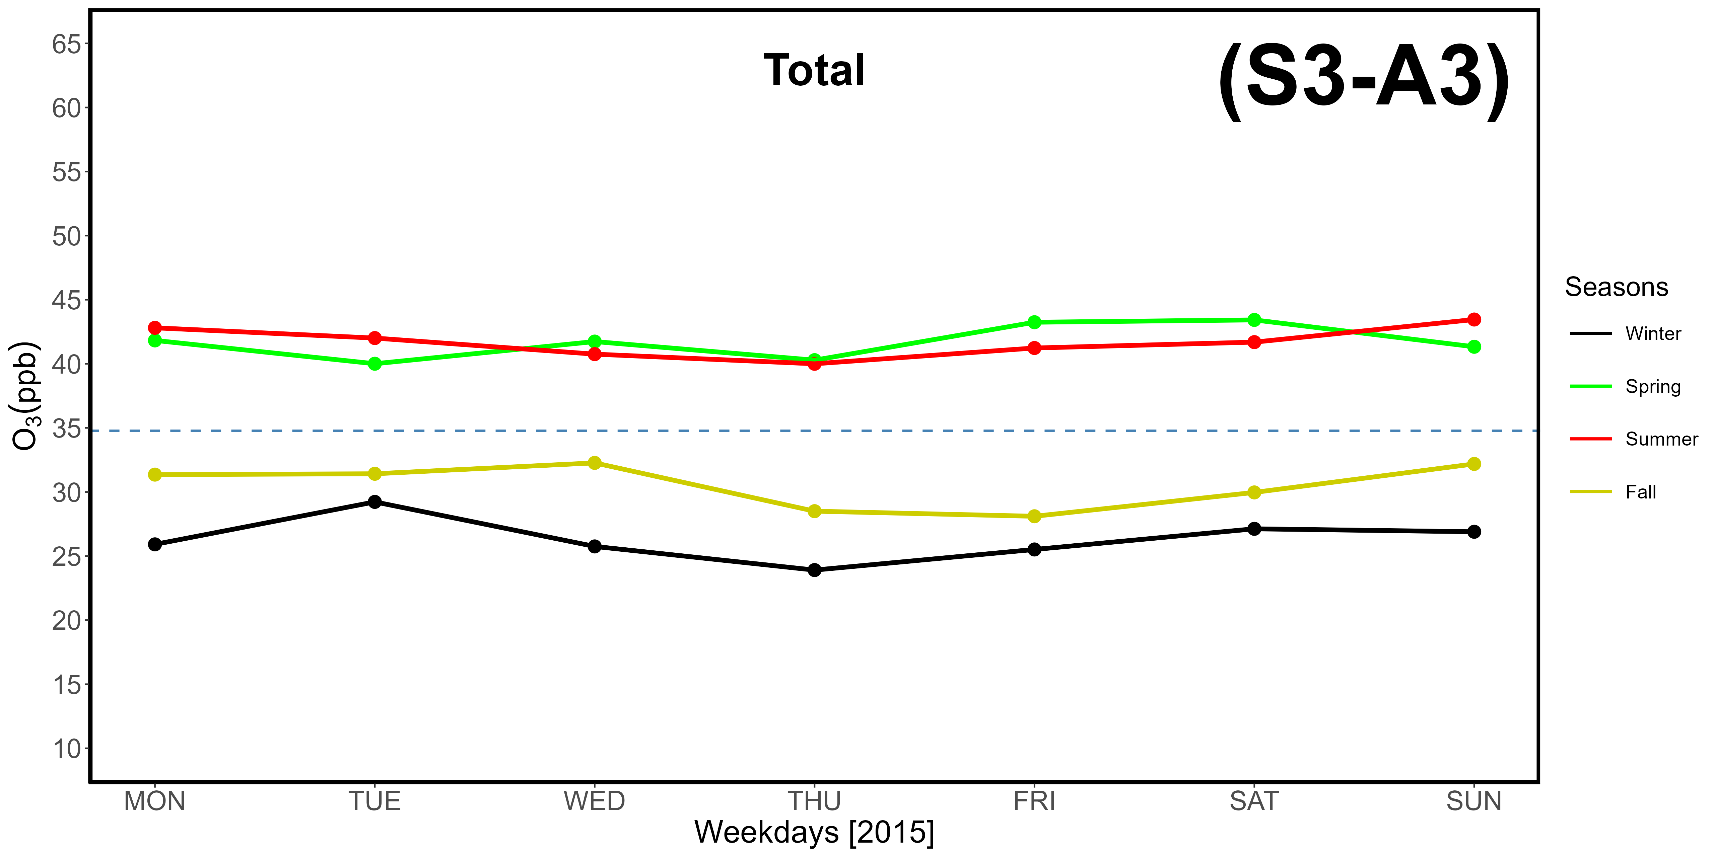
Supplementary Materials S3-A1, -A2, -A3. Evaluation of the OWE (Ozone Weekend Effect) based on hourly ozone data gathered at LMT in 2015, differentiated by weekdays. The dotted horizontal line represents average concentrations. A1: western-seaside (240-300 °N); A2: northeastern-continental (0-90 °N); A3: total data.
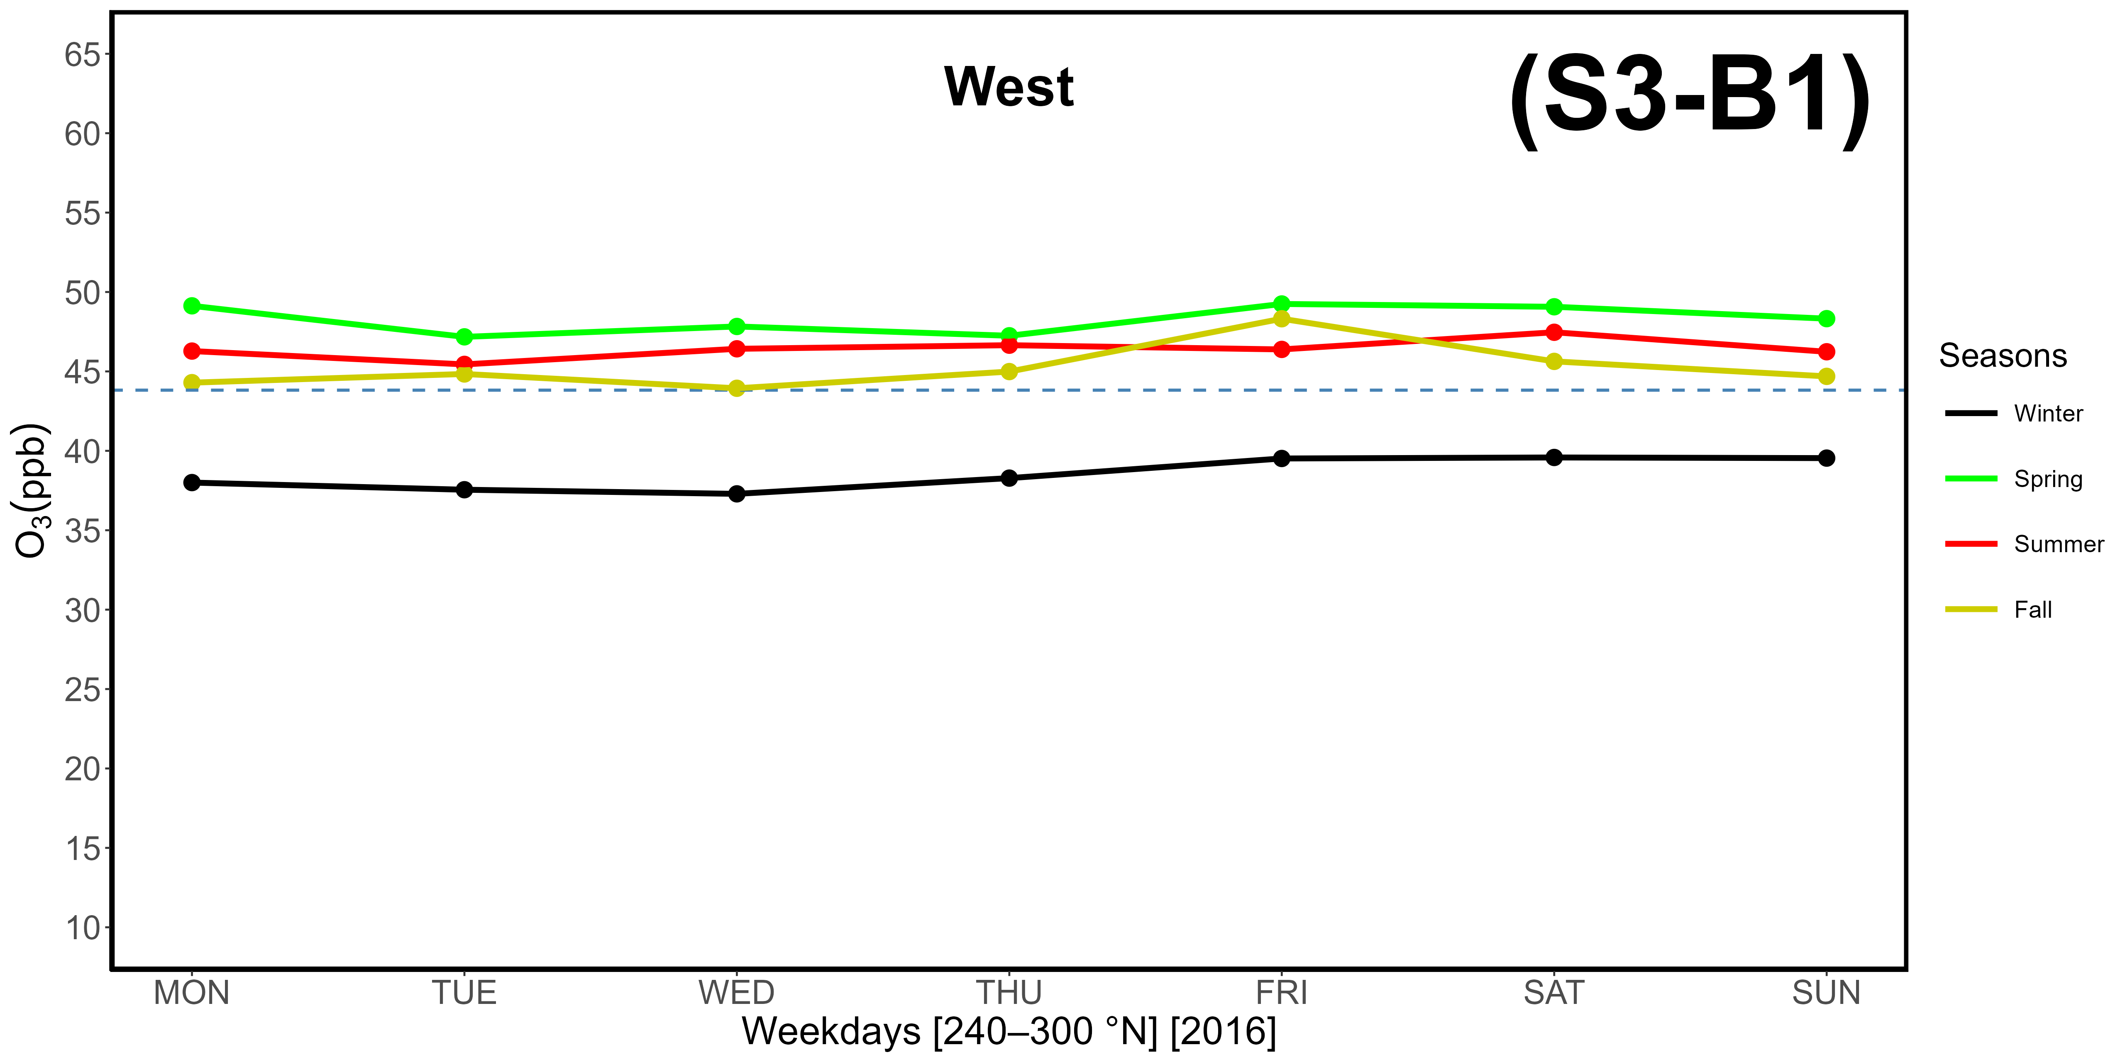
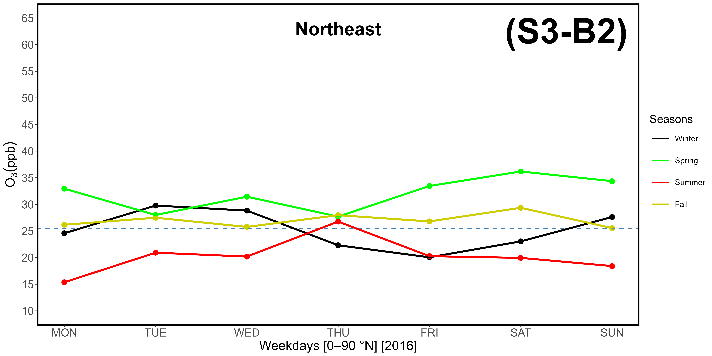
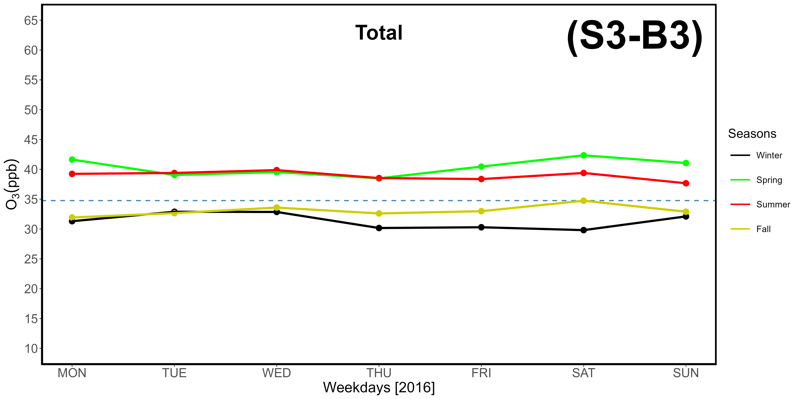
Supplementary Materials S3-B1, -B2, -B3. Evaluation of the OWE (Ozone Weekend Effect) based on hourly ozone data gathered at LMT in 2016, differentiated by weekdays. The dotted horizontal line represents average concentrations. B1: western-seaside (240-300 °N); B2: northeastern-continental (0-90 °N); B3: total data.
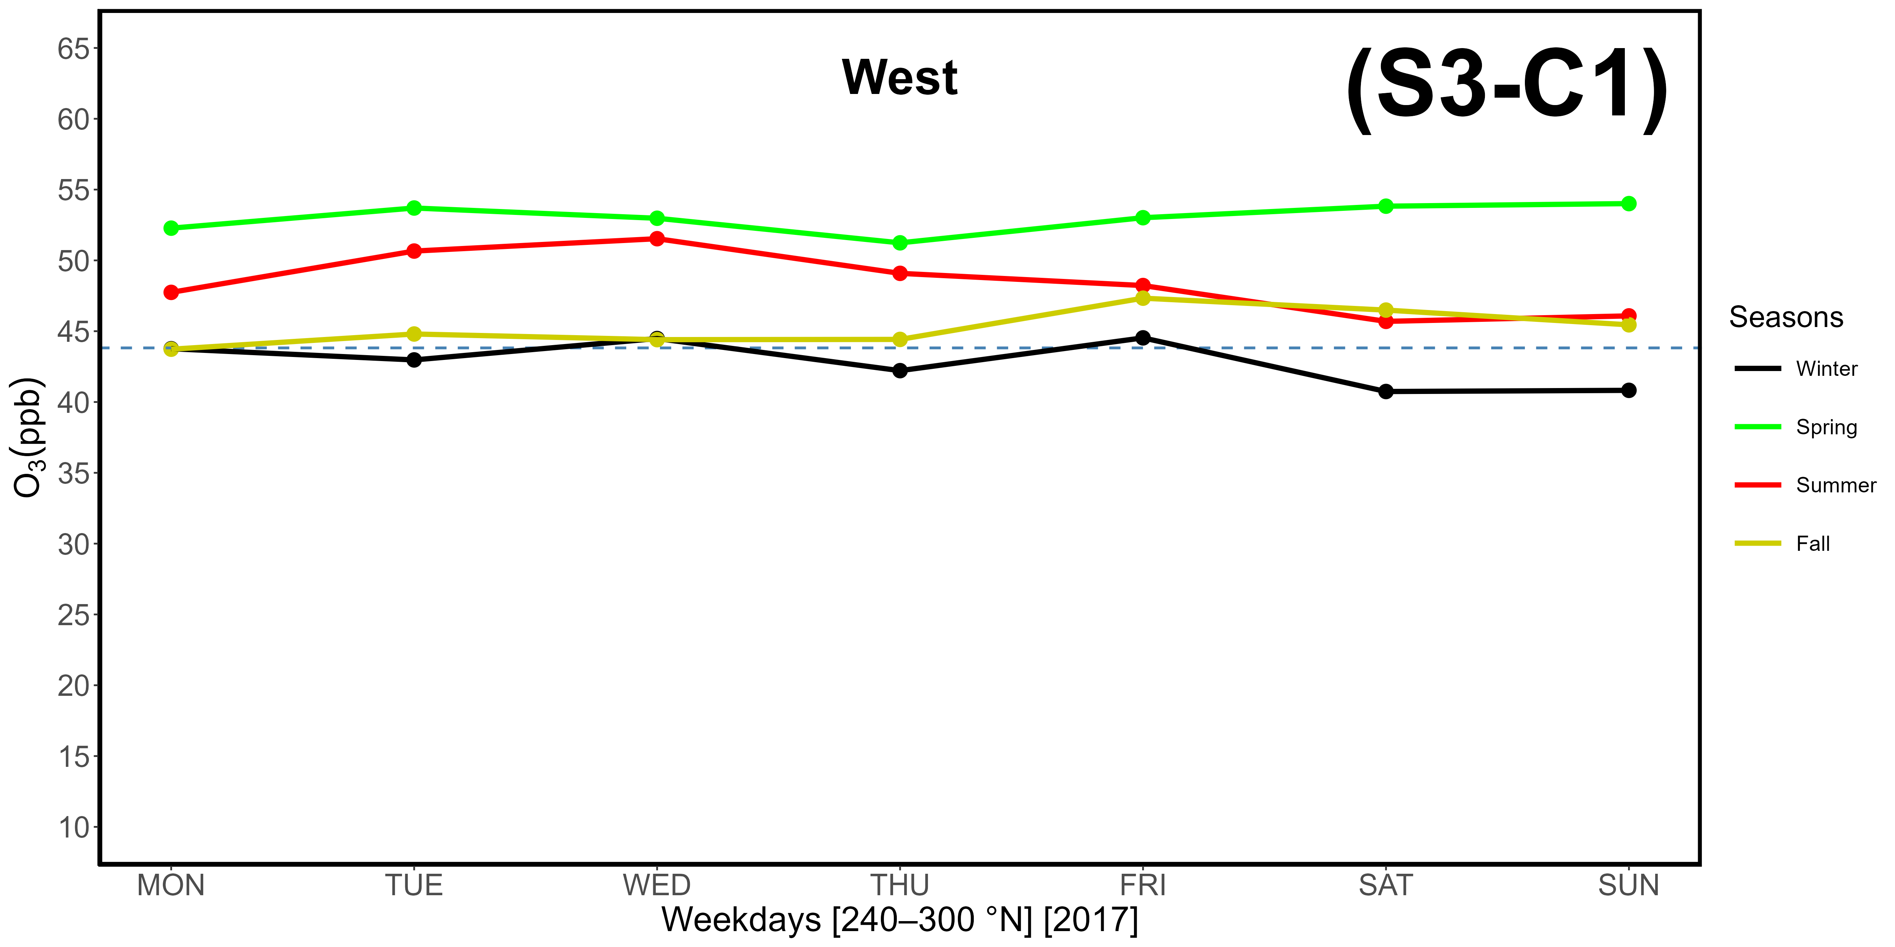
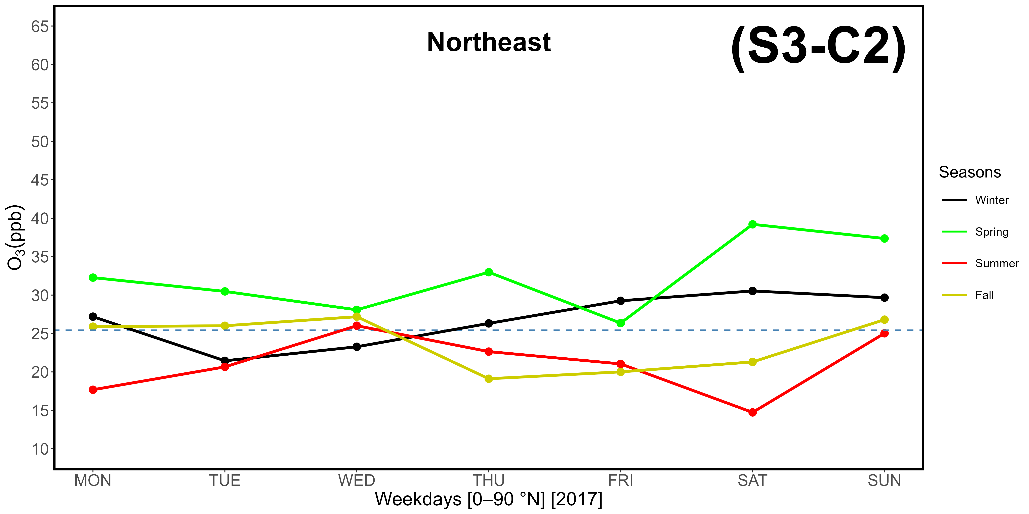
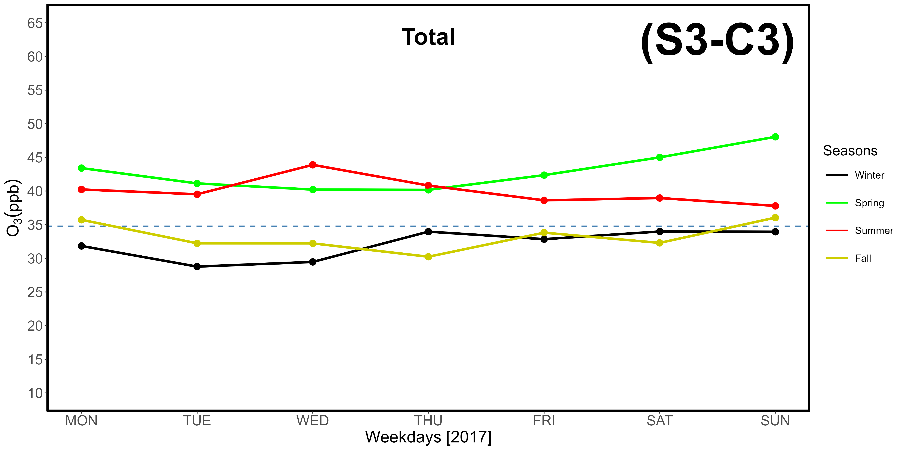
Supplementary Materials S3-C1, -C2, -C3. Evaluation of the OWE (Ozone Weekend Effect) based on hourly ozone data gathered at LMT in 2017, differentiated by weekdays. The dotted horizontal line represents average concentrations. C1: western-seaside (240-300 °N); C2: northeastern-continental (0-90 °N); C3: total data.
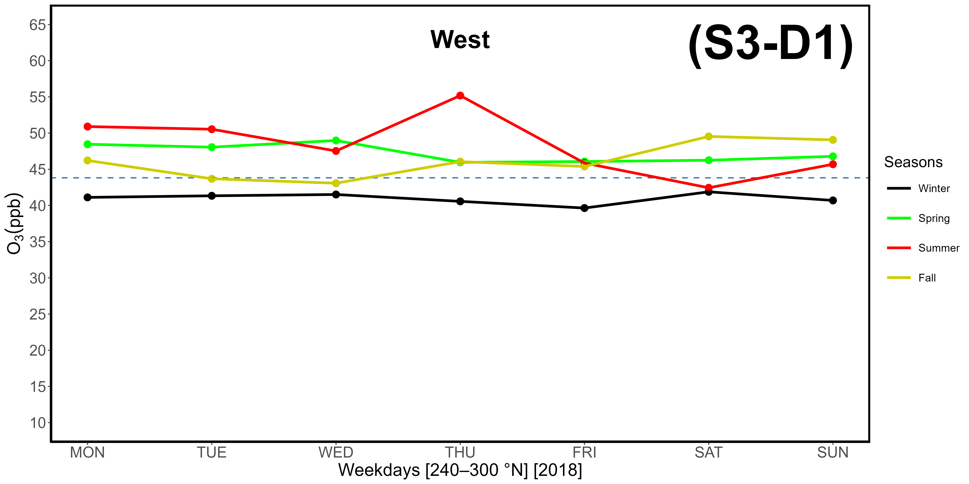
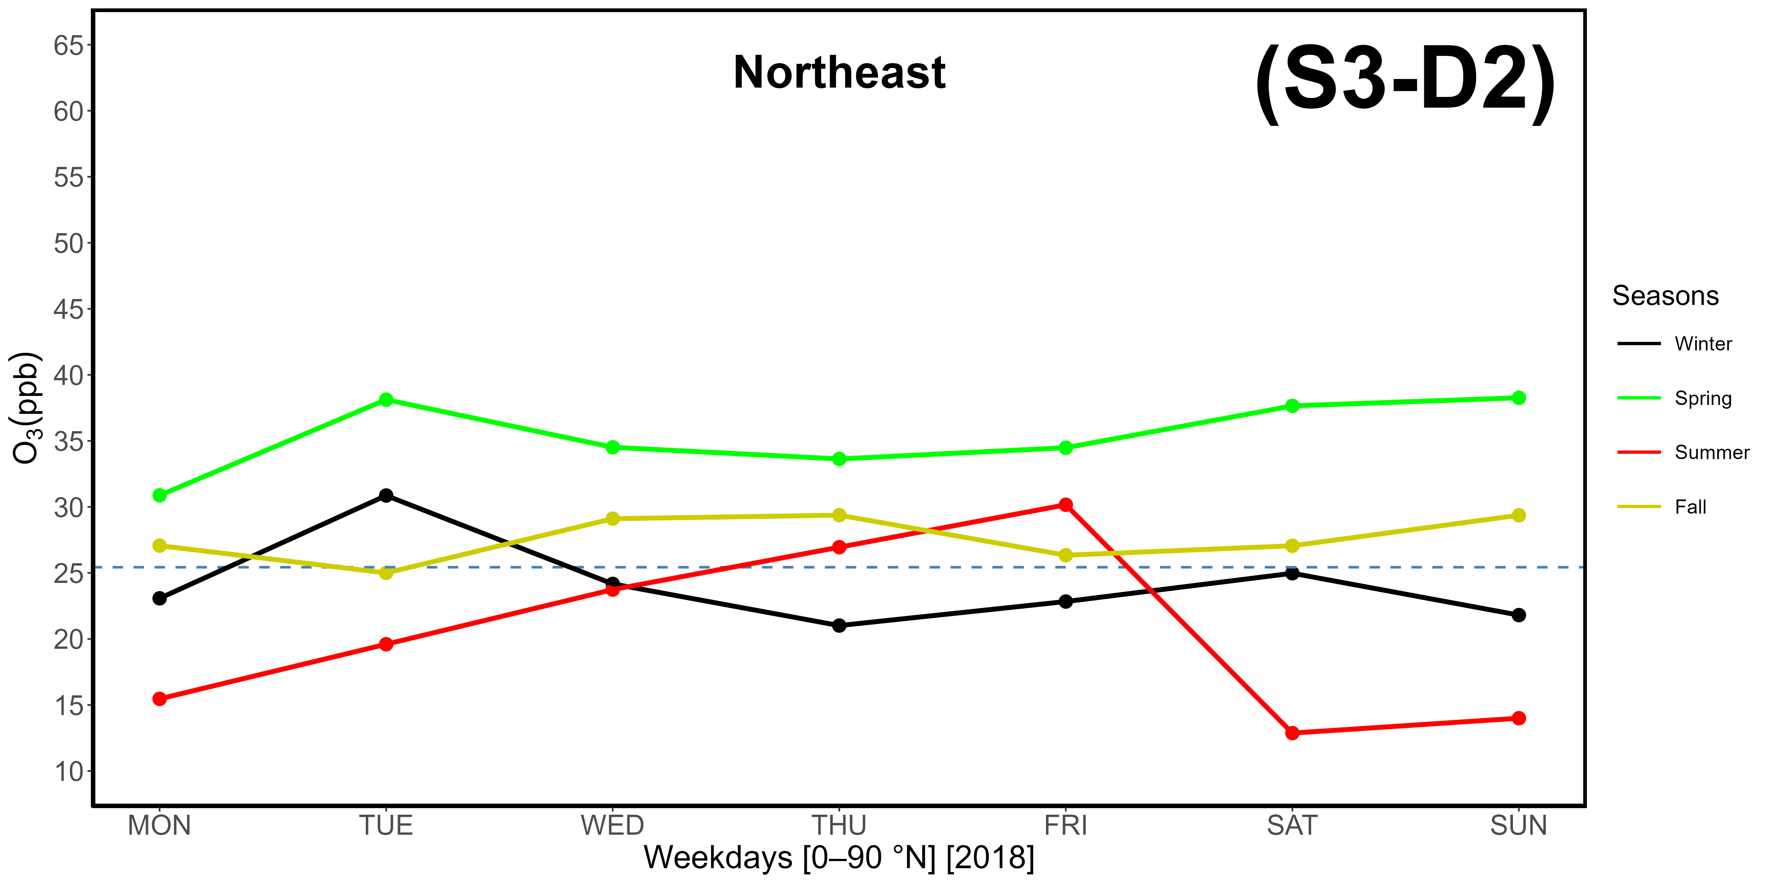
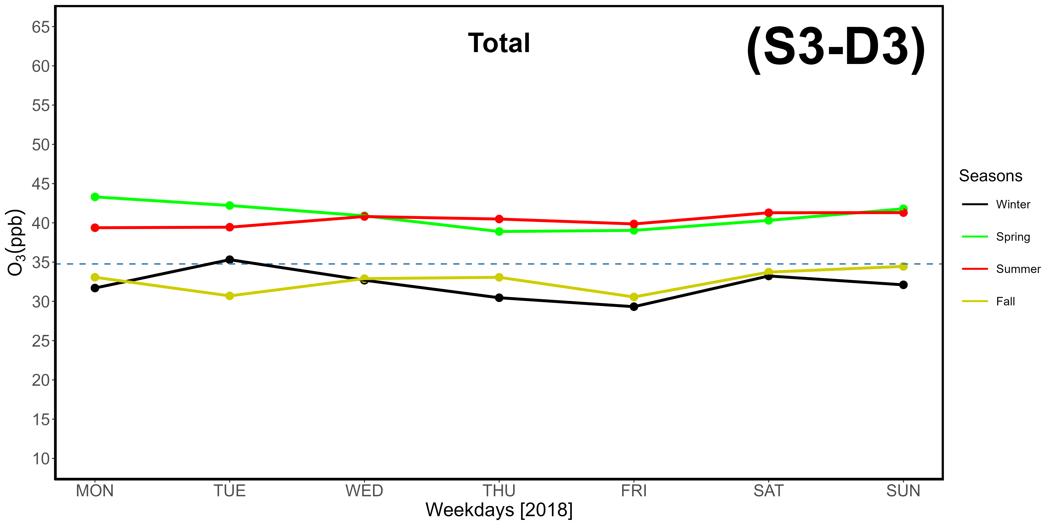
Supplementary Materials S3-D1, -D2, -D3. Evaluation of the OWE (Ozone Weekend Effect) based on hourly ozone data gathered at LMT in 2018, differentiated by weekdays. The dotted horizontal line represents average concentrations. D1: western-seaside (240-300 °N); D2: northeastern-continental (0-90 °N); D3: total data.
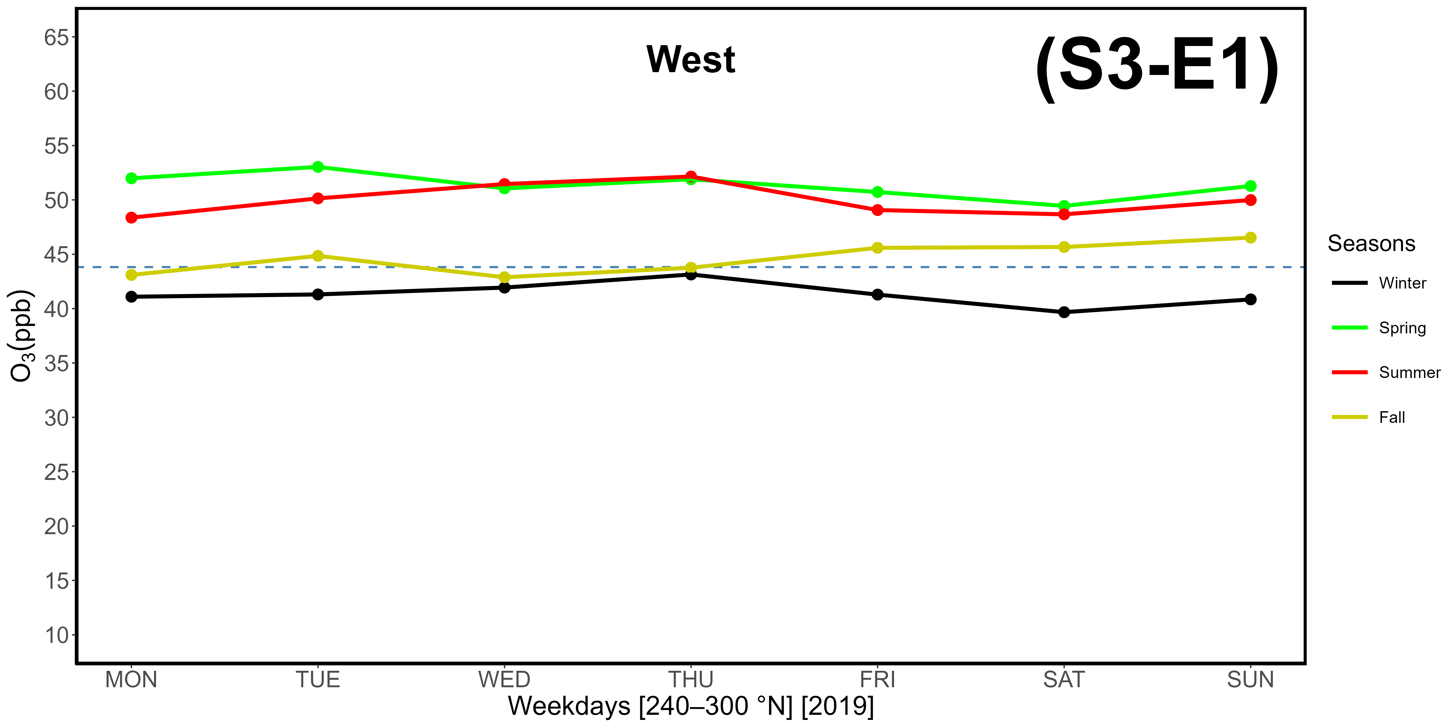
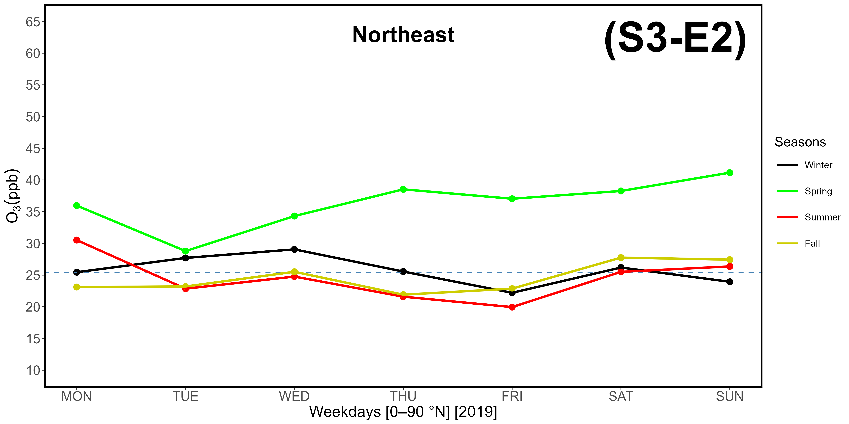
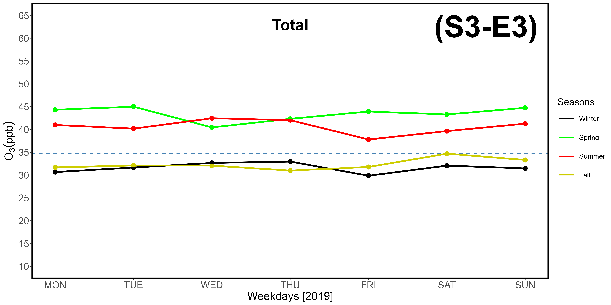
Supplementary Materials S3-E1, -E2, -E3. Evaluation of the OWE (Ozone Weekend Effect) based on hourly ozone data gathered at LMT in 2019, differentiated by weekdays. The dotted horizontal line represents average concentrations. E1: western-seaside (240-300 °N); E2: northeastern-continental (0-90 °N); E3: total data.
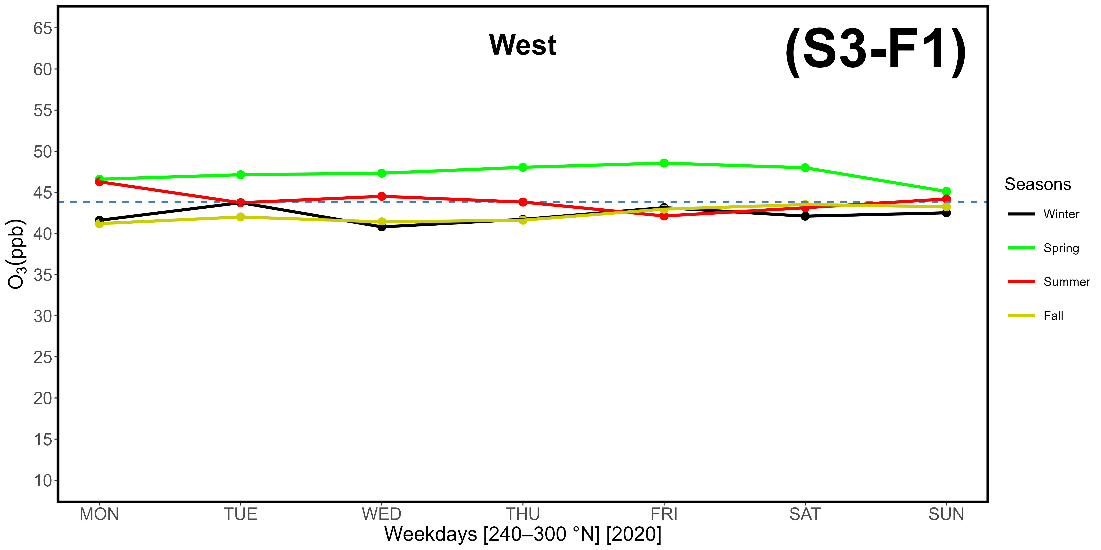
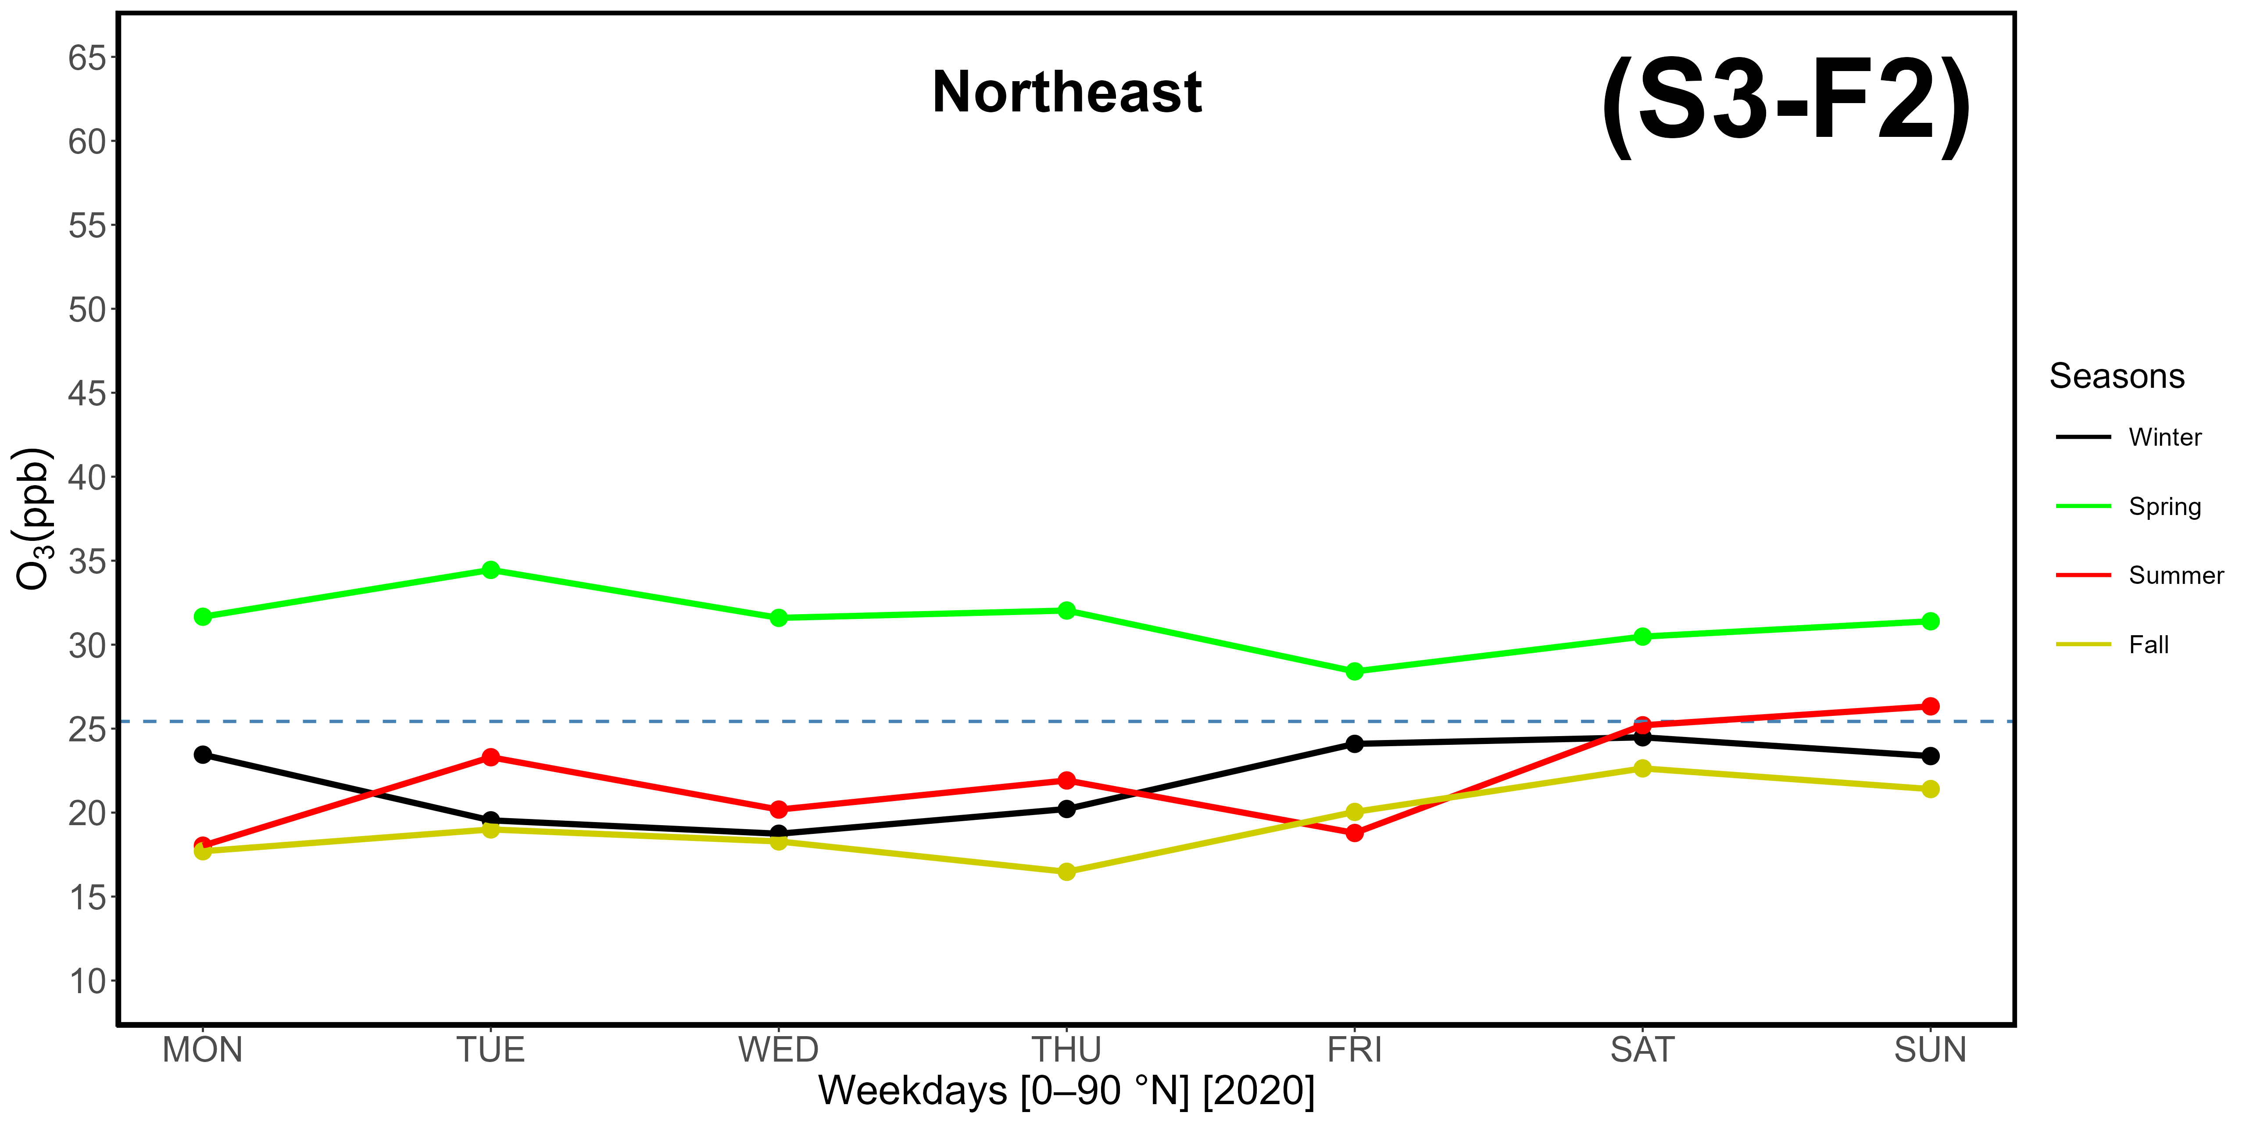
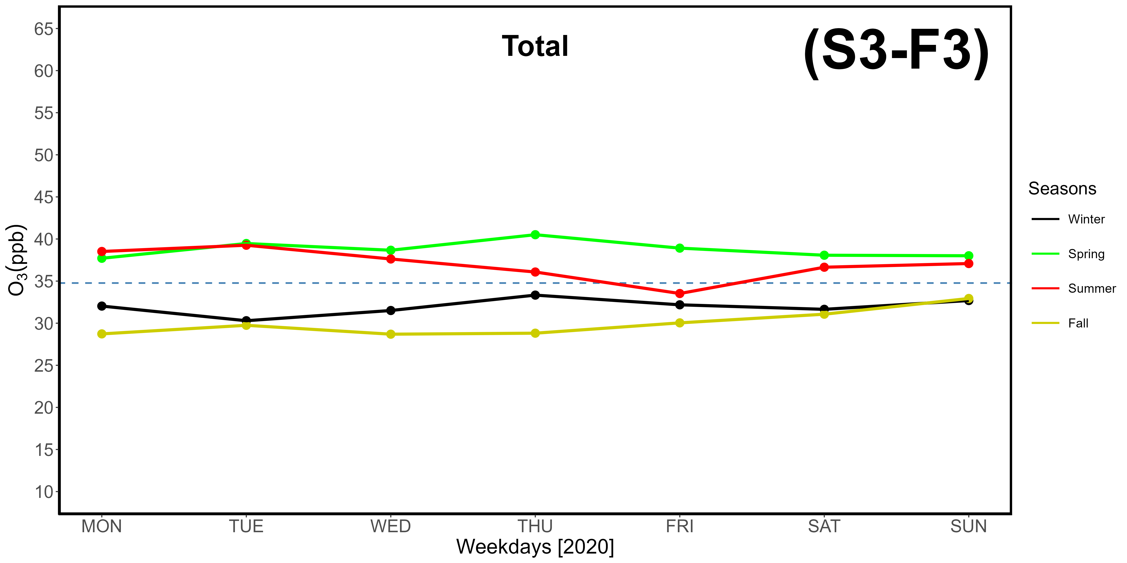
Supplementary Materials S3-F1, -F2, -F3. Evaluation of the OWE (Ozone Weekend Effect) based on hourly ozone data gathered at LMT in 2020, differentiated by weekdays. The dotted horizontal line represents average concentrations. F1: western-seaside (240-300 °N); F2: northeastern-continental (0-90 °N); F3: total data.
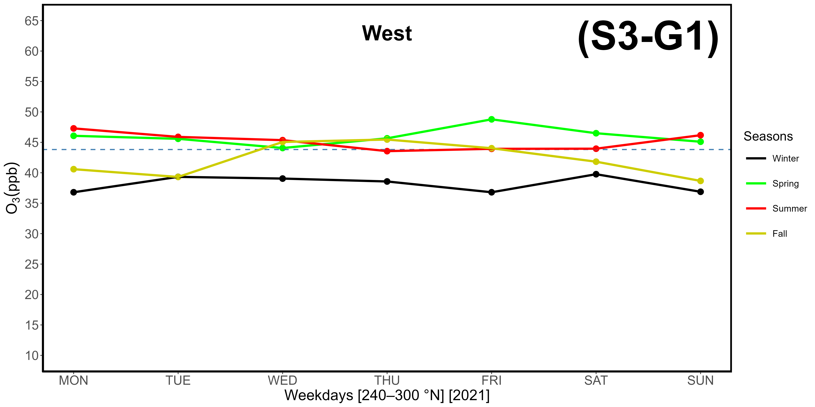
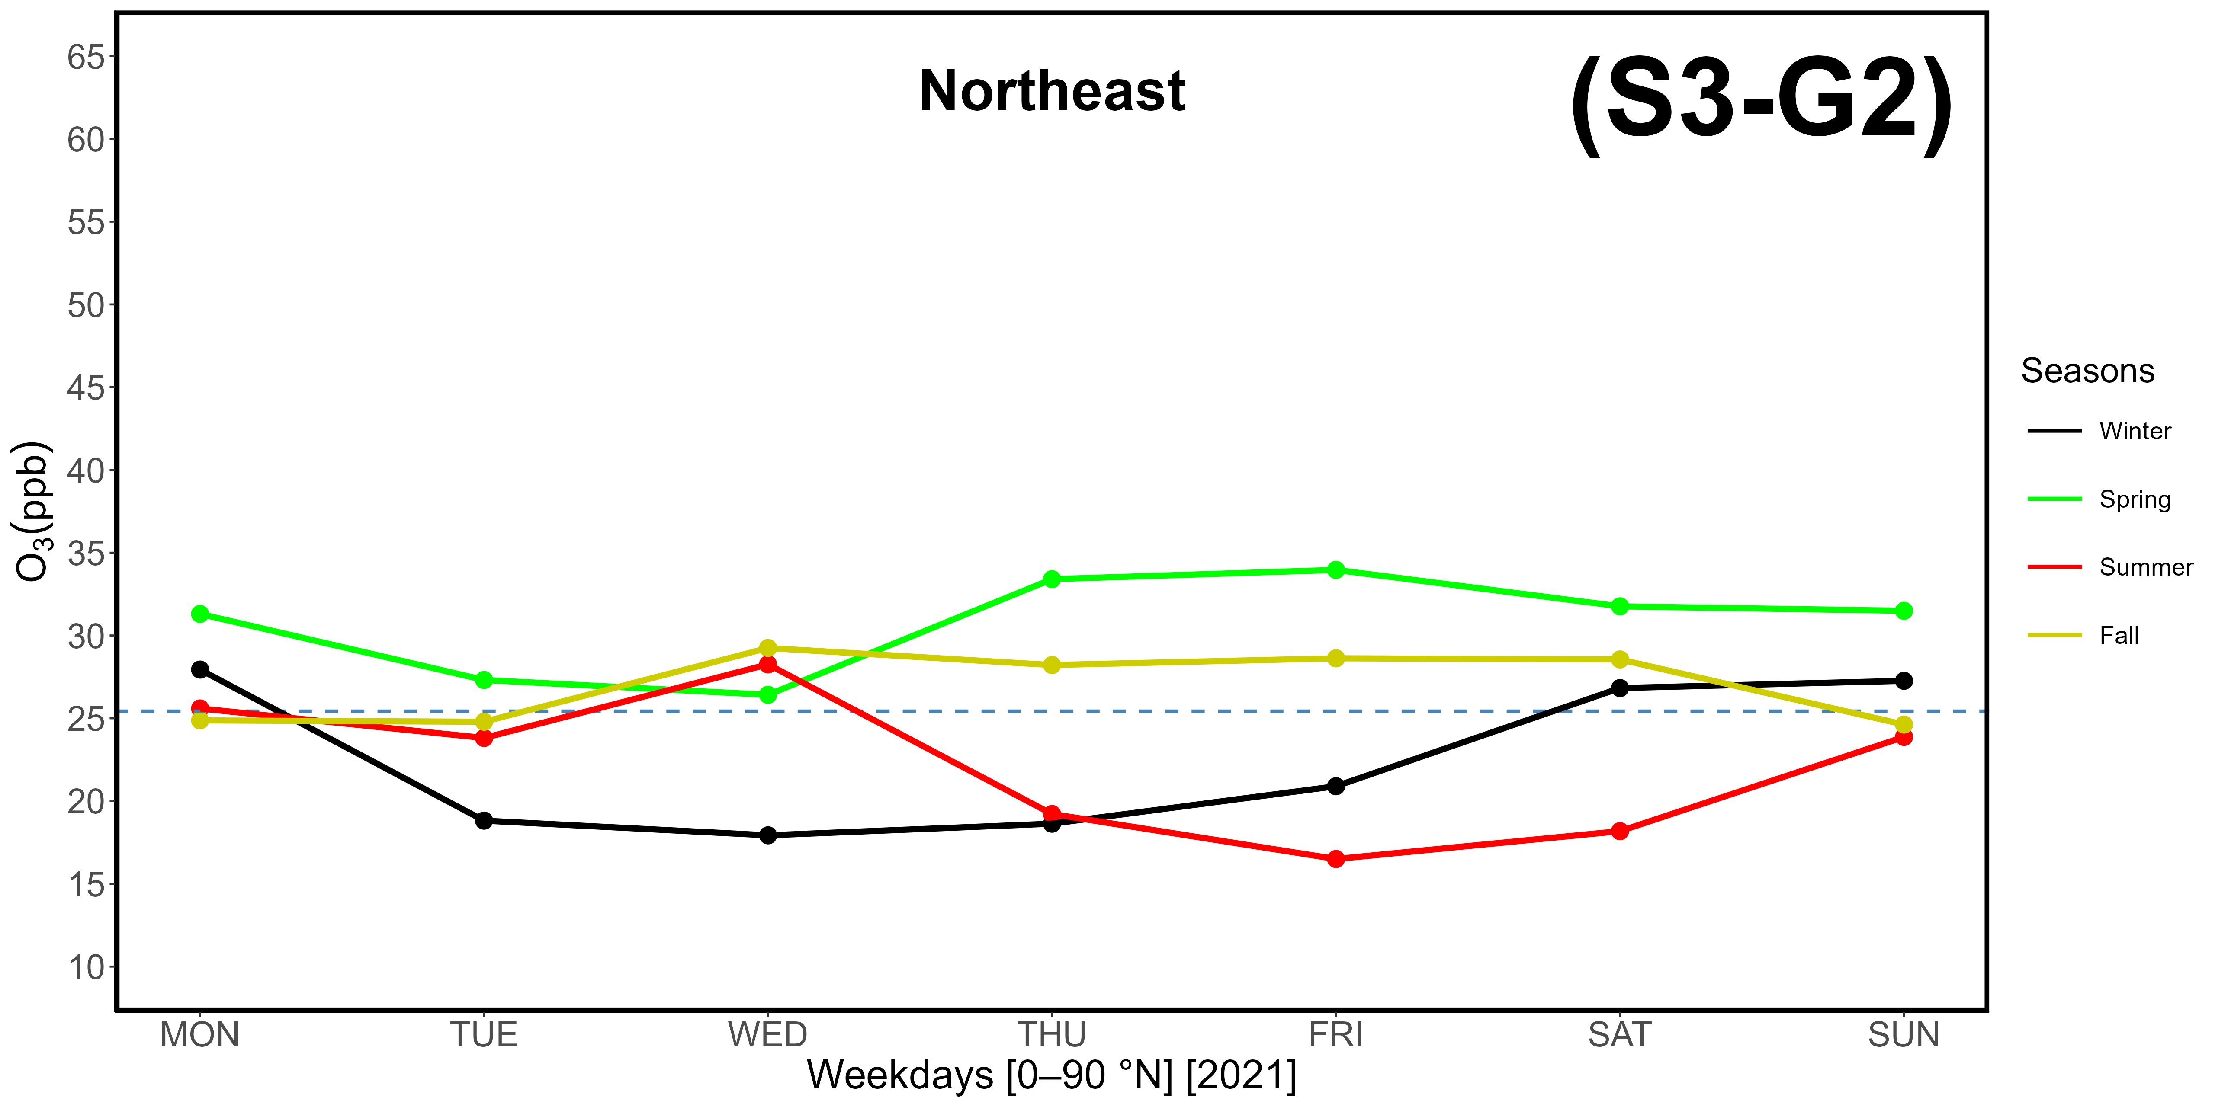
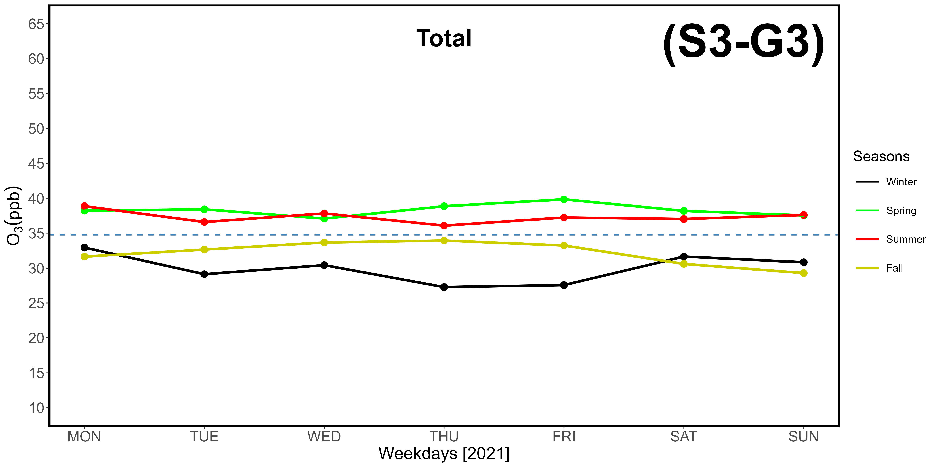
Supplementary Materials S3-G1, -G2, -G3. Evaluation of the OWE (Ozone Weekend Effect) based on hourly ozone data gathered at LMT in 2021, differentiated by weekdays. The dotted horizontal line represents average concentrations. G1: western-seaside (240-300 °N); G2: northeastern-continental (0-90 °N); G3: total data.
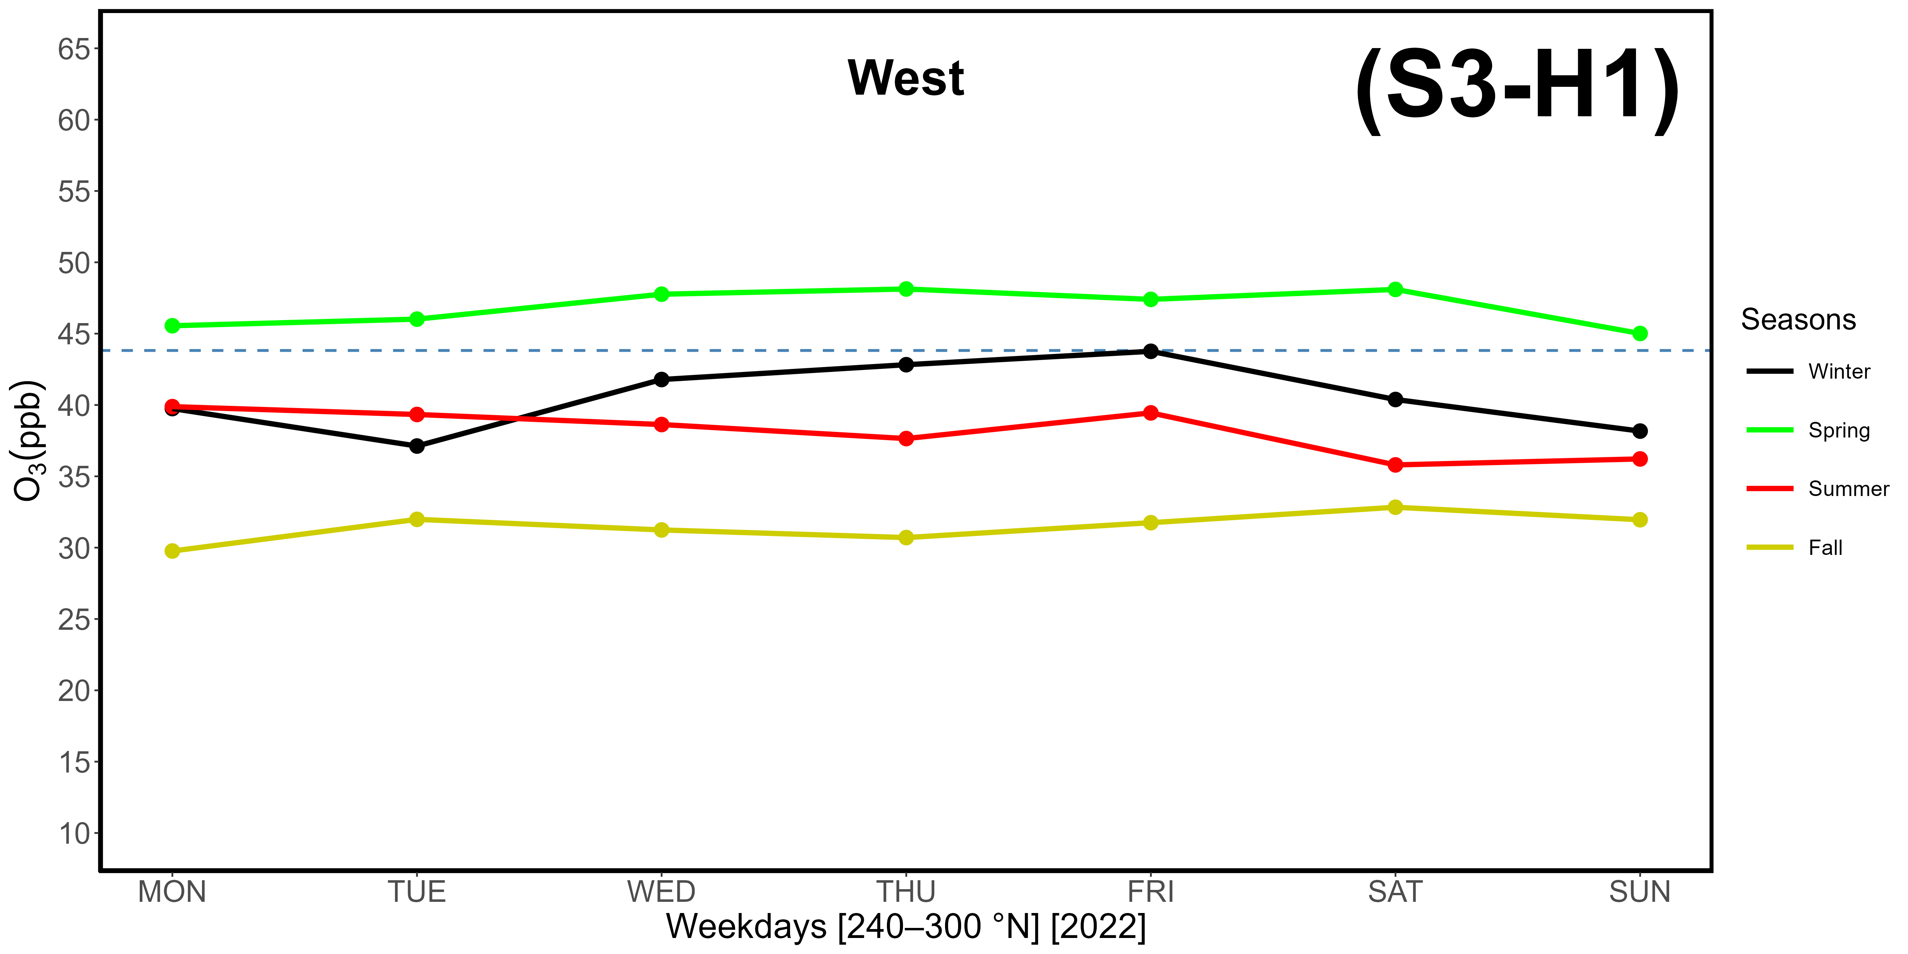
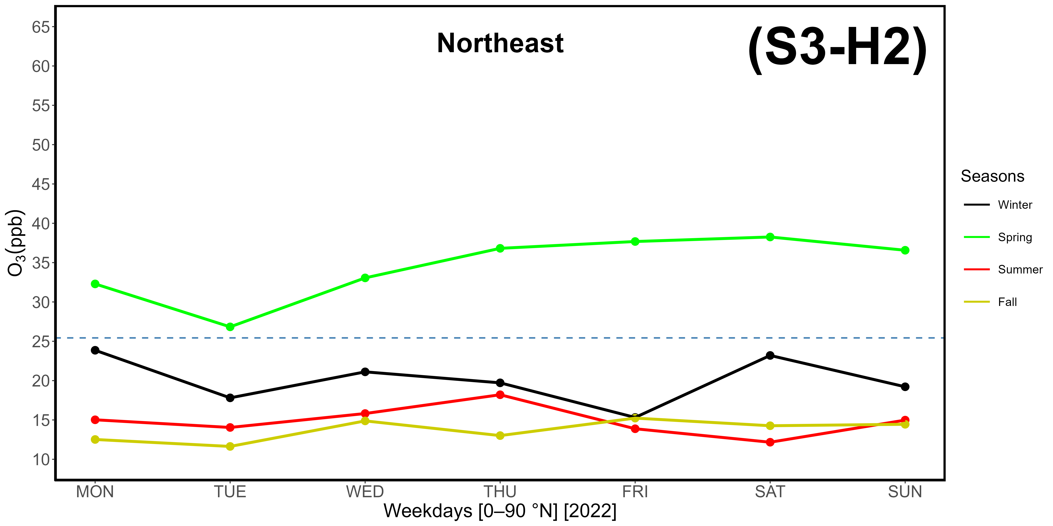
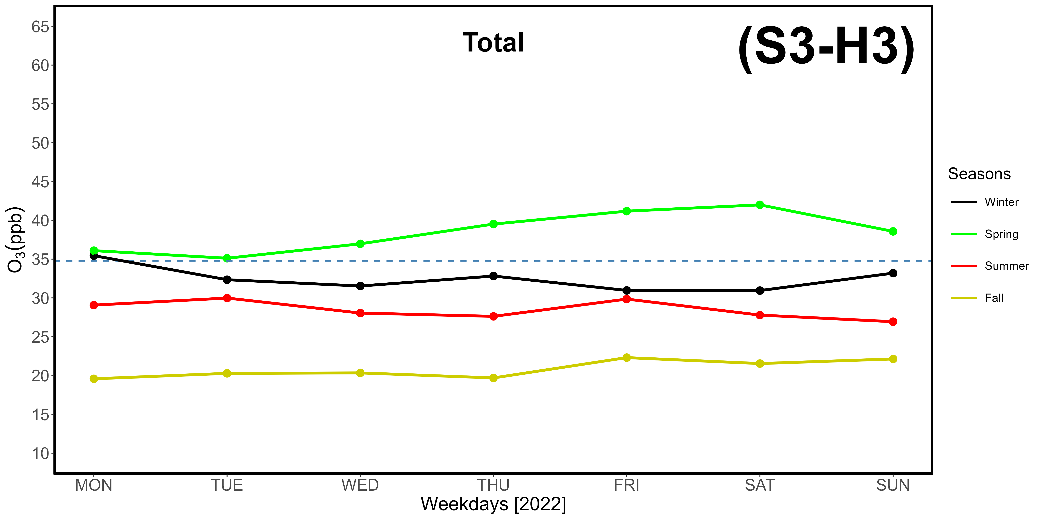
Supplementary Materials S3-H1, -H2, -H3. Evaluation of the OWE (Ozone Weekend Effect) based on hourly ozone data gathered at LMT in 2022, differentiated by weekdays. The dotted horizontal line represents average concentrations. H1: western-seaside (240-300 °N); H2: northeastern-continental (0-90 °N); H3: total data.
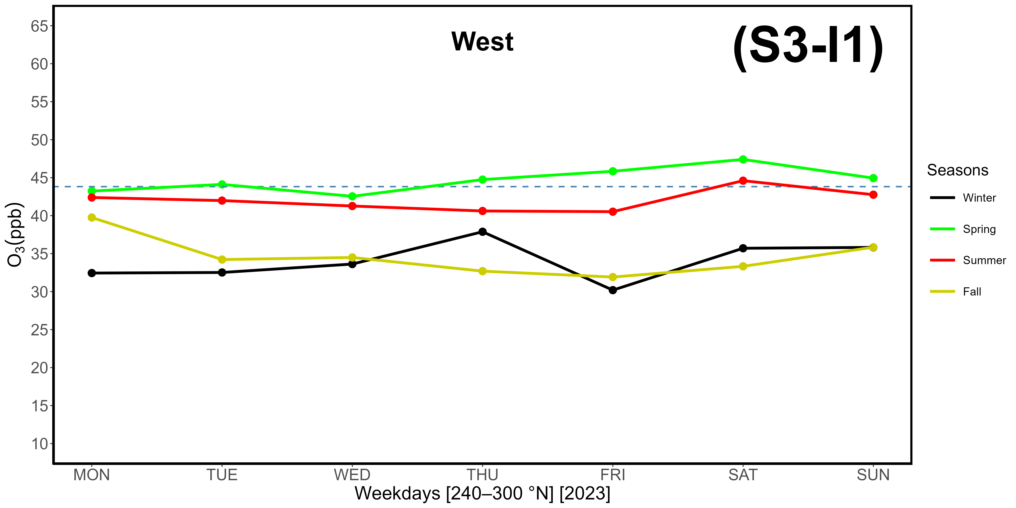
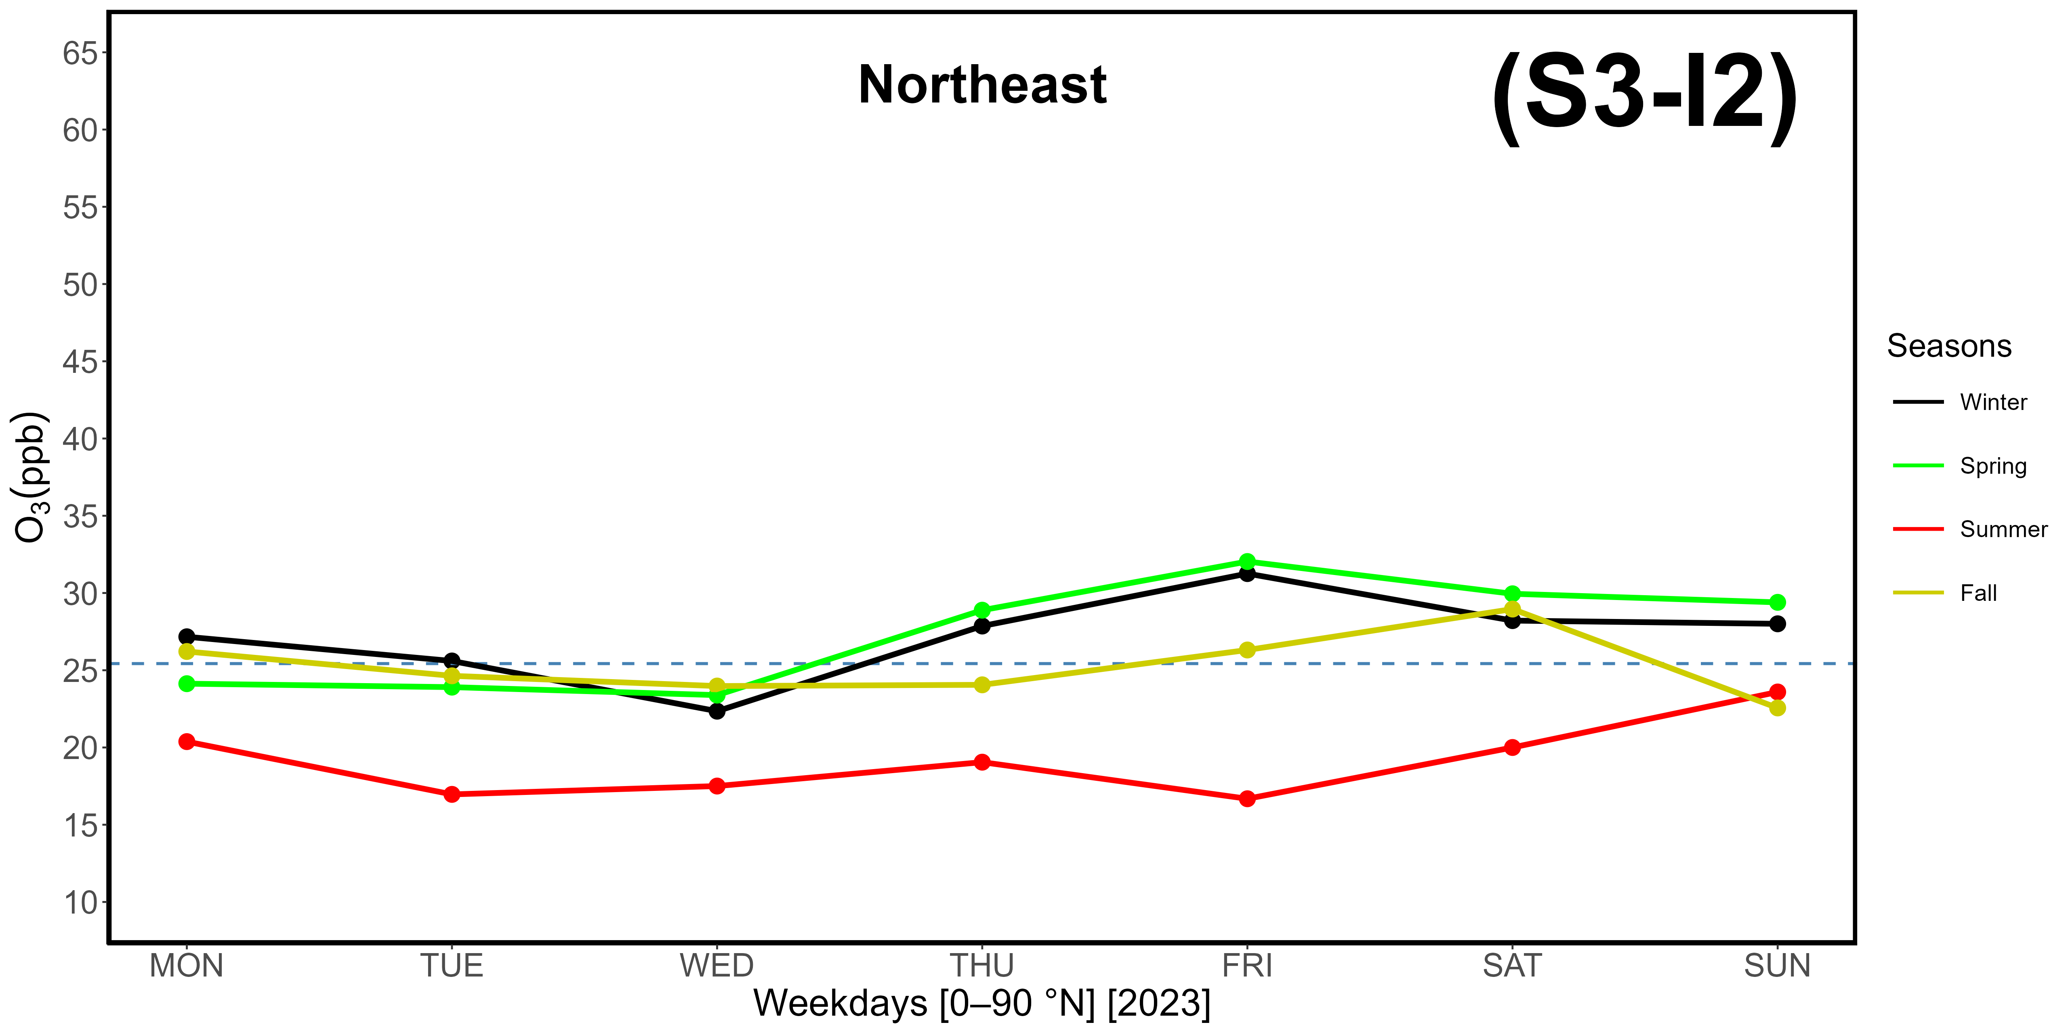
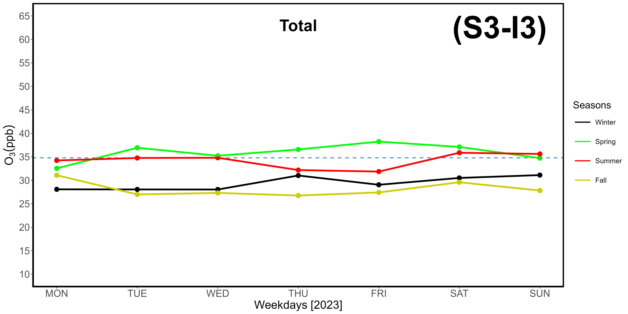
Supplementary Materials S3-I1, -I2, -I3. Evaluation of the OWE (Ozone Weekend Effect) based on hourly ozone data gathered at LMT in 2023, differentiated by weekdays. The dotted horizontal line represents average concentrations. I1: western-seaside (240-300 °N); I2: northeastern-continental (0-90 °N); I3: total data.

