Supplementary materials for

# Landslide Thickness Estimated from InSAR-derived 2D Deformation: Application to the Xiongba ancient Landslide, China

Ying-Hui Yang1, Qian Xu2, Li-Yuan Xie1, Qiang Xu1, Jyr-Ching Hu4, Qiang Chen3

1. State Key Laboratory of Geohazard Prevention and Geoenvironment Protection, Chengdu University of Technology, Chengdu, Sichuan, China
2. College of Air Traffic Management, Civil Aviation Flight University of China, Deyang, Sichuan, China
3. Department of Remote Sensing and Geoinformation Engineering, Southwest Jiaotong University, Chengdu, Sichuan, China
4. Department of Geosciences, National Taiwan University, Taipei, Taiwan, R.O.C.

**Contents of this file**

Figures S1 to S3

Table S1

**Introduction**

Figure S1 shows the time-series InSAR displacements of the points T1 and T2.

Figure S2 shows landslide motion coordinate system.

Figure S3 shows the field investigation of the Xiongba landslide.

Table S1 shows the parameters of the Sentinel-1A SAR images used in this study.

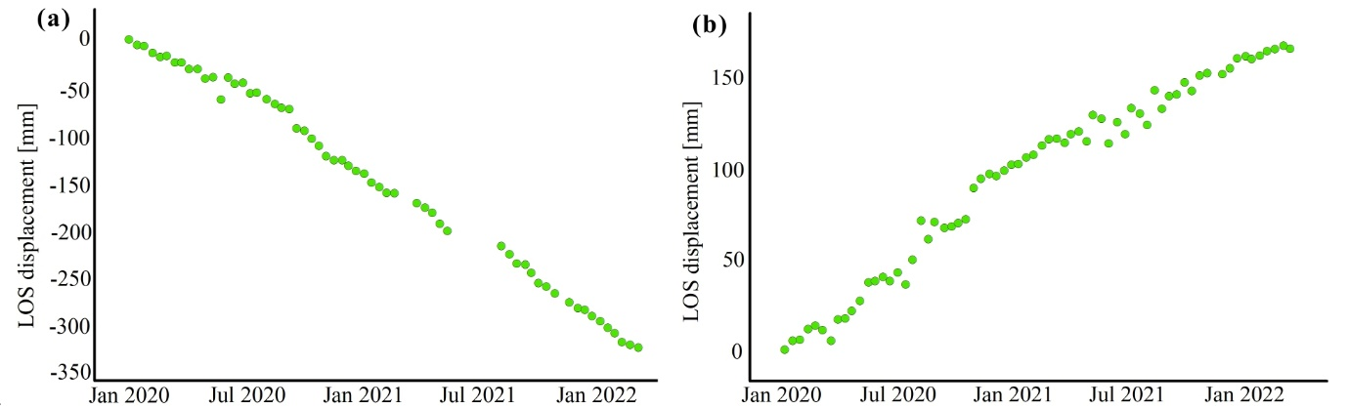

Figure S1. The time-series InSAR displacements of the points T1 and T2, with locations shown in Figure 2.

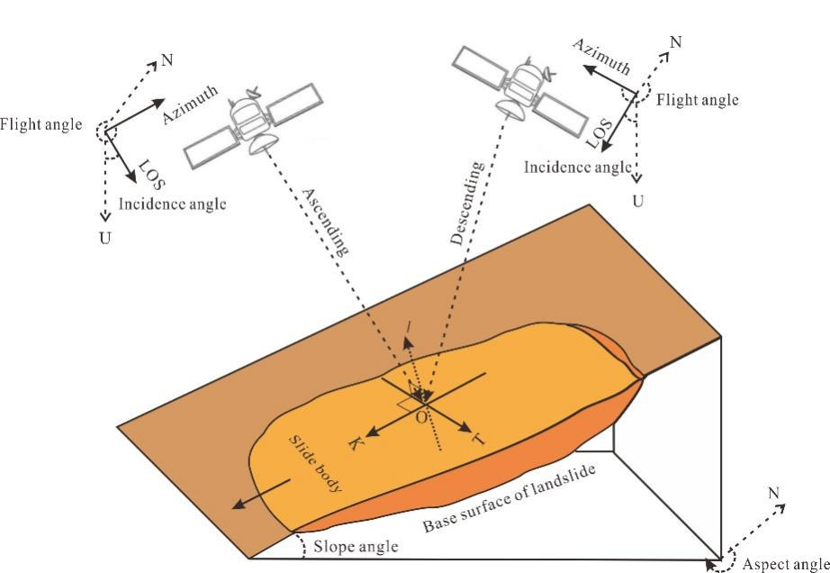

Figure S2. Landslide motion coordinate system. The brown part represents the landslide body. OK, OT and OI respectively indicate the slope, perpendicular to the slope and the normal directions of the landslide.

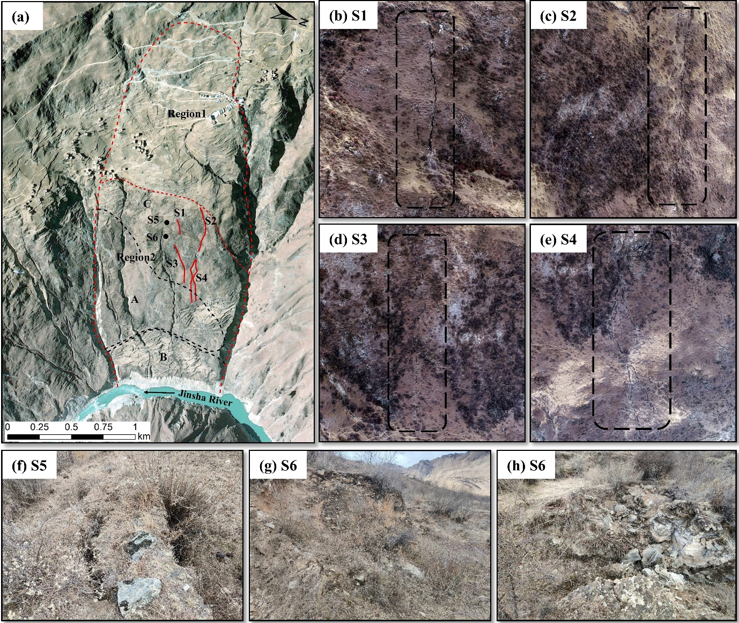

Figure S3. Field investigation of the Xiongba-H2 landslide. Optical images (a) and the recognized surface cracks of the Xiongba-H2 landslide (b-h). The red dashed lines show the spatial scope of the Xiongba-H2 landslide and the boundary between the deformed zone (Region2) and stable zone (Region1), as shown as Figure 2. The solid red lines are the surface cracks, with enlarged views displayed in subfigures (b-e). The black dots in subfigure (a) indicate the positions of the transverse tensile crack (f) and rock mass failures (g-h).

Table S1. Parameters of the Sentinel-1A SAR images used in this study

|  |  |  |  |  |
| --- | --- | --- | --- | --- |
| Flight Direction | Scenes | Incidence angle ( ˚ ) | Heading ( ˚ ) | Time span |
| Ascending | 59 | 33.85 | 349.5 | 20200102-20220316 |
| Descending | 68 | 39.28 | 190 | 20200321-20220323 |