**SUPPLEMENTARY MATERIAL**

**Supplementary Table 1:** Primers used for the evaluation of changes in relative cytokine mRNA levels in hamsters by qPCR.

|  |  |  |  |
| --- | --- | --- | --- |
| **Gene** | **Name** | **Primer (5`-3’)** | **Strand** |
| **IFN-** γ | GamF | *CATCAAGGCAGACCTGTTTGCTAAC* | *Forward* |
| GamR | *CGCTGAACCTGAAGGTCATTTACC* | *Reverse* |
| **IL-12** | IL12F | *CTGGACGAGCCCATGCTGAC* | *Forward* |
| IL12R | *GTAGGGATCCGCTTCTGCCAG* | *Reverse* |
| **IL-4** | IL4F | *ACCCTGTGCTTGAAGAACAATTCCAG* | *Forward* |
| IL4R | *TGGACTCATTCACATTGCAGCTCTTC* | *Reverse* |
| **IL-6** | IL6F | *CAAAGCCAGAGTCATTCAGAGCAC* | *Forward* |
| IL6R | *CAGGATGGCCTTGGAGGTTGG* | *Reverse* |
| **Ribosomal Protein L18** | Rib18F | *TGACGTGAGGATTCTCGAAGTGC* | *Forward* |
| Rib18R | *CTGGTCAAAGGTGAGGATCTTGC* | *Reverse* |

**Supplementary Figure 1**: Dot blot of DNA from yeast clones transformed with plasmid pCBB-sGn. (**A**) Dot Blot of DNA. (**B**) Construct for the expression of sGn in yeast, pCBB-sGn. ***A4****. Clone C4-G1.* ***B5****. Clone C5-G1.* ***J1****. Positive control 5X.* ***J2****. Positive control 1X.* ***J3****. Positive control 0.2X.*

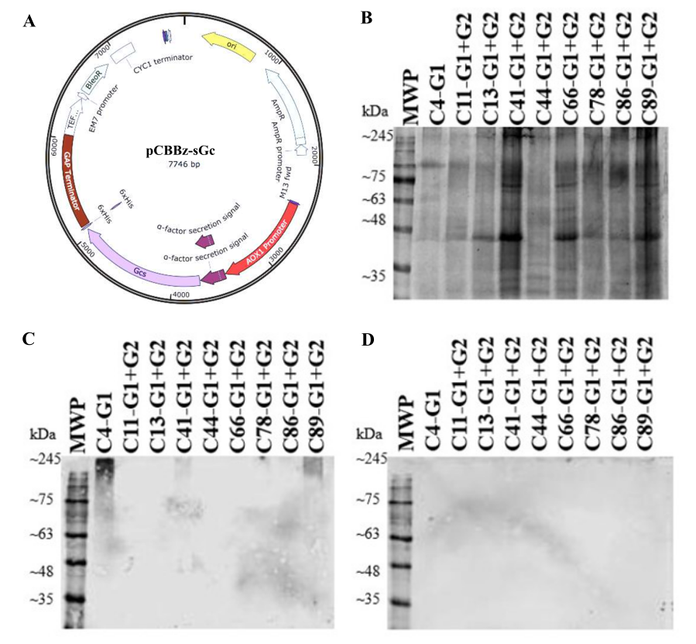

**Supplementary Figure 2. SDS-PAGE and Western Blot of the induction supernatant of clones obtained by re-transformation of C4-G1 with pCBBz-sGc**. (**A**) Construct for the expression of sGc in yeast, pCBBz-sGc. (**B**) SDS-PAGE 10% stained with Coomassie blue. (**C**) Western blot using anti-Gn primary antibody. (**D**) Western blot using anti-Gc primary antibody. *In each lane, the induction of the supernatant of the clones can be observed in the following order: C4-G1, C11-G1+G2, C13-G1+G2, C41-G1+G2, C44-G1+G2, C66-G1+G2, C78-G1+G2, and C89-G1+G2.* ***MWP.*** *Molecular weight pattern.*

**Supplementary Figure 3. SDS-PAGE and Western Blot of the intracellular fractions of the clones obtained by re-transformation of C4-G1 with pCBBz-sGc, after induction.** Cleavage fractions of the clones can be observed in the following order: C4-G1, C11-G1+G2, C13-G1+G2, and C41-G1+G2. **A.** SDS-PAGE 10% stained with Coomassie blue. **B.** Western blot using anti-Gn antibody. **C.** Western blot using anti-Gc primary antibody. ***MWP.*** *Molecular weight pattern.* ***PF.*** *Periplasmic yeast cleavage fraction.* ***SIF.*** *Yeast Intracellular Soluble Intracellular Fraction of Yeast Breakdown.* ***IIF.*** *Yeast Intracellular Insoluble Intracellular Fraction of yeast breakage.*

**Supplementary Figure 4.** Soluble and insoluble fractions after urea solubilization of the insoluble fraction of the fermentation pellet breakdown of clone C11-G1+G2: (**A**) SDS-PAGE 10% Coomassie blue stained soluble fractions, reducing conditions. (**B**) Western blotting using anti-poly His primary antibody of soluble fractions, reducing conditions. (**C**) SDS-PAGE 10% Coomassie blue staining of insoluble fractions, reducing conditions. (**D**) Western Blot using anti-poly-His primary antibody of the insoluble fractions, reducing conditions. ***MWP****. Molecular Weight Pattern.* ***0M****. Solubilization in 0 M urea.* ***1M****. Solubilization in 1 M urea.* ***2M****. Solubilization in 2 M urea.* ***3M****. Solubilization in 3 M urea.* ***4M****. Solubilization in 4M urea.* ***5M****. Solubilization in 5 M urea.* ***6M****. Solubilization in 6 M urea.* ***7M****. Solubilization in 7 M urea.* ***8M****. Solubilization in 8 M urea.*

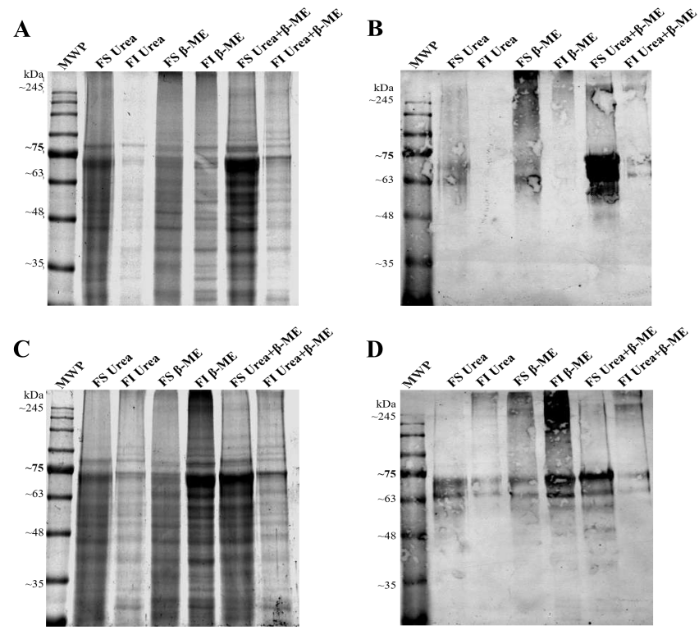

**Supplementary Figure 5.** Soluble and insoluble fractions after solubilization optimization: (**A**) SDS-PAGE 10% stained with Coomassie blue, non-reducing conditions. (**B**) Western blotting using anti-poly His primary antibody, non-reducing conditions. (**C**) SDS-PAGE 10% stained with Coomassie blue, reducing conditions. (**D**) Western Blot using anti-poly-His primary antibody, reducing conditions. ***MWP****. Molecular Weight Pattern.* ***FS Urea****. Fraction soluble in 8 M urea.* ***FI Urea****. Fraction insoluble in 8 M urea.* ***FS β-ME****. Fraction soluble in 10 mM β-mercaptoethanol.* ***FI β-ME****. Fraction insoluble in 10 mM β mercaptoethanol.* ***FS Urea+β-ME****. Fraction soluble in 8 M urea + 10 mM β-mercaptoethanol.* ***FI Urea+β ME.*** *Fraction insoluble in 8 M urea + 10 mM β-mercaptoethanol.*

**Supplementary Figure 6. Characterization of recombinant antigens sGn and sGc under different conditions of purification. A.** SDS-PAGE (right) and Western Blot using anti-poly-His primary antibody (left) under non-reducing conditions. **B.** SDS-PAGE (right) and Western Blot (left) using anti-poly-His primary antibody under reducing conditions of the recombinant antigens before and after the refolding process. **C.** SDS-PAGE (right) and Western blot (left) of post-repletion recombinant antigens using Anti-Gn and Anti-Gc antibodies under reducing conditions. ***MWP.*** *Molecular weight pattern.* ***PreRF.*** *Pre-folding sample (IMAC elution fraction).* ***PostRF.*** *Post-refolding sample.*

**Supplementary Figure 7. Occupancy analysis of potential N-glycosylation sites in the recombinant antigens. A.** SDS-PAGE 10% stained with Coomassie blue, reducing conditions. **B.** Western blot using anti-Gn monoclonal antibody, reducing conditions. **C.** Western blot using anti-Gc monoclonal antibody, reducing conditions. **D.** Western blot using anti-poly-His monoclonal antibody, reducing conditions. ***MWP.*** *Molecular weight pattern.* ***PostRF****. Post-refolding sample.* ***C-.*** *Sample without PNGase-F treatment.* ***PNGase-F.*** *PNGase-F treated sample.*