**Supplementary Figures to Yi-Ying Wu et al. Lidocaine modulates cytokine production and enhances anti-tumor immune response in gastric cancer: Dual effects on normal peripheral blood mononuclear cells and primary gastric tumor-infiltrating immune cells**

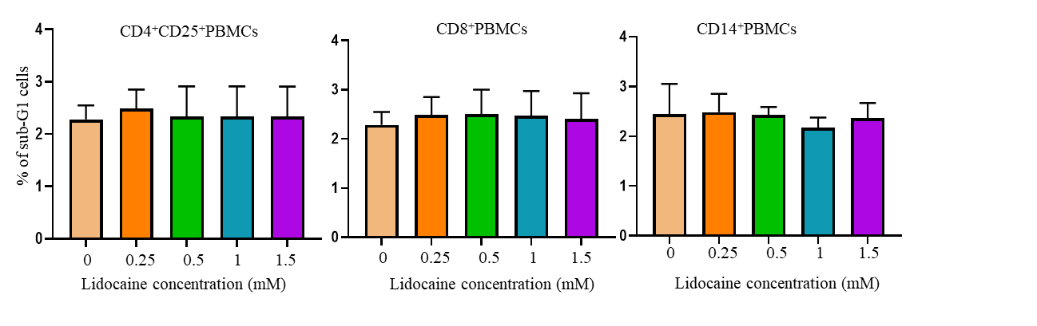

**Figure S1. Lidocaine does not affect** **CD4+CD25+PBMCs, CD8+PBMCs and CD14+ PBMCs.** Human normal CD4+CD25+PBMCs, CD8+PBMCs and CD14+ PBMCs were assessed by flow cytometric analysis using propidium iodide-stained cells. Firstly, 104 cells were incubated in 96-well plates in presence or absence of the indicated concentrations of lidocaine (0.25 mM-1.5 mM). After 72 h treatment, cells were washed with PBS and fixed with 70% ethanol for 1 h on ice. Pelleted cells were incubated with RNase-A (0.1 mg/mL) and propidium iodide (40 μg/mL) for 1 h with shaking and protected from light. The percentage of subG1 population was determined by flow cytometry. Data are representative of three independent experiments; n > = 3.

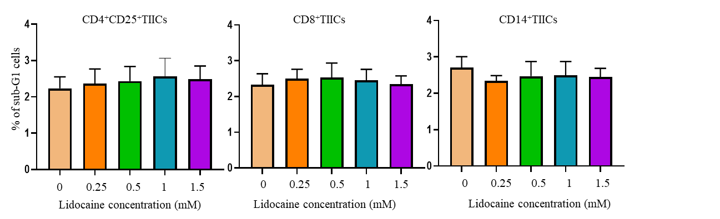

**Figure S2.** **Lidocaine does not affect CD4+CD25+TIICs, CD8+TIICs and CD14+TIICs viability.** Human normal CD4+CD25+TIICs, CD8+TIICs and CD14+TIICs were assessed by flow cytometric analysis using propidium iodide-stained cells. Firstly, 104 cells were incubated in 96-well plates in presence or absence of the indicated concentrations of lidocaine (0.25 mM-1.5 mM). After 72 h treatment, cells were washed with PBS and fixed with 70% ethanol for 1 h on ice. Pelleted cells were incubated with RNase-A (0.1 mg/mL) and propidium iodide (40 μg/mL) for 1 h with shaking and protected from light. The percentage of subG1 population was determined by flow cytometry. Data are representative of three independent experiments; n > = 3.



**Figure S3. Lidocaine-sensitized CD8+TIICs dependent immunogenic cell death of PGCCs****.** CD8+TIICs were co-cultured with PGGCs followed treatment with lidocaine for 48 and 72 h. The ratio of cell numbers of CD8+TIICs and PGGCs was 5:1. Cell death was measured using a LDH cytotoxicity assay. Data represent the mean of triplicate experiments, and experiments were repeated at least three times using different donor with similar results. Data are from distinct samples and presented as the mean± SEM. \**p* < 0.05, \*\**p* < 0.01 compared with mock treated cells; n > = 3.