Supplementary Materials

Inhibition of Aβ aggregation by cholesterol-end-modified PEGs vesicle and micelle

Shota Watanabe, Motoki Ueda and Shoichiro Asayama*

Department of Applied Chemistry, Tokyo Metropolitan University, Hachioji, Tokyo 192-0397, Japan

* Email: asayama-shoichiro@tmu.ac.jp

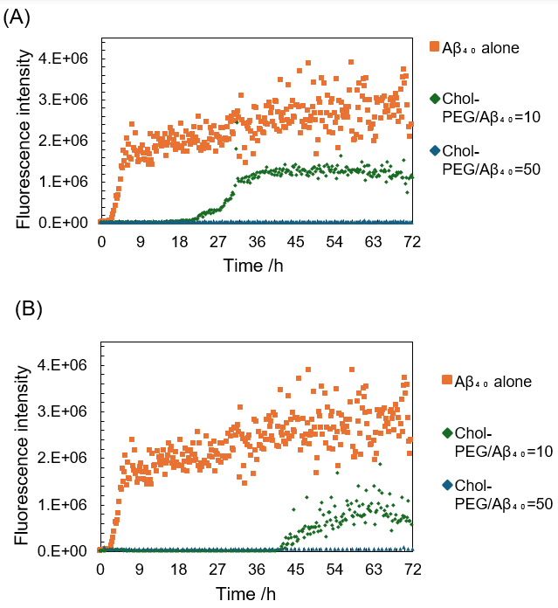
Figure. S1. ThT assay results of Aβ₄₀ aggregation in the presence of each concentration of Chol-PEGs. (A) Aβ₄₀ incubated with Chol-PEG₂₀₀₀, Chol-PEG/Aβ₄₀ (B) Aβ₄₀ incubated with Chol-PEG₅₀₀. The final concentration of Chol-PEGs at Chol-PEG/Aβ=10 and Chol-PEG/Aβ=50 is 94 µM and 470 µM respectively.

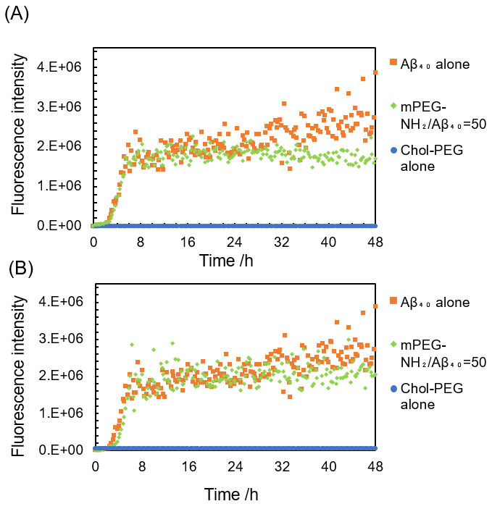
Figure.S2. ThT assay results of Aβ₄₀ aggregation in the presence PEGs and Chol-PEGs alone (without Aβ₄₀) as controls. (A) Aβ₄₀ incubated with mPEG₂₀₀₀-NH₂ and Chol-PEG₂₀₀₀ alone, (B) Aβ₄₀ incubated with mPEG₅₀₀-NH₂ and Chol-PEG₅₀₀ alone.

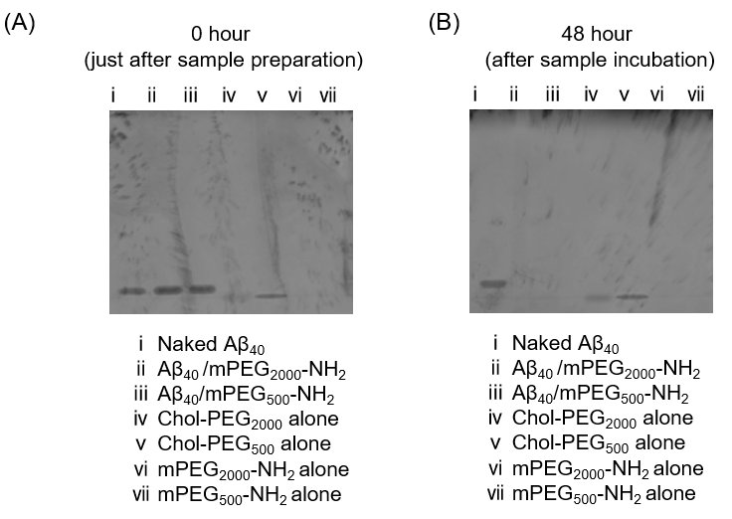
Figure. S3. Polyacrylamide gel electrophoresis of each polymer incubate with or without Aβ₄₀. (A) Immediately after sample preparation, (B) After incubate 48 hour.

