**Assessing the 9G Technology Blood Test for Predicting Lung Cancer in Patients with CT-Detected Lung Nodules: A Multicenter Clinical Trial**

So Yeon Kim,1 Young Sik Park,1 In Ae Kim,2 Hee Joung Kim,2 Kye Young Lee2,*

1 Division of Pulmonary and Critical Care Medicine, Seoul National University Hospital, Seoul, South Korea; lydia0000@hanmail.net (SYK); mdyspark@gmail.com (YSP)

2 Precision Medicine Lung Cancer, Konkuk University Medical Center, Seoul, South Korea; iakim@kuh.ac.kr (IAK); hjkim@kuh.ac.kr (HJK); kyleemd@kuh.ac.kr (KYL)

**\*** Correspondence: kyleemd@kuh.ac.kr (KYL); Tel.: +82-10-8896-3916

**Supporting information**

$n_{Se}=\frac{{\left(Z_{α} + Z_{β}\right)}^{2} p_{1}(1-p_{1})}{{\left(p_{1}-p_{0}\right)}^{2}} = \frac{{\left(1.96 + 2.05\right)}^{2} 0.69(1-0.69)}{{\left(0.69- 0.62\right)}^{2}} = 703.25≅ 704$………… **Eq. S1**

$n_{Sp}=\frac{{\left(Z_{α} + Z_{β}\right)}^{2} p_{1}(1-p_{1})}{{\left(p_{1}-p_{0}\right)}^{2}} = \frac{{\left(1.96 + 1.64\right)}^{2} 0.92(1-0.92)}{{\left(0.92- 0.85\right)}^{2}} = 195.19≅ 196$………… **Eq. S2**

Where, α is the significance level (one-sided test), β is the type 2 error, p1 is the target performance of test device, and p1 is the minimum expected performance.

**Link S1:** 9G test™ Lung Cancer Kit user guide

https://www.youtube.com/watch?v=kbBlS_NpqVI

$Index Value= \left[\left(\frac{CS-1}{CS-2}\right)\left(\frac{LS-1}{LS-2)}\right)\right]$………… **Eq. S3**

Where, CS-1 is the value for p53-anti-p53 autoantibody complex, CS-2 is the value for p53, LS-1 is the value for CYFRA 21-1-anti-CYFRA 21-1 autoantibody complex, and LS-2 is the value for CYFRA21-1.

Table S1. Clinical samples (n=1399) collected at Konkuk University Hospital (n=388, 27.7%), and Seoul National University Hospital (1011, 72.3%).

|  |  |  |  |  |
| --- | --- | --- | --- | --- |
| **Clinical Samples collected at** | **Screening n (%)** | **Random assignment n (%)** | **Clinical performance testing completed n (%)** | **Samples included in analysis Set  n (%)** |
| Konkuk University Hospital | 388 (27.7) | 280 (24.7) | 280 (24.7) | 280 (24.7) |
| Seoul National University Hospital | 1,011 (72.3) | 852 (75.3) | 852 (75.3) | 852 (75.3) |
| **Total** | **1,399 (100.0)** | **1,132 (100.0)** | **1,132 (100.0)** | **1,132 (100.0)** |

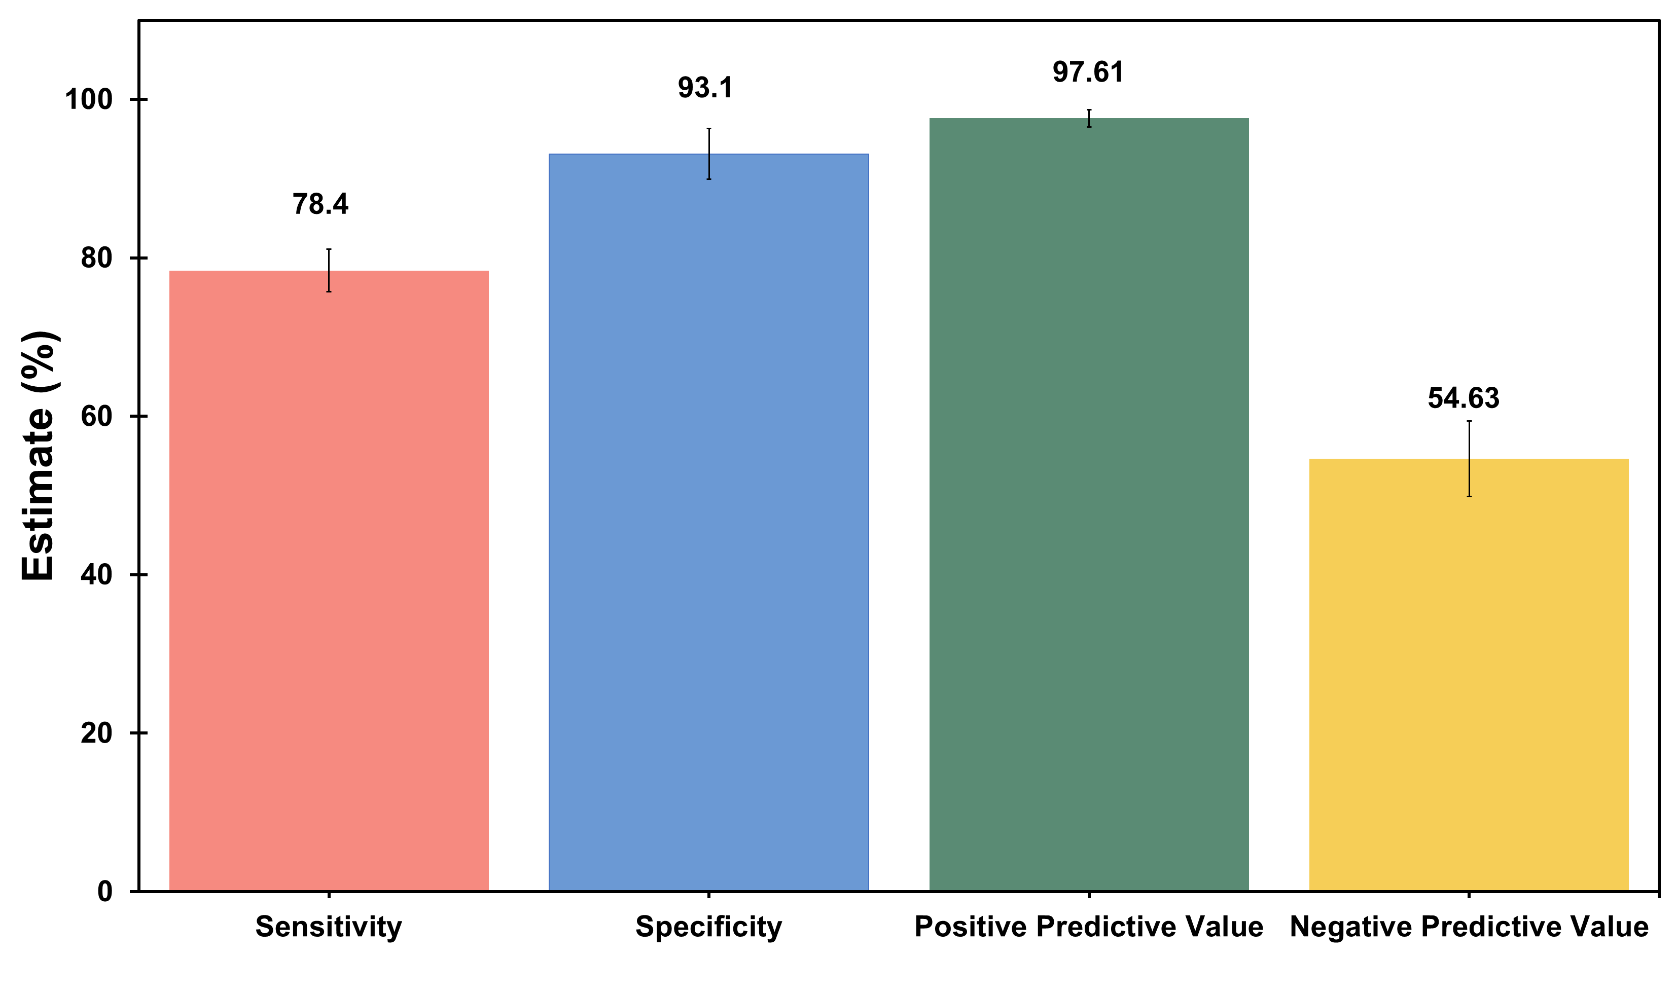

**Figure S1**. Sensitivity, Specificity, PPV and NPV of 9G testTM Cancer/Lung test for identification of risk of lung cancer.

**Table S2**. Gender-specific sensitivity and specificity of 9G testTM Cancer/Lung test for identification of risk of lung cancer

| **Gender** | **Cancer (N = 885)** | **Benign (N = 247)** |
| --- | --- | --- |
| **Men** | **566** | **137** |
| High-risk of lung cancer (Index > 3.5) | 449 (79.3%) | 9 (6.6%) |
| Low-risk of lung cancer (Index ≤ 3.5) | 117 (20.7%) | 128 (93.4%) |
| Sensitivity |  |  |
| Estimates (%) | 79.3 | - |
| (95% CI) | (76.6, 82.7) | - |
| Specificity |  |  |
| Estimates (%) | 93.4 | - |
| (95% CI) | (89.3, 97.6) | - |
| **Women** | **319** | **110** |
| High-risk of lung cancer (Index > 3.5) | 245 (76.8%) | 8 (7.3%) |
| Low-risk of lung cancer (Index ≤ 3.5) | 74 (23.2%) | 102 (92.7%) |
| Sensitivity |  |  |
| Estimates (%) | 76.8 | - |
| (95% CI) | (72.2, 81.4) | - |
| Specificity |  |  |
| Estimates (%) | 92.7 | - |
| (95% CI) | (87.9, 97.6) | - |

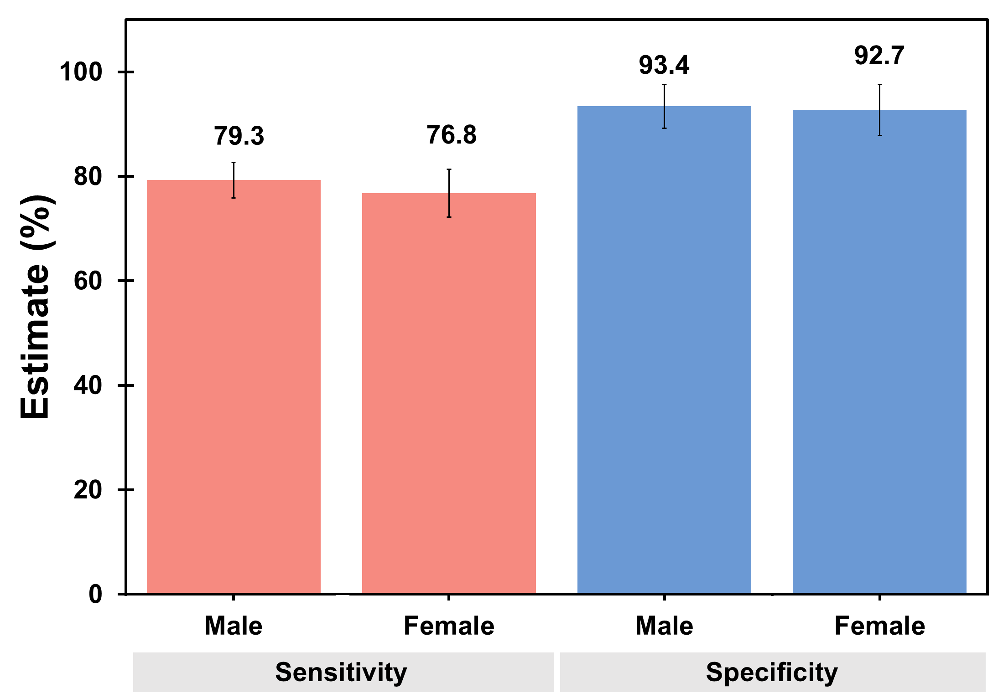

**Figure S2**. Gender specific sensitivity and specificity of 9G testTM Cancer/Lung test for identification of risk of lung cancer

**Table S3.** Sensitivity and specificity of the 9G testTM Cancer/Lung test for identifying the risk of lung cancer in various age groups.

| **Age groups, Years** | **Cancer (N=885)** | **Benign (N=247)** |
| --- | --- | --- |
| **50 – 59** | **153** | **75** |
| High-risk of lung cancer (Index > 3.5) | 120 (78.4%) | 4 (5.3%) |
| Low-risk of lung cancer (Index ≤ 3.5) | 33 (21.6%) | 71 (94.7%) |
| Sensitivity |  |  |
| Estimates (%) | 78.4 | - |
| (95% CI) | (71.9, 85.5) | - |
| Specificity |  |  |
| Estimates (%) | 94.7 | - |
| (95% CI) | (89.6, 99.8) | - |
| **60 – 69** | **380** | **72** |
| High-risk of lung cancer (Index > 3.5) | 300 (79.0%) | 5 (6.9%) |
| Low-risk of lung cancer (Index ≤ 3.5) | 80 (21.0%) | 67 (93.1%) |
| Sensitivity |  |  |
| Estimates (%) | 79.0 | - |
| (95% CI) | (74.9, 83.1) | - |
| Specificity |  |  |
| Estimates (%) | 93.1 | - |
| (95% CI) | (87.2, 98.9) | - |
| **70 – 79** | **352** | **100** |
| High-risk of lung cancer (Index > 3.5) | 274 (77.8%) | 8 (8.0%) |
| Low-risk of lung cancer (Index ≤ 3.5) | 78 (22.2%) | 92 (92.0%) |
| Sensitivity |  |  |
| Estimates (%) | 77.8 | - |
| (95% CI) | (73.5, 82.2) | - |
| Specificity |  |  |
| Estimates (%) | 92.0 | - |
| (95% CI) | (86.7, 97.3) | - |

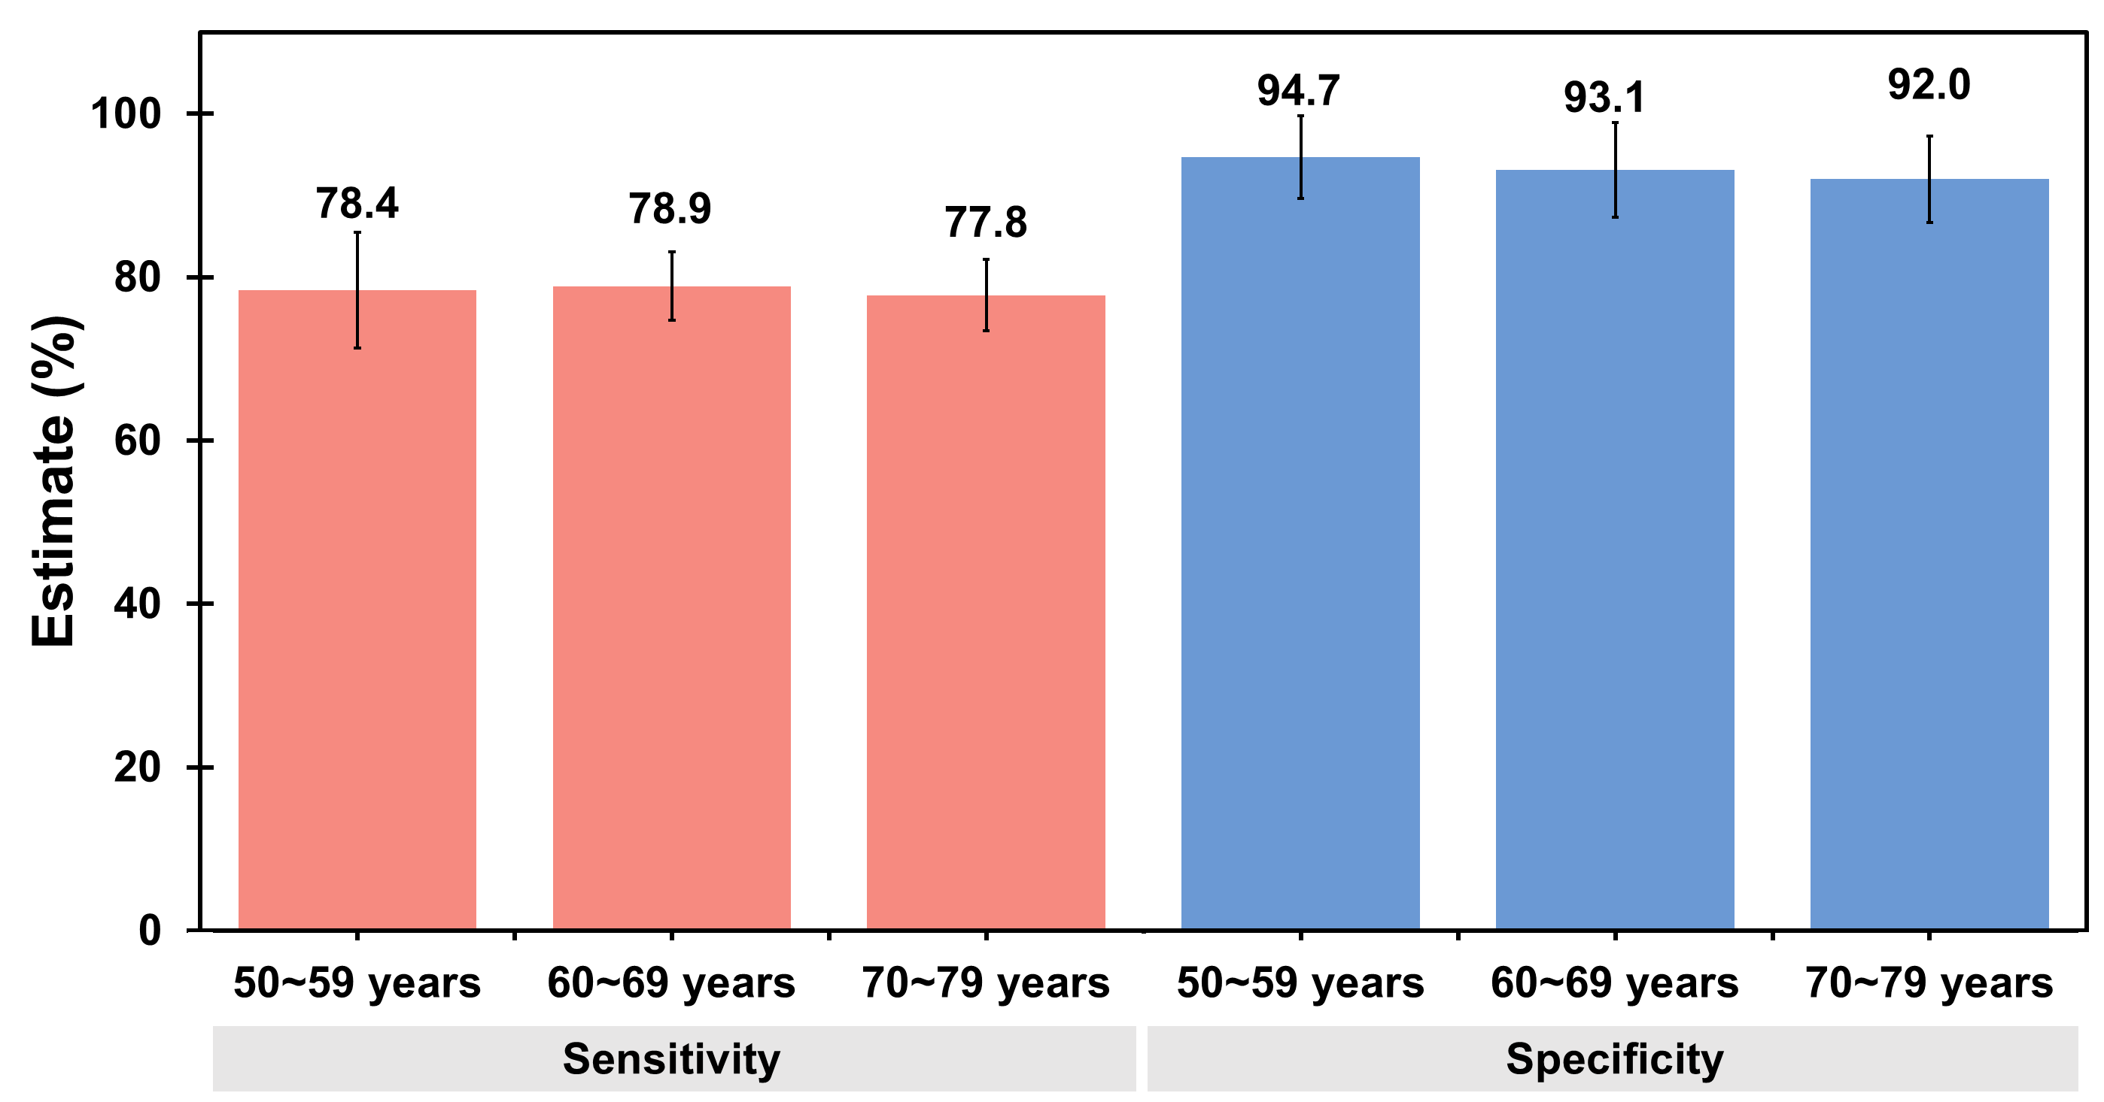

**Figure S3**. Age-group specific sensitivity and specificity of 9G testTM Cancer/Lung test for identification of risk of lung cancer.

**Table S4**. Smoking-history specific sensitivity and specificity of 9G testTM Cancer/Lung test for identification of risk of lung cancer.

| **Smoking history** | **Cancer (N = 885)** | **Benign (N = 247)** |
| --- | --- | --- |
| Smoker | **556** | **125** |
| High-risk of lung cancer (Index > 3.5) | 438 (78.8%) | 7 (5.6%) |
| Low-risk of lung cancer (Index ≤ 3.5) | 118 (21.2%) | 118 (94.4%) |
| Sensitivity |  |  |
| Estimates (%) | 78.8 | - |
| (95% CI) | (75.4, 82.2) | - |
| Specificity |  |  |
| Estimates (%) | 94.4 | - |
| (95% CI) | (90.4, 98.4) | - |
| Never smoker | **329** | **122** |
| High-risk of lung cancer (Index > 3.5) | 256 (77.8%) | 10 (8.2%) |
| Low-risk of lung cancer (Index ≤ 3.5) | 73 (22.2%) | 112 (91.8%) |
| Sensitivity |  |  |
| Estimates (%) | 77.8 | - |
| (95% CI) | (73.3, 82.3) | - |
| Specificity |  |  |
| Estimates (%) | 91.8 | - |
| (95% CI) | (86.9, 96.7) | - |

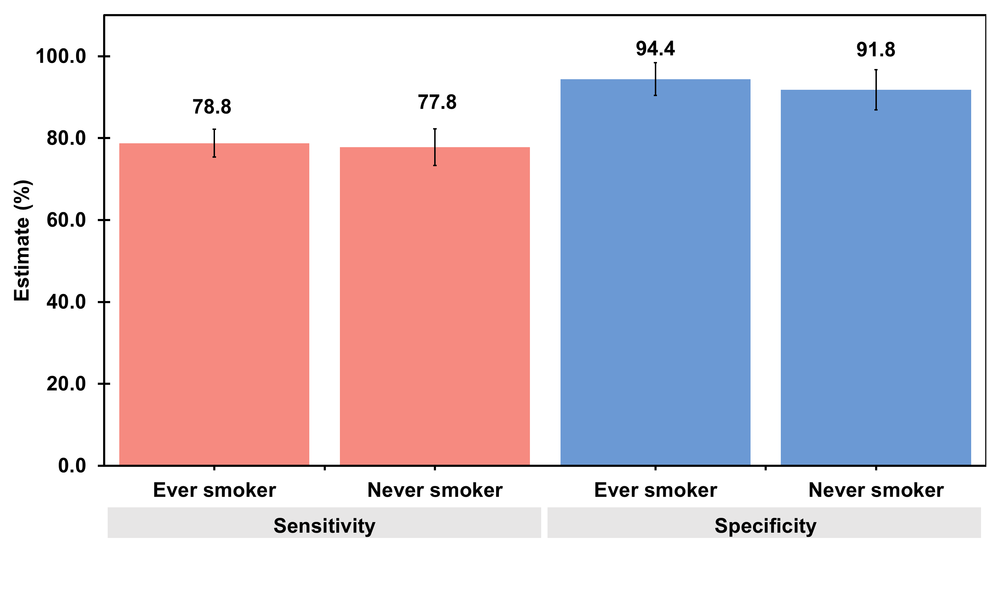

**Figure S4**. Smoking-history specific sensitivity and specificity of 9G testTM Cancer/Lung test for identification of risk of lung cancer.

**Table S5**. Tumor tissue histology based sensitivity and specificity of 9G testTM Cancer/Lung test for identification of risk of lung cancer.

| **Cancer Type** | **Cancer (N = 885)** | **Benign (N = 247)** |
| --- | --- | --- |
| Non-Small Cell Lung Cancer (NSCLC) | **757** | **247** |
| High-risk of lung cancer (Index > 3.5) | 591 (78.1%) | 17 (6.9%) |
| Low-risk of lung cancer (Index ≤ 3.5) | 166 (21.9%) | 230 (93.1%) |
| Sensitivity |  |  |
| Estimates (%) | 78.1 | - |
| (95% CI) | (75.1, 81.0) | - |
| Specificity |  |  |
| Estimates (%) | 93.1 | - |
| (95% CI) | (90.0, 96.3) | - |
| Small Cell Lung Cancer (SCLC) | **128** | **247** |
| High-risk of lung cancer (Index > 3.5) | 103 (80.5%) | 17 (6.9%) |
| Low-risk of lung cancer (Index ≤ 3.5) | 25 (19.5%) | 230 (93.1%) |
| Sensitivity |  |  |
| Estimates (%) | 80.5 | - |
| (95% CI) | (73.6, 87.3) | - |
| Specificity |  |  |
| Estimates (%) | 93.1 | - |
| (95% CI) | (90.0, 96.3) | - |

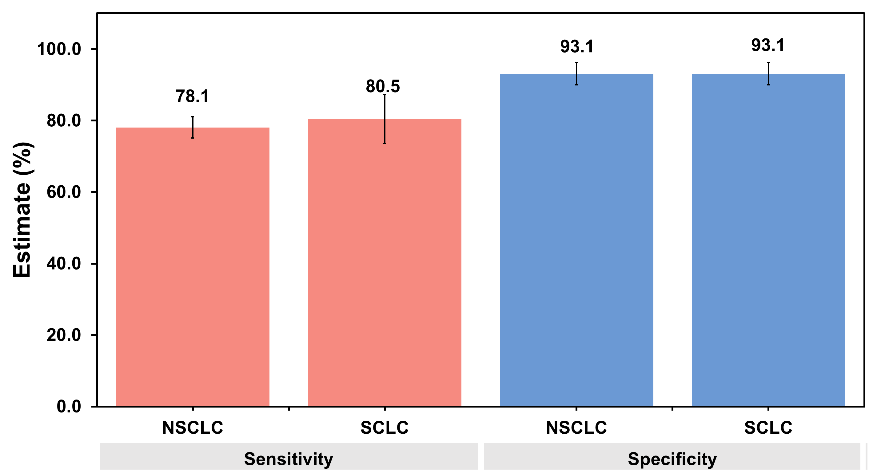

**Figure S5**. Tumor tissue histology based sensitivity and specificity of 9G testTM Cancer/Lung test for identification of risk of lung cancer.

**Table S6.** Lung cancer stage-specific sensitivity and specificity of 9G testTM Cancer/Lung test for identification of risk of lung cancer.

| **Cancer Stages** | **Cancer (N = 885)** | **Benign (N = 247)** |
| --- | --- | --- |
| **Stage I** | **408** | **247** |
| High-risk of lung cancer (Index > 3.5) | 329 (80.6%) | 17 (6.9%) |
| Low-risk of lung cancer (Index ≤ 3.5) | 79 (19.4%) | 230 (93.1%) |
| Sensitivity |  |  |
| Estimates (%) | 80.6 | - |
| (95% CI) | (76.8, 84.5) | - |
| Specificity |  |  |
| Estimates (%) | 93.1 | - |
| (95% CI) | (90.0, 96.3) | - |
| **Stage II** | **142** | **247** |
| High-risk of lung cancer (Index > 3.5) | 104 (73.2%) | 17 (6.9%) |
| Low-risk of lung cancer (Index ≤ 3.5) | 38 (26.8%) | 230 (93.1%) |
| Sensitivity |  |  |
| Estimates (%) | 73.2 | - |
| (95% CI) | (66.0, 80.5) | - |
| Specificity |  |  |
| Estimates (%) | 93.1 | - |
| (95% CI) | (90.0, 96.3) | - |
| **Stage III** | **146** | **247** |
| High-risk of lung cancer (Index > 3.5) | 108 (74.0%) | 17 (6.9%) |
| Low-risk of lung cancer (Index ≤ 3.5) | 38 (26.0%) | 230 (93.1%) |
| Sensitivity |  |  |
| Estimates (%) | 74.0 | - |
| (95% CI) | (66.9, 81.1) | - |
| Specificity |  |  |
| Estimates (%) | 93.1 | - |
| (95% CI) | (90.0, 96.3) | - |
| **Stage IV** | **61** | **247** |
| High-risk of lung cancer (Index > 3.5) | 50 (82.0%) | 17 (6.9%) |
| Low-risk of lung cancer (Index ≤ 3.5) | 11(18.0%) | 230 (93.1%) |
| Sensitivity |  |  |
| Estimates (%) | 82.0 | - |
| (95% CI) | (72.3, 91.6) | - |
| Specificity |  |  |
| Estimates (%) | 93.1 | - |
| (95% CI) | (90.0, 96.3) | - |
| **Limited Disease (LD)** | **57** | **247** |
| High-risk of lung cancer (Index > 3.5) | 47 (82.5%) | 17 (6.9%) |
| Low-risk of lung cancer (Index ≤ 3.5) | 10 (17.5%) | 230 (93.1%) |
| Sensitivity |  |  |
| Estimates (%) | 82.5 | - |
| (95% CI) | (72.6, 92.3) | - |
| Specificity |  |  |
| Estimates (%) | 93.1 | - |
| (95% CI) | (90.0, 96.3) | - |
| **Extensive Disease (ED)** | **71** | **247** |
| High-risk of lung cancer (Index > 3.5) | 56 (78.9%) | 17 (6.9%) |
| Low-risk of lung cancer (Index ≤ 3.5) | 15 (21.1%) | 230 (93.1%) |
| Sensitivity |  |  |
| Estimates (%) | 78.8 | - |
| (95% CI) | (69.4, 88.4) | - |
| Specificity |  |  |
| Estimates (%) | 93.1 | - |
| (95% CI) | (90.0, 96.3) | - |

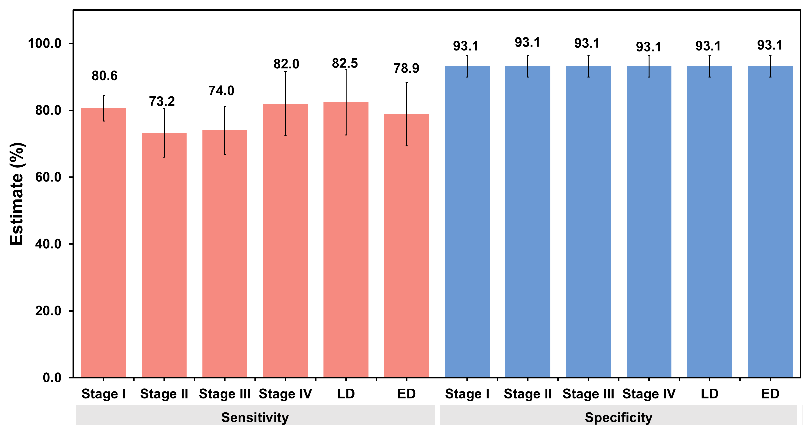

**Figure S6**. Lung cancer stage-specific sensitivity and specificity of 9G testTM Cancer/Lung test for identification of risk of lung cancer.