Supplementary Information

for

Development of a ZRS reporter system for the newt (*Cynops pyrrhogaster*) during terrestrial limb regeneration

Martin Miguel Casco-Robles1,*, Ryosuke Ikeda2, Fumiaki Maruo1 and Chikafumi Chiba1

*MMC-R (email: casco.miguel.gm@u.tsukuba.ac.jp)

1. Supplementary Figures
2. Supplementary Tables

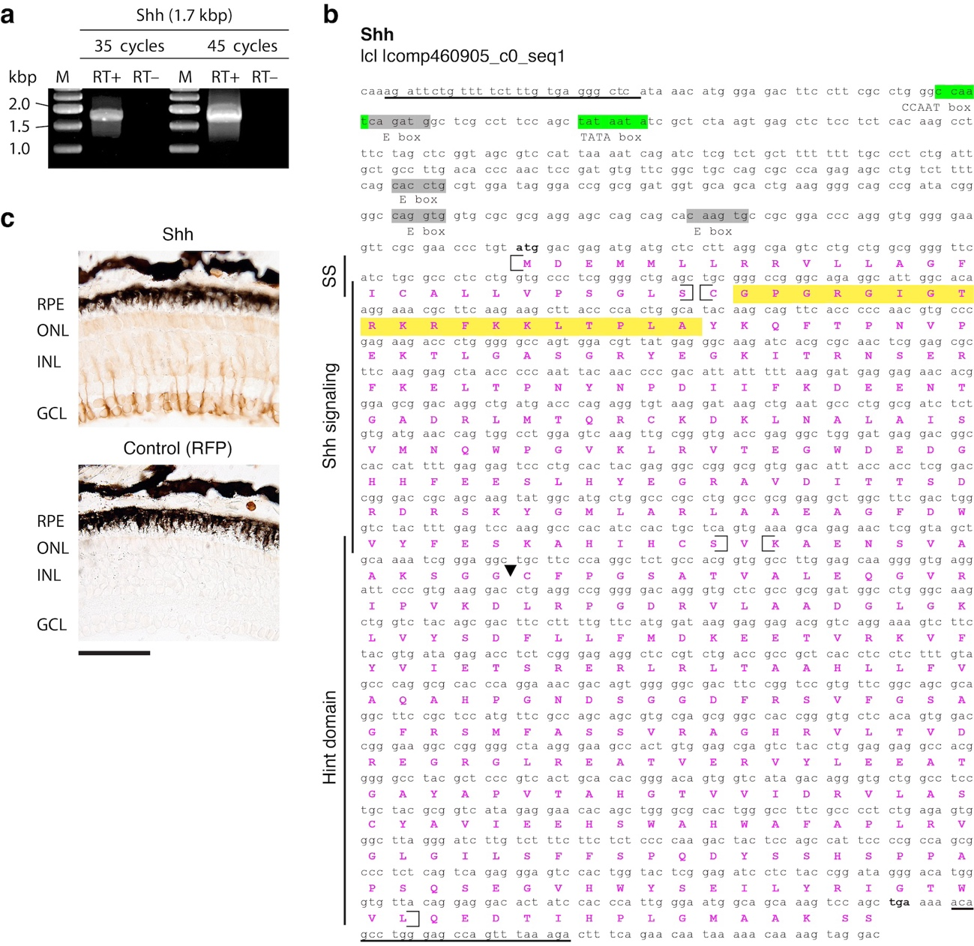

**Figure S1**. Production of the newt anti-Shh antibody and validation. (**a**) PCR for Shh using limb blastema cDNA. Increasing the number of cycles from 35 to 45 did not result in the detection of additional bands. In each sample, the same template was used. +: template with reverse transcription. –: template without reverse transcription. M: marker. (**b**) *Cynops pyrrhogaster* cDNA sequence of Shh (**a**) was referenced to a Shh transcript (comp460905_c0_seq1) found in the transcriptome database TOTAL [13]. Underlined are the primer sets for PCR to amplify the Shh transcript (**a**). The Shh nucleotide sequence is available at Genbank with accession number PQ306330. The 5′ UTR sequence contains the CCAT box and the TATA box (highlighted in green) previously described in the human Shh gene [57]. Three uncharacterized E-boxes were found in the 5′ UTR, highlighted in grey. The amino acid sequence is shown in pink capital letters. The amino acid sequence highlighted in yellow indicates the epitope site for antibody production. The black arrowhead indicates the conserved site for internal auto-proteolytic cleavage of Shh, described previously [58]. Open and closed brackets indicate amino acids corresponding to domains on the left. (**c**) We validated our antibody with IHC. The ABC-DAB method was used to detect anti-Shh immunoreactivity in the wild type newt retina, n=3 eyeballs. Anti-RFP antibody was used as a negative control, n=3 eyeballs. Shh was detected in retinal ganglion cells as previously described in the fish retina [27,58]. GCL: ganglion cell layer; INL: inner nuclear layer; ONL: outer nuclear layer; RPE: retinal pigmented epithelium. Scale bar: **c**, 100 µm.

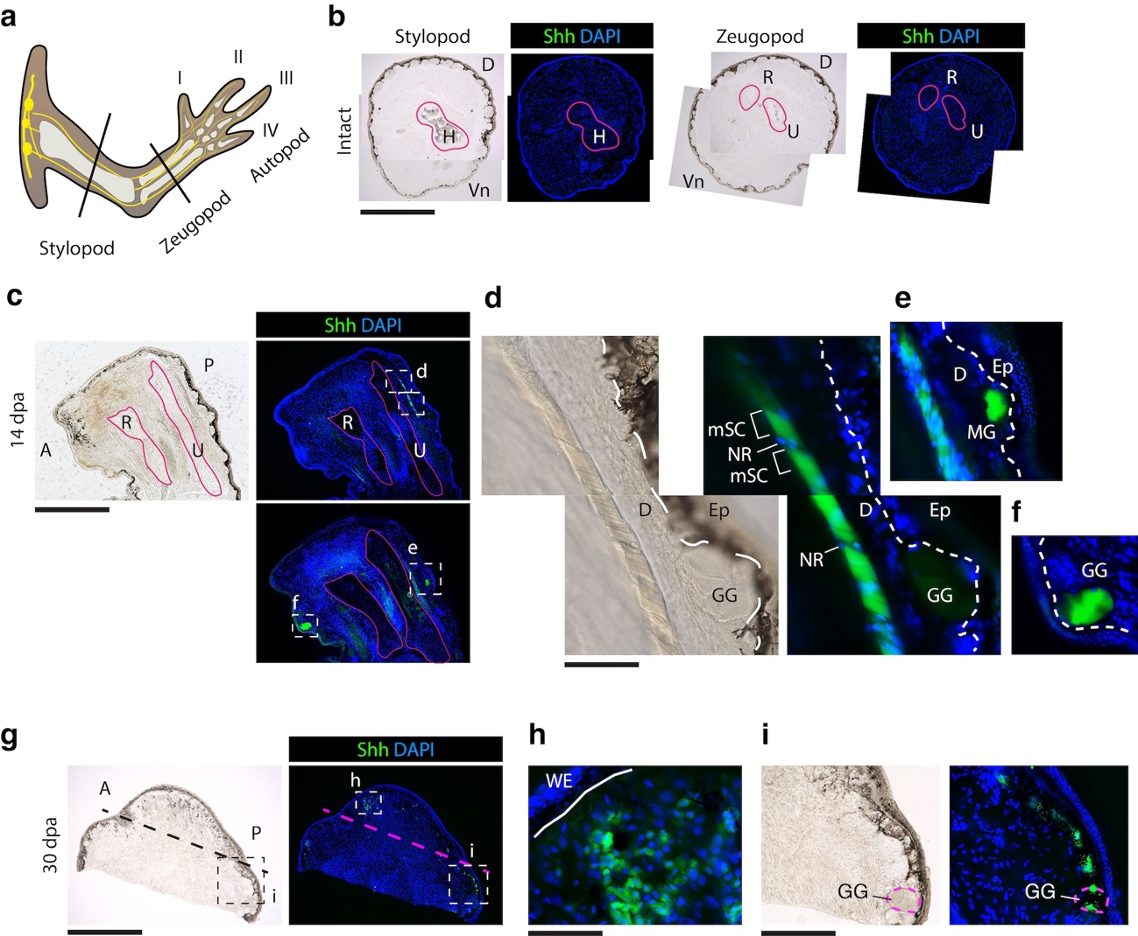

**Figure S2.** Shh protein detection using IHC with anti-Shh polyclonal antibody (Figure S1) was observed in the regenerating limb (dermal nerve mSCs and glands) but not in the intact limb. (**a**) Illustration of the adult newt limb, black solid lines indicating amputations sites used to examine Shh protein in intact limbs. (**b**) Cross-sections of intact limbs were prepared at the level of mid stylopod (humerus) and mid zeugopod (ulna, radius) for IHC, n=3 limbs. Shh protein expression was not detected. Pink outline indicates bone. (**c**) Adult limb, following 14 dpa with Shh expression in the dermal nerve, posterior to the ulna, and below the amputation site. Images to the right obtained from (**c**) and stained with IHC. (**d**) High magnification of the boxed region in (**c**). Image to the right, IHC using anti-Shh antibody; here, the Shh nerve fiber shows myelination and nodes of Ranvier. Dotted line indicates the margin between the dermis and epidermis. (**e**) High magnification of the boxed region in (**c**). Here a posterior dermal gland and the dermal nerve fiber expressed Shh. Note the hyper nucleation surrounding the nerve fiber, and early demyelination. (**f**) High magnification of the boxed region in (**c**). An anterior granular gland expressing Shh. (**g**) Adult limb blastema at 30 dpa. Amputation plane indicated by a black dotted line. Image to the right, IHC. Amputation plane indicated by a pink dotted line. (**h**) High magnification of the boxed region in (**g**) showing expression of Shh blastemal cells below the WE. White solid line indicating the WE margin. (**i**) High magnification of the boxed region in (**g**) showing expression of Shh dermal nerve fiber and a posterior gland below the site of amputation (also observed in Figure 6a-e). A: anterior; D: dorsal; dpa: days post amputation; Ep: epithelium; GG: granular gland; H: humerus; MG: mucosal gland; mSC: myelinated Schwann cell; NR: nodes of Ranvier; P: posterior; R: radius; U: ulna; WE: wound epithelium. Scale bars: **b**, 2 mm; **c**, **g**, 1mm; **d**, **e**, **f**, **i**, 200µm; and **h**, 100µm.

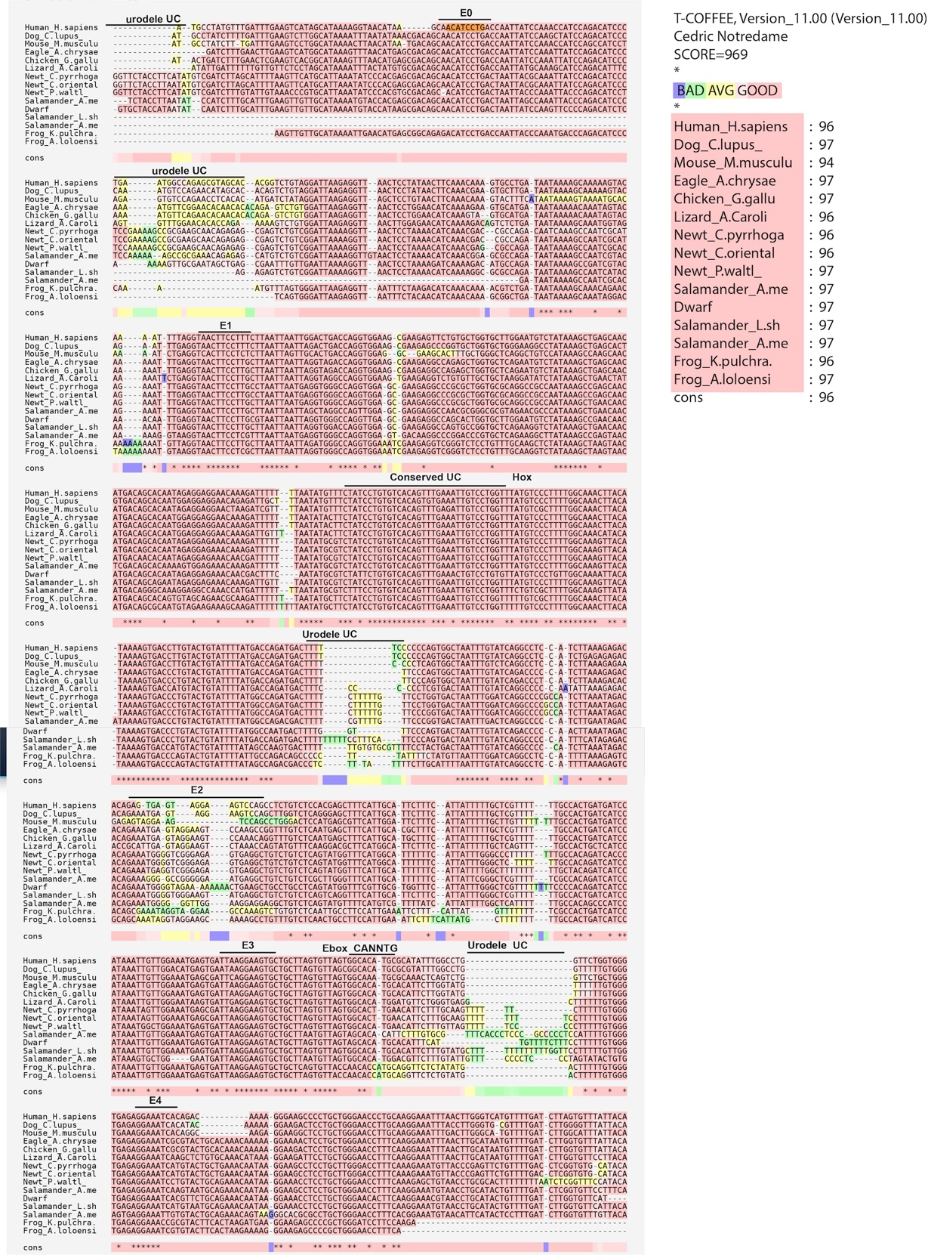

**Figure S3.** Vertebrate ZRS alignment.

Mouse ETS sites are included as E0-E4 [20]. Here we show regions with unique sequences among urodele species that are urodele uncharacterized (UC) and conserved regions among other vertebrates. We detected a 32-bp vertebrate conserved uncharacterized site (UC) (**Supplementary Table 5**) upstream of a reported mouse Hox site [40].

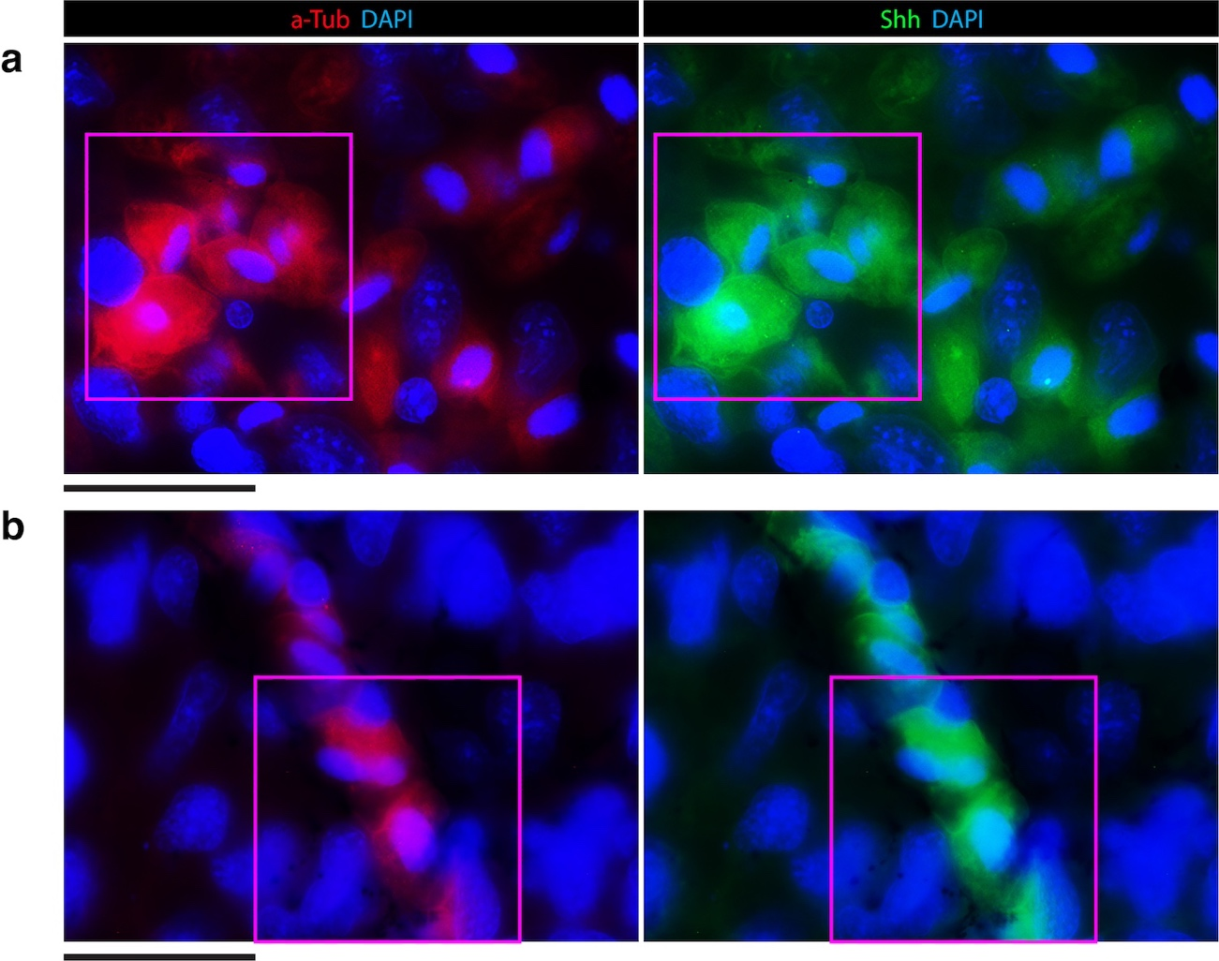

**Figure S4.** Expression of acetylated-tubulin and Shh protein expression in adult wild type blastema at 30 dpa. (**a**)Image enlargement of the panel shown in Figure 6b (pink inset of the blastema). Here, the unmerged image is shown. (**b**) Image enlargement of the panel shown in Figure 6e (pink inset of the blastema). Here, the unmerged image is shown. Scale bars: **a**, **b**, 50µm.

| **Table S1.** Conserved DNA motif/binding sites of the newt nZRS enhancer aligned with those of other vertebrates. Here, the reference mouse ZRS E0 conserved ETS site and HD (Homeodomain) are underlined [20]. | | | | | |
| --- | --- | --- | --- | --- | --- |
| **Name** | **Strand** | **Start** | ***p*-value** | **E0 Conserved Site**  **ETS HD HD** |
| Chicken (*Gallus gallus*) | + | 47 | 6.26e-25 | **CGACAGCAACATCCTGACCAATTATCCAAATTATCCAGACA** |
| Eagle (*Aquila chrysaetos*) | + | 42 | 6.26e-25 | **CGACAGCAACATCCTGACCAATTATCCAAATTATCCAGACA** |
| Dog (*Canis lupus*) | + | 47 | 1.13e-23 | **CGACAGCAACATCCTGACCAATTATCCAAGCTATCCAGACA** |
| Newt (*Cynops orientalis*) | + | 61 | 1.51e-23 | **CGACAGCAACATCCTGACTAATTACGCAAATTATCCAGACA** |
| Newt (*Cynops pyrrhogaster*) | + | 61 | 1.51e-23 | **CGACAGCAACATCCTGACTAATTACGCAAATTATCCAGACA** |
| Axolotl (*Ambystoma mexicanum*) | + | 56 | 5.27e-23 | **CGACAGCAACATCCTGACTAATTAGCCAAATTACCCAGACA** |
| Lizard (*Anolis carolinensis*) | + | 45 | 1.51e-22 | **CGACAGCAACATCCTGACCAATTATGCAAAGCATCCAGACA** |
| Dwarf Siren (*Pseudobranchus axanthus*) | + | 58 | 5.13e-22 | **CGACAGCAACATCCTGACTAATTATCCAAGTTCCCCAGACA** |
| Mouse (*Mus musculus*) | + | 45 | 1.74e-21 | **TGACAGCAcACCAATTATCCAAACCATCCAGCCA** |
| Frog (*Kaloula pulchra*) | + | 28 | 6.03e-21 | **CGGCAGAGACATCCTGACCAATTACCCAAATGACCCAGACA** |
| Human (*Homo sapiens*) | + | 40 | 6.46e-21 | **CATAAGCAACATCCTGACCAATTATCCAAACCATCCAGACA** |
| Frog (*Xenopus tropicalis*) | + | 22 | 9.63e-21 | **CAACAGCAACATCCTGGCCAATTACTCAAACGATCCAGACA** |
| Newt (*Pleurodeles waltl*) | + | 60 | 4.03e-18 | **GCGACAGCACATCCTGACTAATTACCCAAATTACCCAGACA** |

| **Table S2.** Conserved DNA motif/binding sites of the newt nZRS enhancer, detected after alignment with those of other vertebrates. Here, the reference mouse limb development motif sites Pitx1 and Tbx5-Hox like are underlined [41]. | | | | |
| --- | --- | --- | --- | --- |
| **Name** | **Strand** | **Start** | ***p*-value** | **Sites**  **Pitx1 Tbox Hox like** |
| Newt (*Pleurodeles waltl*) | + | 135 | 6.46e-24 | **GTCTGTCGGATTAAAAGGTTAACTCCTAAAACATCAAACGA** |
| Newt (*Cynops orientalis*) | + | 136 | 6.46e-24 | **GTCTGTCGGATTAAAAGGTTAACTCCTAAAACATCAAACGA** |
| Newt (*Cynops pyrrhogaster*) | + | 136 | 6.46e-24 | **GTCTGTCGGATTAAAAGGTTAACTCCTAAAACATCAAACGA** |
| Dog (*Canis lupus*) | + | 116 | 4.84e-22 | **GTCTGTAGGATTAAGAGGTTAACTCCTATAACTTCAAACGA** |
| Frog (*Xenopus tropicalis*) | + | 75 | 1.17e-21 | **TTCTGTGGGATTAAGAGGTTAACTCCTAAAACATCAAACAA** |
| Human (*Homo sapiens*) | + | 109 | 2.60e-21 | **GTCTGTAGGATTAAGAGGTTAACTCCTATAACTTCAAACAA** |
| Salamander (*Liua shihi*) | + | 6 | 3.33e-21 | **GTCTGTCGGATTAAAAGGTTAACTCCTAAAACATCAAAAGG** |
| Eagle (*Aquila chrysaetos*) | + | 112 | 2.83e-19 | **AGTCTGTGGATTAAGAGGTTAACTCCTGGAACATCAAAAGA** |
| Dwarf Siren (*Pseudobranchus axanthus*) | + | 127 | 5.67e-19 | **ATTTGTTGAATTAAAAGGTTAACTCCTAAAAGATCAAAAGA** |
| Mouse (*Mus musculus*) | + | 114 | 1.14e-18 | **ATCTATAGGATTAAGAGGTTAGCTCCTGTAACTTCAAACAA** |
| Chicken (*Gallus gallus*) | + | 117 | 3.12e-18 | **AGTCTGTGGATTAAGAGGTTAACTCCTGGAACATCAAAGTA** |
| Frog (*Kaloula pulchra*) | + | 80 | 8.83e-18 | **TTTAGTGGGATTAAGAGGTTAATTTCTAAGACATCAAACAA** |
| Lizard (*Anolis carolinensis*) | + | 113 | 1.17e-17 | **AGTCTGTGGATTAAGAGGTTAACTTGGAGAACATCAAAAGA** |

| **Table S3.** Conserved DNA motif/binding sites of the newt nZRS enhancer aligned with those of other vertebrates. Here, the reference mouse ZRS E1 conserved ETS site (known as a snake-specific deletion), HD (homeodomain), and ETV2 are underlined [20, 38]. A conserved uncharacterized E-box (CANNTG) was also found among most vertebrates. | | | | |
| --- | --- | --- | --- | --- |
| **Name** | **Strand** | **Start** | ***p*-value** | **Sites**  **E1 Conserved ETS1/ETV2 HD E-box** |
| Salamander (*Liua shihi*) | + | 75 | 1.80e-29 | **AAAAATTTGAGGTAACTTCCTTGCTTAATTAATTAGGTGGACCAGGTGGA** |
| Newt (*Pleurodeles waltl*) | + | 203 | 2.81e-29 | **AGAAATTTGAGGTAACTTCCTTGCTTAATTAATGAGGTGGGCCAGGTGGA** |
| Chicken (*Gallus gallus*) | + | 185 | 2.06e-28 | **AAAAATTTGAGGTAACTTCCTTGCTTAATTAATTAGGTAGACCAGGTGGA** |
| Eagle (*Aquila chrysaetos*) | + | 181 | 2.06e-28 | **AAAAATTTGAGGTAACTTCCTTGCTTAATTAATTAGGTAGACCAGGTGGA** |
| Newt (*Cynops orientalis*) | + | 204 | 3.27e-28 | **AGAAATTTGAGGTAACTTCCTTGCCTAATTAATGAGGTGGGCCAGGTGGA** |
| Newt (*Cynops pyrrhogaster*) | + | 204 | 3.27e-28 | **AGAAATTTGAGGTAACTTCCTTGCCTAATTAATGAGGTGGGCCAGGTGGA** |
| Frog (*Amolops loloensis*) | + | 73 | 9.64e-28 | **AAAAATGTAAGGTAACTTCCTCGCTTAATTAATTAGGTGGGCCAGGTGGA** |
| Frog (*Kaloula pulchra*) | + | 153 | 2.96e-27 | **AAAAATGTTAGGTAACTTCCTTGCTTAATTAATTAGATGGGCCAGGTGGA** |
| Lizard (*Anolis carolinensis*) | + | 184 | 1.24e-26 | **AAAATTCTGAGGTAACTTCCTTGCTTAATTAATTAGGTAGGCCAGGTGGA** |
| Axolotl (*Ambystoma mexicanum*) | + | 200 | 1.03e-25 | **AGAAATTTGAGGTAACTTCCTTGCTTAATTAATTAGCTAGGCCAGTTGGA** |
| Salamander (Amphiuma means) | + | 22 | 2.65e-25 | **AAAAAGGTAAGGTAACTTCCTCGTTTAATTAATGAGGTGGGCCAGGTGGA** |
| Dwarf Siren (*Pseudobranchus axanthus*) | + | 196 | 6.27e-25 | **AAACAATTGAGGTAACTTCCTTGCGTAATTAATTAGGTGGGCCAGGTTGA** |
| Dog (*Canis lupus*) | + | 184 | 8.77e-25 | **CAGAATTTGAGGTAACTTCCTTTCTTAATTAATTAGACTGACCAGGTGGA** |
| Human (Homo sapiens) | + | 177 | 2.11e-24 | **CAAAATTTTAGGTAACTTCCTTTCTTAATTAATTGGACTGACCAGGTGGA** |
| Frog (*Xenopus tropicalis*) | + | 176 | 3.01e-24 | **CGAAATGCAAGGTAACTTCCTAGTGTAATTAATTAGGTGGGCCAGGTGGA** |
| Mouse (*Mus musculus*) | + | 183 | 1.64e-22 | **CAAAATCTGAGGTCACTTCCTCTCTTAATTAGTTGCACTGACCAGGTGGA** |

| **Table S4.** Conserved DNA motif/binding sites of the newt ZRS enhancer aligned with those of other vertebrates. This region contained a characterized mouse ETV, a regulator in the limb bud [37]. | | | | |
| --- | --- | --- | --- | --- |
| **Name** | **Strand** | **Start** | ***p*-value** | **Sites**  **ETV** |
| Chicken (*Gallus gallus*) | + | 269 | 3.18e-30 | **ATAAAGCTGAGCAACATGACAGCACAATGGAGGAGGAACAAAGATTTTTT** |
| Eagle (*Aquila chrysaetos*) | + | 265 | 3.18e-30 | **ATAAAGCTGAGCAACATGACAGCACAATGGAGGAGGAACAAAGATTTTTT** |
| Human (Homo sapiens) | + | 261 | 1.26e-29 | **ATAAAGCTGAGCAACATGACAGCACAATAGAGGAGGAACAAAGATTTTTT** |
| Newt (*Cynops orientalis*) | + | 287 | 4.34e-29 | **ATAAAGCCGAGCAACATGACAGCACAATAGAGGAGAAACAAAGATTTTTT** |
| Newt (*Cynops pyrrhogaster*) | + | 287 | 4.34e-29 | **ATAAAGCCGAGCAACATGACAGCACAATAGAGGAGAAACAAAGATTTTTT** |
| Salamander (*Liua shihi*) | + | 158 | 1.88e-26 | **ATAAAGCTGAACAACATGACAGCAGAATAGAGGAGAAACAAAGATTGTTT** |
| Lizard (*Anolis carolinensis*) | + | 268 | 5.39e-26 | **ATAAAGCTGAACTATATGACAGCACAATGGAGGAGGAACAAAGATTGTTT** |
| Newt (*Pleurodeles waltl*) | + | 286 | 7.30e-26 | **ATAAAGCTGAACAACATGACAACACAATAGAGGAGAAACAACGATTTTTT** |
| Mouse (*Mus musculus*) | + | 264 | 5.41e-25 | **ATAAAGCCAAGCAACATGACAGCACAATAGAGGAGGAACTAAGATCGTTT** |
| Dwarf Siren (*Pseudobranchus axanthus*) | + | 279 | 7.27e-24 | **ATAAAGCCGAACAACATGACAGCACAATAGAGGAGAAACAACGACTTTCA** |
| Axolotl (*Ambystoma mexicanum*) | + | 283 | 7.84e-24 | **ATAAAGCTGAACAACTCGACAGCACAAAAGTGGAGAAACAAAGATTTTTT** |
| Frog (*Amolops loloensis*) | + | 158 | 1.87e-23 | **ATAAAGCTAAGTAACATGACAGCGCAATGTAGAAGAAAGCAAGATTTTTT** |
| Dog (*Canis lupus*) | + | 268 | 1.87e-23 | **ATAAAGCTGAGCACTGTGACAGCACAATGGAGGAGGAACAGAGATTGCTT** |
| Frog (*Kaloula pulchra*) | + | 238 | 2.28e-22 | **ATAAAGCTAAGTAACATGACAGCACAGTGTAGCAGAACGCAAGATTTTTT** |
| Salamander (*Amphiuma means*) | + | 105 | 4.33e-22 | **ATAAAGCCGAGTAACATGACAGGGCAAAGGAGGCCAAACCATGATTTTTT** |
| Frog (*Xenopus tropicalis*) | + | 260 | 1.38e-21 | **ATAAAGCTGGGTTACATGACAGCACCACGGCGAGGGAAGAAAGATTTTTT** |

| **Table S5.** Conserved uncharacterized DNA site of the newt nZRS enhancer aligned with that of other vertebrates. This region contained a ETV2, EOMES, and Tbx4 detected in JASPAR (motif ID: MA0762.1.ETV2, UN0511.1.ETV2::EOMES, and MA0806.1.TBX4), and underlined. Conserved Hox site of the mouse ZRS [40]. | | | | | | | |
| --- | --- | --- | --- | --- | --- | --- | --- |
| **Name** | **Strand** | |  | ***p*-value** | | **Sites**  ETV2::EOMES Tbx4  **Hox** |  | |
| Salamander (*Liua shihi*) | + | 1.46e-30 | | | **CTATCCTGTGTCACAGTTTGAAATTGTCCTGGTTTATGTCCCTTTTGGCA** | | |
| Axolotl (*Ambystoma mexicanum*) | + | 1.46e-30 | | | **CTATCCTGTGTCACAGTTTGAAATTGTCCTGGTTTATGTCCCTTTTGGCA** | | |
| Newt (*Pleurodeles waltl*) | + | 1.46e-30 | | | **CTATCCTGTGTCACAGTTTGAAATTGTCCTGGTTTATGTCCCTTTTGGCA** | | |
| Newt (*Cynops orientalis*) | + | 1.46e-30 | | | **CTATCCTGTGTCACAGTTTGAAATTGTCCTGGTTTATGTCCCTTTTGGCA** | | |
| Newt (*Cynops pyrrhogaster*) | + | 1.46e-30 | | | **CTATCCTGTGTCACAGTTTGAAATTGTCCTGGTTTATGTCCCTTTTGGCA** | | |
| Lizard (*Anolis carolinensis*) | + | 1.46e-30 | | | **CTATCCTGTGTCACAGTTTGAAATTGTCCTGGTTTATGTCCCTTTTGGCA** | | |
| Chicken (*Gallus gallus*) | + | 1.46e-30 | | | **CTATCCTGTGTCACAGTTTGAAATTGTCCTGGTTTATGTCCCTTTTGGCA** | | |
| Eagle (*Aquila chrysaetos*) | + | 1.46e-30 | | | **CTATCCTGTGTCACAGTTTGAAATTGTCCTGGTTTATGTCCCTTTTGGCA** | | |
| Human (Homo sapiens) | + | 1.46e-30 | | | **CTATCCTGTGTCACAGTTTGAAATTGTCCTGGTTTATGTCCCTTTTGGCA** | | |
| Frog (*Amolops loloensis*) | + | 2.92e-30 | | | **CTATCCTGTGTCACAGTTTGAAATTGTCCTGGTTTTTGTCCCTTTTGGCA** | | |
| Dog (*Canis lupus*) | + | 1.03e-29 | | | **CTATCCTGTGTCACAGTGTGAAATTGTCCTGGTTTATGTCCCTTTTGGCA** | | |
| Frog (*Kaloula pulchra*) | + | 1.72e-29 | | | **CTATCCTGTGTCACAGTTTGAAATTGTCCTGGTTTTTGTCGCTTTTGGCA** | | |
| Mouse (*Mus musculus*) | + | 3.69e-29 | | | **CTATCCTGTGTCACAGTTTGAGATTGTCCTGGTTTATGTCGCTTTTGGCA** | | |
| Salamander (*Amphiuma means*) | + | 2.00e-28 | | | **CTTTCCTGTGTCACAGTTTGAAATTGTCCTGGTTTCTGTCGCTTTTGGCA** | | |
| Frog (*Xenopus tropicalis*) | + | 3.81e-27 | | | **TTATCCTGTGTCACAGTTTGAAATTGTCCTGGTTTTTCTCCCTGATGGCA** | | |
| Dwarf Siren (*Pseudobranchus axanthus*) | + | 6.56e-27 | | | **CTATTCTGTGTCACAGTTTGAAACTGTCCTGTGTTATGTCCCTGTTGGCA** | | |

| **Table S6.** Conserved DNA motif/binding sites of the newt nZRS enhancer aligned with those of other vertebrates. This region contained conserved Hox sites, WMS (Werner mesomelic syndrome), and E-box previously described in the mouse ZRS [40], which are underlined. This region also contained the HAND2 mouse site [39]. | | | | |
| --- | --- | --- | --- | --- |
| **Name** | **Strand** | **Start** | ***p*-value** | **Sites**  **Hox WMS Hox HAND2/E-box** |
| Newt (*Pleurodeles waltl*) | + | 395 | 1.85e-29 | **AAGTTACATAAAAGTGACCCTGTACTGTATTTTATGGCCAGATGACTTTT** |
| Newt (*Cynops orientalis*) | + | 396 | 1.85e-29 | **AAGTTACATAAAAGTGACCCTGTACTGTATTTTATGGCCAGATGACTTTT** |
| Newt (*Cynops pyrrhogaster*) | + | 396 | 1.85e-29 | **AAGTTACATAAAAGTGACCCTGTACTGTATTTTATGGCCAGATGACTTTT** |
| Chicken (*Gallus gallus*) | + | 379 | 2.87e-29 | **AACTTACATAAAAGTGACCCTGTACTGTATTTTATGACCAGATGACTTTT** |
| Eagle (*Aquila chrysaetos*) | + | 375 | 2.87e-29 | **AACTTACATAAAAGTGACCCTGTACTGTATTTTATGACCAGATGACTTTT** |
| Salamander (*Liua shihi*) | + | 267 | 5.53e-29 | **AAGTTACATAAAAGTGACCCTGTACTGTATTTTATGACCAGATGACTTTT** |
| Mouse (*Mus musculus*) | + | 374 | 2.76e-28 | **AACTTACATAAAAGTGACCTTGTACTGTATTTTATGACCAGATGACTTTT** |
| Dog (*Canis lupus*) | + | 378 | 2.76e-28 | **AACTTACATAAAAGTGACCTTGTACTGTATTTTATGACCAGATGACTTTT** |
| Human (Homo sapiens) | + | 371 | 2.76e-28 | **AACTTACATAAAAGTGACCTTGTACTGTATTTTATGACCAGATGACTTTT** |
| Lizard (*Anolis carolinensis*) | + | 378 | 3.14e-26 | **AACATACATAAAAGTGACCATGTACTGTATTTTATGACCAGATGACTTTC** |
| Frog (*Xenopus tropicalis*) | + | 370 | 7.30e-26 | **AACTTACATAAAAGTGACCCTTTACTGTATTTTATAGCCAGACAACTTTT** |
| Frog (*Amolops loloensis*) | + | 270 | 1.71e-25 | **AACTTACATAAAAGTGACCCAGTACTGTATTTTATAGCCAGACGACCCTC** |
| Salamander (Amphiuma means) | + | 215 | 2.38e-24 | **AAGTTATATAAAAGTGACCATGTACTGTATTTTATAGCCAAGTGACTTTT** |
| Axolotl (*Ambystoma mexicanum*) | + | 393 | 6.59e-24 | **AGTTACAATAAAAGTGACCCTGTACTGTATTTTATGGCCAGACGACTTTT** |
| Frog (*Kaloula pulchra*) | + | 348 | 2.61e-23 | **AACTTACATAAAAGTGACCCAGTACTGTATTTTATTGCCAGACAGCCCCC** |
| Dwarf Siren (*Pseudobranchus axanthus*) | + | 387 | 1.31e-22 | **AAATTACATAAAAGTGACCCTGTACTGTATTTTATGGCCAATGACTTTTG** |

| **Table S7.** Conserved DNA motif/binding sites of the newt nZRS enhancer aligned with those of other vertebrates. Here the reference mouse ZRS E3 conserved ETS site [20], Hox site [40], and ETV site [20, 37, 38]. | | | | |
| --- | --- | --- | --- | --- |
| **Name** | **Strand** | **Start** | ***p*-value** | **Site**  **Hox E3 ETV/ETS Conserved** |
| Salamander (*Liua shihi*) | + | 464 | 4.69e-30 | **TCCATAAATTGTTGGAAATGAGTGATTAAGGAAGTGCTGCTTAGTGTTAG** |
| Chicken (*Gallus gallus*) | + | 563 | 4.69e-30 | **TCCATAAATTGTTGGAAATGAGTGATTAAGGAAGTGCTGCTTAGTGTTAG** |
| Eagle (*Aquila chrysaetos*) | + | 558 | 4.69e-30 | **TCCATAAATTGTTGGAAATGAGTGATTAAGGAAGTGCTGCTTAGTGTTAG** |
| Human (Homo sapiens) | + | 553 | 4.69e-30 | **TCCATAAATTGTTGGAAATGAGTGATTAAGGAAGTGCTGCTTAGTGTTAG** |
| Frog (*Amolops loloensis*) | + | 458 | 3.05e-29 | **TCCATAAATTGTTGGAAATGAGTGATTAAGGAAGTGCTGCTTAGTGTTAC** |
| Axolotl (*Ambystoma mexicanum*) | + | 584 | 3.05e-29 | **TCCATAAATTGTTGGAAATGAGTGATTAAGGAAGTGCTGCTTAATGTTAG** |
| Newt (*Cynops orientalis*) | + | 589 | 7.50e-29 | **TCCATAAATAGTTGGAAATGAGCGATTAAGGAAGTGCTGCTTAGTGTTAG** |
| Dwarf Siren (*Pseudobranchus axanthus*) | + | 580 | 1.44e-28 | **TCCATAAATTGTTGGAAATGAGTGATTAAGGAAGTACTGCTTAGTGTTAG** |
| Mouse (*Mus musculus*) | + | 552 | 1.77e-28 | **TCCATAAATTGTTGGAAATGAGCGATTCAGGAAGTGCTGCTTAGTGTTAG** |
| Newt (*Pleurodeles waltl*) | + | 589 | 2.02e-28 | **TCCATAAATGGCTGGAAATGAGTGATTAAGGAAGTGCTGCTTAGTGTTAG** |
| Newt (*Cynops pyrrhogaster*) | + | 591 | 3.32e-28 | **CCCATAAATAGTTGGAAATGAGCGATTAAGGAAGTGCTGCTTAGTGTTAG** |
| Frog (*Kaloula pulchra*) | + | 531 | 4.72e-28 | **TCCATAAATTGTTGGAAATGAGTGATTAAGGAAGTGCTGCTCAGTGTTAC** |
| Dog (*Canis lupus*) | + | 559 | 1.05e-27 | **TCCATAAATTGTTGGACATGAGTGAATAAGGAAGTGCTGCTTAGTGTTAG** |
| Frog (*Xenopus tropicalis*) | + | 554 | 2.01e-27 | **TCCATAAATTGCTGGAAATGAGTGATTAAGGGAGTGCTGCTTAATGTTAG** |
| Lizard (*Anolis carolinensis*) | + | 564 | 9.61e-27 | **TCCATAAATTGTTGGGAATAAGTGATTGAGGAAGTGCTGCTTAGTGTTAG** |
| Salamander (*Amphiuma means*) | + | 405 | 9.56e-21 | **CCCATCCATAAAGTGCTGGGAATGATTAAGGAAGTGCTGCTTAATGTTAG** |

| **Table S8.** Conserved DNA motif/binding sites of the newt nZRS enhancer aligned with those of other vertebrates. Here, the reference mouse ZRS E4 conserved ETS site (AGGAAATC elements) and EST1 [20, 37, 38] are underlined, noting that the human and mouse E4 sites are not shown, as blocks were not generated during MEME motif alignment. This region contained a Tbx element detected in JASPAR (motif ID: Tbx4 87 MA0806.1, TBX5 MA0807.1), shown in yellow. | | | | |
| --- | --- | --- | --- | --- |
| **Name** | **Strand** | **Start** | ***p*-value** | **Sites**  **Tbx ETV2/ETS E4 Conserved EST1** |
| Newt (*Cynops orientalis*) | + | 678 | 3.12e-29 | **GTGGGTGAGAGGAAATCATGTACTGCTGAAACAATAAGGAAGCCTCCTGC** |
| Newt (*Cynops pyrrhogaster*) | + | 677 | 3.12e-29 | **GTGGGTGAGAGGAAATCATGTACTGCTGAAACAATAAGGAAGCCTCCTGC** |
| Chicken (*Gallus gallus*) | + | 643 | 8.66e-29 | **GTGGGTGAGAGGAAATCGCGTACTGCACAAACAAAAAGGAAGACTCCTGC** |
| Newt (*Pleurodeles waltl*) | + | 678 | 1.88e-28 | **GTGGGTGAGAGGAAATCCTGTACTGCAGAAACAATAAGGAAACCTCCTGC** |
| Eagle (*Aquila chrysaetos*) | + | 638 | 2.19e-28 | **GTGGGTGAGAGGAAATCGCGTACTGCACAAACAAAAAGGAAAACTCCTGC** |
| Dwarf Siren (*Pseudobranchus axanthus*) | + | 666 | 3.56e-28 | **GTGGGTGAGAGGAAATCACGTTCTGCAGAAACAATAAGGAAACCTCCTGC** |
| Axolotl (*Ambystoma mexicanum*) | + | 680 | 1.73e-27 | **GTGGGTGAGAGGAAATCAAGTAATGCAGAAACAATAAGGAAGCCTCCTGC** |
| Salamander (*Liua shihi*) | + | 562 | 3.22e-26 | **GTTGGTGAGAGGAAATCATGTAATGCAGAAACAATAAGGAAACCTCCTGC** |
| Frog (*Amolops loloensis*) | + | 540 | 4.02e-24 | **GTGGGTGAGAGGAAATCGTGTACTTCACTAAGAAAAGGGAAGAGCCCCGC** |
| Frog (*Xenopus tropicalis*) | + | 636 | 2.41e-23 | **CTGGGTGAGAGGAAATCATGTACTGCTCCAACAATAAGGAAAGGCCCCCG** |
| Frog (*Kaloula pulchra*) | + | 613 | 3.31e-23 | **GTGGGTGAGAGGAAACCGCGTACTTCACTAAGATGAAGGAAGAGCCCCGC** |
| Lizard (*Anolis carolinensis*) | + | 646 | 9.81e-22 | **GTGGGTGAAAGGAAATCAAGCTCTGTGCAAACATAAAGGAAGATTCCTGC** |
| Salamander (*Amphiuma means*) | + | 498 | 1.26e-19 | **CTGTGAGTGAGGAAATTGTGTACTGCAGAAACAGTAAGGGCACGCGCCTG** |

**Table S9.** Generation of transgenic nZRS reporter newts at F0

|  |  |  |  |  |
| --- | --- | --- | --- | --- |
| DNA pga/egg | Embryos injectedb | Survival St. 38 larvae (%) | mCherry+ limb bud St. 38 larvae (%)c | Survivald St. 57-59 (%)  mCherry |
| 200 | 120 | 41 (34) | 9 (22) | 5 (55) |
| 100 | 214 | 76 (35.5) | 24 (31.5) | 20 (83) |
| 0 | 0e | 23 (100) | - | 22 (96) |

a pg is the total mass of pnZRS-hmp-mcherry01 (Figure 1c), including the vector backbone.

b The injection volume was fixed at 2 nL/embryo. *I*-*Sce*I enzyme concentration was fixed at 2×10–3 U/embryo.

c The onset of ZRS reporter expression was detected in the St. 38 limb bud (Figure 2b), larvae were screened having expression as shown in Figures 1 and 2. A subset of larvae expressing mCherry+ cells in the limb bud (Figure 2) were reared until St. 52-59 (Figure 3), beyond metamorphosis or used for subsequent limb amputation experiments (Figures 4-6).

d Percentage was derived from surviving larvae in St. 38 displaying limb bud mCherry expression (c).

e Viability control group (n = 22/23).