**Supplementary Materials (Table S1 – S5)**

Table S1 Weighing the samples according to waste type

|  |  |
| --- | --- |
| Waste type | FT-IR spectrum and image |
| Incineration | 0.1 g |
| Sewage treatment | 0.5 g |
| Landfill | 0.5 g |
| Intermediate treatment | 2 g |

Table S2 Density values for each major plastic type

|  |  |
| --- | --- |
| Plastic type | Density / g/cm3 |
| Polystyrene (PS) | 0.01 – 1.06 |
| Polypropylene (PP) | 0.85 – 0.92 |
| Low-density polyethylene (LDPE) | 0.89 – 0.93 |
| Ethylene vinyl acetate (EVA) | 0.93 -0.95 |
| High-density polyethylene (HDPE) | 0.94 – 0.98 |
| Polyamide (PA) | 1.12 – 1.15 |
| Nylon 6,6 (PA 6,6) | 1.13 – 1.15 |
| Poly methyl methacrylate (PMMA) | 1.16 – 1.20 |
| Polycarbonate (PC) | 1.20 – 1.22 |
| Polyurethane (PU) | 1.20 – 1.26 |
| Polyethylene terephthalate (PET) | 1.38 – 1.41 |
| Polyvinyl chloride (PVC) | 1.38 – 1.41 |

Table S3 Specific gravity of general reagents for density separation

|  |  |  |
| --- | --- | --- |
| Reagent type | Specific gravity (g/cm3) | Note |
| Sodium chloride (NaCl) | 1.2 |  |
| Sodium polytungstate (PST) | 1.4 |  |
| Sodium iodide (NaI) | 1.6 |  |
| Zinc chloride (ZnCl2) | 1.6 | This study |

Table S4 Characteristic of filter papers according to the type

|  |  |  |  |  |
| --- | --- | --- | --- | --- |
| Type | Size  (um) | Advantage | Disadvantage | Note |
| Anodisc  (Al2O3) | 0.02-0.2 | - Easy to transfer mapping and imaging | - Narrow analysis spectral range  - Difficult to distinguish from PTFE |  |
| Silicon | 1-17 | - Analysis at high resolution  - Size, shape, etc. can be analyzed with dark field | - Uneconomical and low durability  - Si-O acts as an analysis interference material within a certain range |  |
| Gold coated PC | 0.4-0.8 | - Wide MIR range | - Uneconomical and low durability  - Unable to apply sample evenly  - PC peaks are always analyzed regardless of the sample |  |
| Metal | 5, 10, 20-450 | - Inexpensive and easy to handle | - Filtration is not easy | This study |
| PTFE | 0.1-5 | - Transmission mode available | - PTFE is absorbed in a certain spectral range |  |
| Cellulose  Glass fibre | 0.22-25  0.7-2.7 | - Inexpensive and easy to handle | - Analysis takes a lot of time  - Possibility of cross-contamination |  |

Table S5 Conditions of each general solution type used for organic decomposition

|  |  |  |  |  |  |
| --- | --- | --- | --- | --- | --- |
| Division | Solution  type | Temperature | Time | Polymer degradation | Note |
| Acid | HNO3 (35%) | 60oC | 1hr | - PET and HDPE melting  - PA destruction |  |
| HNO3 (5-69%) | Room Temp. | 96hrs | - LDPE and PP melting  - PP, PVE, and PET discoloration |  |
| Alkaline | KOH (10-45%) | 60oC | 24hrs | - Deterioration |  |
| NaOH (10M) | 60oC | 24hrs | - Deterioration |  |
| Oxidizing | H2O2 (30%) | 60oC | 1hr |  | This study |
| H2O2 (6%) | 70oC | 24hrs |  |  |
| Biological | Corolase7086 | 60oC | 1hr |  |  |
| Tripsin | 40oC | 0.1hr |  |  |

**Supplementary Materials (Figure S1 – S2)**

Figure S1 Waste treatment facilities with incineration, sewage treatment, landfill, and intermediate treatment

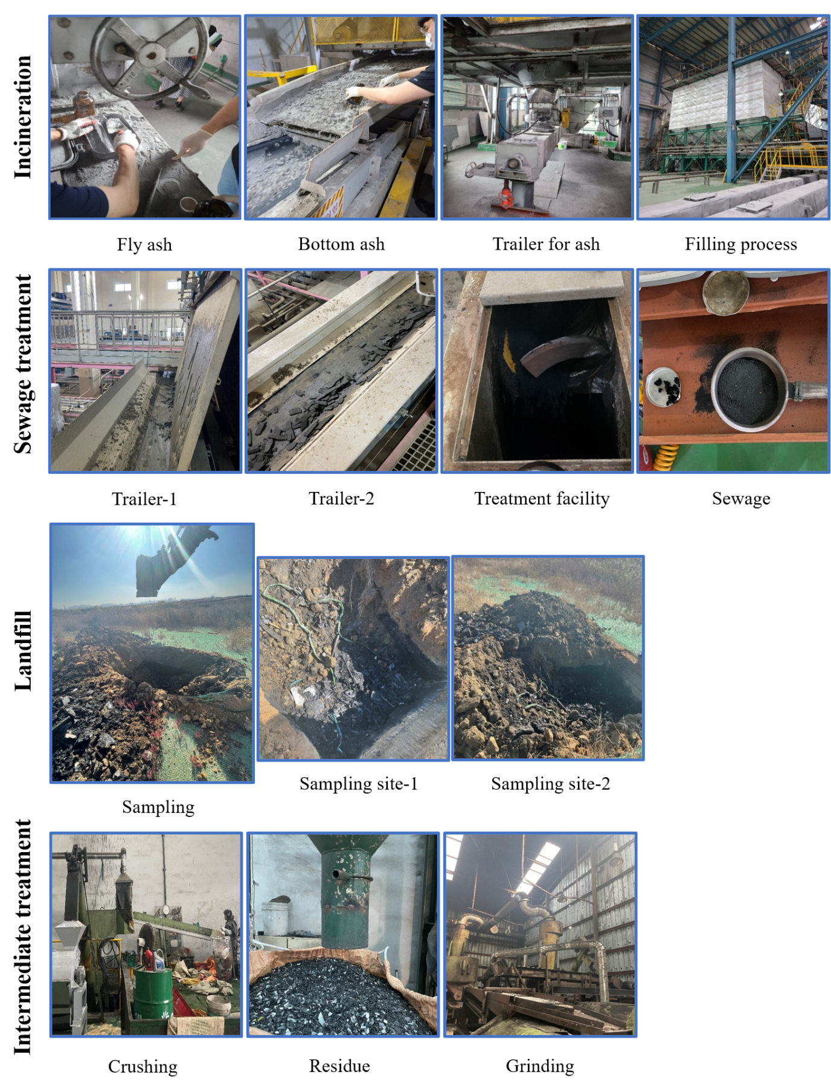

Figure S2 FT-IR (LUMOS Ⅱ, Bruker, USA)

