**Supplementary Materials**

**Contents**

**1. Spectra of compounds**

**2.** **Thermal properties**

**3. Density Functional Theory (DFT) Calculations**

**4.** **Cyclic voltammetry studies**

**1. Spectra of compounds**

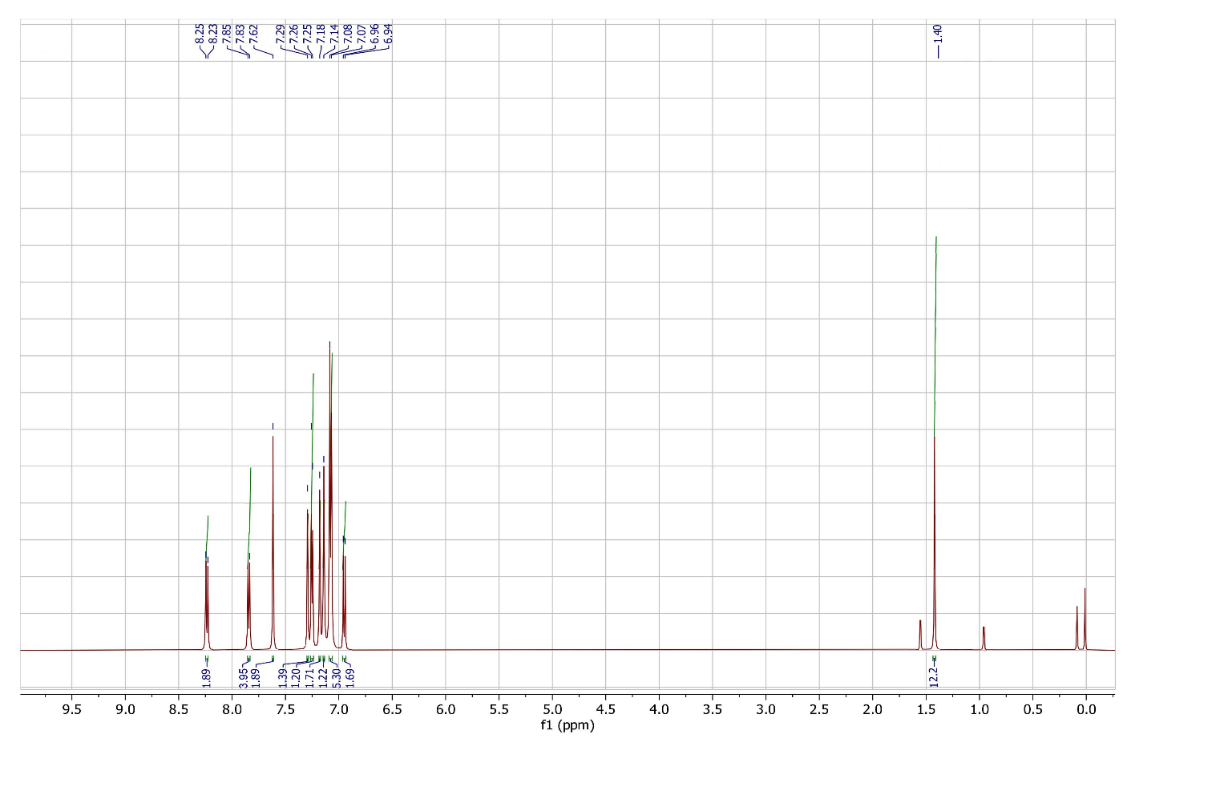

**Figure S1.** 1H NMR spectra of 6-(N,N-diphenylaniline)-2-(4,4,5,5-tetramethyl-1,3,2-dioxaborolanyl)-azulene **4**.

1H NMR: δ 8.25 (d, J = 9.40 Hz, 2H), 7.84 (d, J = 8.3 Hz, 4H), 7.62 (s, 2H), 7.29 – 6.94 (m, 12H), 1.40 (s, 12H).

In this spectrum, the proton signals at С-1 and С-3 (singlet at 7.62 δ) are consistent with the signals of the same protons of the initial molecule **2** [1], which confirms the structure of molecule **4**. In the case of substitution of the azulene position **2** with a diphenylaniline group, a significant shift of proton signals during C-1 and C-3 in a strong field would occur by an average of 1.0 δ due to an increase in electron density in the five-membered ring [2].

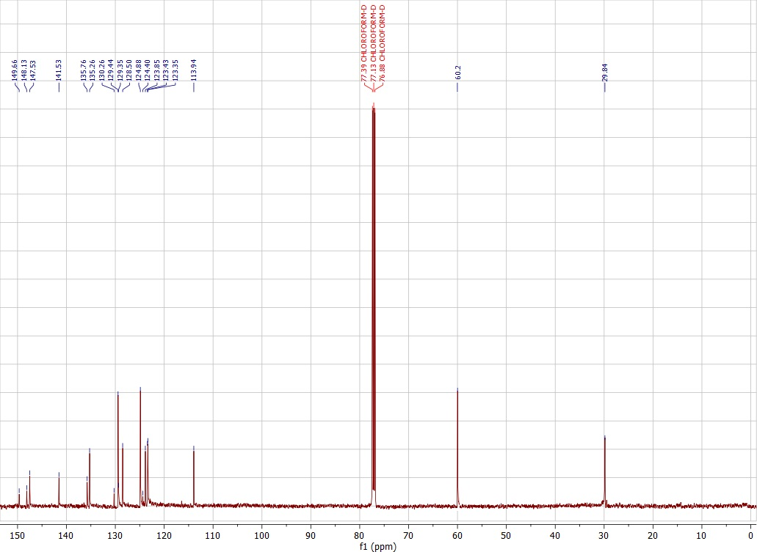

**Figure S2**. 13C NMR spectra of 6-(N,N-diphenylaniline)-2-(4,4,5,5-tetramethyl-1,3,2-dioxaborolanyl)-azulene **4**.

13C NMR: δ 149.66, 148.13, 147.54, 141.53, 135.77, 135.26, 130.26, 129.44, 129.35, 128.50, 124.88, 124.40, 123.85, 123.43, 123.35, 113.94, 60.20, 29.84.

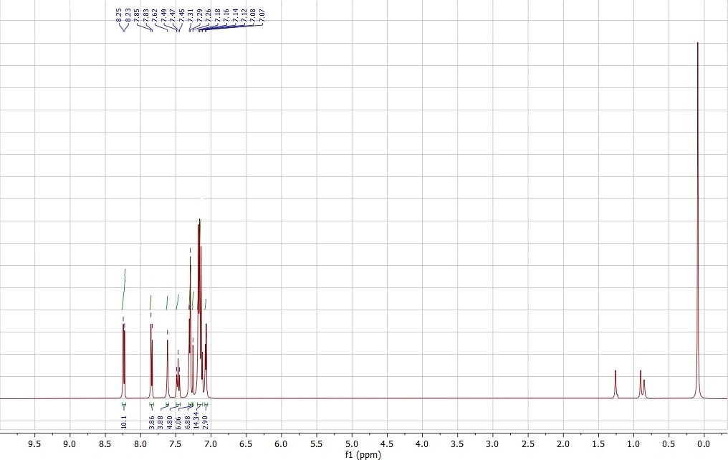

**Figure S3.** 1H NMR spectra of 6,6-Bis(N,N-diphenylaniline)- 2,2-(4-(diphenylamino)phenyl)-bis-azulene  **6**.

1H NMR: δ 8.24 (d, J = 9.4 Hz, 10H), 7.88 (d, J = 12.3 Hz, 4H), 7.62 (s, 4H), 7.47 (t, J = 9.9 Hz, 5H ),7.37 – 7.04 (m, 30H).

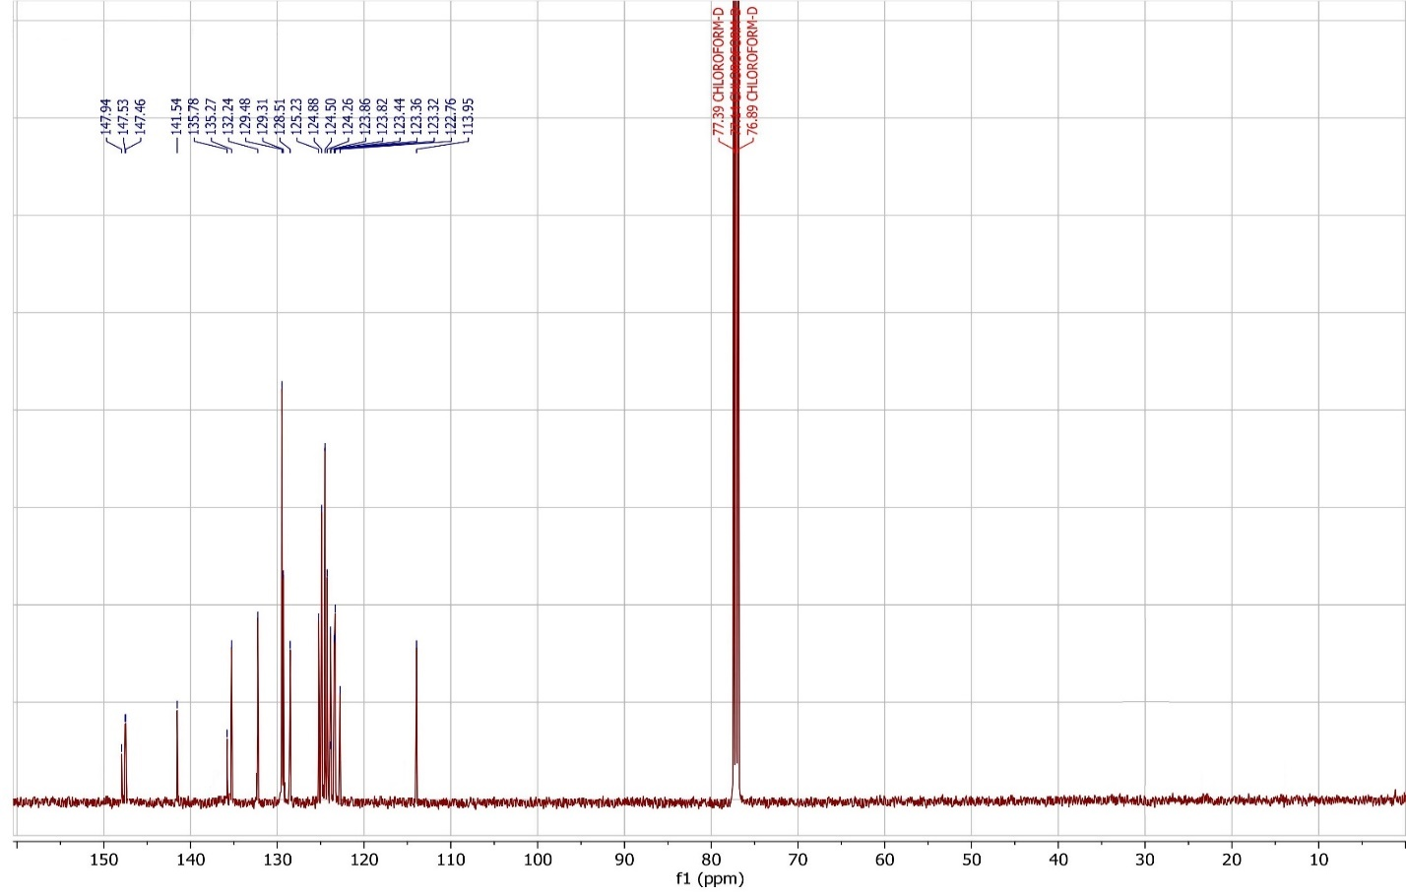

**Figure S4.** 13C NMR spectra of 6,6-Bis(N,N-diphenylaniline)- 2,2-(4-(diphenylamino)phenyl)-bis-azulene  **6**.

13C NMR: δ 147.84, 147.63, 147.44, 141.64, 135.88, 135.37, 132.44, 129.78, 129.21, 128.41, 125.33, 124.78, 124.47, 124.36, 123.76, 123.72, 123.34, 123.46, 123.22, 122.61, 113.84

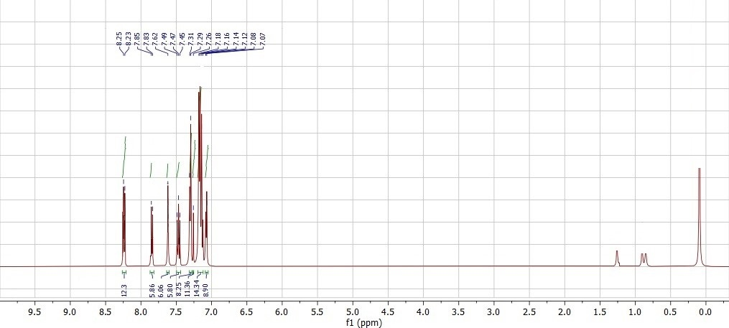

**Figure S5.** 1H NMR spectra of 6,6,6-tris(N,N-diphenylaniline)- 2,2,2-(4-(triphenylamino)-tris-azulene **8**.

1H NMR: δ 8.24 (d, J = 9.4 Hz, 12H), 7.88 (d, J = 12.3 Hz, 6H), 7.62 (s, 6H), 7.47 (t, J = 9.9 Hz, 6H ),7.37 – 7.04 (m, 42H).

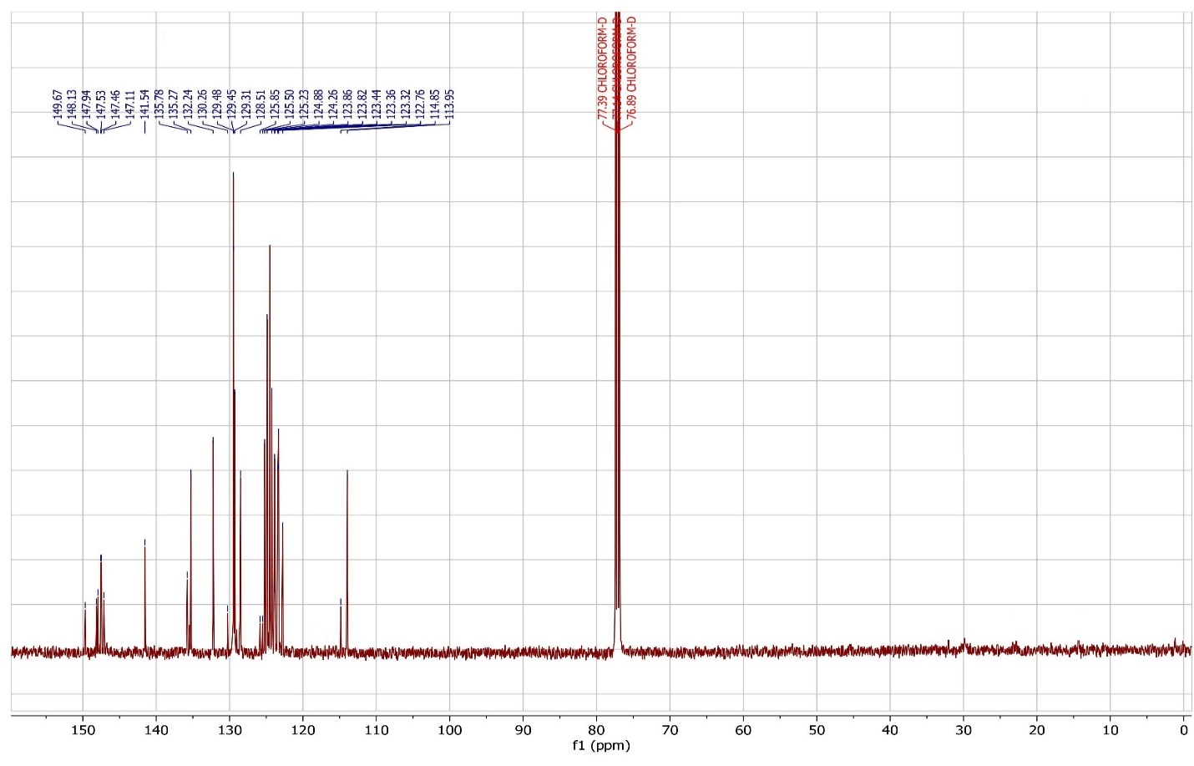

**Figure S6**. 13C NMR spectra of 6,6,6-tris(N,N-diphenylaniline)- 2,2,2-(4-(triphenylamino)-tris-azulene **8**.

13C NMR: δ 149.57, 148.23, 147.84, 147.43, 147.66, 147.21, 141.44, 135.68, 137.37, 132.14, 130.36, 129.58, 129.55, 129.21, 128.41, 125.75, 125.46, 125.32, 124.77, 124.46, 123.36, 13.52, 123.14, 123.66, 123.13, 122.36, 114.55, 113.25.

**2.** **Thermal properties**

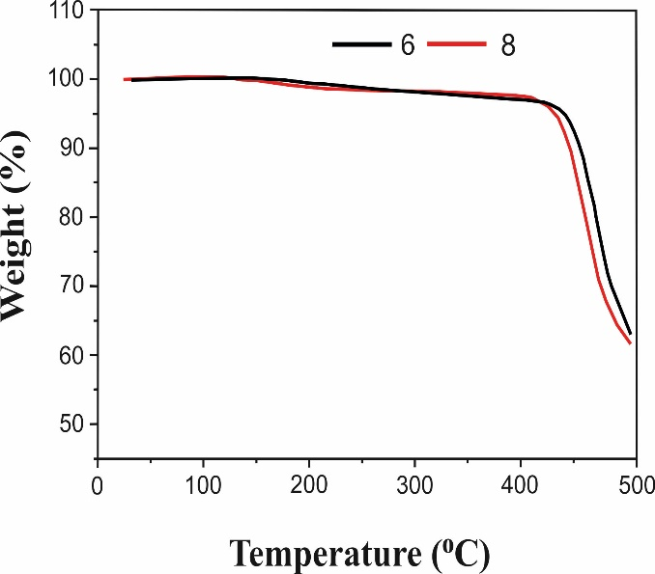

**Figure S7**. Thermogravimetric measurements of co-oligomers **6** and **8**

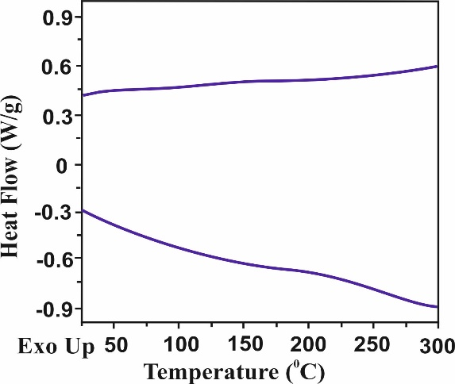 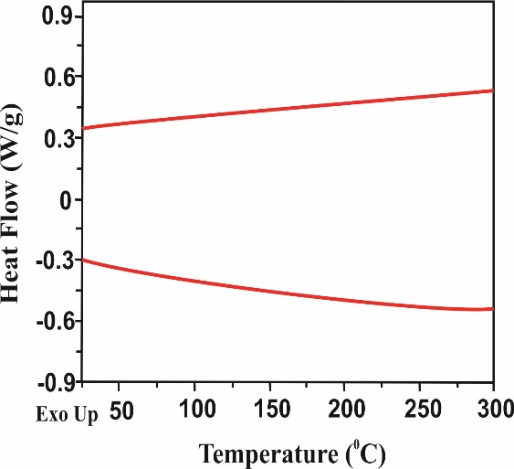

**(a) (b)**

**Figure S8**. Differential scanning calorimetry measurements of co-oligomers **6** (a) and **8** (b)

**3. Density Functional Theory (DFT) Calculations**

To characterize the geometry and orbitals of HOMO-LUMO of co-oligomers **6** and **8**, DFT calculations based on the level of B3LYP/6-31G * (d, p) Gaussian 16 were used. The geometry of the molecules was optimized in a singlet state using the keywords Opt and Freq, and the results were recorded in a .chk file to visualize the boundary orbitals.

After the correct completion of the calculations, the .chk file was opened in GaussView 6.0 and the HOMO-LUMO orbitals were visualized from it using the built-in GaussView tool. Then we obtained the energies of the boundary orbitals in Hartree units and recalculated them into eV, multiplying by the recalculation coefficient 27.2114.

**Table S1**. Atomic coordinates of optimized geometry of **6**

---------------------------------------------------------------------

Center Atomic Atomic Coordinates (Angstroms)

Number Number Type X Y Z

---------------------------------------------------------------------

1 7 0 0.000016 5.209712 -0.000009

2 6 0 0.000032 6.641096 0.000008

3 6 0 -0.882430 7.353068 0.833264

4 6 0 -0.884358 8.750167 0.824065

5 6 0 0.000046 9.457247 0.000018

6 6 0 0.884443 8.750164 -0.824035

7 6 0 0.882501 7.353067 -0.833245

8 6 0 -1.236834 4.500898 -0.003050

9 6 0 -2.324929 4.956612 -0.772650

10 6 0 -3.534011 4.267328 -0.765797

11 6 0 -3.711757 3.090761 -0.005472

12 6 0 -2.610105 2.643332 0.756374

13 6 0 -1.400737 3.332112 0.765894

14 6 0 1.236836 4.500851 0.003087

15 6 0 2.324975 4.956620 0.772590

16 6 0 3.534029 4.267285 0.765791

17 6 0 3.711710 3.090617 0.005611

18 6 0 2.610005 2.643124 -0.756128

19 6 0 1.400663 3.331943 -0.765694

20 6 0 -9.616429 1.091014 -0.447769

21 6 0 -9.586557 -0.252657 -0.009380

22 6 0 -8.447079 -0.965039 0.429476

23 6 0 -7.118814 -0.553799 0.553948

24 6 0 -6.534148 0.682198 0.265004

25 6 0 -7.223288 1.893795 -0.280723

26 6 0 -8.584204 2.022735 -0.570988

27 6 0 -5.179407 1.022003 0.415473

28 6 0 -4.984971 2.365768 -0.006488

29 6 0 -6.239153 2.885059 -0.429519

30 6 0 8.446998 -0.965231 -0.429291

31 6 0 9.586482 -0.252830 0.009510

32 6 0 9.616369 1.090840 0.447894

33 6 0 8.584149 2.022569 0.571104

34 6 0 7.223229 1.893625 0.280862

35 6 0 6.534065 0.681997 -0.264777

36 6 0 7.118723 -0.554005 -0.553713

37 6 0 6.239108 2.884907 0.429608

38 6 0 4.984906 2.365597 0.006654

39 6 0 5.179323 1.021803 -0.415227

40 7 0 -14.599922 -3.099852 -0.009067

41 6 0 -15.309485 -3.309380 1.216062

42 6 0 -15.896771 -4.557781 1.492447

43 6 0 -16.600060 -4.755825 2.683379

44 6 0 -16.715379 -3.722791 3.621671

45 6 0 -16.125483 -2.481760 3.351606

46 6 0 -15.434747 -2.269421 2.155833

47 6 0 -15.144877 -3.600890 -1.233953

48 6 0 -16.517444 -3.461701 -1.510446

49 6 0 -17.049280 -3.963205 -2.701159

50 6 0 -16.222977 -4.594344 -3.639108

51 6 0 -14.855355 -4.727438 -3.368959

52 6 0 -14.317742 -4.244037 -2.173385

53 6 0 -13.361652 -2.397393 -0.009534

54 6 0 -12.439638 -2.559301 1.042909

55 6 0 -11.230979 -1.866232 1.039872

56 6 0 -10.884119 -0.990540 -0.009754

57 6 0 -11.813796 -0.840234 -1.059493

58 6 0 -13.028250 -1.523086 -1.062336

59 7 0 14.599961 -3.099849 0.008948

60 6 0 15.144902 -3.601030 1.233776

61 6 0 16.517461 -3.461854 1.510324

62 6 0 17.049273 -3.963489 2.700991

63 6 0 16.222958 -4.594749 3.638848

64 6 0 14.855345 -4.727830 3.368647

65 6 0 14.317755 -4.244299 2.173117

66 6 0 13.361644 -2.397454 0.009492

67 6 0 13.028230 -1.523228 1.062354

68 6 0 11.813749 -0.840421 1.059569

69 6 0 10.884063 -0.990705 0.009840

70 6 0 11.230922 -1.866339 -1.039836

71 6 0 12.439612 -2.559359 -1.042933

72 6 0 15.309568 -3.309121 -1.216195

73 6 0 15.897001 -4.557416 -1.492755

74 6 0 16.600325 -4.755208 -2.683707

75 6 0 16.715538 -3.722027 -3.621851

76 6 0 16.125499 -2.481102 -3.351612

77 6 0 15.434725 -2.269015 -2.155815

78 1 0 -1.558877 6.808453 1.482219

79 1 0 -1.570103 9.286373 1.472656

80 1 0 0.000051 10.542240 0.000022

81 1 0 1.570191 9.286369 -1.472623

82 1 0 1.558941 6.808449 -1.482205

83 1 0 -2.212149 5.846561 -1.381175

84 1 0 -4.346430 4.628558 -1.387138

85 1 0 -2.714678 1.760277 1.377551

86 1 0 -0.579043 2.975530 1.376371

87 1 0 2.212252 5.846642 1.381017

88 1 0 4.346472 4.628558 1.387074

89 1 0 2.714513 1.759961 -1.377162

90 1 0 0.578928 2.975296 -1.376078

91 1 0 -10.601521 1.466217 -0.709975

92 1 0 -8.628065 -2.003656 0.691161

93 1 0 -6.432634 -1.314822 0.924418

94 1 0 -8.887486 3.001577 -0.941323

95 1 0 -4.408916 0.347499 0.763367

96 1 0 -6.425284 3.892189 -0.776931

97 1 0 8.627984 -2.003848 -0.690969

98 1 0 10.601466 1.466040 0.710082

99 1 0 8.887439 3.001418 0.941412

100 1 0 6.432530 -1.315043 -0.924128

101 1 0 6.425253 3.892053 0.776963

102 1 0 4.408816 0.347273 -0.763037

103 1 0 -15.798369 -5.363743 0.774066

104 1 0 -17.047611 -5.724448 2.883113

105 1 0 -17.256704 -3.882066 4.548339

106 1 0 -16.214048 -1.670156 4.067059

107 1 0 -14.992295 -1.302619 1.943810

108 1 0 -17.157673 -2.961999 -0.792294

109 1 0 -18.110075 -3.848300 -2.901001

110 1 0 -16.638176 -4.976865 -4.565610

111 1 0 -14.205176 -5.221554 -4.084174

112 1 0 -13.261144 -4.362409 -1.961184

113 1 0 -12.677840 -3.224544 1.864645

114 1 0 -10.551349 -1.993494 1.876054

115 1 0 -11.574988 -0.191425 -1.895739

116 1 0 -13.721661 -1.386854 -1.884016

117 1 0 17.157703 -2.962055 0.792251

118 1 0 18.110062 -3.848591 2.900872

119 1 0 16.638140 -4.977373 4.565314

120 1 0 14.205154 -5.222036 4.083790

121 1 0 13.261165 -4.362667 1.960874

122 1 0 13.721643 -1.387028 1.884036

123 1 0 11.574926 -0.191675 1.895861

124 1 0 10.551267 -1.993603 -1.875996

125 1 0 12.677820 -3.224565 -1.864695

126 1 0 15.798687 -5.363493 -0.774491

127 1 0 17.047988 -5.723753 -2.883573

128 1 0 17.256888 -3.881108 -4.548537

129 1 0 16.213981 -1.669382 -4.066944

130 1 0 14.992166 -1.302291 -1.943659

------------------------------------------------------------------------------

Method: DFT B3LYP 6-31G*

Key word: opt freq

E**total** (RB3LYP)= -3015.311973Hartree

**Table S2**. Atomic coordinates of optimized geometry of **8**

---------------------------------------------------------------------

Center Atomic Atomic Coordinates (Angstroms)

Number Number Type X Y Z

---------------------------------------------------------------------

1 7 0 0.002269 0.000027 -0.001192

2 6 0 0.717952 -1.234013 0.008182

3 6 0 1.877505 -1.387611 0.792488

4 6 0 2.575416 -2.591804 0.793479

5 6 0 2.146002 -3.697250 0.026744

6 6 0 0.978294 -3.529356 -0.749486

7 6 0 0.280115 -2.325456 -0.766622

8 6 0 0.712706 1.237070 -0.010418

9 6 0 1.872075 1.395382 -0.794068

10 6 0 2.564936 2.602485 -0.794881

11 6 0 2.130404 3.706282 -0.028663

12 6 0 0.962928 3.533670 0.746880

13 6 0 0.269826 2.326838 0.763891

14 6 0 -1.424747 -0.003054 -0.001176

15 6 0 -2.142285 -0.917695 0.793381

16 6 0 -3.534202 -0.920821 0.785120

17 6 0 -4.272405 -0.009162 -0.001006

18 6 0 -3.538214 0.905632 -0.787246

19 6 0 -2.146296 0.908474 -0.795684

20 6 0 6.194875 8.427721 -0.528145

21 6 0 5.496742 9.568383 -0.068989

22 6 0 4.162313 9.601228 0.397375

23 6 0 3.224071 8.574989 0.520222

24 6 0 3.342205 7.214319 0.224033

25 6 0 4.547706 6.518290 -0.325874

26 6 0 5.780656 7.099007 -0.635290

27 6 0 2.348755 6.234277 0.385313

28 6 0 2.859990 4.976894 -0.037807

29 6 0 4.201076 5.164684 -0.471043

30 6 0 -10.395986 0.657777 -1.062833

31 6 0 -11.032742 -0.023227 -0.000094

32 6 0 -10.392856 -0.701653 1.062434

33 6 0 -9.034577 -0.870474 1.336768

34 6 0 -7.916357 -0.420349 0.629594

35 6 0 -7.918207 0.386727 -0.630747

36 6 0 -9.038489 0.832184 -1.337604

37 6 0 -6.570409 -0.639433 0.966518

38 6 0 -5.738205 -0.012261 -0.000863

39 6 0 -6.573260 0.611392 -0.968044

40 7 0 8.367151 14.566519 -0.099922

41 6 0 7.709878 15.778139 0.285492

42 6 0 7.904485 16.958322 -0.455421

43 6 0 7.272282 18.143057 -0.069579

44 6 0 6.426976 18.167302 1.046543

45 6 0 6.226626 16.992037 1.781200

46 6 0 6.867735 15.806638 1.412549

47 6 0 9.742939 14.605905 -0.492714

48 6 0 10.668153 15.374639 0.237126

49 6 0 12.008062 15.422113 -0.155998

50 6 0 12.449116 14.694849 -1.268390

51 6 0 11.531079 13.923636 -1.991960

52 6 0 10.186020 13.883395 -1.616062

53 6 0 7.658687 13.332778 -0.092488

54 6 0 6.303465 13.276149 -0.472932

55 6 0 5.611679 12.067327 -0.454586

56 6 0 6.239622 10.861741 -0.077298

57 6 0 7.599388 10.930406 0.292034

58 6 0 8.294870 12.137246 0.295537

59 7 0 -16.798058 -0.034846 0.000930

60 6 0 -17.520768 0.832365 0.880727

61 6 0 -18.645217 0.357541 1.580666

62 6 0 -19.356950 1.209615 2.428922

63 6 0 -18.952121 2.538450 2.605443

64 6 0 -17.829007 3.010921 1.915181

65 6 0 -17.121164 2.170782 1.051909

66 6 0 -15.374493 -0.031967 0.000686

67 6 0 -14.652850 0.126335 1.199927

68 6 0 -13.259626 0.132074 1.193794

69 6 0 -12.525374 -0.026234 0.000177

70 6 0 -13.259413 -0.187487 -1.193173

71 6 0 -14.652650 -0.187356 -1.198812

72 6 0 -17.517504 -0.904998 -0.878653

73 6 0 -18.643933 -0.434697 -1.578456

74 6 0 -19.352403 -1.289662 -2.426538

75 6 0 -18.942326 -2.616896 -2.603001

76 6 0 -17.817255 -3.084855 -1.912854

77 6 0 -17.112630 -2.241837 -1.049755

78 6 0 6.229368 -8.402061 0.529137

79 6 0 5.536730 -9.545299 0.068047

80 6 0 4.203210 -9.583333 -0.400535

81 6 0 3.260882 -8.560933 -0.524078

82 6 0 3.372848 -7.200012 -0.226635

83 6 0 4.574605 -6.499350 0.325552

84 6 0 5.809476 -7.075150 0.636497

85 6 0 2.375555 -6.224015 -0.388703

86 6 0 2.880895 -4.964802 0.036063

87 6 0 4.222119 -5.147305 0.471141

88 7 0 8.427813 -14.531501 0.100932

89 6 0 9.803040 -14.565438 0.496188

90 6 0 10.732765 -15.329790 -0.232517

91 6 0 12.072144 -15.371973 0.163012

92 6 0 12.508140 -14.643698 1.276737

93 6 0 11.585589 -13.876833 1.999186

94 6 0 10.241065 -13.841901 1.620856

95 6 0 7.776281 -15.745651 -0.286323

96 6 0 7.974067 -16.925277 0.454624

97 6 0 7.347502 -18.112433 0.067022

98 6 0 6.504714 -18.139709 -1.050934

99 6 0 6.301186 -16.965016 -1.785635

100 6 0 6.936696 -15.777158 -1.415202

101 6 0 7.714234 -13.300738 0.092925

102 6 0 8.346202 -12.102274 -0.292957

103 6 0 7.645697 -10.898346 -0.289972

104 6 0 6.284933 -10.835581 0.076743

105 6 0 5.661275 -12.044057 0.451898

106 6 0 6.358025 -13.250014 0.470697

107 1 0 2.219633 -0.562090 1.406112

108 1 0 3.451111 -2.689433 1.426051

109 1 0 0.631862 -4.344951 -1.375015

110 1 0 -0.602373 -2.219239 -1.387124

111 1 0 2.218023 0.571183 -1.407327

112 1 0 3.440593 2.703679 -1.426951

113 1 0 0.612713 4.347958 1.372010

114 1 0 -0.612570 2.217049 1.383901

115 1 0 -1.602387 -1.624424 1.413136

116 1 0 -4.059387 -1.646955 1.395969

117 1 0 -4.066592 1.629534 -1.397995

118 1 0 -1.609510 1.617533 -1.415482

119 1 0 7.204527 8.618873 -0.880103

120 1 0 3.820559 10.573109 0.741550

121 1 0 2.257660 8.878677 0.921530

122 1 0 6.527665 6.413347 -1.034146

123 1 0 1.345060 6.425300 0.739950

124 1 0 4.869824 4.390429 -0.821715

125 1 0 -11.067979 1.146668 -1.762356

126 1 0 -11.062617 -1.193311 1.762158

127 1 0 -8.812959 -1.453142 2.230412

128 1 0 -8.819562 1.415716 -2.231347

129 1 0 -6.234193 -1.173286 1.844866

130 1 0 -6.239495 1.146659 -1.846469

131 1 0 8.548193 16.939903 -1.327569

132 1 0 7.431476 19.045823 -0.651016

133 1 0 5.932691 19.087564 1.339661

134 1 0 5.580247 16.999273 2.653306

135 1 0 6.722251 14.902430 1.992764

136 1 0 10.332420 15.928655 1.106431

137 1 0 12.710677 16.019210 0.416894

138 1 0 13.491561 14.729008 -1.567156

139 1 0 11.858502 13.361671 -2.861108

140 1 0 9.475232 13.297426 -2.187756

141 1 0 5.800923 14.180697 -0.795159

142 1 0 4.577414 12.050524 -0.782254

143 1 0 8.107868 10.031686 0.625360

144 1 0 9.331109 12.162034 0.612053

145 1 0 -18.953701 -0.674301 1.456285

146 1 0 -20.222322 0.829198 2.962622

147 1 0 -19.503292 3.195571 3.269909

148 1 0 -17.509179 4.041092 2.037129

149 1 0 -16.261134 2.544561 0.507786

150 1 0 -15.188610 0.251137 2.133689

151 1 0 -12.731727 0.279501 2.130210

152 1 0 -12.731258 -0.332783 -2.129780

153 1 0 -15.188234 -0.314324 -2.132382

154 1 0 -18.956474 0.595929 -1.454121

155 1 0 -20.219350 -0.912731 -2.960154

156 1 0 -19.490983 -3.276258 -3.267330

157 1 0 -17.493368 -4.113762 -2.034749

158 1 0 -16.251055 -2.612152 -0.505708

159 1 0 7.239216 -8.589262 0.882648

160 1 0 3.866067 -10.556357 -0.746022

161 1 0 2.296393 -8.868344 -0.927174

162 1 0 6.552999 -6.386664 1.036994

163 1 0 1.373235 -6.418996 -0.745067

164 1 0 4.887129 -4.370555 0.823395

165 1 0 10.400917 -15.884557 -1.102834

166 1 0 12.778278 -15.965726 -0.409027

167 1 0 13.550171 -14.673743 1.577383

168 1 0 11.909086 -13.314142 2.869334

169 1 0 9.526807 -13.259298 2.191664

170 1 0 8.615797 -16.904527 1.328175

171 1 0 7.509084 -19.014748 0.648499

172 1 0 6.014791 -19.061863 -1.345424

173 1 0 5.656724 -16.974577 -2.659135

174 1 0 6.788801 -14.873337 -1.995414

175 1 0 9.383163 -12.122498 -0.607420

176 1 0 8.151110 -9.997290 -0.621645

177 1 0 4.626321 -12.031804 0.777578

178 1 0 5.858596 -14.156865 0.791282

---------------------------------------------------------------------

Method: DFT B3LYP 6-31G*

Key word: opt freq

E**total** (RB3LYP)= -4148.205875 Hartree

**4.** **Cyclic voltammetry studies**

Electrochemical studies were performed in an acetonitrile solution containing tetrabutylammonium hexafluorophosphate (nBu4NPF6) under an argon atmosphere. Ag/AgCl electrode, glassy carbon electrodes and platinum electrodes were used as reference electrodes, working electrodes and counter electrodes, respectively. 5 μl of a 0.8 mg/ml dichloromethane solution of co-oligomer **6** (or **8**) was pipetted and dropped onto a glass-carbon electrode which was allowed to evaporate under the pressure of a washing flask at room temperature (the circular opening of the electrode had a diameter of 4 mm).

References

1. M. Fujinaga, T. Murafuji, K. Kurotobi, Y. Sugihara, Polyborylation of azulenes. *Tetrahedron* **2009**, *Volume 65*, 7115–7121.
2. T.Tsuchiya, T. Hamano, M. Inoue, T. Nakamura, A. Wakamiya, Y. Mazaki. Intense absorption of azulene realized by molecular orbital inversion. *Chem. Commun*. **2023**, *Volume 59*, 10604–10607.