**Supplementary Materials**

**Appendix A**

**Figure A1. KeepCalm Heart Rate Zone Stress Rainbow**

***Note.*** The arrow touching the heart rate stress rainbow indicates the color zone a given child is in with the percentage inside the heart indicating how a given child’s current heart rate compares to their baseline. E.g., in this image, the child Heather’s heart rate is 4% above their baseline.

**Figure A2. KeepCalm Pop-Up Notification**

***Note.***Example of pop-up notification educators receive when a child is in the orange or red heart rate zone.

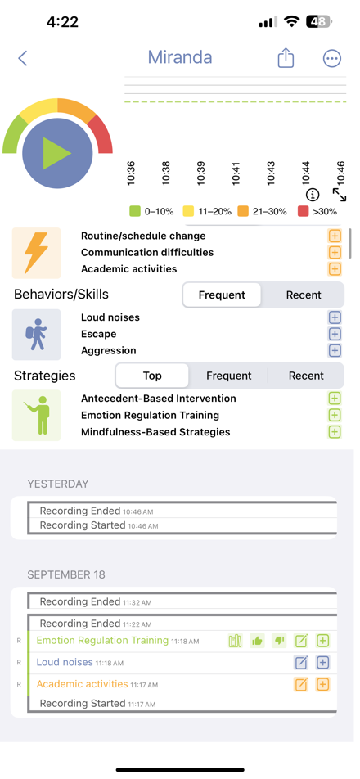

**Figure A3. Teacher Strategy Data Log Form from KeepCalm**

**Table A1. Rank Ordering of “Top Strategies”**

|  |  |  |
| --- | --- | --- |
| Criteria | Description | Ranking Principle |
| 1. Success of the Strategy in Addressing Challenging Behavior | Teachers/aides report strategy success as successful, unsuccessful, or not reported. | Higher rank for strategies with a lower percentage of unsuccessful reporting. |
| 2. Number of Challenging Behaviors Observed Post-Intervention | Number of behaviors observed after the intervention was implemented (or timed marked as being implemented), including existing or additional challenging behaviors. | Higher rank for strategies with fewer challenging behaviors observed. |
| 3. Number of Skills Observed | Number of skills observed after the intervention, including academic, developmental, motor, gross, adaptive, language, communication, and play/social skills. | Higher rank for strategies with more skills observed. |
| 4. Heart Rate Reduction | Magnitude of heart rate reduction following the implementation of an intervention strategy. | Higher rank for strategies with a greater reduction in heart rate. |
| 5. Time for the Child to Return to the Green Heart Rate Zone | Overall time taken for a child to return to their heart rate resting state baseline (green zone) following the intervention. | Higher rank for strategies with a shorter time to return to the green zone. |
| 6. Time Since the Strategy was Employed | Consideration of the amount of time since the strategy was used. | Higher rank for strategies that have been more recently implemented. |
| **Results** | Strategies are sequentially assessed, progressing to the next criterion only if the preceding one is identical between strategies. | Strategies are rank ordered to determine the top 3 strategies for pop-up notifications. |

***Note.***Green heart rate zone indicates when a child’s heart rate is at baseline. Heart rate reduction, observed challenging behaviors, and observed skills are measured in the 5 minutes succeeding the implementation of an intervention strategy.

**Table A2. Observation Guide (First 3 of 15 Minutes)**

|  |  |  |  |  |
| --- | --- | --- | --- | --- |
| Time Interval | Child Behavior | Intervention Strategies | Strategy Effectiveness | Notes |
| 0-3 mins  Time:  ______-______ | Challenging Behavior   * Aggression (towards another person) * Climbing on furniture (at least 3 seconds) * Dropping (body to floor) * Escape behavior (fleeing) * Loud noises (screaming) * Negative peer interaction (not aggression) * Noncompliance (defiance after directive) * Property destruction (aggression towards objects/furniture) * Self-injury (aggression towards self) * Stripping (not in context) * Swearing (to self or others) * Other: | * Proactive   Antecedent-Based Interventions  Augmentative and Alternative Communication  Class-Wide Behavior Management  Cognitive Behavioral/Instructional Strategies  Delay- and Denial-Tolerance Training  Differential Reinforcement  Discrete Trial Training  Emotion-Regulation Training  Feedback  Functional Behavioral Assessment  Functional Communication Training  Homework  Metaphors/Analogies  Mindfulness-Based Strategies  Modeling  Naturalistic Intervention  Prompting  Reinforcement  Role Play & Practice  Self-Management  Social Narratives  Social Skills Training  Time Delay (Prompting)  Video Modeling  Visual Supports   * Other: | Overall Proactive Strategies were:   * Effective * Not effective * Cannot determine * N/A |  |
| Activity |
| IRR  ____ / 21  _____% | Skill Acquisition   * Academic and developmental skills (e.g. numeracy, literacy, motor, sensory processing) * Adaptive skills (e.g. personal care, independence) * Language and communication (e.g. expressive or receptive language, or spontaneous communication) * Play or social skills (e.g. pretending, peer interaction) * Other: | * Reactive   Emotion-Regulation Training  Extinction  Mindfulness-Based Strategies  Modeling  Naturalistic Intervention  Physical Safety Management  Prompting  Response Interruption/Redirection  Time Delay (Prompting)  Visual Supports   * Other: | Overall Reactive Strategies were:   * Effective * Not effective * Cannot determine * N/A |

**Appendix B**

**Table B1.** Descriptive Statistics of Strategy Effectiveness

|  |  |  |
| --- | --- | --- |
| Effectiveness | Frequency | Percent |
| Missing | 63 | 24.50 |
| Effective | 153 | 59.50 |
| Ineffective | 41 | 16.00 |
| Total | 257 | 100.00 |

**Table B2.** Binary Logistic Regression on the Effect of Heart Rate Reduction % and Behavioral Data on Intervention Strategy Effectiveness, Controlling for Child

|  |  |  |  |  |  |  |  |  |
| --- | --- | --- | --- | --- | --- | --- | --- | --- |
|  | Model | | Individual Predictors | | | | 95% C.I. for Exp(B) | |
|  | *p* | *χ2* | *p* | | *Exp(B)* | *B* | *Lower* | *Upper* |
| *Block*  HR Reduction %  Mins to Return to Green HR Zone  Subsequent Behaviors  Subsequent Skills  Child | <.001 | 29.54 | | .101  .354  .036  .001  .009 | 1.05  .783  .784  3.65  3.63 | .05  -.24  -.24  1.29  1.29 | .991  .468  .625  1.67  1.38 | 1.10  1.31  .985  7.94  9.58 |

***Note.*** *HR = Heart Rate. Green HR Zone is when a child’s heart rate is at baseline. Strategy Type coded so that 1 is reactive and 0 is proactive.*

**Table B3.** Frequency and Average Heart Rate Reduction % of Intervention Strategies by Strategy Type

|  |  |  |
| --- | --- | --- |
| **Intervention Strategy by Strategy Type** | **Frequency** | **HR Reduction %** |
|  |  |  |
| ***Proactive*** |  |  |
| Antecedent-Based Intervention | 37 | 18.33% |
| Augmentative and Alternative Communication | 1 | 11.38% |
| Class-Wide Behavior Management | 3 | 11.85% |
| Delay and Denial Tolerance Training | 1 | 21.48% |
| Discrete Trial Training | 1 | 22.83% |
| Emotion Regulation Training | 7 | 26.08% |
| Feedback | 9 | 24.65% |
| Functional Communication Training | 9 | 15.05% |
| Metaphors/Analogies | 1 | 16.81% |
| Mindfulness-Based Strategies | 5 | 24.00% |
| Modeling | 14 | 14.65% |
| Naturalistic Intervention | 35 | 17.78% |
| Prompt Time Delay | 1 | 26.60% |
| Prompting | 35 | 16.16% |
| Reinforcement | 22 | 16.96% |
| Self-Management | 5 | 30.53% |
|  | ***N* = 186** | ***M* = 18.24%** |
| ***Reactive*** |  |  |
| Emotion Regulation Training | 2 | 21.30% |
| Extinction | 1 | 21.48% |
| Mindfulness-Based Strategies | 1 | 22.68% |
| Modeling | 3 | 14.33% |
| Naturalistic Intervention | 3 | 14.63% |
| Physical Safety Management | 3 | 3.14% |
| Prompting | 9 | 18.07% |
| Response Interruption/Redirection | 18 | 12.20% |
|  | ***N* = 40** | ***M* = 14.13%** |

**Table B4.** Binary Logistic Regression on the Effect of Strategy Type, Heart Rate Reduction %, and Behavioral Data on Strategy Effectiveness, Controlling for Child

|  |  |  |  |  |  |  |  |  |
| --- | --- | --- | --- | --- | --- | --- | --- | --- |
|  | Model | | Individual Predictors | | | | 95% C.I. for Exp(B) | |
|  | *p* | *χ2* | *p* | | *Exp(B)* | *B* | *Lower* | *Upper* |
| *Block*  HR Reduction %  Mins to Return to Green HR Zone  Subsequent Behaviors  Subsequent Skills  Strategy Type (1)  Child | <.001 | 34.18 | | .127  .331  .054  .001  .031  .551 | 1.04  .773  .796  3.61  3.19  .551 | .043  -.257  -.228  1.28  1.16  -.101 | .988  .461  .632  1.66  1.11  .647 | 1.10  1.30  1.00  7.89  9.17  1.26 |

***Note.*** *HR is an abbreviation for heart rate. Green HR Zone is when a child’s heart rate is at baseline. Strategy Type coded so that 0 is proactive and 1 is reactive.*