**A dual-channel Naked-Eye fluorescent probe for discriminative detection of sulfur dioxide and hydrazine**

Sha Li a[1]*, Yu Haoa, Jun Zhenga , Xingao Zhanga

aDepartment of Chemistry, Xinzhou Teachers University, Xinzhou 034000, China

**1. Characterization of compounds**

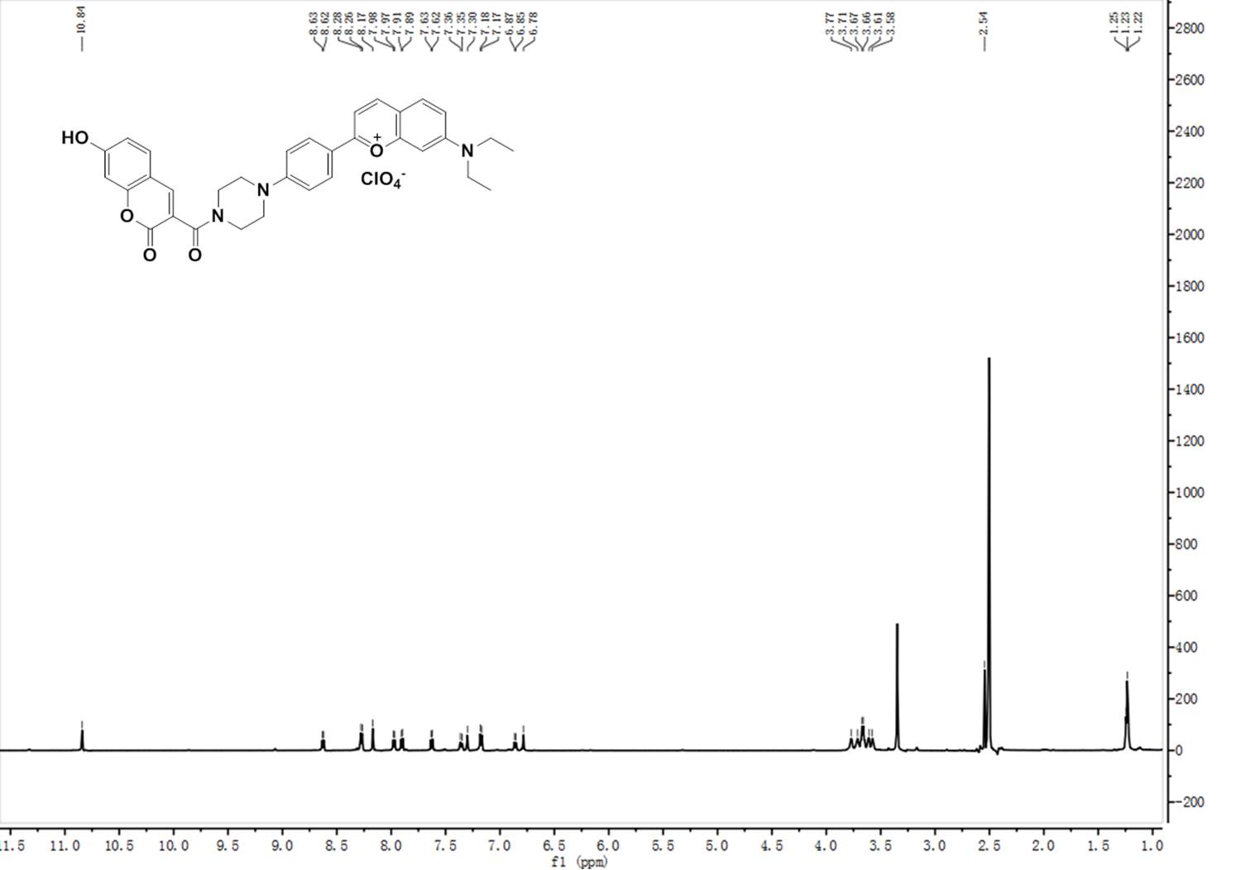

Figure S1 1H NMR (600 MHz) of **PI-CO** in DMSO-*d*6

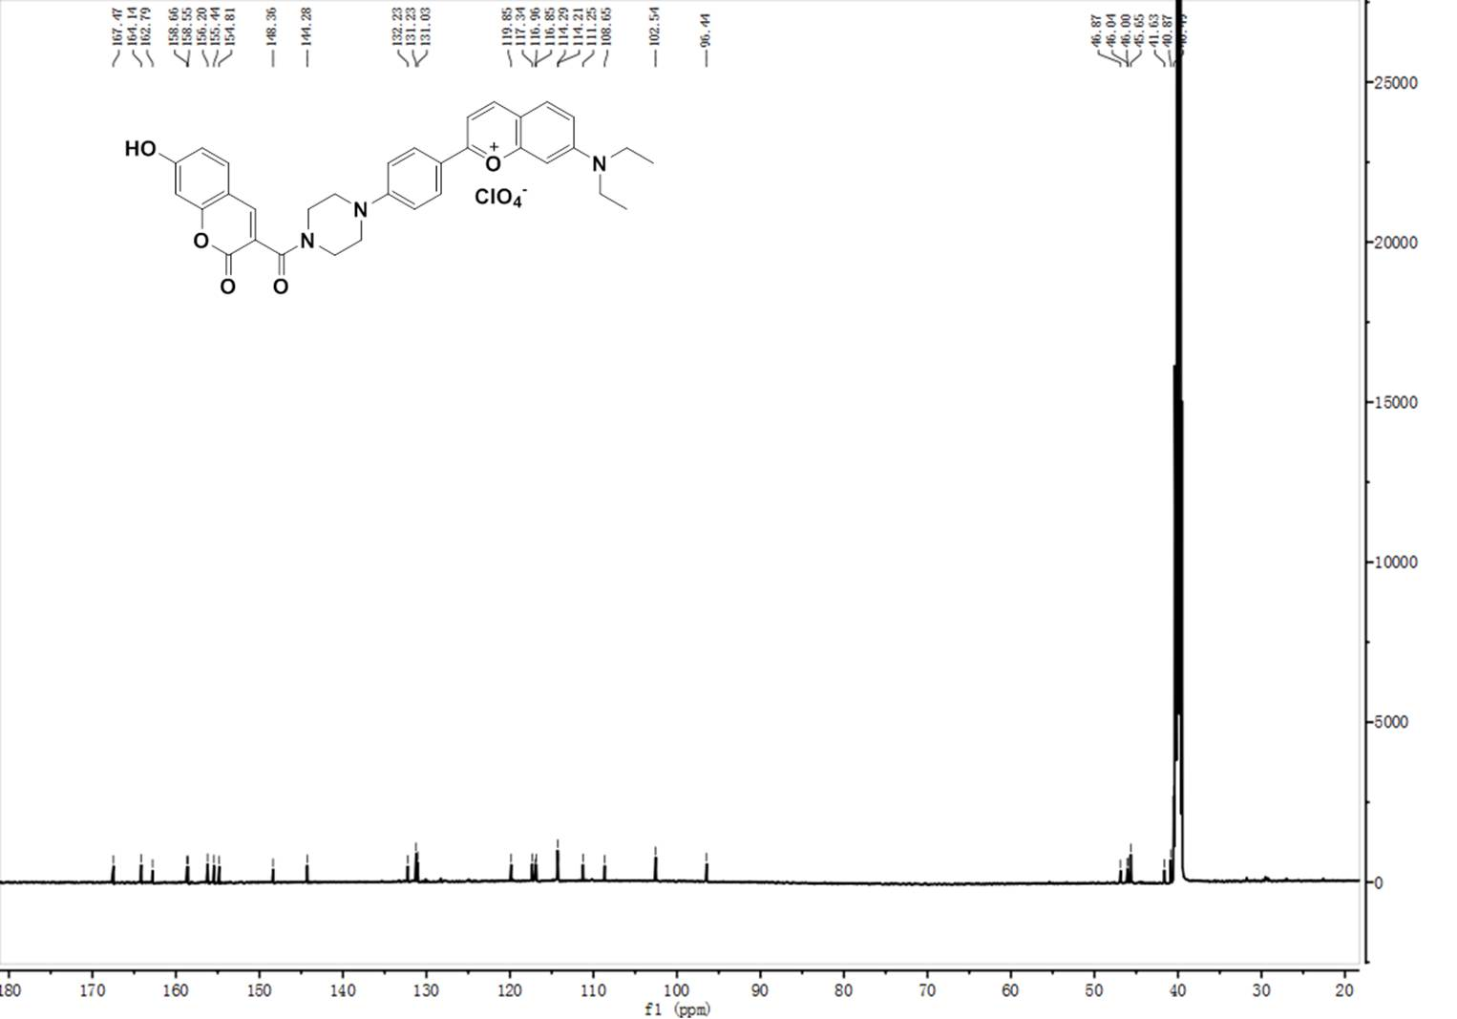

13C NMR (150 MHz) of **PI-CO** in DMSO-*d*6



Figure S2 1H NMR (600 MHz) of **PI-CO-NH** in DMSO-*d*6



13C NMR (150 MHz) of **PI-CO-NH** in DMSO-*d*6

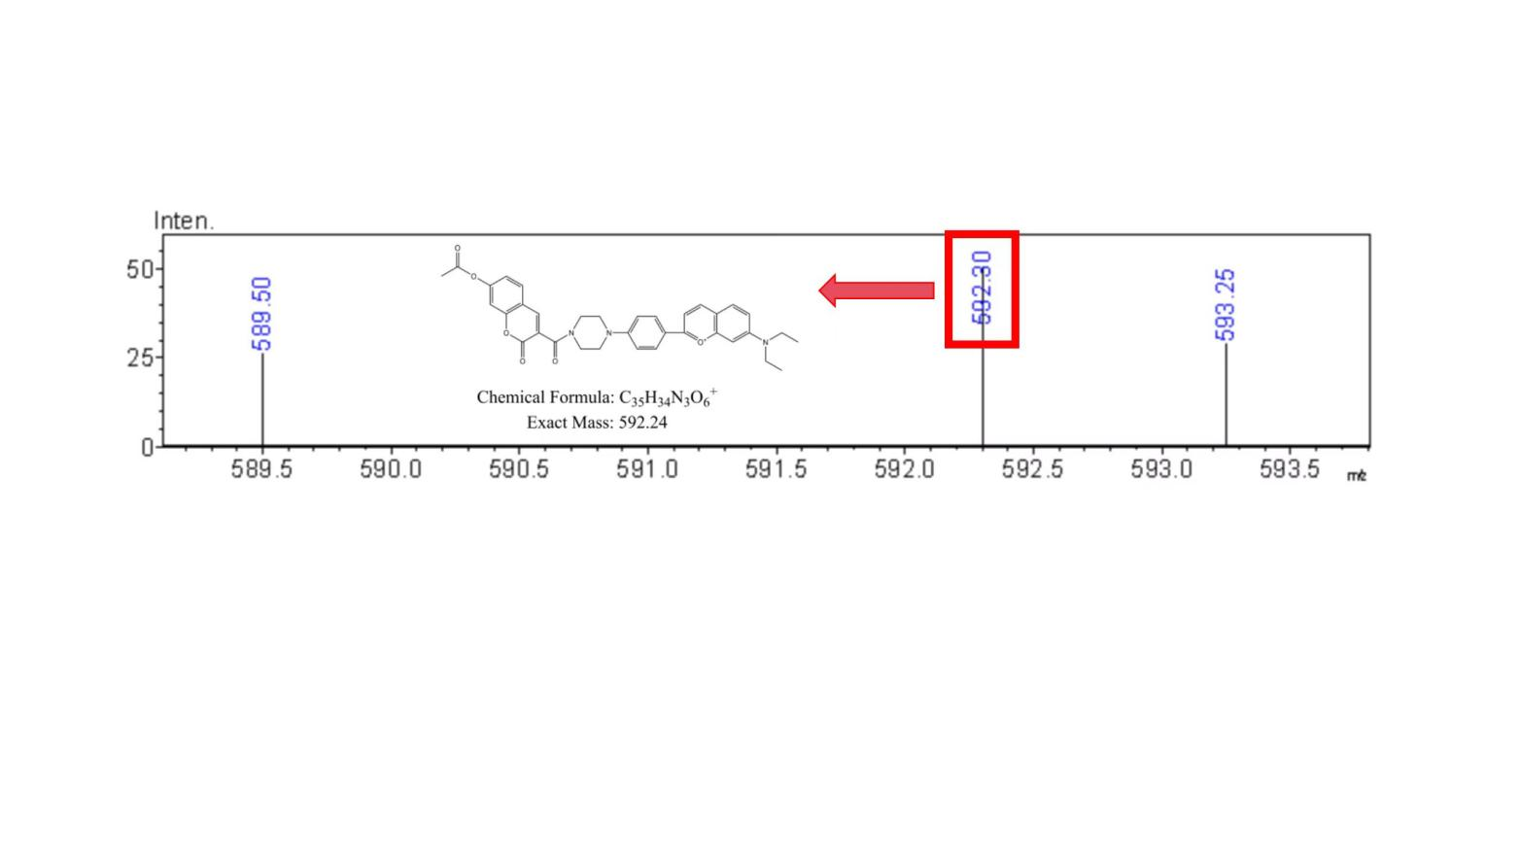

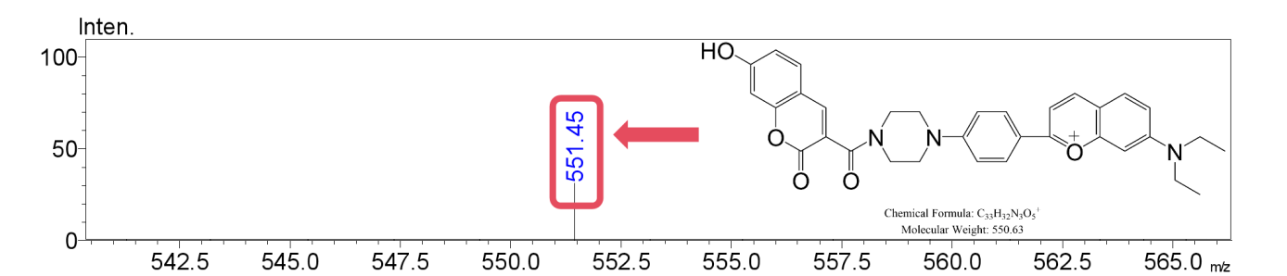

（a）

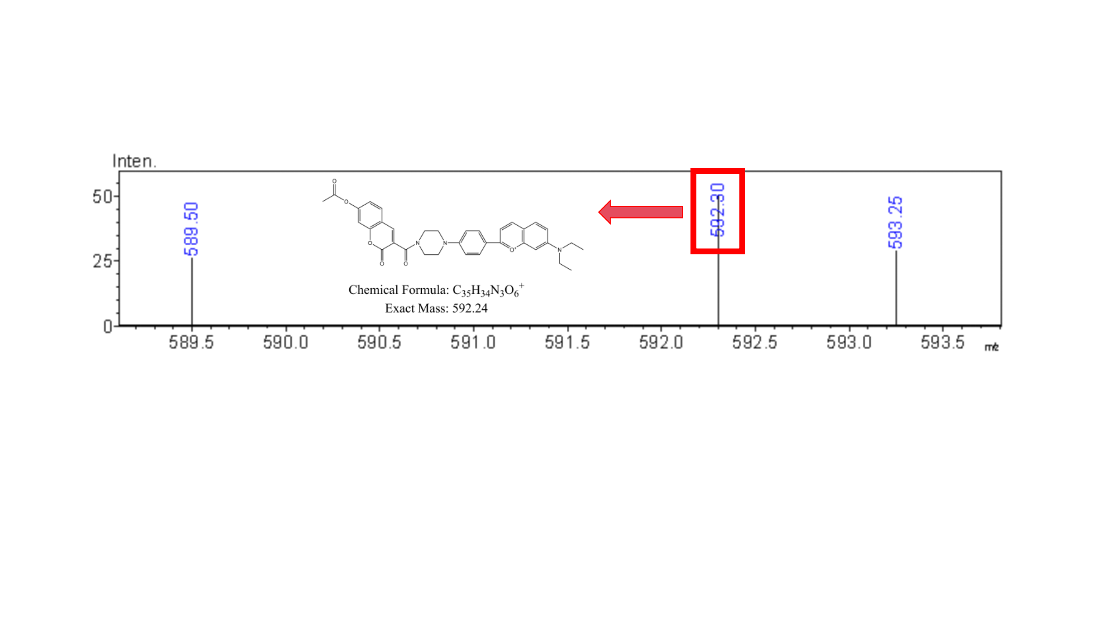

（b）

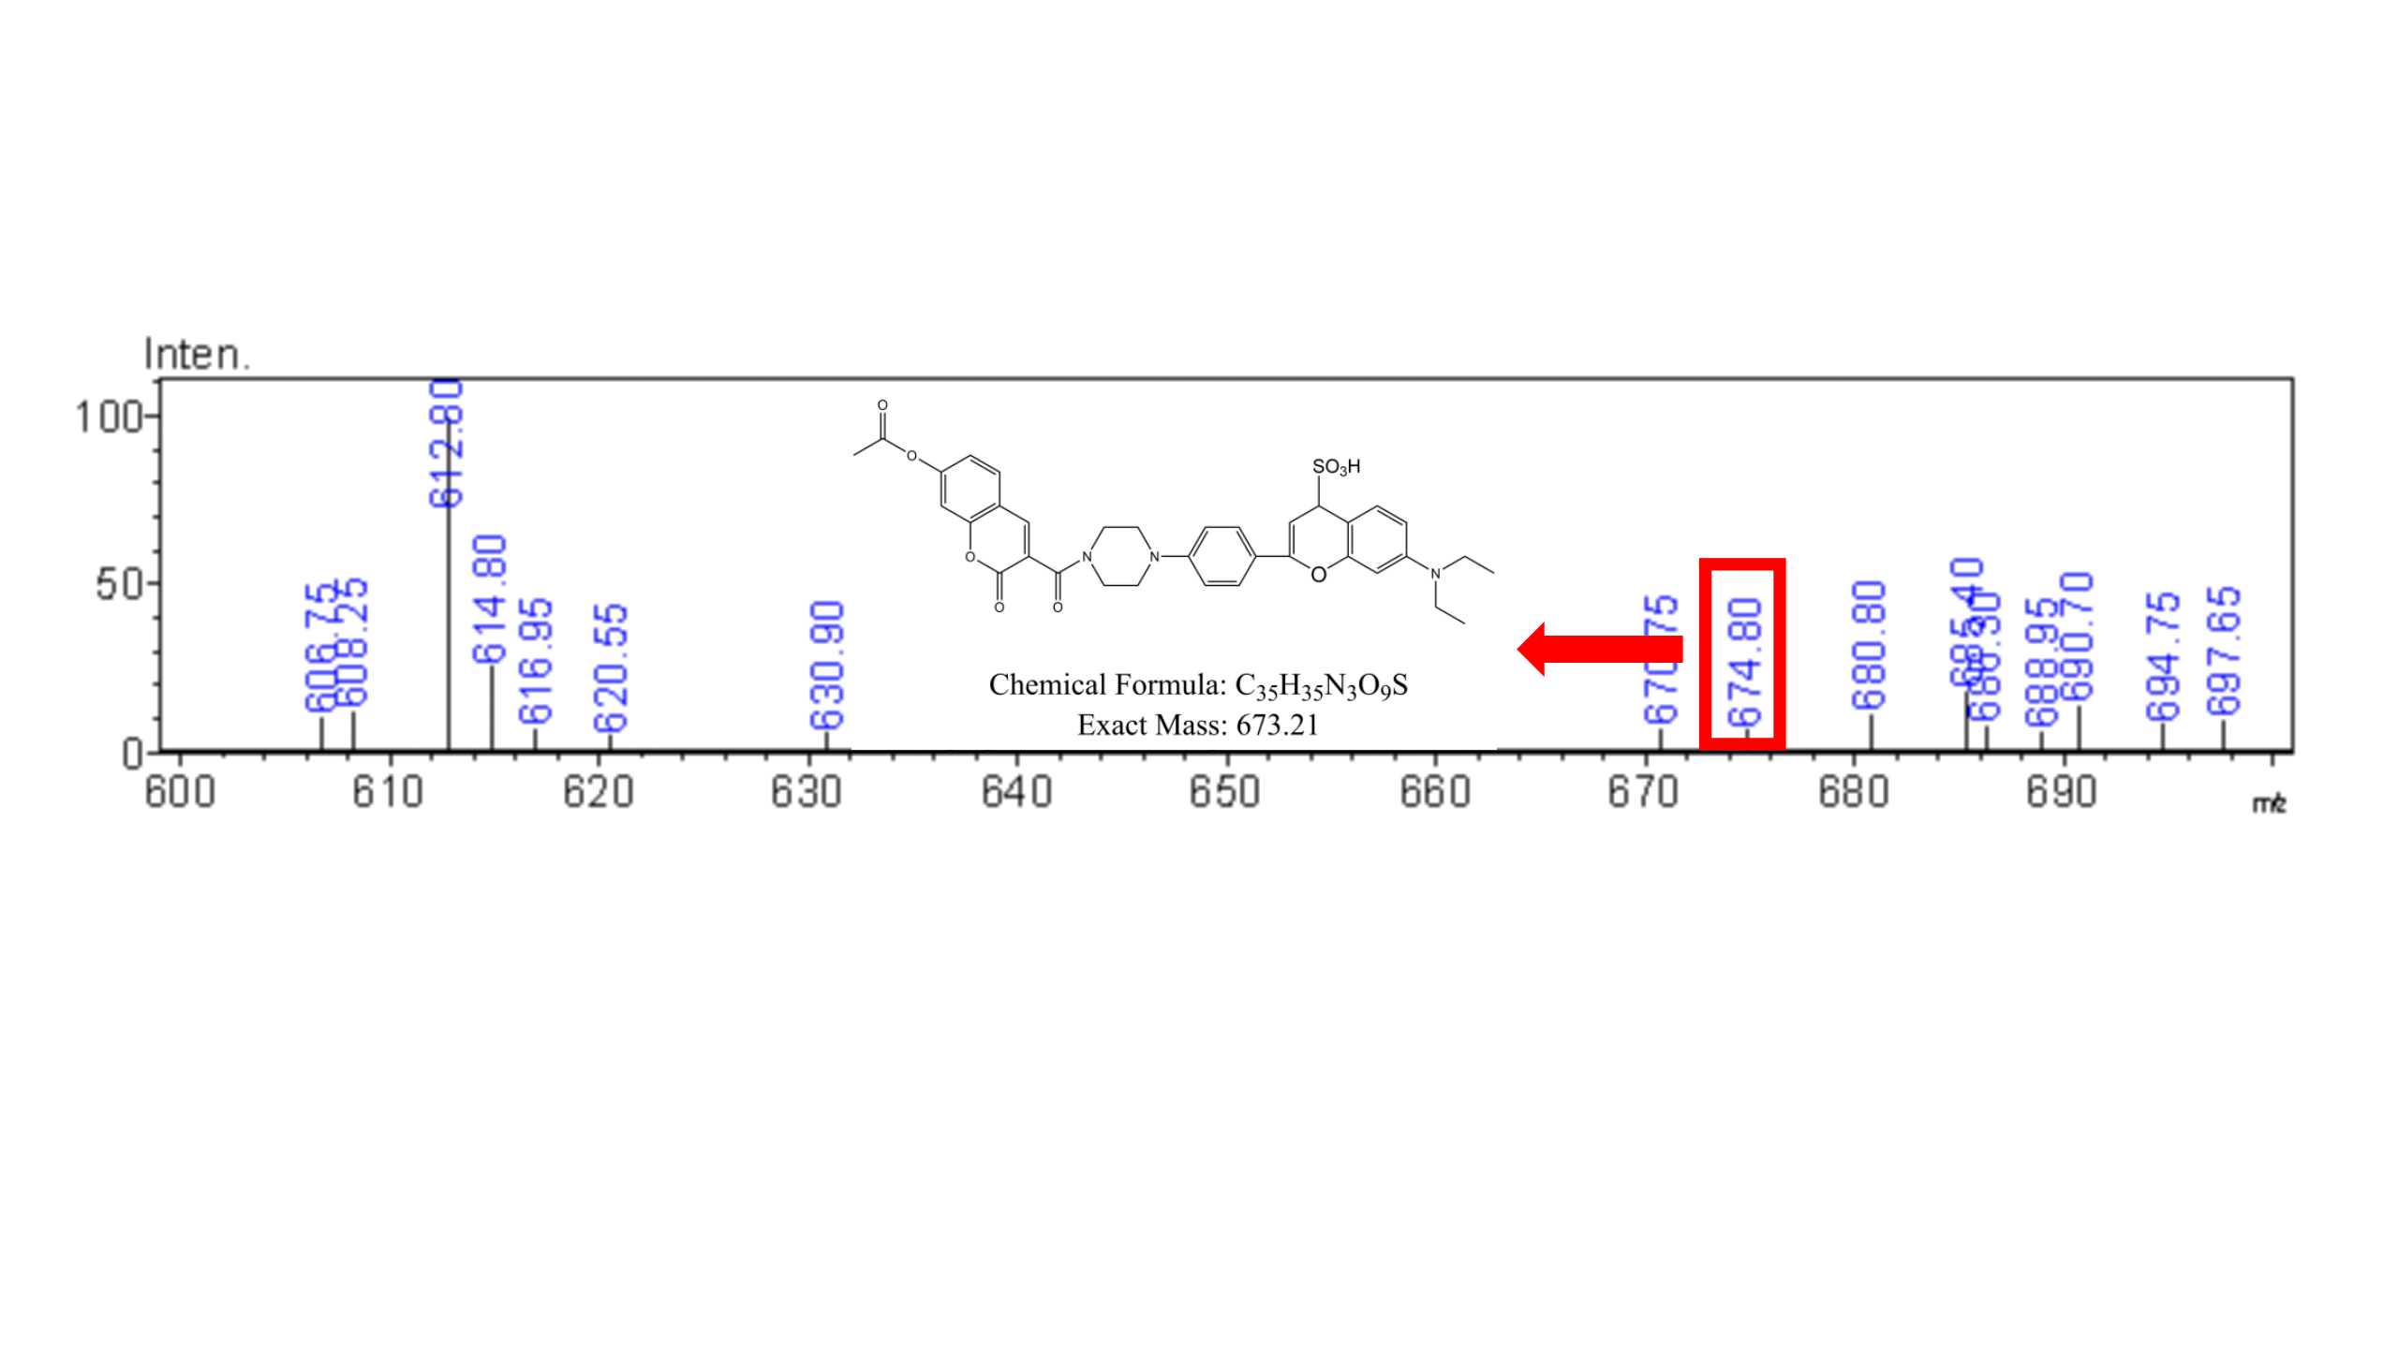

Figure S3 HRMS spectra of **PI-CO-NH** with N2H4 and SO2

1. E-mail address: [lisaa0612@163.com](mailto:lisaa0612@163.com)