Restoration of Sestrin 3 expression mitigates cardiac oxidative damage in the Ischemia-Reperfusion injury model

Supplementary table 1. Antibodies used for western blot.
Antigen | Species | Manufacturer | Catalog Number | Dilution
SESN3 | Rabbit | Proteintech | 11431-2-AP | 1:5000
PARP | Rabbit | abcam | ab191217 | 1:5000
Caspase 9 | Mouse | Cell signaling | 9508 | 1:5000
Bcl-XL | Rabbit | Cell signaling | 2764 | 1:2000
TGF-β | Rabbit | Cell signaling | 3711 | 1:5000
Fibronectin | Rabbit | Proteintech | 15613-1-AP | 1:5000
SERCA2a | Rabbit | 21st Century Biochemicals | Custom made | 1:5000
GFP | Rabbit | Santa Cruze | SC-8334 | 1:5000
GAPDH | Rabbit | Cell signaling | 2118 | 1:5000

Supplementary table 2. Quantitative RT-PCR primer information
Gene |  | Sequence (5’to 3’)
pri-miR-25 | F | 5’-CTC ACA GGA CAG CTG AAC ACC- 3’
 | R | 5’-CCC CCA CAT CTG CAG TGT TG- 3’
pre-miR-25 | F | 5’-CAG TGT TGA GAG GCG GAG ACT- 3’
 | R | 5’-GCA CTG TCA GAC CGA GAC AAG- 3’
miR-25-3p | F | 5’-CAT TGC ACT TGT CTC GGT CTG A- 3’
SESN 1 | F | 5’-GCA TGT TCC AAC ATT TCG TG- 3’
 | R | 5’-TCC CAC ATC TGG ATA AAG GC- 3’
SESN 2 | F | 5’-GAC CAT GGC TAC TCG CTG AT- 3’
 | R | 5’-GCT GCC TGG AAC TTC TCA TC- 3’
SESN 3 | F | 5’-CCA AGC AAA TAC GGC GGA TG- 3’
 | R | 5’-TGT AGA ACT GGC TCC GCA AG- 3’
18S | F | 5’-TAA CGA ACG AGA CTC TGG CAT- 3’
 | R | 5’-CGG ACA TCT AAG GGC ATC ACAG-3’
U6 | F | 5’-CGC TTC ACG AAT TTG CGT GTC AT-3’
 | R | 5’-GCT TCG GCA GCA CAT ATA CTA AAA T-3’

Supplementary figure 1. SESN3 expression following Pre miR-25 transfection in H9c2 cells
Immunofluorescence staining of SESN3 (red) and nuclei (blue) in H9c2 cells transfected with Pre miR-25.
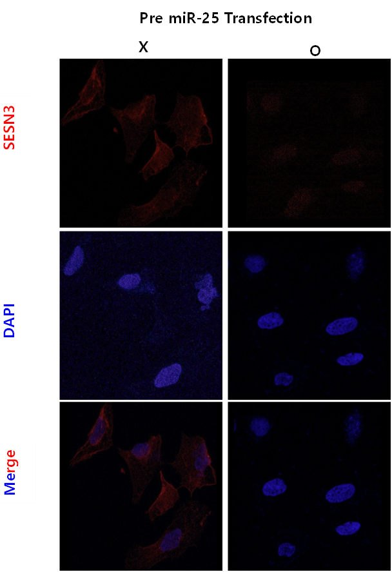
Supplementary figure 2. SESN1, SESN2 mRNA expression in H9c2 cells under Normoxia and hypoxia/reoxygenation (H/R) conditions.
