**Supporting information**

**Enzyme free Impedimetric Sensor for L-Glutamic Acid Using Flower-Like NiO/Carbon Microspheres**

**Najva Sadri1, Mohammad Mazloum-Ardakani1*, Farzaneh Asadpour2, Yvonne Joseph3, Parvaneh Rahimi3\***

1Department of Chemistry, Faculty of Science, Yazd University, Yazd 89195-741, Islamic Republic of Iran; [Najva.Sadri.0226@gmail.com](mailto:Najva.Sadri.0226@gmail.com); [mazloum@yazd.ac.ir](mailto:mazloum@yazd.ac.ir)

2Department of Chemistry, University of Cincinnati, 312 College Drive 404 Crosley Tower, Cincinnati, Ohio 45221-0172, United States.

3Institute of Nanoscale and Biobased Materials, Faculty of Materials Science and Technology, Technische Universität Bergakademie Freiberg, 09599 Freiberg, Germany.

*Corresponding authors: E-mail: [mazloum@yazd.ac.ir](mailto:mazloum@yazd.ac.ir) (M. Mazloum-Ardakani), [Parvaneh.Rahimi@esm.tu-freiberg.de](mailto:Parvaneh.Rahimi@esm.tu-freiberg.de) (P.Rahimi)

**Figure S1.** CVs of fl-NiO/C/GCE in 5.0 mM [Fe (CN)6]3-/4- in 0.1 M KCl at a scan rate of 20-800 mv/s (A), the plot of I versus υ1/2 (B).

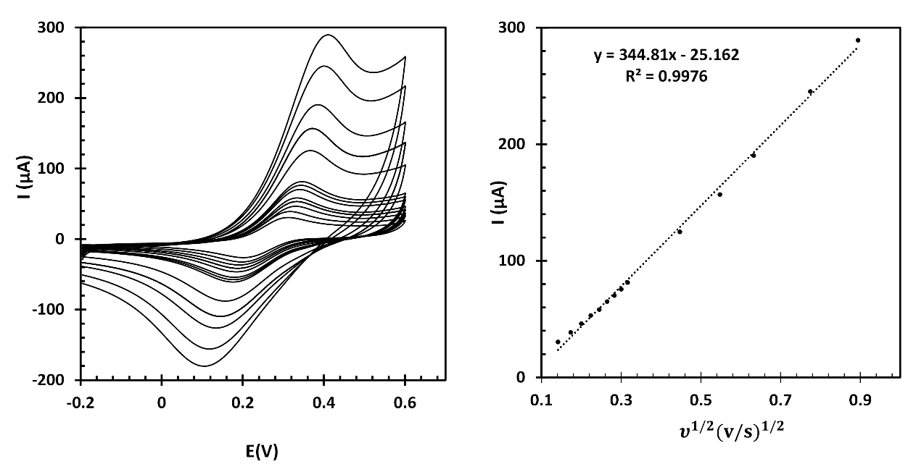

**(B)**

**(A)**

**Figure S2.** Cyclic voltammogram of fl-NiO/C/GCE in 1M NaOH solution at various scan rate 10-100mV/s. (Inset: Plot of I versus υ)

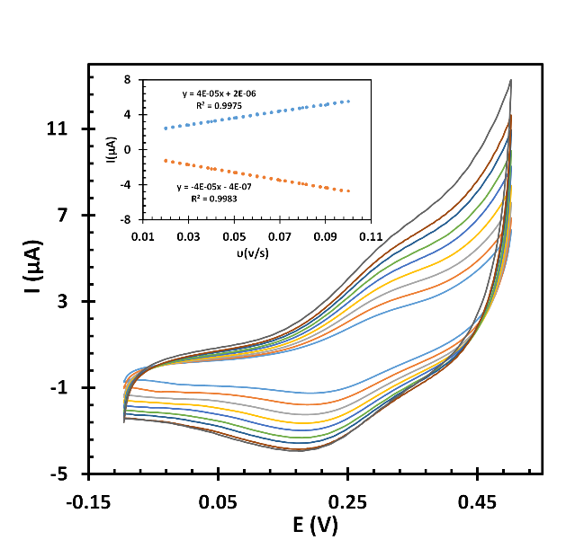

**Figure S3.** CVs of fl-NiO/C/GCE in 1mM LGA in 1 M NaOH at a scan rate of 10 mV/s (A). Tafel plot E vs log I (B).

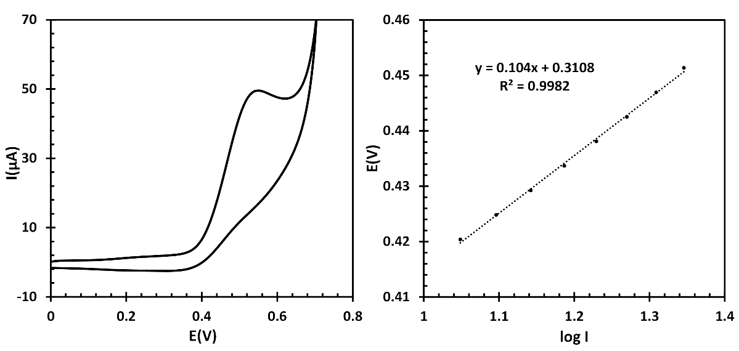

**(A)**

**(B)**

Laviron’s equation: E = E0′ + [2.303 R T/ (1- α) nα F] log ν + constant where E0′, ν, α, F, T, and R are the formal potential, scan rate (mV/s ); the electron transfer coefficient; Faraday’s constant, the temperature, and the universal gas constant, respectively. nα is the electron number involved in the rate determining step; as the reaction is irreversible, assume that the value of α is 0.5.

**Figure S4**. The IC/IL vs. t1/2 plot at different concentrations of LGA (250, 500, 700, 1000 μM) (A). The plot of the slope of the (IC/IL vs.t1/2) vs. C1/2 (B).

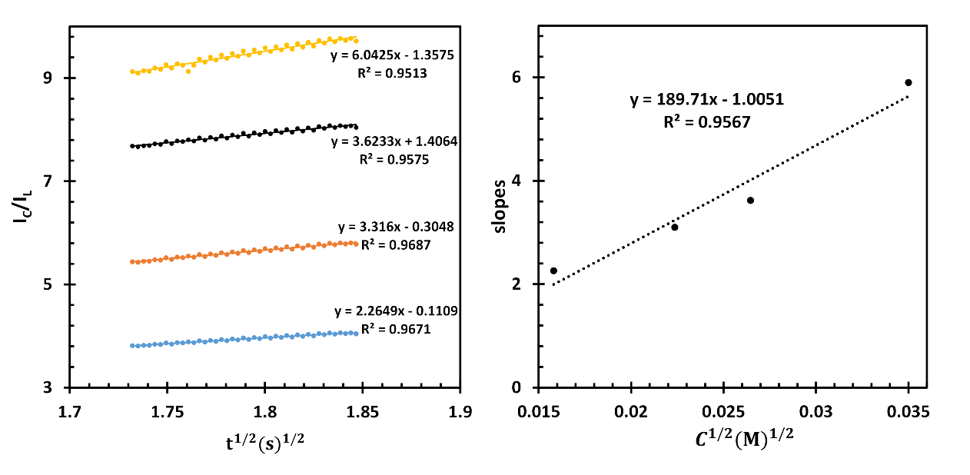

**(A)**

**(B)**

**Figure S5.** Amprometric response of fl-NiO/C/GCE 600 second before and after injection of 200µL GLA.

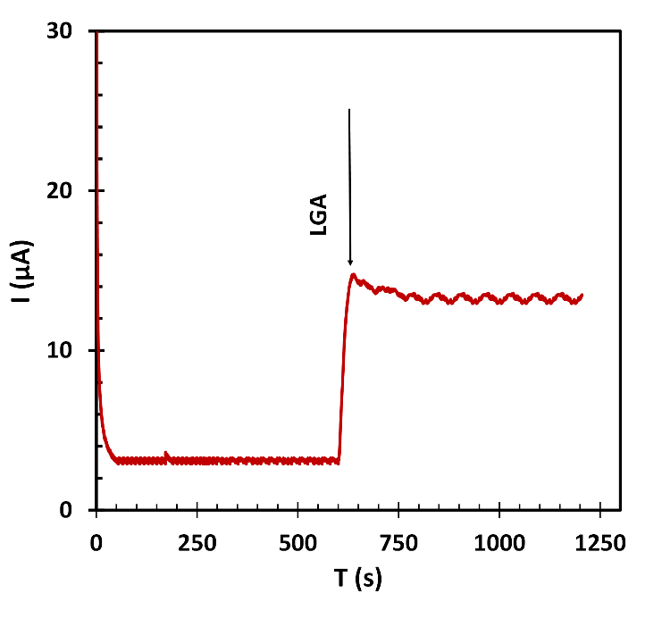

**Figure S6.** CVs of 5 prepared fl-NiO/C/GCE in 1mM LGA in 1 M NaOH at a scan rate of 50 mV/s.

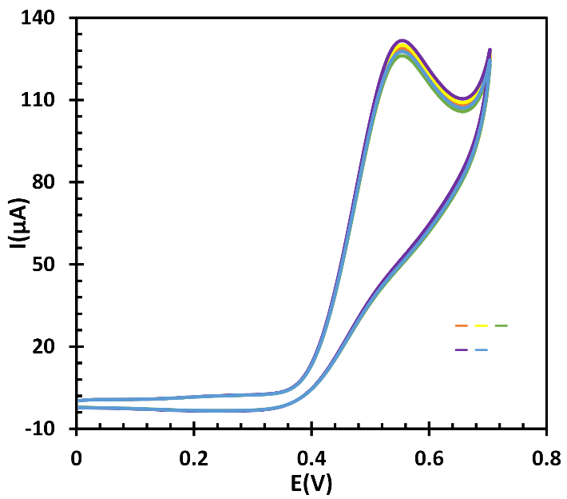

**Figure S7.** EIS responses of sample (I-III) were recorded at the fl-NiO/C/GCE using standard addition method.

