**Title: A Muscle Physiology-Based Framework for Quantifying Training Load in Resistance Exercises**

**Running title: Physiology-based framework for training load**

, , , and

1 Seenovate, Montpellier, 34000, France

2 EuroMov Digital Health in Motion, Univ Montpellier, IMT Mines Alès, Montpellier, France

3 DMeM, Univ Montpellier, INRAE, Montpellier, France

*Corresponding author: Stephane Perrey – stephane.perrey@umontpellier.fr

# Appendix 1

## Tables

Table 1. Configuration of the three-knee extension testing sessions

|  |  |  |  |  |
| --- | --- | --- | --- | --- |
| Session | Sets | Repetitions | Intensity (% MVC) | Passive recovery (s) |
| 1 | 1 | 24 | 58 % | N/A |
| 2 | 2 | 9 | 77 % | 180 |
| 3 | 5 | 3 | 93 % | 240 |

Table 2. Parameters inference regarding then normalised averaged torque produced at exercise.

|  |  |  |  |  |  |  |  |
| --- | --- | --- | --- | --- | --- | --- | --- |
| Effect | Parameter | $$β$$ | Std.error | t | p.value | $$CI_{lower}$$ | $$CI_{upper}$$ |
| Fixed | Intercept | 27.762 | 2.590 | 10.719 | < 0.001 | 22.547 | 32.978 |
| Fixed | C2 | 10.862 | 0.883 | 12.297 | < 0.001 | 9.134 | 12.590 |
| Fixed | C3 | 17.865 | 0.933 | 19.144 | < 0.001 | 16.039 | 19.690 |
| Fixed  Fixed  Fixed  Random  Random | $${\text{N}}_{\text{rep}}$$ $${\text{N}}_{\text{rep}}:C2$$ $${\text{N}}_{\text{rep}}:C3$$ Intercept (sd)  Observation (sd) | -0.301  0.361  0.515  9.779  5.219 | 0.040  0.073  0.090 | -7.442  4.913  5.723 | < 0.001  < 0.001  < 0.001 | -0.377  0.217  0.339  6.843  4.962 | -0.220  0.504  0.691  14.199  5.465 |

Table 3. Parameters inference regarding the distributions of summated EMG signals at exercise. $β^{*}$ denotes standardised regression coefficients.

|  |  |  |  |  |  |  |  |
| --- | --- | --- | --- | --- | --- | --- | --- |
| Effect | Parameter | $$β^{*}$$ | Std.error | t | p.value | $${\text{CI}}_{\text{lower}}$$ | $${\text{CI}}_{\text{upper}}$$ |
| Fixed | Intercept | 376.969 | 13.272 | 28.402 | < 0.001 | 351.232 | 404.090 |
| Fixed | N | 8.730 | 2.068 | 4.221 | < 0.001 | 4.690 | 12.778 |
| Fixed | C2 | 4.528 | 13.171 | 0.344 | 0.732 | -22.175 | 31.302 |
| Fixed | C3 | -50.893 | 59.541 | -0.855 | 0.395 | -172.570 | 70.940 |
| Fixed | Velocity | 43.982 | 7.960 | 5.525 | < 0.001 | 27.879 | 60.129 |
| Fixed | C2:velocity | -51.639 | 11.390 | -4.534 | < 0.001 | -74.226 | -28.284 |
| Fixed | C3:velocity | -48.122 | 47.279 | -1.018 | 0.311 | -143.725 | 48.820 |
| Random | Intercept (sd) | 38.178 |  |  |  | 24.999 | 56.029 |
| Random | Observation (sd) | 52.809 |  |  |  | 49.996 | 55.462 |

Table 4. Parameters inference regarding changes in blood lactate concentrations ($\left[lact_{p}\right]$) in response to exercise.

|  |  |  |  |  |  |  |  |
| --- | --- | --- | --- | --- | --- | --- | --- |
| Effect | Parameter | $$β^{*}$$ | Std.error | t | p.value | $${\text{CI}}_{\text{lower}}$$ | $${\text{CI}}_{\text{upper}}$$ |
| Fixed | Intercept | 3.273 | 0.519 | 6.306 | < 0.001 | 2.287 | 4.240 |
| Fixed | C2 | -1.932 | 0.599 | -3.224 | 0.003 | -3.053 | -0.803 |
| Fixed | C3 | -9.412 | 2.364 | -3.982 | < 0.001 | -13.820 | -4.853 |
| Fixed | Velocity | -0.652 | 0.370 | -1.762 | 0.086 | -1.343 | 0.051 |
| Fixed | C2:velocity | -1.641 | 0.729 | -2.252 | 0.031 | -3.006 | -0.282 |
| Fixed | C3:velocity | -7.814 | 2.400 | -3.256 | 0.002 | -12.303 | -3.285 |
| Random | Intercept (sd) | 0.762 |  |  |  | 0.257 | 1.251 |
| Random | Observation (sd) | 1.025 |  |  |  | 0.752 | 1.255 |

## Figures

Figure 1. Distribution of regression slopes for changes in (a) ${\text{RFD}}_{\text{peak}}$ and (b) ${\text{RFD}}_{0-100}$ across repetitions of knee extensions.

Figure 2. Distribution of regression slopes for changes in median frequencies from power spectrum (${\text{MDF}}_{α}$) across repetitions of isokinetic knee extensions.

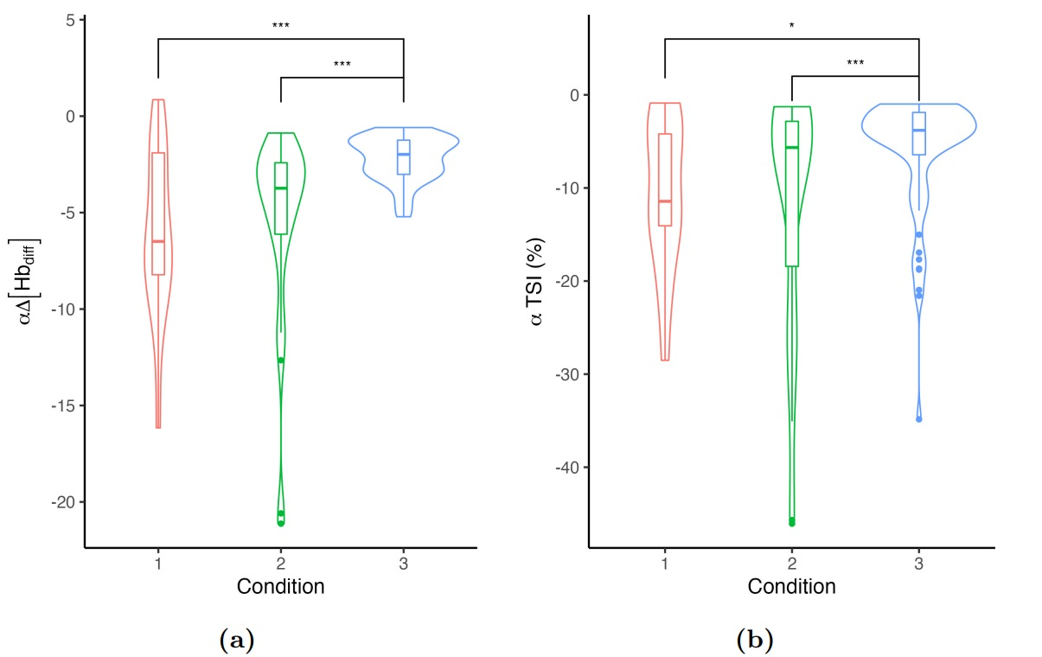

Figure 3. Distribution of (a) rate decay of $Δ\left[{\text{Hb}}_{\text{diff}}\right]$ and (b) rate decay of TSI at exercise.