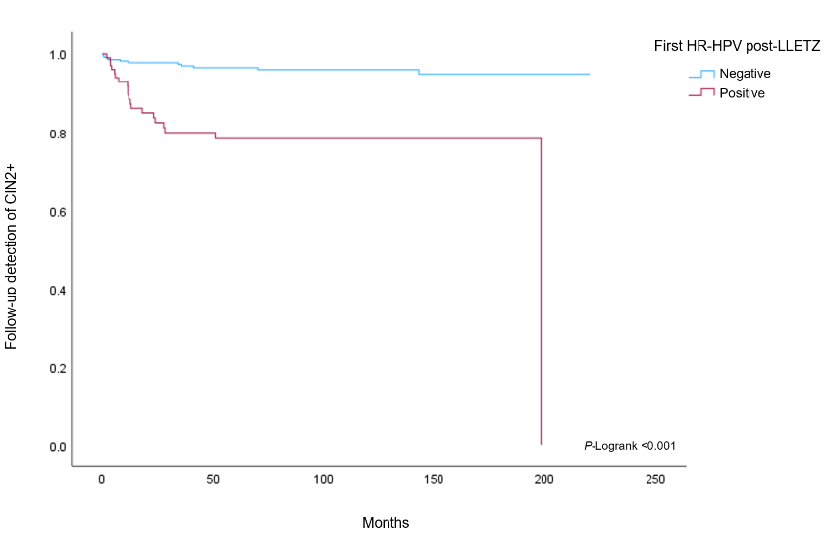  (A) | 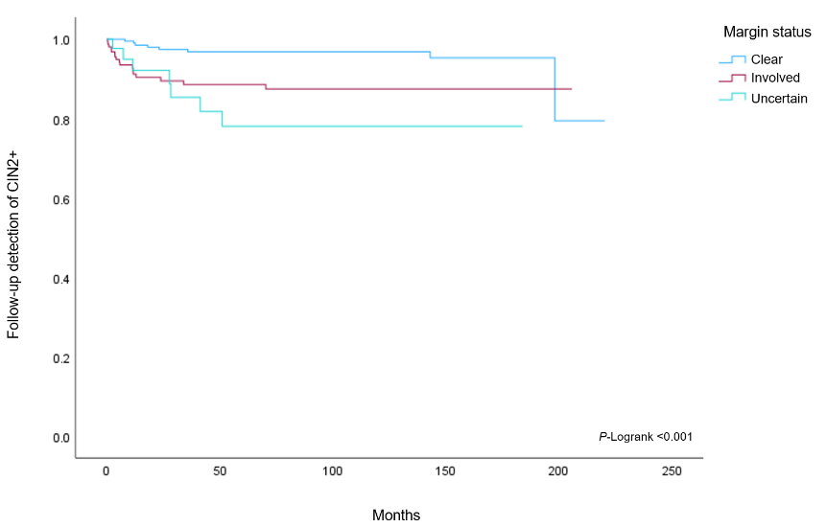  (B)
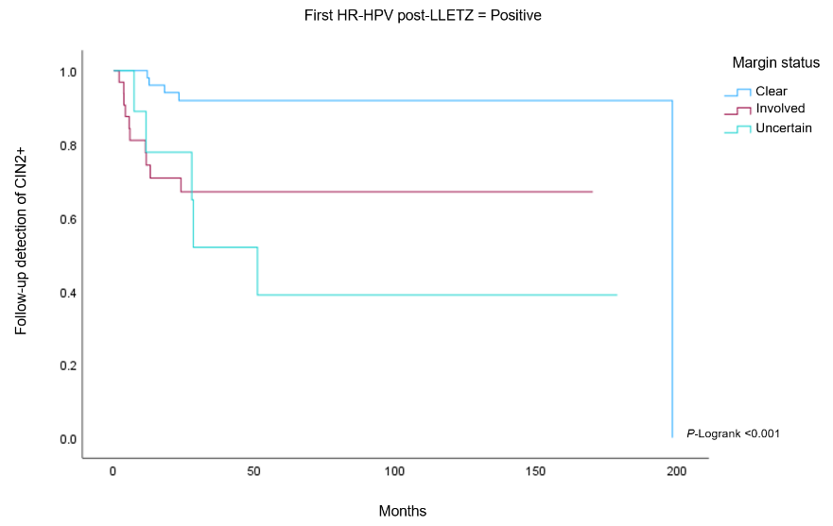  (C) | 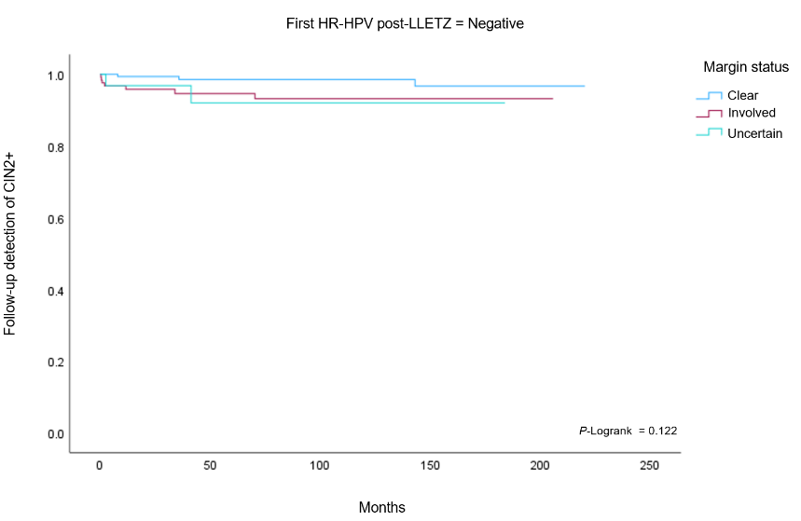  (D)
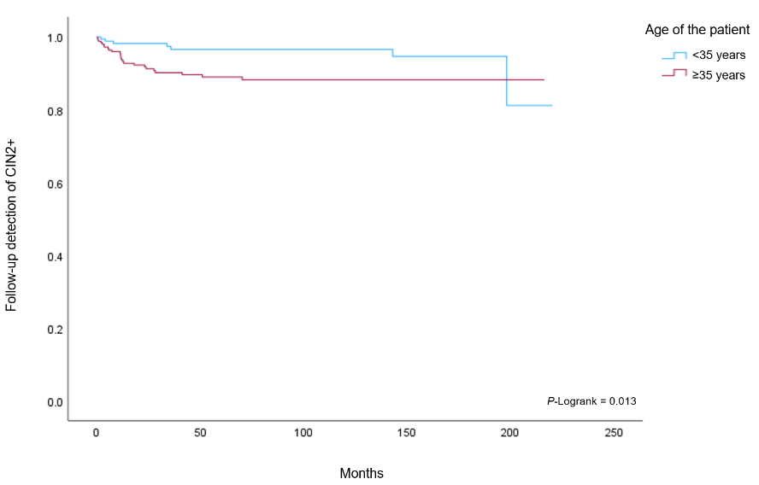  (E) | 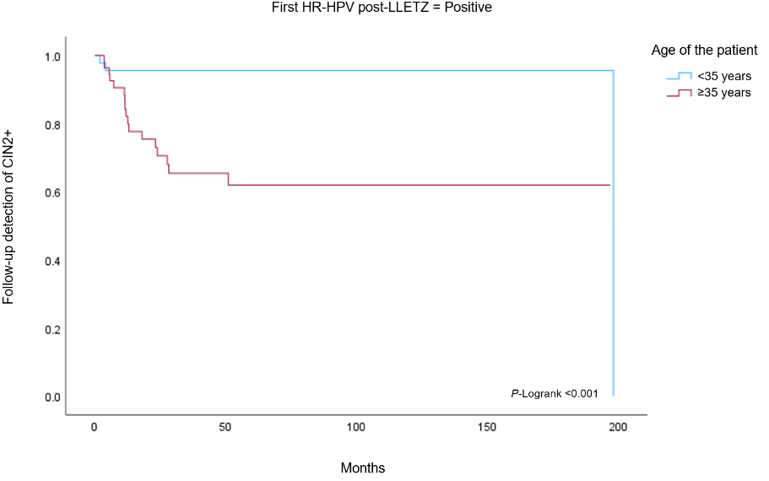  (F)
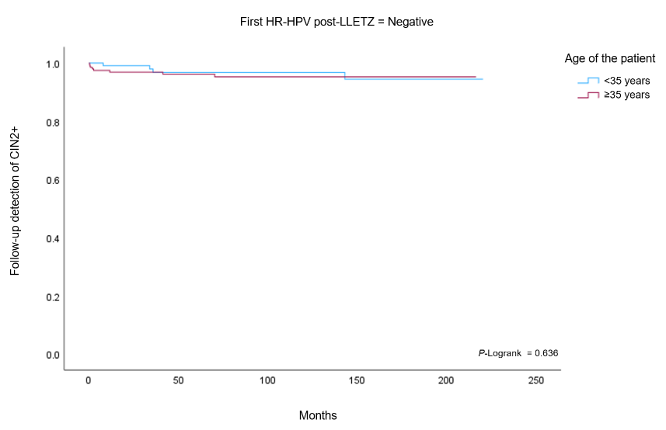
(G))
Figure S1. (A) Kaplan-Meier curve for follow-up detection of CIN2+ by HR-HPV post-LLETZ (p log-rank < 0.001). (B) Kaplan-Meier curve for follow-up detection of CIN2+ by margin status (p log-rank < 0.001). (C) Kaplan-Meier curve for follow-up detection of CIN2+ by margin status for positive HR-HPV post-LLETZ (p log-rank < 0.001). (D) Kaplan-Meier curve for follow-up detection of CIN2+ by margin status for negative HR-HPV post-LLETZ (p log-rank = 0.122). (E) Kaplan-Meier curve for follow-up detection of CIN2+ by age of the patients (p log-rank = 0.013). (F) Kaplan-Meier curve for follow-up detection of CIN2+ by age for positive HR-HPV post- LLETZ (p log-rank < 0.001). (G) Kaplan-Meier curve for follow-up detection of CIN2+ by age for negative HR-HPV post-LLETZ (p log-rank = 0.636).

Table S1. Univariate analysis of predictive factors associated with follow-up detection of CIN2+ after large loop excision of the transformation zone (LLETZ).
Characteristics | Total  n | CIN2+  n (%) | HR | 95% CI | P-value*
Age at the time of LLETZ (years)
< 35 years old | 181 | 7 (3.8) | Ref. |  | Ref.
≥ 35 years old | 251 | 25 (9.9) | 2.84 | (1.20-6.70) | 0.017
Age (years)
Median (min-max) | 36.1 (18.3-77) | 39.2 (24-62) | 1.02 | (0.99-1.06) | 0.184
Smoking habit
No | 195 | 14 (7.2) | Ref. |  | Ref.
Yes | 209 | 15 (7.2) | 0.93 | (0.45-1.93) | 0.850
Unknown | 28 | 3 (10.7) | 1.51 | (0.42-5.41) | 0.526
Parity
Nulliparous | 118 | 7 (5.9) | Ref. |  | Ref.
< 4 full term births | 264 | 18 (6.8) | 1.08 | (0.45-2.59) | 0.862
≥ 4 full-term births | 15 | 4 (26.7) | 4.99 | (1.46-17.1) | 0.010
Unknown | 35 | 3 (8.6) | 1.19 | (0.30-4.75) | 0.802
Contraceptive method
Nothing | 77 | 7 (9.1) | Ref. |  | Ref.
Hormonal | 113 | 10 (8.8) | 0.59 | (0.20-1.68) | 0.321
IUD | 47 | 3 (6.4) | 1.04 | (0.39-2.72) | 0.944
Condom | 130 | 7 (5.4) | 0.60 | (0.15-2.38) | 0.471
Others | 19 | 2 (10.5) | 1.09 | (0.22-5.43) | 0.916
HPV vaccine prior to or after LLETZ
No | 326 | 24 (7.4) | Ref. |  | Ref.
Yes | 91 | 7 (7.7) | 1.19 | (0.51-2.78) | 0.696
HR-HPV result (HC2 and Cobas 4800)
First HR-HPV post-LLETZ
Negative | 332 | 12 (3.6) | Ref. |  | Ref.
Positive | 100 | 20 (20.0) | 5.98 | (2.92-12.3) | < 0.001
First RLU HR-HPV post-LLETZ
Median (Min-Max) | 0.21 (0.06-3249.9) | 0.23 (0.07-561.43) | 1.00 | (0.99-1.01) | 0.604
First RLU HR-HPV post-LLETZ category
Negative | 301 | 12 (37.5) | Ref. |  | Ref.
1-100 pg/ml | 60 | 7 (11.7) | 2.86 | (1.12-7.26) | 0.027
> 100 pg/ml | 27 | 9 (33.3) | 11.0 | (4.60-26.2) | < 0.001
Unknown | 44 | 4 (9.1) | 2.98 | (0.93-9.56) | 0.067
Surgical specimen characteristics
Margin status
Clear | 232 | 8 (3.4) | Ref. |  | Ref.
Ecto+/endo- | 68 | 3 (4.4) | 1.43 | (0.38-5.38) | 0.600
Ecto-/endo+ | 70 | 12 (17.1) | 5.64 | (2.30-13.8) | < 0.001
Ecto+/endo+ | 11 | 2 (18.2) | 6.86 | (1.45-32.5) | 0.015
Endo+/deep+ | 2 | 0 (0.00)** | 0.00 | (0.00) | 0.999
All | 4 | 0 (0.00)** | 0.00 | (0.00) | 0.998
Table 1. (Continued)
Characteristics | Total  n | CIN2+  n (%) | HR | 95% CI | P-value*
Deep | 2 | 0 (0.00)** | 0.00 | (0.00) | 0.999
Uncertain | 43 | 7 (16.3) | 5.54 | (1.99-15.4) | 0.001
Margin status category
Clear | 232 | 8 (3.4) | Ref. |  | Ref.
Involved | 157 | 17 (10.8) | 3.56 | (1.53-8.25) | 0.003
Uncertain | 43 | 7 (16.3) | 5.53 | (1.99-15.4) | 0.001
Type of excision
Type 1¹ | 141 | 12 (8.5) | Ref.
Type 2² | 199 | 15 (7.5) | 0.92 | (0.33-2.56) | 0.540
Type 3³ | 92 | 5 (5.4) | 0.71 | (0.22-2.29) | 0.272
Length (mm)⁴
Median (IQR) | 10.0 (7.0-15.0) | 9.5 (7.0-13.0) | 0.84 | (0.37-1.94) | 0.688
Thickness (mm)⁵
Median (IQR) | 10.5 (9.5-12.5) | 10.0 (9.0-13.0) | 0.34 | (0.08-1.44) | 0.143
Circumference (mm)⁶
Median (IQR) | 103.0 (90.6-120.0) | 99.0 (85.5-119.0) | 0.92 | (0.78-1.10) | 0.363
Volume Carcopino (cm³)⁷
Median (IQR) | 3.94 (2.27-6.18) | 3.66 (1.60-7.24) | 0.98 | (0.88-1.10) | 0.761
Volume Phadnis (cm³)⁸
Median (IQR) | 2.18 (1.31-3.50) | 1.96 (1.19-2.93) | 0.86 | (0.65-1.12) | 0.263
Quadrants involved
1-2 | 203 | 13 (6.4) | Ref. |  | Ref.
3-4 | 158 | 16 (10.1) | 0.54 | (0.12-2.43) | 0.429
Not valuable | 18 | 2 (11.1) | 0.93 | (0.21-4.09) | 0.933
Unknown | 53 | 1 (1.9) | 0.19 | (0.01-2.18) | 0.185
Total | 432 | 32 (7.4)
CI, confidence interval; HR, hazard ratio; LLETZ, large loop excision of the transformation zone; IUD, intrauterine device; HPV, human papilloma virus; HR-HPV, high-risk human papilloma virus; RLU, relative light unit; Ecto, ectocervical; Endo, endocervical; IQR, interquartile range (25-75%). ¹Length of <10 mm. ²Length of 10-15 mm. ³Length of 15-25 mm. ⁴The distance from the external margins to the internal margins, with data available from 307 cases for inclusion in the analysis. ⁵The distance from the stromal margins to the surface of the excised specimen. ⁶The perimeter of the excised specimen, formula: 2*3.14159*sqrt((cone amplitude^2+cone depth^2)/2), with data available from 363 cases for inclusion in the analysis. ⁷Volume = (1/2) (4/3) π x length x (circumference /2π) x thickness, with data available from 305 cases for inclusion in the analysis. ⁸Volume = 1/2 (4/3) π (a/2) (b/2) c [a: transverse diameter, b: longitudinal diameter, c: depth of the cone biopsy] with data available from 302 cases for inclusion in the analysis. Values in bold indicate significant differences between study groups. *Log-likelihood ratio test p-value. **No recurrences observed in the category.

Table S2. Association between type of excision, length of the cone, age of the women, and first HR-HPV post -LLETZ with ectocervical and endocervical margins of the surgical specimen in women treated with large loop excision of the transformation zone (LLETZ) for cervical intraepithelial neoplasia 2-3 (CIN2+).
 | n = 138** | EctocervicaL margin involvement  n= 68 | EndocervicaL margin involvement  n = 70 | OR (95% CI) | P-value***
Type of excision
Type 1, n (%)* | 46 (33.3) | 23 (50.0) | 23 (50.0) | Ref. | Ref.
Type 2, n (%)* | 70 (50.7) | 34 (48.6) | 36 (51.4) | 1.01 (0.44-2.32) | 0.985
Type 3, n (%)* | 22 (15.9) | 11 (50.0) | 11 (50.0) | 0.98 (0.32-3.20) | 0.979
Length (cm)
Median (IQR) | 1.00 (0.70-1.37) | 1.00 (0.70-1.33) | 1.00 (0.70-1.37) | 1.29 (0.62-2.68) | 0.496
Age (years)
< 35 years old, n (%)* | 53 (38.4) | 30 (56.6) | 23 (43.4) | Ref. | Ref.
≥ 35 years old, n (%)* | 85 (61.6) | 38 (44.7) | 47 (55.3) | 0.767 (0.445-1.320) | 0.338
First HR-HPV post-LLETZ
Negative, n (%)* | 110 (79.7) | 58 (52.7) | 52 (47.3) | Ref. | Ref.
Positive, n (%)* | 28 (20.3) | 10 (35.7) | 18 (64.3) | 1.800 (0.831-3.899) | 0.136
CI, confidence interval; OR odd ratio; IQR, interquartile range (25-75%); HR-HPV, high-risk human papilloma virus; LLETZ, large loop excision of the transformation zone; *row percentage; **Column percentage; *** Log-likelihood ratio test p-value.

