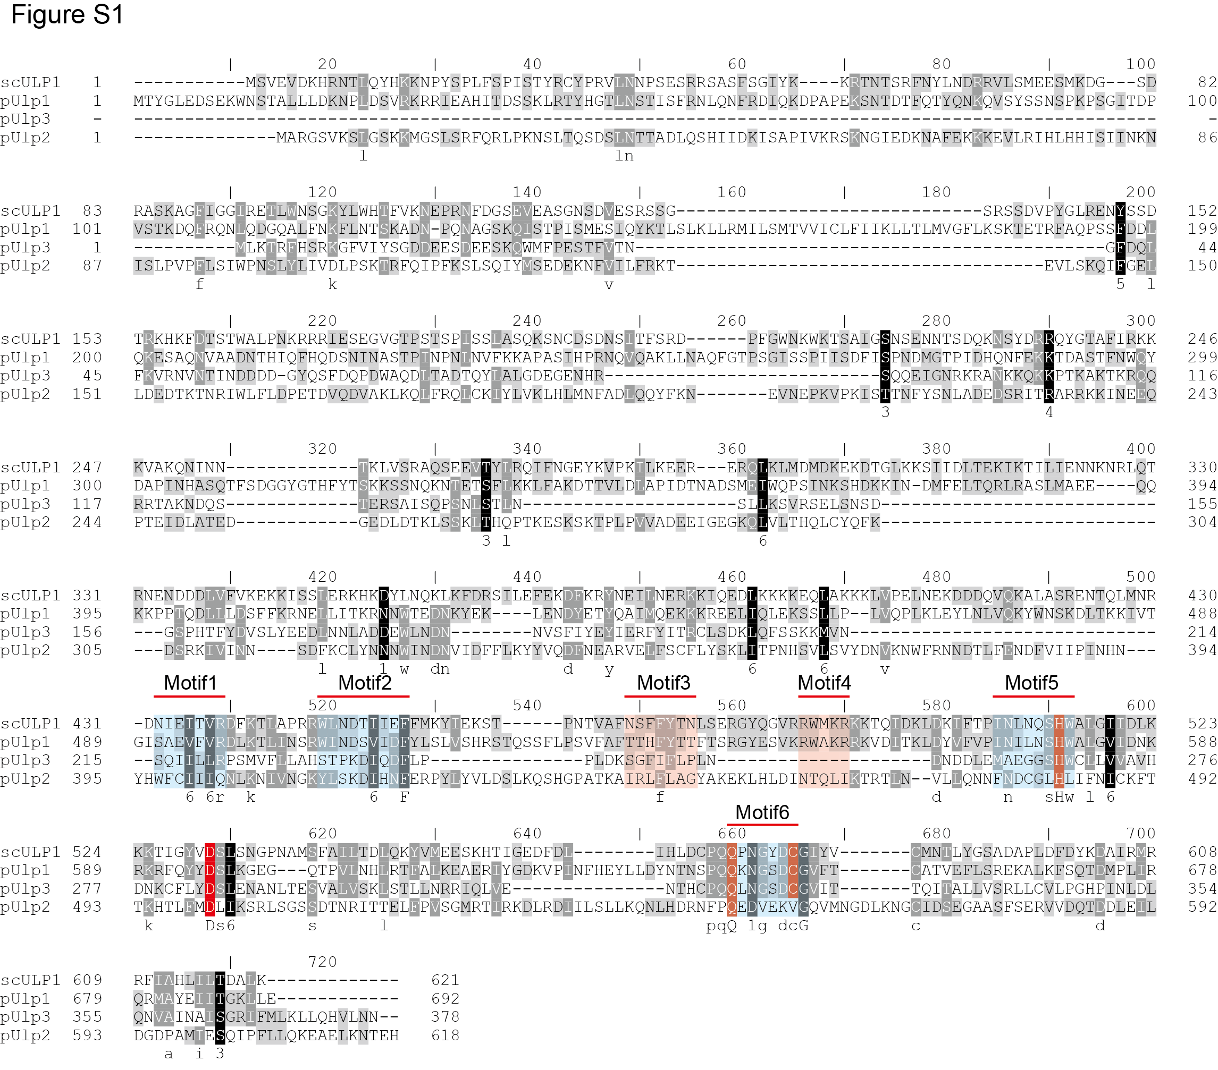

**Figure S1. Amino acid sequence alignment of scUlp1, pUlp1, pUlp2, and pUlp3.** scUlp1 refers to the Ulp1 protein from *Saccharomyces cerevisiae*. pUlp1, pUlp2, and pUlp3 are the Ulp proteins from *Pichia pastoris*, named based on their sequence similarity to the Ulp1 protein of *Saccharomyces cerevisiae*. Conserved motifs and amino acids are highlighted with red and blue color.