**Supplementary Materials**

Development of Novel Imipridones with Alkyne- and Triazole-linked Warheads on the Tricyclic Skeleton, Showing Superior Ability to Eradicate PANC-1 and Fadu Cells Compared to ONC201

Tamás Czuczi1,2, József Murányi1, István Móra3, Bianka Gurbi3, Attila Varga3, Dávid Papp2,4, Gitta Schlosser4, Miklós Csala3,* and Antal Csámpai1,*

1. Department of Organic Chemistry, Eötvös Loránd University (ELTE), Pázmány P. sétány 1/A, H-1117 Budapest, Hungary; czuczi.tamas@gmail.com (T.C.).
2. Hevesy György PhD School of Chemistry, Pázmány P. sétány 1/A, H-1117 Budapest, Hungary
3. Department of Molecular Biology, Semmelweis University, Tűzoltó u. 37-47, H-1094 Budapest, Hungary; istvan.mora1313@gmail.com (I.M.); gurbi.bianka@semmelweis.hu (B.G.); varga.attila3@semmelweis.hu (A.V.); csala.miklos@semmelweis.hu (M.C.)
4. MTA-ELTE Lendület Ion Mobility Mass Spectrometry Research Group, ELTE Eötvös Loránd University, Institute of Chemistry, Pázmány Péter sétány 1/A, H-1117 Budapest, Hungary; david.papp@ttk.elte.hu (D.P.); gitta.schlosser@ttk.elte.hu (G.S.)

* Correspondence: antal.csampai@ttk.elte.hu (A.C.); Tel.: +36-01-372-2500 (ext. 6591) and csala.miklos@semmelweis.hu (M.C.); Tel.: +36-01-266-2615

**Content:**

**S.1. 1H-, 13C NMR and HRMS data of the targeted compounds pp. 2 – 13**

**S.2. Copies of the 1H-NMR and 13C-NMR spectra of the targeted compounds pp. 14 – 50**

**S.3. Copies of the HRMS spectra the targeted compounds pp. 51 – 87**

**S.1. 1H-, 13C NMR and HRMS data of the targeted compounds**



**Figure S.1**. Numbering of atoms presented on the structures of representative compounds used for the assignment of all 1H- and 13C-NMR data.

**7-(4-(4-(3-Aminophenyl)-1H-1,2,3-triazol-1-yl)benzyl)-4-(4-(3-aminoprop-1-yn-1-yl)benzyl)-2,4,6,7,8,9-hexahydroimidazo[1,2-a]pyrido[3,4-e]pyrimidin-5(1H)-one (1a)**: 1H-NMR (CDCl3): 8.14 (s, 1H, H-11”); 7.74 (d, *J* = 7.9 Hz, 2H, H-3”,5”); 7.52 (d, *J* = 7.9 Hz, 2H, H-2”,6”); 7.40 (d, *J* = 7.4 Hz, 2H, H-2’,6’); 7.35 and 7.34 (overlapping br s and d, *J* =7.4 Hz for the d, 3H, H-13” and H-3’,5’); 7-27-7.21 (overlapping m’s, 2H, H-16”,17”); 6.71 (dt, *J* = 6.9 Hz and 2.3 Hz, 1H, H-15”); 5.04 (s, 2H, H-10); 3.91 (br s, 4H, H-1 and H-2); 3.72 (s, 2H, H-11); 3.64 (s, 2H, H-13’); 3.32 (br s, 2H, H-6); 2.71 (t, *J* = 5.7 Hz, 2H, H-8); 2.50 (t, *J* = 5.7 Hz, 2H, H-9). 13C-NMR (CDCl3): 161.4 (C-5); 152.9 (C-3a); 148.5 =C-10”); 147.0 (two coalesced lines, C-9a and C-14”); 138.8 (C-1”); 136.9 (C-1’); 136.2 (C-4”); 131.5 (C-3’,5’); 131.2 (C-12”), 130.3 (C-2”,6”); 129.2 (C-16”); 128.5 (C-2’,6’); 122.3 (C-4’); 120.6 (C-3”,5”); 117.7 (C-11”); 116.1 (C-17”); 115.2 (C-15”); 112.5 (C-13”); 101.7 (C-5a); 90.1 (C-12’),82.4 (C-11’); 61.6 (C-11); 50.6 (C-1); 49.4 (C-6); 48.4 (C-8), 32.2 (C-13’); 26.8 (C-9). HRMS exact mass calcd. for [C34H33N9O]+: 584.2881 [M+H] +; found: 584.28697; mass error: –1.93 ppm.

**4-(4-(3-Hydroxyprop-1-yn-1-yl)benzyl)-7-(4-(4-ferrocenyl-1H-1,2,3-triazol-1-yl)benzyl)-2,4,6,7,8,9-hexahydroimidazo[1,2-a]pyrido[3,4-e]pyrimidin-5(1H)-one (1b):** 1H-NMR (CDCl3): 7.90 (s, 1H, H-11”); 7.74 (d, *J* = 8.3 Hz, 2H, H-3”,5”); 7.51 (d, *J* = 8.3 Hz, 2H, H-2”,5”); 7.40 (d, *J* = 8.4 Hz, 2H, H-2’,6’); 7.35 (d, *J* = 8.4 Hz, 2H, H-3’,5’); 5.05 (s, 2H, H-10); 4.80 (t, *J* = 1.8 Hz, 2H, H-13”16”); 4.47 (s, 2H, H-13’); 4.36 (t, *J* = 1.8 Hz, 2H, H-14”15”); 4.13 (s, 5H, 5-C5H5); 3.91 (br s, 4H, H-1 and H-2); 3.74 (s, 2H, H-11); 3.31 (br s, 2H, 6-H); 2.71 (t, *J* = 5.7 Hz, 2H, H-8); 2.50 (t, *J* = 5.7 Hz, 2H, H-9). 13C-NMR (CDCl3): 161.4 (C-5); 153.0 (C-3a); 147.6 (C-10”); 145.7 (C-9a); 138.5 (C-1”); 137.3 (C-1’); 136.3 (C-4”); 131.6 (C-3’,5’); 130.2 (C-2”,6”); 128.5 (C-2’,6’); 121.6 (C-4’); 120.4 (C-3”,5”); 116.6 (C-11’); 101.8 (C-5a); 87.4 (C-12’); 85.5 (C-11’); 74.9 (C-12”); 69.6 (5-C5H5); 68.8 (C-14”,15”); 66.8 (C-13”,16”); 61.6 (C-11); 51.5 (C-13’); 50.5 (C-1); 49.4 (C-6); 48.4 (C-8); 46.9 (C-2); 45.2 (C-10); 26.7 (C-9). ). HRMS exact mass calcd. for [C38H35FeN7O2]: 678.2274 [M+H] +; found: 678.22904; mass error: 2.42 ppm.

**4-(4-(3-Hydroxyprop-1-yn-1-yl)benzyl)-7-(4-(4-phenyl-1H-1,2,3-triazol-1-yl)benzyl)-2,4,6,7,8,9-hexahydroimidazo[1,2-a]pyrido[3,4-e]pyrimidin-5(1H)-one (1c)**: 1H-NMR (CDCl3): 8.20 (s, 1H, H-11”); 7.94 (br d, *J* ‘ 8 Hz, 2H, H-13”,17”); 7.76 (d, *J* = 8.4 Hz, 2H, H-3”,5”); 7.53 (d, *J* = 8.4 Hz, 2H, H-2”,6”); 7.48 (t, *J* = 7.5 Hz, 2H, H-14”,16”); 7.39 and 7.48 (overlapping d and tt, *J* = 8.5 Hz for d and 7.5 Hz and 1.5 Hz, for tt, 3H, H-2’,6’ and H-15”); 7.33 (d, *J* = 8.5 Hz, 2H, H-3’,5’); 5.04 (s, 2H, H-10); 4.46 (br s, 2H, H-13’); 3.90 (s, 4H, H-1 and H-2); 3.74 (s, 2H-11); 3.31 (br s, 2H, H-6), 2.71 (t, *J* = 5.7 Hz, 2H, H-8); 2.50 (t, *J* = 5.7 Hz, 2H, H-9); 2.12 (br s, OH). 13C-NMR (CDCl3): 161.4 (C-5); 153.0 (C-3a); 148.4 (C-10”); 145.1 (C-9a); 138.8 (C-1”); 137.3 (C-1’); 136.2 (C-4”); 131.6 (C-3’,5’); 130.3 (C-2”,6”); 130.2 (C-12”); 128.9 (C-14”,16”); 128.49 (C-2’,6’); 128.45 (C-15”); 125.9 (C-13”,17”); 121.7 (C-4’); 120.6 (C-3”,5”); 117.7 (C-11’); 101.8 (C-5a); 87.5 (C-12’); 85.5 (C-11’); 61.6 (C-11’); 51.5 (C-13’); 50.5 (C-1); 49.4 (C-6); 48.4 (C-8); 46.9 (C-2); 45.2 (C-10); 26.8 (C-9). HRMS exact mass calcd. for [C34H31N7O2]+: 570.2612 [M+H] +; found: 570.2630; mass error: 3.16 ppm.

**7-(4-(4-(3-Aminophenyl)-1H-1,2,3-triazol-1-yl)benzyl)-4-(4-(3-hydroxyprop-1-yn-1-yl)benzyl)-2,4,6,7,8,9-hexahydroimidazo[1,2-a]pyrido[3,4-e]pyrimidin-5(1H)-one (1d):** 1H-NMR (DMSO-*d*6): 8.12 (s, 1H, H-11”); 7.92 (d, *J* = 8.3 Hz, 2H, H-3”,5”); 7.56 (d, *J* = 8.3 Hz, 2H, H-2”,6”); 7.35 (d, *J* = 8.1 Hz, 2H, H-3’,5’); 7.28 (d, *J* = 8.1 Hz, 2H, H-2’,6’); 7.22 (t, *J* = 1.7 Hz, 1H, H-13”); 7.12 (t, *J* = 8.0 Hz, 1H, H-16”); 7.04 (br d, *J* ~ 8 Hz, 1H, H-17”); 6.58 (dd, *J* = 8.0 Hz and 1.7 Hz, 1H, H-15”); 5.32 (t, *J* = 5.8 Hz, 1H, OH); 5.23 (br s, 2H, NH2); 4.90 (s, 2H, H-10); 4.29 (d, *J* = 5.8 Hz, 2H, H-13’); 3.94 (t, *J* = 9.1 Hz, 2H, H-1); 3.71 (overlapping t and s, *J* = 9.1 for t, 4H, H-2 and H-11); 3.07 (br s, 2H, H-6), 2.68 (t, *J* = 5.7 Hz, 2H, H-8); 2.55 (t, *J* = 5.7 Hz, 2H, H-9). 13C-NMR (DMSO-*d*6): 161.1 (C-5); 152.5 (C-3a); 147.8 (C-9a); 149.6 (C-14”); 148.6 (C-10”); 139.4 (C-1”); 138.2 (C-1’); 136.0 (C-4”); 131.6 (C-3’,5’); 131.2 (C-12”); 130.6 (C-2”,6”); 129.9 (C-16”); 128.4 (C-2’,6’); 121.6 (C-4’); 120.4 (C-3”,5”); 119.6 (C-11”); 114.4 (C-15”); 113.7 (C-17”); 111.1 (C-13”); 99.7 (C-5a); 90.2 (C-12’); 84.0 (C-11’); 61.0 (C-11); 50.6 (C-1); 49.9 (C-13’); 49.2 (C-6); 48.8 (C-8); 46.8 (C-2); 26.3 (C-9). HRMS exact mass calcd. for [C34H32N8O2]: 585.2721 [M+H] +; found: 585.27152; mass error: –0.99 ppm.

**N-(3-(1-(4-((4-(4-(3-Aminoprop-1-yn-1-yl)benzyl)-5-oxo-1,2,4,5,8,9-hexahydroimidazo[1,2-a]pyrido[3,4-e]pyrimidin-7(6H)-yl)methyl)phenyl)-1H-1,2,3-triazol-4-yl)phenyl)acrylamide (1e):** 1H-NMR (DMSO-*d*6): 10.32 (s, H-18”); 9.26 (s, 1H, H-11”); 8.34 (br s, 1H, H-13”); 7.94 (d, *J* = 8.3 Hz, 2H, H-3”,5”); 7.71 (br d, J = 8.0 Hz, H-15”); 7.61 (br d, *J* = 8.0 Hz, 1H, H-17”); 7.57 (d, *J* = 8.3 Hz, 2H, H-2”,6”); 7.45 (t, *J* = 8.0 Hz, 1H, H-16”); 7.32 (d, *J* = 7.8 Hz, 2H, H-3’,5’); 7.26 (d, *J* = 7.8 Hz, 2H, H-2’,6’); 6.49 (dd, *J* = 17.0 Hz and 10.2 Hz, 1H, H-20”); 6.31 (dd, *J* = 17.0 Hz and 1.5 Hz, 1H, H-21”A); 5.79 (dd, *J* = 10.2 Hz and 1.5 Hz, 1H, H-21”B); 4.90 (s, 2H, H-10); 3.96 (t, *J* = 9.2 Hz, 2H, H-1); 3.72 (overlapping t and s, *J* = 9.2 for t, 4H, H-2 and H-11); 3.49 (s, 2H, H-13’); 3.08 (br s, 2H, H-6); 2.69 (t, *J* = 5.6 Hz, 2H; H-8); 2.56 (t, *J* = 5.6 Hz, 2H; H-9). 13C-NMR (DMSO-*d*6): 163.7 (C-19”); 161.1 (C-5); 152.5 (C-3a); 147.8 (C-9a); 147.6 (C-10”); 140.1 (C-14”); 139.6 (C-1”); 137.8 (C-1’); 136.1 (C-4”); 132.3 (C-21”); 131.5 (C-3’,5’); 131.3 (C-12”); 130.5 (C-2”,6”); 128.3 (C-2’,6’); 127.5 (two coalesced lines, C-16” and C-20”); 122.1 (C-4’); 121.2 (C-17”); 120.5 (C-3”,5”); 120.2 (C-11”); 119.7 (C-15”); 116.6 (C-13”); 99.6 (C-5a); 92.5 (C-12’); 81.6 (C-11’); 61.0 (C-11); 50.6 (C-1); 49.2 (C-6); 48.8 (C-8); 46.8 (C-2); 31.8 (C-13’); 44.8 (C-10); 26.3 (C-9). HRMS exact mass calcd. for [C37H35N9O2]: 638.2986 [M+H] +; found: 638,29871; mass error: 0.17 ppm.

**4-(3-(3-aminoprop-1-yn-1-yl)benzyl)-7-(4-(4-ferrocenyl-1H-1,2,3-triazol-1-yl)benzyl)-2,4,6,7,8,9-hexahydroimidazo[1,2-a]pyrido[3,4-e]pyrimidin-5(1H)-one (2a)**:1H-NMR (DMSO-*d*6):8.88 (s, 1H, H-11”); 7.91 (d, *J* = 8.3 Hz, 2H, H-3”,5”); 7.56 (d, *J* = 8.3 Hz, 2H, H-2”,5”); 7.33-7.24 (overlapping m’s, 4H, H-2’, H-4’, H5’ and H-6’); 4.89 (s, 2H, H-10); 4.80 (br s, 2H, H-13”16”); 4.36 (br s, 2H, H-14”15”); 4.09 (s, 5H, 5-C5H5); 3.95 (t, *J* = 9.5 Hz, 2H, H-1); 3.72 and 3.71 (overlapping s and t, *J* = 9.5 Hz for t, 4H, H-11 and H-2); 3.50 (s, 2H, H-13’); 3.09 (br s, 2H, 6-H); 2.68 (t, *J* = 5.7 Hz, 2H, H-8); 2.55 (t, *J* = 5.7 Hz, 2H, H-9). 13C-NMR (DMSO-*d*6): 161.2 (C-5); 152.5 (C-3a); 147.8 (C-9a); 147.0 (C-10”); 139.2 (C-1”); 138.2 (C-1’); 136.1 (C-4”); 130.8 (C-2’); 130.5 (C-2”,6”); 130.4 (C-4’); 129.0 (C-5’); 128.3 (C-6’); 123.2 (C-3’); 120.2 (C-3”,5”); 118.9 (C-11’); 99.6 (C-5a); 92.7 (C-12’); 81.7 (C-11’); 76.8 (C-12”); 69.8 (5-C5H5); 68.9 (C-14”,15”); 66.8 (C-13”,16”); 61.0 (C-11); 50.6 (C-1); 49.2 (C-6); 48.8 (C-8); 46.8 (C-2); 44.7 (C-10); 31.8 (C-13’), 26.2 (C-9). HRMS exact mass calcd. for HRMS exact mass calcd. for [C38H36FeN8O]+: 677.2434 [M+H] +; found: 677.24278; mass error: –0.92 ppm.

**4-(3-(3-Aminoprop-1-yn-1-yl)benzyl)-7-(4-(4-phenyl-1H-1,2,3-triazol-1-yl)benzyl)-2,4,6,7,8,9-hexahydroimidazo[1,2-a]pyrido[3,4-e]pyrimidin-5(1H)-one (2b)**:1H-NMR (DMSO-*d*6): 9.28 (s, 1H, H-11”); 7.92 (d, *J* = 8.3 Hz, 2H, H-3”,5”); 7.96 (d, *J* = 7.4 Hz, 2H, H-13”,17”); 7.57 (d, *J* = 8.3 Hz, 2H, H-2”,5”); 7.50 (t, *J* = 7.4 Hz, 2H, H-14”,16”); 7.39 (tt, *J* = 7.4 Hz and 1.8 Hz, 1H, H-15”); 7.32-7.24 (overlapping m’s, 3H, H-4’, H5’ and H-6’); 4.88 (s, 2H, H-10); 3.95 (t, *J* = 9.5 Hz, 2H, H-1); 3.72 and 3.71 (overlapping s and t, *J* = 9.5 Hz for t, 4H, H-11 and H-2); 3.49 (s, 2H, H-13’); 3.09 (br s, 2H, 6-H); 2.68 (t, *J* = 5.7 Hz, 2H, H-8); 2.54 (t, *J* = 5.7 Hz, 2H, H-9). 13C-NMR (DMSO-*d*6): 161.2 (C-5); 152.5 (C-3a); 147.76 (C-9a); 147.72 (C-10”); 139.5 (C-1”); 138.2 (C-1’); 136.1 (C-4”); 130.8 (two coalesced lines, C-2’ and C-14”,16”); 130.6 (C-2”,6”); 130.4 (coalesced lines, C-4’ and C-12”); 129.0 (C-5’); 128.7 (C-15”); 128.3 (C-6’); 125.8 (C-13”,17”); 123.1 (C-3’); 120.4 (C-3”,5”); 120.1 (C-11’); 99.7 (C-5a); 92.7 (C-12’); 81.7 (C-11’); 60.9 (C-11); 50.6 (C-1); 49.2 (C-6); 48.8 (C-8); 46.8 (C-2); 44.8 (C-10); 31.8 (C-13’), 26.2 (C-9). HRMS exact mass calcd. for [C34H32N8O]+: 569.2772 [M+H] +; found 569,27763; mass error: –0.76 ppm.

**4-(3-(3-Hydroxyprop-1-yn-1-yl)benzyl)-7-(4-(4-ferrocenyl-1H-1,2,3-triazol-1-yl)benzyl)-2,4,6,7,8,9-hexahydroimidazo[1,2-a]pyrido[3,4-e]pyrimidin-5(1H)-one (2c): )**:1H-NMR (CDCl3): 7.90 (s, 1H, H-11”); 7.74 (d, *J* = 8.3 Hz, 2H, H-3”,5”); 7.51 (d, *J* = 8.3 Hz, 2H, H-2”,5”); 7.50 (br s, 1H, H-2’); 7.43 (br d, *J* = 7.6 Hz, 1H, H-6’); 7.31 (br d, *J* = 7.6 Hz, 1H, H-4’); 7.24 (t, *J* = 7.6 Hz, 1H, H-5’); 5.04 (s, 2H, H-10); 4.81 (t, *J* = 1.8 Hz, 2H, H-13”16”); 4.47 (s, 2H, H-13’); 4.36 (t, *J* = 1.8 Hz, 2H, H-14”15”); 4.13 (s, 5H, 5-C5H5); 3.92 (br s, 4H, H-1 and H-2); 3.74 (s, 2H, H-11); 3.31 (br s, 2H, 6-H); 2.71 (t, *J* = 5.7 Hz, 2H, H-8); 2.50 (t, *J* = 5.7 Hz, 2H, H-9). 13C-NMR (CDCl3): 161.4 (C-5); 152.9 (C-3a); 147.6 (C-10”); 145.7 (C-9a); 138.5 (C-1”); 137.1 (C-1’); 136.3 (C-4”); 131.4 (C-2’); 130.7 (C-4’); 130.3 (C-2”,6”); 128.8 (C-6’); 128.3 (C-5’); 122.7 (C-3’); 120.4 (C-3”,5”); 116.6 (C-11’); 101.7 (C-5a); 87.4 (C-12’); 85.6 (C-11’); 74.9 (C-12”); 69.6 (5-C5H5); 68.8 (C-14”,15”); 66.8 (C-13”,16”); 61.6 (C-11); 51.5 (C-13’); 50.5 (C-1); 49.4 (C-6); 48.5 (C-8); 46.9 (C-2); 45.0 (C-10); 26.7 (C-9). HRMS exact mass calcd. for [C38H35FeN7O2]+: 678.2274 [M+H] +; found: 678.22748; mass error: 0.12 ppm.

**4-(3-(3-Hydroxyprop-1-yn-1-yl)benzyl)-7-(4-(4-phenyl-1H-1,2,3-triazol-1-yl)benzyl)-2,4,6,7,8,9-hexahydroimidazo[1,2-a]pyrido[3,4-e]pyrimidin-5(1H)-one (2d):** 1H-NMR (CDCl3): 8.21 (s, 1H, H-11”); 7.92 (d, *J* = 7.8 Hz, 2H, H-13”,17”); 7.75 (d, *J* = 8.3 Hz, 2H, H-3”,5”); 7.52 (d, *J* = 8.3 Hz, 2H, H-2”,5”); 7.50 (br s, 1H, H-2’); 7.48 (t, *J* = 7.8 Hz, 2H, H-14”,16”); 7.42 (br d, *J* = 7.6 Hz, 1H, H-6’); 7.38 (t, *J* = 7.8 Hz, 1H, H-15”); 7.30 (br d, *J* = 7.6 Hz, 1H, H-4’); 7.23 (t, *J* = 7.6 Hz, 1H, H-5’); 5.03 (s, 2H, H-10); 4.47 (s, 2H, H-13’); 3.89 (br s, 4H, H-1 and H-2); 3.72 (s, 2H, H-11); 3.31 (br s, 2H, 6-H); 2.70 (t, *J* = 5.7 Hz, 2H, H-8); 2.49 (t, *J* = 5.7 Hz, 2H, H-9). 13C-NMR (CDCl3): 161.4 (C-5); 152.9 (C-3a); 148.5 (C-10”); 145.8 (C-9a); 138.8 (C-1”); 137.0 (C-1’); 136.3 (C-4”); 131.3 (C-2’); 130.6 (C-4’); 130.3 (C-2”,6”); 130.2 (C-12”); 129.0 (C-14”,16”); 128.8 (two coalesced lines, C-6’ and C-15”); 128.3 (C-5’); 122.6 (C-3’); 120.6 (C-3”,5”); 117.8 (C-11’); 101.7 (C-5a); 87.6 (C-12’); 85.4 (C-11’); 61.5 (C-11); 51.4 (C-13’); 50.5 (C-1); 49.4 (C-6); 48.4 (C-8); 46.9 (C-2); 45.0 (C-10); 26.7 (C-9). HRMS exact mass calcd. for [C34H31N7O2]+: 570.2612 [M+H] +; found: 570.2630; mass error: 3.16 ppm.

**4-(4-(3-Aminoprop-1-yn-1-yl)benzyl)-7-(3-(4-ferrocenyl-1H-1,2,3-triazol-1-yl)benzyl)-2,4,6,7,8,9-hexahydroimidazo[1,2-a]pyrido[3,4-e]pyrimidin-5(1H)-one (3a):** 1H-NMR (CDCl3): 7.92 (s, 1H, H-11”); 7.80 (br s, 1H, H-2”); 7.70 (br d, *J* = 7.8 Hz, 1H, H-4”); 7.49 (t, *J* = 7.8 Hz, 1H, H-5”); 7.42-7.38 (overlapping m’s, 3H, H-2’,6’ and H-6”); 7.33 (d, *J* = 8.3 Hz, 2H, H-3’,5’); 5.04 (s, 2H, H-10); 4.80 (br s, 2H, H-13”,16”); 4.35 (br s, 2H, H-14”,15”); 4.13 (s, 5H, 5-C5H5); 3.91 (br s, 4H, H-1 and H-2); 3.77 (s, 2H, H-11); 3.65 (s, 2H, H-13’); 3.33 (br s, 2H, 6-H); 2.74 (t, *J* = 5.6 Hz, 2H, H-8); 2.56 (t, *J* = 5.6 Hz, 2H, H-9). 13C-NMR (CDCl3): 161.4 (C-5); 152.9 (C-3a); 147.6 (C-10”); 145.7 (C-9a); 140.2 (C-1”); 137.3 (C-3”); 134.8 (C-1’); 131.5 (C-3’,5’); 129.8 (C-5”); 129.1 (C-6”); 128.5 (C-2’,6’); 122.4 (C-4’); 120.6 (C-2”); 119.4 (C-4”); 116.8 (C-11’); 101.7 (C-5a); 84.7 (C-12’); 82.5 (C-11’); 74.9 (C-12”); 69.6 (5-C5H5); 68.8 (C-14”,15”); 66.8 (C-13”,16”); 61.8 (C-11); 50.6 (C-1); 49.5 (C-6); 48.5 (C-8); 46.9 (C-2); 45.2 (C-10); 32.2 (C-13’); 26.8 (C-9). HRMS exact mass calcd. for [C38H36FeN8O]+: 677.2434 [M+H] +; found: 677,24557; mass error: 3.20 ppm.

**4-(4-(3-Aminoprop-1-yn-1-yl)benzyl)-7-(3-(4-phenyl-1H-1,2,3-triazol-1-yl)benzyl)-2,4,6,7,8,9-hexahydroimidazo[1,2-a]pyrido[3,4-e]pyrimidin-5(1H)-one (3b):** 1H-NMR (DMSO-*d*6): 9.32 (s, 1H, H-11”); 7.98 (br d, *J* = 7.9 Hz, 2H, H-13”,17”); 7.95 (br s, 1H, H-2”);7.86 (br d, *J* = 7.7 Hz, 1H, H-4”); 7. 60 (t, *J* = 7.7 Hz, 1H, H-5”); 7.50 (t, , *J* = 7.9 Hz, 2H, H-14”,16”); 7.47 (br d, *J* = 7.7 Hz, 1H, H-6”); 7.39 (t, *J* = 7.9 Hz, 1H, H-15”); 7.32 (d, *J* = 8.0 Hz, 2H, H-3’,5’); 7.26 (d, *J* = 8.0 Hz, 2H, H-2’,6’); 4.89 (s, 2H, H-10); 3.75 (s, 2H, H-11); 3.94 (t, *J* = 9.7 Hz, 2H, H-1); 3.71 (t, *J* = 9.7 Hz, 2H, H-2); 3.49 (s, 2H, H-13’); 3.11 (br s, 2H, H-6); 2.69 (t, *J* = 5.6 Hz, 2H, H-8); 2.56 (t, *J* = 5.6 Hz, 2H, H-9). 13C-NMR (DMSO-*d*6): 161.2 (C-5); 152.5 (C-3a); 147.8 (C-10”); 147.6 (C-9a); 141.2 (C-1”); 137.8 (C-1’); 137.3 (C-2”); 131.5 (C-3’,5’); 130.7 (C-3”); 130.3 (C-5”); 129.5 (C-14”,16”); 129.4 (C-6”); 128.7 (C-15”); 128.3 (2’,6’); 125.8 (C-13”,17”); 122.0 (C-4’); 120.4 (C-2”); 120.1 (C-11”); 119.2 (C-4”); 99.6 (C-5a); 92.5 (C-12’); 81.8 (C-11’); ”); 61.2 (C-11); 50.5 (C-1); 49.3 (C-6); 48.8 (C-8); 46.8 (C-2); 44.8 (C-10); 31.9 (C-13’); 26.2 (C-9). HRMS exact mass calcd. for [C34H32N8O]+: 569.2772. [M+H] +; found: 569.27695; mass error: –0.44 ppm.

**4-(4-(3-Hydroxyprop-1-yn-1-yl)benzyl)-7-(3-(4-ferrocenyl-1H-1,2,3-triazol-1-yl)benzyl)-2,4,6,7,8,9-hexahydroimidazo[1,2-a]pyrido[3,4-e]pyrimidin-5(1H)-one (3c):** 1H-NMR (CDCl3): 7.92 (s, 1H, H-11”); 7.80 (br s, 1H, H-2”); 7.70 (br d, *J* = 7.8 Hz, 1H, H-4”); 7.49 (t, *J* = 7.8 Hz, 1H, H-5”); 7.42-7.38 (overlapping m’s, 3H, H-2’,6’ and H-6”); 7.33 (d, *J* = 8.3 Hz, 2H, H-3’,5’); 5.04 (s, 2H, H-10); 4.80 (t, *J* = 1.8 Hz, 2H, H-13”,16”); 4.46 (s, 2H, H-13’); 4.35 (t, *J* = 1.8 Hz, 2H, H-14”,15”); 4.13 (s, 5H, 5-C5H5); 3.89 (br s, 4H, H-1 and H-2); 3.76 (s, 2H, H-11); 3.32 (br s, 2H, 6-H); 2.72 (t, *J* = 5.6 Hz, 2H, H-8); 2.50 (t, *J* = 5.6 Hz, 2H, H-9). 13C-NMR (CDCl3): 161.4 (C-5); 152.9 (C-3a); 147.6 (C-10”); 145.7 (C-9a); 140.2 (C-1”); 137.3 (C-3”); 137.2 (C-1’); 131.6 (C-3’,5’); 129.8 (C-5”); 129.1 (C-6”); 128.5 (C-2’,6’); 121.9 (C-4’); 120.6 (C-2”); 119.3 (C-4”); 116.7 (C-11’); 101.7 (C-5a); 87.5 (C-12’); 85.4 (C-11’); 74.9 (C-12”); 69.6 (5-C5H5); 68.8 (C-14”,15”); 66.8 (C-13”,16”); 61.8 (C-11); 51.5 (C-13’); 50.5 (C-1); 49.4 (C-6); 48.5 (C-8); 46.9 (C-2); 45.2 (C-10); 26.7 (C-9). HRMS exact mass calcd. for [C38H35FeN7O2]+: 678.2274 [M+H] +; found: 678.22769; mass error: 0.43 ppm.

**4-(4-(3-Hydroxyprop-1-yn-1-yl)benzyl)-7-(3-(4-phenyl-1H-1,2,3-triazol-1-yl)benzyl)-2,4,6,7,8,9-hexahydroimidazo[1,2-a]pyrido[3,4-e]pyrimidin-5(1H)-one (3d):** 1H-NMR (DMSO-*d*6): 9.31 (s, 1H, H-11”); 7.97 (dd, *J* = 7.4 Hz and 1.4 Hz, 2H, H-13”,17”); 7.95 (br s, 1H, H-2”); 7.86 (br d, *J* = 7.8 Hz, 1H, H-4”); 7.60 (t, *J* = 7.8 Hz, 1H, H-5”); 7.50 (t, *J* = 7.4 Hz, 2H, H-14”,16”); 7.47 (br d, *J* = 8.3 Hz, 1H, H-6”);7.39 (tt, *J* = 7.4 Hz and 1.4 Hz, 1H, H-15”); 7.35 (d, *J* = 8.3 Hz, 2H, H-3’,5’); 7.27 (d, *J* = 8.3 Hz, 2H, H-2’,6’); 5.31 (t, *J* = 5.5 Hz, 1H, OH); 4.90 (s, 2H, H-10); 4.29 (d, *J* = 5.5 Hz, 2H, H-13’); 3.95 (t, *J* = 9.7 Hz, 2H, H-1); 3.76 (s, 2H, H-11); 3.71 (t, *J* = 9.7 Hz, 2H, H-2); 3.12 (br s, 2H, 6-H); 2.70 (t, *J* = 5.7 Hz, 2H, H-8); 2.56 (t, *J* = 5.7 Hz, 2H, H-9). 13C-NMR (DMSO-*d*6): 161.2 (C-5); 152.5 (C-3a); 147.77 (C-10”); 147.79 (C-9a); 141.2 (C-1”); 138.2 (C-1’); 137,2 (C-3”); 131.6 (C-3’,5’); 130.7 (C-12”); 130.3 (C-5”); 129.5 (C-14”,16”); 129.4 (C-6”); 128.7 (C-15”); 128.3 (C-2’,6’); 125.8 (C-13”,17”); 121.6 (C-4’); 120.4 (C-2”); 120.1 (C-11’); 119.2 (-4”); 99.6 (C-5a); 90.3 (C-12’); 84.0 (C-11’); 61.2 (C-11); 50.5 (C-1); 49.9 (C-13’), 49.3 (C-6); 48.8 (C-8); 46.8 (C-2); 44.8 (C-10); 26.2 (C-9). HRMS exact mass calcd. for [C34H31N7O2]+: 570.2612. [M+H] +; found: 570,25985 mass error: –2.37 ppm.

**4-(3-(3-Aminoprop-1-yn-1-yl)benzyl)-7-(3-(4-ferrocenyl-1H-1,2,3-triazol-1-yl)benzyl)-2,4,6,7,8,9-hexahydroimidazo[1,2-a]pyrido[3,4-e]pyrimidin-5(1H)-one (4a):** 1H-NMR (CDCl3): 7.92 (s, 1H, H-11”); 7.80 (br s, 1H, H-2”); 7.70 (br d, *J* = 7.6 Hz, 1H, H-4”); 7.50 and 7.49 (overlapping br s and t, *J* = 7.6 Hz for the t, 2H, H-2’ and H-5”); 7.42-7.38 (overlapping m’s, 2H, H-6’ and H-6”); 7.28 (br d, *J* = 7.6 Hz, 1H, H-4’); 7.22 (t, *J* = 7.6 Hz, 1H, H-5’); 5.03 (s, 2H, H-10); 4.80 (br s, 2H, H-13”,16”); 4.35 (br s, 2H, H-14”,15”); 4.13 (s, 5H, 5-C5H5); 3.91 (br s, 4H, H-1 and H-2); 3.77 (s, 2H, H-11); 3.64 (s, 2H, H-13’); 3.33 (br s, 2H, 6-H); 2.73 (t, *J* = 5.6 Hz, 2H, H-8); 2.52 (t, *J* = 5.6 Hz, 2H, H-9). 13C-NMR (CDCl3): 161.4 (C-5); 152.9 (C-3a); 147.6 (C-10”); 145.7 (C-9a); 140.2 (C-1”); 137.3 (C-3”); 137.0 (C-1’); 130.6 (C-5”); 130.3 (C-2’); 129.2 (C-4’); 129.1 (C-6”); 128.5 (C-6’); 128.3 (C-5’); 123.2 (C-3’); 120.6 (C-2”); 119.5 (C-4”); 116.7 (C-11’); 101.6 (C-5a); 84.7 (C-12’); 82.7 (C-11’); 74.9 (C-12”); 69.6 (5-C5H5); 68.8 (C-14”,15”); 66.8 (C-13”,16”); 61.8 (C-11); 50.6 (C-1); 49.5 (C-6); 48.5 (C-8); 46.9 (C-2); 45.1 (C-10); 32.2 (C-13’); 26.8 (C-9). HRMS exact mass calcd. for [C38H36FeN8O]+: 677.2434 [M+H] +; found: 677.24278; mass error: –0.92 ppm.

**4-(3-(3-Aminoprop-1-yn-1-yl)benzyl)-7-(3-(4-phenyl-1H-1,2,3-triazol-1-yl)benzyl)-2,4,6,7,8,9-hexahydroimidazo[1,2-a]pyrido[3,4-e]pyrimidin-5(1H)-one (4b):** 1H-NMR (DMSO-*d*6): 9.32 (s, 1H, H-11”); 7.95 (br d, *J* = 7.5 Hz, 2H, H-13”,17”); 7.90 (br s, 1H, H-2”); 7.87 (br d, *J* = 7.6 Hz, 1H, H-4”); 7.60 (t, *J* = 7.6 Hz, 1H, H-5”); 7.50 (t, *J* = 7.5 Hz, 2H, H-14”,16”); 7.47 (br d, *J* = 7.6 Hz, 1H, H-6”); 7.39 (t, *J* = 7.5 Hz, 1H, H-15”); 7.31-7.24 (overlapping m’s, 4H, H-2’, H4’, H5’ and H-6’); 4.89 (s, 2H, H-10); 3.95 (t, *J* = 9.7 Hz, 2H, H-1); 3.76 (s, 2H, H-11); 3.72 (t, *J* = 9.7 Hz, 2H, H-2); 3.49 (s, 2H, H-13’); 3.13 (br s, 2H, 6-H); 2.70 (t, *J* = 5.7 Hz, 2H, H-8); 2.56 (t, *J* = 5.7 Hz, 2H, H-9). 13C-NMR (DMSO-*d*6): 161.2 (C-5); 152.5 (C-3a); 147.81 (C-10”); 147.78 (C-9a); 141.2 (C-1”); 138.2 (C-1’); 137.2 (C-3”); 130.8 (C-12”); 130.4 (C-5’); 130.3 (C-2’); 129.5 (C-14”,16”); 129.4 (C-6”); 129.0 (C-4’); 128.7 (two coalesced lines, C-5’ and C-15”); 128.2 (C-6’); 125.8 (C-13”,17”); 123.2 (C-3’); 120.4 (C-2”); 120.1 (C-11’); 119.2 (C-4”); 99.6 (C-5a); 92.6 (C-12’); 81.7 (C-11’); 61.2 (C-11); 50.6 (C-1); 49.3 (C-6); 48.7 (C-8); 46.8 (C-2); 44.7 (C-10); 31.7 (C-13’); 26.2 (C-9). HRMS exact mass calcd. for [C34H32N8O]+: 569.2772 [M+H] +; found: 569.27853; mass error: 2.34 ppm.

**4-(3-(3-Hydroxyprop-1-yn-1-yl)benzyl)-7-(3-(4-ferrocenyl-1H-1,2,3-triazol-1-yl)benzyl)-2,4,6,7,8,9-hexahydroimidazo[1,2-a]pyrido[3,4-e]pyrimidin-5(1H)-one (4c):** 1H-NMR (DMSO-*d*6): 8.92 (s, 1H, H-11”); 7.92 (br s, 1H, H-2”); 7.85 (br d, *J* = 7.6 Hz, 1H, H-4”); 7.58 (t, *J* = 7.6 Hz, 1H, H-5”); 7.45 (br d, *J* = 7.6 Hz, 1H, H-6”); 7.34-7.26 (overlapping m’s, 4H, H-2’, H4’, H5’ and H-6’); 5.34 (t, *J* = 5.5 Hz, 1H, OH); 4.89 (s, 2H, H-10); 4.81 (br s, 2H, H-13”,16”); 4.37 (br s, 2H, H-14”,15”); 4.29 (d, *J* = 5.5 Hz, 2H, H-13’); 4.09 (s, 5H, 5-C5H5); 3.96 (t, *J* = 9.8 Hz, 2H, H-1); 3.76 (s, 2H, H-11); 3.72 (t, *J* = 9.8 Hz, 2H, H-2); 3.13 (br s, 2H, 6-H); 2.70 (t, *J* = 5.6 Hz, 2H, H-8); 2.56 (t, *J* = 5.6 Hz, 2H, H-9). 13C-NMR (DMSO-*d*6): 161.2 (C-5); 152.5 (C-3a); 145.8 (C-9a); 147.2 (C-10”); 141.2 (C-1”); 138.3 (C-1’); 137.3 (C-3”); 130.8 (C-2’); 130.4 (C-5”); 130.3 (C-4’); 129.15 (C-6”); 129.09 (C-5’); 128.6 (C-6’); 122.7 (C-3’); 120.2 (C-2”); 118.92 (C-4”); 118.87 (C-11’); 99.6 (C-5a); 90.4 (C-12’); 84.0 (C-11’); 75.8 (C-12”); 69.8 (5-C5H5); 69.0 (C-14”,15”); 66.9 (C-13”,16”); 61.2 (C-11); 50.6 (C-1); 49.9 (C-13’); 49.3 (C-6); 48.8 (C-8); 46.8 (C-2); 44.6 (C-10); 26.2 (C-9). HRMS exact mass calcd. for [C38H35FeN7O2]+: 678.2274 [M+H] +; found: 678.22748; mass error: 0.12 ppm.

**4-(3-(3-Hydroxyprop-1-yn-1-yl)benzyl)-7-(3-(4-phenyl-1H-1,2,3-triazol-1-yl)benzyl)-2,4,6,7,8,9-hexahydroimidazo[1,2-a]pyrido[3,4-e]pyrimidin-5(1H)-one (4d):** 1H-NMR (DMSO-*d*6): 9.32 (s, 1H, H-11”); 7.97 (br d, *J* = 7.5 Hz, 2H, H-13”,17”); 7.95 (br s, 1H, H-2”); 7.87 (br d, *J* = 7.6 Hz, 1H, H-4”); 7.60 (t, *J* = 7.6 Hz, 1H, H-5”); 7.50 (t, *J* = 7.5 Hz, 2H, H-14”,16”); 7.47 (br d, *J* = 7.6 Hz, 1H, H-6”); 7.39 (t, *J* = 7.5 Hz, 1H, H-15”); 7.33-7.27 (overlapping m’s, 4H, H-2’, H4’, H5’ and H-6’); 5.33 (t, *J* = 5.5 Hz, 1H, OH); 4.89 (s, 2H, H-10); 4.29 (d, *J* = 5.5 Hz, 2H, H-13’); 3.95 (t, *J* = 9.7 Hz, 2H, H-1); 3.76 (s, 2H, H-11); 3.72 (t, *J* = 9.7 Hz, 2H, H-2); 3.13 (br s, 2H, 6-H); 2.69 (t, *J* = 5.7 Hz, 2H, H-8); 2.55 (t, *J* = 5.7 Hz, 2H, H-9). 13C-NMR (DMSO-*d*6): 161.2 (C-5); 152.5 (C-3a); 147.82 (C-10”); 147.79 (C-9a); 141.2 (C-1”); 138.3 (C-1’); 137.2 (C-3”); 130.8 (C-2’); 130.7 (C-12”); 130.4 (C-5”); 130.3 (C-4’); 129.5 (C-14”,16”); 129.4 (C-6”); 129.1 (C-5’); 128.7 (C-15”); 128.6 (C-6’); 125.8 (C-13”,17”); 122.7 (C-3’); 120.4 (C-2”); 120.1 (C-11’); 119.2 (C-4”); 99.6 (C-5a); 90.4 (C-12’); 84.0 (C-11’); 61.2 (C-11); 50.6 (C-1); 49.8 (C-13’); 49.3 (C-6); 48.7 (C-8); 46.8 (C-2); 44.7 (C-10); 26.2 (C-9). HRMS exact mass calcd. for [C34H31N7O2]+: 570.2612 [M+H] +; found: 570.26085; mass error: –0.61 ppm.

**N-(4-((4-(3-(3-Aminoprop-1-yn-1-yl)benzyl)-5-oxo-1,2,4,5,8,9-hexahydroimidazo[1,2-a]pyrido[3,4-e]pyrimidin-7(6H)-yl)methyl)phenyl)ferrocenecarboxamide (23a)**: 1H-NMR (DMSO-*d*6): 9.41 (s, 1H, H-5”); 7.68 (d, *J* = 8.3 Hz, 2H, H-3”,5”); 7.23-7.27 (overlapping m’s, 6H, H-2’, H-4’, H-5’, H-6’ and H-2”,6”); 5.00 (br s, 2H, H-8”,11”); 4.88 (s, 2H, H-10); 4.45 (br s, 2H, H-9”,10”); 4.22 (s, 5H, 5-C5H5); 3.95 (t, *J* = 9.1 Hz, 2H, H-1); 3.72 (t, *J* = 9.1 Hz, 2H, H-2); 3.59 (s, 2H, H-11); 3.52 (br, s, 2H, H-13”); 3.05 (br s, 2H, H-6); 2.64 (t, *J* = 5.6 Hz, 2H, H-8); 2.54 (t, *J* = 5.6 Hz, 2H, H-9). 13C-NMR (DMSO-*d*6): 168.5 (C-6”); 161.2 (C-5); 152.5 (C-3a); 147.8 (C-9a); 138. 7 (C-4”); 138.2 (C-1’); 137.3 (C-2”); 133.3 (two coalesced lines, C-4’ and C-1”); 130.8 (C-2’); 130.3 (C-5’); 129.5 (C-2”,6”); 128.3 (C-6’); 123.2 (C-3’); 120.7 (C-3”,5”); 99.8 (C-5a); 92.3 (C-12’), 81.8 (C-11’); 77.0 (C-7”); 70.9 (C-8”,9”); 69.9 (5-C5H5); 69.1 (C-8”,10”); 61.4 (C-11); 50.6 (C-1); 49.1 (C-6), 48.7 (C-8); 46.8 (C-2); 44.7 (C-10); 31.7 (C-13”); 26.3 (C-9). HRMS exact mass calcd. for [C37H36FeN6O2]+: 653.2322. [M+H] +; found: 653,23324; mass error: 1.59 ppm.

**N-(4-((4-(3-(3-Aminoprop-1-yn-1-yl)benzyl)-5-oxo-1,2,4,5,8,9-hexahydroimidazo[1,2-a]pyrido[3,4-e]pyrimidin-7(6H)-yl)methyl)phenyl)benzamide (23b):** 1H-NMR (DMSO-*d*6): 10.25 (s, 1H, H-7”); 7.96 (d, *J* = 7.6 Hz, 2H, H-10”,14”); 7.76 (d, *J* = 8.2 Hz, 2H, H-3”,5”); 7.59 (t, *J* = 7.6 Hz, 1H, H-12”); 7.53 (t, *J* = 7.6 Hz, 2H, H-11”,13”); 7.33-7.24 (overlapping m’s, 6H, H-2’, H-4’, H-5’, H-6’and H-2”,6”); 4.88 (s, 2H, H-10); 3.94 (t, *J* = 9.7 Hz, 2H, H-1); 3.71 (t, *J* = 9.7 Hz, 2H, H-2); 3.59 (s, 2H, H-11); 3.51 (s, 2H, H-13’); 3.04 (br s, 2H, H-6); 2.63 (t, *J* = 5.7 Hz, 2H, H-8); 2.53 (t, *J* = 5.7 Hz, 2H, H-9); 13C-NMR (DMSO-*d*6): 165.9 (C-8”); 161.2 (C-5); 152.5 (C-3a); 147.8 (C-9a); 138.6 (C-4”); 138.3 (C-1’); 135.5 (C-9”); 133.9 (C-1”); 132-0 (C-12”); 130.8 (C-2’); 130.3 (C-4’); 129.6 (C-2”,6”); 129.0 (C-5’); 128.8 (C-11”,13”); 128.3 (C-6’); 128.1 (C-10”,14”); 123.2 (C-3’); 120.7 (C-3”,5”); 99.8 (C-5a); 92.3 (C-12’); 81.9 (C-11”); 61.3 (C-11); 50.6 (C-1); 49.1 (C-6), 48.7 (C-8); 46.8 (C-9); 44.7 (C-10); 31.7 (C-13’); 26.3 (C-9). HRMS exact mass calcd. for [C33H32N6O2]+: 545,2660. [M+H] +; found: 545,26641; mass error: 0.75 ppm.

**4-((4-(3-(3-Aminoprop-1-yn-1-yl)benzyl)-5-oxo-1,2,4,5,8,9-hexahydroimidazo[1,2-a]pyrido[3,4-e]pyrimidin-7(6H)-yl)methyl)-N-ferrocenylnylbenzamide (33a)**: 1H-NMR (DMSO-*d*6): 9.70 (s, 1H, H-8”); 7.87 (d, *J* = 7.9 Hz, 2H, H-3”,5”); 7.45 (d, *J* = 7.9 Hz, 2H, H-2”,6”); 7.34-7.24 (overlapping m’s, 4H, H-2’, H-4’ H-5’ and H-6’); 4.88 (s, 2H, H-10); 4.80 (br s, 2H, H-10”,13”); 4.13 (s, 5H, 5-C5H5); 4.01 (br s, 2H, H-11”,12”); 3.96 (t, *J* = 9.6 Hz, 2H, H-1); 3.72 (partly overlapping t and s, *J* = 9.6 Hz for t, 4H, H-2 and H-11); 3,51 (s, 2H, H-13’); 3.07 (br s, 2H, H-6); 2.67 (t, *J* = 5.6 Hz, 2H, H-8); 2.55 (t, *J* = 5.6 Hz, 2H, H-9). 13C-NMR (DMSO-*d*6): 165.3 (C-7”); 161.2 (C-5); 152.5 (C-3a); 147.8 (C-9a); 142.2 (C-1’); 138.2 (C-1’); 134.2 (C-4”); 130.8 (C-2’); 130.4 (C-5’); 129.04 (C-2”,6”); 129.02 (C-4’); 128.3 (C-6’); 127.9 (C-3”,5”); 123.2 (C-3’); 99.7 (C-5a); 96.3 (C-9”); 92.5 (C-12’); 81.7 (C-11’); 69.3 (5-C5H5); 64.4 (C-11’,12”); 61.6 (C-10”,13”); 61.3 (C-11); 50.6 (C-1); 49.2 (C-6); 48.9 (C-8); 44.7 (C-10); 31.8 (C-13’); 26.2 (C-9). HRMS exact mass calcd. for [C37H36FeN6O2]+: 653.2322. [M+H] +; found: 653.22814; mass error: –6.22 ppm.

**4-((4-(3-(3-Aminoprop-1-yn-1-yl)benzyl)-5-oxo-1,2,4,5,8,9-hexahydroimidazo[1,2-a]pyrido[3,4-e]pyrimidin-7(6H)-yl)methyl)-N-phenylbenzamide (33b)**: 1H-NMR (DMSO-*d*6): 10.22 (s, 1H, H-8”); 7.92 (d, *J* = 7.9 Hz, 2H, H-3”,5”); 7.78 (d, *J* = 7.7 Hz, 2H, H-10”,14”); 7.35 (t, *J* = 7.7 Hz, 2H, H-11”,13”); 7.48 (d, *J* = 7.9 Hz, 2H, H-2”,6”); 7.33-7.23 (overlapping m’s, 4H, H-2’, H-4’ H-5’ and H-6’); 7.10 (t, *J* = 7.7 Hz, 1H, H-12”); 4.88 (s, 2H, H-10); 3.96 (t, *J* = 9.6 Hz, 2H, H-1); 3.74 (partly overlapping t and s, *J* = 9.6 Hz for t, 4H, H-2 and H-11); 3,50 (s, 2H, H-13’); 3.06 (br s, 2H, H-6); 2.68 (t, *J* = 5.6 Hz, 2H, H-8); 2.55 (t, *J* = 5.6 Hz, 2H, H-9). 13C-NMR (DMSO-*d*6): 166.0 (C-7”); 161.2 (C-5); 152.5 (C-3a); 147.8 (C-9a); 142.5 (C-1’); 139.7 (C-9”); 138.3 (C-1’); 134.5 (C-4”); 130.7 (C-2’); 130.4 (C-4’); 129.09 (C-11”,13”); 129.02 (C-5’); 129.05 (C-2”,6”); 128.20 (C-6’); 128.18 (C-3”,5”); 124.1 (C-12”); 123.2 (C-3’); 120.07 (C-10”,14”); 99.6 (C-5a); 92.6 (C-12’); 81.7 (C-11’); 61.3 (C-11); 50.6 (C-1); 49.1 (C-6); 48.9 (C-8); 44.7 (C-10); 31.8 (C-13’); 26.2 (C-9). HRMS exact mass calcd. for [C33H32N6O2]+: 545.2660 [M+H] +; found: 545.26669; mass error: 1.27 ppm.

**4-(3-(3-Aminoprop-1-yn-1-yl)benzyl)-7-(4-(4-(3-fluorophenyl)-1H-1,2,3-triazol-1-yl)benzyl)-2,4,6,7,8,9-hexahydroimidazo[1,2-a]pyrido[3,4-e]pyrimidin-5(1H)-one (36a)**: 1H-NMR (DMSO-*d*6): 9.39 (s, 1H, H-11”); 7.91 (d, *J* = 8.3 Hz, 2H, H-3”,5”); 7.81 (br d, *J* = 8.8 Hz, 1H, H-17”); 7.75 (br d, *J* = 10.1 Hz, 1H, H-13”); 7.59 (d, *J* = 8.3 Hz, 2H, H-2”,6”); 7.55 (t, *J* = 8.8 Hz, 1H, H-16”); 7.31–7.26 (overlapping m’s, 4H, H-2’, H-4’, H-5’, H-6’); 7.22 (td, *J* = 8.8 Hz and 2.4 Hz, 1H, H-15”); 4.88 (s, 2H, H-10); 3.96 (t, *J* = 9.5 Hz, 2H, H-1); 3.74 and 3.72 (overlapping t and s, *J* = 9.5 Hz for the t, 4H, H-11 and H-2); 3.51 (s, 2H, H-13’); 3.09 (br s, 2H, H-6); 2.69 (t, *J* = 5.7 Hz, 2H, H-8); 2.55 (t, *J* = 5.7 Hz, 2H, H-9). 13C-NMR (DMSO-*d*6): 163.1 (d, *J* = 243.1 Hz, C-14”); 161.2 (C-5); 152.5 (C-3a); 147.8 (C-9a); 146.7 (C-10”); 139.6 (C-1”); 138.3 (C-1’); 136.2 (C-4”), 133.1 (d, *J* = 8.1 Hz, C-12”); 133.3 (C-4’); 131.6 (d, *J* = 9.0 Hz, C-16”); 130.9 (C-2’); 130.6 (C-2”,6”); 130.2 (C-5’); 128.3 (C-6’); 123.4 (C-3’); 121.8 (d, *J* = 2.2 Hz, C-17”); 120.9 (C-11”); 120.5 (C-3”,5”); 115.4 (d, *J* = 20.1 Hz, C-15”); 112.4 (d, *J* = 22.1 Hz, C-13”); 99.6 (C-5a); 92.7 (C-12’); 81.8 (C-11”); 60.9 (C-11); 50.7 (C-1); 49.2 (C-6), 48.8 (C-8); 46.8 (C-9); 44.8 (C-10); 31.8 (C-13”); 26.2 (C-9). HRMS exact mass calcd. for [C34H31FN8O]+: 587.2678. [M+H] +; found: 587.26811; mass error: 0.53 ppm.

**4-(3-(3-Aminoprop-1-yn-1-yl)benzyl)-7-(4-(4-(4-fluorophenyl)-1H-1,2,3-triazol-1-yl)benzyl)-2,4,6,7,8,9-hexahydroimidazo[1,2-a]pyrido[3,4-e]pyrimidin-5(1H)-one (36b)**: 1H-NMR (DMSO-*d*6): 9.26 (s, 1H, H-11”); 7.91 (d, *J* = 8.4 Hz, 2H, H-3”,5”); 7.98 (dd, J = 8.5 Hz and 5.5 Hz), 2H, H-13”,17”); 7.57 (d, *J* = 8.4 Hz, 2H, H-2”,6”); 7.32-7.24 (overlapping m’s, 4H, H-2’, H-4’, H-5’, H-6’); 4.88 (s, 2H, H-10); 3.96 (t, *J* = 9.6 Hz, 2H, H-1); 3.73 (overlapping s and t, *J* = 9.6 Hz for the t, 4H, H-11 and H-2); 3.50 (s, 2H, H-13’); 3.10 (br s, 2H, H-6); 2.69 (t, *J* = 5.7 Hz, 2H, H-8); 2.56 (t, *J* = 5.7 Hz, 2H, H-9). 13C-NMR (DMSO-*d*6): 162.5 (d, *J* = 245.5 Hz, C-15”); 161.2 (C-5); 152.6 (C-3a); 147.9 (C-9a); 145.7 (C-10”); 139.3 (C-1”); 138.2 (C-1’); 136.2 (C-4”), 134.3 (t, *J* = 10.8 Hz, C-12”); 133.3 (C-4’); 130.9 (C-2’); 130.6 (C-2”,6”); 130.3 (C-5’); 128.3 (C-6’); 127.8 (d, *J* = 8.3 Hz, C-13”,17”); 127.3 (d, *J* = 2.9 Hz, C-12”); 123.3 (C-3’); 120.5 (C-3”,5”); 120.0 (C-11”); 116.4 (d, *J* = 21.7 Hz, C-14”,16”); 99.6 (C-5a); 92.6 (C-12’); 81.8 (C-11”); 61.0 (C-11); 50.6 (C-1); 49.2 (C-6), 48.8 (C-8); 46.8 (C-9); 44.7 (C-10); 31.8 (C-13”); 26.3 (C-9). HRMS exact mass calcd. for [C34H31FN8O]+: 587.2678. [M+H] +; found: 587.26770; mass error: –0.17 ppm.

**4-(3-(3-Aminoprop-1-yn-1-yl)benzyl)-7-(4-(4-(3,5-difluorophenyl)-1H-1,2,3-triazol-1-yl)benzyl)-2,4,6,7,8,9-hexahydroimidazo[1,2-a]pyrido[3,4-e]pyrimidin-5(1H)-one (36c)**: 1H-NMR (DMSO-*d*6): 9.41 (s, 1H, H-11”); 7.89 (d, *J* = 8.3 Hz, 2H, H-3”,5”); 7.65 (m, 2H, H-13”,17”); 7.59 (d, *J* = 8.3 Hz, 2H, H-2”,6”); 7.32-7.24 (overlapping m’s, 4H, H-2’, H-4’, H-5’, H-6’); 6.69 (tt, *J*=9.0 Hz and 2.3 Hz, 1H, H-15”); 4.88 (s, 2H, H-10); 3.96 (t, *J* = 9.6 Hz, 2H, H-1); 3.73 (overlapping s and t, *J* = 9.6 Hz for the t, 4H, H-11 and H-2); 3.50 (s, 2H, H-13’); 3.10 (br s, 2H, H-6); 2.69 (t, *J* = 5.7 Hz, 2H, H-8); 2.56 (t, *J* = 5.7 Hz, 2H, H-9). 13C-NMR (DMSO-*d*6): 163.4 (dd, *J* = 246.6 Hz and 15.1 Hz, C-14”,16”); 161.2 (C-5); 152.6 (C-3a); 147.9 (C-9a); 145.7 (C-10”); 139.3 (C-1”); 138.2 (C-1’); 136.2 (C-4”), 134.3 (t, *J* = 10.8 Hz, C-12”); 133.3 (C-4’); 130.9 (C-2’); 130.6 (C-2”,6”); 130.3 (C-5’); 128.3 (C-6’); 123.3 (C-3’); 121.6 (C-11”); 120.5 (C-3”,5”); 108.8 (dd, *J* = 20.4 Hz and 5.7 Hz, C-13”,17”); 103.9 (t, *J* = 25.7 Hz, C-15”); 99.7 (C-5a); 92.7 (C-12’); 81.8 (C-11”); 60.9 (C-11); 50.6 (C-1); 49.2 (C-6), 48.8 (C-8); 46.8 (C-9); 44.8 (C-10); 31.8 (C-13”); 26.3 (C-9). HRMS exact mass calcd. for [C34H30F2N8O]+: 605.2583. [M+H] +; found: -; mass error: -.

**4-(3-(Aminomethyl)benzyl)-7-(4-(4-ferrocenyl-1H-1,2,3-triazol-1-yl)benzyl)-2,4,6,7,8,9-hexahydroimidazo[1,2-a]pyrido[3,4-e]pyrimidin-5(1H)-one** (**37a**): 1H-NMR (DMSO-*d*6): 8.89 (s, 1H, H-11”); 7.91 (d, *J* = 8.2 Hz, 2H, H-3”,5”); 7.56 (d, *J* = 8.2 Hz, 2H, H-2”,5”); 7.25 (br s, 1H, H-2’); 7.23-7.18 (br m, 2H, H-4’ and H-5’); 7.12-7.09 (br m, 1H, H-6’); 4.89 (s, 2H, H-10); 4.80 br s, 2H, H-13”,16”); 4.36 br s, 2H, H-14”,15”); 4.10 (s, 5H, 5-C5H5); 3.95 (t, *J* = 9.7 Hz, 2H, H-1); 3.72 and 3.70 (overlapping s and *t*, *J* = 9.7 Hz, 4H, H-11 and H-2); 3.67 (s, 2H, H-11’); 3.09 (br s, 2H, H-6); 2.69 (t, *J*=5.7 Hz, 2H, H-8); 2.56 (t, 2H, *J*=5.7 Hz, H-9). 13C-NMR (DMSO-*d*6): 161.2 (C-5); 152.6 (C-3a); 147.5 (C-9a); 147.0 (C-10”); 144.5 (C-3’); 139.2 (C-1”); 137,5 (C-1’); 136.1 (C-4”); 130.5 (C-2”,6”); 128.4 (C-5’); 126.9 (C-2’); 126.2 (C-3’); 125.9 (C-6’); 120.2 (C-3”,5”); 118.9 (C-11”); 99.7 (C-5a); 75.8 (C-12”); 69.8 (5-C5H5); 69.0 (C-14”,15”); 66.9 (C-13”,16”); 61.0 (C-11); 50.7 (C-1); 49.2 (C-6); 48.8 (C-8); 46.8 (C-2); 46.1 (C-11’); 45.1 (C-10); 26.2 (C-9). HRMS exact mass calcd. for [C36H36FeN8O]+: 653.2434. [M+H] +; found: 653.24266; mass error: –1.13 ppm.

**4-(3-(Aminomethyl)benzyl)-7-(4-(4-phenyl-1H-1,2,3-triazol-1-yl)benzyl)-2,4,6,7,8,9-hexahydroimidazo[1,2-a]pyrido[3,4-e]pyrimidin-5(1H)-one** (**37b**): 1H-NMR (DMSO-*d*6): 9.28 (s, 1H, H-11”); 7.95 (d, *J* = 7.6 Hz, 2H, H-13”,17”); 7.92 (d, *J*=8.4 Hz, 2H, H-3’,5’); 7.57 (d, *J* = 8.2 Hz, 2H, H-2”,5”); 7.51 (d, *J* = 7.6 Hz, 2H, H-14”,16”); 7.39 (t, *J* = 7.6 Hz, 1H, H-15”); 7.25 (br s, 1H, H-2’); 7.23-7.18 (br m, 2H, H-4’ and H-5’); 7.12-7.09 (br m, 1H, H-6’); 4.89 (s, 2H, H-10); 3.94 (t, *J* = 9.5 Hz, 2H, H-1); 3.71 (overlapping s and *t*, *J* = 9.5 Hz, 4H, H-11 and H-2); 3.67 (s, 2H, H-11’); 3.09 (br s, 2H, H-6); 2.68, (t, *J*=5.7 Hz, 2H, H-8); 2.55 (t, 2H, *J*=5.7 Hz, H-9). 13C-NMR (DMSO-*d*6): 161.3 (C-5); 152.6 (C-3a); 147.7 (C-10”); 147.5 (C-9a); 144.4 (C-3’); 139.2 (C-1”); 137.6 (C-1’); 136.1 (C-4”); 130.8 (C-12”); 130.6 (C-14”,16”); 130.5 (C-2”,6”); 128.7 (C-15”); 128.4 (C-5’); 126.9 (C-2’); 126.3 (C-3’); 126.0 (C-6’); 125.8 (C-13”,17”); 120.4 (C-3”,5”); 120.1 (C-11”); 99.8 (C-5a); 61.1 (C-11); 50.6 (C-1); 49.2 (C-6); 48.8 (C-8); 46.9 (C-2); 46.0 (C-11’); 45.1 (C-10); 26.3 (C-9). HRMS exact mass calcd. for [C32H32N8O]+: 545.2772. [M+H] +; found: .; mass error: -.

**4-(3-(3-(Methylamino)prop-1-yn-1-yl)benzyl)-7-(4-(4-ferrocenyl-1H-1,2,3-triazol-1-yl)benzyl)-2,4,6,7,8,9-hexahydroimidazo[1,2-a]pyrido[3,4-e]pyrimidin-5(1H)-one (38a)**: 1H-NMR (DMSO-*d*6):8.89 (s, 1H, H-11”); 7.91 (d, *J* = 8.3 Hz, 2H, H-3”,5”); 7.56 (d, *J* = 8.3 Hz, 2H, H-2”,5”); 7.33-7.26 (overlapping m’s, 4H, H-2’, H-4’, H5’ and H-6’); 4.89 (s, 2H, H-10); 4.80 (br s, 2H, H-13”16”); 4.37 (br s, 2H, H-14”15”); 4.09 (s, 5H, 5-C5H5); 3.97 (t, *J* = 9.7 Hz, 2H, H-1); 3.73 and 3.72 (overlapping s and t, *J* = 9.7 Hz for t, 4H, H-2 and H-11); 3.50 (s, 2H, H-13’); 3.09 (br s, 2H, 6-H); 2.69 (t, *J* = 5.7 Hz, 2H, H-8); 2.56 (t, *J* = 5.7 Hz, 2H, H-9); 2.33 (s, 3H, H-15’). 13C-NMR (DMSO-*d*6): 161.3 (C-5); 152.5 (C-3a); 147.8 (C-9a); 147.1 (C-10”); 139.2 (C-1”); 138.3 (C-1’); 136.1 (C-4”); 130.9 (C-2’); 130.54 (C-2”,6”); 130.49 (C-4’); 129.0 (C-5’); 128.3 (C-6’); 123.0 (C-3’); 120.2 (C-3”,5”); 118.9 (C-11’); 99.6 (C-5a); 89.3 (C-12’); 83.2 (C-11’); 76.8 (C-12”); 69.8 (5-C5H5); 69.0 (C-14”,15”); 66.9 (C-13”,16”); 61.0 (C-11); 50.6 (C-1); 49.1 (C-6); 48.8 (C-8); 46.8 (C-2); 44.7 (C-10); 40.59 (close to the *septet* signal of the solvent, C-13’); 35.3 (C-15’); 26.2 (C-9). HRMS exact mass calcd. for [C39H38FeN8O]+: 691.2591. [M+H] +; found: 691.25909; mass error: –0.01 ppm.

**4-(3-(3-(Methylamino)prop-1-yn-1-yl)benzyl)-7-(4-(4-phenyl-1H-1,2,3-triazol-1-yl)benzyl)-2,4,6,7,8,9-hexahydroimidazo[1,2-a]pyrido[3,4-e]pyrimidin-5(1H)-one (38b)**: 1H-NMR (DMSO-*d*6): 9.28 (s, 1H, H-11”); 7.95 (d, *J* = 7.6 Hz, 2H, H-13”,17”); 7.92 (d, *J* = 8.3 Hz, 2H, H-3”,5”); 7.58 (d, *J* = 8.3 Hz, 2H, H-2”,5”); 7.51 (t, *J* = 7.6 Hz, 2H, H-14”,16”); 7.39 (t, *J* = 7.6 Hz, 1H, H-15”); 7.33-7.26 (overlapping m’s, 4H, H-2’, H-4’, H5’ and H-6’); 4.88 (s, 2H, H-10); 3.96 (t, *J* = 9.7 Hz, 2H, H-1); 3.73 and 3.72 (overlapping s and t, *J* = 9.7 Hz for t, 4H, H-2 and H-11); 3.50 (s, 2H, H-13’); 3.09 (br s, 2H, 6-H); 2.69 (t, *J* = 5.7 Hz, 2H, H-8); 2.55 (t, *J* = 5.7 Hz, 2H, H-9); 2.33 (s, 3H, H-15’). 13C-NMR (DMSO-*d*6): 161.3 (C-5); 152.5 (C-3a); 147.79 (C-10”); 147.72 (C-9a); 139.6 (C-1”); 138.3 (C-1’); 136.1 (two coalesced signals, C-4” and C-12”); 130.9 (C-2’); 130.6 (C-2”,6”); 130.5 (C-4’); 129.5 (C-14”,16”); 129.0 (C-5’); 128.7 (C-15”); 128.3 (C-6’); 125.8 (C-13”,17”); 123.0 (C-3’); 120.4 (C-3”,5”); 120.1 (C-11’); 99.6 (C-5a); 89.4 (C-12’); 83.2 (C-11’); 60.9 (C-11); 50.6 (C-1); 49.2 (C-6); 48.8 (C-8); 46.8 (C-2); 44.7 (C-10); 40.59 (close to the *septet* signal of the solvent, C-13’); 35.4 (C-15’); 26.2 (C-9). HRMS exact mass calcd. for [C35H34N8O]+: 583.2928 [M+H] +; found: 583.29369; mass error: 1.53 ppm.

**4-(3-(3-(dimethylamino)prop-1-yn-1-yl)benzyl)-7-(4-(4-ferrocenyl-1H-1,2,3-triazol-1-yl)benzyl)-2,4,6,7,8,9-hexahydroimidazo[1,2-a]pyrido[3,4-e]pyrimidin-5(1H)-one (39a):** 1H-NMR (DMSO-*d*6):8.87 (s, 1H, H-11”); 7.90 (d, *J* = 8.3 Hz, 2H, H-3”,5”); 7.56 (d, *J* = 8.3 Hz, 2H, H-2”,5”); 7.35 (br s, 1H, H-2’); 7.33-7.25 (overlapping m’s, 3H, H-4’, H5’ and H-6’); 4.89 (s, 2H, H-10); 4.80 (br s, 2H, H-13”16”); 4.37 (br s, 2H, H-14”15”); 4.09 (s, 5H, 5-C5H5); 3.97 (br t, *J* = 10 Hz, 2H, H-1); 3.73 and 3.72 (overlapping s and br t, *J* ~ 10 Hz for t, 4H, H-2 and H-11); 3.42 (s, 2H, H-13’); 3.09 (br s, 2H, 6-H); 2.69 (br ~t, *J* ~ 6 Hz, 2H, H-8); 2.56 (br ~t, *J* ~ 6 Hz, 2H, H-9); 2.22 (s, 6H, H-15’,16’). 13C-NMR (DMSO-*d*6): 161.2 (C-5); 152.5 (C-3a); 147.8 (C-9a); 147.1 (C-10”); 139.2 (C-1”); 138.3 (C-1’); 136.1 (C-4”); 131.1 (C-2’); 130.6 (C-4’); 130.5 (C-2”,6”); 129.0 (C-5’); 128.4 (C-6’); 122.8 (C-3’); 120.2 (C-3”,5”); 118.9 (C-11’); 99.7 (C-5a); 86.1 (C-12’); 85.2 (C-11’); 75.8 (C-12”); 69.8 (5-C5H5); 69.0 (C-14”,15”); 66.9 (C-13”,16”); 61.0 (C-11); 50.6 (C-1); 49.1 (C-6); 48.8 (C-8); ); 48.2 (C-13’); 46.8 (C-2); 44.7 (C-10); 44.3 (C-15’,16’); 26.2 (C-9). HRMS exact mass calcd. for [C40H40FeN8O]+: 705.2747. [M+H] +; found: 705,27461; mass error: –0.13 ppm.

**4-(3-(3-(dimethylamino)prop-1-yn-1-yl)benzyl)-7-(4-(4-phenyl-1H-1,2,3-triazol-1-yl)benzyl)-2,4,6,7,8,9-hexahydroimidazo[1,2-a]pyrido[3,4-e]pyrimidin-5(1H)-one (39b):** 1H-NMR (CDCl3): 8.19 (s, 1H, H-11”); 7.93 (br d, *J* ‘ 8 Hz, 2H, H-13”,17”); 7.75 (d, *J* = 8.4 Hz, 2H, H-3”,5”); 7.53 (d, *J* = 8.4 Hz, 2H, H-2”,6”); 7.51 (br s, 1H, H-2’); 7.48 (t, *J* = 7.9 Hz, 2H, H-14”,16”); 7.42-7.37 (overlapping m’s, 2H, H-5’ and H-6’); 7.33 (br d *J* = 7.6 Hz, 1H, H-4’); 7.23 (t, *J* = 7.6 Hz, 1H, H-5’); 5.04 (s, 2H, H-10); 3.91 (br s, 4H, H-1 and H-2); 3.75 (s, 2H, H-11); 3.45 (s, 2H, H-13’); 3.33 (s, H-6); 2.72 (t, *J* = 5.7 Hz, 2H, H-8); 2.51 (t, *J* = 5.7 Hz, 2H, H-9); 2.37 (s, 6H, H-15’,16’).13C-NMR (CDCl3): 161.4 (C-5); 152.9 (C-3a); 148.4 (C-10”); 145.6 (C-9a); 139.0 (C-1”); 137.1 (C-1’); 137.0 (C-4”); 136.2 (C-12”); 131.5 (C-2’); 130.8 (C-4’); 130.3 (C-2”,6”); 128.9 (C-14”,16”); 128.43 and128.40 (C-5’and C-6’, interchangeable assignments); 128.2 (C-5”); 125.9 (C-13”,17”); 123.2 (C-3’); 120.7 (C-3”,5”); 117.7 (C-11”); 101.8 (C-5a); 85.3 (C-11’); 84.6 (C-12’); 61.5 (C-11); 50.6 (C-1); 49.5 (C-6); 48.6 (C-13’); 48.4 (C-8); 46.9 (C-2); 45.1 (C-10); 44.4 (C-15’,16’); 35.4 (C-15’); 26.8 (C-9). HRMS exact mass calcd. for [C36H36N8O]+: 597.3085 [M+H] +; found: 597.30836; mass error: –0.13 ppm.

**7-(4-(4-Ferrocenyl-1H-1,2,3-triazol-1-yl)benzyl)-4-(3-(3-(piperidin-1-yl)prop-1-yn-1-yl)benzyl)-2,4,6,7,8,9-hexahydroimidazo[1,2-a]pyrido[3,4-e]pyrimidin-5(1H)-one (40a):** 1H-NMR (CDCl3): 7.89 (s, 1H, H-11”); 7.75 (d, *J* = 8.4 Hz, 2H, H-3”,5”); 7.52 (d, *J* = 8.4 Hz, 2H, H-2”,6”); 7.51 (br s, 1H, H-2’); 7.39 (d, *J* = 7.7 Hz, 1H, H-6’); 7.32 (d, *J* = 7.7 Hz, 1H, H-4’); 7.23 (t, *J* = 7.7 Hz, 1H, H-5’); 5.03 (s, 2H, H-10); 4.80 (t, *J* = 1.8 Hz, 2H, H-13”,16”); 4.35 (t, *J* = 1.8 Hz, 2H, H-14”,15”); 4.13 (s, 5H, 5-C5H5); 3.91 (br s, 4H, H-1 and H-2); 3.74 (s, 2H, H-11); 3.46 (s, 2H, H-13’); 3.32 (s, 2H, H-6); 2.71 (t, *J* = 5.6 Hz, 2H, H-8); 2.57 (br~s, 4H, H-15’,19’); 2.51 (t, *J* = 5.6 Hz, 2H, H-9); 1.65 (qi, *J* = 5.8 Hz, 4H, H-16’,18’); 1.46 (br~s, 2H, H-17’). 13C-NMR (CDCl3): 161.3 (C-5); 153.0 (C-3a); 147.6 (C-10”); 145.6 (C-9a); 138.7 (C-1”); 137.0 (C-1’); 136.3 (C-4”); 131.4 (C-2’); 130.8 (C-5’); 130.2 (C-2”,6”), 128.4 (C-6’); 128.2 (C-4’); 123.0 (C-3’); 120.4 (C-3”,5”); 116.0 (C-11’); 101.7 (C-5a); 85.1 (C-12’); 85.0 (C-11’); 75.0 (C-12”); 69.6 (5-C5H5); 68.9 (C-14”,15”); 66.8 (C-13”,16”); 61.6 (C-11); 53.6 (C-15’,19’); 50.6 (C-1); 49.5 (C-6), 48.5 (C-13’); 48.4 (C-8); 46.9 (C-2); 45.0 (C-10); 26.8 (C-9); 26.0 (C-16’,18’); 23.9 (C-17’). HRMS exact mass calcd. for [C43H44FeN8O]+: 745.3060 [M+H] +; found: 745.3060; mass error: 1.25 ppm.

**7-(4-(4-Phenyl-1H-1,2,3-triazol-1-yl)benzyl)-4-(3-(3-(piperidin-1-yl)prop-1-yn-1-yl)benzyl)-2,4,6,7,8,9-hexahydroimidazo[1,2-a]pyrido[3,4-e]pyrimidin-5(1H)-one (40b):** 1H-NMR (CDCl3): 7.92 (s, 1H, H-11”); 7.93 (dd, *J* = 7.5 Hz and 2.0 Hz, 2H, H-13”,17”); 7.75 (d, *J* = 8.4 Hz, 2H, H-3”,5”); 7.53 (d, *J* = 8.4 Hz, 2H, H-2”,6”); 7.51 (br s, 1H, H-2’); 7.47 (t, *J* = 7.5 Hz, 2H, H-14”,16”); 7.40-7.38 (overlapping m’s, 2H, H-6’ and H-15”); 7.32 (d, *J* = 7.7 Hz, 1H, H-4’); 7.22 (t, *J* = 7.7 Hz, 1H, H-5’); 5.03 (s, 2H, H-10); 3.92 (br s, 4H, H-1 and H-2); 3.74 (s, 2H, H-11); 3.45 (s, 2H, H-13’); 3.33 (s, 2H, H-6); 2.72 (t, *J* = 5.6 Hz, 2H, H-8); 2.57 (br~s, 4H, H-15’,19’); 2.51 (t, *J* = 5.6 Hz, 2H, H-9); 1.65 (qi, *J* = 5.8 Hz, 4H, H-16’,18’); 1.46 (br~s, 2H, H-17’). 13C-NMR (CDCl3): 161.3 (C-5); 152.9 (C-3a); 148.4 (C-10”); 145.6 (C-9a); 138.9 (C-1”); 137.0 (C-1’); 136.2 (two coalesced lines, C-4” and C-12”); 131.4 (C-2’); 130.8 (C-5’); 130.3 (C-2”,6”), 128.9 (C-14”,16”); 128.4 (C-6’); 128.3 (C-15”); 128.2 (C-4’); 125.9 (C-13”,17”); 123.3 (C-3’); 120.6 (C-3”,5”); 117.6 (C-11’); 101.7 (C-5a); 85.04 and 85.05 (interchangeable signals,C-12’ and C-11’); 61.5 (C-11); 53.5 (C-15’,19’); 50.6 (C-1); 49.5 (C-6), 48.5 (two coalesced lines, C-8 and C-13’); 46.9 (C-2); 45.0 (C-10); 26.8 (C-9); 255.9 (C-16’,18’); 23.9 (C-17’). HRMS exact mass calcd. for [C39H40N8O]+: 637.3398 [M+H] +; found: 637.34082; mass error: 1.60 ppm.

**4-(3-(3-(4-Methylpiperazin-1-yl)prop-1-yn-1-yl)benzyl)-7-(4-(4-ferrocenyl-1H-1,2,3-triazol-1-yl)benzyl)-2,4,6,7,8,9-hexahydroimidazo[1,2-a]pyrido[3,4-e]pyrimidin-5(1H)-one (41a):** 1H-NMR (CDCl3): 7.89 (s, 1H, H-11”); 7.77 (d, *J* = 8.4 Hz, 2H, H-3”,5”); 7.52 (d, *J* = 8.4 Hz, 2H, H-2”,6”); 7.49 (t, *J* = 1.5 Hz, 1H, H-2’); 7.39 (d, *J* = 7.7 Hz, 1H, H-6’); 7.32 (dt, *J* = 7.7 Hz and 1.5 Hz, 1H, H-4’); 7.22 (t, *J* = 7.7 Hz, 1H, H-5’); 5.03 (s, 2H, H-10); 4.80 (t, *J* = 1.8 Hz, 2H, H-13”,16”); 4.35 (t, *J* = 1.8 Hz, 2H, H-14”,15”); 4.13 (s, 5H, 5-C5H5); 3.92 (br s, 4H, H-1 and H-2); 3.75 (s, 2H, H-11); 3.50 (s, 2H, H-13’); 3.32 (s, 2H, H-6); 2.71 (t, *J* = 5.6 Hz, 2H, H-8); 2.7 and 2.5 (two very br ~s’s, ~2x2H, H-15’,19’ and H-16’,18’); 2.31 (s, 3H, H-20’). 13C-NMR (CDCl3): 161.2 (C-5); 152.9 (C-3a); 147.5 (C-10”); 145.6 (C-9a); 138.6 (C-1”); 137.0 (C-1’); 136.3 (C-4”); 131.4 (C-2’); 130.8 (C-5’); 130.2 (C-2”,6”); 128.4 (C-6’); 128.1 (C-4’); 123.1 (C-3’); 120.4 (C-3”,5”); 116.6 (C-11’); 101.7 (C-5a); 85.4 (C-12’); 84.4 (C-11’); 74.9 (C-12”); 69.6 (5-C5H5); 68.8 (C-14”,15”); 66.8 (C-13”,16”); 61.6 (C-11); 55.1 (C-16’,18’); 52.2 (C-15’,19’); 50.6 (C-1); 49.4 (C-6); 48.4 (C-8); 47.7 (C-13’); 46.9 (C-2); 46.0 (C-20’); 45.1 (C-10); 26.8 (C-9). HRMS exact mass calcd. for [C43H45FeN9O]+: 760.3169 [M+H] +; found: 760.3179; mass error: 1.32 ppm.

**4-(3-(3-(4-Methylpiperazin-1-yl)prop-1-yn-1-yl)benzyl)-7-(4-(4-phenyl-1H-1,2,3-triazol-1-yl)benzyl)-2,4,6,7,8,9-hexahydroimidazo[1,2-a]pyrido[3,4-e]pyrimidin-5(1H)-one (41b):** 1H-NMR (CDCl3): 8.20 (s, 1H, H-11”); 7.92 (d, *J* = 7.6 Hz, 2H, H-13”,17”); 7.75 (d, *J* = 8.4 Hz, 2H, H-3”,5”); 7.53 (d, *J* = 8.4 Hz, 2H, H-2”,6”); 7.49 (br s, 1H, H-2’); 7.47 (t, *J* = 7.6 Hz, 2H, H-14”,16”); 7.41-7.36 (overlapping m’s, H-6’ and H15”); 7.32 (d, *J* = 7.7 Hz, 1H, H-4’); 7.22 (t, *J* = 7.7 Hz, 1H, H-5’); 5.03 (s, 2H, H-10); 3.92 (br s, 4H, H-1 and H-2); 3.74 (s, 2H, H-11); 3.51 (s, 2H, H-13’); 3.33 (s, 2H, H-6); 2.7 (overlapping m’s, 6H, H-8 and H-15’,19’); 2.5 (overlapping m’s, 6H, H-9 and H-16’,18’); 2.32 (s, 3H, H-20’). 13C-NMR (CDCl3): 161.4 (C-5); 152.9 (C-3a); 148.4 (C-10”); 145.6 (C-9a); 138.9 (C-1”); 137.0 (C-1’); 136.2 (C-4”); 131.4 (C-2’); 130.8 (C-4’); 130.3 (two coalesced lines, C-2”,6” and C-12”); 128.9 (C-14”,16”); 128.5 (C-6’); 128.4 (C-5’); 128.2 (C-15”); 125.9 (C-13”,17”); 123.1 (C-3’); 120.6 (C-3”,5”); 117.6 (C-11’); 101.6 (C-5a); 85.3 (C-12’); 84.4 (C-11’); 61.5 (C-11); 55.0 (C-16’,18’); 52.2 (C-15’,19’); 50.6 (C-1); 49.5 (C-6); 48.4 (C-8); 47.8 (C-13’); 46.9 (C-2); 46.0 (C-20’); 45.1 (C-10); 26.8 (C-9). HRMS exact mass calcd. for [C39H41N9O]+: 652.3507. [M+H] +; found: 652.35219; mass error: 2.28 ppm.

**4-(3-(3-Morpholinoprop-1-yn-1-yl)benzyl)-7-(4-(4-ferrocenyl-1H-1,2,3-triazol-1-yl)benzyl)-2,4,6,7,8,9-hexahydroimidazo[1,2-a]pyrido[3,4-e]pyrimidin-5(1H)-one (42a):** 1H-NMR (CDCl3): 7.89 (s, 1H, H-11”); 7.75 (d, *J* = 8.3 Hz, 2H, H-3”,5”); 7.53 and 7.51 (partly overlapping d and br s, *J* = 8.3 Hz for t, 3H, H-2”,6” and H-2’); 7.41 (d, *J* = 7.6 Hz, 1H, H-6’); 7.32 (br d, *J* = 7.6 Hz, 1H, H-4’); 7.24 (t, *J* = 7.6 Hz, 1H, H-5’); 5.03 (s, 2H, H-10); 4.80 (br s, 2H, H-13”,16”); 4.35 (br s 2H, H-14”,15”); 4.13 (s, 5H, 5-C5H5); 3.92 (br s, 4H, H-1 and H-2); 3.78 (t, *J* = 4.6 Hz, 4H, H-16’,18’); 3.74 (s, 2H, H-11); 3.50 (s, 2H, H-13’); 3.33 (s, 2H, H-6); 2.71 (t, *J* = 5.6 Hz, 2H, H-8); 2.64 (t, *J* = 4.6 Hz, 4H, H-15’,19’); 2.51 (t, *J* = 5.6 Hz, 2H, H-9). 13C-NMR (CDCl3): 161.4 (C-5); 152.9 (C-3a); 147.6 (C-10”); 145.6 (C-9a); 138.6 (C-1”); 137.1 (C-1’); 136.3 (C-4”); 131.4 (C-2’); 130.8 (C-5’); 130.3 (C-2”,6”); 128.6 (C-6’); 128.2 (C-4’); 123.1 (C-3’); 120.4 (C-3”,5”); 116.6 (C-11’); 101.8 (C-5a); 85.6 (C-12’); 84.0 (C-11’); 75.0 (C-12”); 69.5 (5-C5H5); 68.8 (C-14”,15”); 66.8 (C-13”,16”); 66.9 (C-16’,18’); 61.6 (C-11); 52.6 (C-15’,19’); 50.6 (C-1); 49.4 (C-6); 48.2 (C-13’); 48.1 (C-8); 46.9 (C-2); 45.1 (C-10); 26.8 (C-9). HRMS exact mass calcd. for [C42H42FeN8O2]+: 747.2853. [M+H] +; found: 747.28687; mass error: 2.10 ppm.

**4-(3-(3-Morpholinoprop-1-yn-1-yl)benzyl)-7-(4-(4-phenyl-1H-1,2,3-triazol-1-yl)benzyl)-2,4,6,7,8,9-hexahydroimidazo[1,2-a]pyrido[3,4-e]pyrimidin-5(1H)-one (42b)**:1H-NMR (CDCl3): 8.20 (s, 1H, H-11”); 7.92 (d, *J* = 7.6 Hz, 2H, H-13”,17”); 7.75 (d, *J* = 8.4 Hz, 2H, H-3”,5”); 7.52 (overlapping br s and d *J* = 8.4 Hz for the d, 3H, H-2’ and H-2”,6”); 7.48 (t, *J* = 7.6 Hz, 2H, H-14”,16”); 7.42 (br d, *J* = 7.7 Hz, 1H, H-6’); 7.38 (t, *J* = 7.6 Hz, 1H, H-15”); 7.32 (br d, *J* = 7.7 Hz, 1H, H-4’); 7.23 (t, *J* = 7.7 Hz, 1H, H-5’); 5.03 (s, 2H, H-10); 3.91 (br s, 4H, H-1 and H-2); 3.77 (t, *J* = 5.2 Hz, 4H, H-16’,18’); 3.74 (s, 2H, H-11); 3.48 (s, 2H, H-13’); 3.32 (br s, 2H, H-6); 2.71 (t, *J* = 5.7 Hz, 2H, H-8); 2.64 (br ~t, *J* ~ 5 Hz, 4H, H-15’,19’); 2.56 (t, *J* = 5.7 Hz, 2H, H-9). 13C-NMR (CDCl3): 161.4 (C-5); 152.9 (C-3a); 148.4 (C-10”); 145.6 (C-9a); 138.9 (C-1”); 137.1 (C-1’); 136.2 (C-4”); 131.5 (C-2’); 130.8 (C-4’); 130.3 (two coalesced lines, C-2”,6” and C-12”); 128.9 (C-14”,16”); 128.6 (C-6’); 128.4 (C-5’); 128.2 (C-15”); 125.9 (C-13”,17”); 122.9 (C-3’); 120.6 (C-3”,5”); 117.6 (C-11’); 101.6 (C-5a); 85.6 (C-12’); 84.1 (C-11’); 66.9 (C-16’,18’); 61.5 (C-11); 52.6 (C-15’,19’); 50.6 (C-1); 49.5 (C-6); 48.4 (C-8); 48.1 (C-13’); 46.9 (C-2); 45.0 (C-10); 26.8 (C-9). HRMS exact mass calcd. for [C38H38N8O2]+: 639.3190. [M+H] +; found: 639.31912; mass error: 0.19 ppm.

**7-(4-(4-(3-Fluorophenyl)-1H-1,2,3-triazol-1-yl)benzyl)-4-(3-(3-(methylamino)prop-1-yn-1-yl)benzyl)-2,4,6,7,8,9-hexahydroimidazo[1,2-a]pyrido[3,4-e]pyrimidin-5(1H)-one (43a):** 1H-NMR (DMSO-*d*6): 9.35 (s, 1H, H-11”); 7.91 (d, *J* = 8.3 Hz, 2H, H-3”,5”); 7.81 (br d, *J* = 8.8 Hz Hz, 2H, H-17”); 7.75 (br d, *J* = 10.1 Hz, 1H, H-13”); 7.59 (d, *J* = 8.3 Hz, 2H, H-2”,5”); 7.55 (t, *J* = 8.8 Hz, 1H, H-16”); 7.32 (br s, 1H, H-2’); 7.30-7.26 (overlapping m’s, 3H, H-4’, H5’ and H-6’); 7.22 (td, *J* = 8.8 Hz and 2.4 Hz, 1H, H-15”); 4.88 (s, 2H, H-10); 3.95 (t, *J* = 9.0 Hz, 2H, H-1); 3.72 and 3.71 (overlapping s and t, *J* = 9.0 Hz for t, 4H, H-11 and H-2); 3.49 (s, 2H, H-13’); 3.09 (br s, 2H, 6-H); 2.68 (t, *J* = 5.6 Hz, 2H, H-8); 2.55 (t, *J* = 5.6 Hz, 2H, H-8); 2.33 (s, 3H, H-15’). 13C-NMR (DMSO-*d*6): 163.1 (d, *J* = 243.0 Hz, C-14”); 161.2 (C-5); 152.5 (C-3a); 147.8 (C-9a); 146.7 (C-10”); 139.7 (C-1”); 138.3 (C-1’); 136.0 (C-4”); 133.1 (d, *J* = 8.1 Hz, C-12”); 131.6 (d, *J* = 9.0 Hz, C-16”); 130.9 (C-6’); 130.6 (C-2”,6”); 130.5 (C-4’); 129.0 (C-5’); 128.3 (C-2’); 123.1 (C-3’); 120.5 (C-3”,5”); 120.9 (C-11’); 115.4 (d, *J* = 20.1 Hz, C-15”); 112.4 (d, *J* = 23.1 Hz, C.13”); 99.6 (C-5a); 89.5 (C-12’); 83.1 (C-11’); 60.9 (C-11); 50.8 (C-1); 49.2 (C-6); 48.8 (C-8); 46.8 (C-2); 44.7 (C-10); 40.5 (overlapped by the solvent signal, C-13’), 35.4 (C-15’); 26.2 (C-9). HRMS exact mass calcd. for [C35H33FN8O]+: 601.2834. [M+H] +; found: 601.28288; mass error: –0.86 ppm.

**7-(4-(4-(4-Fluorophenyl)-1H-1,2,3-triazol-1-yl)benzyl)-4-(3-(3-(methylamino)prop-1-yn-1-yl)benzyl)-2,4,6,7,8,9-hexahydroimidazo[1,2-a]pyrido[3,4-e]pyrimidin-5(1H)-one (43b):** 1H-NMR (DMSO-*d*6): 9.26 (s, 1H, H-11”); 7.98 (dd, *J* = 8.5 Hz and 5.5 Hz, 2H, H-13”,17”); 7.91 (d, *J* = 8.4 Hz, 2H, H-3”,5”); 7.57 (d, *J* = 8.5 Hz, 2H, H-2”,5”); 7.35 (t, *J* = 8.5 Hz, 2H, H-14”,16”); 7.31 (br s, 1H, H-2’); 7.30-7.26 (overlapping m’s, 3H, H-4’, H5’ and H-6’); 4.88 (s, 2H, H-10); 3.95 (t, *J* = 9.2 Hz, 2H, H-1); 3.71 and 3.70 (overlapping s and t, *J* = 9.2 Hz for t, 4H, H-11 and H-2); 3.49 (s, 2H, H-13’); 3.09 (br s, 2H, 6-H); 2.68 (t, *J* = 5.6 Hz, 2H, H-8); 2.54 (t, *J* = 5.6 Hz, 2H, H-8); 2.32 (s, 3H, H-15’). 13C-NMR (DMSO-*d*6): 162.5 (d, *J* = 245.5 Hz, C-15”); 161.3 (C-5); 152.5 (C-3a); 147.8 (C-9a); 146.9 (C-10”); 139.6 (C-1”); 138.3 (C-1’); 136.1 (C-4”); 131.0 (C-6’); 130.6 (C-2”,6”); 130.5 (C-4’); 129.0 (C-5’); 128.3 (C-2’); 127.8 (d, *J* = 8.3 Hz, C-13”,17”); 127.3 (d, *J* = 2.9 Hz, C-12”); 123.2 (C-3’); 120.5 (C-3”,5”); 120.2 (C-11’); 116.4 (d, *J* = 21.7 Hz, C-14”,16”); 99.6 (C-5a); 89.6 (C-12’); 83.4 (C-11’); 61.0 (C-11); 50.6 (C-1); 49.2 (C-6); 48.8 (C-8); 46.8 (C-2); 44.7 (C-10); 40.5 (overlapped by the solvent signal, C-13’), 35.4 (C-15’); 26.3 (C-9). HRMS exact mass calcd. for [C35H33FN8O]+: 601.2834. [M+H] +; found: 601.28303; mass error: –0.62 ppm.

**7-(4-(4-(3,5-Difluorophenyl)-1H-1,2,3-triazol-1-yl)benzyl)-4-(3-(3-(methylamino)prop-1-yn-1-yl)benzyl)-2,4,6,7,8,9-hexahydroimidazo[1,2-a]pyrido[3,4-e]pyrimidin-5(1H)-one (43c):** 1H-NMR (DMSO-*d*6): 9.39 (s, 1H, H-11”); 7.90 (d, *J* = 8.3 Hz, 2H, H-3”,5”); 7.65 (m, 2H, H-13”,17”); 7.59 (d, *J* = 8.3 Hz, 2H, H-2”,6”); 7.32 (br s, 1H, H-2’); 7.30-7.26 (overlapping m’s, 3H, H-4’, H-5’, H-6’); 6.69 (tt, *J*=9.0 Hz and 2.3 Hz, 1H, H-15”); 4.88 (s, 2H, H-10); 3.96 (t, *J* = 9.6 Hz, 2H, H-1); 3.73 (overlapping s and t, *J* = 9.6 Hz for the t, 4H, H-11 and H-2); 3.49 (s, 2H, H-13’); 3.09 (br s, 2H, H-6); 2.69 (t, *J* = 5.7 Hz, 2H, H-8); 2.56 (t, *J* = 5.7 Hz, 2H, H-9); 2.32 (s, 3H, H-15’). 13C-NMR (DMSO-*d*6): 163.4 (dd, *J* = 246.6 Hz and 15.4 Hz, C-14”,16”); 161.3 (C-5); 152.5 (C-3a); 147.8 (C-9a); 145.7 (C-10”); 139.1 (C-1”); 138.3 (C-1’); 136.1 (C-4”), 134.3 (t, *J* = 10.8 Hz, C-12”); 131.2 (C-2’); 131.0 (C-6’); 130.6 (C-2”,6”); 130.3 (C-4’); 130.3 (C-5’); 123.3 (C-2’); 120.8 (C-11”); 120.5 (C-3”,5”); 108.8 (dd, *J* = 20.4 Hz and 5.7 Hz, C-13”,17”); 103.9 (t, *J* = 25.9 Hz, C-15”); 99.6 (C-5a); 89.6 (C-12’); 83.4 (C-11”); 61.0 (C-11); 50.6 (C-1); 49.2 (C-6), 48.8 (C-8); 46.8 (C-9); 44.7 (C-10); 40.5 (C-13”); 35.4 (C-15’); 26.3 (C-9). HRMS exact mass calcd. for [C35H32F2N8O]+: 619.2740. [M+H] +; found: 619.27594; mass error: 3.13 ppm.

**S3. Copy of 1H- and 13C-NMR spectra of the targeted compounds**

1H-NMR of **1a**

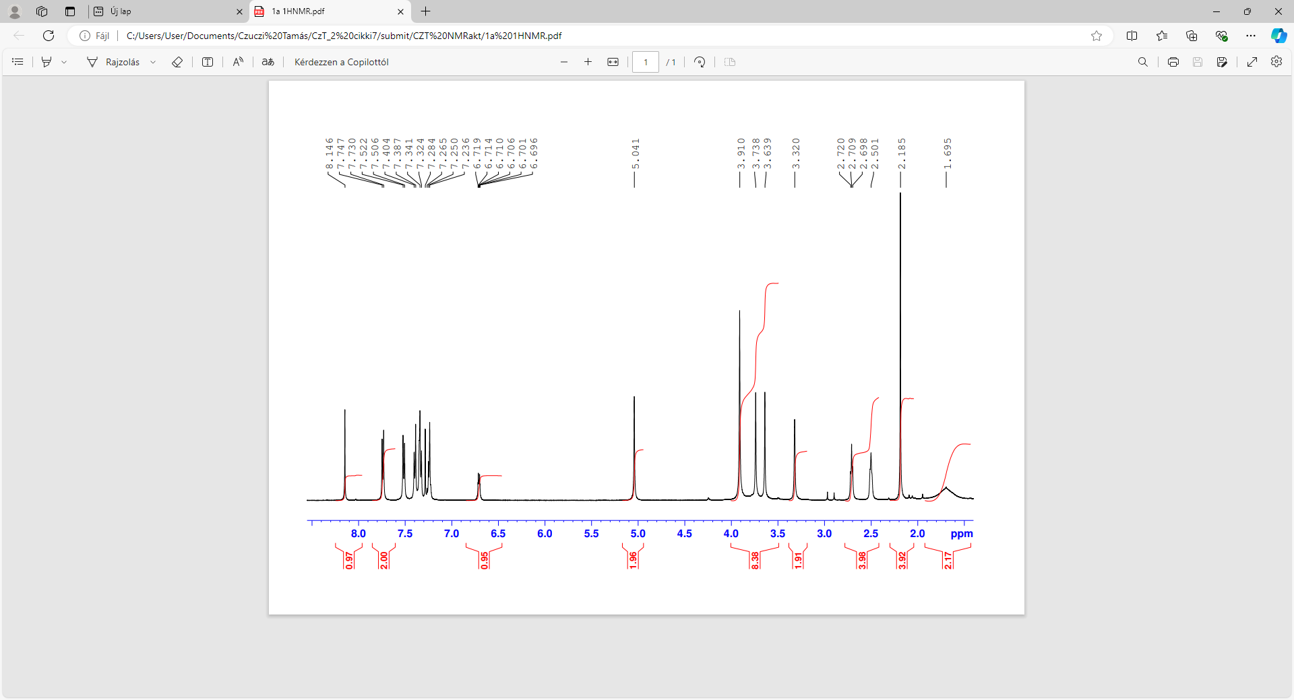

13C-NMR of **1a**

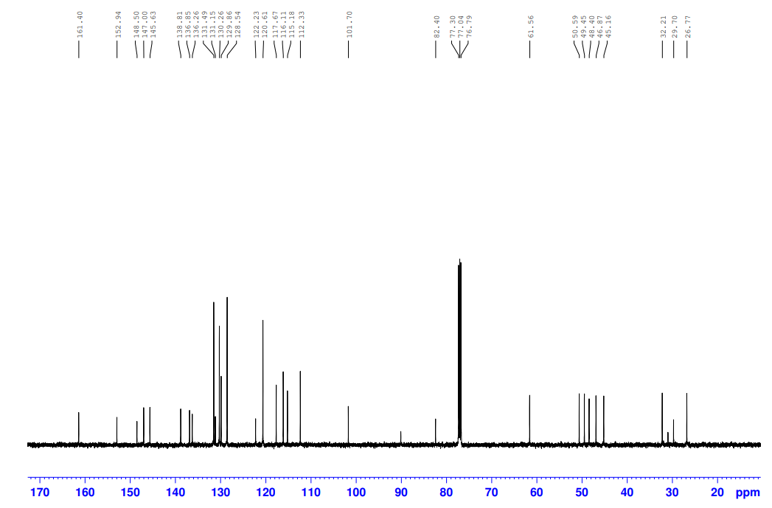

1H-NMR of **1b**

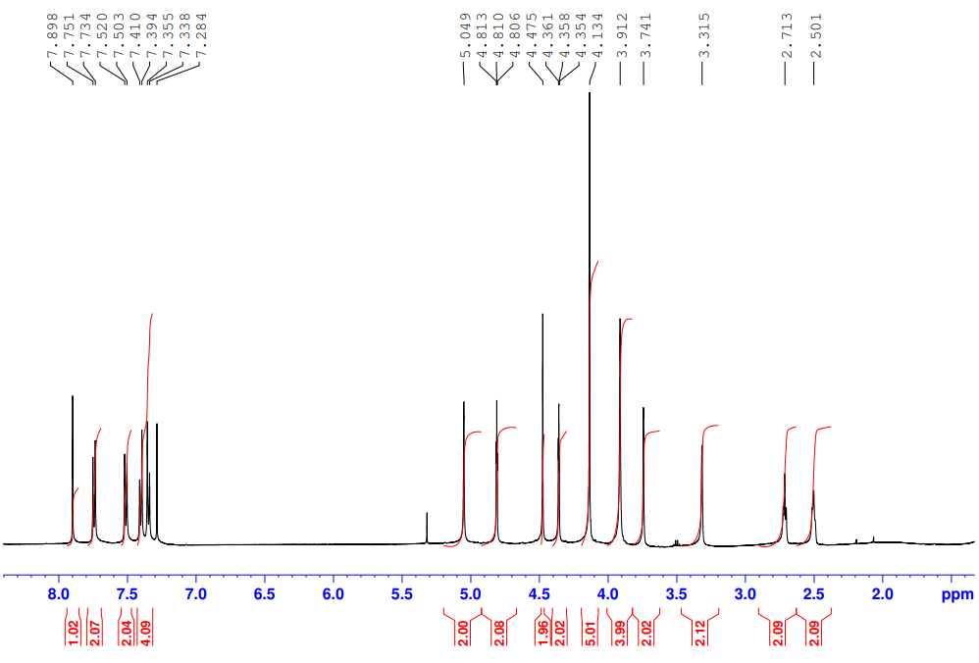

13C-NMR of **1b**

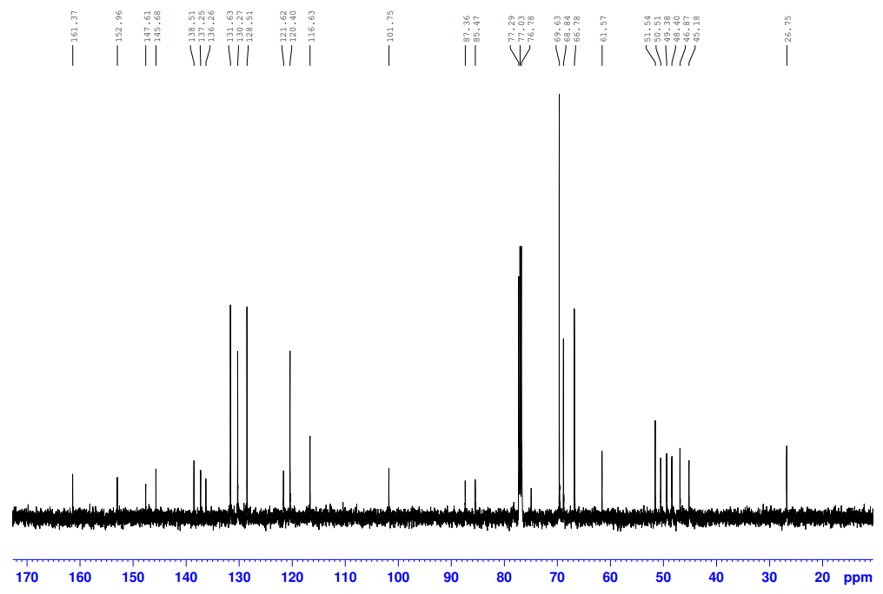

1H-NMR of **1c**

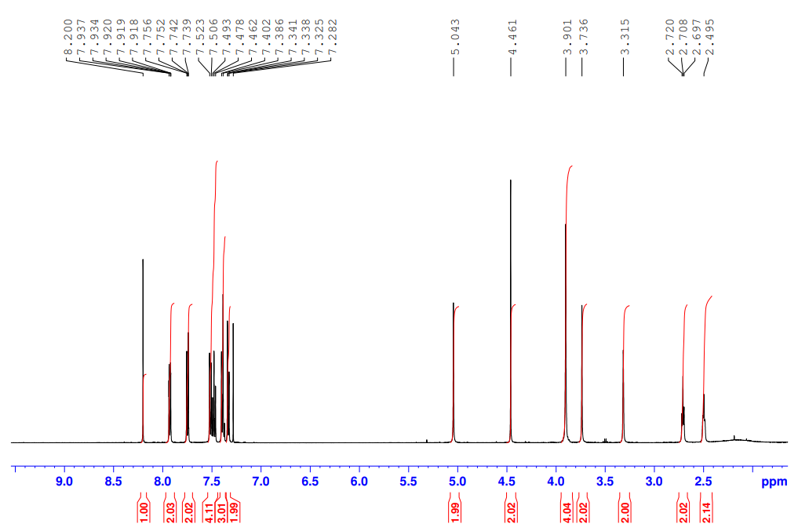

13C-NMR of **1c**

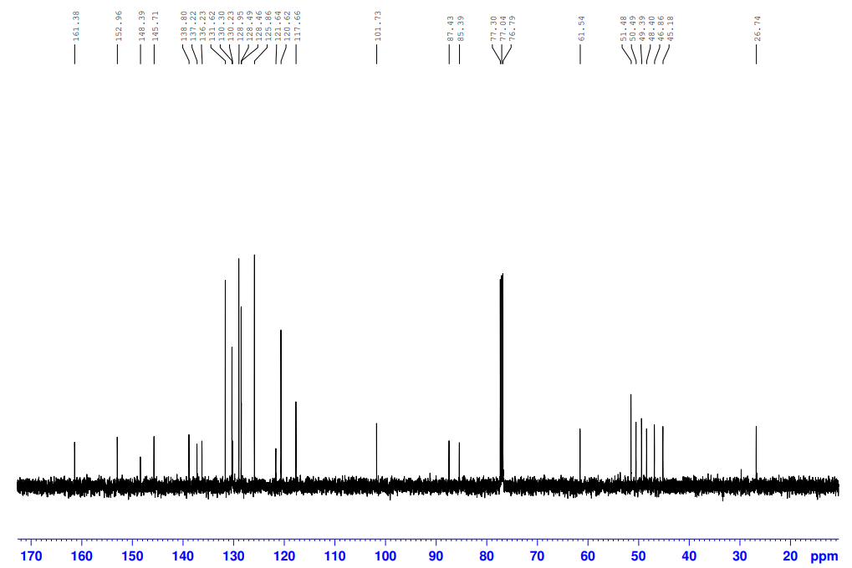

1H-NMR of **1d**

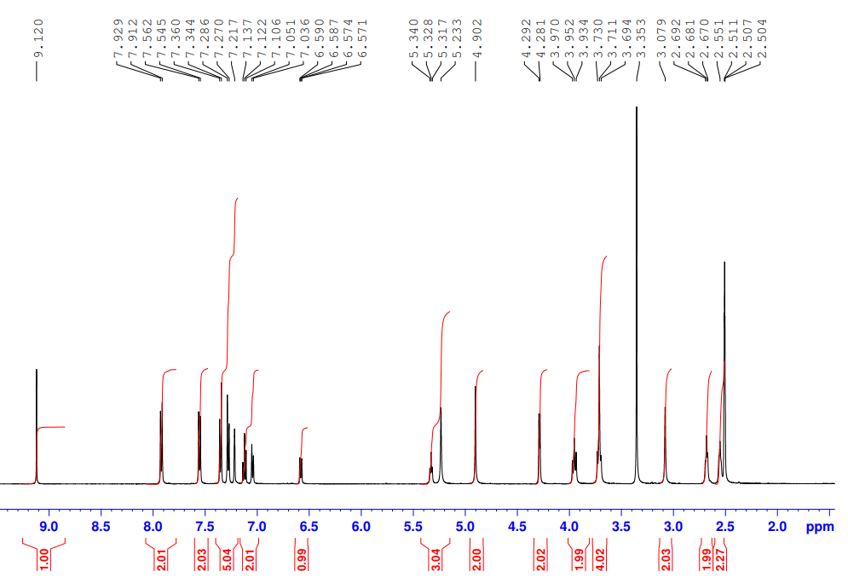

13C-NMR of **1d**

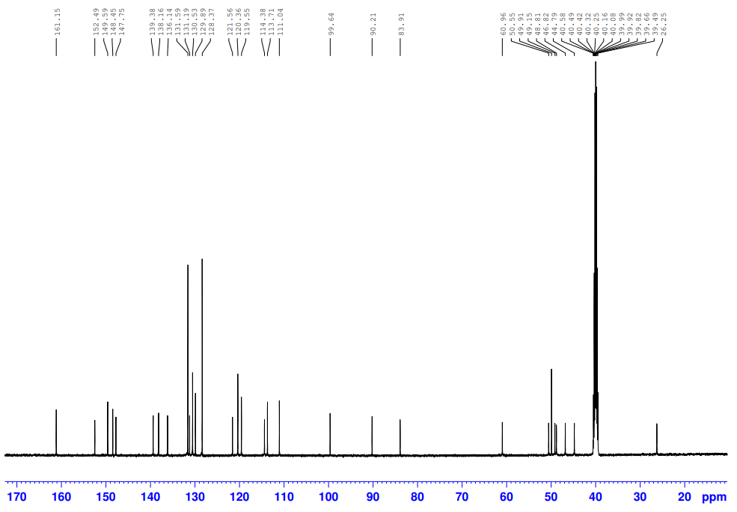

1H-NMR of **1e**

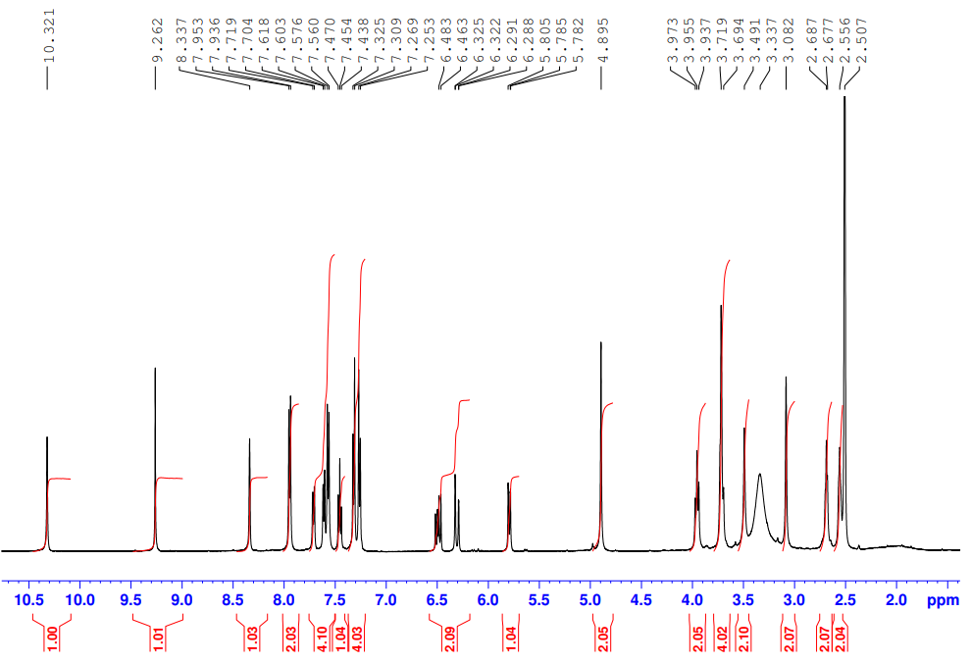

13C-NMR of **1d**

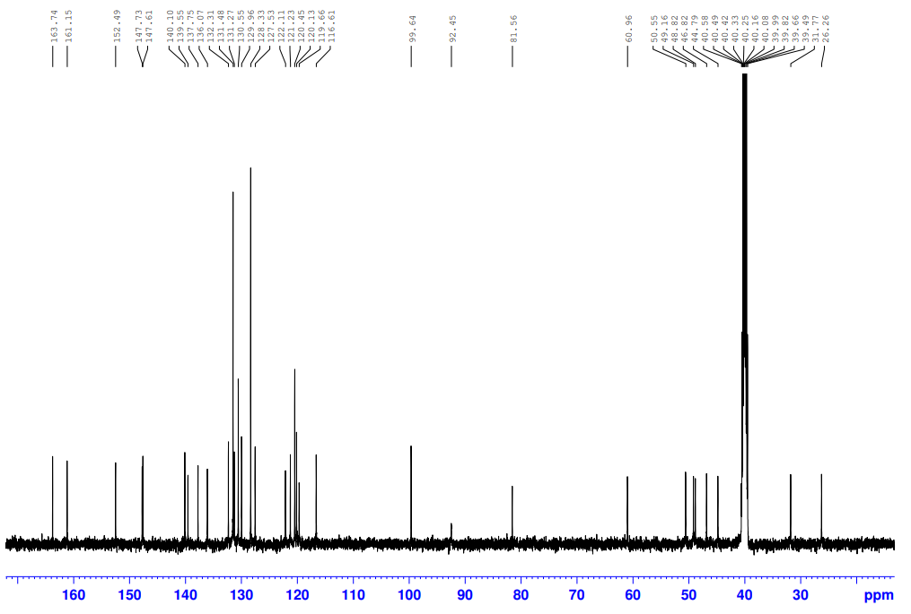

1H-NMR of **2a**

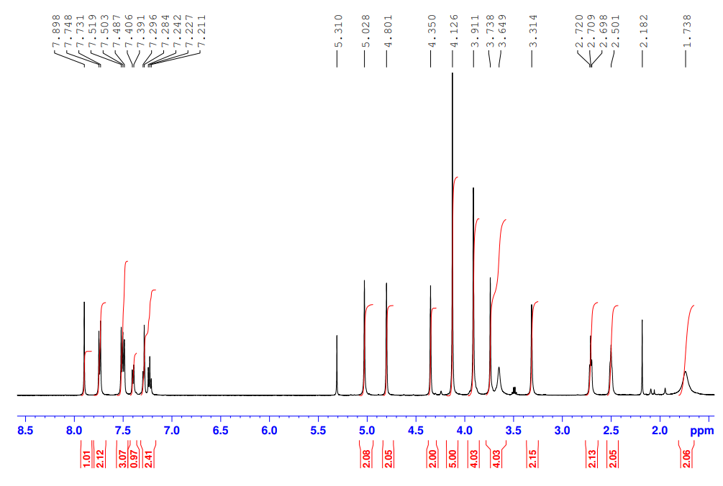

13C-NMR of **2a**

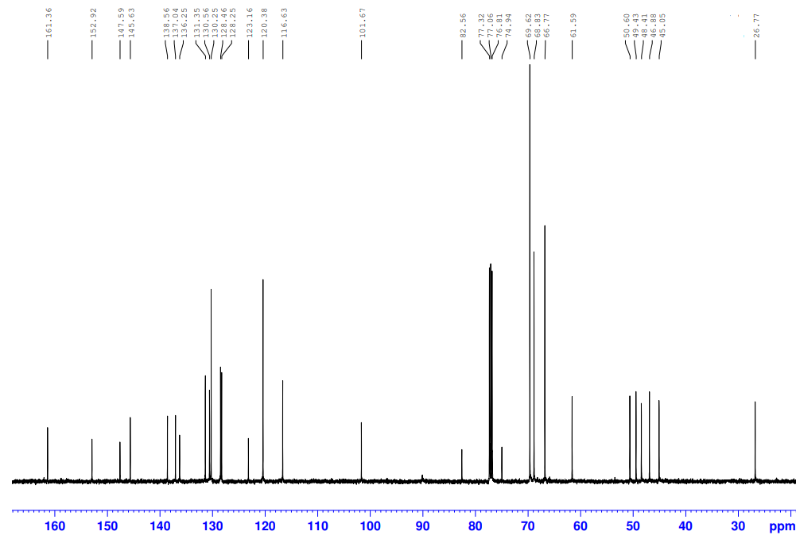

1H-NMR of **2b**

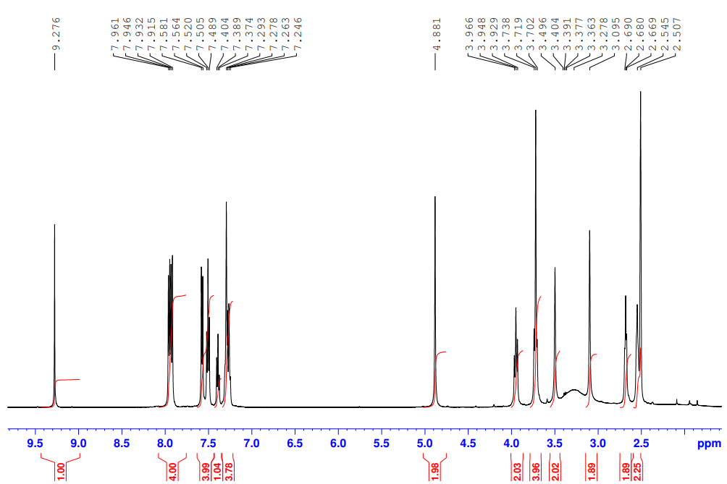

13C-NMR of **2b**

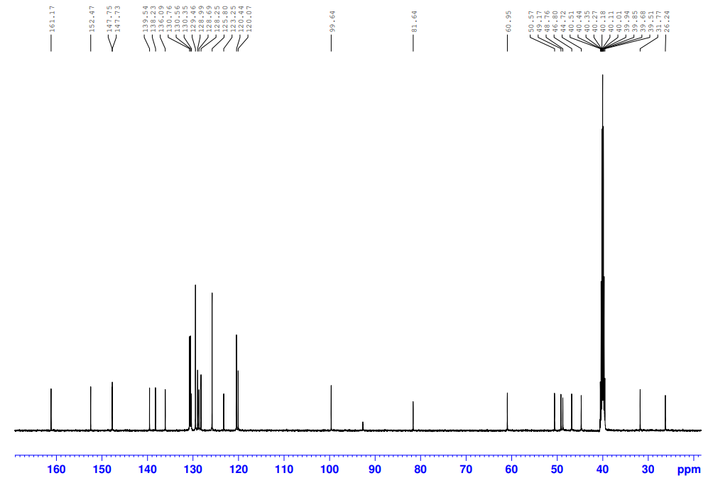

1H-NMR of **2c**

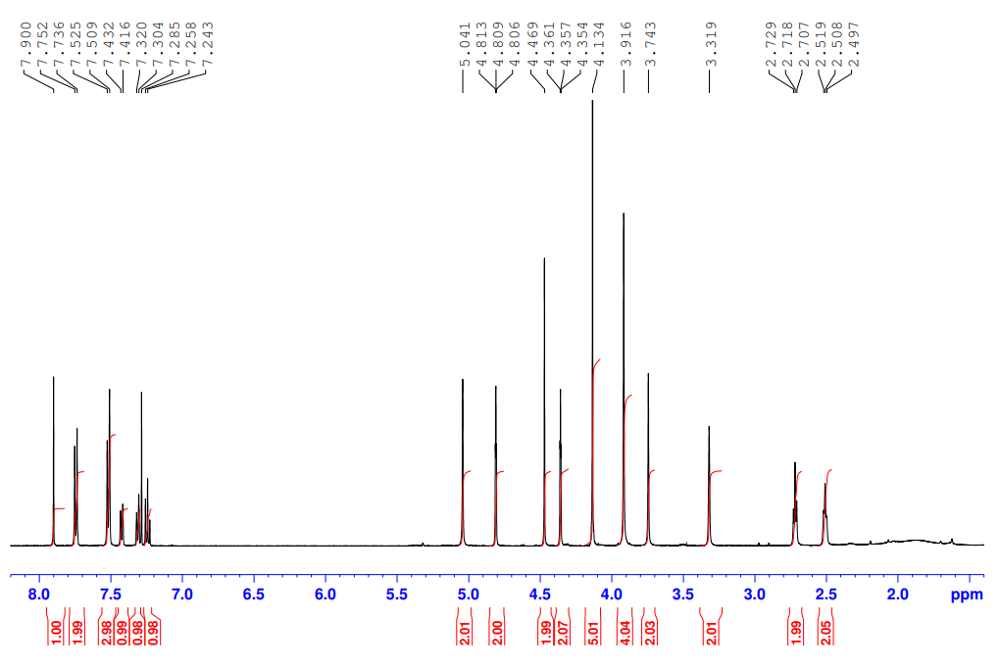

13C-NMR of **2c**

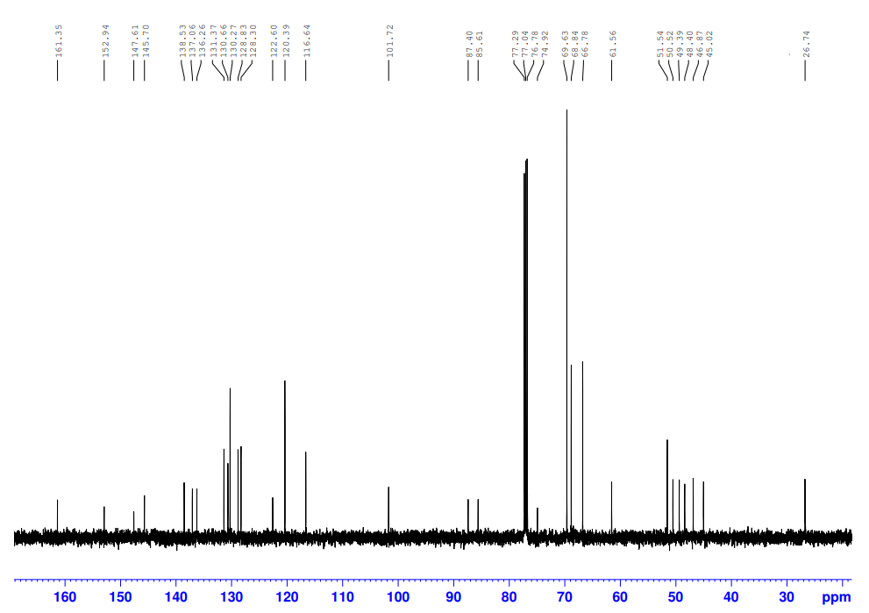

1H-NMR of **2d**

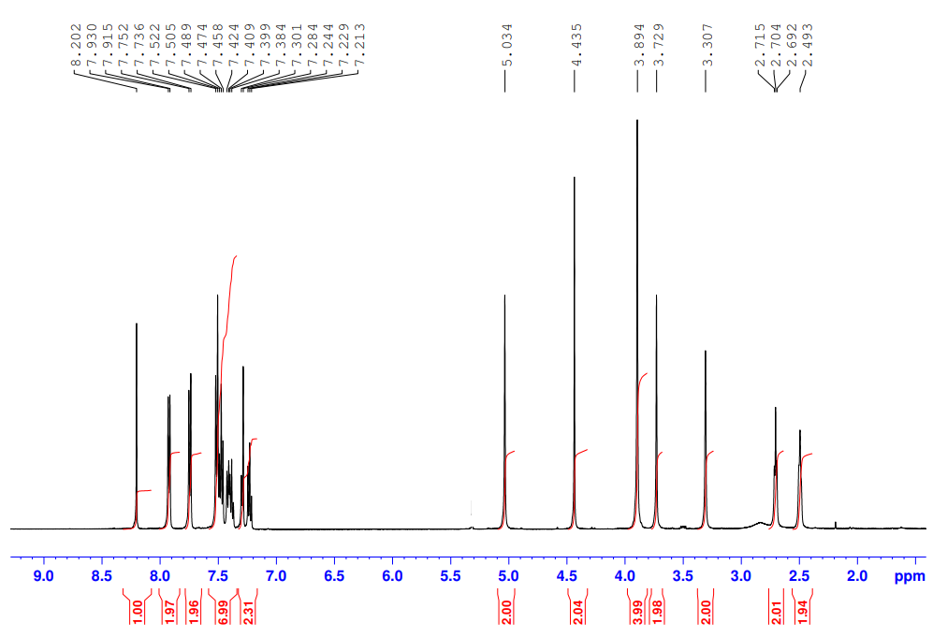

13C-NMR of **2d**

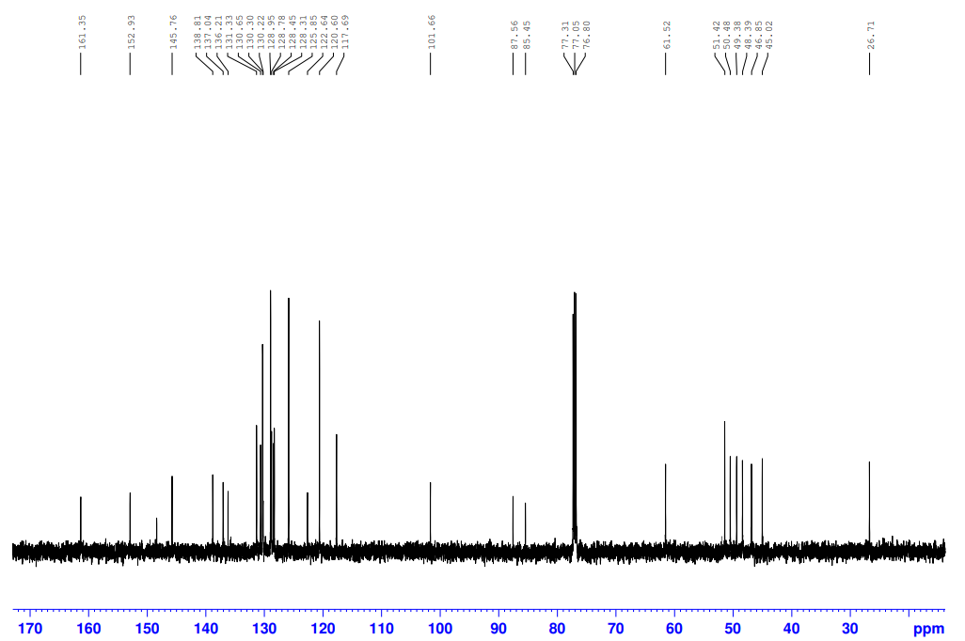

1H-NMR of **3a**

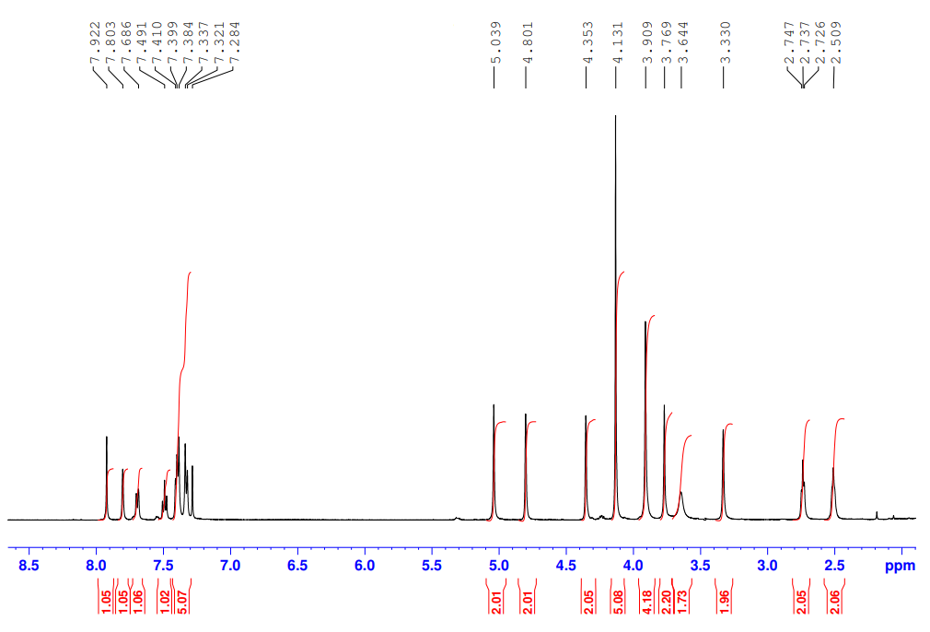

13C-NMR of **3a**

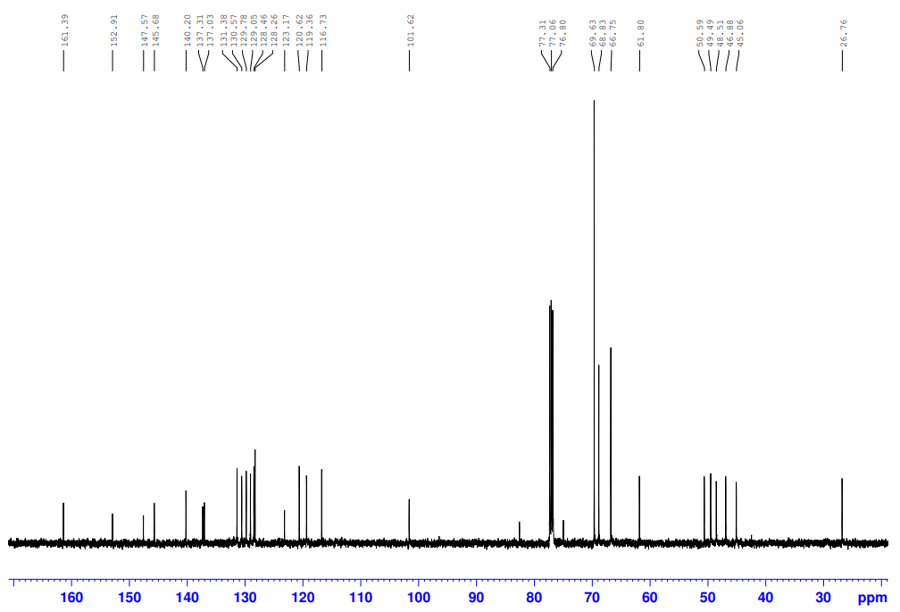

1H-NMR of **3b**

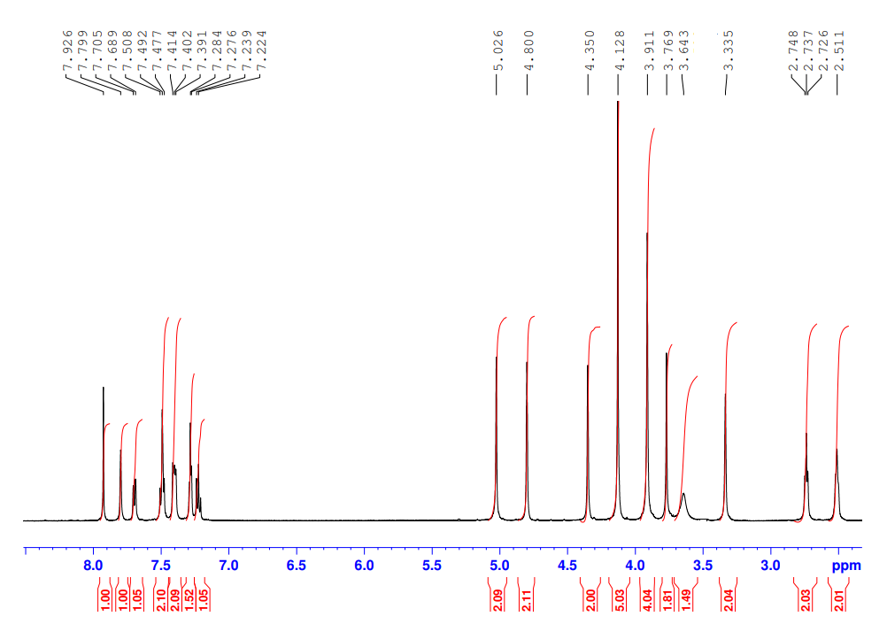

13C-NMR of **3b**

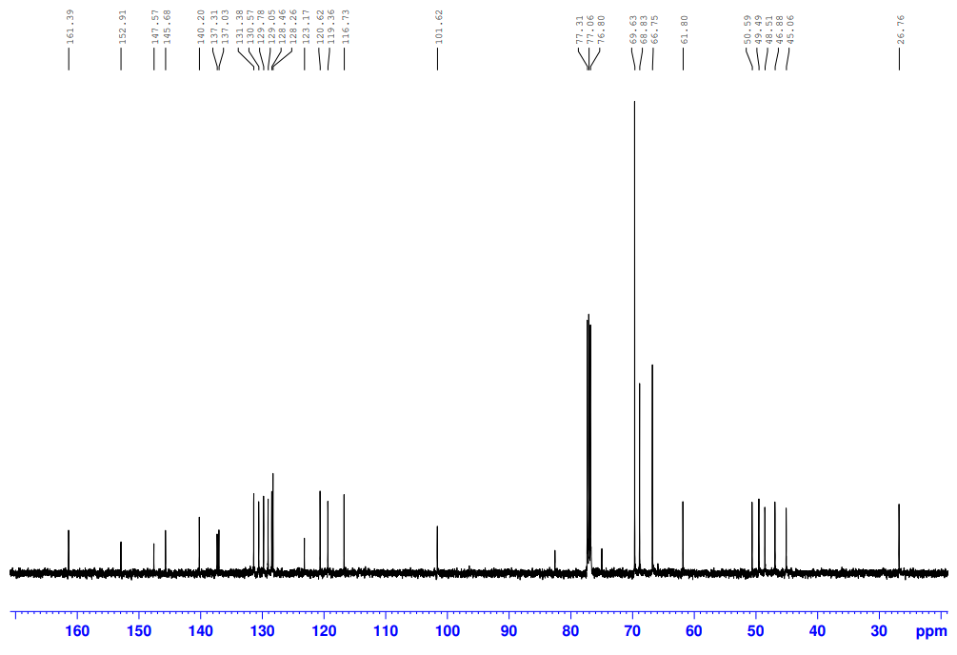

1H-NMR of **3c**

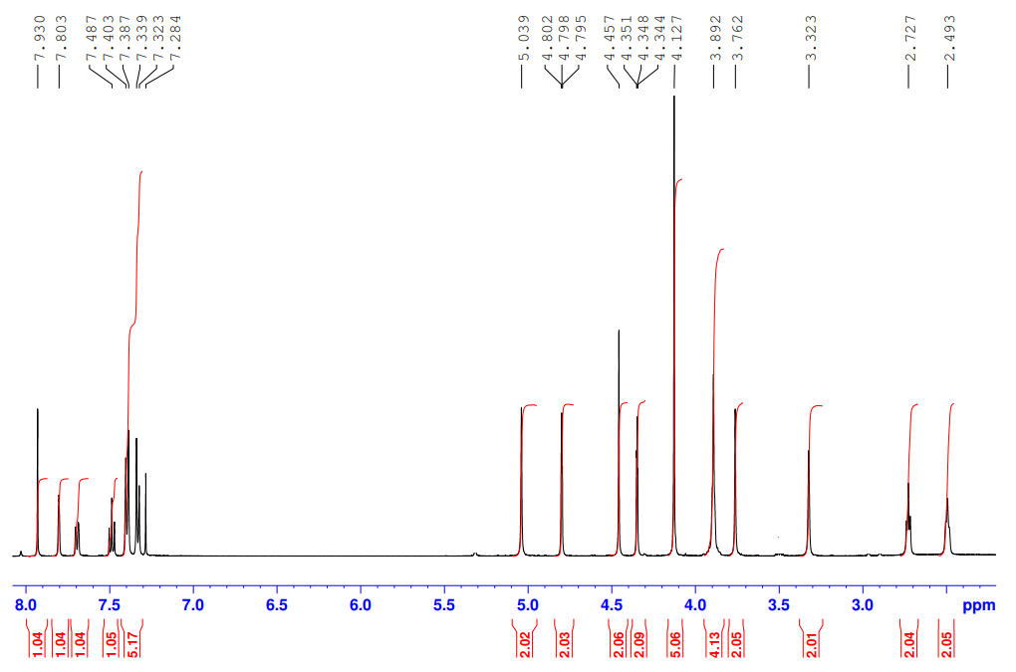

13C-NMR of **3c**

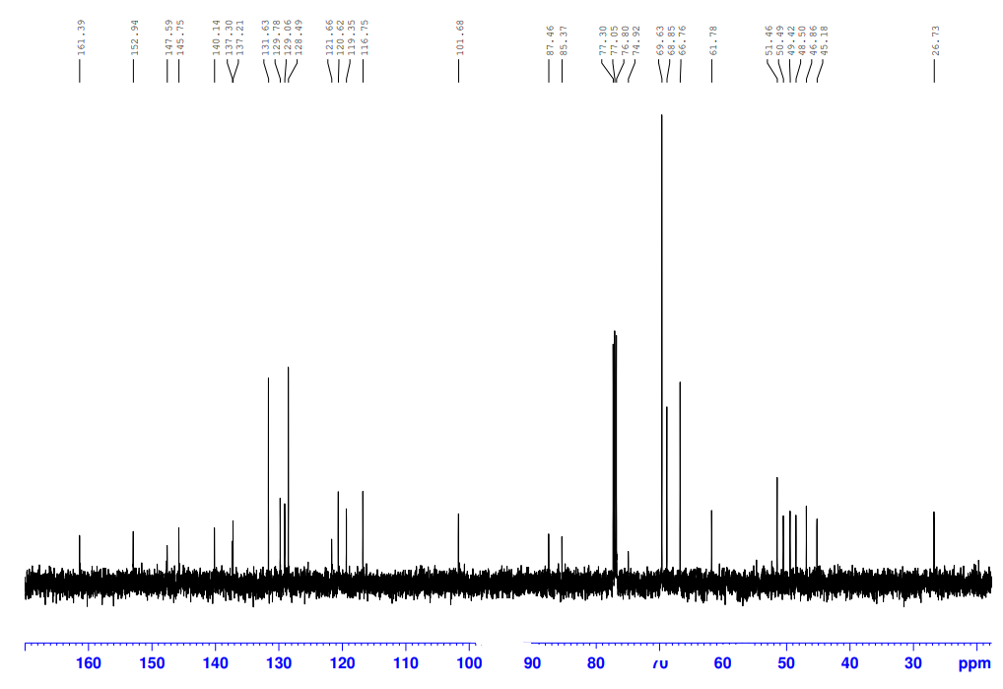

1H-NMR of **3d**

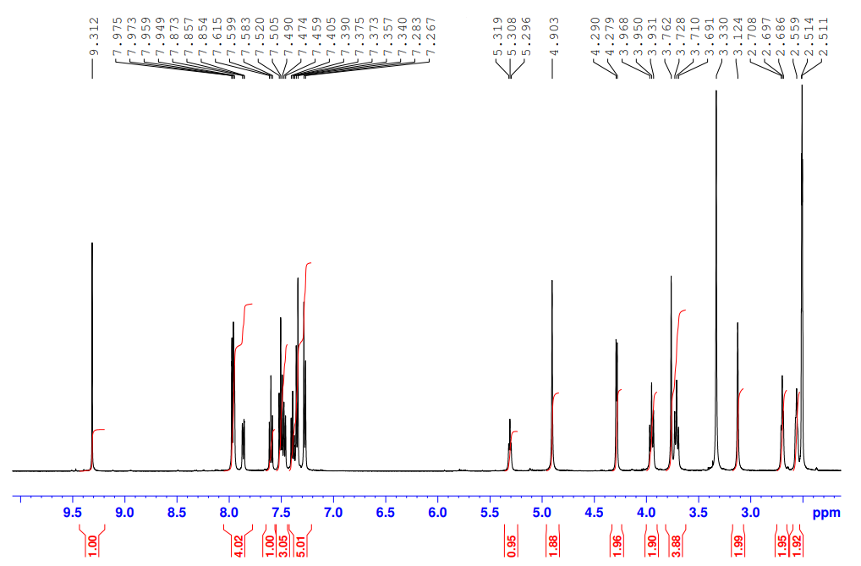

13C-NMR of **3d**

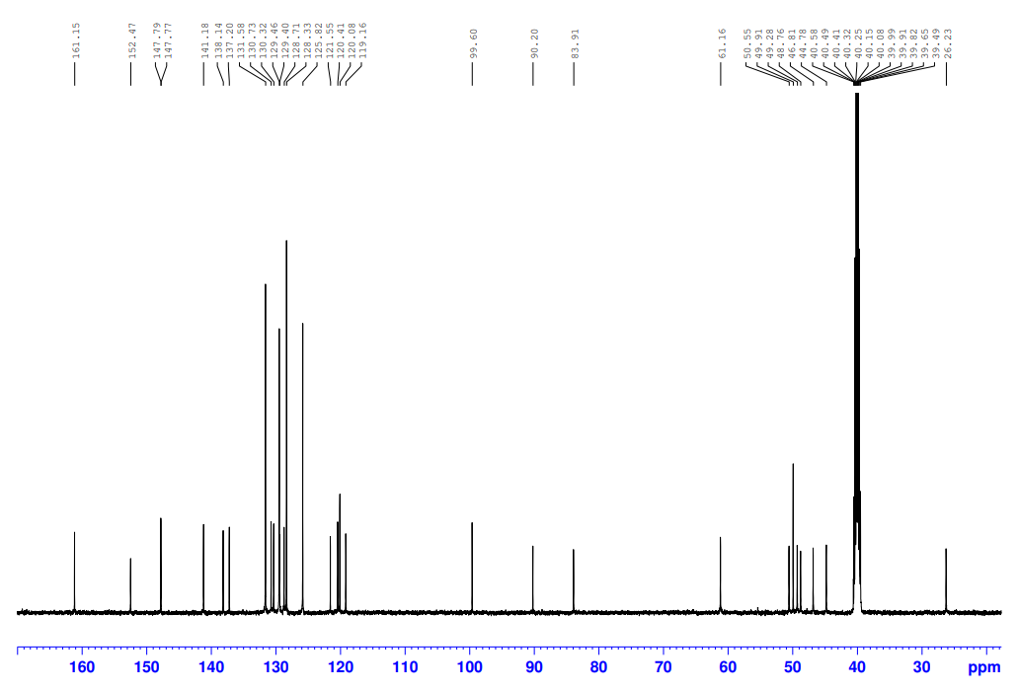

1H-NMR of **4a**

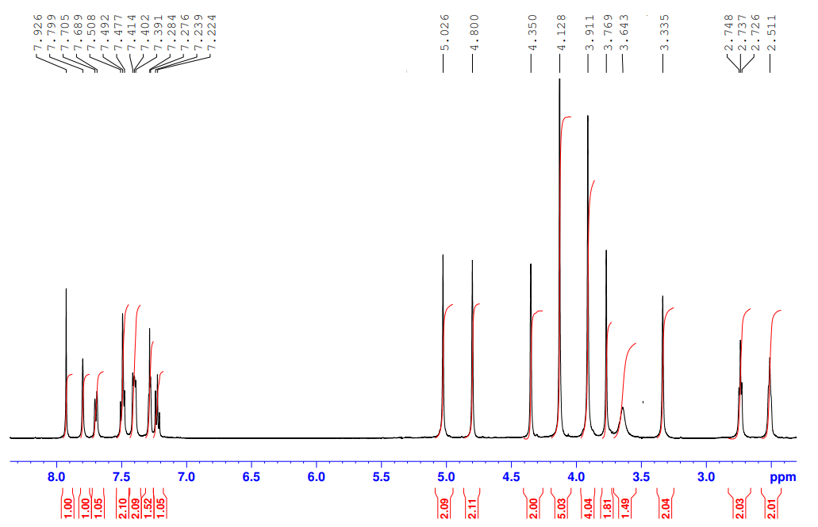

13C-NMR of **4a**

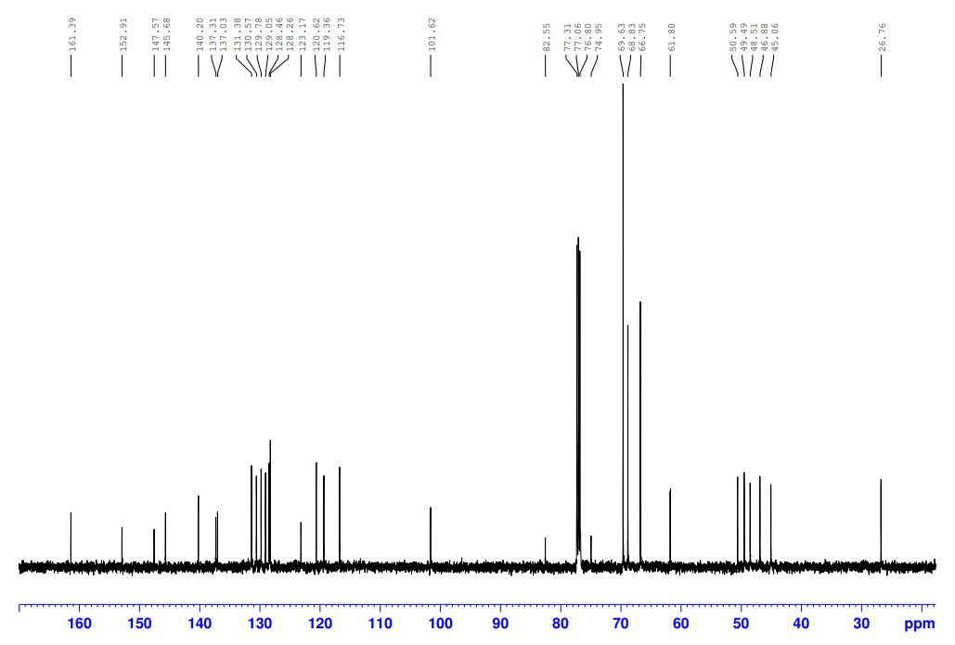

1H-NMR of **4b**

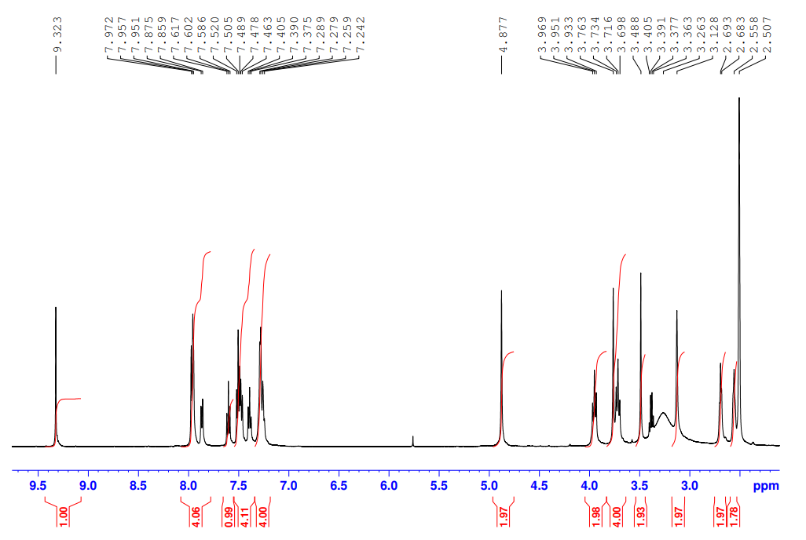

13C-NMR of **4b**

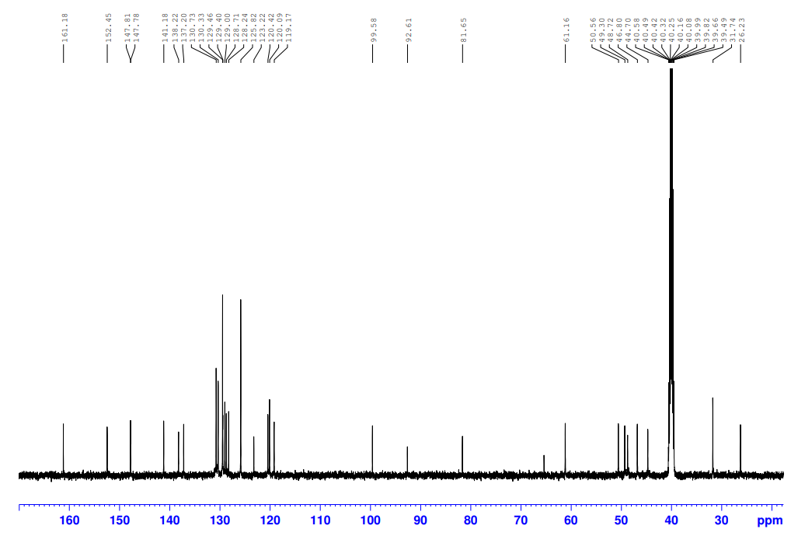

1H-NMR of **4c**

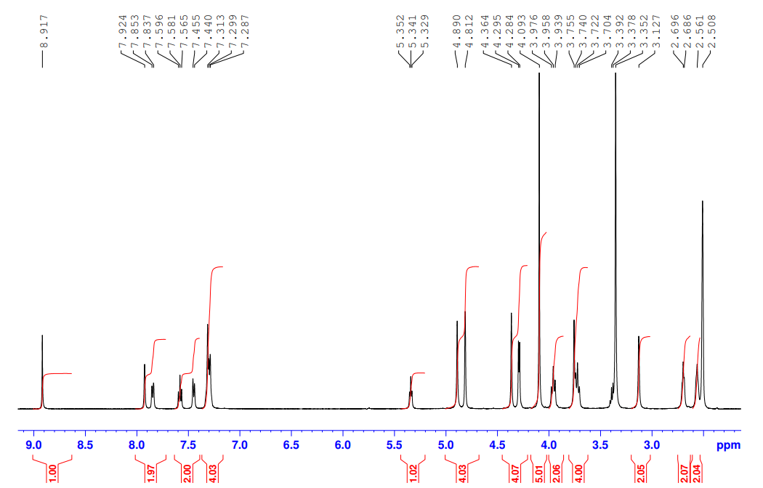

13C-NMR of **4c**

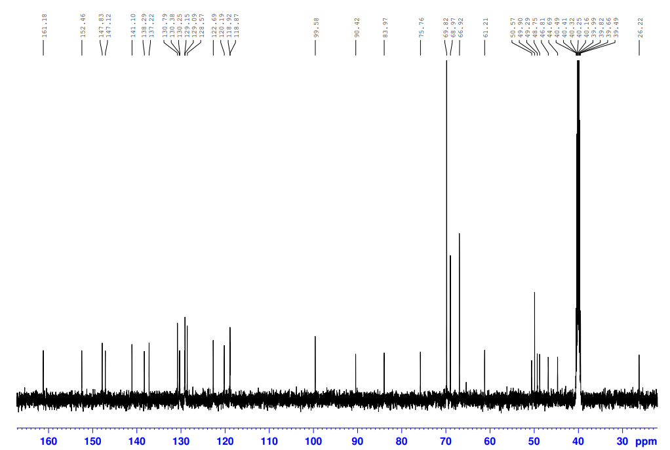

1H-NMR of **4d**

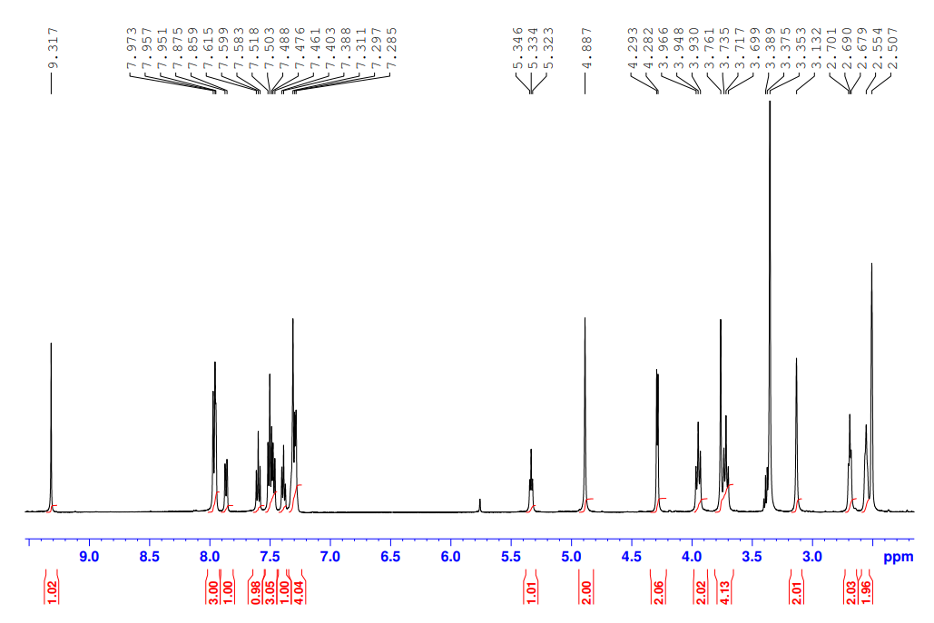

13C-NMR of **4d**

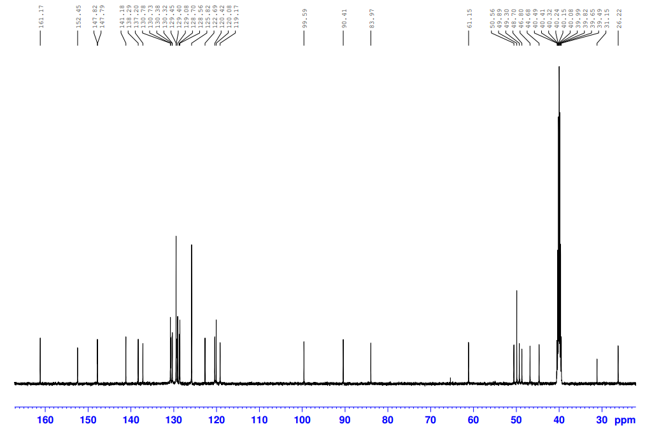

1H-NMR of **23a**

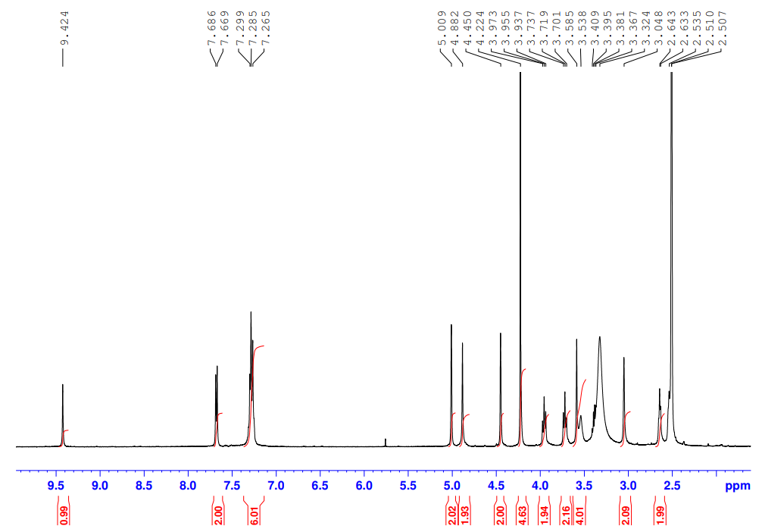

13C-NMR of **23a**

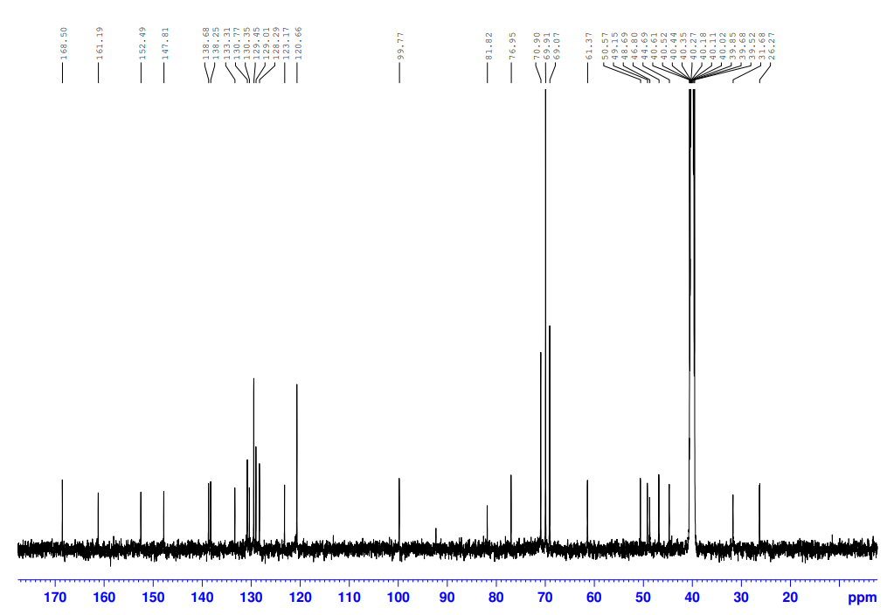

1H-NMR of **23b**

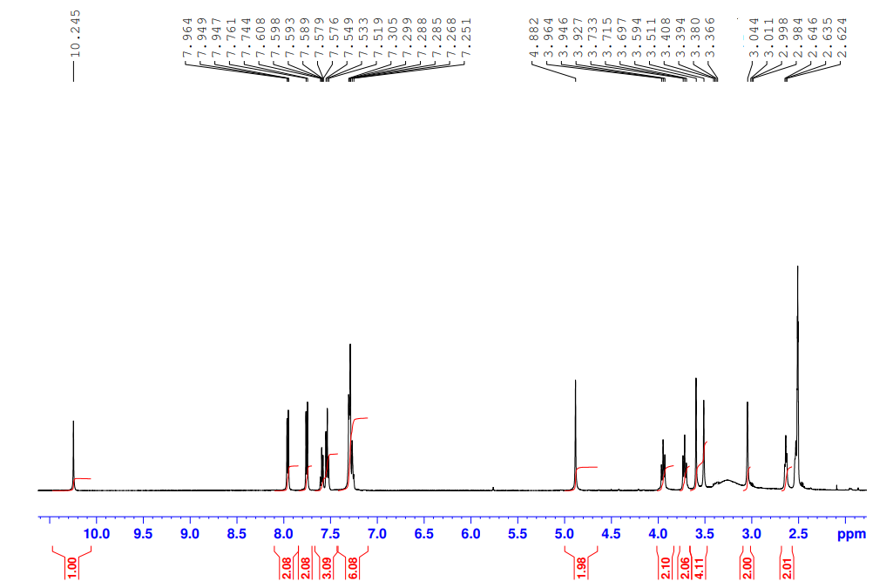

13C-NMR of **23b**

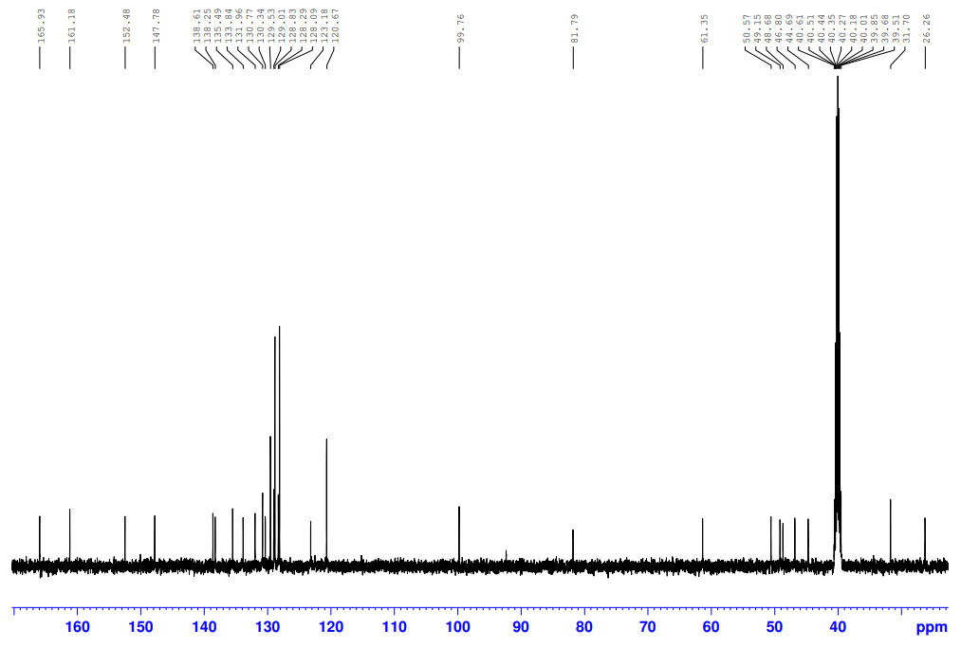

1H-NMR of **33a**

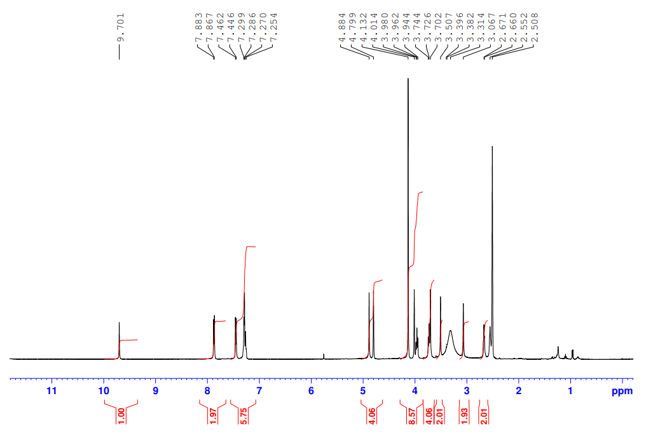

13C-NMR of **33a**

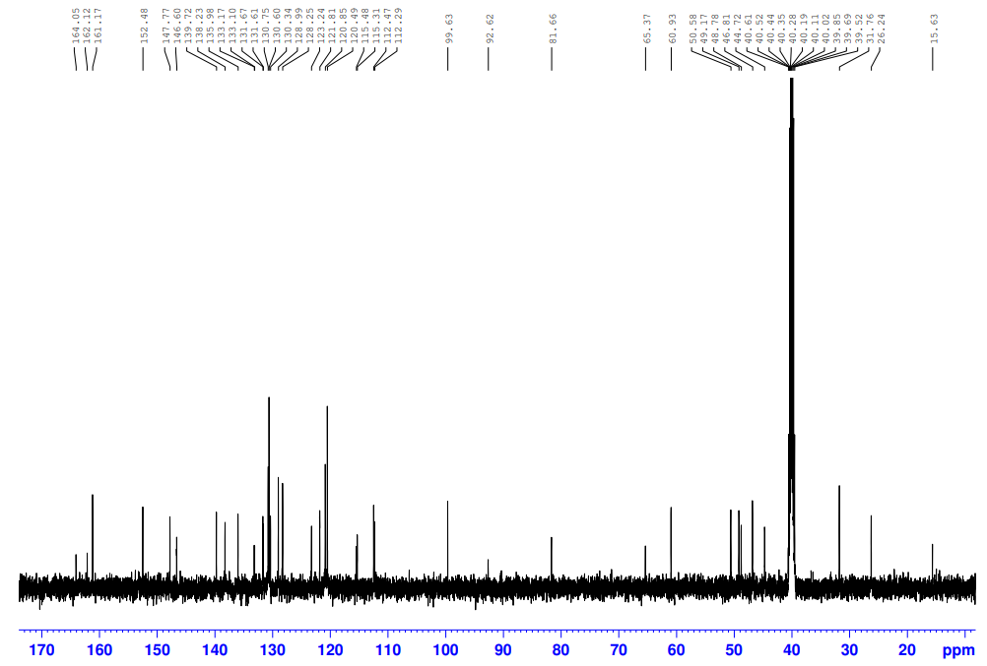

1H-NMR of **33b**

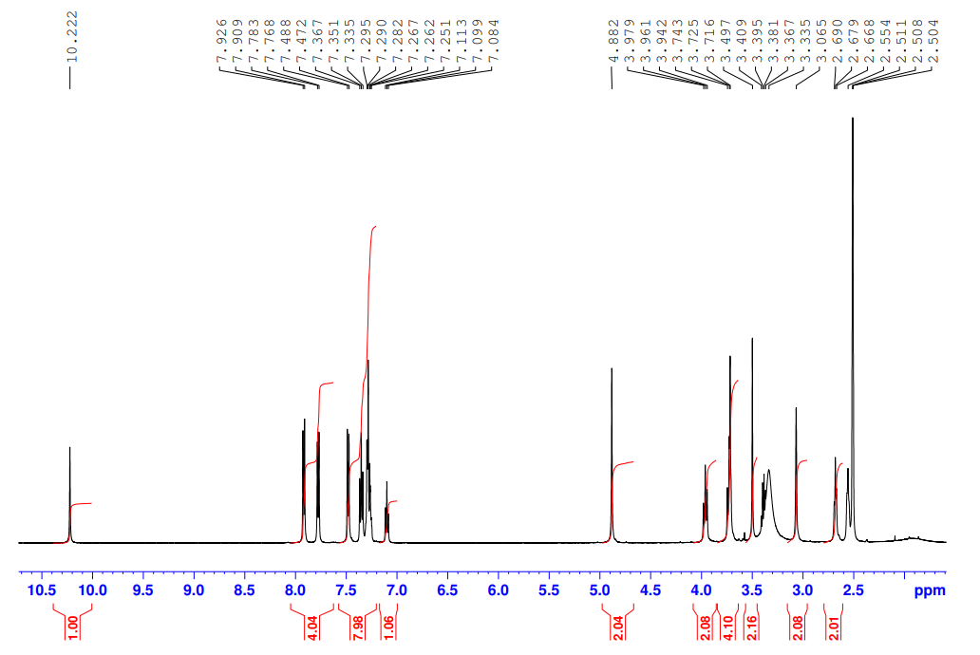

13C-NMR of **33b**

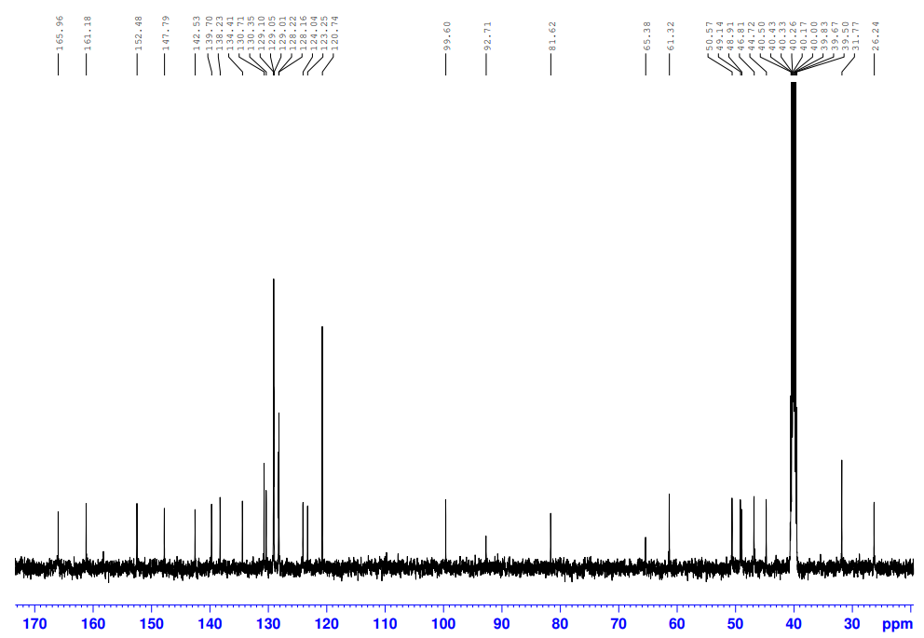

1H-NMR of **36a**

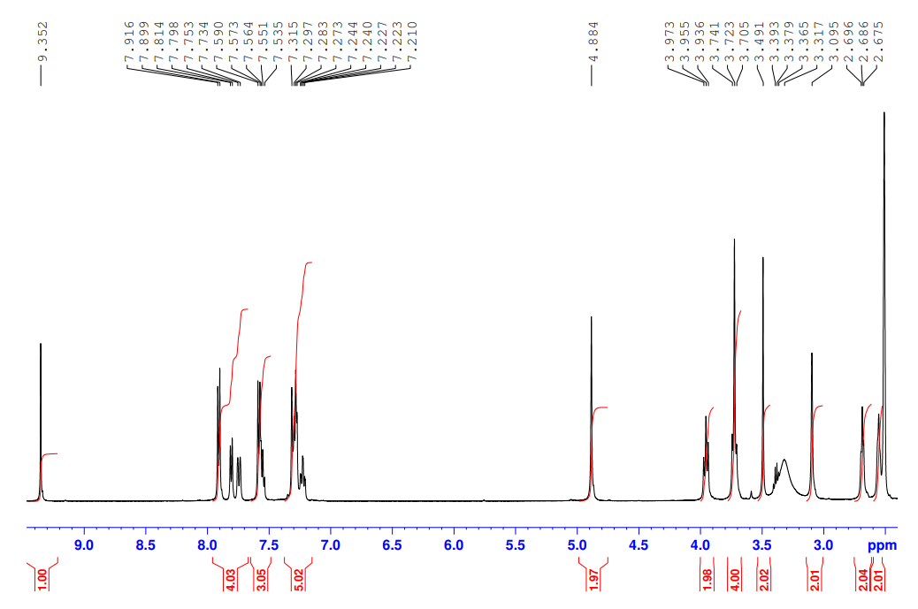

13C-NMR of **36a**

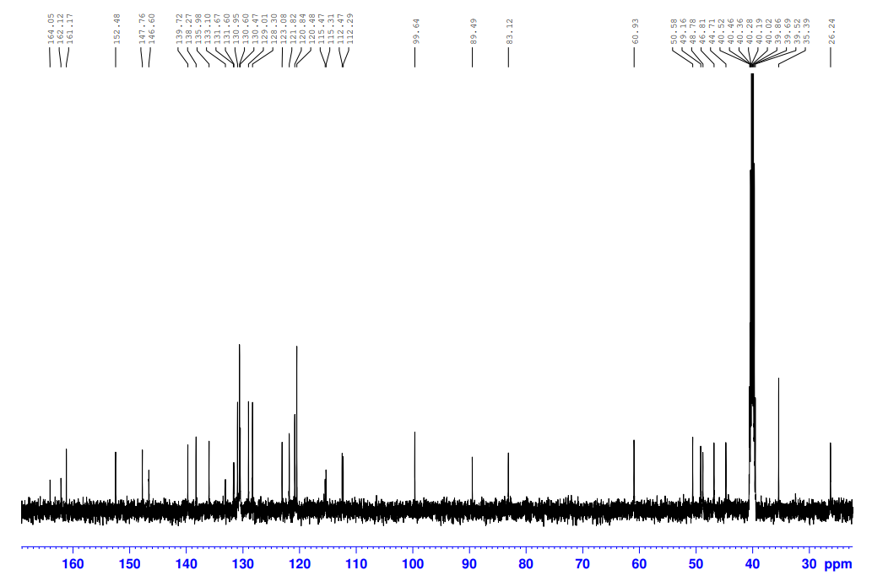

1H-NMR of **36b**

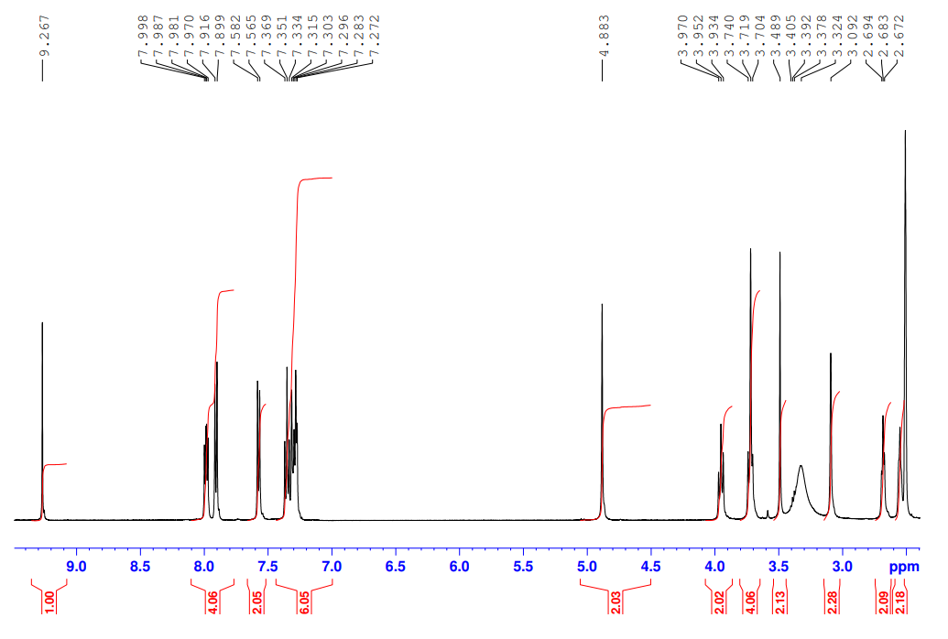

13C-NMR of **36b**

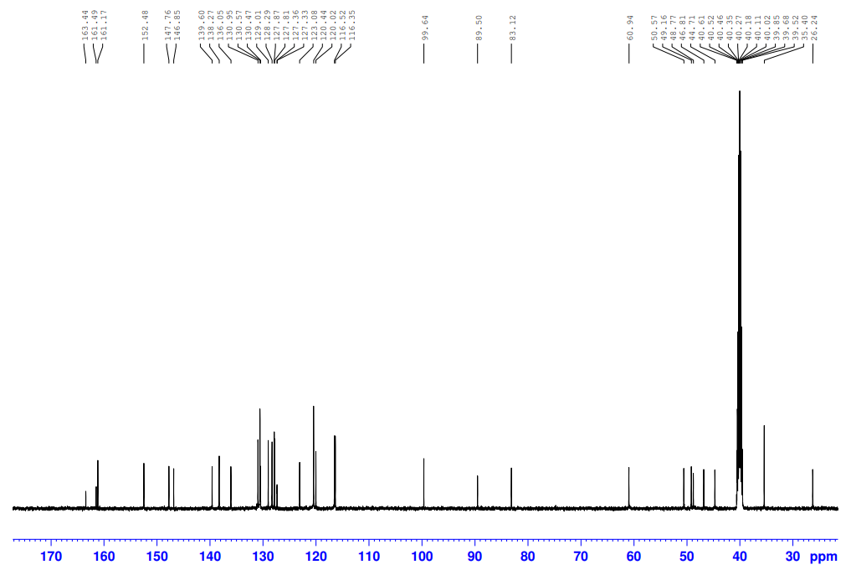

1H-NMR of **36c**

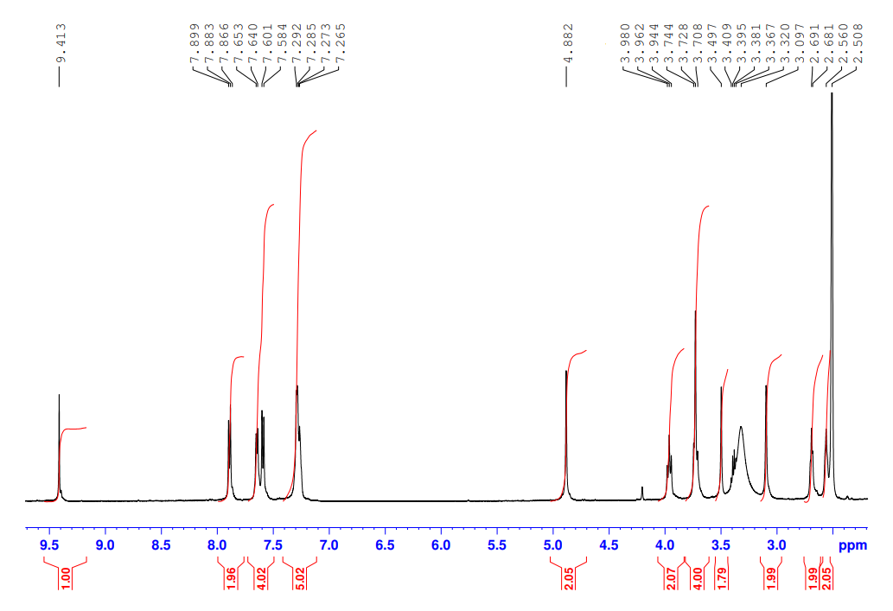

13C-NMR of **36c**

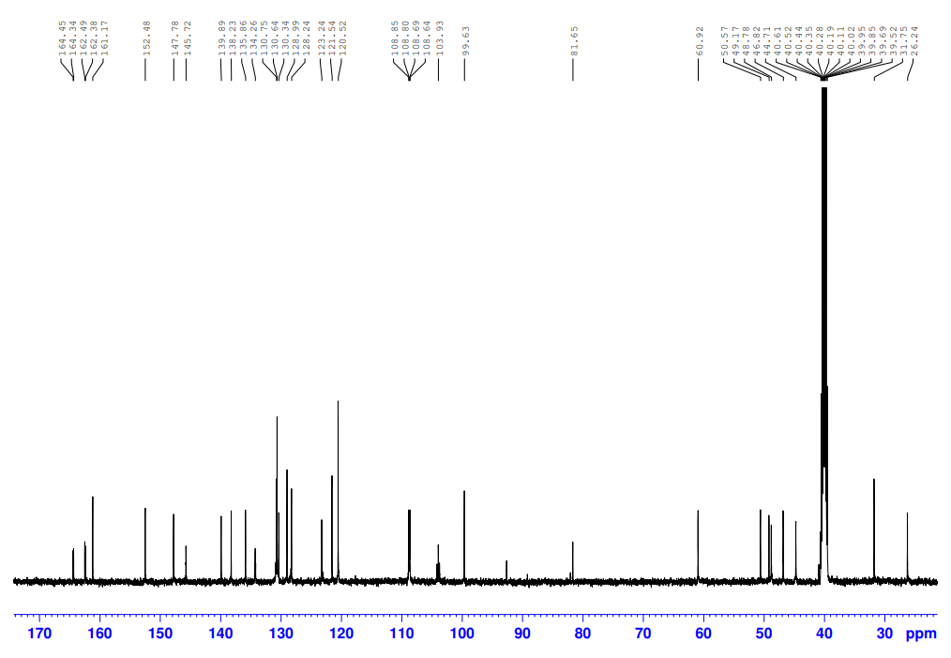

1H-NMR of **37a**

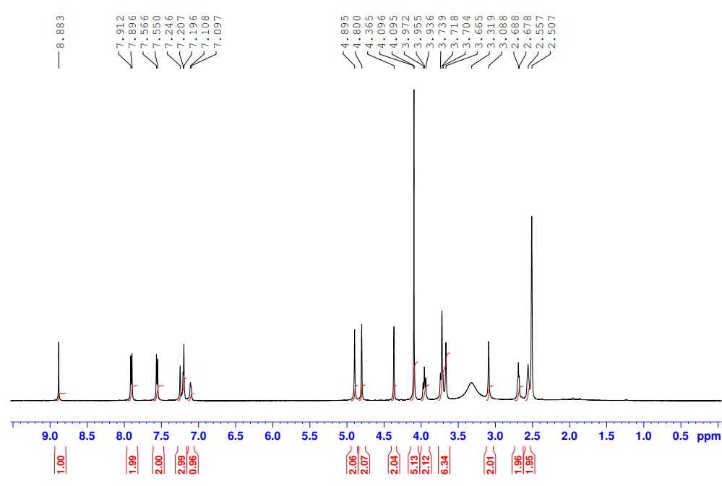

13C-NMR of **37a**

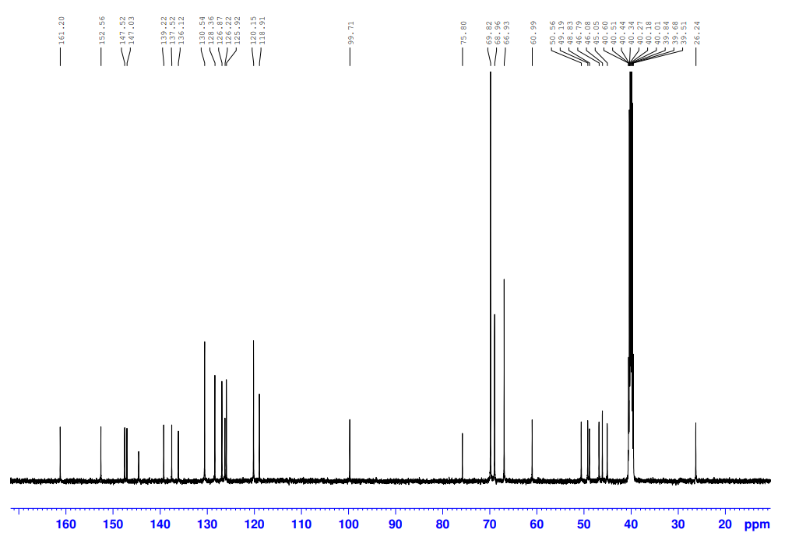

1H-NMR of **37b**

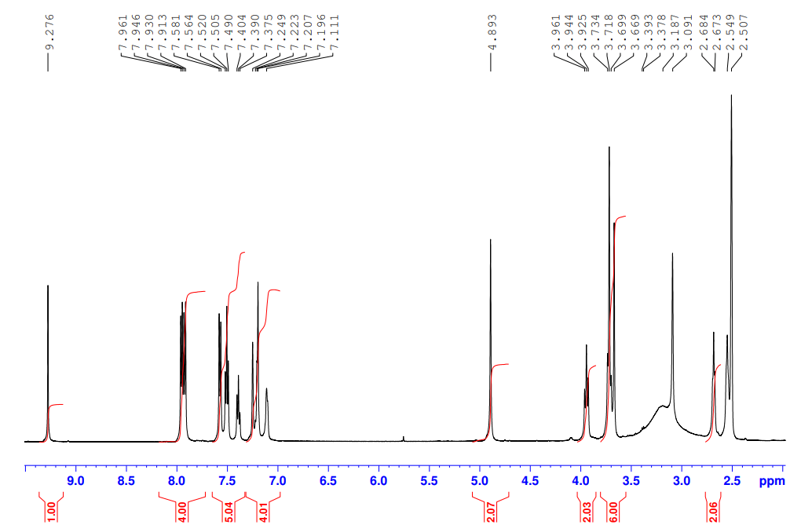

13C-NMR of **37b**

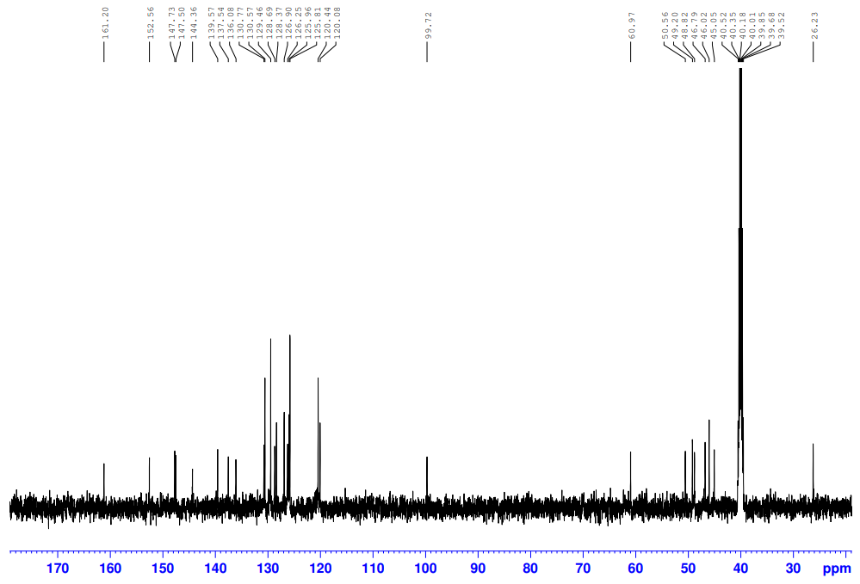

1H-NMR of **38a**

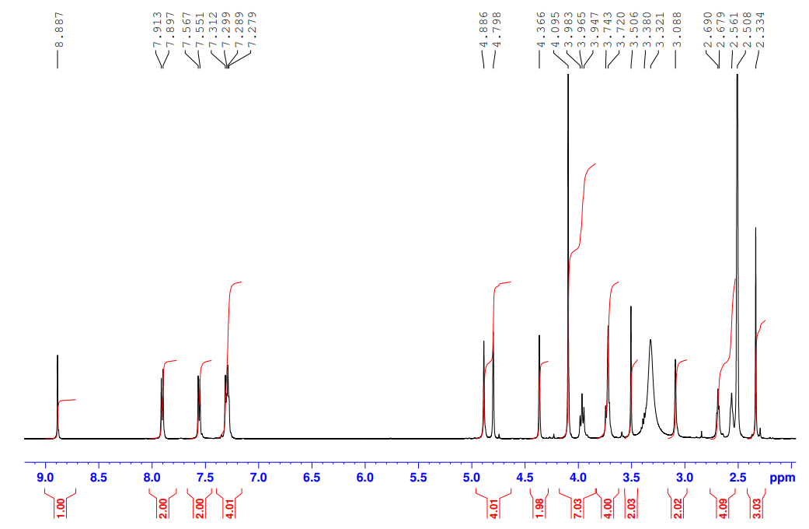

13C-NMR of **38a**

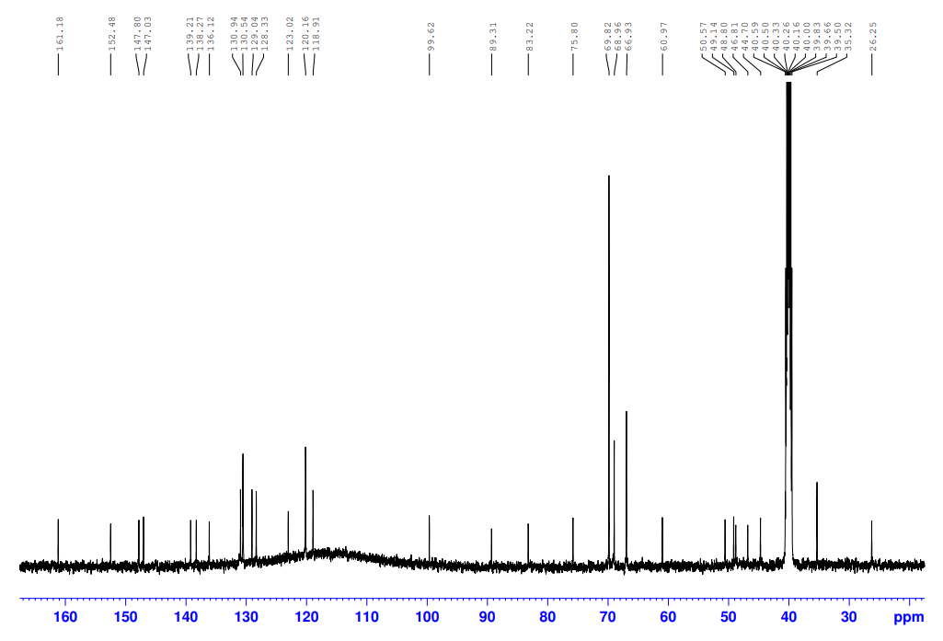

1H-NMR of **38b**

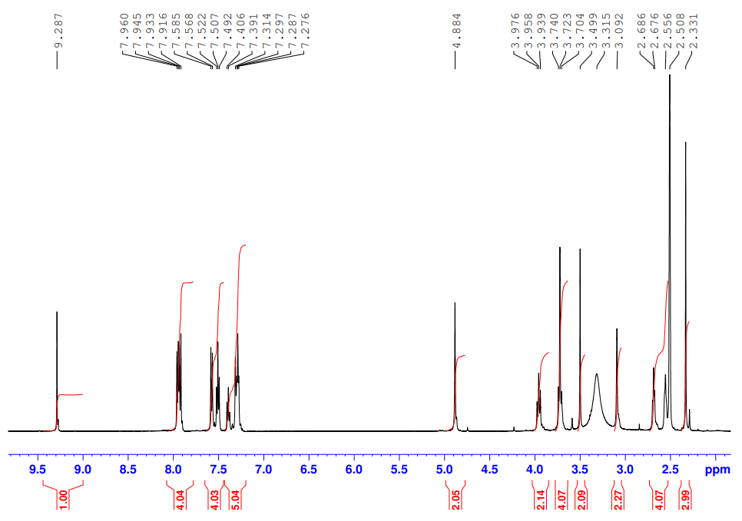

13C-NMR of **38b**

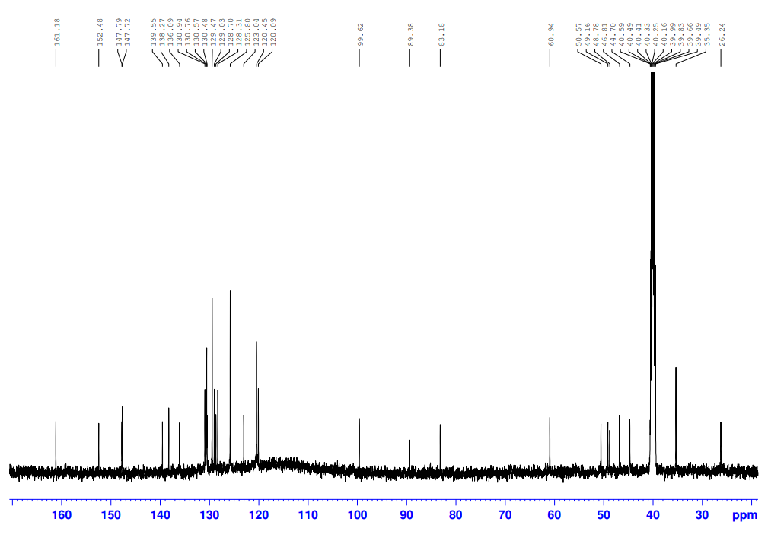

1H-NMR of **39a**

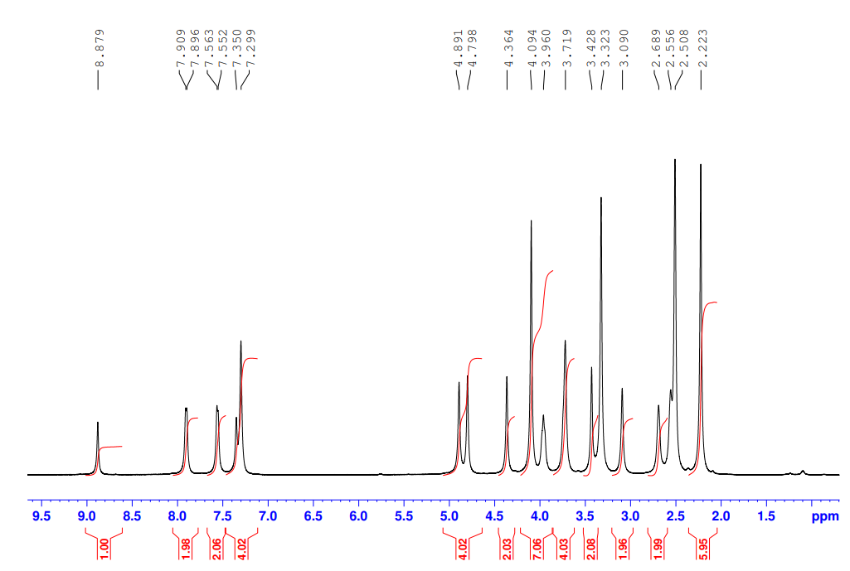

13C-NMR of **39a**

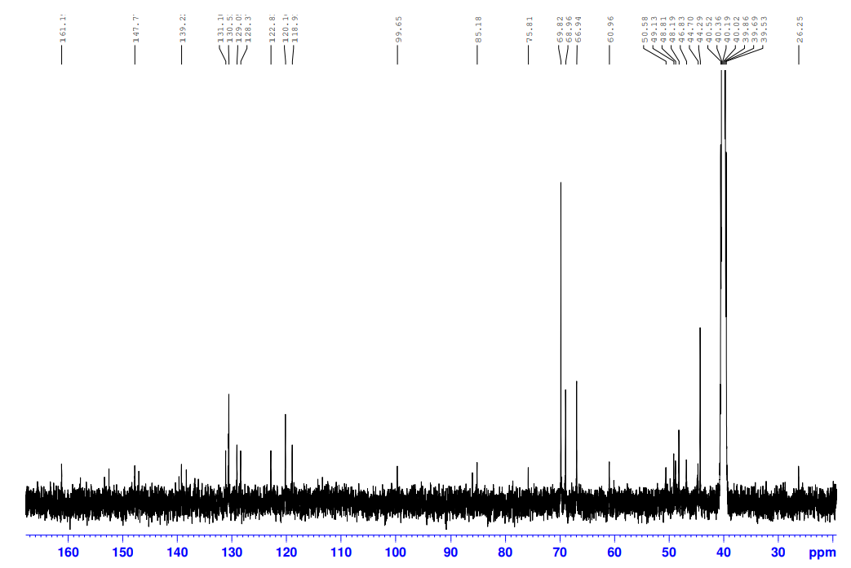

1H-NMR of **39b**

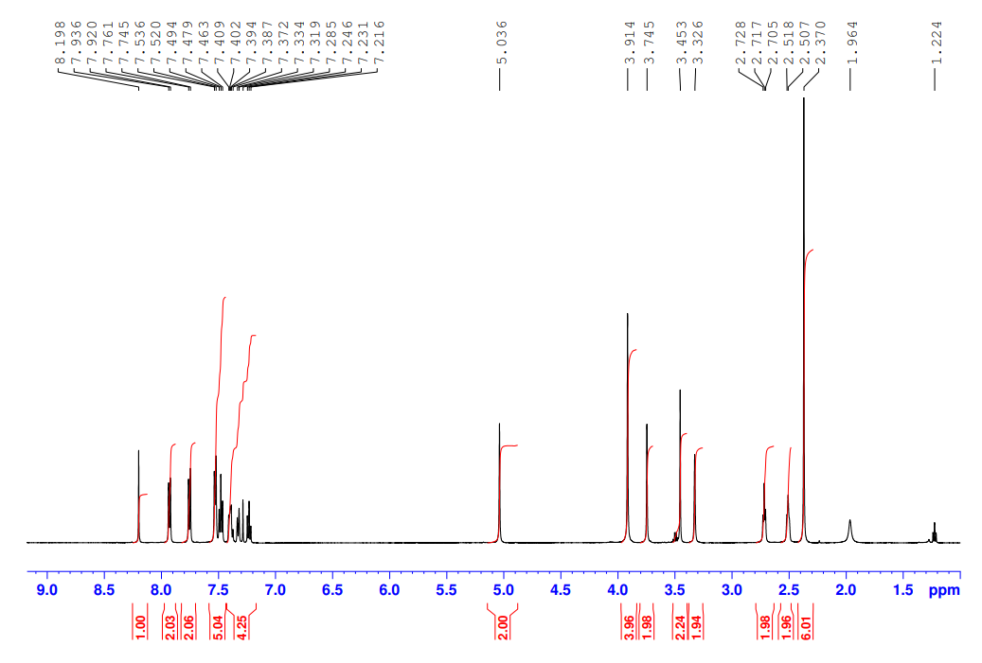

13C-NMR of **39b**

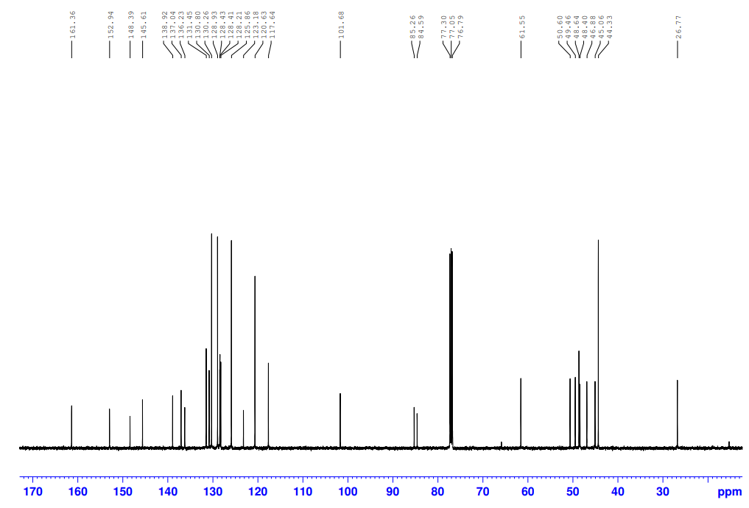

1H-NMR of **40a**

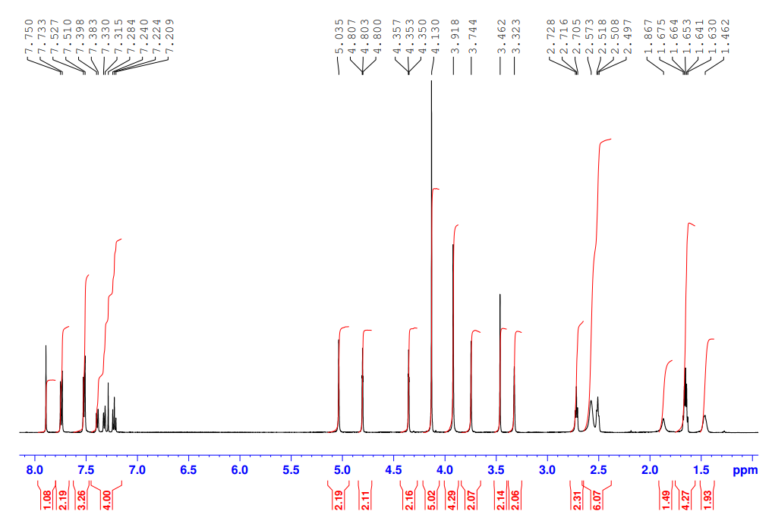

13C-NMR of **40a**

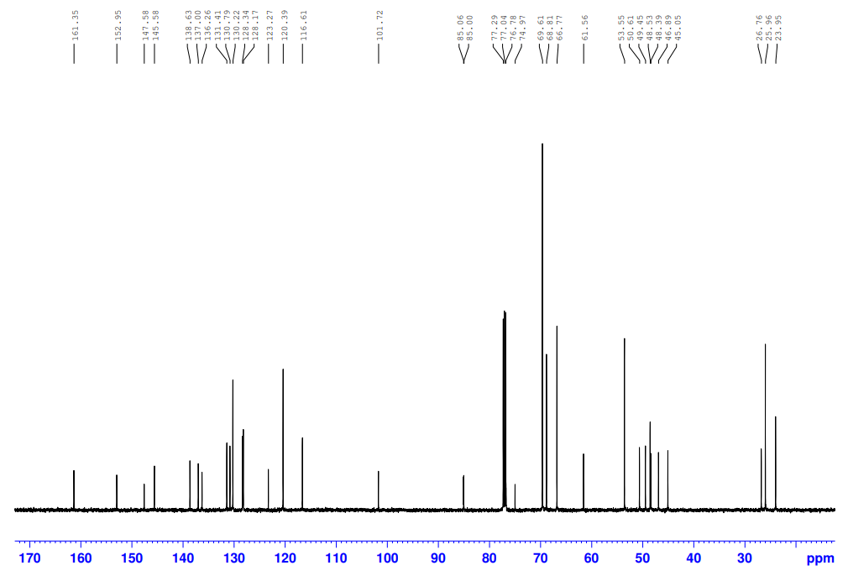

1H-NMR of **41a**

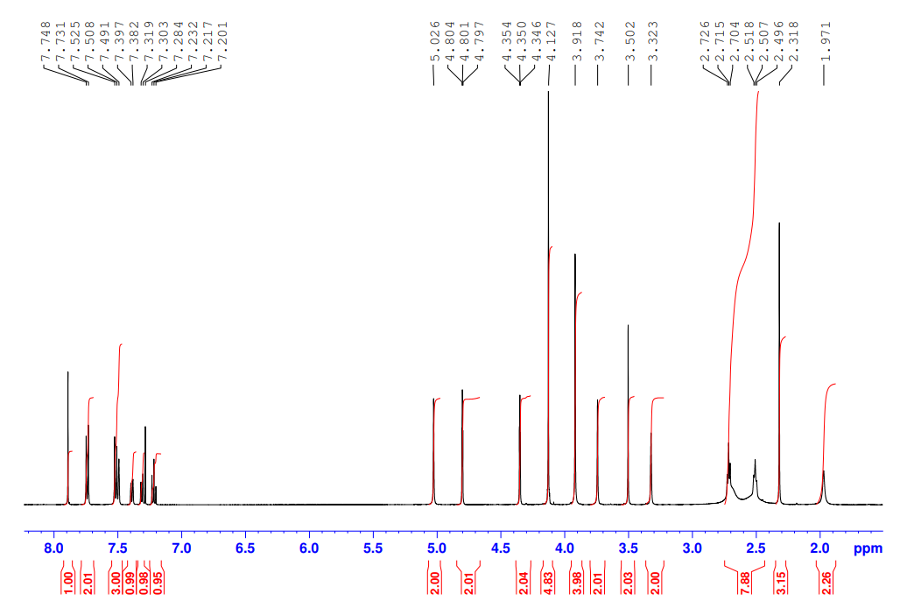

13C-NMR of **41a**

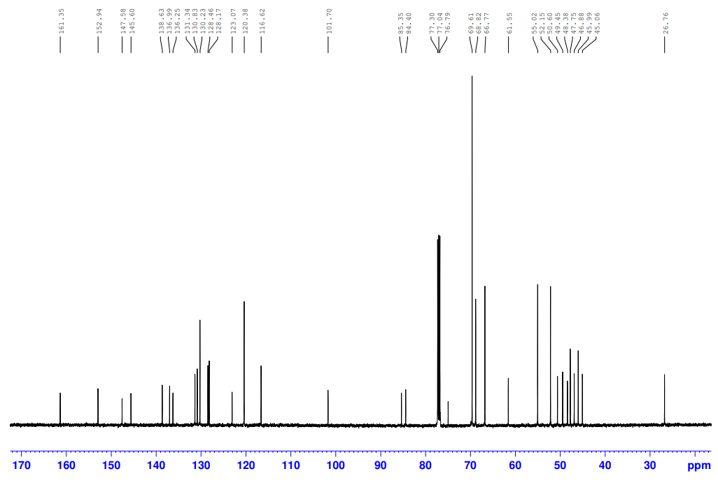

1H-NMR of **42a**

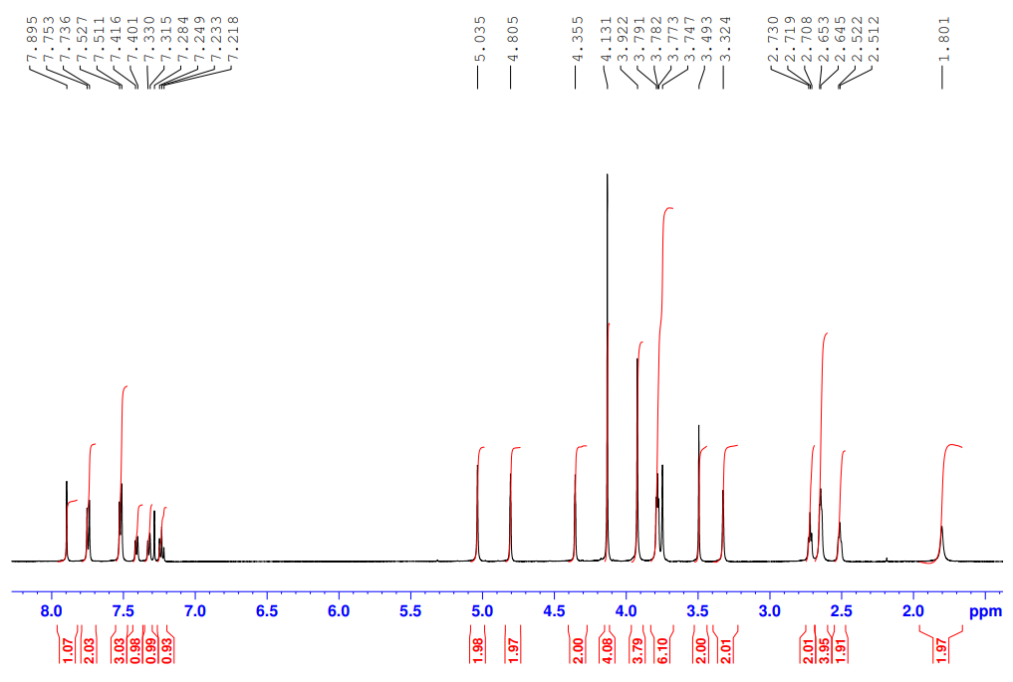

13C-NMR of **42a**

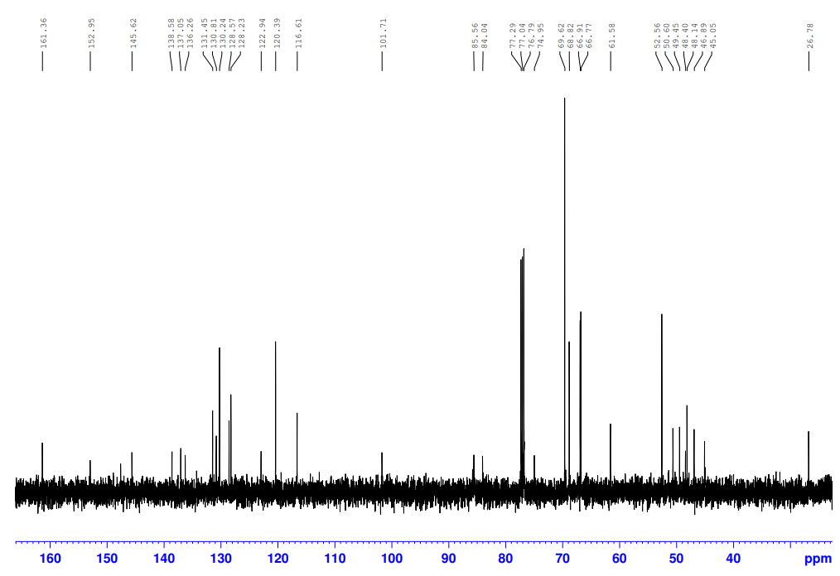

1H-NMR of **42b**

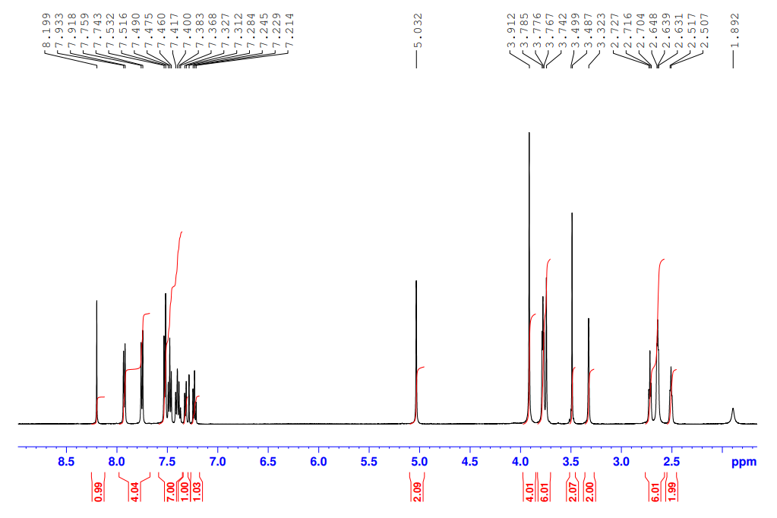

13C-NMR of **42b**

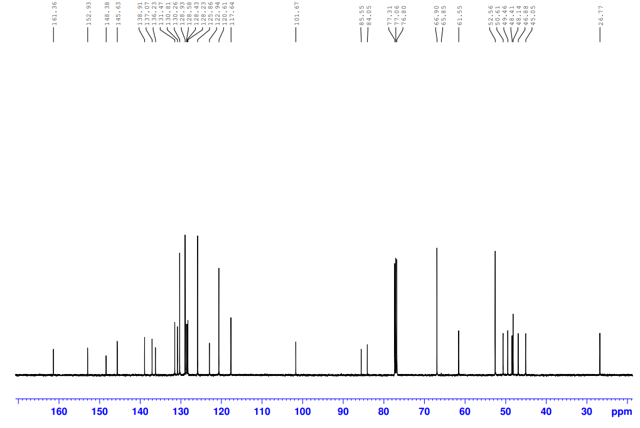

1H-NMR of **43a**

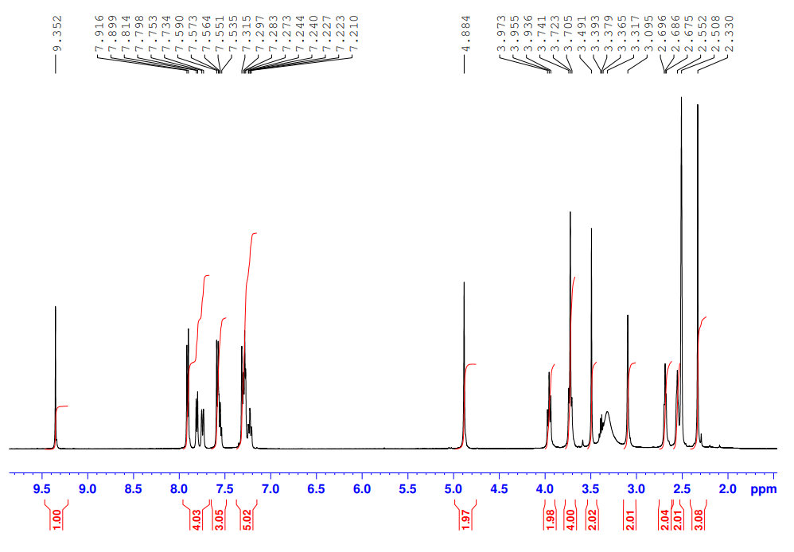

13C-NMR of **43a**

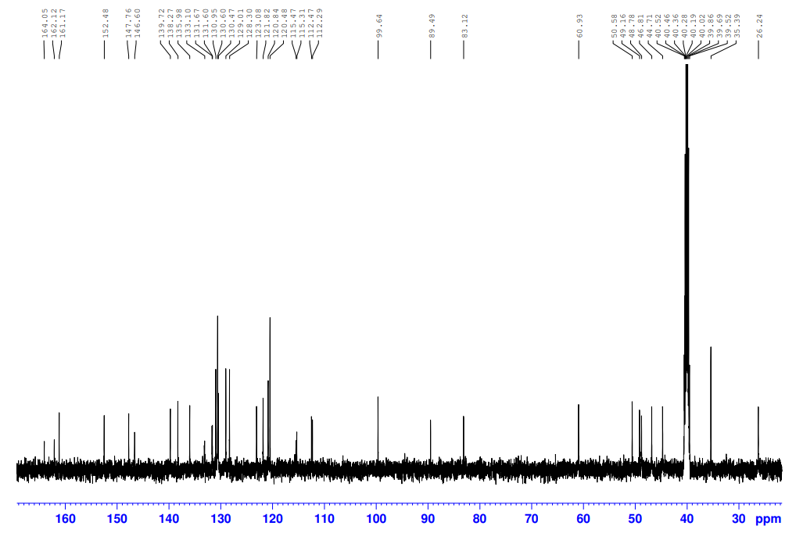

1H-NMR of **43b**

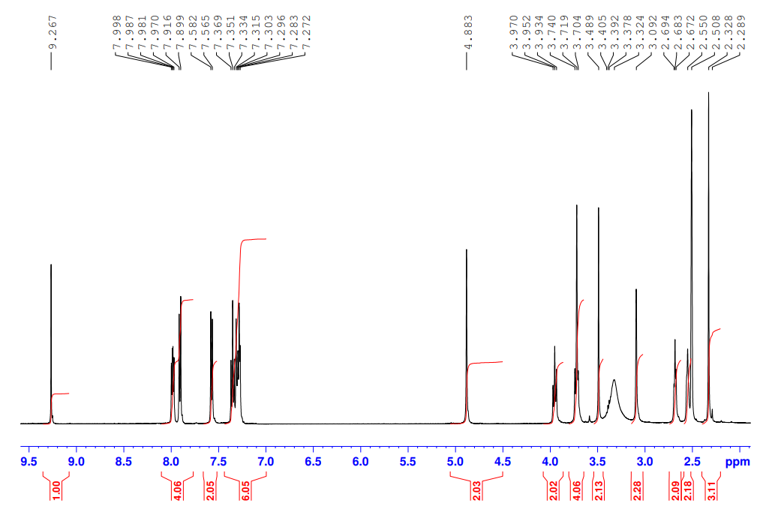

13C-NMR of **43b**

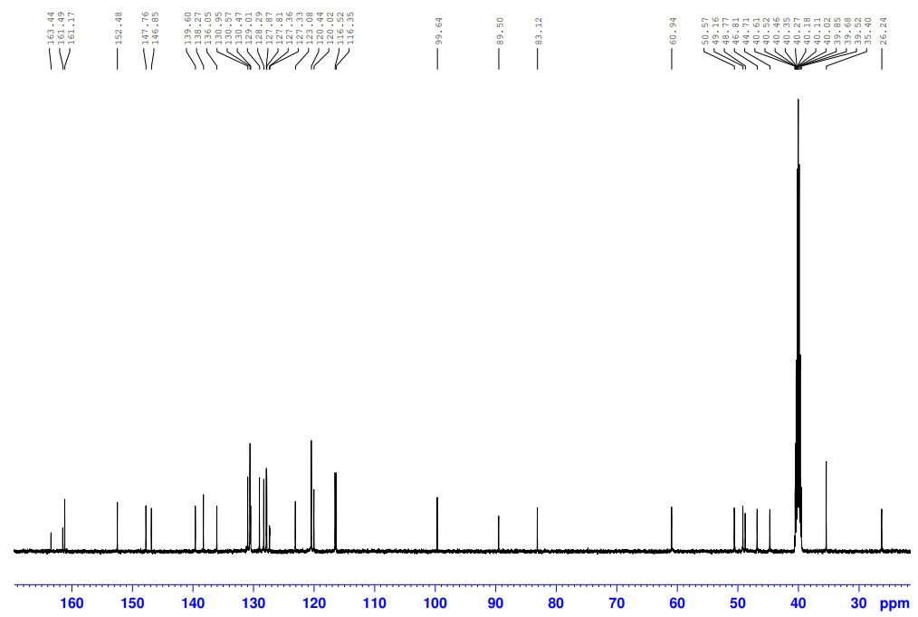

1H-NMR of **43c**

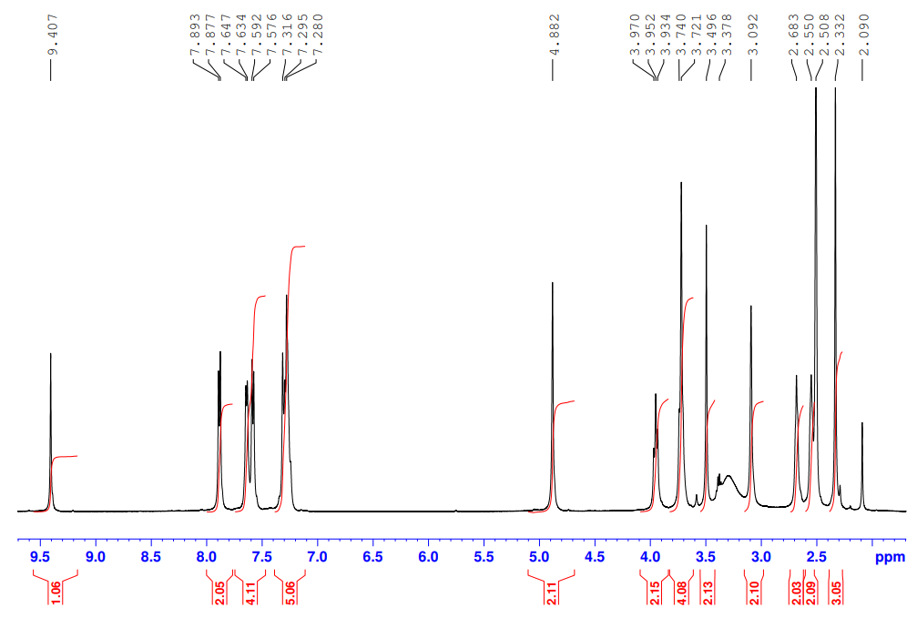

13C-NMR of **43c**

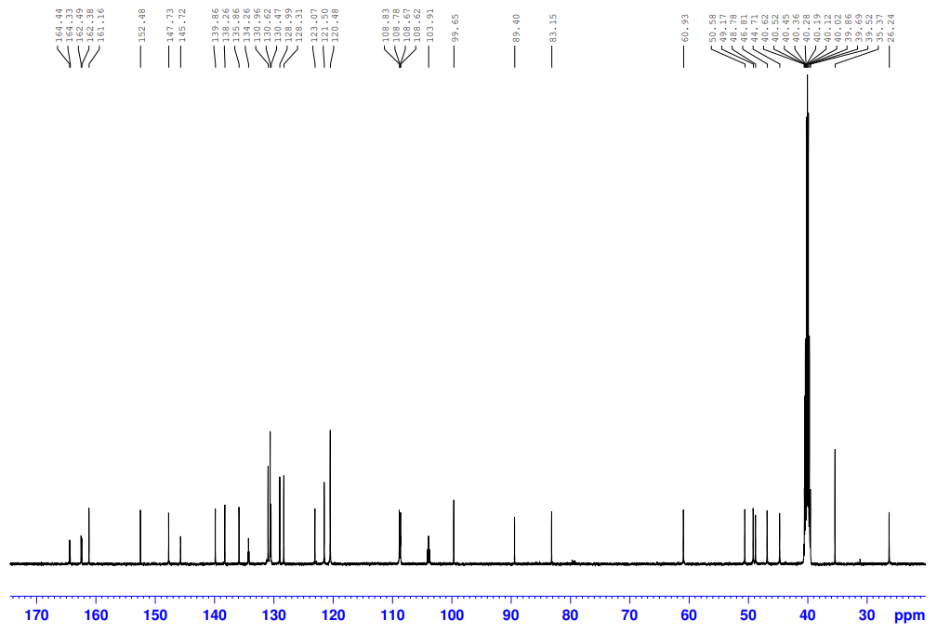

**S3. Copy of HRMS spectra of the targeted compounds**

HRMS of **1a**

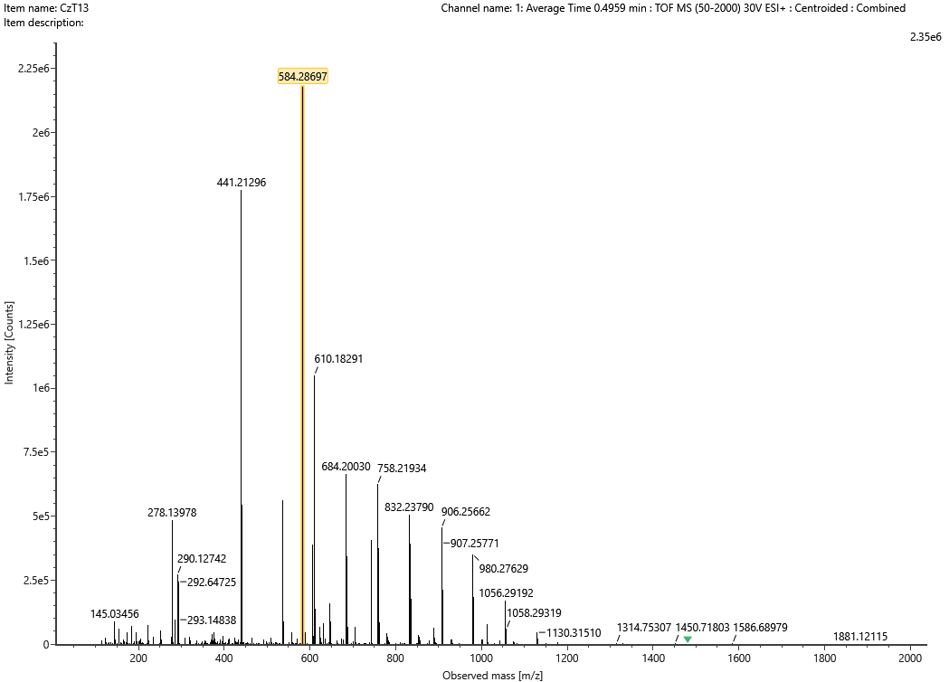

HRMS of **1b**

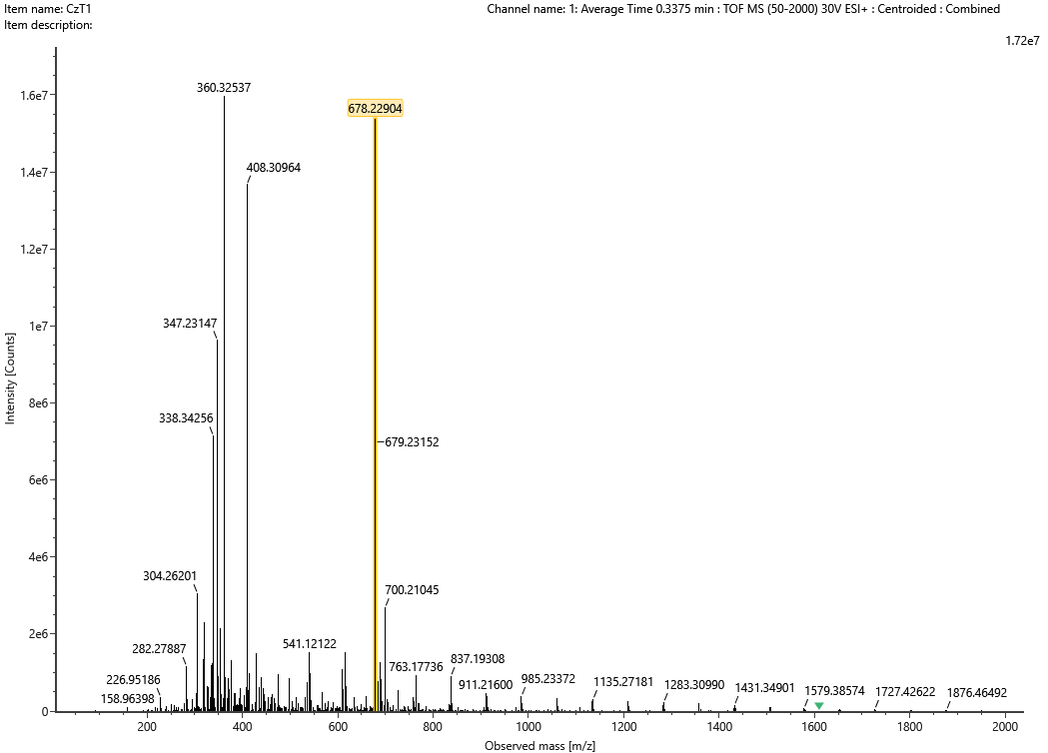

HRMS of **1c**

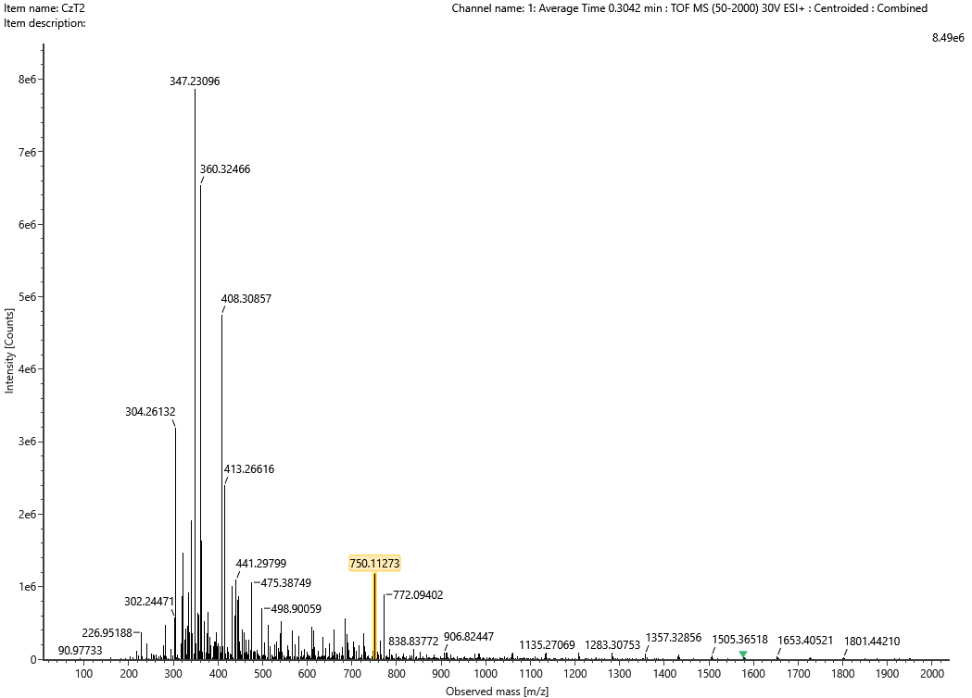

HRMS of **1c**

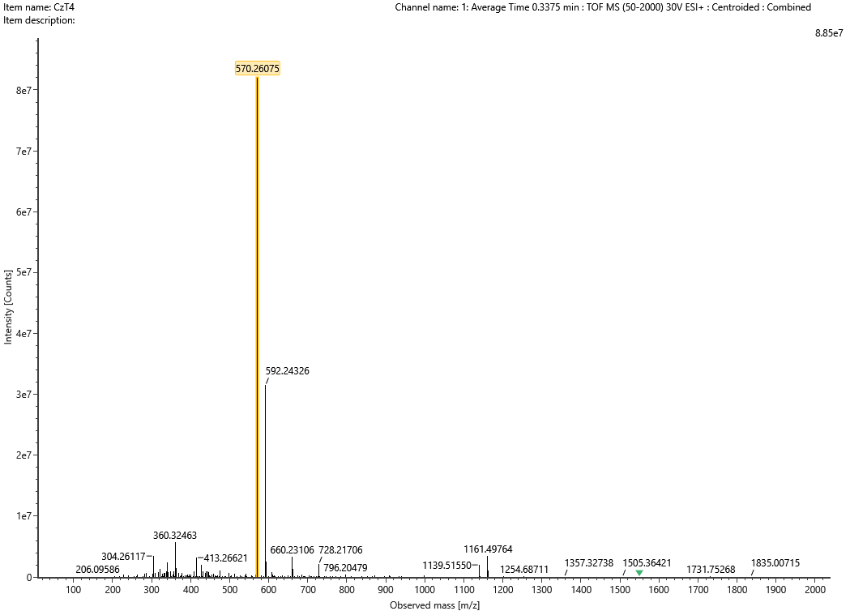

HRMS of **1d**

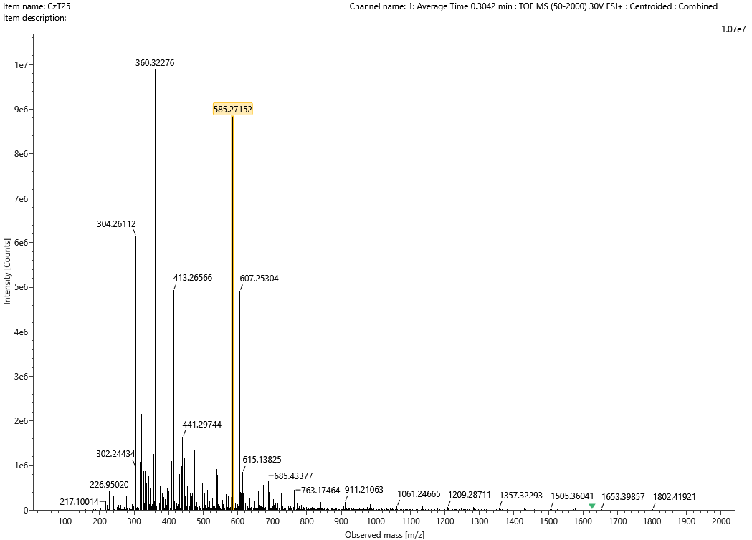

HRMS of **1e**

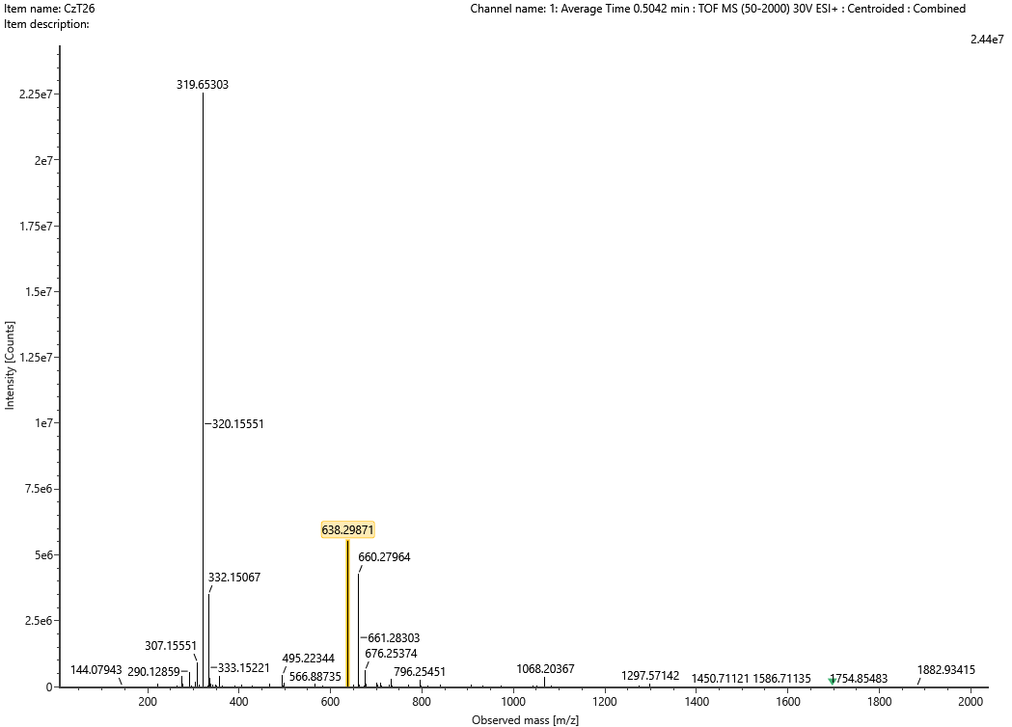

HRMS of **2a**

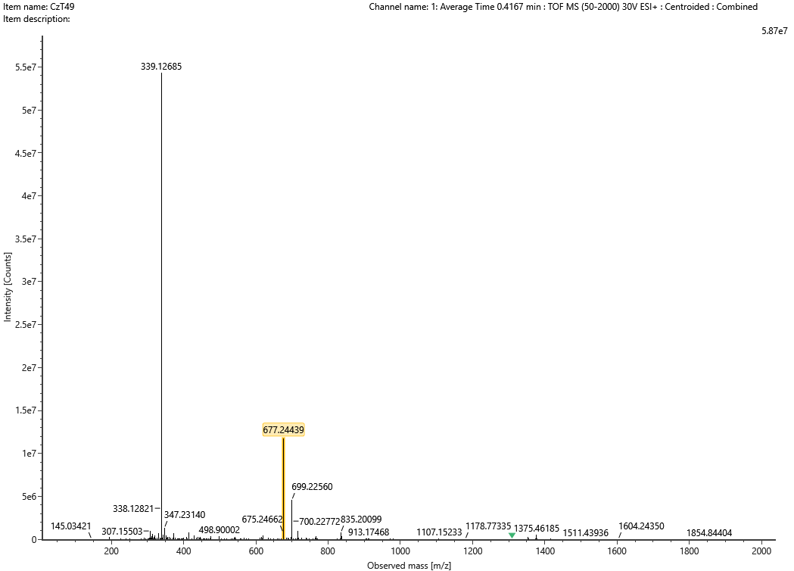

HRMS of **2b**

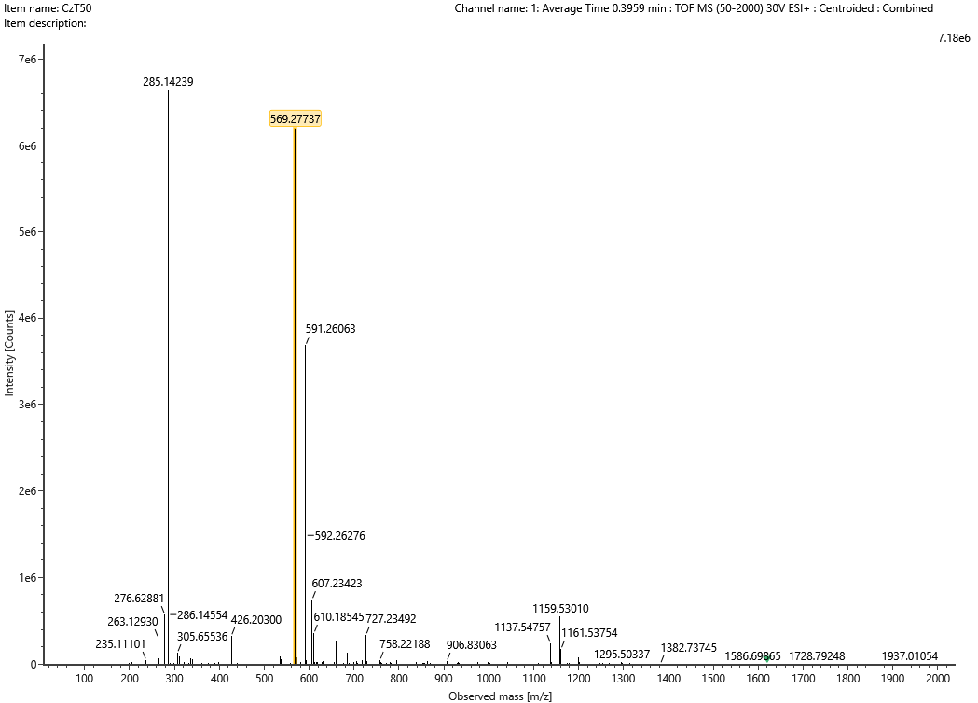

HRMS of **2c**

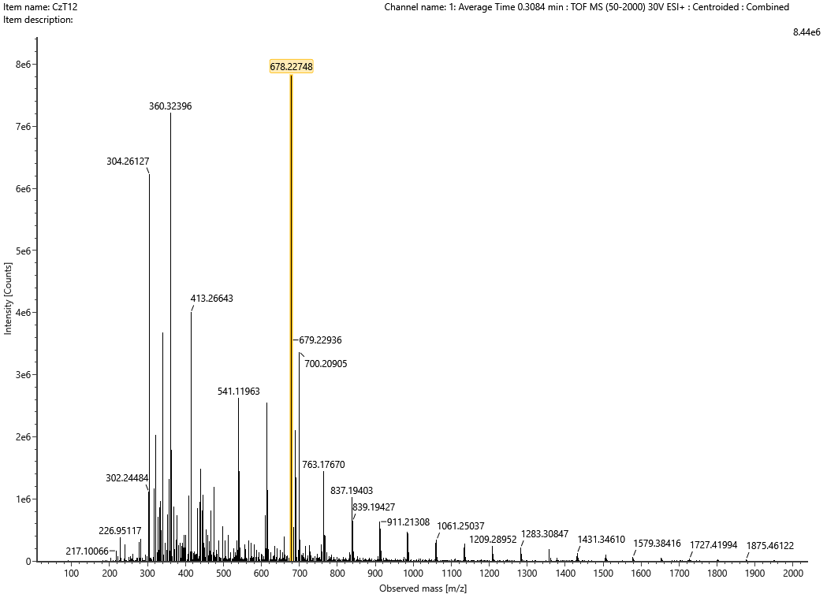

HRMS of **2d**

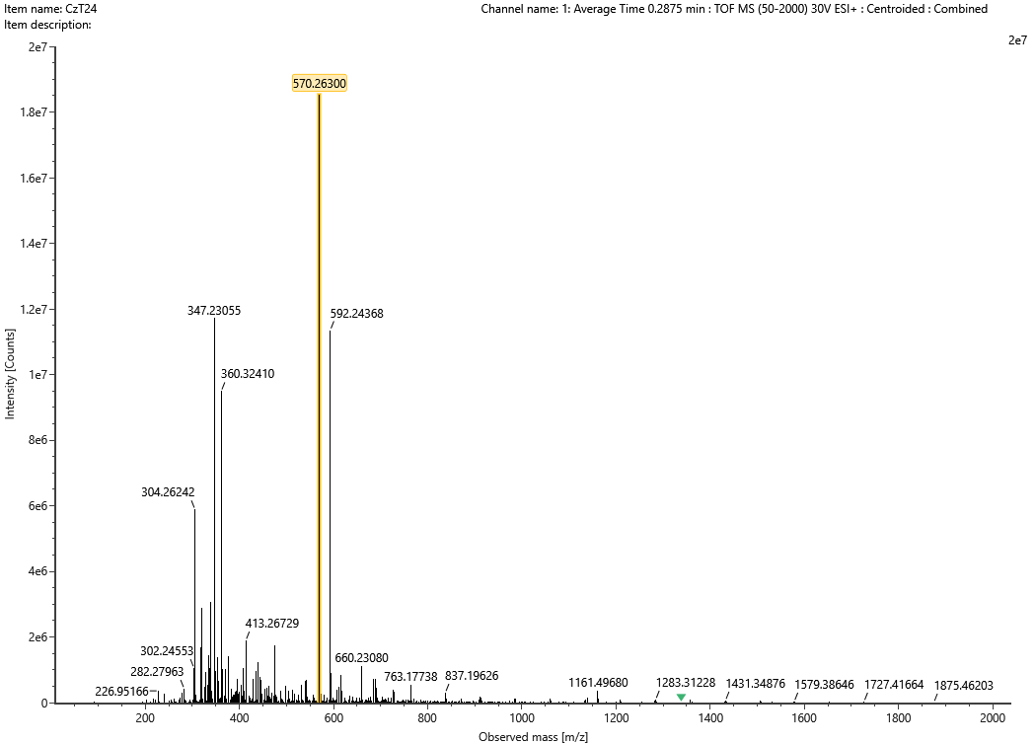

HRMS of **3a**

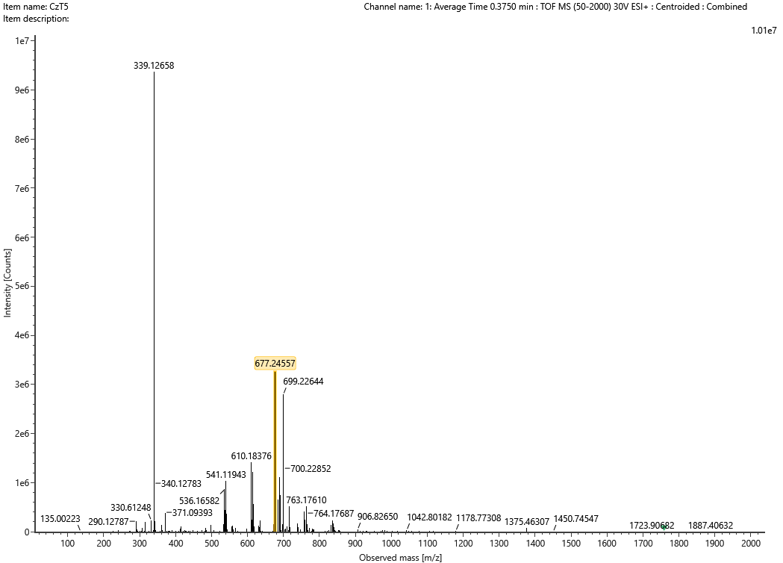

HRMS of **3b**

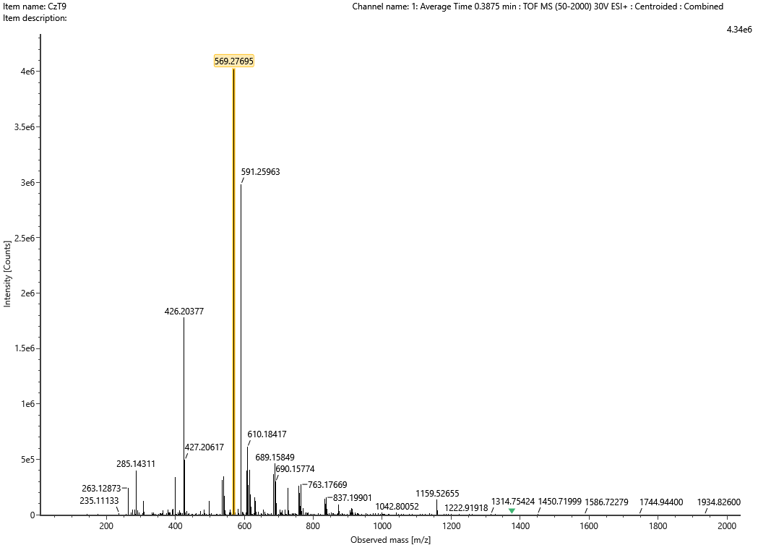

HRMS of **3c**

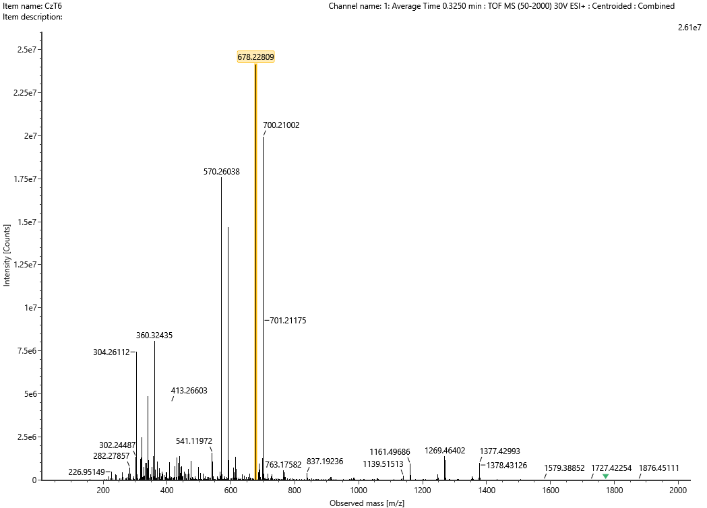

HRMS of **3d**

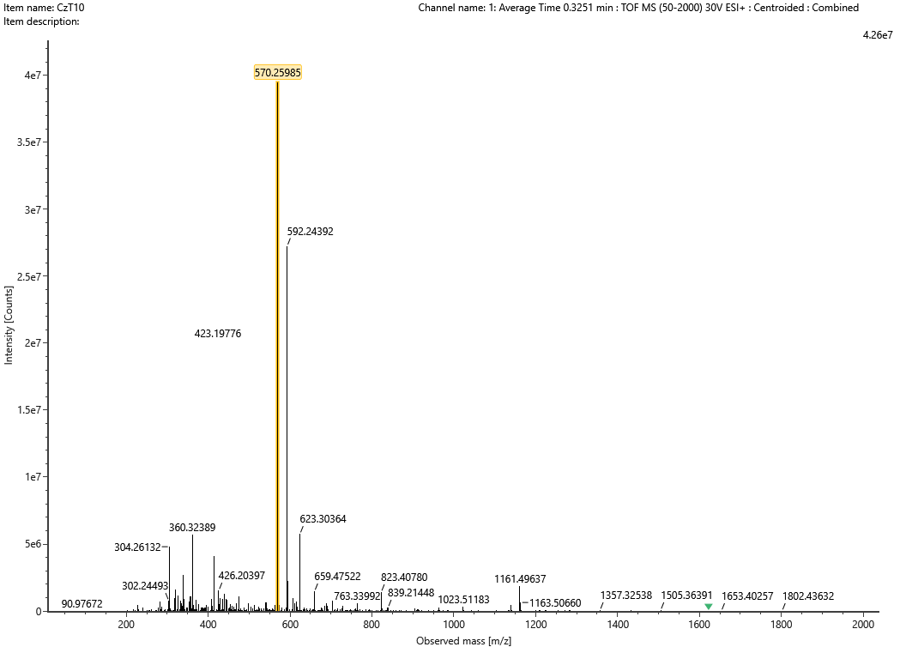

HRMS of **4a**

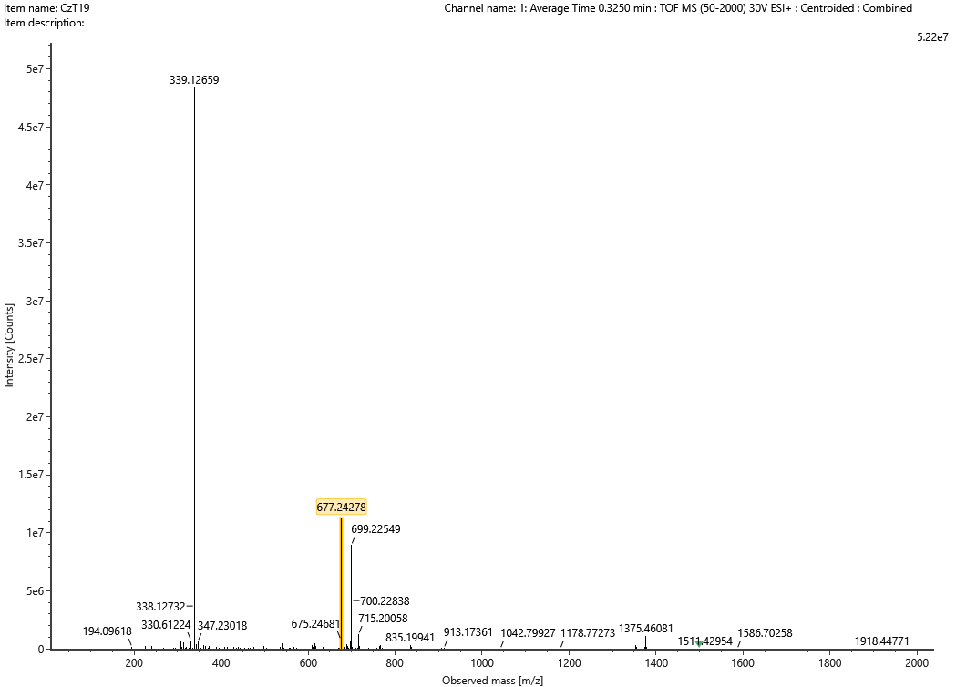

HRMS of **4b**

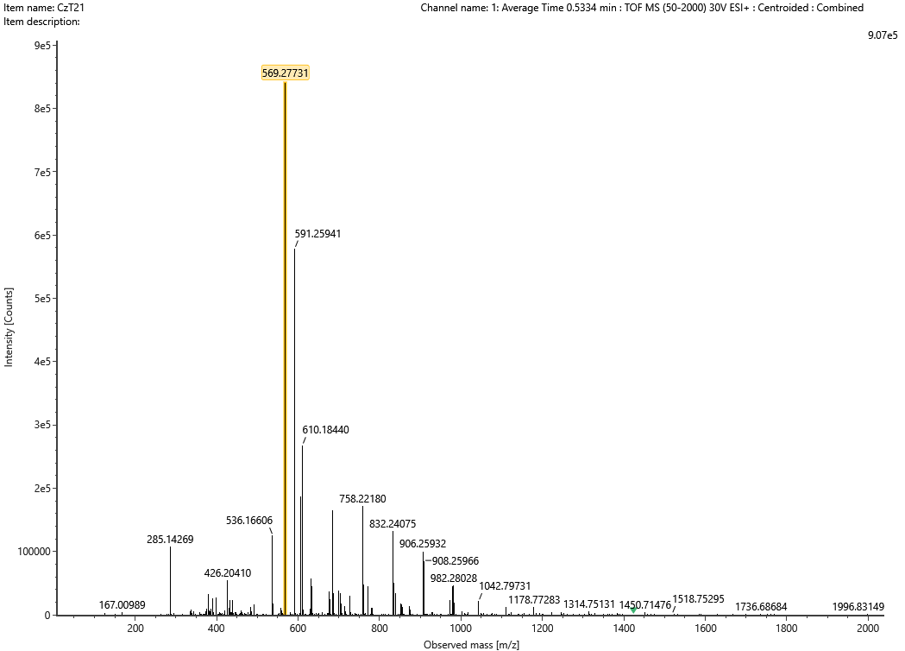

HRMS of **4d**

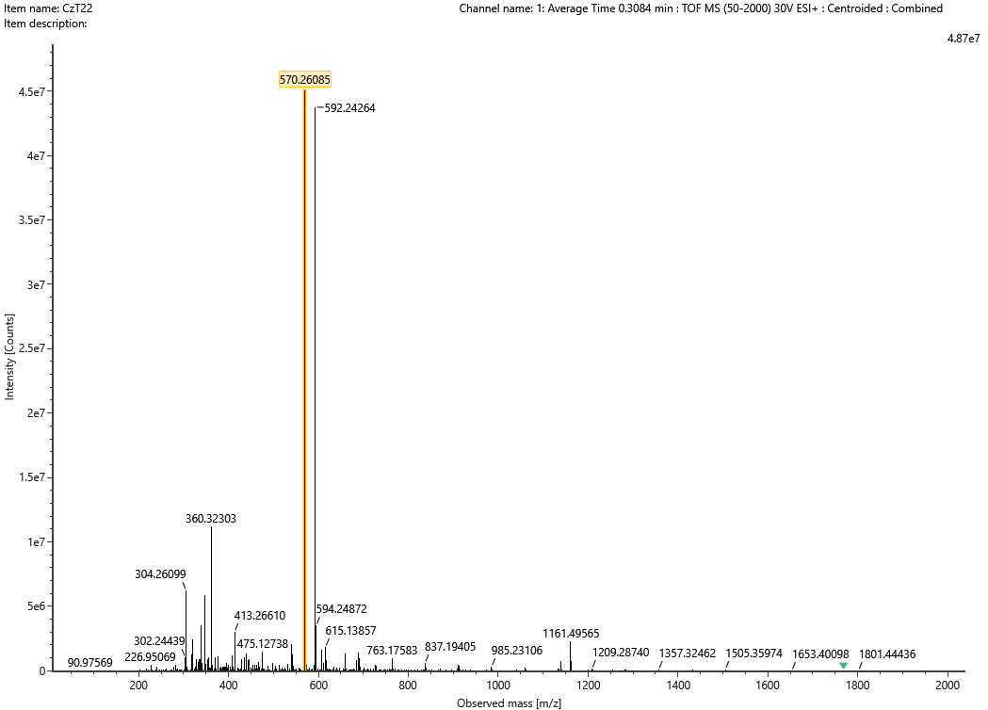

HRMS of **23a**

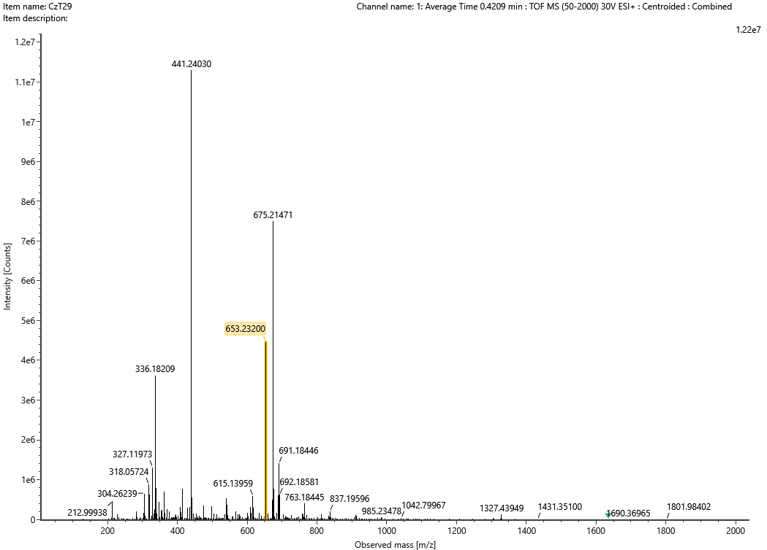

HRMS of **23b**

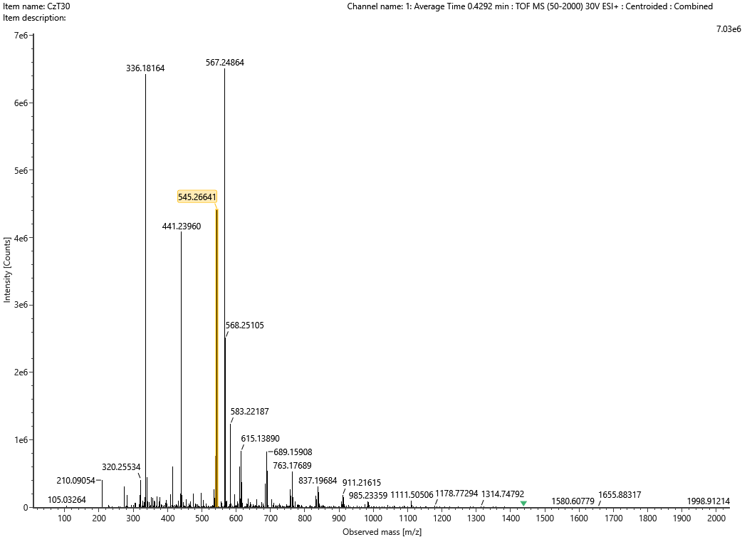

HRMS of **33b**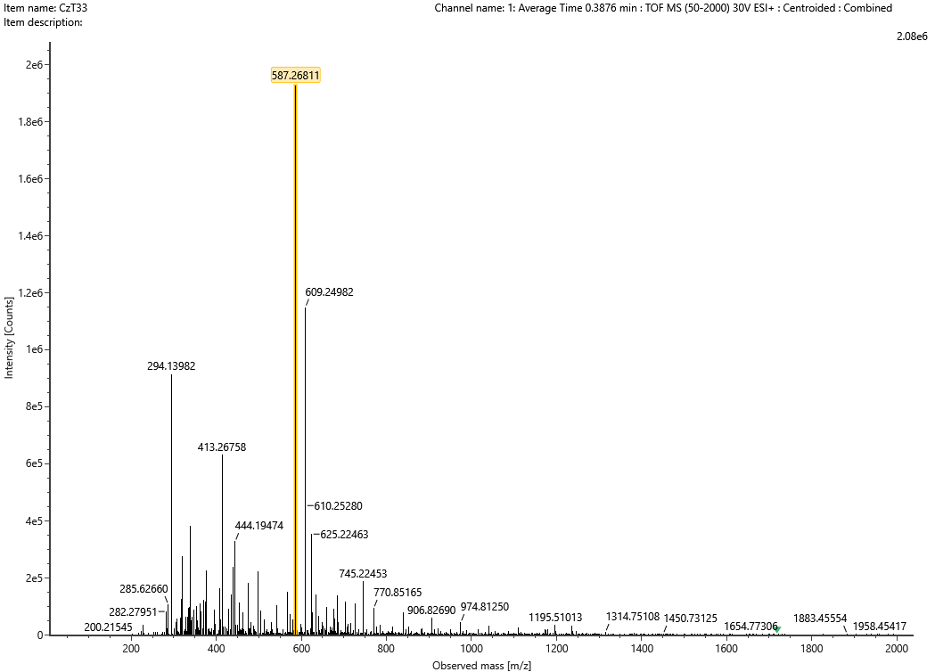

HRMS of **36a**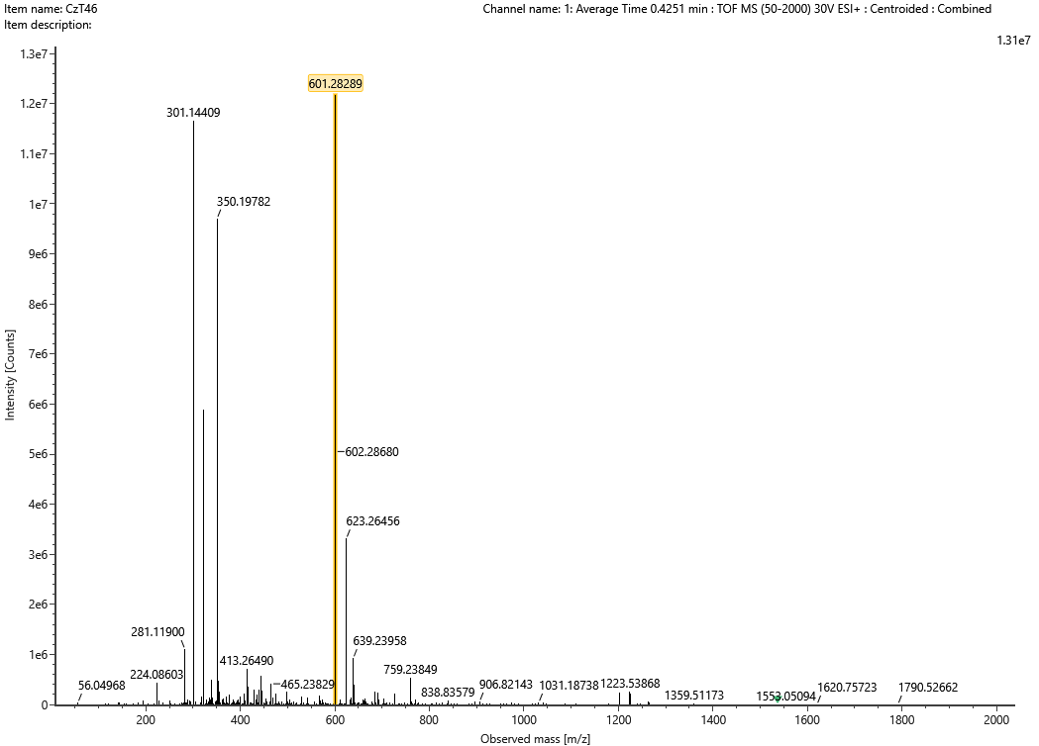

HRMS of **36b**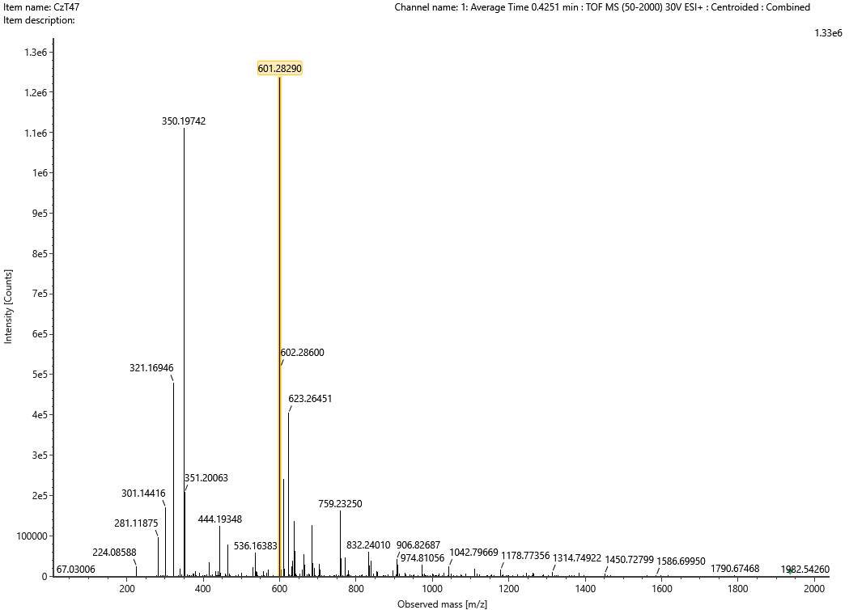

HRMS of **36c**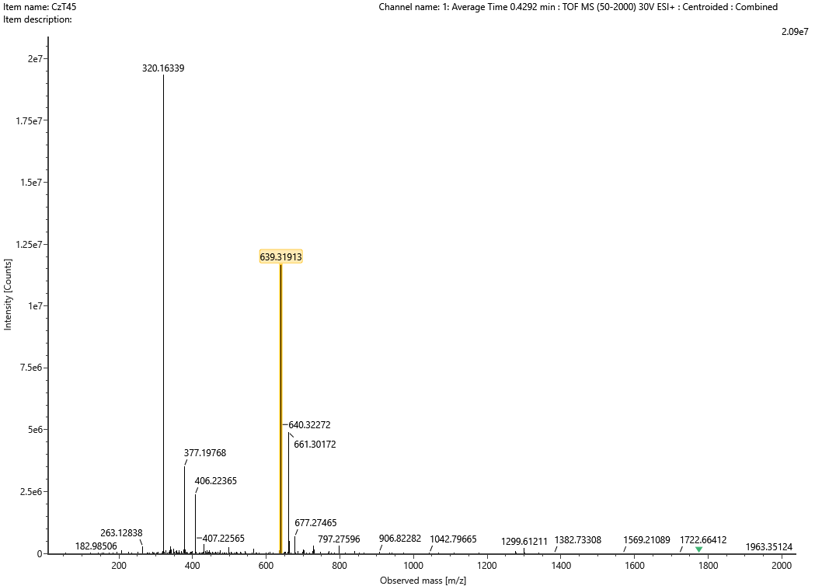

HRMS of **37a**

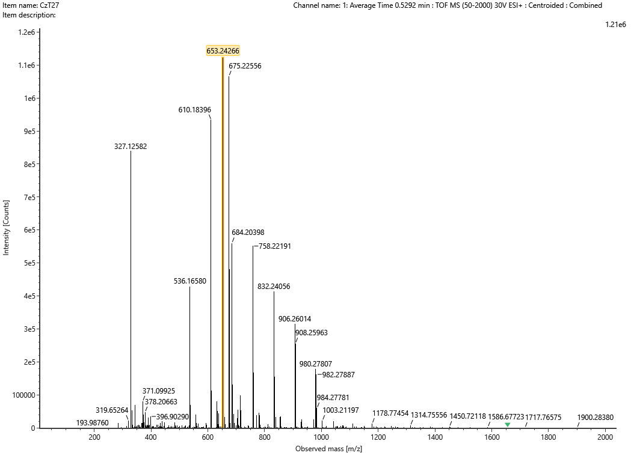

HRMS of **38a**

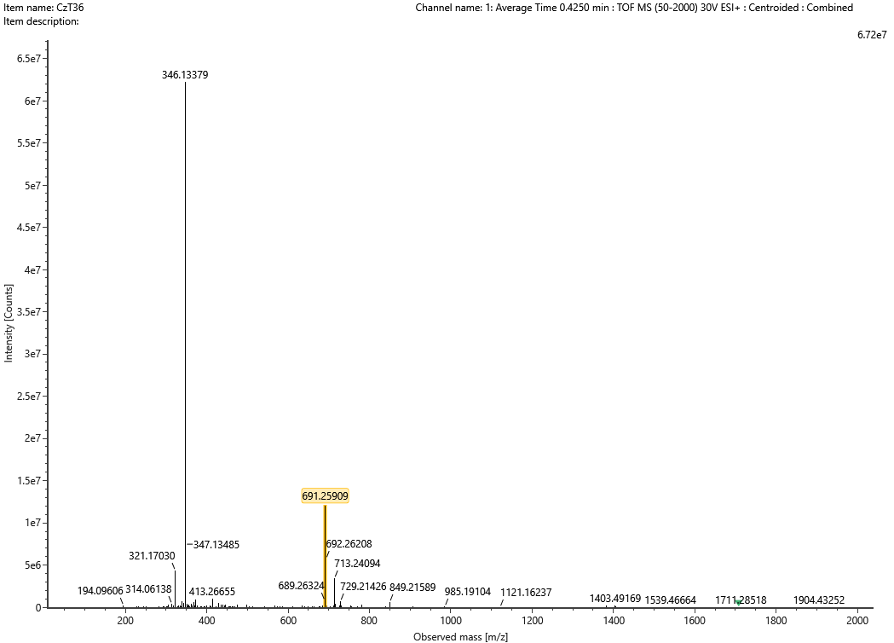

HRMS of **38b**

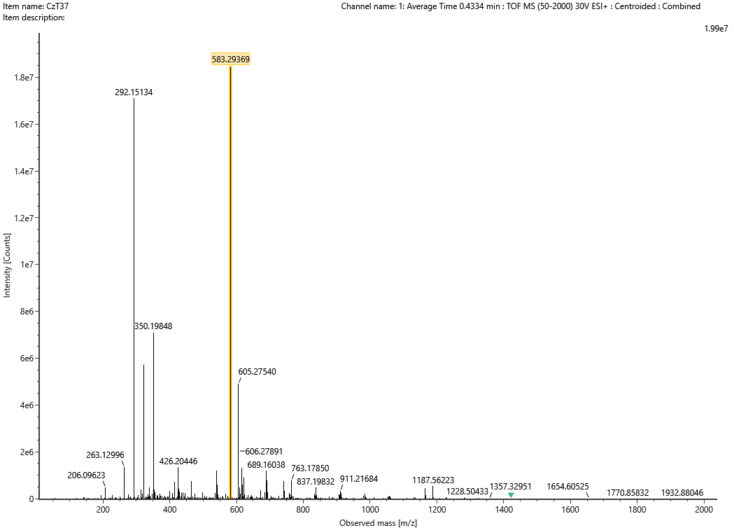

HRMS of **39a**

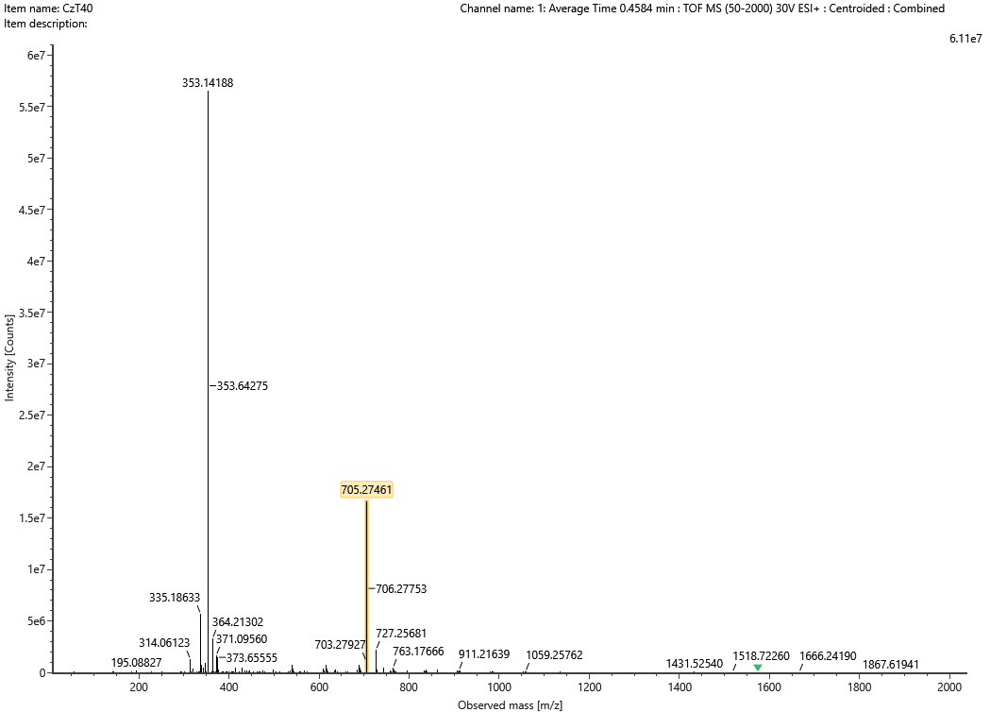

HRMS of **39b**

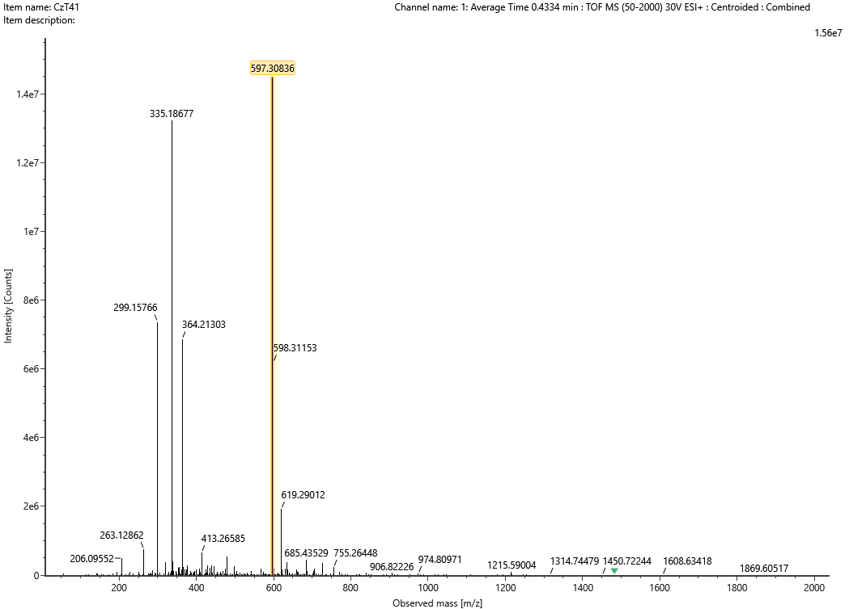

HRMS of **40a**

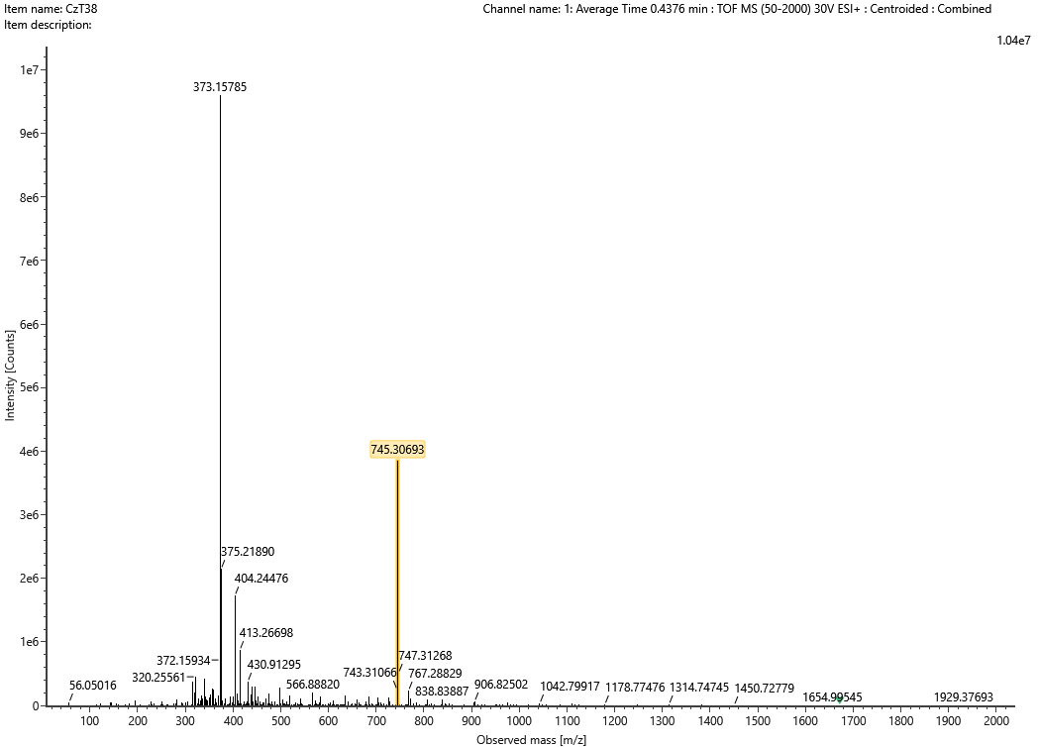

HRMS of **40b**

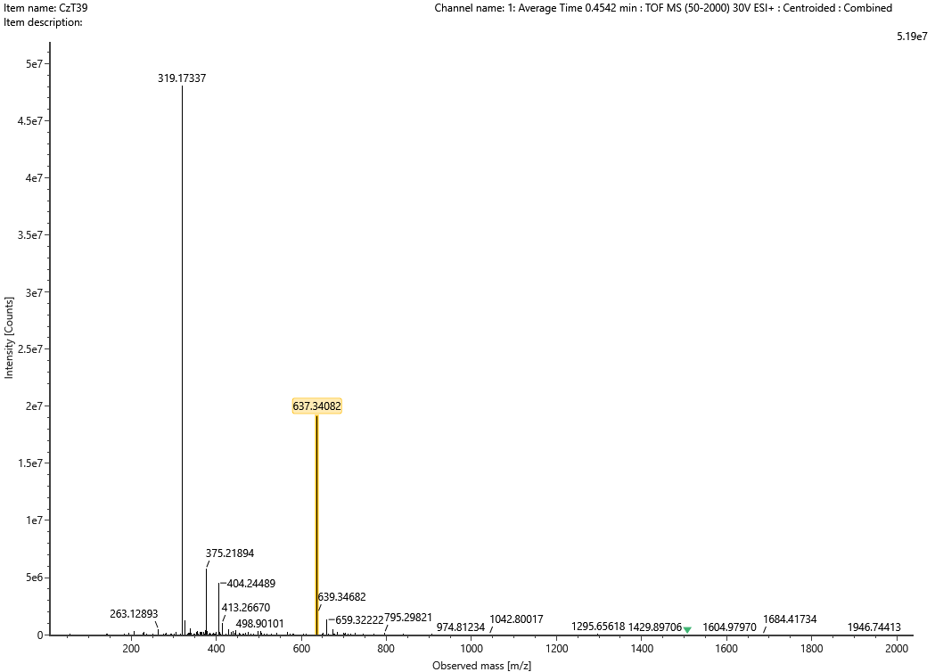

HRMS of **41a**

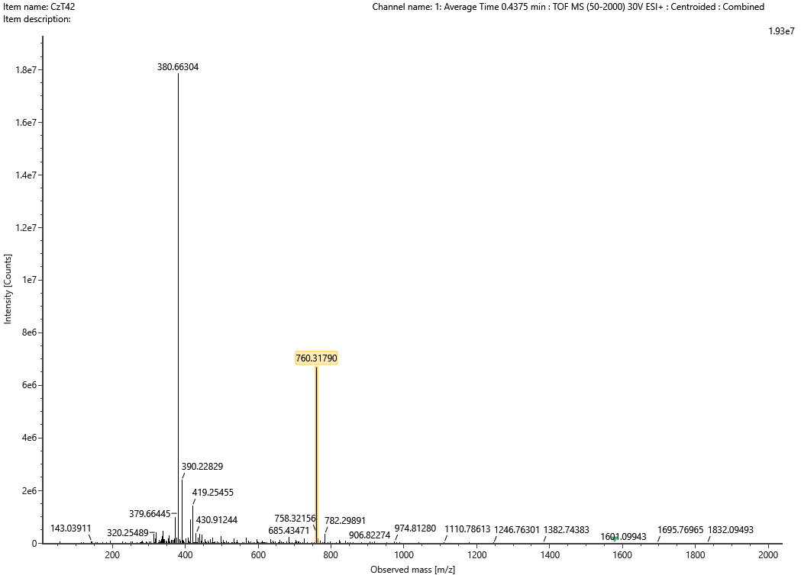

HRMS of **41b**

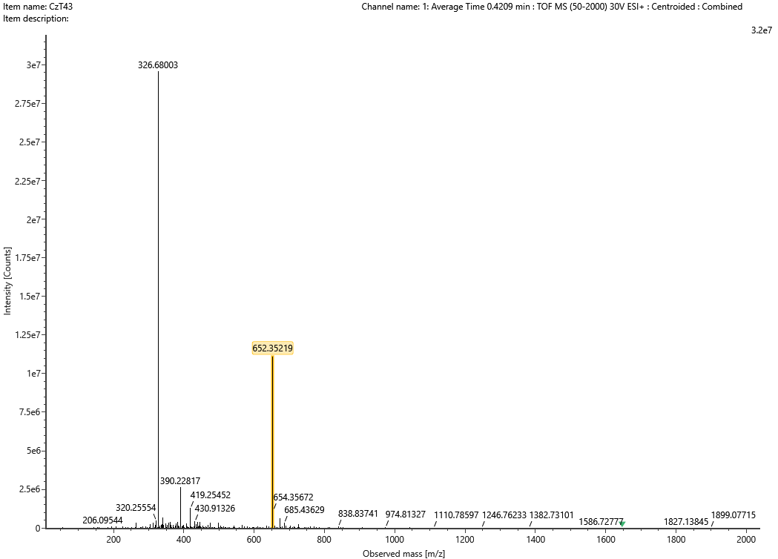

HRMS of **42a**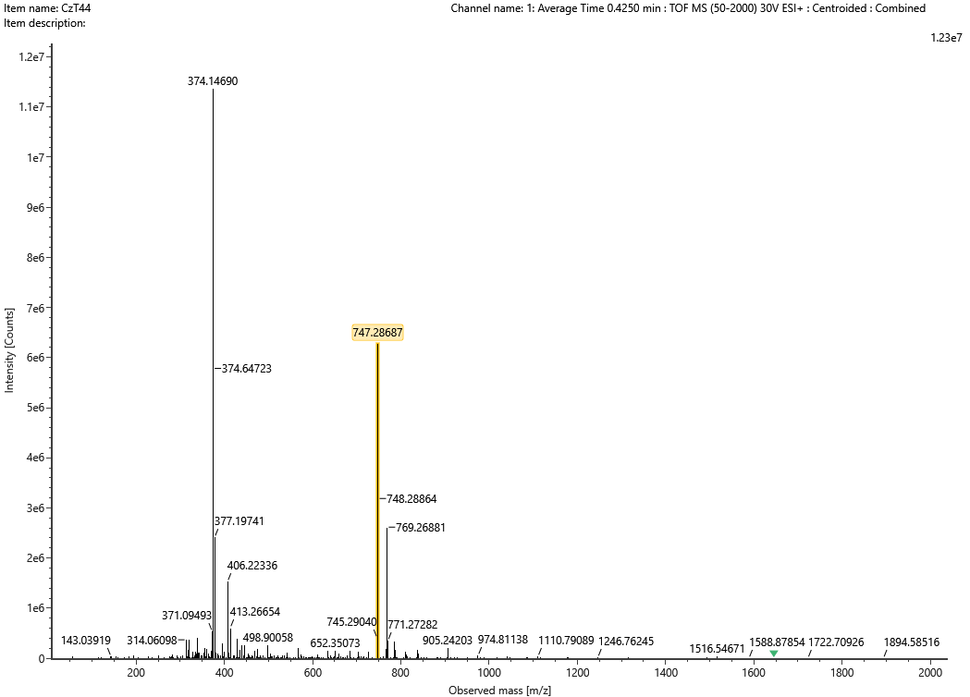

HRMS of **42b**

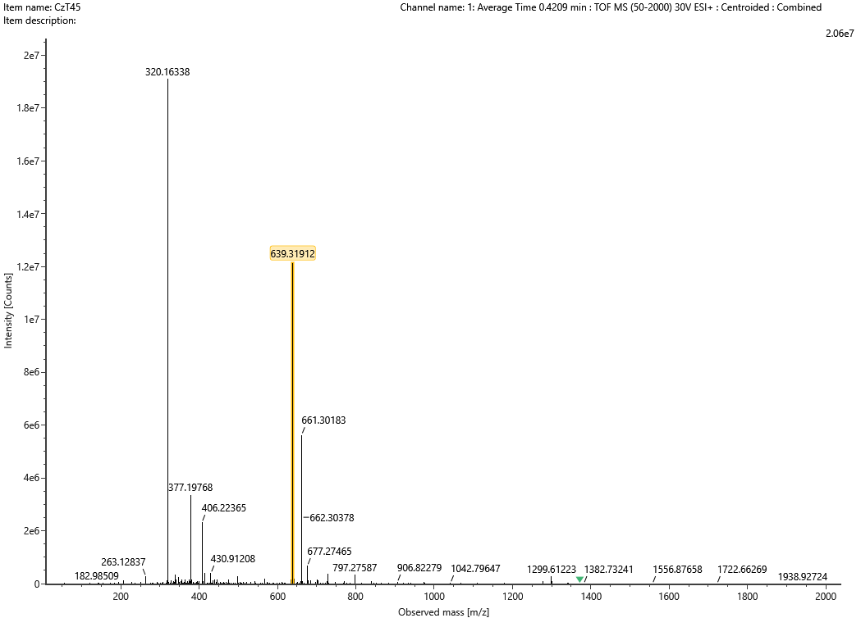

HRMS of **43a**

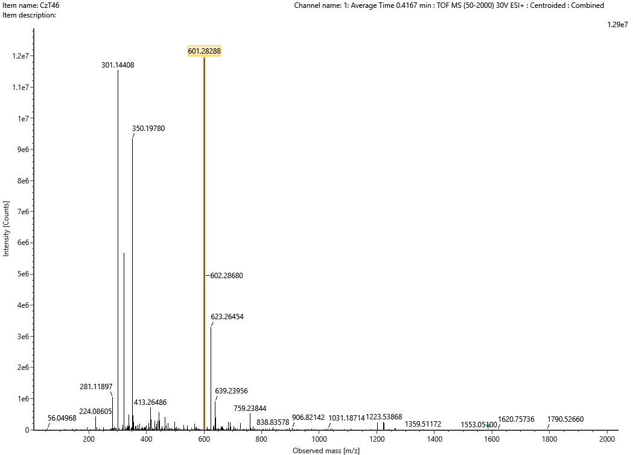

HRMS of **43b**

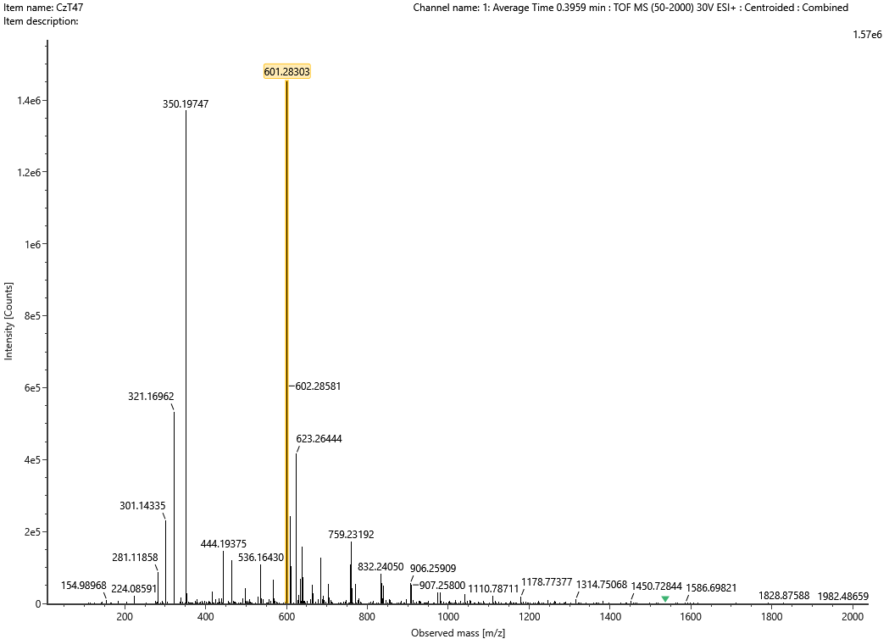

HRMS of **43c**

