**Supplementary Materials**

**Novel peptide-drug conjugates with dual anticancer activity**

Siobhán O’Flaherty, Olga A. Luzina, Nadezhda. S. Dyrkheeva, Ysaline Krier, Jérôme Leprince, Alexandra L. Zakharenko,Mikhail A. Pokrovsky, Andrey G. Pokrovsky, Olga I. Lavrik, Nariman F. Salakhutdinov, Mihayl Varbanov, Marc Devocelleand Konstantin P. Volcho

ESI-MS and RP-HPLC for L-K6 peptide amide.

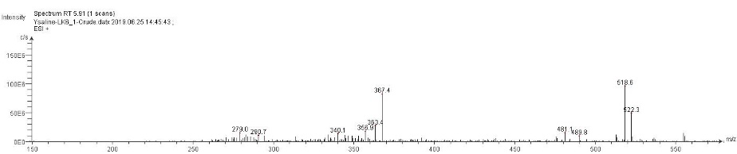

Figure S1 ESI-MS (m/z): Calcd for C75H146N20O14 1551.13, Found: 518.6 [M+3H]3+.

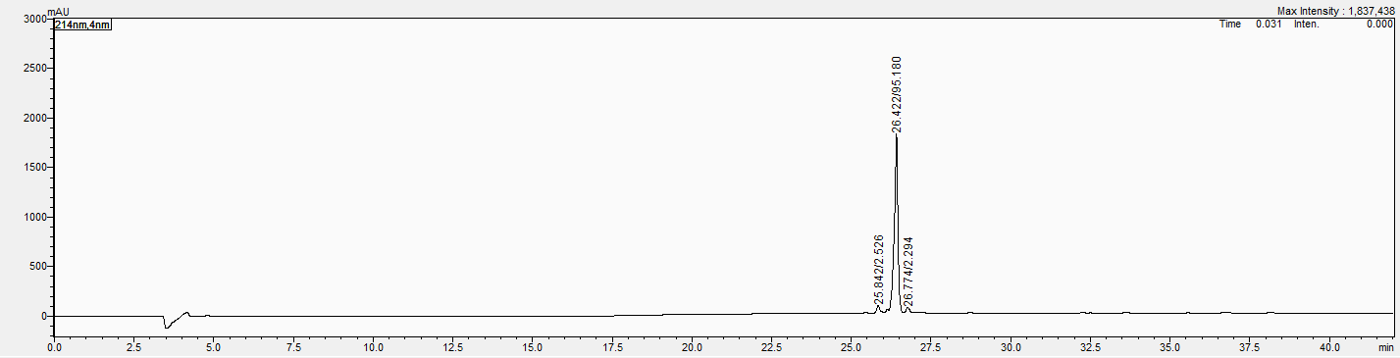

Figure S2 RP-HPLC: tR = 26.422 min, 95% purity.

ESI-MS, RP-HPLC, and MALDI-TOF MS of hydrazinoacetylated L-K6 peptide, **6**

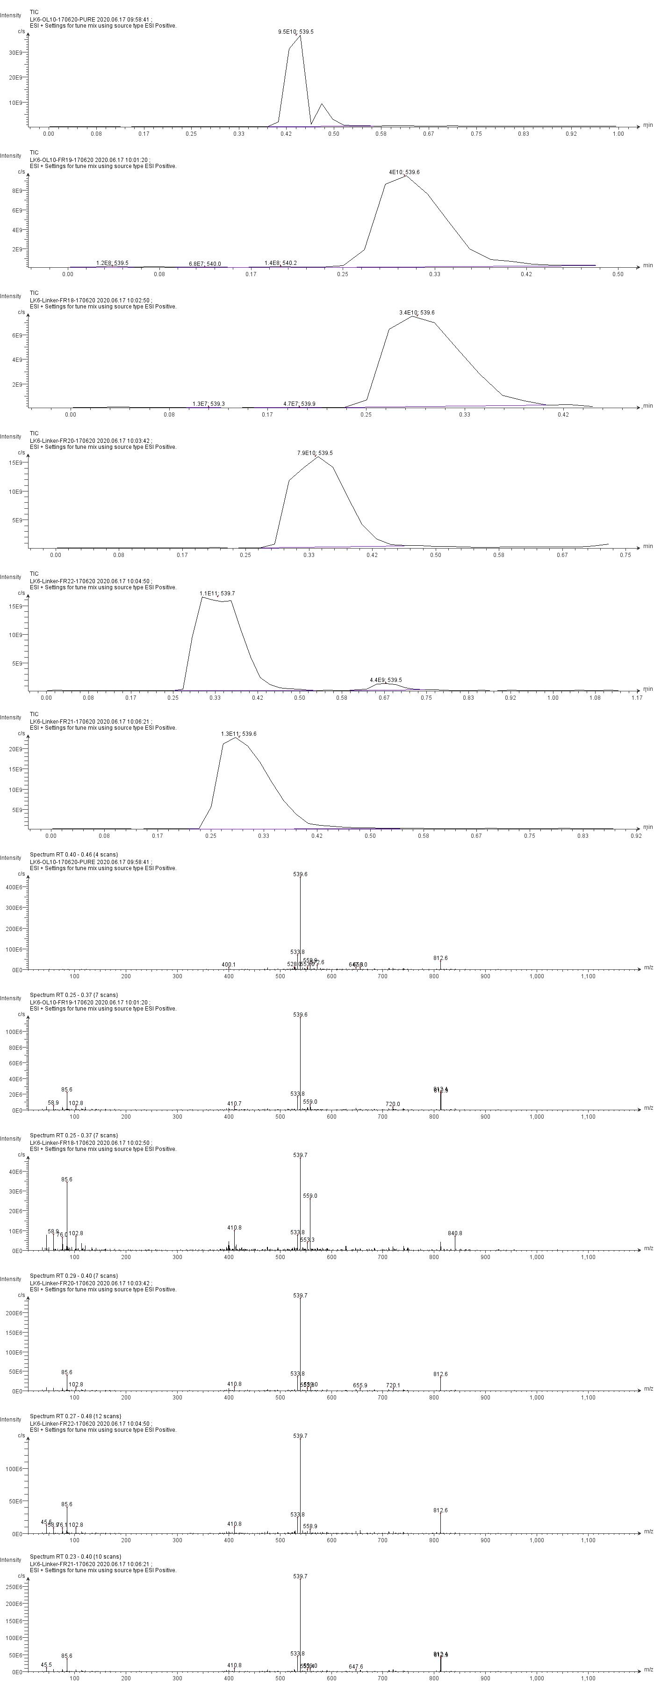

Figure S3 ESI-MS (m/z): Calcd for C77H150N22O15 1624.15, Found: 812.6 [M+2H]2+.

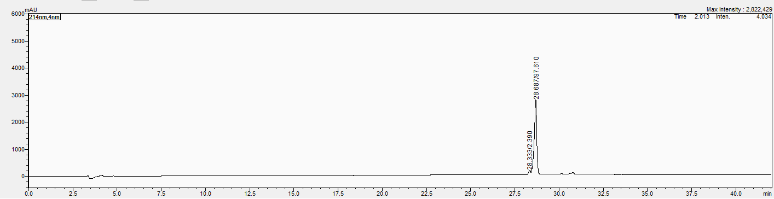

Figure S4 RP-HPLC: tR = 28.687 min, 97% purity.

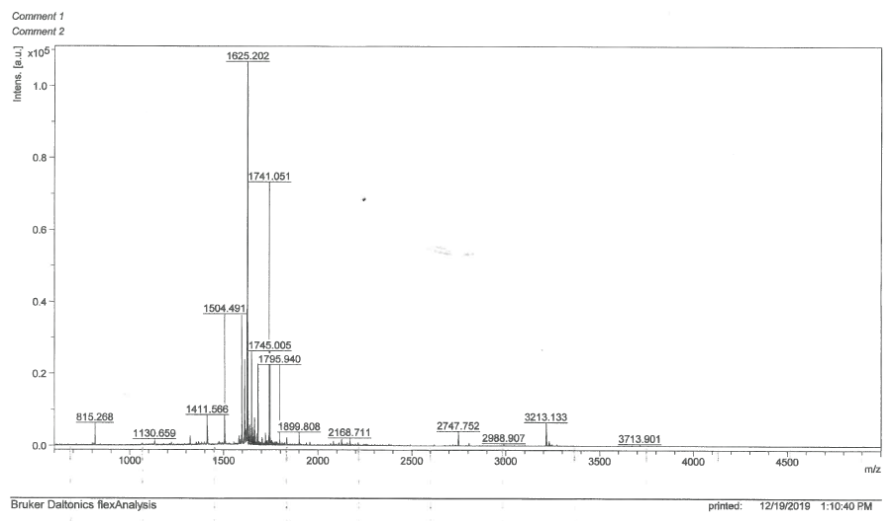

Figure S5 MALDI-TOF MS (m/z): Calcd for C77H150N22O15 1624.15, Found: 1625.202 [M+H]+.

ESI-MS, RP-HPLC, and MALDI-TOF MS for the conjugate **7** from the hydrazinothiazole-based usnic acid derivative **4** and the hydrazinoacetylated peptide **6**.

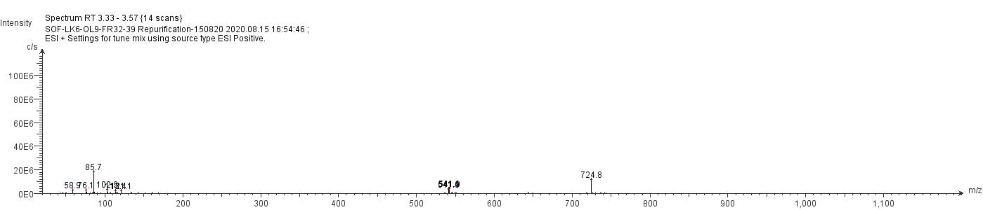

Figure S6 ESI-MS (m/z): Calcd for C103H166BrN25O19S 2170.58, Found: 724.4 [M+3H]3+.

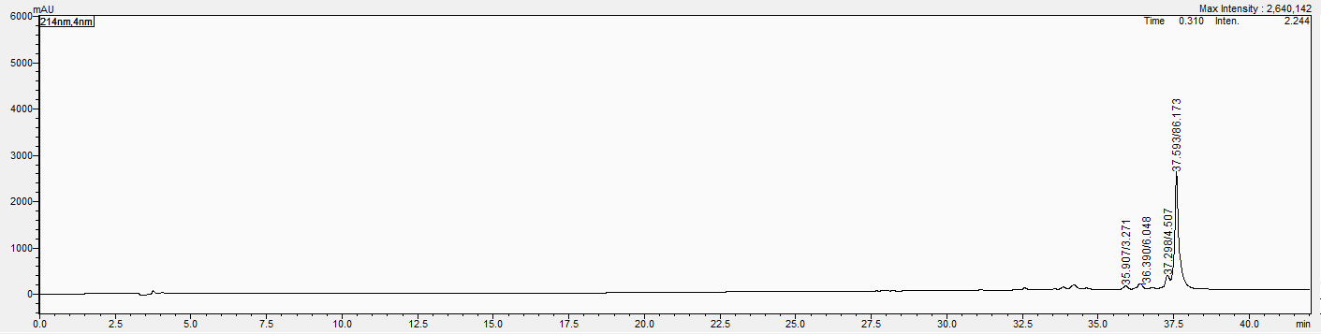

Figure S7 RP-HPLC: tR = 37.593 min, 86% purity.

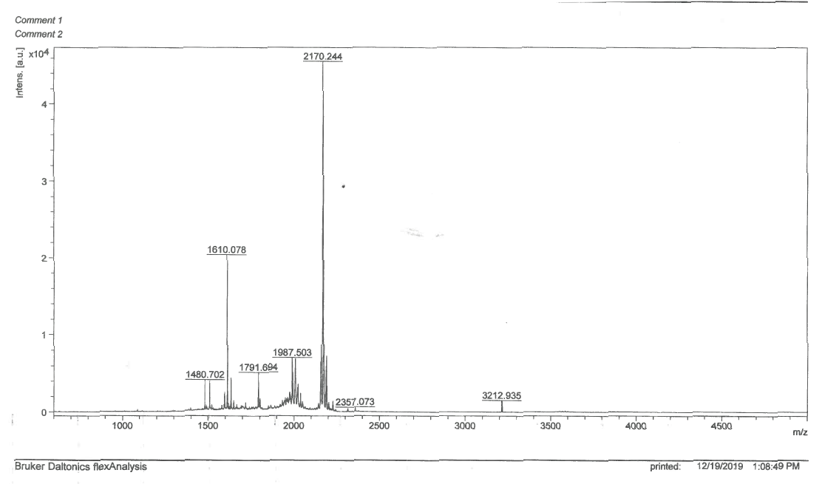

Figure S8 MALDI-TOF MS (m/z): Calcd for C103H166BrN25O19S: 2170.58, Found: 2170.244 [M+].

ESI-MS, RP-HPLC, and MALDI-TOF MS for conjugate **8** from the benzylidenefuranone-based usnic acid derivative **5** and the hydrazinoacetylated peptide **6**.

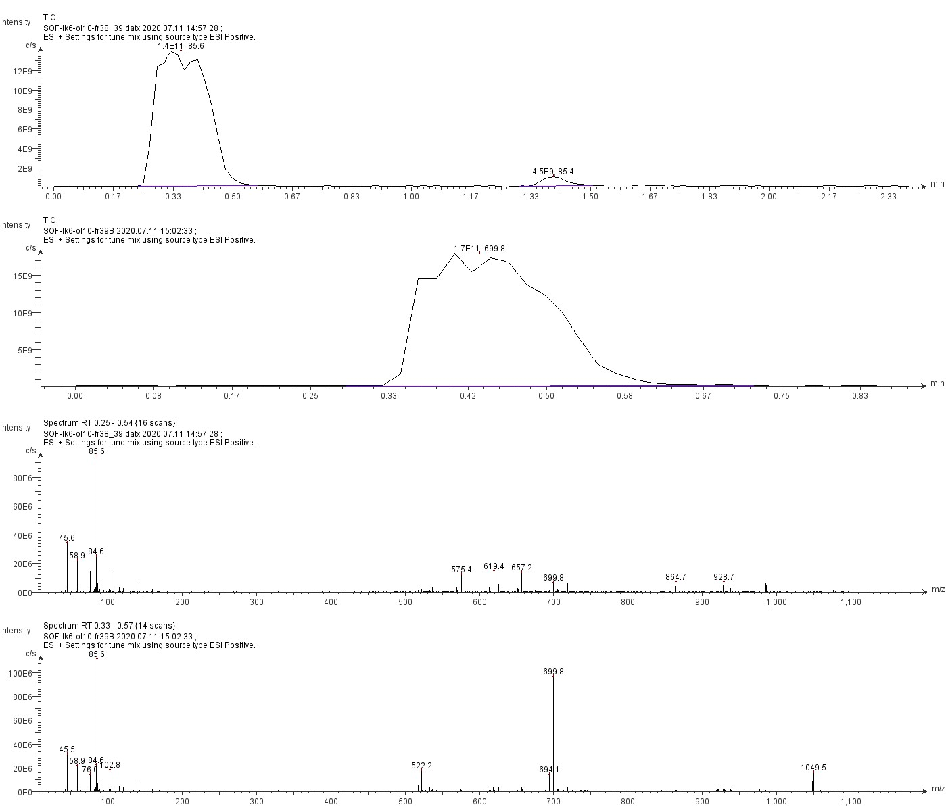

Figure S9 ESI-MS (m/z): Calcd for C102H163BrN22O20 2095.16, Found: 699.8 [M+3H]3+, 1049.5 [M+2H]2+.

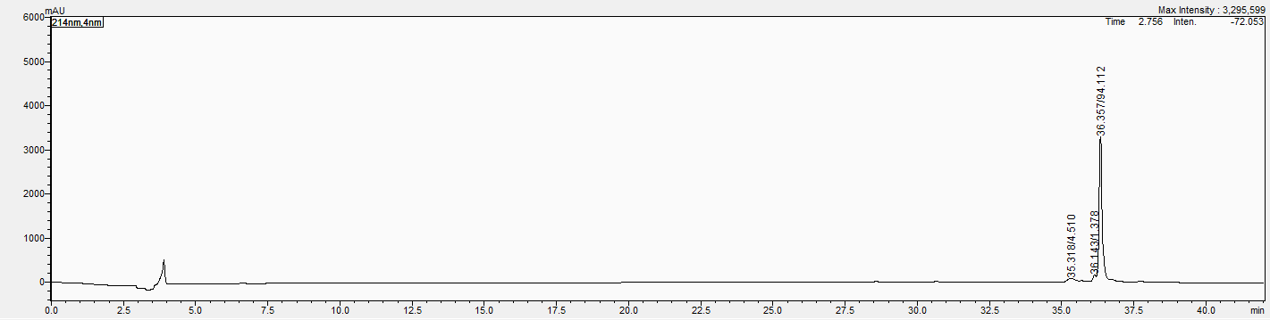

Figure S10 RP-HPLC: tR = 36.357 min, 94% purity.

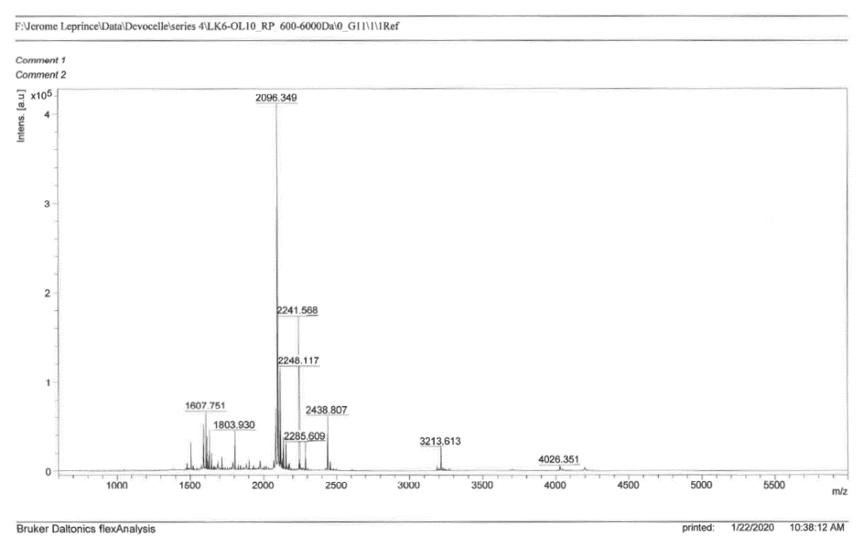

Figure S11 MALDI-TOF MS (m/z): Calcd for C102H163BrN22O20 2095.16, Found: 2096.349 [M+H]+.