Supplementary Materials
Supplementary Table S1 shows the data on days to flowering, days to maturity, and yield (kg per ha) of the BC₂F₄ rice population.
Line No. | Day to Flowering (Days) | Day to Maturity (days) | Yield (Kg per ha)
10D04 | 112 | 135 | 4335
15B12 | 123 | 150 | 4271
14H08 | 121 | 139 | 3959
10E.02 | 127 | 153 | 3635
2G04 | 128 | 153 | 3527
6C11 | 110 | 131 | 3484
12A05 | 112 | 133 | 3360
8C12 | 118 | 146 | 3339
3C03 | 118 | 147 | 3325
14B10 | 110 | 139 | 3295
2D09 | 119 | 146 | 3256
8D10 | 122 | 150 | 3112
3E.05 | 112 | 139 | 3103
14F12 | 112 | 143 | 3090
15C05 | 119 | 146 | 3031
14A12 | 113 | 135 | 3013
15D02 | 116 | 146 | 2997
14A08 | 129 | 154 | 2865
9B09 | 112 | 135 | 2855
14E.01 | 114 | 133 | 2756
14E.12 | 110 | 139 | 2737
13A06 | 108 | 133 | 2604
10B09 | 127 | 151 | 2598
8G04 | 108 | 135 | 2551
9G04 | 121 | 149 | 2548
9D06 | 118 | 150 | 2543
7A02 | 112 | 135 | 2441
16B09 | 120 | 150 | 2408
14A04 | 123 | 153 | 2404
10A11 | 122 | 149 | 2387
14B01 | 113 | 135 | 2327
16H02 | 113 | 135 | 2316
14H03 | 131 | 156 | 2239
14A03 | 131 | 156 | 2187
10C01 | 122 | 153 | 2156
12D01 | 127 | 153 | 2099
10A01 | 118 | 133 | 2035
5B07 | 110 | 135 | 2025
9G01 | 123 | 153 | 1907
10G01 | 128 | 153 | 1863
15F02 | 112 | 131 | 1859
6D11 | 112 | 146 | 1853
4D02 | 112 | 139 | 1811
16E.03 | 116 | 145 | 1789
2G03 | 131 | 156 | 1726
5D03 | 135 | 158 | 1682
9E.03 | 108 | 133 | 1661
14F10 | 108 | 131 | 1648
7F09 | 133 | 156 | 1512
3E.07 | 127 | 153 | 1499
12B01 | 122 | 153 | 1334
8F01 | 106 | 131 | 1319
5B09 | 116 | 153 | 1280
8F03 | 110 | 131 | 1277
9B08 | 112 | 146 | 1064
8B12 | 135 | 156 | 933
9A04 | 133 | 156 | 909
5H03 | 108 | 139 | 847
9D02 | 127 | 156 | 677
5B06 | 102 | 127 | 673
5G06 | 99 | 129 | 614
4E.05 | 113 | 139 | 348

Supplementary Table S2 Amylose content and rapidly available glucose (RAG) of cooked rice with low gelatinization temperature (GT)
Rice lines | GT | %Amylose content  (base on rice flour) | Rapidly available glucose at 20 mins  base on dry solid of cooked rice
5B07 | Low | 10.52 | 88.0 | + | 2.1a
9E03 | Low | 11.57 | 84.7 | + | 1.0abc
16H02 | Low | 11.79 | 84.6 | + | 1.3abc
5B06 | Low | 11.91 | 83.0 | + | 3.4bcd
7A02 | Low | 12.57 | 81.7 | + | 1.8bcdef
8F01 | Low | 12.59 | 84.1 | + | 1.5bcd
14E01 | Low | 12.79 | 73.2 | + | 2.7jkl
5G06 | Low | 13.05 | 71.5 | + | 2.0klm
9A04 | Low | 13.08 | 77.4 | + | 2.8ghi
14B01 | Low | 13.25 | 73.3 | + | 1.4jkl
9B09 | Low | 13.69 | 71.2 | + | 0.5klm
14A12 | Low | 13.86 | 69.2 | + | 2.5 m
2D09 | Low | 13.88 | 78.7 | + | 3.1fgh
14E02 | Low | 14.03 | 70.3 | + | 2.0lm
12A05 | Low | 14.42 | 64.6 | + | 3.3n
10A01 | Low | 14.46 | 79.2 | + | 0.4efgh
14B10 | Low | 14.66 | 81.1 | + | 1.1cdef
8G04 | Low | 14.76 | 80.6 | + | 1.5defg
5H03 | Low | 14.88 | 82.6 | + | 0.1bcde
10D04 | Low | 15.36 | 74.0 | + | 0.9ijk
8B12 | Low | 15.61 | 72.3 | + | 0.8klm
14H08 | Low | 15.78 | 82.9 | + | 1.1bcd
6C11 | Low | 16.12 | 85.1 | + | 1.5ab
13A06 | Low | 16.28 | 81.6 | + | 2.3bcdef
4D02 | Low | 16.69 | 76.0 | + | 0.3hij
15C05 | Low | 16.77 | 84.1 | + | 1.3bcd
3E05 | Low | 19.26 | 69.7 | + | 1.4lm
8C12 | Low | 19.50 | 82.3 | + | 2.3bcde
8F03 | Low | 22.69 | 42.9 | + | 0.6o
15D02 | Low | 24.37 | 37.8 | + | 0.9pq
16B09 | Low | 25.34 | 26.8 | + | 1.6r
16E03 | Low | 25.54 | 27.1 | + | 0.6r
10B09 | Low | 26.02 | 36.2 | + | 1.5q
117A08 | Low | 26.80 | 40.3 | + | 1.6op
Results are the mean ± SD on a dry basis and expressed as the percentage of whole grain flour. Values with different letters in the same column significantly differ with p ≤ 0.05.

Supplementary Table S3 Amylose content and rapidly available glucose (RAG) of cooked rice with high gelatinization temperature (GT)
Rice lines | GT |  | %Amylose content  (base on rice flour) | Rapidly available glucose at 20 mins  base on dry solid of cooked rice
6D11 | High |  | 12.57 | 79.6 | + | 1.5a
4E05 | High |  | 13.61 | 58.5 | + | 3.4b
9D02 | High |  | 15.15 | 60.9 | + | 1.0b
14F10 | High |  | 21.55 | 31.5 | + | 0.0hi
9G01 | High |  | 23.25 | 26.0 | + | 0.0jklm
12B01 | High |  | 23.71 | 33.7 | + | 2.5fgh
14A08 | High |  | 23.93 | 37.7 | + | 1.2e
3E07 | High |  | 24.37 | 26.6 | + | 1.4jkl
14F12 | High |  | 24.42 | 33.2 | + | 2.3fgh
3C03 | High |  | 24.66 | 28.8 | + | 0.5ij
12D01 | High |  | 24.88 | 29.5 | + | 0.2ij
14A03 | High |  | 25.00 | 42.4 | + | 0.1d
9D06 | High |  | 25.61 | 36.5 | + | 3.0ef
2G04 | High |  | 25.80 | 33.2 | + | 0.2fgh
14H03 | High |  | 25.92 | 34.6 | + | 2.5efgh
10A11 | High |  | 26.02 | 25.0 | + | 1.7klm
9B04 | High |  | 26.34 | 28.5 | + | 0.3ijk
5D03 | High |  | 26.46 | 29.4 | + | 2.0ij
5B09 | High |  | 26.61 | 43.7 | + | 0.3d
9B08 | High |  | 26.63 | 31.7 | + | 3.5hi
15F02 | High |  | 26.80 | 43.9 | + | 0.1d
10G01 |  | High | 26.87 | 49.3 | + | 0.4c
14A04 |  | High | 27.07 | 35.4 | + | 1.0efg
10C01 |  | High | 27.77 | 44.7 | + | 2.6d
10E02 |  | High | 28.21 | 31.9 | + | 3.3ghi
2G03 |  | High | 28.55 | 22.9 | + | 2.3m
15B12 |  | High | 29.22 | 29.0 | + | 0.6ij
8D10 |  | High | 29.63 | 44.8 | + | 0.5d
7F09 |  | High | 29.74 | 23.6 | + | 1.6lm
Results are the mean ± SD on a dry basis and expressed as the percentage of whole grain flour. Values with different letters in the same column significantly differ with p ≤ 0.05.

Supplementary Table S4 Amylose content, rapidly available glucose, and slowly available glucose of cooked rice with low and high Gelatinization temperature
Rice lines | GT | %Amylose content  (base on rice flour) | available glucose  base on dry solid of cooked rice
 |  |  | Rapid available glucose at 20 mins |  |  | Slow available glucose at 120 mins
12A05 | Low | 17.61 | 64.6 | + | 3.3b | 18.8 | + | 0.0f
117A08 | Low | 28.86 | 40.3 | + | 1.6de | 36.1 | + | 1.6d
8F03 | Low | 30.31 | 42.9 | + | 0.6d | 45.6 | + | 0.6ab
15D02 | Low | 31.29 | 37.8 | + | 0.9e | 48.1 | + | 1.1a
6D11 | High | 15.56 | 79.6 | + | 1.5a | 13.5 | + | 1.3g
9D02 | High | 16.97 | 60.9 | + | 1.0c | 26.2 | + | 1.6e
4_E05 | High | 17.42 | 58.5 | + | 3.4c | 26.1 | + | 2.9e
9G01 | High | 29.28 | 26.0 | + | 0.0i | 41.6 | + | 2.8c
12B01 | High | 29.57 | 33.7 | + | 2.5f | 43.0 | + | 2.5bc
12D01 | High | 29.72 | 29.5 | + | 0.2gh | 41.1 | + | 1.8c
14A08 | High | 29.92 | 37.7 | + | 1.2e | 43.6 | + | 1.7bc
14A03 | High | 29.97 | 42.4 | + | 0.1d | 35.6 | + | 3.0d
3C03 | High | 30.23 | 28.8 | + | 0.5ghi | 43.6 | + | 1.0bc
14F12 | High | 30.31 | 33.2 | + | 2.3f | 42.3 | + | 1.5bc
3_E07 | High | 30.34 | 26.6 | + | 1.4hi | 43.8 | + | 0.6bc
14F10 | High | 30.74 | 31.5 | + | 0.0gh | 43.3 | + | 1.3bc
Results are the mean ± SD on a dry basis and expressed as the percentage of whole grain flour. Values with different letters in the same column significantly differ with p ≤ 0.05.

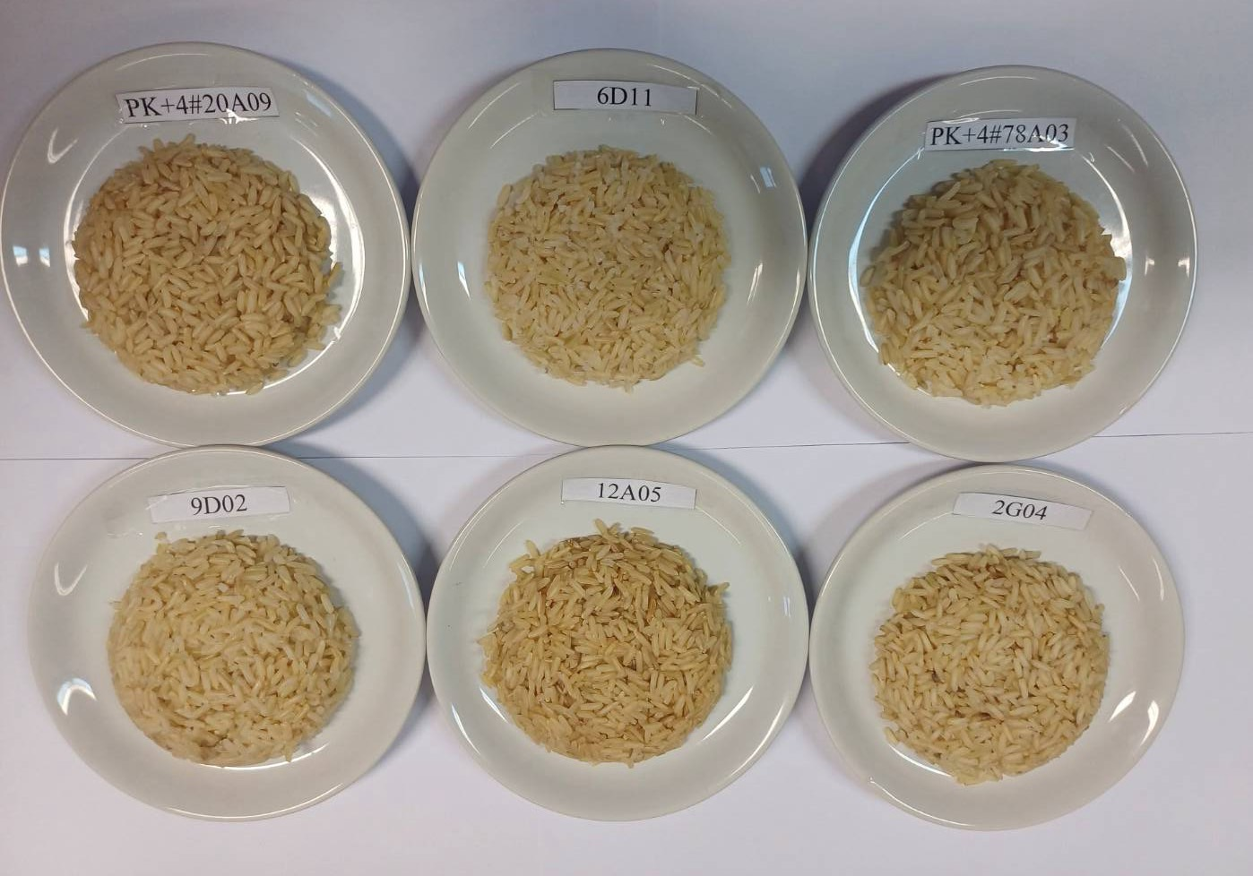
Supplementary Figure S1 The whole-grain rice samples were cooked using a rice cooker with a rice-to-water ratio 1:2 and cooked for 30 to 40 minutes.
Supplementary Figure S2 Days to Flowering, Days to Maturity, and Yield of BC₂F₃ population.
Supplementary Figure S3 The rate of starch digestion by amylase enzyme over varying incubation times (20 to 180 minutes) differs among cooked whole-grain rice varieties. The samples was prepared as freeze-dried (fine powder).

