DecipheringFusarium-banana interactions in resistant and susceptible banana cultivars using a GFP-tagged subtropical race 4 strain of *Fusarium oxysporum* f. sp. *cubense*

Andrew Chen 1, †, *, Ting Yan Chou 1, †, Yi Chen 1, †, Sumayyah M. A. Fallatah 1, Jay Anderson 1, ‡, Jiaman Sun 2, Harry Cosgrove 1, #, Siyuan Gao 1, Brett Ferguson 3, Amelie Soper 1, Donald M. Gardiner 4 and Elizabeth A. B. Aitken 1, *

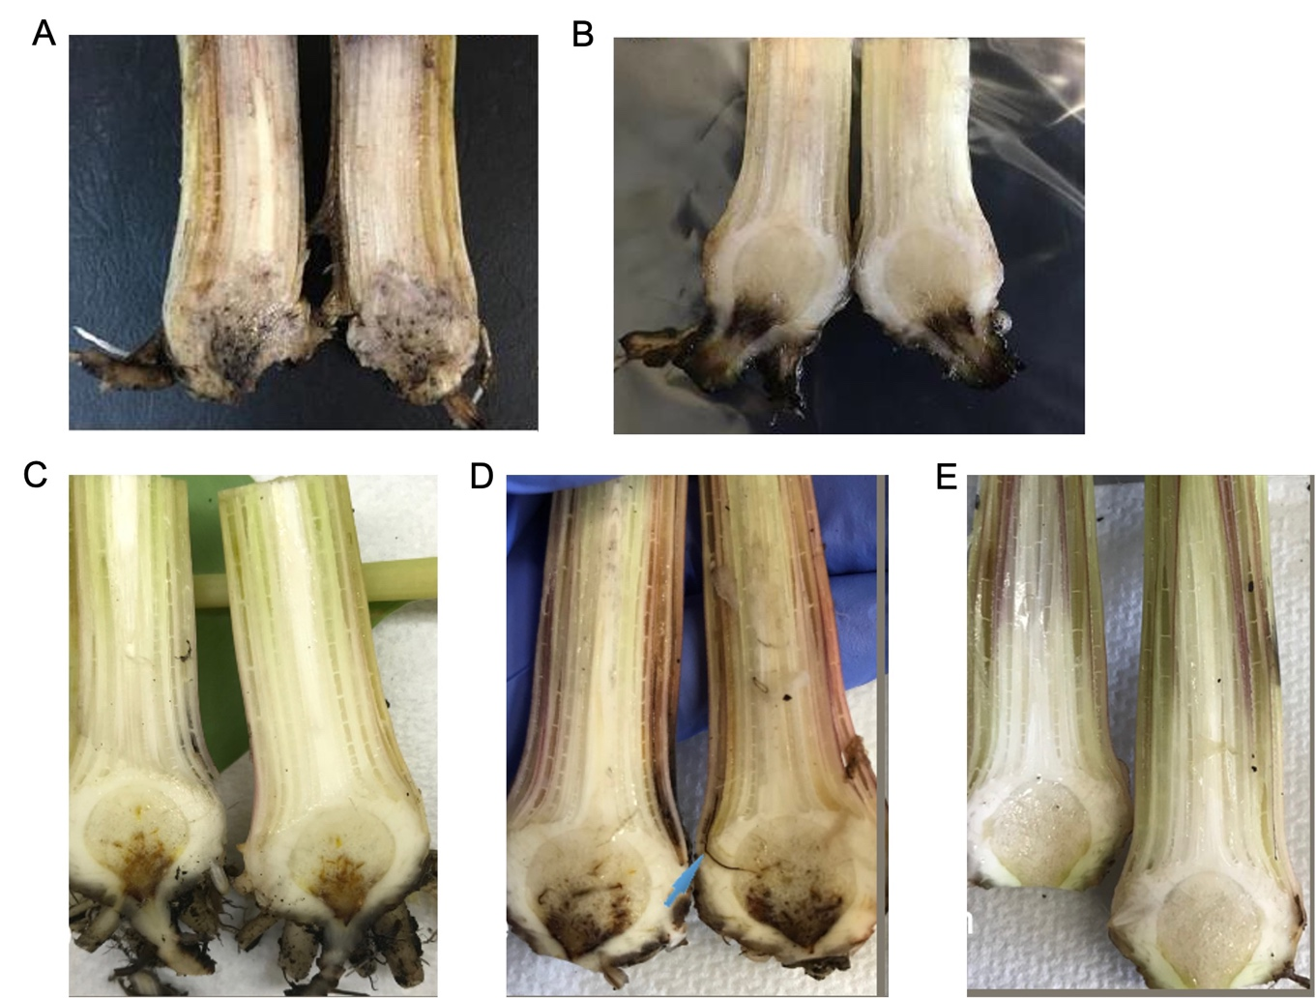

**Figure S1.** Assessment of discolouration in the rhizomes of the banana cultivars used in this study. (**A**) 'FHIA2' at 35 dpi. (**B**) 'FHIA25' at 35 dpi. (**C**) 'Lady finger' at 32 dpi. (**D**) 'Williams' at 34 dpi. (**E**) 'GCTCV119' at 34 dpi.

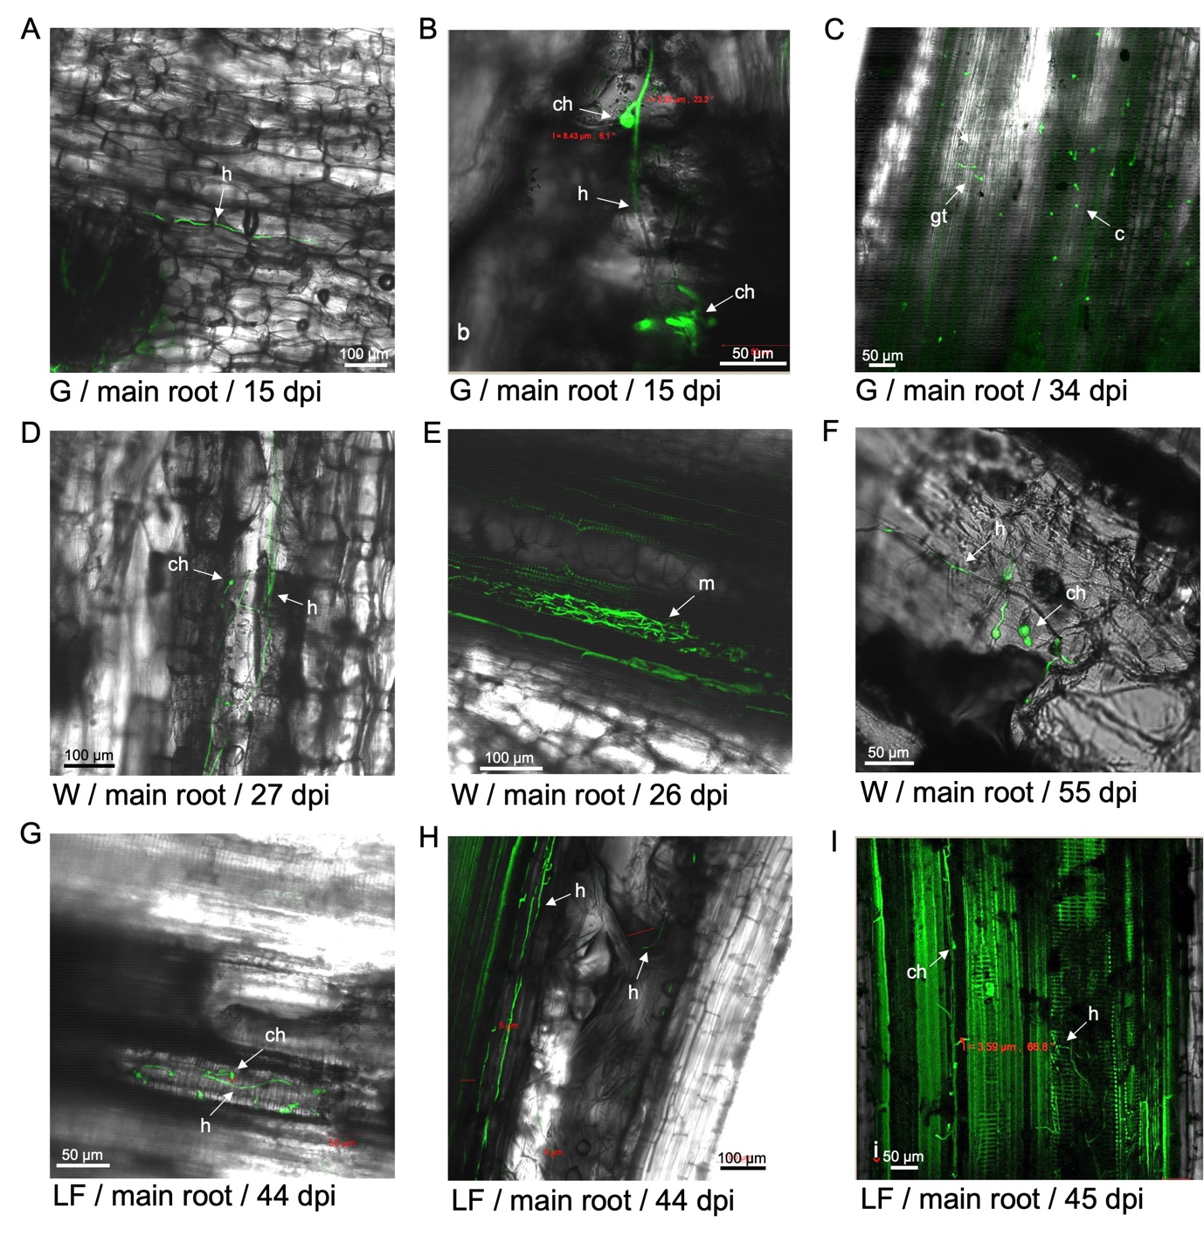

**Figure S2.** GFP-*Foc*-STR4 visualised in the main roots of 'GCTCV119' (G), 'Williams' (W) and 'Lady Finger' (LF) at 15—45 dpi. (**A**) Hyphae moving through the epidermis of a main root in 'GCTCV119' at 15 dpi. (**B**) terminal and intercalary chlamydospores on a monophialide conidiophore in a main root of 'GCTCV119' at 15 dpi. (**C**) Germinating conidia visualised on a main root of 'GCTCV119' at 34 dpi. (**D**) terminal chlamydospore and hyphae visualised in the main root cortex of 'Williams' at 27 dpi. (**E**) Mycelial networks visualised in the vasculature of the main root of 'Williams' at 26 dpi. (**F**) Chlamydospores on monophialide conidiophores visualised on the main root of 'Williams' at 55 dpi. (**G**) Chlamydospores on monophialide conidophores visualised in the xylem vessels of the main root of 'Lady Finger' at 44 dpi. (**H**) Hyphae visualised in the xylem vessels and the cortex of the main root of 'Lady Finger' at 44 dpi. (**I**) Chlamydospores and hyphae visualised in the vasculature of the main root in 'Lady Finger' at 45 dpi. Arrows indicate conidia (c); chlamydospores (ch); hyphae (h); mycelium (m); germ tube (gt). Horizontal bars indicate the scale used to capture the confocal images.

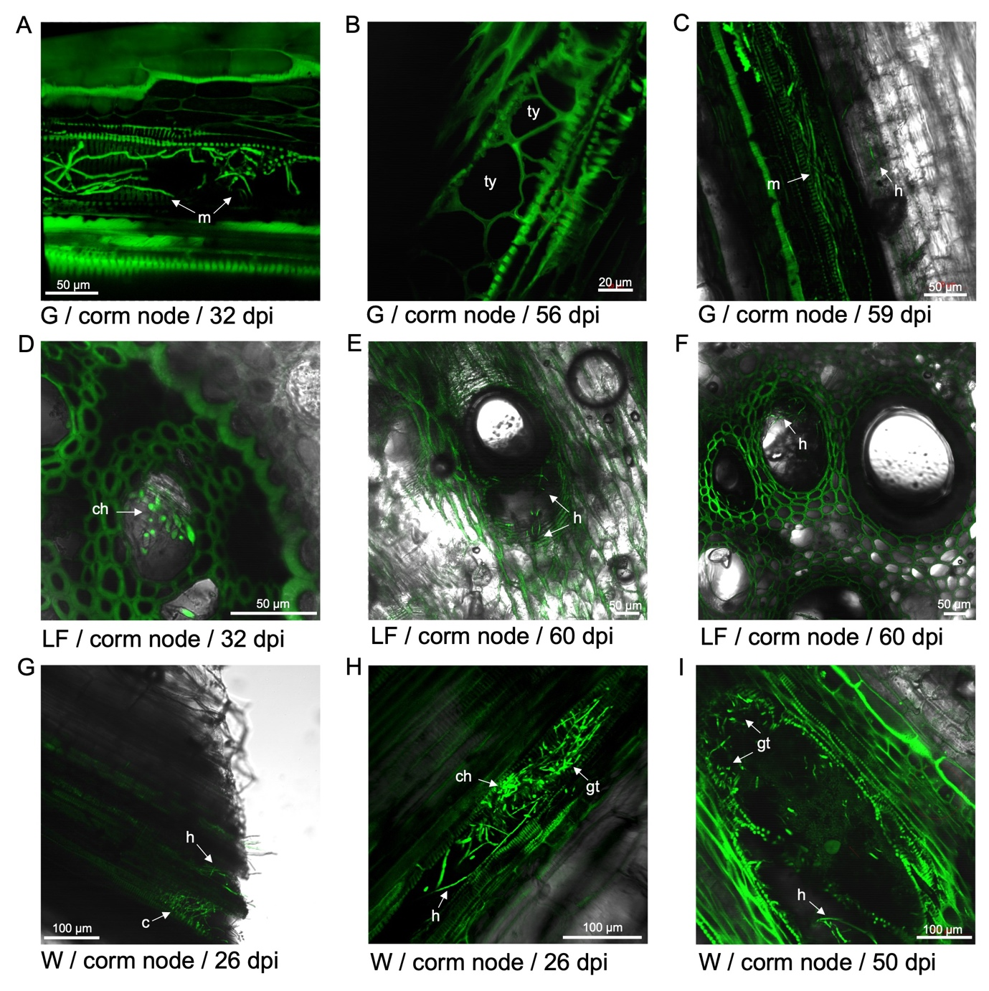

Figure S3. GFP-*Foc*-STR4 visualised in the corm nodes of 'Williams' (W), 'GCTCV119' (G) and 'Lady Finger' (LF) at 26—60 dpi. (**A**) Mycelia moving in the vasculature of a corm node in 'GCTCV119' at 32 dpi. (**B**) Tyloses formed in a corm node of 'GCTCV119' at 56 dpi. (**C**) Mycelia and hypha visualised within and around the xylem vessels of a corm node at 59 dpi. (**D**) Chlamydospores visualised in the corm of 'Lady Finger' at 32 dpi. (**E-F**) Hyphae visualised near the pits of a corm node in 'Lady Finger' at 60 dpi. (**G**) Conidia and hypha visualised in the vasculature of a corm node in 'Williams' at 26 dpi. (**H**) Chlamydospores and germinating tubes visualised in the xylem vessel of a corm node in 'Williams' at 26 dpi. (**I**) Germinating tubes and hypha visualised in the xylem vessel of a corm node in 'Williams' at 50 dpi. Arrows indicate conidia (c); chlamydospores (ch); hyphae (h); mycelium (m); germ tube (gt). Horizontal bars indicate the scale used to capture the confocal images.

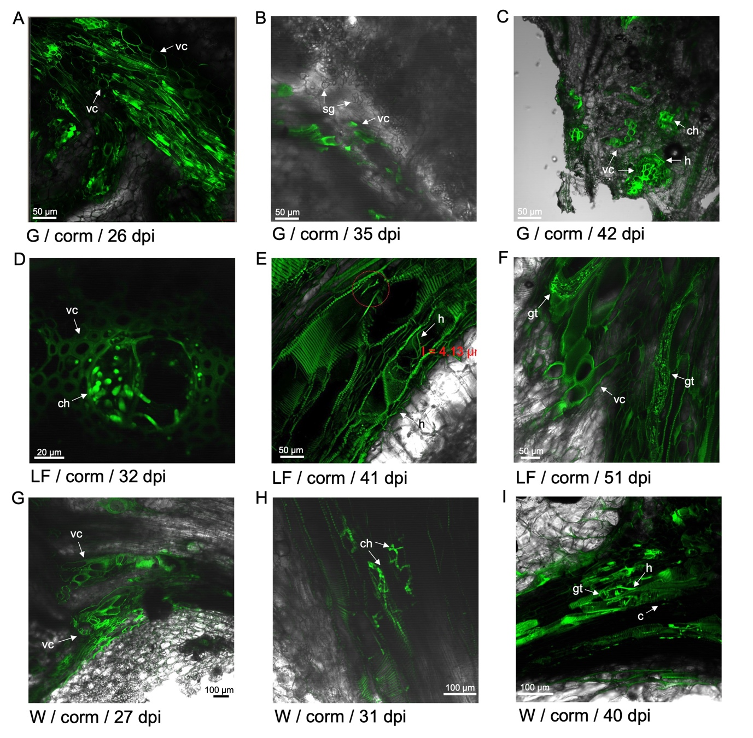

**Figure S4**. GFP-*Foc*-STR4 visualised in the corms of 'Williams' (W), 'GCTCV119' (G) and 'Lady Finger' (LF) at 26—51 dpi. (**A**) vascular discolouration visualised in the corm of 'GCTVC119'. (**B**) vascular coating and sugar granules visualised in the corm of 'GCTCV119' at 35 dpi. (**C**) vascular coating, chlamydospores and hypha visualised in the corm of 'GCTCV119' at 42 dpi. (**D**) Chlamydospores and vascular coating visualised around a pit in the corm of 'Lady Finger' at 32 dpi. (**E**) Hypha visualised in the vasculature of a corm in 'Lady Finger' at 41 dpi. (**F**) Vascular coating and germinating tubes visualised in the corm of 'Lady Finger' at 51 dpi. (**G**) Vascular coating visualised in the corm of 'Williams' at 27 dpi. (**H**) Chlamydospores visualised in the corm of 'Williams' at 31 dpi. (**I**) Germinating conidia and hypha visualised in the corm of 'Williams' at 40 dpi. Arrows indicate conidia (c); chlamydospores (ch); hyphae (h); mycelium (m); germ tube (gt); vascular coating (vc); sugar granule (sg). Horizontal bars indicate the scale used to capture the confocal images.

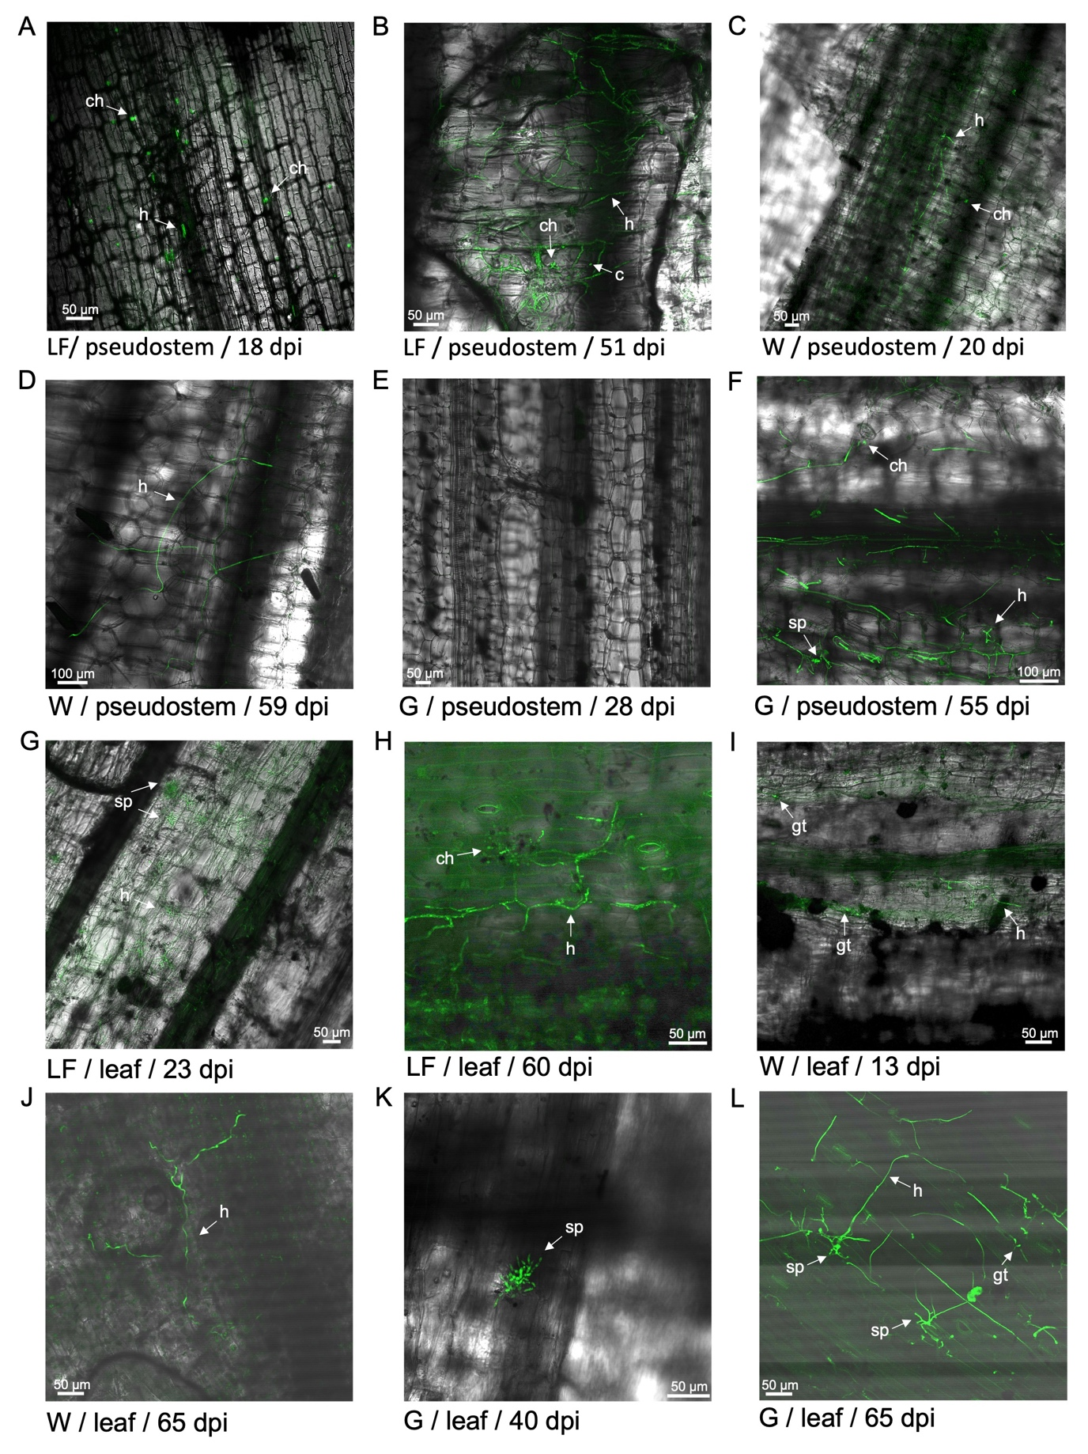

**Figure S5**. GFP-*Foc*-STR4 visualised in the pseudostems and leaves of 'Lady Finger' (LF), 'Williams' (W) and 'GCTCV119' (G) at 18—65 dpi. (**A**) Chlamydospores and hypha visualised in the pseudostem of 'Lady Finger' at 18 dpi. (**B**) Conidia, chlamydospores and hypha visualised in the pseudostem of 'Lady Finger' a 51 dpi. (**C**) Chlamydospores and hypha visualised in the pseudostem of 'Williams' at 20 dpi. (**D**) Hypha visualised in the pseudostem of 'Williams' at 59 dpi. (**E**) Pseudostem of 'GCTCV119' in the absence of GFP-*Foc*-STR4 at 28 dpi. (**F**) Sporodochia visualised on the leaf of 'GCTCV119' at 40 dpi. (**G**) Sporodochia visualised on the leaf of 'Lady Finger' at 23 dpi. (**H**) Chlamydospores and hyphae visualised on the leaf epidermis of 'Lady Finger' at 60 dpi. (**I**) Hyphae and germinating tubes were present on the leaf of 'Williams' at 13 dpi. (**J**) The movement of hyphae was detected on the leaf of 'Williams' at 65 dpi. (**K**) Sporodochia visualised on the leaf of 'GCTCV119' at 40 dpi. (**L**) Sporodochia, hypha and germinating tubes visualised on the leaf of 'GCTCV119' at 65 dpi. Arrows indicate conidia (c); chlamydospores (ch); hyphae (h); mycelium (m); germ tube (gt); sporodochia (sp). Horizontal bars indicate the scale used to capture the confocal images.

**Table S1**. Reisolation of *Fusarium oxysporum*-like colonies from the leaves, petioles, lower sems and rhizomes of 'FHIA02' and 'FHIA25' plants inoculated with GFP-*Foc*-STR4. '+' indicates a *F. oxysporum*-like colony with GFP fluorescence. '-' by itself indicates the absence of a *F. oxysporum*-like colony. '-' with '*' indicates the presence of a *F. oxysporum*-like colony but it was negative for GFP fluorescence.

|  |  |  |  |  |  |  |  |  |  |  |  |  |  |  |  |  |  |  |  |  |
| --- | --- | --- | --- | --- | --- | --- | --- | --- | --- | --- | --- | --- | --- | --- | --- | --- | --- | --- | --- | --- |
|  | GFP fluorescence | | | | | | | | | | | | | | | | | | | |
| Plant | Leaf | | | | | Petiole | | | | | Lower stem | | | | | Rhizome | | | | |
| FHIA25-1 | - | -* | -* | - | - | - | - | - | -* | -* | - | - | - | - | - | - | + | + | - | - |
| FHIA25-2 | - | -* | - | -* | -* | -* | -* | - | - | - | + | - | - | - | - | - | + | - | - | - |
| FHIA25-3 | -* | -* | - | - | - | - | - | -* | -* | - | -* | - | - | - | - | - | - | + | - | + |
| FHIA02-1 | - | -* | - | - | -* | - | - | - | - | - | - | - | - | + | -* | - | + | + | + | - |
| FHIA02-2 | -* | - | -* | -* | - | - | - | -* | - | -* | + | - | - | - | - | + | + | + | + | + |