Supplemental Figure 1. Participant flow diagram

Supplemental Figure S2. Pre and post vaccination level of distress according to sex

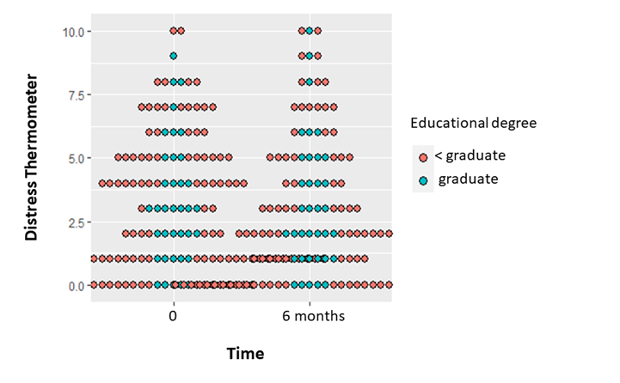
Supplemental Figure S3. Dotplot of repeated measure analysis of distress according to educational level

Supplemental Table 1. Comparison of vaccine non-responders between assay methods
 | Dimeric AU  (N = 175) | Trimeric BAU  (N = 218) | p value
Non responders | 18 (10.2) | 31 (14.2) | 0.31
Responders | 157 (89.8) | 187 (85.8) | 0.31
n (%)
Supplemental Table 2. Univariable analyses describing the association between high and low psychological symptoms and cancer sites.
 | High  n (%) | Low  n (%) | p value
 | 80 (30.1) | 186 (69.9) | p value
Anxiety, by Tumor site  Digestive  Lung  Breast  Genitourinary and gynecologic  Other | 7 (41.2)  17 (32.1)  10 (25.6)  46 (29.3)  46 (29.3) | 10 (58.8)  36 (67.9)  29 (74.4)  111 (70.7)  46 (29.3) | 0.68
Depressive symptoms, by Tumor site  Digestive  Lung  Breast  Genitourinary and gynecologic  Other | 19 (32.2)  37 (35.9)  17 (26.1)  4 (21.0)  3 (15.0) | 40 (67.8)  66 (64.1)  48 (73.9)  15 (79.0)  17 (85.0) | 0.27
Distress, by Tumor site  Digestive  Lung  Breast  Genitourinary and gynecologic  Other | 29 (31.9)  9 (32.1)  23 (35.9)  17 (23.6)  2 (18.2) | 62 (68.1)  19 (67.9)  41 (64.1)  55 (76.4)  9 (81.8) | 0.50

