**Supporting information**



(g)

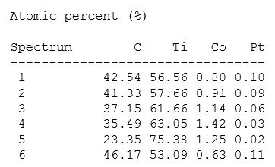

**Fig.S1.(a) SEM image of PtCo/Ti3C2Tx-32, (b) EDS mapping of PtCo/Ti3C2Tx-32, (c) Pt element, (d) Co element, (e) C element, (f) Ti element; (g) element proportion at each point in map**

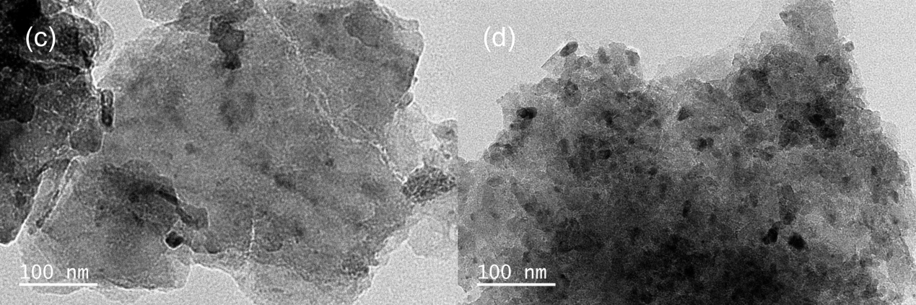

Fig.S2 TEM images of (a) Ti3C2Tx，(b) Co/Ti3C2Tx-32，(c) Pt/Ti3C2Tx-6.64，(d) PtCo/Ti3C2Tx-32



Fig.S3 XPS diagram of Ti3C2Tx

 

 

Fig.S4 XPS diagram of Co/Ti3C2Tx-32





Fig.S5 XPS diagram of Pt/Ti3C2Tx-6.64

 





Fig.S6 XPS diagram of PtCo/Ti3C2Tx-32

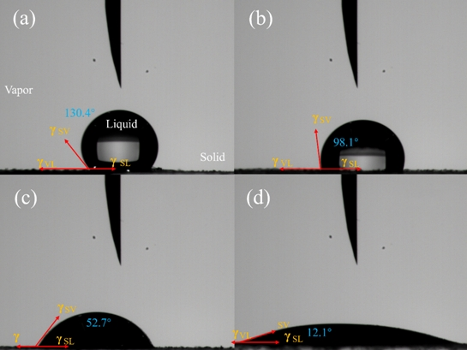

**Fig.S7 Contact angles of (a) Ti3C2T**x**，(b) Pt/Ti3C2Tx-6.64，(c) Co/Ti3C2Tx-32 and (d) PtCo/Ti3C2Tx-32**

**Fig.S8 Schematic diagram of Co/Ti3C2Tx, Pt/Ti3C2Tx and PtCo/Ti3C2Tx models**

**Simulation structure of (a): PtCo/Ti3C2Tx, (b): Co/Ti3C2Tx, (c): Pt/Ti3C2Tx; (d): ΔGH* of Co/Ti3C2Tx, Pt/Ti3C2Tx and PtCo/Ti3C2Tx; PDOS diagram of Pt atoms on the surface of (e): PtCo alloy, (f): Pt; (g) d-band center diagram of Pt**