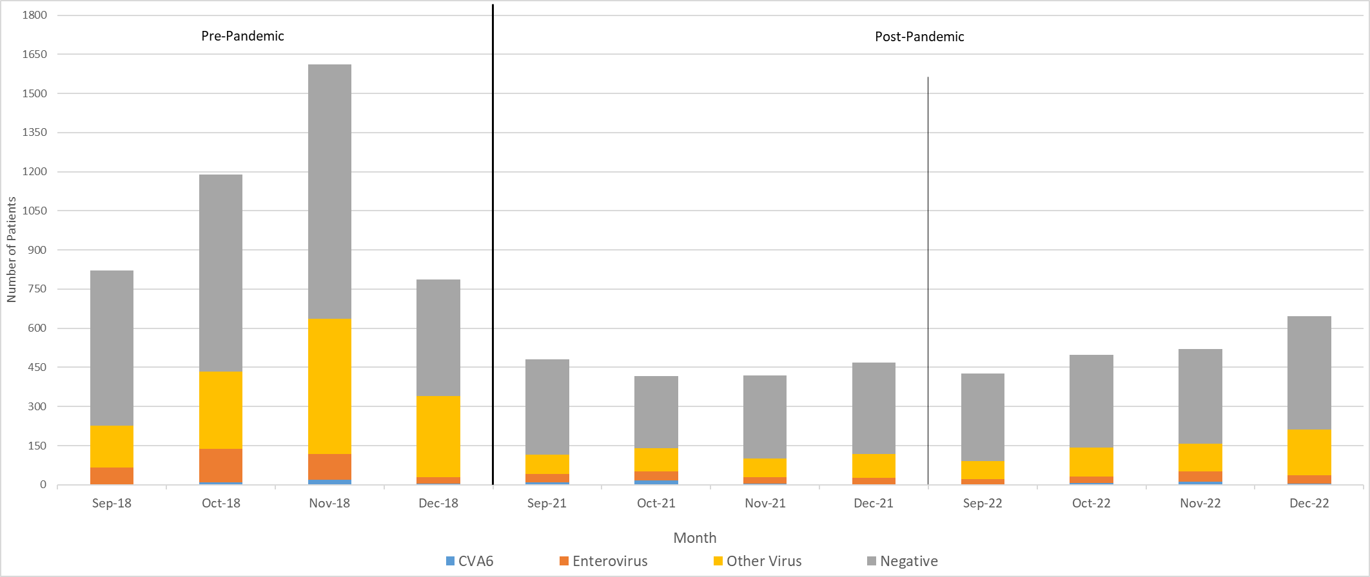

**Figure S1. Proportion of respiratory diagnostic test results in pre- and post- pandemic eras.** Total number of patients is represented by full length bars. Pre-pandemic era covers 1st September to 17th December 2018, post-pandemic era covers 11th May 2021 and 26th April 2023. Only data for September to December of each year is presented as this encompasses the peak period for CVA6 infection (see Figure 1).

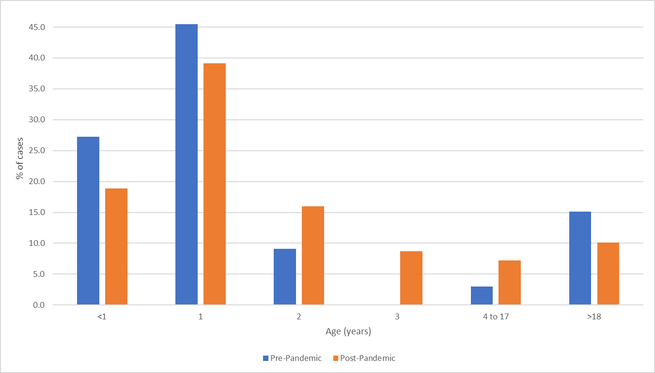

**Figure S2. CVA6 case proportion by age grouping in pre- and post-pandemic eras.**

Pre-pandemic era covers 1st September to 17th December 2018, post-pandemic era covers 11th May 2021 and 26th April 2023.

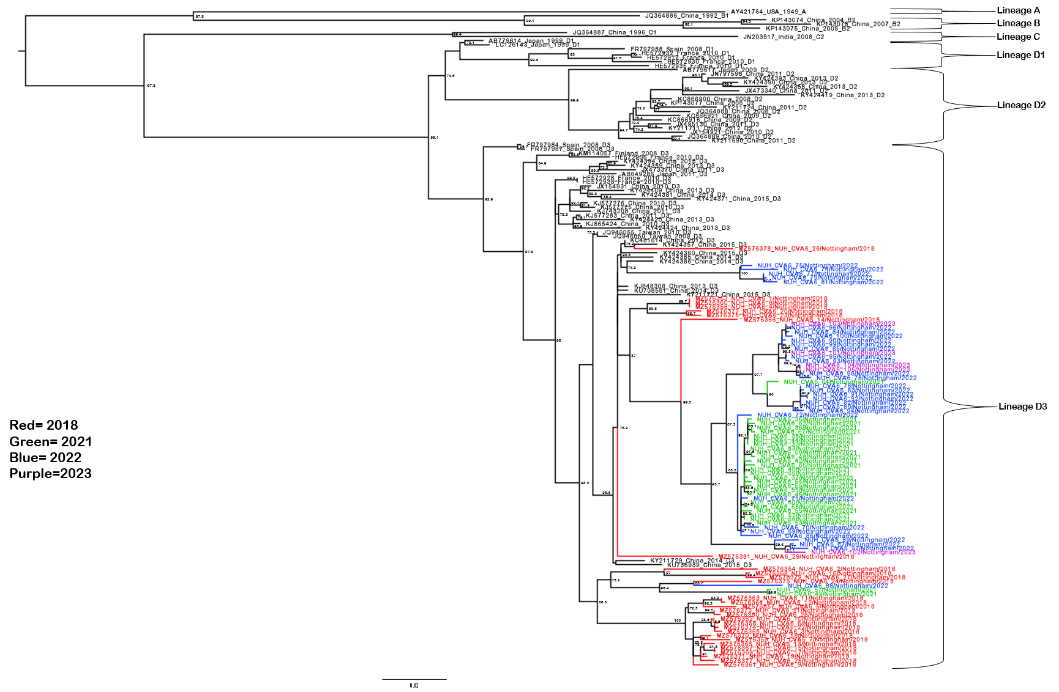

**Figure S3. Lineage analysis of CVA6 complete VP1 gene.** Molecular phylogenetic analysis of full VP1 CVA6 gene using the maximum likelihood method with SYM+I+G4 model in IQ-TREE2. Includes all novel sequences from this study and illustrates that they cluster amongst lineage D3 sequences. Also includes all lineage A, B, C and D using the dataset from Song et al., 2017 [37], with lineages annotated. Bootstrapping based on 1000 replications is shown next to each branch at a scale of 0.002, with bootstrap values below 70 omitted. Tree is midpoint rooted.

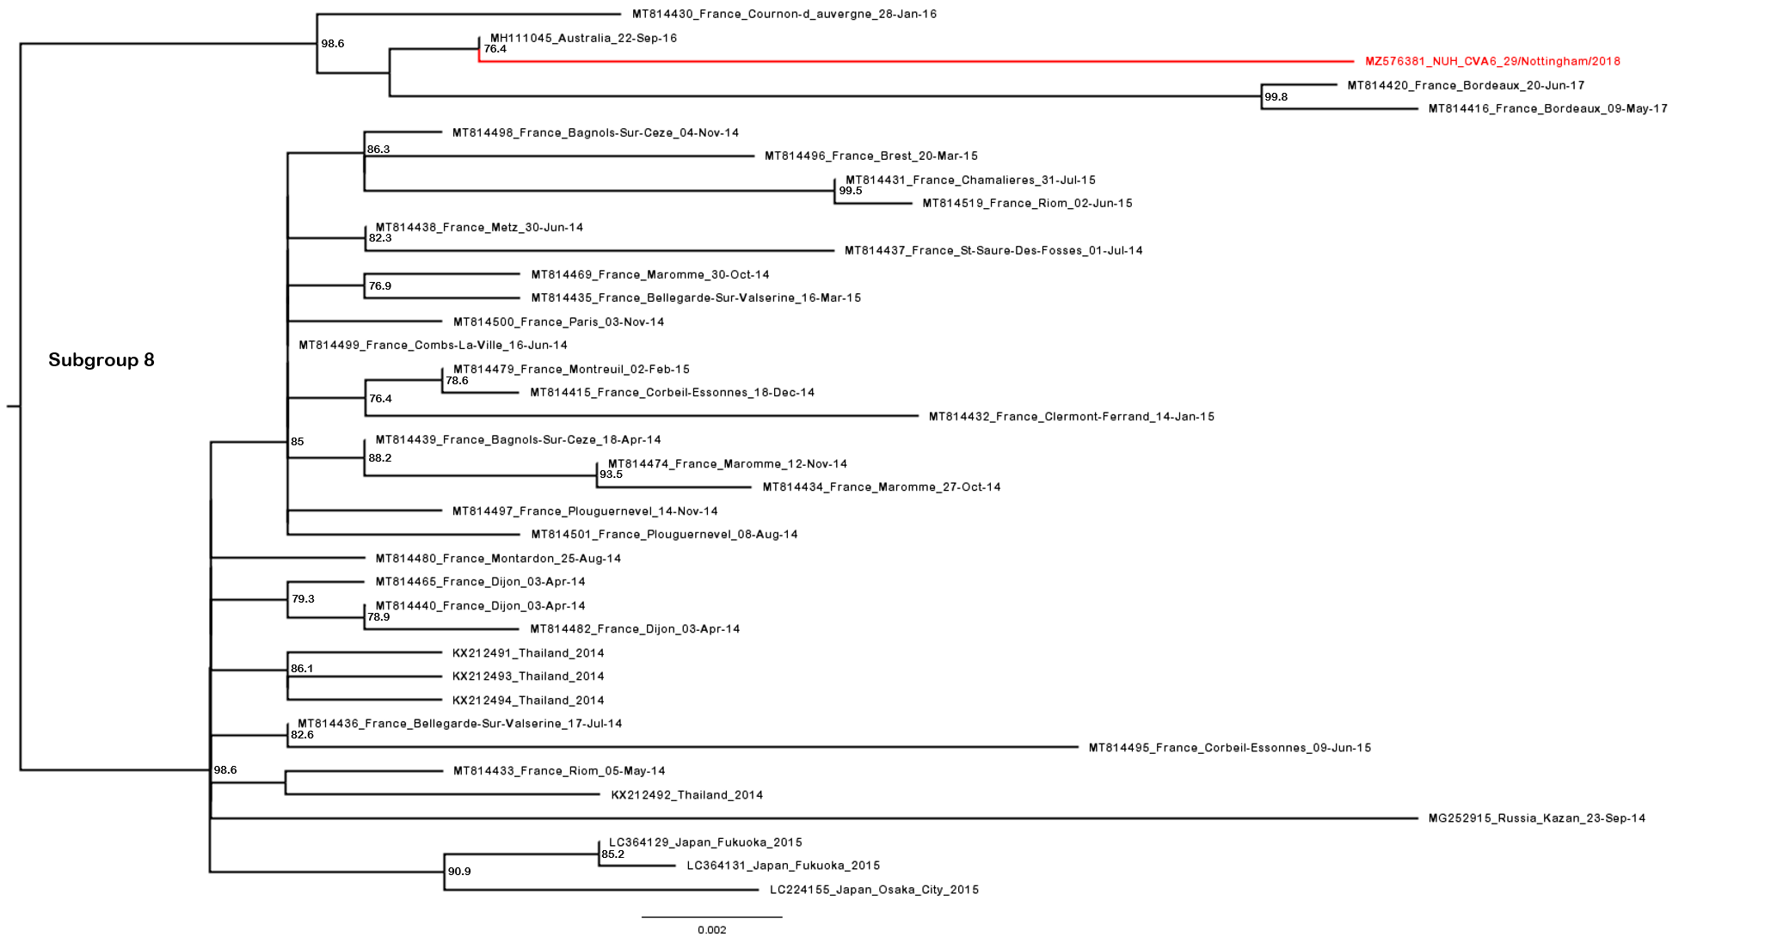**Figure S4.** **Phylogenetic analysis of CVA6 complete VP1 subgroup 8.** Molecular phylogenetic analysis of full VP1 CVA6 gene using the maximum likelihood method with SYM+I+R6 model in IQ-TREE2. Analysis was completed to include the subgroup 8 sequences highlighted in the comprehensive CVA6 lineage D tree (Figure Y), including a novel sequence from 2018 (red) and 37 publicly available sequences from GenBank. Bootstrapping based on 1000 replications is shown next to each branch at a scale of 0.002, with bootstrap values below 70 omitted. Tree is midpoint rooted.

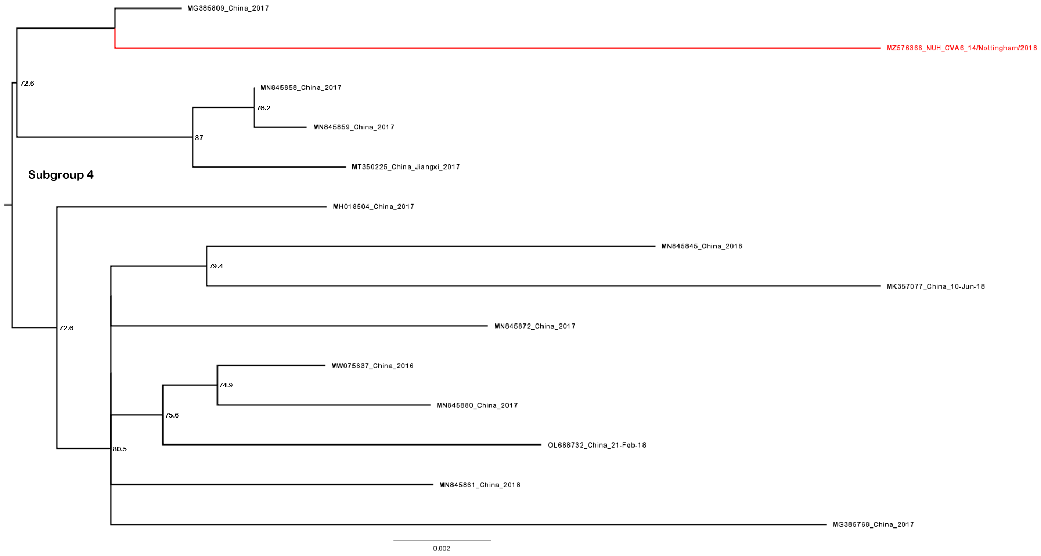**Figure S5. Phylogenetic analysis of CVA6 complete VP1 subgroup 4.** Molecular phylogenetic analysis of full VP1 CVA6 gene using the maximum likelihood method with SYM+I+R6 model in IQ-TREE2. Analysis was completed to include the subgroup 4 sequences highlighted in Figure 2, including 1 novel sequence from 2018 (red) and 13 publicly available sequences from GenBank. Bootstrapping based on 1000 replications is shown next to each branch at a scale of 0.002, with bootstrap values below 70 omitted. Tree is midpoint rooted.

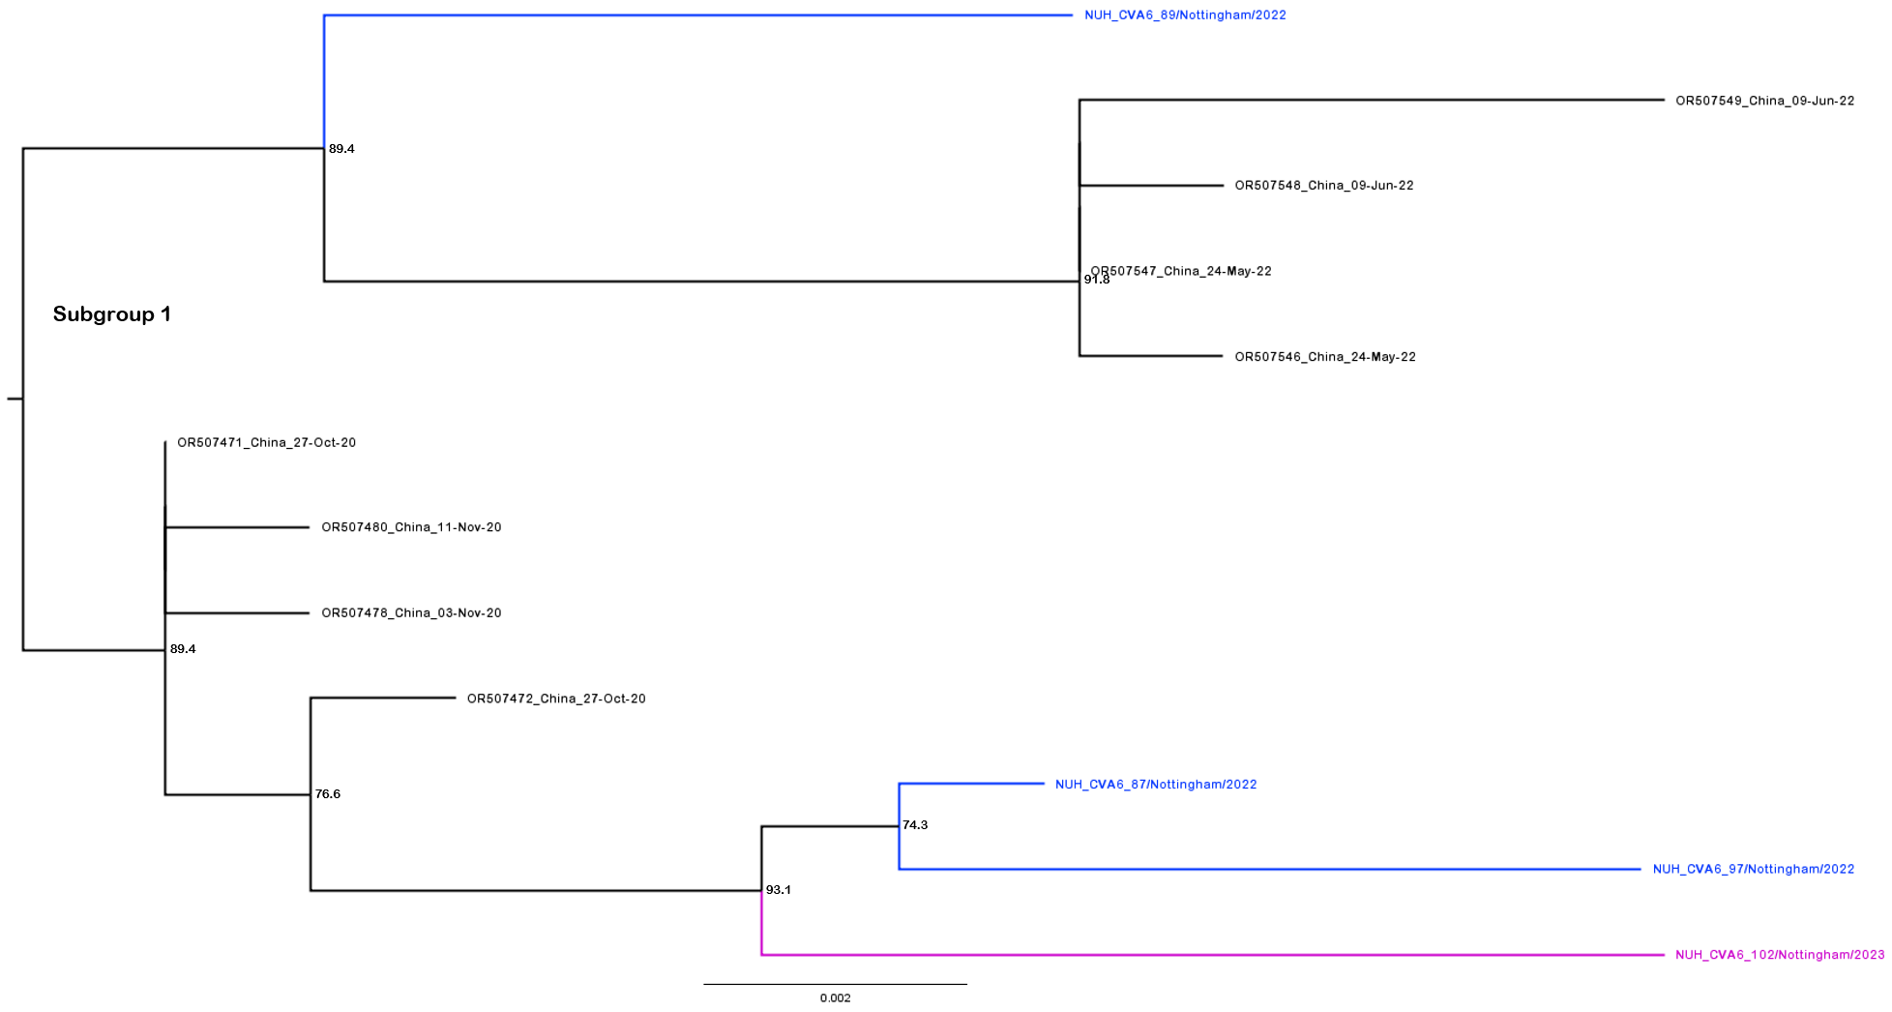

**Figure S6.** **Phylogenetic analysis of CVA6 complete VP1 subgroup 1.** Molecular phylogenetic analysis of full VP1 CVA6 gene using the maximum likelihood method with SYM+I+R6 model in IQ-TREE2. Analysis was completed to include the subgroup 1 sequences highlighted in Figure 2, including 3 novel sequences from 2022 (blue), 1 novel sequence from 2023 (purple), and 8 publicly available sequences from GenBank. Bootstrapping based on 1000 replications is shown next to each branch at a scale of 0.002, with bootstrap values below 70 omitted. Tree is midpoint rooted.

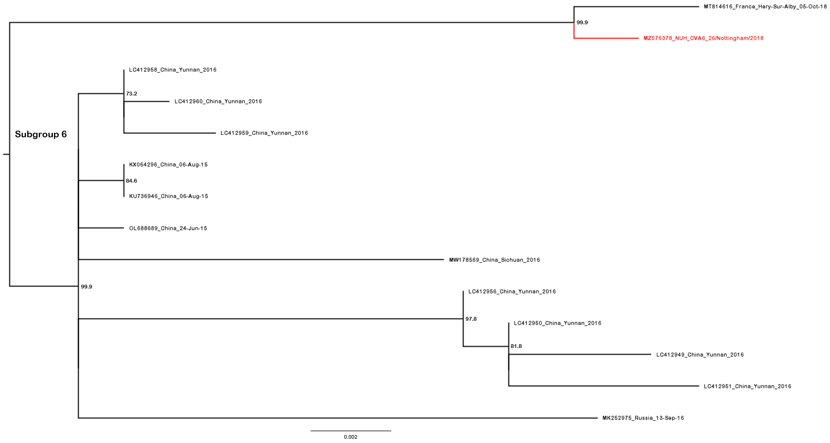**Figure S7. Phylogenetic analysis of CVA6 complete VP1 subgroup 6.** Molecular phylogenetic analysis of full VP1 CVA6 gene using the maximum likelihood method with SYM+I+R6 model in IQ-TREE2. Analysis was completed to include the subgroup 6 sequences highlighted in Figure 2, including 1 novel sequence from 2018 (red) and 13 publicly available sequences from GenBank. Bootstrapping based on 1000 replications is shown next to each branch at a scale of 0.002, with bootstrap values below 70 omitted. Tree is midpoint rooted.

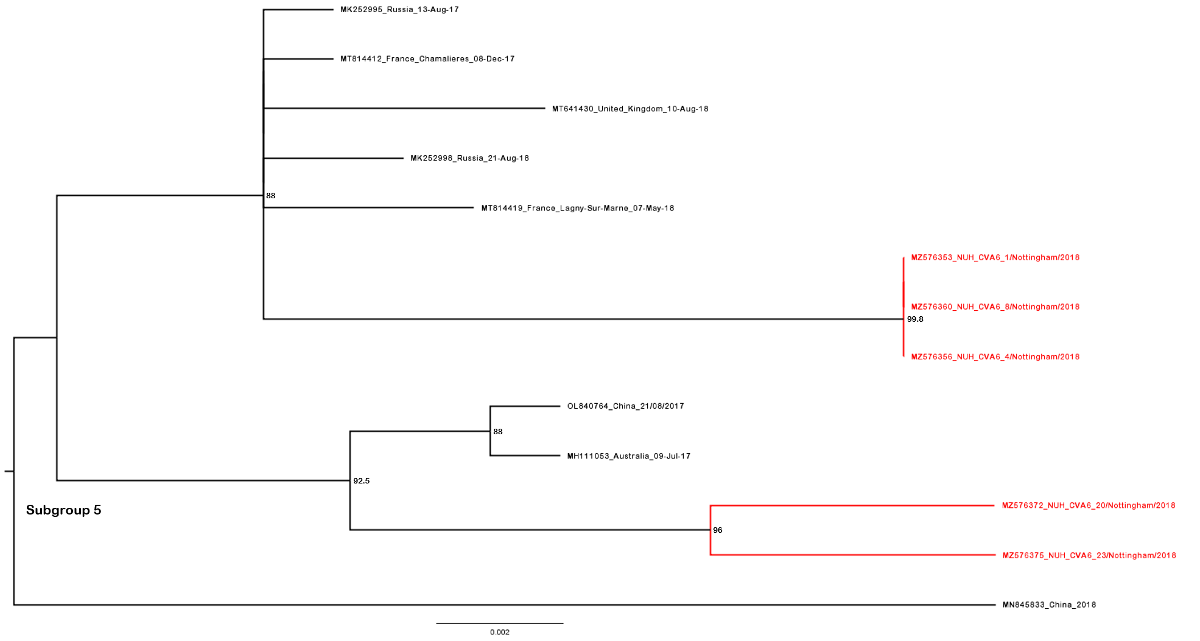**Figure S8. Phylogenetic analysis of CVA6 complete VP1 subgroup 5.** Molecular phylogenetic analysis of full VP1 CVA6 gene using the maximum likelihood method with SYM+I+R6 model in IQ-TREE2. Analysis was completed to include the subgroup 5 sequences highlighted in Figure 2, including 5 novel sequences from 2018 (red) and 8 publicly available sequences from GenBank. Bootstrapping based on 1000 replications is shown next to each branch at a scale of 0.002, with bootstrap values below 70 omitted. Tree is midpoint rooted.

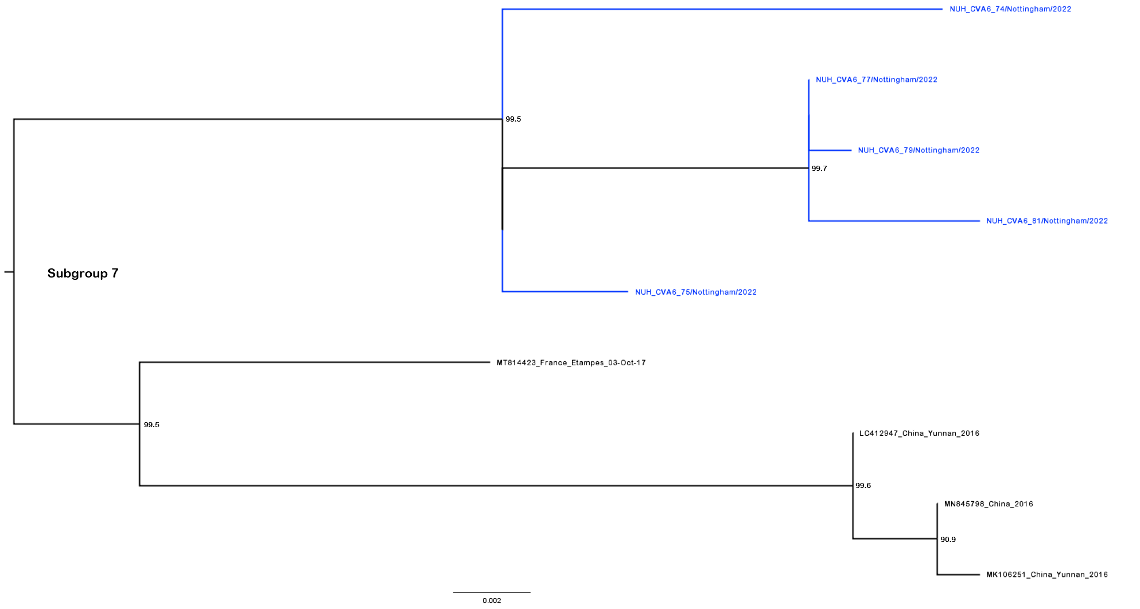**Figure S9. Phylogenetic analysis of CVA6 complete VP1 subgroup 7.** Molecular phylogenetic analysis of full VP1 CVA6 gene using the maximum likelihood method with SYM+I+R6 model in IQ-TREE2. Analysis was completed to include the subgroup 7 sequences highlighted in Figure 2, including 5 novel sequences from 2022 (blue) and 4 publicly available sequences from GenBank. Bootstrapping based on 1000 replications is shown next to each branch at a scale of 0.002, with bootstrap values below 70 omitted. Tree is midpoint rooted.