SUPPORTING INFORMATION
A study of the potential anti-inflammatory drugs chalcone derivatives through the combination of NMR spectroscopy and molecular modeling
Nikitas Georgiou¹, Andromachi Tzani², Kyriaki Vavougyiou¹, Christos Papadopoulos³, Nikolaos Eleftheriadis³, Primoz Sket⁴, Demeter Tzeli^{5,6}, Tuomas Niemi-Aro⁷, Anastasia Detsi², Thomas Mavromoustakos^{1*}
¹Laboratory of Organic Chemistry, Department of Chemistry, National and Kapodistrian University of Athens, Panepistimioupolis Zografou, 11571 Athens, Greece
^{b}Laboratory of Organic Chemistry, Department of Chemical Sciences, School of Chemical Engineering, National Technical University of Athens, Heroon Polytechniou 9, Zografou Campus, 15780 Athens, Greece
³Department of Chemistry, University of Crete, Voutes, 70013 Heraklion, Greece
⁴Slovenian NMR Centre, National Institute of Chemistry, SI-1001 Ljubljana, Slovenia
⁵Laboratory of Physical Chemistry, Department of Chemistry, National and Kapodistrian University of Athens, Panepistimioupolis Zografou, 11571 Athens, Greece
⁶Theoretical and Physical Chemistry Institute, National Hellenic Research Foundation, 48 Vassileos Constantinou Ave., 11635 Athens, Greece
⁷Institute of Biotechnology, Helsinki Institute of Life Sciences, P.O 65 (Viikinkaari 1), 00014 University of Helsinki

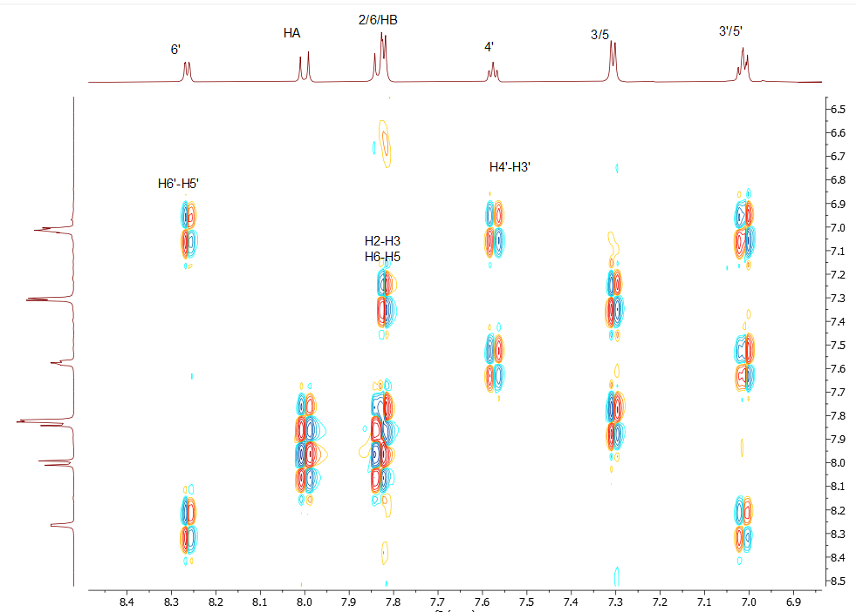
Figure S1: 2D-COSY NMR spectrum of compound 1. The spectra were recorded in DMSO-d₆ on a Bruker AC 850 MHz spectrometer at 25 ºC.
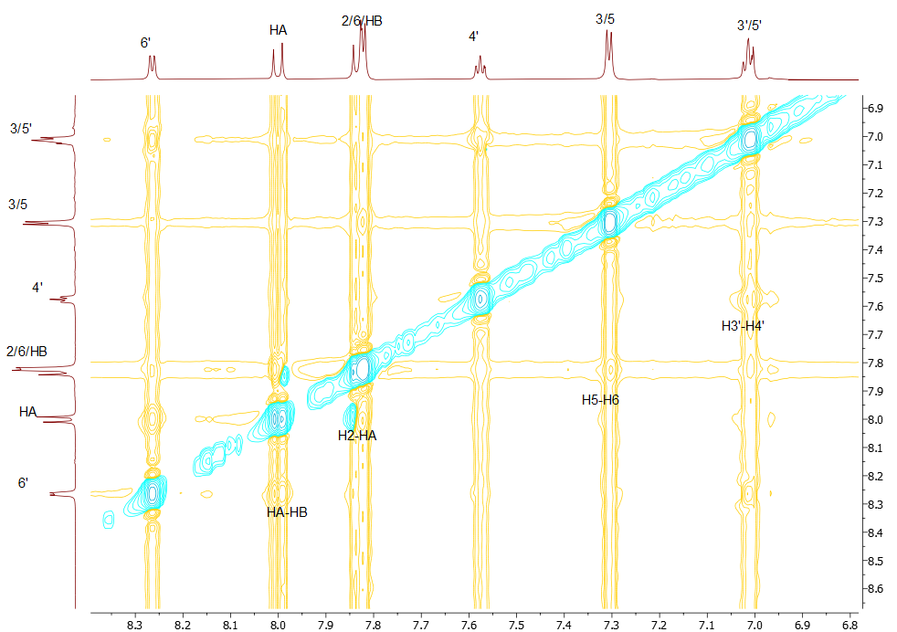
Figure S2: 2D-NOESY NMR spectrum of compound 1. The spectra were recorded in DMSO-d₆ on a Bruker AC 850 MHz spectrometer at 25 ºC.
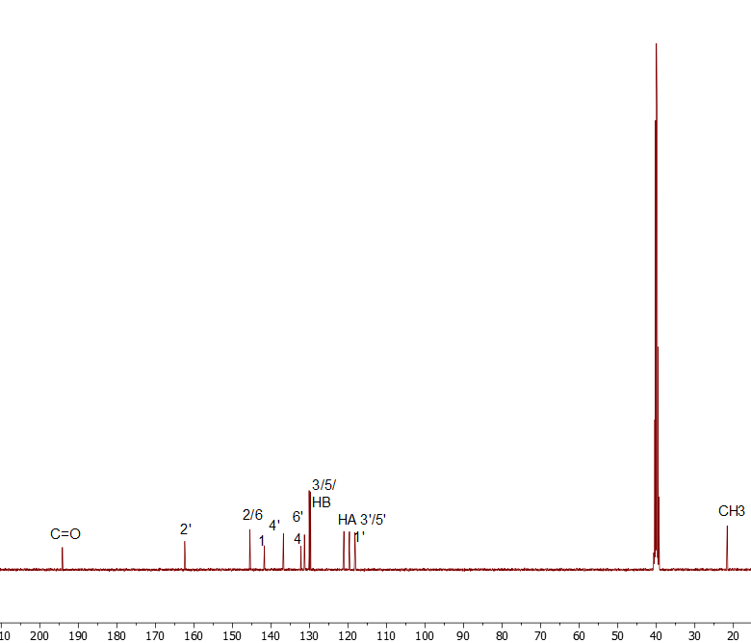

Figure S3: ¹³C NMR spectrum of compound 1. The spectra were recorded in DMSO-d₆ on a Bruker AC 850 MHz spectrometer at 25 ºC.
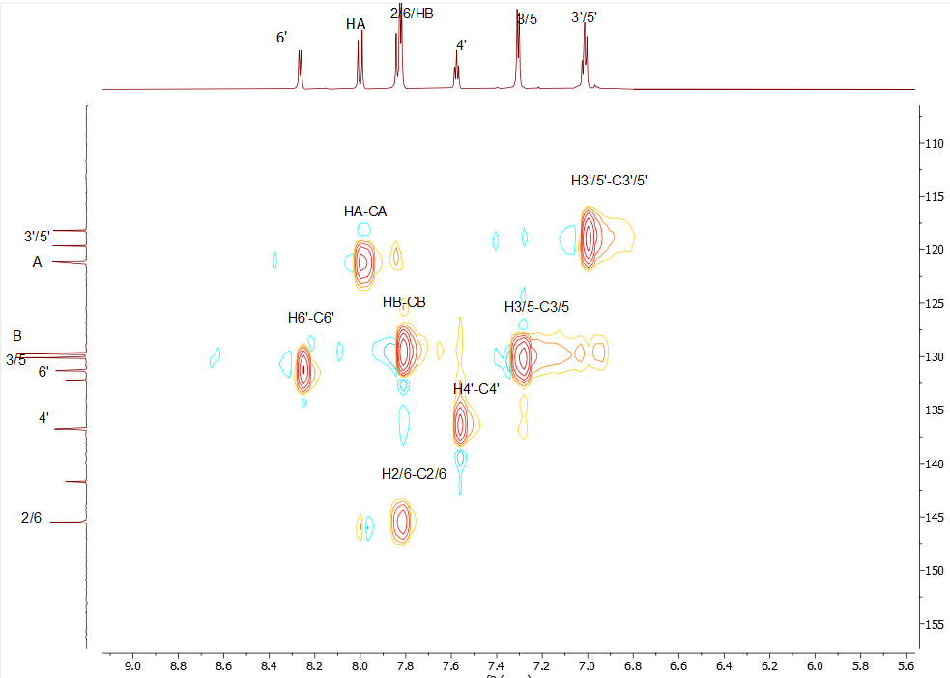
Figure S4: 2D-HSQC NMR spectrum of compound 1. The spectra were recorded in DMSO-d₆ on a Bruker AC 850 MHz spectrometer at 25 ºC.
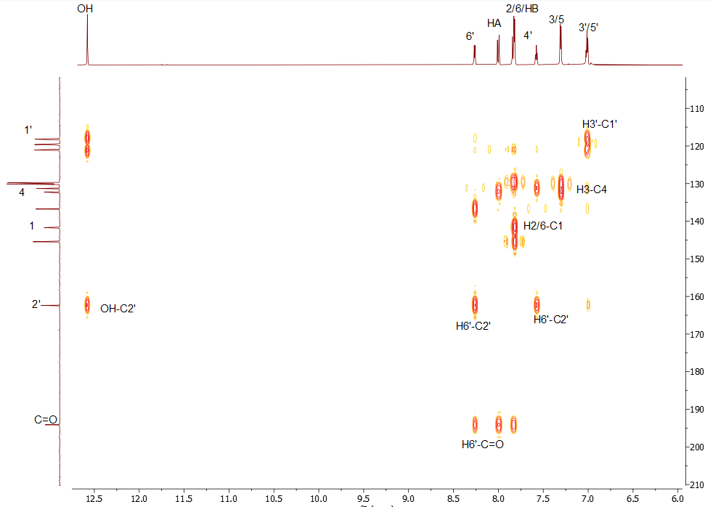
Figure S5: 2D-HMBC NMR spectrum of compound 1. The spectra were recorded in DMSO-d₆ on a Bruker AC 850 MHz spectrometer at 25 ºC.
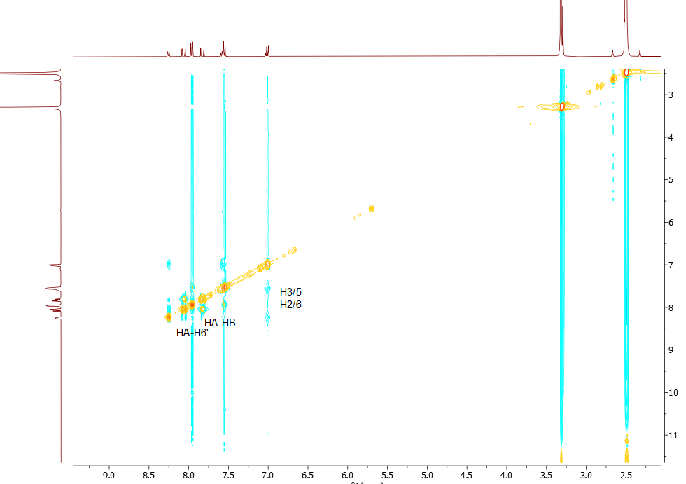
Figure S6: 2D-NOESY NMR spectrum of compound 2. The spectra were recorded in DMSO-d₆ on a Bruker AC 400 MHz spectrometer at 25 ºC.
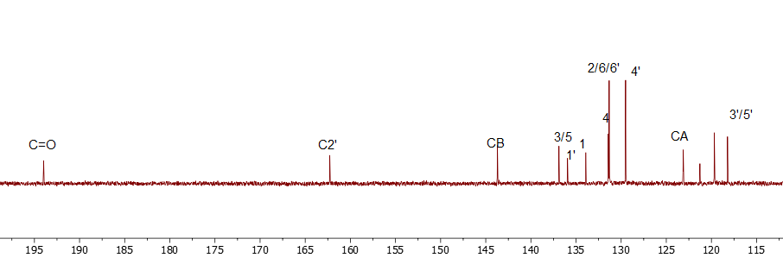
Figure S7: ¹³C NMR spectrum of compound 2. The spectra were recorded in DMSO-d₆ on a Bruker AC 400 MHz spectrometer at 25 ºC.
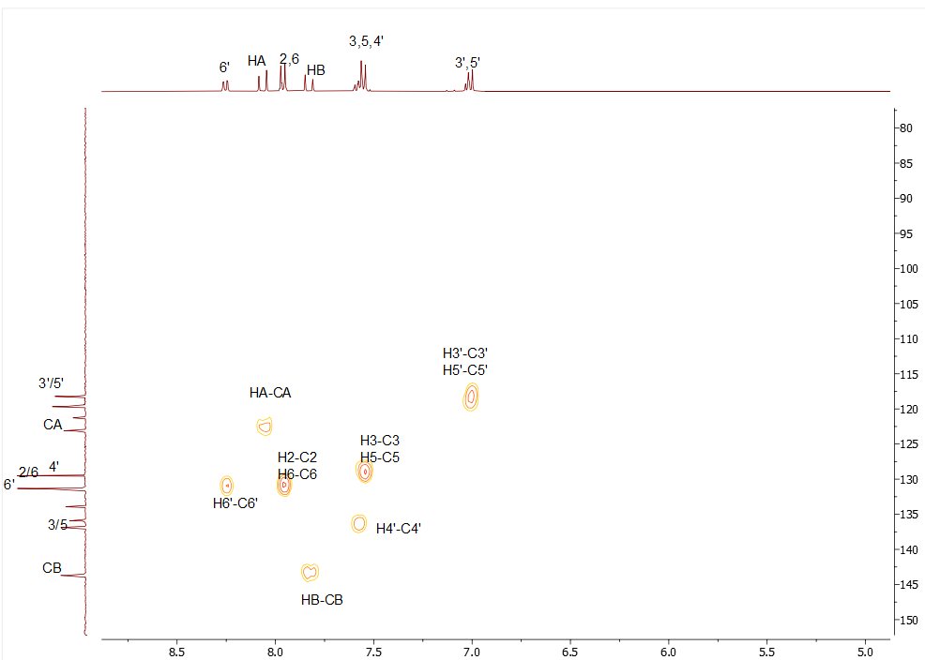
Figure S8: 2D-HSQC NMR spectrum of compound 2. The spectra were recorded in DMSO-d₆ on a Bruker AC 400 MHz spectrometer at 25 ºC.
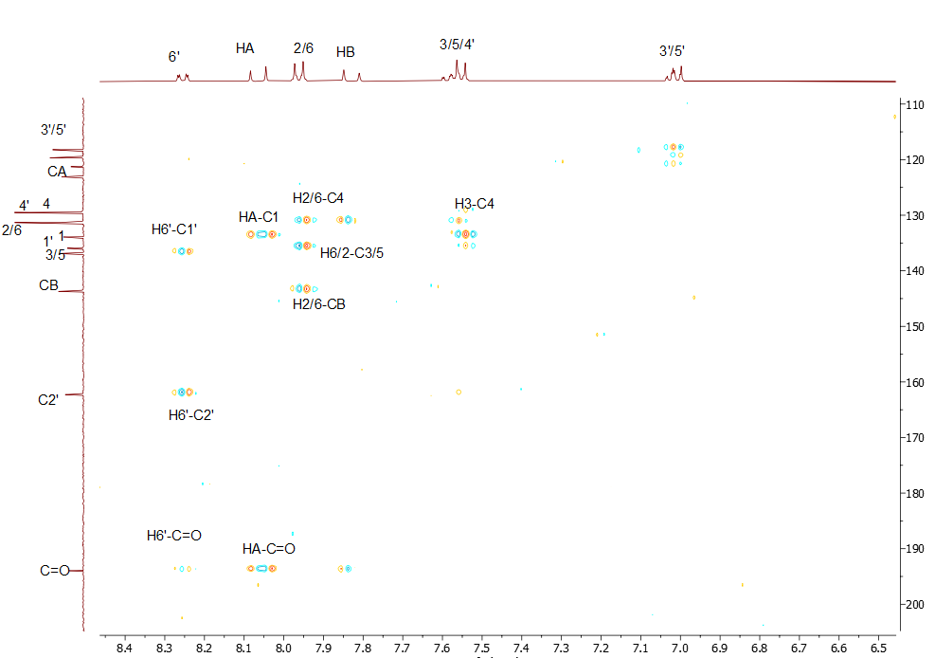
Figure S9: 2D-HMBC NMR spectrum of compound 2. The spectra were recorded in DMSO-d₆ on a Bruker AC 400 MHz spectrometer at 25 ºC.

