Article
In Vitro and In Vivo Translational Insights on the Intraoperative Use of Antiseptics and Lavage Solutions Against Microorganisms Causing Orthopedic Infections
Bartłomiej Dudek^{1*}, Malwina Brożyna¹, Michał Karoluk², Mariusz Frankiewicz², Paweł Migdał³, Konrad Szustakiewicz⁴, Tomasz Matys⁵, Adrian Wiater⁶, Adam Junka^{1*}
Citation: To be added by editorial staff during production.
Academic Editor: Firstname Lastname
Received: date
Revised: date
Accepted: date
Published: date

Copyright: © 2024 by the authors. Submitted for possible open access publication under the terms and conditions of the Creative Commons Attribution (CC BY) license (https://creativecommons.org/licenses/by/4.0/).
¹ “P.U.M.A.”, Platform for Unique Model Application, Department of Pharmacy, Wroclaw Medical University, Borowska 211, 50-534 Wrocław, Poland. B.D.: bartlomiej.dudek@umw.edu.pl;
M.B: malwina.brozyna@umw.edu.pl; A.J: adam.junka@umw.edu.pl
² Faculty of Mechanical Engineering, Department of Laser Technologies, Automation and Production Organization, Wrocław University of Science and Technology, Ignacego Łukasiewicza 5, 50-371 Wrocław, Poland. P.Sz-Z: michal.karoluk@pwr.edu.pl ; mariusz.frankiewicz@pwr.edu.pl
³ Department of Bees Breeding, Institute of Animal Husbandry and Breeding, Faculty of Biology and Animal Science, Wroclaw University of Environmental and Life Sciences, Chełmońskiego 38C, 51-630 Wrocław, Poland; P.M.: pawel.migdal@upwr.edu.pl
⁴ Department of Polymer Engineering and Technology, Faculty of Chemistry, Wrocław University of Science and Technology (WUST), Wyb. Wyspianskiego 27, 50-370, Wrocław, Poland. K.Sz: konrad.szustakiewicz@pwr.edu.pl
⁵ The Department and Clinic of Angiology and Internal Medicine, Wroclaw Medical University; Borowska 213, 50-556 Wrocław T.M.: tomasz.matys@umw.edu.pl
⁶ Department of Industrial and Environmental Microbiology, Institute of Biological Sciences, Faculty of Biology and Biotechnology, Maria Curie-Skłodowska University, Akademicka 19, 20-033 Lublin, Poland. A.W.: adrian.wiater@mail.umcs.pl

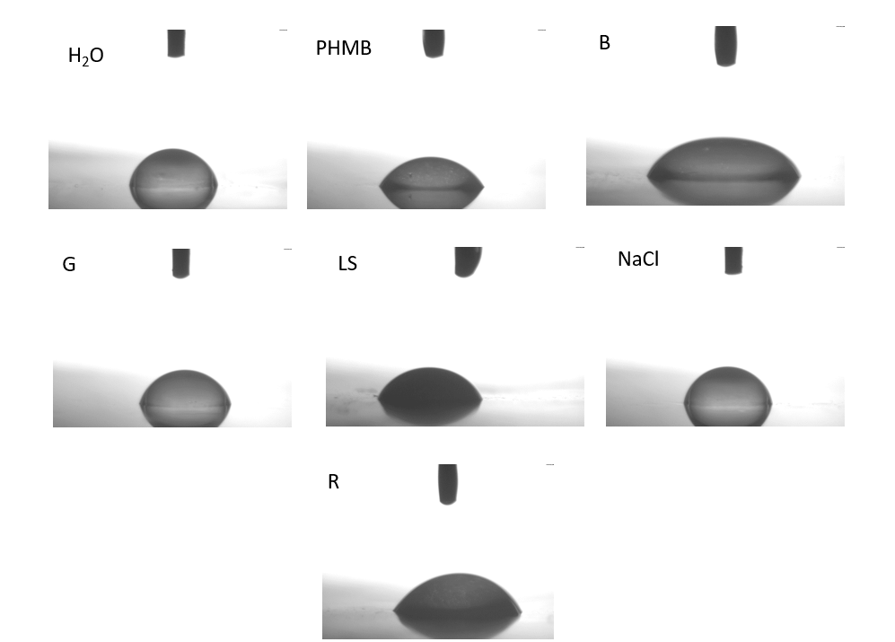
Supplementary Material 1. The wettability of the tested solutions. H₂O – water; NaCl: saline, PHMB: 0.1% polyhexanide + poloxamer surfactant, G: low-concentrated hypochlorite; LS: 0.04% polyhexanide + macrogol surfactant; R: ringer solution; B: iodine-containing antiseptic.

