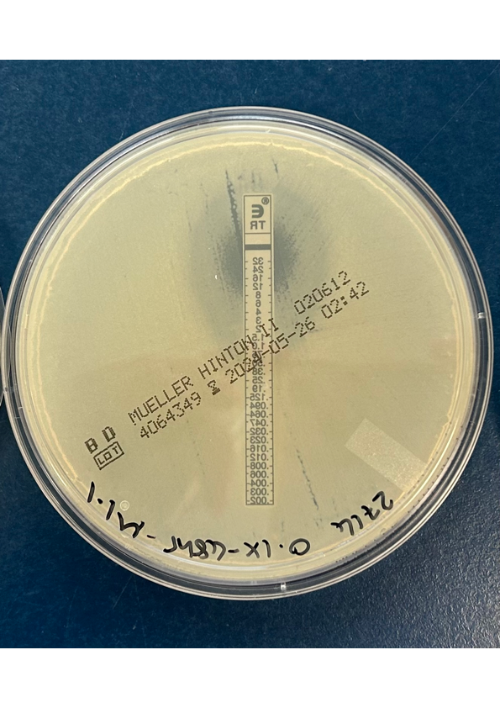
Supplementray Figure 1. A photograph depicting the double ellipse observed in the E-test for isolate 0.1xADI 1.1 (48hrs) 5 days post in vitro passaging.

